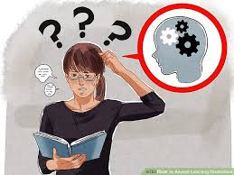
Mr Z had a learning disability.

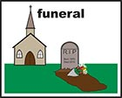

Mr Z died in 2016.

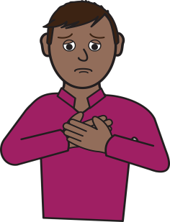

Everyone involved in Mr Z’s care express their sympathy and condolences to Mr Z’s loved ones.

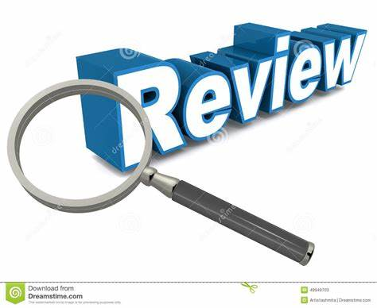
The Safeguarding Adults Board did a review to find out if we could have done anything differently to help Mr Z.

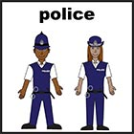
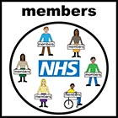

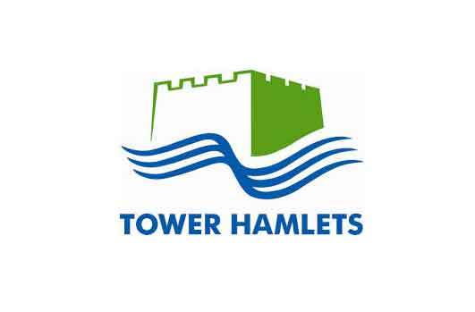
The Board is made up of the council, NHS, the Police and other local organisations.

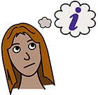

We found that staff did not know enough about Mr Z’s health needs.

We also found staff did not speak to each other about Mr Z as well as they might have done.

We asked everyone to make some changes.

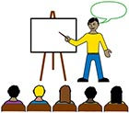

We asked everyone to train staff around mental capacity.

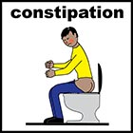

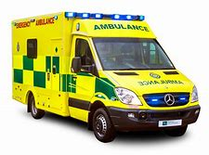
We gave staff better information on constipation, which had made Mr Z unwell.

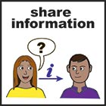

We asked everyone to speak and share information better.

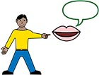

We also said we would do more to help people with a learning disability to speak out through ‘advocacy’.

