Title page: Impact of Brexit on Tower Hamlets - February 2019

# **Foreword**

More than two years after the June 2016 referendum on the UK’s membership of the European Union, the nature of our future relationship with the 27 other member states of the EU remains unclear. There has been a lack of clarity and certainty in the debate that has made it difficult for businesses and organisations providing vital public services to plan. This commission was set up to explore how Brexit is likely to impact on Tower Hamlets and to identify the risks and

opportunities involved.

Tower Hamlets is one of London’s most diverse boroughs, not only demographically but also socially and economically.

We are home to one of the largest concentrations of global financial firms in Canary Wharf and growing networks of professional services and tech companies are taking shape in the City Fringe and Shoreditch

areas.

Our borough is home to The Royal London, one of the capital’s largest hospitals and a leading major trauma centre. Queen Mary University welcomes students not only from around the UK, but across the world.

We are one of the fastest growing local authority areas in the country with one of the youngest populations.

More than 41,000 non-UK EU citizens who will see their legal status change as a result of Brexit have made their home in Tower Hamlets.

The commission has carried out a comprehensive analysis of the available   
  
  
  
evidence to produce an assessment of the likely impact of Brexit on Tower Hamlets, but such is the nature of our borough that we are confident these are observations that will equally apply across London.

The 24 recommendations detailed in this report will provide businesses, community organisations, public sector bodies and others with a framework to shape their essential preparations for Brexit.

I would like to thank the commissioners, witnesses and officers for their commitment throughout this process. I look forward to working closely with our partners to ensure the recommendations in this report are received positively and implemented effectively.

Together we can ensure that Tower Hamlets is ready for Brexit and positioned to continue to thrive beyond it.

Picture of Amina Ali

Councillor Amina Ali

Chair of the Tower Hamlets Brexit Commission

# **Executive summary**

Local authorities have been tasked by government with carrying out their own risk assessments and developing contingency arrangements in preparation for Brexit. The Tower Hamlets Brexit Commission, led by a panel of independent commissioners drawn from business, the public sector and academia has gone further than this by looking beyond the direct impact on the council to the wider impact on the borough as a whole.

In establishing the commission, the mayor and the Tower Hamlets Partnership identified three key focus areas:

> The impact on the local economy

> The impact on the delivery of public services

> The impact on civil society

## Local economy

Research firm Capital Economics was commissioned to map three different Brexit scenarios to examine how the impact on the borough’s economy would vary. These were ‘no deal’, a ‘Chequers style’ trade agreement and the ‘Canada plus’ model. They looked at a range of measures including jobs, skills and the import/export of goods.

> The economic impact in any scenario would be unevenly distributed across the borough due to the distinct characteristics and demographics of each local area.

> There is a high risk of skills shortages in certain sectors; however that also presents an opportunity for local people to fill vacancies created. A review of existing skills training programmes is required to ensure that the offer is matched to employers’ existing and future needs.

> The borough’s economy is less exposed to trade in goods than it is to services. However, some businesses may still experience impacts on their supply chains. Impacts felt by the financial services sector   
  
  
  
  
  
  
are also likely to have consequences across the borough due to the number of local companies that support its work.

> House building and the construction sector more widely have already reacted to Brexit-related uncertainty with a slow-down in delivery. A continued lack of clarity would likely see that trend continue.

> While larger companies have recognised the need to plan for Brexit, the same realisation has not taken place among many small and medium sized businesses. In particular, there has been insufficient planning for a ‘no deal’ scenario.

## Public services

> Restrictions on the mobility of talent in higher education will present significant challenges for the recruitment and retention of research staff and students.

> Public sector programmes that have previously been delivered with the support of EU funding will face an uncertain future. With similar losses being felt in the voluntary and community sectors, any replacement funds made available are unlikely to be sufficient to replicate current funding arrangements.

> Demand for public services, across multiple sectors, is increasing. Should the financial implications of Brexit mean that public sector funding is placed under greater strain, there is a risk that the increasing demand for services will not be met.

> Some parts of the public sector, for example the delivery of adult social care services, have been particularly reliant on EU staff in recent years. Uncertainty around Brexit could lead to challenges with recruitment and retention and ultimately, the quality and scope of service delivery.

## Civil society

> Some non-UK EU citizens are yet to make the connection between Brexit and the need to secure their individual rights. This lack of awareness is compounded by a lack of assistance and advice available, from government, to non-UK EU citizens.

> There is a concern that changes to immigration, employment and settlement rights could lead to greater discrimination against EU residents. The ‘leave’ vote created the perception of a permissive space where hate crime, not only targeted at non-UK EU citizens, increased.

> EU funding has been a significant enabler for a number of charities and voluntary groups in Tower Hamlets and they are struggling to plan given the current uncertainty around future levels of financial support.

> Brexit has already started to have a negative impact on the voluntary and community sectors’ ability to recruit and retain paid staff and volunteers.

The commission also sought recommendations from the witnesses that appeared before it, as well as relevant stakeholders on what the most appropriate responses to the challenges and opportunities highlighted above might be. These can be broadly summarised as follows:

> Given the significance of Canary Wharf and the City Fringe to the borough’s economy, the council and partners should redouble efforts to work closely with businesses to maintain Tower Hamlets’ position at the centre of London as a global

financial hub.

> There is a clear need to review our borough-wide skills strategies, in order to address shortages and ensure talent mobility.

> There will be an increased need to support local businesses, following Brexit, to ensure their sustainability and to create the conditions to allow them to continue making a positive contribution to the borough’s economy.

> All sectors should be encouraged to carry out their own contingency planning for Brexit, being particularly aware of the impact that it might have on staffing and supply chains.

> Businesses and community organisations should assess the impact of the proposals in the government’s immigration white paper and respond accordingly. Particular attention should be paid to the need for both high skilled and low skilled workers, the availability of those workers from the existing local population and the impact that the proposed pay threshold might have.

> Funding for key public sector and charities programmes, currently reliant on EU funding streams, should be maintained by government in any future post-Brexit funding frameworks.

> Non-UK EU residents and workers should be given greater support, including the provision of clear and timely advice and information. The council should work with its partners to ensure non-UK EU residents continue to feel welcomed and valued in Tower Hamlets.

# **Recommendations**

The following recommendations look at the role the council’s local partners. While this report has identified actions that can be taken at a local level, there are a number of the actions that require wider support, or intervention, from central government, the GLA, the Mayor of London, MPs and   
  
  
  
  
  
  
  
  
representative trade bodies. This will require an effective lobbying strategy, led by the Mayor of Tower Hamlets and delivered in coordination with key partners. Where the council is referred to, this infers strategic action led by the mayor’s office and the corporate leadership team.

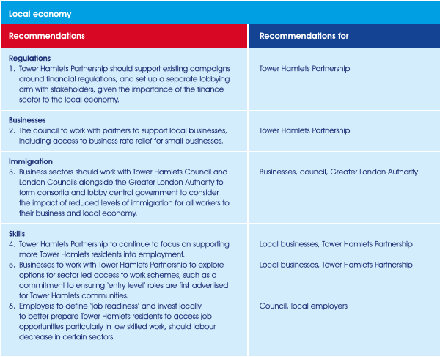

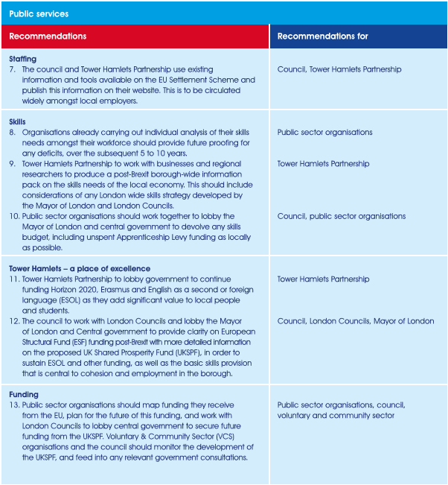

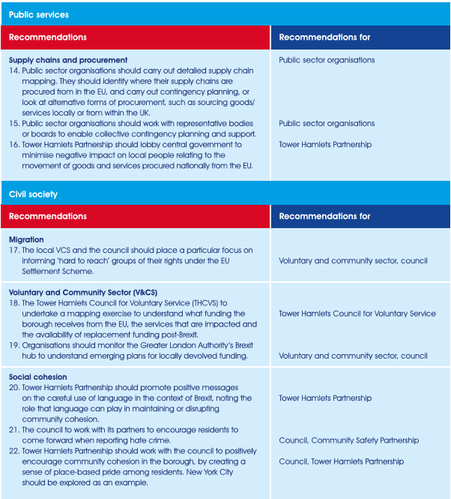

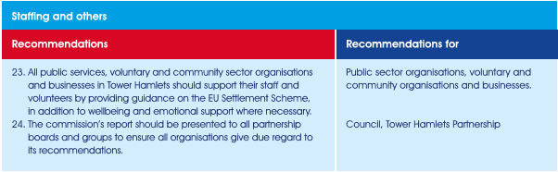

# **Introduction**

The commission was launched in September 2018 by Mayor John Biggs, in coordination with the Tower Hamlets Partnership, to explore the likely impact of Brexit on the borough. The commission was tasked with gathering evidence to inform an assessment of the likely impact in three specific areas – the local economy, the delivery of public services and civil society.

# **Remit and scope**

In each area, a number of exploratory questions were posed to shape the gathering of information. In each case, the commission was encouraged to explore both threats and opportunities.

## Local economy

> How is Brexit likely to impact on our competitiveness as a borough for international business over the short, medium and long term?

> How is Brexit likely to impact on our small and medium sized enterprises over the short, medium and long term?

> How it Brexit likely to impact on the continued success and sustainability of our local tourism sector?

> What measures can be identified to ensure that we are positioned to retain and attract a suitably skilled workforce to respond to the challenges of Brexit and to create the conditions for continued

economic growth?

## Public services

> How will Brexit impact on the delivery of statutory services by public sector organisations?

> How can public sector organisations in Tower Hamlets best apply pressure to government to ensure their interests are represented in the Brexit planning process?

## Civil society

> What does the borough need to do to support non-UK EU citizens who have made their home here? How does that differ from the support that will be required by those arriving during the transition period?

> How can the council and its partners work to strengthen community cohesion and promote continued integration in the context of Brexit?

> What steps are necessary to reassure non-UK EU residents of Tower Hamlets in the lead up to, and after, Brexit?

> How is Brexit likely to impact on the borough’s voluntary and community organisations? In particular, how well equipped is the sector to respond to changes in funding models after Brexit?

The commission was also asked to consider the potential impacts of Brexit for people with protected characteristics as defined by the Equality Act 2010 and how the borough can work together to mitigate them:

> Womens’ rights, including maternity and parental leave

> Disability rights, including improved employment opportunities and protections at work

> Tackling workplace discrimination, including protection on the grounds of religion or belief, sexual orientation and age.

The commission was also asked to:

> Explore ways to promote diversity and community cohesion while considering appropriate and specific support that could be offered to non- UK EU citizens living, working and studying in Tower Hamlets.

> Identify the key actions required for the effective lobbying of central government to ensure that equality and workers’ rights continue to be treated as priorities in setting a progressive agenda for post-Brexit Britain.

Tower Hamlets Council had already undertaken some preparatory work for Brexit, with a Scrutiny Challenge Session completed during the 2017/18 financial year. The limited time available for this work meant that its scope was restricted to an initial assessment of corporate risks and opportunities facing the council as an organisation.

The commission’s more comprehensive work was conducted over four months. Evidence was collected through a combination of oral hearings, the submission of written evidence, and desk-based research. Three roadshows were organised in the community to inform non-UK EU residents about their rights in the Brexit context. There were separate engagement events with BME-owned businesses in the borough and a further event to engage young people and hear their views on the issue.

Capital Economics was commissioned to consider the impact of Brexit on the local economy in three different scenarios; their research methodology included a series of interviews with local businesses.

Table entitled: the Commissioners with 9 people listed: Cllr Amina Ali (LBTH), Cllr Bex White (LBTH), Michael Pantlin (BARTS Health), Professor Tony Travers (LSE), Sue Terpilowski (FSB), Ivana Bartoletti (FWN), Howard Dawber (CWG), Fahimul Islam (LBTH), Sadie Ahmed (LBTH)


# **Local economy**

Under the hard Brexit scenario, GVA or economic output will be around two per cent lower. In Tower Hamlets, economic output is predicted to be 3.6 per cent lower than it would be otherwise. The initial impact of a hard Brexit is predicted to be more significant in Tower Hamlets and the City of London.”

**Naomi Clayton, Centre for Cities**

The commission was asked to address the following questions relating to the impact of Brexit on the local economy.

> How is Brexit likely to impact on our competitiveness as a borough for international business over the short, medium and long term?

> How is Brexit likely to impact on our small and medium sized enterprises over the short, medium and long term?

> How it Brexit likely to impact on the continued success and sustainability of our local tourism sector?

> What measures can be identified to ensure that we are positioned to retain and attract a suitably skilled workforce to respond to the challenges of Brexit and to create the conditions for continued economic growth?

The commission was also asked to consider the potential impacts of Brexit for people with protected characteristics as defined by the Equalities Act 2010 and how the borough can work together to mitigate them.

Capital Economics was commissioned to undertake desk-based and qualitative research into the potential impact of Brexit on the local economy.

This looked at three scenarios:

> There is no deal and the United Kingdom leaves the European Union on 29 March 2019.

> The proposed withdrawal agreement is agreed and a ‘Chequers style’ trading relationship is agreed over the next two years.

> A withdrawal agreement of some form is agreed and a bespoke ‘Canada Plus’ style trade arrangement is agreed over the next two years.

The commission received 30 written responses to its call for evidence and heard from 13 witnesses who provided oral evidence.

## Key findings

Tower Hamlets has a significant local economy, accounting for 1.6 per cent of the UK’s economic output. In 2015, the borough had the third highest output of 391 local authority areas in the UK, next to the London Borough of Westminster and the City of London.1

The risk of skills shortages is a major concern for many businesses in Tower Hamlets. The ability to recruit workers with appropriate skills is already a challenge for many businesses in the borough. In general, London has a higher immigrant population and European Union nationals make up a higher share of the capital’s workforce than elsewhere. This makes the borough more exposed to changes in immigration policy, and the confidence of overseas workers to come here for work. Some sectors, such as hospitality, are particularly reliant on EU workers for lower skilled roles, which are most likely those that will face significant restrictions if freedom of movement is ended. Other sectors, such as information and digital services, currently have a lower share of labour from the European Union, but still have some of the highest rates of hard to fill vacancies.

“Any policy that reduces the pool of labour reduces the quality of our team. That would reduce the effectiveness of our business and would therefore do the same for the industry as a whole. The British architectural profession is a world leader in terms of the volume of projects it undertakes throughout the world and its expertise in global influence – particularly in the developing world and emerging economies. The profession has thrived as part of an international community and benefited immeasurably from the freedom of movement that allows EU architects to contribute to British architecture as well as allowing many British architects to work throughout Europe.”

**Rupert Wheeler, Mackenzie Wheeler Architects and Designers**

Freedom of movement is likely to end whatever the specific Brexit deal. That means the extent to which Brexit helps or exacerbates skills shortages will depend upon the government’s future policy. The only outcome which would retain freedom of movement is if Britain stayed within the single market, which looks unlikely (although not impossible). In this case, however, movement of labour from non-EU countries would continue to be restricted. At the end of the commission’s period of work, in December 2018, the government published an immigration white paper outlining its proposed new laws, which included the following: to lift the current cap on the number of skilled workers, a consultation on a minimum salary requirement of £30,000 for skilled migrants seeking five-year visas, visitors from the EU not requiring visas and plans to phase in this new system from 2021.

Brexit provides opportunities and risks for borough residents. On the one hand, a future immigration policy that restricts lower skilled workers could provide more opportunities for these workers and have a positive impact on wages. Businesses in sectors predominantly using lower skilled workers have smaller profit margins, and are therefore more at risk from changes in the broader economy. On the other hand, businesses in these sectors tend to be more exposed to immigration restrictions and increased costs, in terms of trade and wages. This could limit jobs growth and opportunities in these sectors.

It is possible that immigration restrictions would provide more opportunities for local residents that are not currently in employment. However, this does not address the underlying skill levels of residents. There are already job vacancies in the borough that are not being filled by local residents. A witness to the commission made the point that regardless of the Brexit outcome, the real challenges for the local economy, if it is to grow and thrive, are related to skills and employment.

The London School of Economics’ submission to the commission highlighted that a plan to tackle shortages in skills at all levels is needed, in particular addressing basic skills deficiencies and increasing skills and confidence in groups disadvantaged in the current labour market, for example, women.

**Tower Hamlets is less exposed to barriers to trade in goods.** Tower Hamlets is overwhelmingly a service based economy, with services accounting for 96 per cent of output in the borough. As such, the borough is less exposed to any tariff or non-tariff barriers that increase the cost of goods trade with the EU after Brexit. Furthermore, trade statistics show that local Tower Hamlets businesses that do trade are more likely to export or import goods from outside the European Union than the national average.

This does not mean that there would be no impact on local businesses. There will be supply chain impacts. Although few local businesses import and export goods directly, their supply chains will involve goods originating from Europe. Some key sectors in the borough, such as hospitality, retail and the public sector, are more exposed to these costs than others, such as financial and professional services. A no-deal would have the most impact on trade costs, with the potential imposition of tariffs on some goods from next year and the administrative costs of customs declarations and checks.

Uncertainty was cited by several witnesses as a key issue for local businesses that wanted to know what the Brexit deal is to inform their investment decisions, workforce planning and to mitigate risks and impacts. The referendum vote in 2016 led to an immediate reduction in business for some firms, particularly in consumer sectors, where it was felt that people were being more cautious due to uncertainty around economic conditions. Falls in revenue of up to 30 per cent were reported in some cases.

Some businesses, particularly high value service companies, have opened new offices in Europe, changed entity structures and moved staff out of London. A number of businesses that made written submissions to the commission said that they were taking measures to mitigate risks. Some were taking a more cautious business planning approach while others were actively looking for opportunities in new market conditions. Others reported bulk-buying company supplies in anticipation of short term disruption.

Several businesses stated they were affected by the downturn in activity in the commercial property market and were concerned about London becoming a less attractive location for international businesses and for foreign investment in property.

“I don’t believe on April 1st there’s

going to be a blue sky and everyone

is going to know what’s going to

happen. I think this uncertainty

is going to be with us for two to

three years. If the construction and

development industry stays where

it is, I can see construction starts

continuing to decrease, which

means in four to five years’ time, the

supply of homes is going to be a

much bigger problem even than it is

today.”

**Robert Mulryan, Ballymore**

In the tourism and hospitality sectors there was concern among some businesses that the perception of London as a tourism destination would change for the worse due to Brexit.

Brexit poses significant risks and opportunities for financial services. Almost half (46 per cent) of economic value generated in Tower Hamlets is from financial services. The vast majority of that activity is located in Canary Wharf, which is an international employment hub for financial and professional services. Canary Wharf is therefore crucial to the Tower Hamlets economy. It employs around 10 per cent of residents and generates business for local small and medium sized enterprises (SMEs). In addition, it provides support to local public finances through planning contributions and business rates.

The contribution made by financial services to the local economy

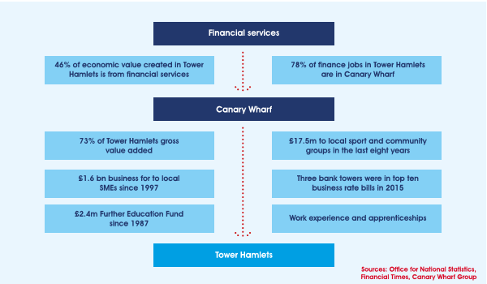

Any impact on financial services will have an impact on Tower Hamlets and its communities. Financial services is one sector of the economy that is most at risk from Brexit because of the potential loss of ‘passporting’ rights. Passporting allows financial service providers to sell to other European countries without having a presence there. This is particularly relevant for the banking sector where it is estimated that around one fifth of revenue is related to the access that the passport currently grants. This may lead to the loss of some banking activity as businesses relocate.

However, there are more opportunities for the finance sector compared to other sectors of the economy if it is outside the scope of future European Union financial services regulations. It is possible that Britain can open up a ‘regulatory gap’ with the European Union, which will act to make the domestic market more attractive for foreign business. Safeguards for employees and investors however should be maintained. It is likely that passporting rights will be lost whichever Brexit scenario occurs. The more important factor would be the negotiation of trade in services in the future agreement and whether that entails adherence to European regulations.

**The impact of Brexit in Tower Hamlets will be unevenly distributed** across the borough and will impact some groups of residents more than others.

Tower Hamlets has a diverse economy with significant differences and variations across its geographies. Given its size, Canary Wharf can dominate statistics, so it is important to look more closely at different areas within the borough. In their report, Capital Economics split the borough into four ‘local areas’ which are fairly well defined in terms of the nature of their economy.

Four local areas in Tower Hamlets

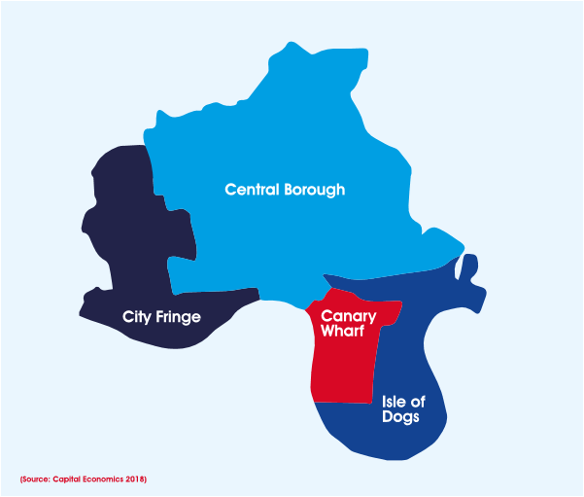

**The Central Borough area is more exposed to immigration restrictions**. Job opportunities are dominated by the public sector, which currently provide over 50 per cent of the jobs. The next largest sectors are hospitality and retail respectively. This sectoral mix makes the area more exposed to restrictions on low skilled European Union immigration. It will also be more impacted by any increase in the costs of trade in goods. Although not directly exposed to impacts on financial services businesses, the impact on Canary Wharf will affect the borough as a whole.

With around 44 per cent of jobs in financial services, and the majority of others in related services, **Canary Wharf is highly exposed to the impact on the financial services sector. The Isle of Dogs and South Poplar are similarly exposed**. Their economy is largely made up of services supporting the financial activity in Canary Wharf, such as building security, as well as a range of auxiliary financial and professional services.

The City Fringe is a mixed economy and has a range of key sectors, including public sector, financial and professional services, digital services, hospitality, retail, advertising and the media. Given its mix, **the City Fringe is particularly exposed to immigration restrictions and trade costs** (particularly through hospitality and retail sectors) as well as being highly dependent on the financial services sectors of the City of London and Canary Wharf.

**Brexit will have significantly different impacts on different local populations**. Tower Hamlets has a broad mix of residents with different challenges and opportunities. Canary Wharf’s resident population ranks comparatively well on skills levels, economic inactivity and unemployment rates. The reverse is true for the central borough population where the share of the resident population aged over sixteen with no qualifications is 23 per cent, almost three times the share in Canary Wharf.

Overall, 30 per cent of Tower Hamlets’ residents work in the borough. However, this tends to be within their local area. Only 6 per cent of Central Borough and City Fringe working residents work in Canary Wharf. Meanwhile, on the Isle of Dogs, 36 per cent of Canary Wharf residents work within the two local areas and this is also the case for 28 per cent of residents from the Isle of Dogs and South Poplar.

70 per cent of Tower Hamlets residents in employment work outside the borough and have lower paid jobs. Assessing the sectors in which residents work compared to Tower Hamlets jobs shows that there are a higher share working in lower value industries such as retail, wholesale, hospitality and the public sector. These lower skilled, lower paid jobs are disproportionately taken up by the black and ethnic minority population.

The female employment inactivity rate in Tower Hamlets is 37 per cent, significantly higher than the national average of 27 per cent. This proportion is even higher among women from black and ethnic minority groups.

**There is insufficient planning for a ‘no deal’ scenario**. The Mayor of London has asked the London Resilience Forum to investigate how well-prepared the city would be in a ‘no-deal’ Brexit scenario. Witnesses told the commission that the government was not doing enough to plan for a ‘no deal’. There is also a lack of information to guide businesses in their contingency planning.

# **Recommendations**

1. Tower Hamlets Partnership should support existing campaigns around financial regulations, and set up a separate lobbying arm with stakeholders, given the importance of the finance sector to the local economy.

2. The Council to work with partners to support local businesses, including access to business rate relief for small businesses.

3. Business sectors should work with Tower Hamlets Council and London Councils alongside the Greater London Authority, to form consortia and lobby central government to consider the impact of reduced levels of immigration for all workers to their business and the local economy.

4. Tower Hamlets Partnership to continue to focus on supporting more Tower Hamlets residents into employment.

5. Businesses to work with Tower Hamlets Partnership to explore options for sector led access to work schemes, such as a commitment to ensuring ‘entry level’ roles are first advertised for Tower Hamlets communities.

6. Employers to define ‘job readiness’ and invest locally to better prepare Tower Hamlets residents to access job opportunities particularly in low skilled work, should labour decrease in certain

sectors.

# **Public services**

“I think there are likely to be many challenges in the future caused by Brexit. It’s very difficult to plan for workforce deficits, it’s difficult to plan for a lack of medicine and it’s difficult to plan for other eventualities when we don’t know what the mechanisms are going to be or what the deficits are going to be.”

**Violeta Sanchez, Barts Health NHS Trust**

The commission was asked to address the following questions relating to the impact of Brexit on the delivery of public services in Tower Hamlets.

> How will Brexit impact on the delivery of statutory services by public sector organisations?

> How can public sector organisations in Tower Hamlets best apply pressure to government to ensure their interests are represented in the Brexit planning process?

The commission was also asked to consider the potential impacts of Brexit for people with protected characteristics as defined by the Equalities Act 2010 and how the borough can work together to mitigate them.

The commission received 12 written responses to its call for evidence and heard from 13 witnesses who provided oral evidence. Desk-based research was also undertaken to further inform the findings and subsequent recommendations.

## Key findings

There are 52,000 people working in public sector organisations in Tower Hamlets. This represents 18 per cent of all jobs in the borough. One in five working age residents are employed in public services either within the borough or outside it. The commission was unable to identify how many non-UK EU citizens work in local public sector bodies. However, there are figures for some of the major public sector employers with Barts Health NHS Trust employing 1,700 non-UK EU workers, East London NHS Foundation Trust employing 600 and Queen Mary University of London employing 765.

Witnesses told the commission that some of their staff from the EU had already left or were planning to leave their jobs. They suggested that if this pattern continues it **could lead to staff and skills shortages particularly in hard to recruit positions**. Increased demand for staff could push up wage costs within the public sector. In the health and social care sectors the existing problem of unfilled posts could be heightened, especially for social workers, nurses and doctors. This would impact directly on the quality and safety of those services and potentially increase costs due to reliance on agency staff.

Some public sector organisations who gave evidence indicated that they were actively supporting non-UK EU employees with information and advice, particularly on the EU Settlement Scheme. Some organisations were also contributing towards the cost of the fee of this application, prior to the announcement that the fee would be scrapped.

Queen Mary University Students’ Union told the commissioners about rising levels of insecure work amongst international students. Increasing numbers of students are already turning to insecure work, including zero hour contracts or cash in hand jobs. They were worried that this problem could get worse if non-UK EU students find it harder to work in the future.

**There is an opportunity for local people to fill some vacancies in the public sector**. This could include those who have previously found it difficult to enter the labour market, including people with disabilities. Barts Health NHS Trust told the commission that they reach out to approximately 1,000 local people a year, some of whom they support getting job ready via placements and apprenticeships. However, people may need additional support to be job ready, including basic skills training. There is therefore also a potential opportunity for local education and skills providers to meet this demand. Additional investment would be needed.

Two organisations told the commission how they were developing their talent pool. This included reviewing training, staff development and performance management, scaling up internal secondments and building on apprenticeship and graduate schemes to create a steady pipeline of local, highly capable talent.

**Reduction in talent mobility** between the UK and EU could impact the local public sector. Some witnesses expressed concern about the potential loss of access to EU research and student mobility schemes. This may prevent talented individuals from taking part in research or study programmes in the UK and vice versa. In their written submission, Queen Mary University of London stated that 10 per cent of their research income came from programmes funded by the European Union. This funding can also support junior academics early in their career, allowing them to benefit from both domestic and international collaboration.

There is uncertainty about future access to the EU funded Erasmus exchange programme. Witnesses stated that the programme was particularly beneficial for students from low income backgrounds who were able to enhance career prospects by taking part.

“We are encouraging academics

and researchers to keep on applying

for European research money – but it

is becoming harder because of the

levels of uncertainty about what kind

of deal we are going to get and what

kind of future access we are going to

get to funding programmes.”

**Vicky Byers, Queen Mary University**

**of London**

As is the case for the private sector, **there will be supply chain impacts** for public sector organisations. Research by the Chartered Institute for Public Finance and Accountancy (CIPFA) indicates that a drop in the value of sterling since the referendum has increased the cost of imported products and services for the public sector. In a hard Brexit scenario, additional tariffs and customs checks would further increase costs.

Several witnesses from local healthcare providers were concerned about the procurement of essential medicines and medical supplies. Stockpiling, which has been recommended by the government as a solution for short term supply chain disruption, is not possible for some products with a short shelf life. This includes medical isotopes and blood products imported from the EU.

Local government receives significant amounts of funding through the EU’s Structural, Social and Regional Development Fund (SSRDF) and the European Social Fund (ESF). The future of SSRDF and ESF funding streams is uncertain. As a borough with high levels of deprivation, Tower Hamlets has benefitted substantially from EU funded enterprise, employment and training programmes. The council has received around £2.7m funding from the EU in the last two to three years5, with external organisations able to bid for EU funds. With emerging plans to devolve these budgets under the UK Shared Prosperity Fund,

(the ‘successor fund’ when the UK leaves the EU), the council could receive less funding than it had previously due to uncertainties on how this funding will be divided. Loss of, or reductions in, EU funding streams by public services, could compound the impact of similar losses in the voluntary and community sector.

The EU contributes funding to some English as a Second Language (ESOL) training and basic skills provision in the borough. Uncertainty about the future of these funding streams makes curriculum planning problematic. It also potentially hampers the social integration of migrants, both from the EU27 and elsewhere. A witness from Tower Hamlets College highlighted an additional challenge they face on local funding for education services. For instance, the college can train someone in healthcare between ages 16 to 18 which is fully funded, but then significantly reduced for those aged between 19 and 24.

“Much of the work we do is funded by the European Social Fund. We know that we have that money for the next year, but we have no certainty or clarity beyond that. The adult education budget is being devolved to the GLA, but we see nothing in their planning that recognises that the ESF money is going to dry out.”

**Alison Arnaud, Tower Hamlets College**

The economic impact of Brexit could place public finances, and therefore local public services, under further financial pressure when demand is rising. The 2017 Budget forecast that economic growth will be slow, reducing taxation revenues, and potentially prolonging the fiscal austerity which has reduced public sector funding by 40 per cent since 2010. This is at odds with the government’s 2018 Budget which committed to ending austerity.

Six of the twelve public sector organisations that made written submissions told us that they had made contingency plans. These included business and financial scenario mapping and identifying future opportunities for collaboration outside the EU.

# **Recommendations**

1. The council and Tower Hamlets Partnership to use existing information and tools available on the EU Settlement Scheme and publish this information on their website. This is to be circulated widely amongst local employers.

2. Organisations already carrying out individual analysis of their skills needs amongst their workforce should provide future proofing for any deficits, over the subsequent 5 to 10 years.

3. Tower Hamlets Partnership to work with businesses and regional researchers to produce a post-Brexit borough-wide information pack on the skills needs of the local economy. This should include considerations of any London wide skills strategy developed by the Mayor of London and London Councils.

4. Public sector organisations should work together, with the council, to lobby the Mayor of London and central government to devolve any skills budget, including unspent Apprenticeship Levy funding, as locally as possible.

5. Tower Hamlets Partnership to lobby government to continue funding Horizon 2020, Erasmus and English as a second or foreign language (ESOL) programmes as they add significant value to local people and students.

6. The council to work with London Councils and lobby the Mayor of London and central government to provide clarity on European Structural Funding (ESF) funding post-Brexit with more detailed information on the proposed UK Shared Prosperity Fund (UKSPF), in order to sustain ESOL and other funding, we well as the basic skills provision that is central to cohesion and employment in the borough.

7. Public sector organisations should map funding they receive from the EU, plan for the future of this funding, and work with London Councils to lobby central government to secure future funding from the UKSPF. Voluntary and Community Sector (VCS) organisations and the council should monitor the development of the UKSPF, and feed into any relevant government consultations.

8. Public sector organisations should carry out detailed supply chain mapping. They should identify where their supply chains are procured from in the EU, and carry out contingency planning, or look at alternative forms of procurement, such as sourcing goods/services locally or from within the UK.

9. Public sector organisations should work with representative bodies or boards to enable collective contingency planning and support.

10. Tower Hamlets Partnership should lobby central government to minimise the negative impact on local people relating to the movement of goods and services procured nationally from the EU.

# **Civil Society**

“A lot of the trusts that our smaller charities rely on have seen falls in the investment rate, which means falls in the amount of money that they can put into the system through grants. That has become an issue because things are already quite tight generally. The issue that we will see is increased competition for money.”

**Damian Brady, Tower Hamlets CVS**

The commission was asked to address the following questions relating to the impact of Brexit on civil society in Tower Hamlets.

> What does the borough need to do to support non-UK EU citizens who have made their home here? How does that differ from the support that will be required by those arriving during the transition period?

> How can the council and its partners work to strengthen community cohesion and promote continued integration in the context of Brexit?

> What steps are necessary to reassure non-UK EU residents of Tower Hamlets in the lead up to, and after, Brexit?

> How is Brexit likely to impact on the borough’s voluntary and community organisations? In particular, how well equipped is the sector to respond to changes in funding models after Brexit?

The commission was also asked to consider the potential impacts of Brexit for people with protected characteristics as defined by the Equalities Act 2010 and how the borough can work together to mitigate them.

The commission received seven written responses to its call for evidence. The commission also heard from ten witnesses who provided oral evidence. Desk-based  
  
  
  
 research was also undertaken to inform the findings and subsequent recommendations.

## Key findings

In June 2018, the government issued a statement of intent on the EU Settlement Scheme which outlined a ‘settled’ and ‘pre-settled’ status for EU nationals in the UK post-2020. An agreement on this scheme was reached with the EU, guaranteeing the rights of EU citizens living in the UK after Brexit.

By acquiring settled or pre-settled status, EU nationals, including those living with family, can continue to reside in the UK and maintain rights to work and study, as well as receive benefits and other public services. EU citizens would need to have lived continuously in the UK for five years by 2020, in order to obtain settled status. Those with less than five years’ continuous residence would be granted pre-settled status and would be able to apply for settled status after reaching the five year point.

Witnesses who gave evidence highlighted some concerns. One stated that their organisation had held 100 public advice sessions across the UK, including in Tower Hamlets, and found that some non-UK citizens failed to connect Brexit with the need to secure individual rights. There was a common misunderstanding that the scheme would not apply to those who were already resident. See recommendation 24.

There is a lack of assistance and advice available to EU citizens who wish to remain in the UK after Brexit. Witnesses expressed concern about the extent of the documentation required by the Home Office to process applications, and that there may be some who may not have the full documentation required. They also highlighted that some individuals may not be able to access the online application system or may have difficulty with the complexity of the scheme.

These include those who are currently unemployed or not working, people on low incomes, homeless people, people with disabilities or mental health problems and people from communities who already experience social exclusion, such as travellers and Roma.

Witnesses also alerted the commission to the **potential for discrimination**, for example non-UK EU citizens being denied access to the NHS due to a lack of settled/pre-settled status or evidence of that status. There were particular concerns about what would happen under a no-deal scenario.

“The advice sector is already under strain from having to deal with these issues. There is a communication and legal advice side that needs a lot of work because we need to make EU citizens aware of the evidence that they require for the Settlement Scheme.”

**Chris Desira, Seraphus**

The EU has been a major financial contributor to regional and local economic development across the UK. EU funds are vital for some voluntary and community organisations working with disadvantaged communities. Tower Hamlets Council has received significant EU funding through the European Social Fund (ESF) and the European Regional Development Fund (ERDF). The council is part of a £1.35m ESF co-financed employment programme which offers grants to local voluntary and community organisations. Mapping of EU funding of the local voluntary and community sector has not been undertaken, so it is difficult to estimate the likely impact of any changes to funding currently received from the EU.

Tower Hamlets Council for Voluntary Services (THCVS) and Toynbee Hall told the commission that EU funding remains a significant income stream for the sector and that local organisations are struggling to plan in a context of uncertainty. In July 2018, the government committed to underwriting all EU funding until 2020. There therefore appears to be no immediate threat to EU funded programmes. Some witnesses expressed doubt, however, about whether funding would be replaced like for like. This is in a context where charity funding is already under significant pressure.

Five organisations that made written submissions stated that Brexit will have a negative impact on the recruitment of staff and volunteers in the community and voluntary sector. Concerns included loss of non-UK EU employees and volunteers, increased challenges for recruitment, increased anxiety for existing staff and volunteers and a loss of funding leading to project closures and job losses.

One witness stated that there is confusion among EU nationals who are working or volunteering in the UK about their rights to work or volunteer after March 2019.

The commission was told that if the government’s new immigration policy was to restrict migration to an income threshold of around £30,000 per annum they would not be able to recruit high calibre staff. The average salary in the charity sector is lower than in the private sector but the skills, knowledge and experience required are equivalent.

Six organisations highlighted concerns raised by their service users. These included worries about restrictions on their ability to volunteer in order to gain work experience and contribute to the broader community. Others were concerned about the impact of Brexit on the cost of living. Witnesses also expressed concern for homeless non-UK EU citizens, suggesting that more support may be needed for this group in the lead up to and after Brexit. Several witnesses noted higher levels of anxiety amongst non-UK EU citizens on their future, and the potential need for appropriate mental health

provision and support.

“For a lot of our members, their workforce has a disproportionate amount of people from Eastern Europe. We’ve had people already leaving, but more worryingly, there are significant numbers of people in that workforce who are planning to get out. Reasons reported back included the rising cost of living here and improved living standards back home. This means the business case for not being home is getting weaker and weaker.”

**Damian Brady, Tower Hamlets CVS**

Analysis by the council indicates that the EU referendum may have influenced levels of hate crime in Tower Hamlets. Reported hate crimes in the borough spiked around the time of the EU referendum in 2016. There were 608 hate crimes reported compared to 431 in the same period the previous year. Some witnesses expressed concern that a further spike may occur around the time of Brexit.

The witnesses noted that the borough can work together through its partnerships to continue to ensure there is a positive and welcoming environment for non-UK EU citizens.

# **Recommendations**

1. The local VCS and the council should place a particular focus on informing ‘hard to reach’ groups of their rights under the EU Settlement Scheme.

2. The Tower Hamlets Council for Voluntary Service (THCVS) to undertake a mapping exercise to understand what funding the borough receives from the EU, the services that are impacted and the availability of replacement funding post-Brexit.

3. Organisations should monitor the Greater London Authority’s Brexit hub to understand emerging plans for locally devolved funding.

4. Tower Hamlets Partnership should promote positive messages on the careful use of language in the context of Brexit, noting the role that language can play in maintaining or disrupting community cohesion.

5. The council to work with its partners to encourage residents to come forward when reporting hate crime.

6. Tower Hamlets Partnership should work with the council to positively encourage community cohesion in the borough, by creating a sense of place-based pride among residents. New York City should be explored as an example.

7. All public services, voluntary and community sector organisations and businesses in Tower Hamlets should support their staff and volunteers by providing guidance on the EU Settlement Scheme, in addition to wellbeing and emotional support where necessary.

8. The commission’s report should be presented to all partnership boards and groups to ensure all organisations give due regard to its recommendations.

# **Appendices**

## Young people and Brexit

On 25 January 2019, the council facilitated an event for young people in Tower Hamlets to share their thoughts on Brexit. The event was chaired by Cabinet Member for Children, Schools and Young People, Cllr

Danny Hassell.

### Future opportunities

A key concern for many of the young people was around access to opportunities after Brexit. Many felt that the opportunities available to them, particularly for study, would be limited once the UK left the EU. Within the EU, UK students were able to participate in the Erasmus+ exchange programme, which enabled students to attend university in Europe for a year. These opportunities were deeply valued by the young people, as it helped them to develop new perspectives and increased their employability after university. There were also concerns around Brexit making it harder for young people to find jobs in future. Children were also being encouraged to learn European languages at school, but would no longer access jobs in the EU as easily.

### Poverty, jobs and trade

Another issue highlighted by the young people was Brexit’s potential to exacerbate poverty in the borough, and negatively affect families who may already be struggling. Some questioned the impact of Brexit on individual incomes, suggesting that people would overall be financially disadvantaged as a result. Some thought that those who were already living in poverty would struggle even more outside of the EU and its ‘safety net’. Others remained hopeful that Brexit could bring more local people into jobs that may traditionally have been filled by migrants. One group thought that migrants were good   
  
  
  
  
  
  
  
  
for the economy and had shaped the UK today.

### The community

The young people also spoke about Brexit’s potential to aggravate hate crime and racial intolerance in the borough. Many felt that Brexit had deepened racial divides in Tower Hamlets, and had created an ‘us versus them’ mentality amongst residents. They felt xenophobia in Britain had increased since the Brexit referendum, and this was particularly relevant for the local borough. One group questioned whether Tower Hamlets had the security measures in place to deal with potential outbursts of hate crime, and whether it would be able to protect local residents against such incidents. The young people felt it was important for their generation to act as a collective, and to see unity in their community rather than divisions in a post-Brexit setting.

## Methodology

### Evidence Hearings

Evidence was gathered through both oral and written submissions. Oral evidence submissions were heard through ‘select committee’ style oral hearings, for each theme (public services, local economy and civil society). Invited guests attended public hearings at various locations around the borough. ‘Open calls’ for written evidence in the form of surveys were also sent to a range of local public services, residents and community and voluntary sector organisations. The surveys were designed to capture local perspectives and collected a mixture of qualitative and quantitative data.

