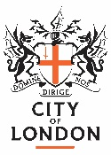
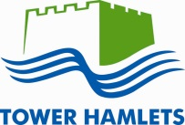

Youth Rehabilitation Order (YRO)

Tower Hamlets and City of London Youth Justice Service

- What is a YRO?
A YRO is given to you when you have committed an offence (i.e. you have done something against the law).

You may have had a previous order such as a Referral Order and now the court/Youth Justice Service think you need extra help to stop offending or your offence is more serious.

2. How long will my YRO last?
My order will last _____________

- What happens now?
You will meet with your caseworker from the Youth Justice Service who will talk to you and your parent/carer. You will agree a plan of the work you will do to support you.

- What can my plan include?

The court may have decided on activities you need to do to help you to stay out of trouble. This can include:
- Being supervised by the Youth Justice Service (meeting with your caseworker)
- Having an electronic tag with a curfew (times you have to be at home)
- Reparation activities (repairing the harm that has happened)

5. What happens if I don’t complete my YRO?

If you do not attend or complete activities/appointments for your YRO then you may have to go back to court and you may get into more serious trouble.

6. What happens if I still don’t understand my YRO?

It is okay not to understand. Ask your caseworker at the Youth Justice Service to explain your YRO to you.

- Contact details for Tower Hamlets and City of London Youth Justice Service
Address: Youth Justice Service, Mulberry Place,
5 Clove Crescent, Tower Hamlets, E14 2BG

Telephone: 020 7364 1144

