NOTICE OF POLL AND SITUATION OF POLLING STATIONS

London Borough of Tower Hamlets Council
Spitalfields Neighbourhood Planning Referendum

1. A Residential Referendum and a Business Referendum will be held in parallel on Thursday 11 November 2021 to decide on the question below:
Do you want the London Borough of Tower Hamlets to use the Neighbourhood Plan for Spitalfields to help it decide planning applications in the neighbourhood area?
2. The hours of poll will be from 7am to 10pm
3 Applications, amendments or cancellations of postal votes had to reach the Electoral Registration Officer at Town Hall, 7th Floor, Mulberry Place, 5 Clove Crescent, London, E14 2BG by 5pm 27 October 2021.
4. Applications to vote by proxy had to reach the Electoral Registration Officer at Town Hall, 7th Floor, Mulberry Place, 5 Clove Crescent, London, E14 2BG by 5pm Wednesday 3 November 2021.
5. Applications to vote by emergency proxy can be applied for on grounds of
- illness or disability,
- if you are a mental health patient detained under civil powers,
- if your occupation, service, or employment means you cannot reasonably attend a polling station
- if, because of corona virus advice, you cannot reasonably attend a polling station
where that physical incapacity or advice occurred after 5pm Wednesday 3 November 2021.
Applications must reach the Electoral Registration Officer by 5pm Thursday 11 November 2021.

6. The situation of polling stations and the description of persons entitled to vote thereat are as follows:

No. of polling station | Situation of polling station | Persons entitled to vote within these ranges
1 | Toynbee Hall, 28 Commercial Street, London, E1 6LS (Residential and Business) | SB1-1 to SB1-2817  (Including 13 registered business voters)
2 | Montefiore Centre, Hanbury Street, London, E1 5HZ (Residential only) | SB2-59 to SB2-1945/1  SB3-1 to SB3-2218
3 | William Davis Primary School, Wood Close, Cheshire Street, London, E2 6ET (Residential only) | WE3-253 to WE3-2515/3

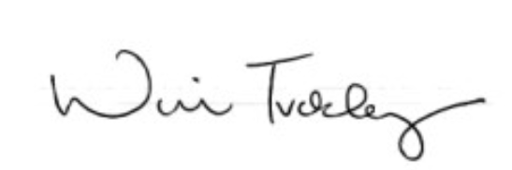

Will Tuckley
Counting Officer
Dated: Wednesday 3 November 2021

