|  |  |
| --- | --- |
| Corporate Leadership Team Update |  |
| 24 September 2019 |  |
| **Report of:** Debbie Jones – Corporate Director for Children’s Services & Culture | **Classification:**  Unrestricted |
| **Review of Education Traded Services delivery model** |  |

**Proposed Decision Path**

|  |  |  |
| --- | --- | --- |
|  | Step | Date |
| DLT Level (Tier One) | DLT / CD | 9 September 2019 |
| CLT Level (Tier Two) | CLT / CE | 24 September 2019 |
| Member Level (Tier Three) | MAB / 121 | N/A |
| Decision (Tier Four) | Cabinet / IMD | N/A |

|  |  |
| --- | --- |
| Lead Member | Councillor Danny Hassell, Cabinet Member for Children’s and Culture |
| Originating Officer(s) | Christine McInnes |
| Wards affected | All wards |
| Key Decision? | No |
| Forward Plan Notice Published | N/A |
| Reason for Key Decision | N/A |
| Strategic Plan Priority / Outcome | People say we work together across boundaries in a strong and effective partnership to achieve the best outcomes for our residents |

|  |
| --- |
| Executive Summary |
| This is a further update on progress with the Schools Traded services project since discussions at Children’s Services & Culture DLT and CLT Transformation Board.  Grant Thornton have concluded their review of the costs and incomes of each delivery team which provides Traded Services, but were unable to evaluate all services or reach firm conclusions in the time available. Further work is starting to look in more depth at finance records with the service delivery teams, to assess whether data will allow the establishment of baselines based on clear allocations of costs.  From benchmarking it is clear is that many councils take a more proactive and portfolio-based approach to their offers than Tower Hamlets has to date. The proposed operating model addresses this issue directly. It sets out responsibilities for service delivery with each delivery team, customer access and operational support with the new commercial team in procurement, and business functions (marketing, pricing, service development and relationship management) with a new central Education Traded Services team.  A simple marketing model has been developed, to guide decisions on appropriate management of each service based on income and market penetration.  The next stages in developing the model will be to develop the proposals for the Education Traded Services team and to use findings from the additional finance work to ascertain reliable costs and revenues for each of the traded services to identify any remedial action necessary to ensure they each cover their costs. |

**THIS SECTION TO BE DELETED BEFORE PUBLICATION**

**Decision Type**

|  |  |  |  |  |  |  |
| --- | --- | --- | --- | --- | --- | --- |
| **Key Decision?** |  | **Urgent Decision?** |  | **Exempt from Call-In?** |  | **Restricted Report or Partially Restricted (e.g. appendix)?** |
| No |  | No |  | No |  | No |

*If the answer is yes make sure the forthcoming decision on the website states this or else the decision cannot be taken.

**Guidance Documents**

Further details on the procedure for Urgent Decisions can be found in the [Intranet Library](http://edemoc2ksrv:8070/ecSDDisplay.aspx?NAME=FP3%20-%20Executive%20Decisions%20Urgency%20Procedures&ID=4604&RPID=2147812&sch=doc&cat=13011&path=13011) and the Guide to Report Writing [guidance note](http://edemoc2ksrv:8070/ecSDDisplay.aspx?NAME=SD4687&ID=4687&RPID=2147819&sch=doc&cat=13048&path=13048).

**Specific Issues for Pre-Decision Meetings**

(Officers may use the following table to add points of note for internal meetings such as CLT, MAB or DMTs. Content can be deleted at any stage and, in any case, will be before publication for the decision making meeting.)

|  |
| --- |
| **Directorate Leadership Team** |
|  |
| **Corporate Leadership Team** |
|  |
| **Mayor’s Advisory Board** |
|  |
| **Communications** |
|  |

**THIS SECTION TO BE DELETED BEFORE PUBLICATION**

|  |
| --- |
| Recommendations: The Transformation Board is recommended to: |
| 1. Note the progress of the review 2. Agree the next actions, to review costs and incomes and to develop proposals for a new central Education Traded Services team. |

|  |
| --- |
| 1. **REASONS FOR THE DECISIONS** |
| This is a further update on progress with the Schools Traded services project since discussions at Children’s Services & Culture DLT and CLT Transformation Board.  It covers recent and planned actions, and gives more detail on the proposed operating model. |

1. **ALTERNATIVE OPTIONS**

Alternative options were considered in the June discussions, and the recommended option “to establish a new Education Traded Services operating model” was accepted.

1. **DETAILS OF THE REPORT**

**Introduction**

CLT agreed in June to the development of a new operating model for Education Traded Services, to develop and enhance services provided by the Council to schools. This update describes the proposed target operating model and way of working, including demarcation between the new roles, service delivery teams and transaction management which is now part of Procurement.

Grant Thornton have concluded their review of the costs and incomes of each delivery team which provides Traded Services, but were unable to evaluate all services or reach firm conclusions in the time available. The review did highlight three concerns which mean it is not currently possible to identify whether individual Traded Services cover their costs or are loss-making and made recommendations to address them:

* If staff time for work on statutory or other non-traded work is included in the trading account, it will overstate the costs of Traded Services. *R19 – Statutory and non-traded services should be excluded from the trading account*
* Conversely, staff time may not be correctly accounted for when teams carry out other work as well as providing Traded Services. If the Traded element uses more time than estimated schools would be receiving an effective subsidy from General Fund budgets. *R21 – Relevant employee costs should be included in the trading accounts*
* Overheads for Corporate recharges (including the costs of accommodation, ICT and HR etc) are not being correctly allocated between Traded Services and other work. If overheads are being met in full from General Fund budgets, again schools would be effectively being subsidised. *R22 – Non-pay and central recharges should be included in the trading accounts*

On the basis of the available information, Grant Thornton concluded that “the Council’s services traded with schools are not fit-for-the-future and 5 out of 11 services were loss making and the remaining we were unable to asses. Our findings would suggest that at least 50% of the services traded with schools are likely to be loss making, which could provide significant savings for the Council, if these services ceased or arrangements were made to ensure all costs were covered”.

Further work has been proposed to look in more depth at finance records with the service delivery teams, to establish baselines based on clear allocations of costs. However, preparatory work is needed to establish whether the financial data available across all service areas, including those omitted by Grant Thornton, is of sufficient quality to allow the establishment of baselines and, if not, what needs to be done to reach this standard. The outcome of the preparatory work will include action plans for the Grant Thornton recommendations above.

Once baselines can be established, this will allow appropriate pricing of Traded Services to ensure that they fully meet the cost of provision or, on the basis of accurate data, allow a decision to be made whether to cease any service. A separate business case has been prepared for external resource to carry out this baselining work.

As part of the review of Finance functions, responsibility for the online portal and payments for Traded Services has moved from the Children’s Services Finance team to Procurement in Corporate Finance. These functions are now managed by a Commercial Officer who will report to a new post which is currently being specified.

The proposed operating model for Traded Services will need to take account of this change, ensuring there are no gaps, overlaps or conflicts between the roles.

Initial benchmarking with other councils has been carried out. Direct comparisons are limited, because councils tend to have different portfolios of Traded Services, differences in the services themselves, and a variety of pricing structures.

What is clear, however, is that many councils take a more proactive and portfolio-based approach to their offers than Tower Hamlets has to date. The proposed operating model addresses this issue directly.

The paper agreed in June put forward criteria that a new operating model would have to satisfy:

* Criterion 1 – Any delivery model will promote the achievement of plans and priorities contained in the Councils strategic plan
* Criterion 2 – Any delivery model will sustain and improve the relationship between Council and schools
* Criterion 3 – Any delivery model will seek to work on a cost recovery basis and where improbable a clear justification is provided
* Criterion 4 – Any delivery model will identify who is best placed to deliver on quality and value for money
* Criterion 5 – Any delivery model will seek to outline responsibilities for delivery functions and enabling functions and provide clear management, marketing and improvements of service offers

The proposed operating model has been developed to meet each of these criteria.

**Operating Model Overview**

The current operation of Traded Services is summarised in the diagram below:

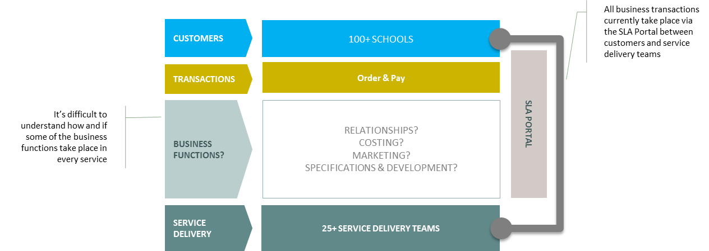

* Customers Over 100 schools and academies in Tower Hamlets plus three from other boroughs purchased one or more of the Traded Services during 2018-19.
* Transactions Almost 2,500 transactions worth £6,480k were made through the Frontline Data SLA portal. The portal allows service delivery teams to publish their service offering and prices, and allows schools to place orders. Delivery teams then deliver the service requested while data from the portal is compiled to invoice schools.
* Business Functions While some service teams do actively manage relationships with schools and the development, costing and marketing of their services, this is not totally the case for all of them and there is no consistent approach.
* Service Delivery The actual provision of each Traded Service is necessarily different according to the service itself.

The proposed operating model includes clear demarcation of roles and responsibilities, as shown below:

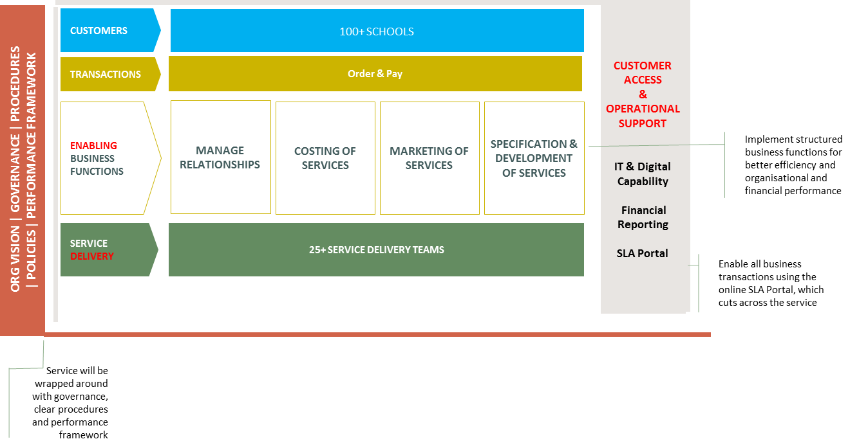

* Customers A portfolio management approach will allow the schools market to be segmented in a number of ways to support the management of relationships and active selling of services. Options include: primary v secondary schools; maintained schools v academies; and purchasing decision-makers (heads, school managers or subject specialists). Active marketing could attract more schools from outside Tower Hamlets (paying a premium price), especially where Tower Hamlets has a known strength or the other borough has a weakness in provision of particular services.
* Transactions There will be no change to the use of the SLA portal. However, greater focus from the new team in Procurement is expected to support improvements in Customer Access and Operational Support activities: exploiting system developments; timely and accurate billing; active monitoring of income and payments
* Business Functions These Enabling activities will be the responsibility of the proposed new central Education Traded Services team, who will both take the lead as portfolio owners and support service delivery teams. These activities are covered in detail in the next section.
* Service Delivery The role of Service Delivery teams will not change. However, there will be a clear demarcation of costs and incomes for their Traded Services and other work.
* Parameters A new holistic approach will set the parameters shown on the left of the diagram:
  + Vision Affirmation of partnership working and TOWER values, working together to provide services which satisfy both the needs of schools and the Council’s commercial goals
  + Governance Overall objectives for Education Traded Services, reporting lines and a framework for interactions between the teams represented in the operating model
  + Procedures Documented descriptions of roles, rights, responsibilities and activities
  + Policies Documented descriptions of how Education Traded Services will deliver its objectives through the operating model
  + Performance framework Documented targets and regular monitoring of key deliverables, such as costs, revenue and market share

As mentioned in the list above, the Enabling activities of the operating model ensure that key Business Functions are managed for the whole portfolio by the Education Traded Services team. These cover:

* Relationship Management The team will build and maintain relationships with customers, both collectively and individually, with the goal of preserving and growing income from the Traded Services portfolio by understanding their needs and informing service developments. They will also support service delivery teams to manage day-to-day relationships and to develop their own understanding of changing customer needs. Direct relationship management will have a number of targets:
  + Schools with the largest spend, particularly academies, which may be more attractive to competitors
  + Schools which have stopped using Council services, or which are similar to others which do use the Council’s services, to attract their business
  + Schools outside Tower Hamlets, especially if their own local services are failing
* Costing The team will maintain records of the costs of service delivery, and will propose changes to prices or specifications to ensure that (unless otherwise agreed) the costs of Education Traded Services are fully covered by income
* Marketing The team will manage the portfolio according to each service’s value to the Council. A simple framework for this is proposed based on market penetration and income from each customer school, as shown below. Note that the figures given for the income and penetration thresholds are suggestions only, and that the result is indicative only and may be ignored if there are business grounds for doing so:

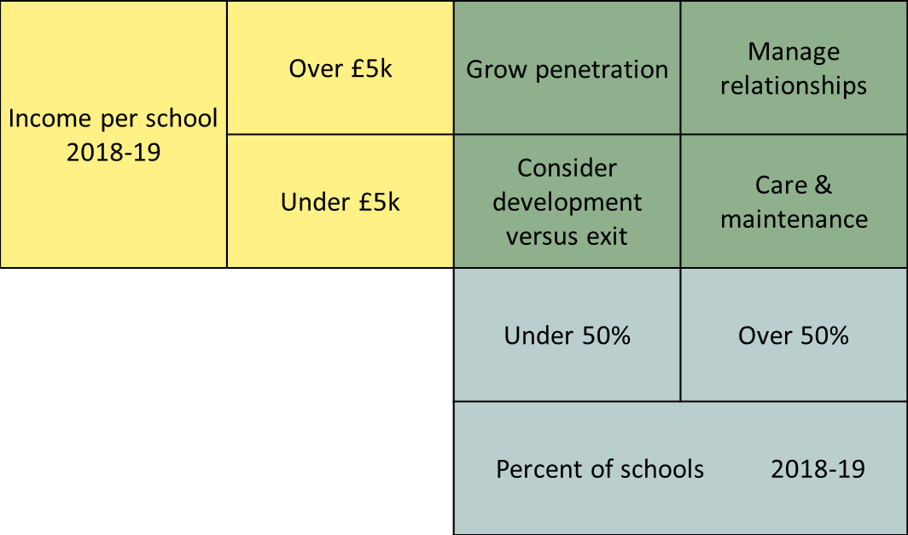

* + High income, high penetration – manage relationships to preserve and seek to grow income

An example is Behaviour & Attendance Support, with penetration to 63% of schools and average income of £15k per school as indicated by the orange diamond:



* + High income, low penetration – grow penetration to attract income from more schools
  + Low income, high penetration – care and maintenance to sustain penetration without major investment of funds or effort
  + Low income, low penetration – consider whether the service can be developed to attract more customers or whether it should be ceased

An example is Finance, with penetration of 29% and average £4k income, also shown by the orange diamond:



* Specification & Development The team will use insight from school relationships and other sources such as benchmarking, both to develop existing services in line with changing needs and to introduce new services to the portfolio. In each case it will work with the service delivery team to produce new specifications and pricing, and will consult with schools to understand the market impact of the development

**Benchmarking**

Phone calls and visits with two London boroughs highlight different approaches within similar structures to the one proposed above:

* Hackney Services For Schools
  + Well-established team of seven people reporting to a commercial manager
  + Roles include a dedicated web team of manager, content and technical staff. Hackney have their own site rather than the SLA portal which is in widespread use including LBTH. Web content is also used to create a brochure [Hackney brochure](https://www.hackneyservicesforschools.co.uk/sites/default/files/document/Services%20for%20Schools%20Brochure%202019.pdf)
  + There are two operations staff who manage orders and pass them to delivery teams and also manage billing and payments, with monthly reports to each service
  + The other roles are in marketing and business development, manging relationships between schools and services and supporting service enhancements
  + A total of 25 services are traded to about 80 schools
  + Comparison of pricing and services is not straightforward because of different service packages. There are similarities in payroll (LBTH £5.12 per payslip compared to £4.40 in Hackney) and the behaviour and attendance support offer (£6.1k in LBTH and £6.6k in Hackney for half a day per week)
  + Hackney price services as staff costs + 30% for overheads
* Bexley Services Network
  + Established a central team of three people in 2016, taking over what they describe as a “neglected” portfolio of 50 separate traded services (including waste and grounds maintenance)
  + Their initial work concentrated on data cleansing and restructuring service pricing, which may also be required in LBTH
  + They have a commercial manager in finance and two business support officers, who manage sales and incomes through the same SLA portal as LBTH
  + There are just over 100 schools in Bexley, mainly academies. The team also provide services outside the borough including to some schools on the south coast
  + Bexley price services as staff costs + 10% for overheads (based on a sample of direct and overhead costs for all traded services)
* Others
  + Further research has been carried out, in discussion with Frontline Data Ltd, who supply the SLA portal, and through the community discussion pages of the portal itself
  + Many councils already had a central team managing a Traded Services portfolio, and others are moving towards this model. Some, like Hackney, combine the management of Traded Services with their School Improvement activities, while for others the two are independent
  + Additional contacts are being arranged, to broaden the scope of benchmarking and understand the drivers, experience and outcomes of different operating models

**Conclusions & Next Steps**

Like other councils, Tower Hamlets would benefit from proactive management of an Education Traded Services portfolio. This would ensure that service delivery costs are correctly allocated between traded, statutory and discretionary activities, and are correctly aligned to incomes and budgets. From this foundation, opportunities to protect (as a minimum) and grow income from Traded Services can be identified and exploited.

The proposed operating model is an approach to managing the portfolio. The next stages in developing the model will be:

* Specify the roles and responsibilities of a central team for Education Traded Services, for draft job descriptions, person specifications and indicative grading
* Map their relationships with stakeholders in schools, service delivery teams and the Commercial team in Procurement
* Propose reporting lines for the new team

In parallel, findings from the additional finance work to compile adequate data and thenascertain reliable costs and revenues for each of the traded services will be used to identify any remedial action necessary to ensure they each cover their costs. This will be guided by the indicative marketing matrix and by the views of schools on any service or price changes.

See draft time plan at Appendix 1.

1. **EQUALITIES IMPLICATIONS**
   1. A detailed impact assessment will be conducted as part of the full proposal but there are likely to be implications for staff which will be worked out.
   2. The main considerations will relate to the potential impact of the proposed model of delivery. This may involve changing contract terms from permanent to fixed term and secondments to provide flexibility, and in some cases where services are transferred or ceased can cause implications for staff..
2. **OTHER STATUTORY IMPLICATIONS**
   1. Best Value Implications

This activity is intended to secure the long-term provision of services to schools on a commercial basis. For the council, this means that accurately-recorded costs will be fully recovered, with no hidden subsidy from council funding. For schools, it means that they will choose the council to provide services which meet their needs and those of their pupils and staff, and which give good value for their money.

1. **COMMENTS OF THE CHIEF FINANCE OFFICER**
   1. [Financial implications to be prepared by Directorate Finance Manager and agreed with Corporate Finance]

____________________________________

**Linked Reports, Appendices and Background Documents**

**Linked Report**

* NONE.

**Appendices**

* NONE.

**Background Documents – Local Authorities (Executive Arrangements)(Access to Information)(England) Regulations 2012**

* NONE.

**Officer contact details for documents:**

N/A

**Appendix 1 – Estimated time plan (revised for preparatory finance work)**

