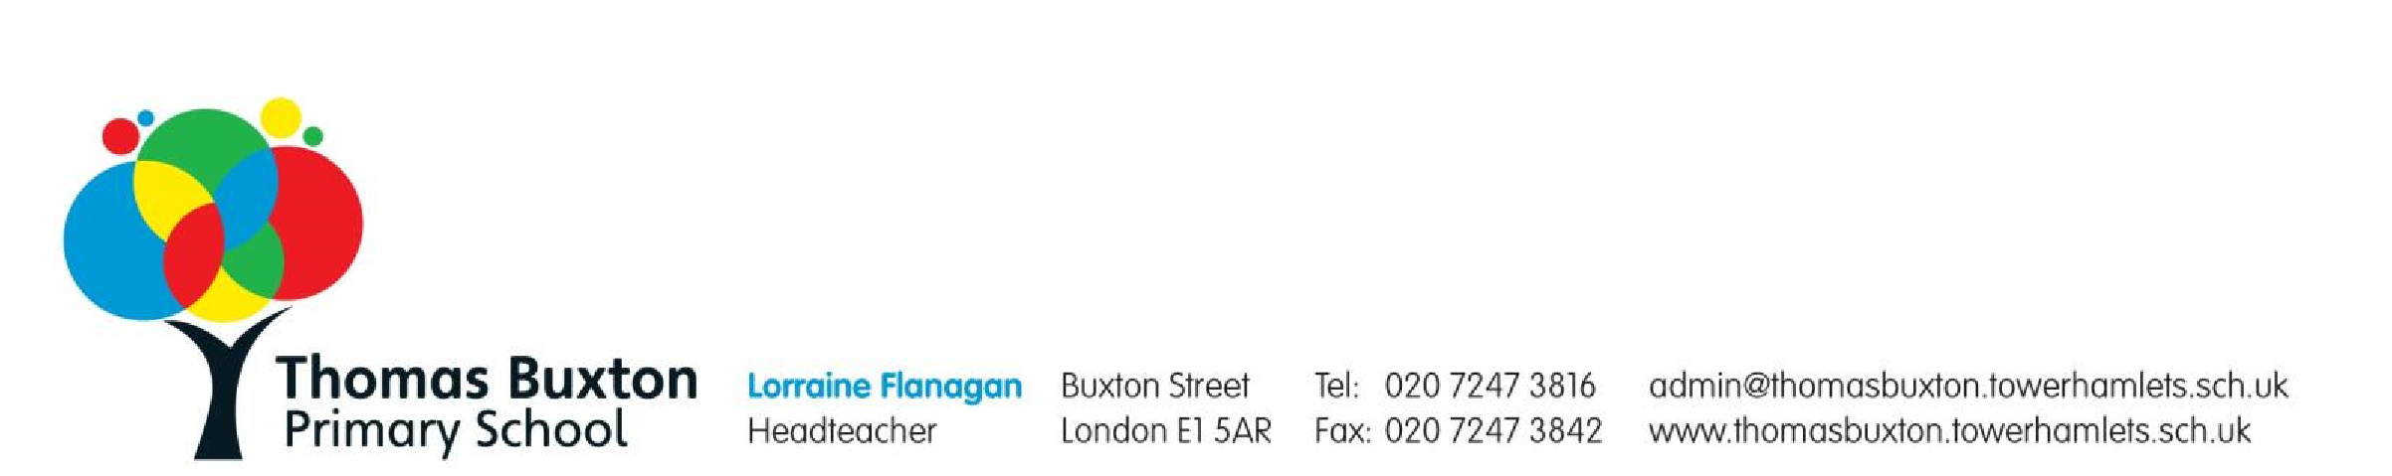

Wednesday 10

October 2018

Dear

Councillors,

I am writing to you on behalf of the London Borough of Tower Hamlets Schools Forum in

response to the decision taken by

C

abinet

to

close

the Local Authority Day Nurseries (Mary

Sambrook

,

Overland and

John Smith Day Care Nurseries

)

.

We wish to make clear that this is

the

correct

but

difficult

decision

to make

in light of the

financial evidence

and

qualitative

statements

that

show that

these settings are no longer viable

. The LADN

cannot be unfairly

subsidised

when there is evident

capacity in schools, nurseries and other providers

to meet

the needs of those children and their families.

I wish to clarify that the decision

taken

by the Schools Forum to withhold funding for these

settings was taken after full consideration of the fun

ding implications for

**all schools and**

**early years providers**

across the Borough.

It is clear from the public record

s

of School

s

Forum meetings that

the funding formula for all Early Years providers

and the discrepancy in

the

funding

subsidy

for these Local Area

Day Nurseries

is

obvious and no longer justifiable.

The

burden of

challenge

in

operating an EY Education or Childcare service is shared by all

providers in the Borough.

Council Officers have worked tirelessly to ensure that the family of schools

, Nursery

Schools

and Early Years providers

in Tower Hamlets

are able to sustain

a

servi

ce

in what are

,

inarguably

,

very challenging times. The Schools Forum has a statutory duty to make

informed decisions about public funding which

are

based on principles of transparency and

equality.

We have been presented with t

he evidence about

changes to Early Years funding

for a number

of

years. It is the same evidence which Councillors have scrutinised in their

decision making process

many times both

recently and in the past.

The fact remains that

these Nurseries cannot maintain their service to families without significant subsidy at the

cost of all other children in Tower Hamlets;

it

is evidently neither transparent nor just.

C

ampaigning by group

s to keep these Nurseries open has been

understandably

emotive and

distr

essing for the

few families who use these centres

and the staff employed there

.

This

has led to some misinformation about the

viability of the Nurseries and

to

claims that full

cons

ultati

on

has

not

been undertaken. This is simply not true.



It

is worth noting by Cabinet Members that th

e Schools Forum is constituted of

Headteachers and

Governors

of many different

types of

school

s

as well as

representatives

of

a range of

Early Year

s education and childcare providers. We are

all

deeply committed to

keeping

an

equality of access to all children and families in our

B

orough. We are inclusive

and have a

long

history of working with families from all parts of our wonderful community.

The

shared knowledge, expertise and belief in the value of education is

deep and broad

within the Forum, i

t

informs all discussion and decision making.

In conclusion, we urge you

act fro

m

the

moral

imperative to consider all Tower Hamlets

children.

T

hey

deserve

to have the best foundations for life, our duty is to provide it

equitably.

Yours sincerely,

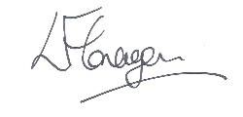

Lorraine Flanagan

Headteacher

Thomas Buxton Primary School

Chair of the

LBTH

Schools Forum