STRATEGY FOR THE IDENTIFICATION OF CONTAMINATED LAND

November 2022

Environmental Health and Trading Standards London Borough of Tower Hamlets Mulberry Place, 5 Clove Crescent
London E14 2BG

Forward

This is the council’s strategy for the inspection of land within the London Borough of Tower Hamlets (the council) to determine the presence of any contaminated land, as defined by statute. The strategy sets out the local characteristics of the borough, historic land use ranging from dockland activity to local gas works and the inspection regime that is planned to identify local unacceptable risks to human health and/or the environment.

The strategy outlines the legal framework within which we are working and how information gathered will be managed, to ensure that the whole process is open and clear. This will enable the local community, developers and landowners to know and understand the law that exists to protect our environment and how the council is implementing the Government’s national policy.

Regeneration of the East End and improving the quality of life for all those who live or work in the borough are key priorities for the council. This strategy forms an important part of that process. As the strategy is implemented, the information gathered will help landowners and developers understand local conditions within the borough. This will give confidence in redeveloping brownfield sites, making full use of the ever-increasing shortage of land in Tower Hamlets.

We will continue to work together with our neighbouring boroughs, the Mayor for London and the Environment Agency, all who have important roles to play in the successful implementation of this strategy.

Mayor Lutfur Rahman
Executive Mayor of Tower Hamlets

Executive Summary

The London Borough of Tower Hamlets is committed to identifying and dealing with local areas of contaminated land and any unacceptable risks to human health or the wider environment, which may arise.

In Tower Hamlets there is a legacy of land contamination across the Borough as a result of widespread past industrial activity, particularly around the former docks. Industrial activities included shipbuilding and dock-related activities, and chemical, metal and gas works.

Part 2A of the Environmental Protection Act 1990 and relevant guidance came into effect in April 2000. The legislation requires each local authority to inspect their borough and identify contaminated land that requires remedial work. The first strategy was prepared and submitted to the Environment Agency in July 2001 and detailed out how we will identify contaminated land in a rational, ordered and efficient manner. The legislation also requires the strategy to be updated periodically. The aim of the current review is to ensure the Strategy remains up to date since the last review of 2017.

The strategy aims to find and deal with the most seriously contaminated sites first. Contaminated land is where the land in its current condition is causing, or is likely to cause, significant harm to human health and/or the environment and controlled waters

The process to identify contaminated sites is a staged risk-based approach:

a) Sites are prioritised by applying a risk model. This applies weighting factors according to the risks associated with a site’s historic industrial use and how sensitive the current land use would be to contamination effects. The result is a score or risk rating of sites where there is a “potential contaminant linkage”. The sites which have the greatest potential for contamination to be causing significant harm to human health and/or the environment, are identified at this first stage.

b) The second stage is to investigate the highest priority sites and to establish an “actual contaminant linkage”. This investigation will involve carrying out a detailed desk-based assessment of available information and a walkover survey of the site.

c) The final stage is to confirm, without doubt, the presence or absence of “a significant contaminant linkage”. This may involve carrying out an intrusive site investigation, for example, taking soil, water and/or ground gas samples for chemical analysis to determine the extent, location and concentrations of contaminants in the soil and or water.

Legislations and statutory and technical guidance set out clear criteria that must be established before any site can be formally designated as contaminated land. Information on sites that are formally designated must be kept on a public register available for inspection.

Once a site has been designated as contaminated land, the council will find the most appropriate methods to clean up the site. Interested parties will be consulted throughout the process.

Table of Contents

FOREWORD I
EXECUTIVE SUMMARY II
  - THE PURPOSE OF THIS STRATEGY 1
    - INTRODUCTION 1
    - AIM OF THE STRATEGY 2
  - SUMMARY OF LOCAL AUTHORITY DUTIES 3
    - OVERVIEW OF DUTIES 3
    - DUTY TO IDENTIFY CONTAMINATED LAND 4
    - DUTY TO PREPARE A STRATEGY 5
  - CHARACTERISTICS OF THE BOROUGH AND IMPLICATIONS FOR THE STRATEGY 7
    - CHARACTERISTICS OF THE BOROUGH 7
      - LOCATION, POPULATION AND SIZE 7
      - MODERN HISTORY OF DEVELOPMENT ...9
      - HISTORICAL INDUSTRIAL LAND USE 11
    - CURRENT PLANNING CONTROLS 14
    - OTHER REGULATORY CONTROLS 16
    - PROTECTED SITES AND ECOLOGY 16
    - LOCAL GEOLOGY 21
    - LOCAL HYDROGEOLOGY 22
3.1.9 LOCAL HYDROLOGY 24
    - IMPLICATIONS FOR THE STRATEGY 24
  - APPROACH TO IDENTIFYING CONTAMINATED LAND 25
    - THE RISK ASSESSMENT APPROACH 25
    - THE THREE-STAGE CONCEPTUAL MODEL 27
    - STAGE 1: IDENTIFY POTENTIAL POLLUTANT LINKAGES 27
    - THE USE OF A GEOGRAPHICAL INFORMATION SYSTEM 28
  - HISTORICAL INDUSTRIAL LAND USE (SOURCE) DATASET 29
  - RECEPTOR DATASETS 29
  - CLASSIFICATION OF THE SOURCE/RECEPTOR DATASETS 30
  - BUILDING AND APPLYING THE RISK MODEL………………………………………..31
  - Matrix of Likelihood of Pollutant Linkage Being Present 32
  - Revision of the Risk Prioritisation Exercise- GeoEnviron/ArcGIS………32
4.11. STAGE 2: IDENTIFY ACTUAL POLLUTANT LINKAGES 33
  - STAGE 3: IDENTIFY SIGNIFICANT POLLUTANT LINKAGE 34
  - RISK ASSESSMENT TO IDENTIFY SIGNIFICANT POLLUTANT LINKAGE 34
4.14. SUMMARY OF STAGES 1 TO 3 35
  - DETERMINATION OF CONTAMINATED LAND 37
  - LIAISON WITH OWNERS AND OCCUPIERS OF LAND 38
  - CONSULTATION WITH OTHER AGENCIES 40
    - ENVIRONMENT AGENCY 40
7.2 THAMES WATER………………………………………………………...41

  - HANDLING INFORMATION FROM THE PUBLIC, BUSINESSES, VOLUNTARY ORGANISATIONS AND THE ENVIRONMENT
AGENCY. 42
    - COMPLAINTS 42
    - OBTAINING/RECEIVING INFORMATION 42
  - HANDLING REQUESTS FROM THE PUBLIC FOR INFORMATION ON CONTAMINATED LAND 44
9.1 REGISTER OF CONTAMINATED LAND 44
  - LAND FOR WHICH THE COUNCIL IS DIRECTLY RESPONSIBLE 45
  - REVIEW AND UPDATE PROCEDURES 46
ABBREVIATIONS 47
REFERENCES 48
GLOSSARY 51
APPENDIX A – RISK CLASSIFICATION 53
TABLE A SOURCE CLASSIFICATION 54
APPENDIX B -DEFINITION OF SIGNIFICANT HARM (SH) 60
SIGNIFICANT POSSIBILITY OF SIGNIFICANT HARM (SPOSH) 60
APPENDIX C -DEFINITION OF SPECIAL SITES 65
NON TECHNICAL SUMMARY 67
- INTRODUCTION 69
- PURPOSE 69
- LEGISLATIVE REVIEW 71
- THE POLICY 74
- THE PROCEDURE 75
KP1 - ESTABLISHING REASONABLE COSTS IN CARRYING OUT REMEDIATION WORKS 76
KP2 - INDIVIDUAL HOME/LANDOWNER/OCCUPIERS(S) – CLASS B APPROPRIATE PERSON(S) 76
TEST 1 LAND / PROPERTY BOUGHT PRIOR TO JUNE 2001 77
TEST 2 – REASONABLE PRECAUTIONS TAKEN 77
TEST 3 – CONTAMINATIVE PAST USE INDENTIFIED 77
TEST 4 – INFORMATION ACTED UPON BY THE PURCHASER 78
TEST 5 – FINANCIAL HARDSHIP 78
TEST 6 – LAND VALUE 78
KP3 – NON HOME/LANDOWNER/OCCUPIER(S) CLASS A AND CLASS B PERSON(S) 79
KP4 – COST RECOVERY 84
GLOSSARY…………………………………………………………………………85

- THE PURPOSE OF THIS STRATEGY

Introduction

This strategy sets out how the London Borough of Tower Hamlets (the council) proposes to identify contaminated land within its Borough in accordance with the requirements of Part 2A of the Environment Protection Act 1990 (Part 2A). The intention of the strategy is to ensure that unacceptable risks to human health or to the wider environment, from exposure to contaminated land, are addressed in an appropriate and cost- effective manner.

This strategy was initially developed by consultants W.S. Atkins and then amended and adapted to the needs and priorities of the council by the Pollution Team.

The Part 2A legislation and the corresponding obligations of local authorities are described in Section 2. The council is committed to the effective implementation of the requirements of the legislation and to ensure proper protection of human health and the environment within the borough.

Land contamination is not a new issue for the council. It is already considered through the use of planning controls. For example, if former industrial land is to be redeveloped for housing, the developer needs to satisfy the council, as the planning authority, that land contamination has been properly defined and appropriate mitigation measures are incorporated into the development of the land. This includes making the land suitable for the proposed use and addressing any wider environmental risks.

The requirements of Part 2A complement the planning controls. It also represents a more pro-active and strategic approach to identifying contaminated land and a risk-based approach to securing remedial action that may be needed to return the land to such a condition that unacceptable risks to human health and the environment no longer arise. The first stage is to identify contaminated land. This Strategy sets out how the council proposes to carry this out.

The aim of the current review is to ensure the Strategy complies with changes in the Local Plan and statutory and technical guidance since the

last revision in April 2017, and to comply with the statutory requirement to update the Strategy periodically.

Aim of the Strategy

The aims of the strategy have been outlined below:

    - to comply with the requirements of Part 2A of the Environmental Protection Act (1990)
    - to ensure the effects of historic and present contamination are not causing significant risks to human health and/or the environment
    - to encourage redevelopment of brownfield sites in accordance with government objectives and strategy
    - to complement the planning control system that ensures that risks associated with contamination on a site are appropriately dealt with during redevelopment
    - to provide information and respond to requests from the public, businesses and community organisations with increased efficiency and accuracy
    - to provide accurate information to the Environment Agency for its National Report on contaminated land
    - To compile accurate and up to date information on land contamination in a central location
    - to facilitate and encourage information exchange between council departments and regulatory authorities thereby minimising duplication of work
    - to protect historic sites and the historic environment, especially ‘designated historic sites’ and areas of local importance

SUMMARY OF LOCAL AUTHORITY DUTIES

Overview of Duties

Part 2A of the Environmental Protection Act (1990), inserted by Section 57 of the Environment Act (1995), introduce statutory requirements for the identification and remediation of contaminated land. This came into effect on the 1st April 2000 along with the Contaminated Land Regulations 2000, made under the 1990 Act. The Statutory Guidance (Defra, 2012) provides an outline of the local authorities’ responsibilities under the Act along with other guidance on statutory requirements.

The responsibility for the implementation of the legislation is assigned to local authorities who are responsible for the identification of contaminated land and deciding whether any such land is required to be designated as a special site.
For most sites, local authorities will also be responsible for establishing the appropriate person(s) to bear financial responsibility for any remediation required; deciding the nature of that remediation; and recording regulatory actions. A summary of the local authority’s responsibilities is provided in Table 1 at page 76. This responsibility will be co-ordinated by the Pollution Team. For certain classes of sites, identified by the local authority as ‘special sites’, legislative powers are transferred to the Environment Agency (Refer to Section 8.1 for more information).

There are also requirements for the local authority to consult with external organisations. These include the Environment Agency (i.e., where controlled waters may be at risk of pollution or where a site is a potential candidate for designation as a special site), Natural England, English Heritage, Department for Environment, Food and Rural Affairs (DEFRA), Food Standards Agency (FSA), UK Health Security Agency (UKHSA) and the Health and Safety Executive (HSE).

If the council identifies land which it considers (if the land were to be determined as contaminated land) would be likely to meet one or more of the descriptions of a special site set out in the Contaminated Land (England) Regulations 2006 (as amended in 2012) the council will consult the Environment Agency and, subject to the Agency’s advice and agreement, arrange for the Agency to carry out any intrusive inspection of the land on its

behalf. All the council’s legislative powers will be transferred to the Environment Agency.

These duties can be summarised in the table below.

Table 1. Key Statutory Duties on Local Authorities under Part 2A.
- Adopt and Implement this strategy.
- Consult various other parties.
- Identify contaminated special sites (for regulation by the Environment Agency).
- Prepare and serve notifications of contaminated land (which effectively starts the consultation process as to what remediation is necessary).
- Serve remediation notices where appropriate (remediation by voluntarily agreed action being preferred).
- Determine exclusion from, and apportionment of, liability for remediation and address cost recovery.
- Compile and maintain a public register.

- Provide key information to the Environment Agency, so it can
produce a national report on the ‘State of contaminated land.’

Duty to Identify contaminated land

The duty to identify contaminated land is established in Section 78B of the Environmental Protection Act 1990 as follows:

78B (1) “Every local authority shall cause its area to be inspected from time to time for the purpose-
    - of identifying contaminated land; and
    - of enabling the authority to decide whether any such land is land which is required to be designated as a special site.”

A statutory definition of contaminated land is also introduced for the first time in s78A (2), based on the likelihood of significant harm or the pollution of controlled waters, as follows:

78A (2) contaminated land is any land which appears to the local authority in whose area it is situated to be in such a condition, by reason of substances in, on or under the land, that -
- significant harm is being caused or there is a significant possibility of such harm being caused; or
- significant pollution of controlled waters is being, or is likely to be caused.
and, in determining whether any land appears to be such land, the local authority shall act in accordance with guidance issued by the secretary of state.

The assessment of contaminated land needs to take account of the statutory guidance and technical guidance that incorporates the principles of risk assessment. The risk assessment approach is to identify current unacceptable risks to health or to the environment including ecology and buildings.

Significant harm includes unacceptable risk to human health, specified harm to protected ecological systems, controlled waters, substantial damage to or failure of buildings and specified damage to or loss of crops or livestock (Refer to Section 4, page 23 of this report for more information on the risk assessment methodology applied to identify contaminated land). Appendix B also provides a definition of significant harm as detailed in the statutory guidance (Defra, 2012).

Duty to Prepare a Strategy

Local authorities are required by the statutory guidance to take a strategic approach to the identification of contaminated land which:

- is rational, ordered, and efficient
- is proportionate to the potential seriousness of the risk and seeks to locate the most serious problems first
- focuses on where contaminated land is most likely to be found
- establishes an efficient framework for detailed inspection
- involves consultation with the Environment Agency and other relevant bodies
- is documented, adopted, published, implemented and periodically reviewed at least every 5 years
The aims of the strategy must be specified and include objectives taking into account the local characteristics and their influence on the strategy, proposed time scales and resources, arrangements for consultation, managing information received, and a review and update procedure.

Local Authorities are also required to consider local circumstances and local factors, as demonstrated in Table 2 below.

Table 2. Local Factors to be Considered in the Strategy.

- The distribution of specified receptors across the Borough (e.g., housing
or ecological receptors etc.) and the extent to which receptors are likely to be exposed to a potential pollutant

- The history, scale, and nature of industrial activities

- The nature and timing of past redevelopment

- Current information on land contamination

- Existing evidence of significant harm and pollution of controlled waters

- Previous remediation carried out and any remediation that is expected to be carried out in the context of pending redevelopment

- Related studies carried out by other authorities

CHARACTERISTICS OF THE BOROUGH AND IMPLICATIONS FOR THE STRATEGY

Characteristics of the Borough

Location, Population and Size

The London Borough of Tower Hamlets is an inner-city borough which shares boundaries with the City of London and the London Boroughs of Newham and Hackney. The east side of Tower Hamlets is bordered by the River Lea. The river Thames flows along the south of the borough separating it from the Royal Borough of Greenwich and the London Borough of Southwark.

Tower Hamlets is made up of places with distinct and unique characteristics, from the major international business centres of Canary Wharf and parts of the City Fringe, to residential areas with traditional East End character such as Bow and Stepney, historic Whitechapel, and vibrant Shoreditch. Alongside these places are major leisure attractions and landmarks such as Brick Lane, Spitalfields Market, the Tower of London and Victoria Park.

Figure 1. Geographical Location.

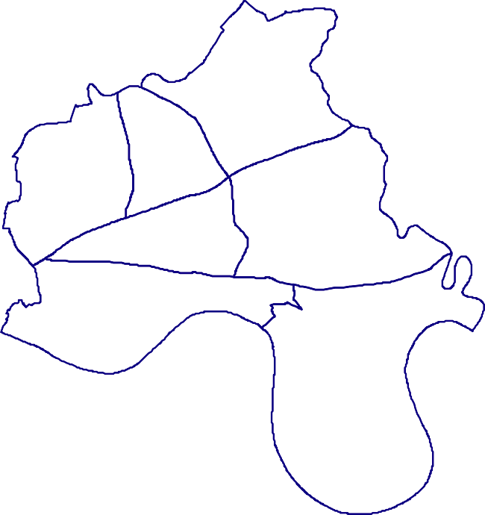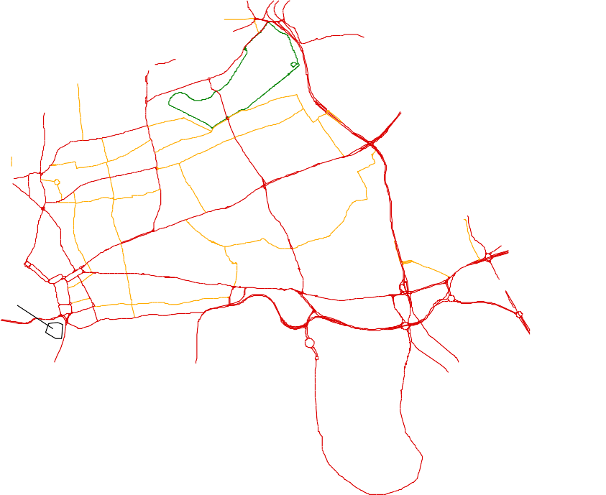
L. B. Hac kne y
L. B. New ha m
Bow
Globe Town
Bethnal Green
Cit y of London
Poplar
Stepney
Tower of London
#
Wapping
Isle of Dogs
L. B. G re enw ich
L. B. Sout hwa rk
B . L e w i s h a m

The Borough is approximately 2150 hectares in size. According to the 2021 Census, Tower Hamlets population is 310,300 and saw the largest population increase in London (22.1%) since the last Census in 2011 and is the most densely populated of London’s 33 local authorities. The population is forecast to increase to 377,896 by 2030 making it the fastest growing population nationally. Within Tower Hamlets, about 45% of the dwellings are local authority owned (34,538 dwellings) with a further 13% being owned by housing associations or other public bodies. In terms of percentage of land, approximately 18% of the land in Tower Hamlets is owned by the Council and approximately 2% by THCH (Tower Hamlets Community Housing) and HARCA (Registered Social Landlords) (LBTH, 2012).

Table 3 contains some (not indicative of all land uses) of the general current land use characteristics relevant to the Part 2A assessment within the borough.

Table 3. Land Use in Tower Hamlets.

Land Use | % of land in Tower Hamlets
Residential | 31
Allotments | 0.11
Parks/open spaces | 10.6
Schools | 3.77
Commercial | 8.55
Industrial | 5.77

Modern History of Development

Tower Hamlets has undergone substantial change in the past decade, with billions of pounds from public and private investment being contributed to regeneration. The Isle of Dogs, which includes West India, Millwall and East India Docks, has become a prime commercial development area. Canary Wharf, one of the largest commercial developments in Europe, is at the very heart of the new Docklands and is the world’s leading finance centre. Tower Hamlets Local Plan 2031 has identified the need for 54,000 new homes to be built to support the council’s growing population.

In 1981, The London Docklands Development Corporation (LDDC) was established with funding from the central government to regenerate the Docklands. In Tower Hamlets this included all the Isle of Dogs and part of Wapping, (south of the Highway and East of the Tower of London- See Figure 3). Regeneration was secured by bringing land and buildings into use, encouraging industry and commerce, creating an attractive environment and assisting the provision of housing and social facilities to encourage people to live and work in the area. Major Roads were constructed along with the Docklands Light Railway (DLR) to improve the infrastructure of the area and encourage regeneration.

The LDDC was also made the Local Planning Authority for control of development within its area (See Figure 3). When the LDDC was disbanded in 1997 its planning control functions were returned to Tower Hamlets.

In 2012, the London Legacy Development Corporation (LLDC) was created in East London to promote economic and environmental regeneration of the Olympic Park and its surrounding areas. The LLDC area encompasses parts of London Boroughs of Hackney, Newham, Waltham Forest, and Tower Hamlets as outlined in the figure below.

LLDC MAP:
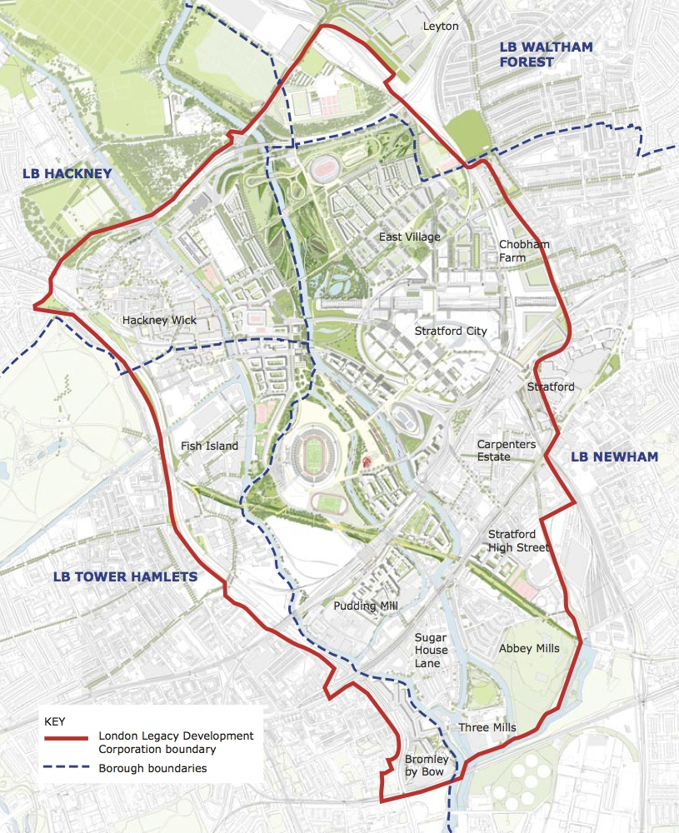

Tower Hamlets now has one of the most dynamic economies in the country. 11,440 local businesses provide approximately 251,000 jobs in the borough with the majority being located in the City Fringe/ Whitechapel and Canary Wharf/Isle of Dogs areas.

The opening of the new Crossrail in May 2022 is expected to boost the borough’s transport infrastructure.

The City Fringe area of Tower Hamlets, including Tech City, is emerging as one of London’s most significant areas for economic growth, providing considerable opportunities for new and emerging sectors of the economy. The council’s Whitechapel Vision Masterplan is driving forward regeneration in Whitechapel including new homes and job opportunities, public realm improvements and a new civic hub for Tower Hamlets.

The Isle of Dogs and South Poplar has been identified as an Opportunity Area (OA) by the Mayor of London in the London Plan 2021. Both OA Zones has the potential for 29,000 and 9,000 new homes by 2041 respectively.

In Tower Hamlets, the Lower Lea Valley Opportunity Area comprises the areas of Hackney Wick/Fish Island, Bromley-by-Bow and Poplar Riverside Housing Zone which will use brownfield land as the basis of much of the redevelopment. The LLDC is the planning authority to determine planning applications within Hackney Wick/Fish Island and the Olympic Legacy Area. The planning powers of LLDC will return to the relevant boroughs by 24th December 2024.

In this area, the Olympic Legacy has been a catalyst attracting development opportunities and investment specially to promote affordable housing, jobs and social infrastructure for local communities in the area.

More recently, the Poplar Riverside Housing Zone is an initiative of the GLA to drive forward growth located on the redevelopment of former industrial land and existing social housing estates.

Historical Industrial Land Use

The historical land use in Tower Hamlets was largely rural until the 16th Century when the maritime industry began to grow and areas along the river and main road transport routes became built up with industries including breweries, smithies and roperies such as Ropemakers Fields. By the 18th Century, shipbuilding was one of the main industries to be carried out at Docks in Blackwall, Wapping, and Ratcliff with more than a dozen shipbuilding yards in existence in 1860. Industries to support this grew up around these areas and included Ironworks that would have produced sheet and rod iron, anchors and mounting chains. In 1853 it was estimated that there were 8 Chemical Works, 6 Iron Works and 3 Ropemakers on the Bank of the Thames between Limehouse and Blackwall.

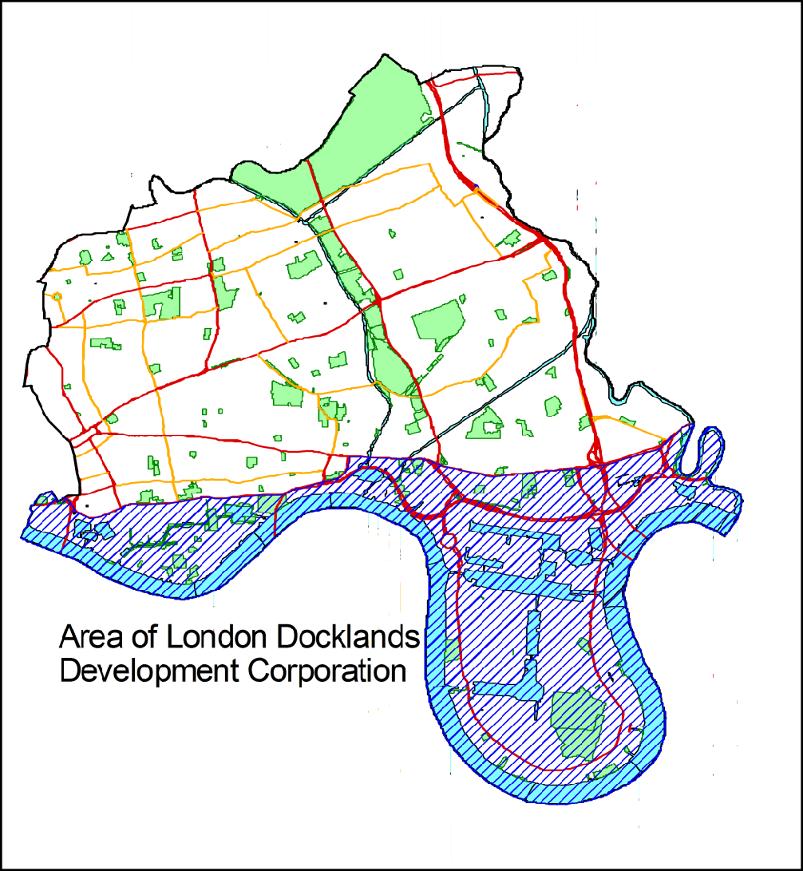

Figure 3 Extent of London Docklands Development Corporation Area

In 1994, a study of former industrial land in Tower Hamlets (See Section 4.3.2 of this report) identified over 900 industrial sites. Many were located along the River Thames, particularly along the periphery of the Isle of Dogs. Other areas identified were the banks of the Limehouse Cut and Bow, particularly the area south of Hampton Wick, the historic centre of the British chemical industry. Table 4 below provides a summary of industry types found in this study.

Table 4. Summary of Former Industrial Land in Tower Hamlets (1994 study).

Industry Type | Number of Sites
Metal works | 80
Roperies | 12
Gas Works | 13
Chemical Works | 180
Engineering | 91
Waste Sites | 40

Current Planning Controls

The redevelopment of potentially contaminated historical industrial sites is undertaken through the planning regime. Where contamination is likely to affect the proposed end use of the development, planning permission will normally be granted subject to planning conditions. Usually, these conditions require the developer to carry out a desk study, walkover survey, intrusive investigation, and risk assessment to determine the nature and extent of contamination within the ground. Any contamination identified is assessed against appropriate assessment criteria for the proposed land use scenario to assess whether remediation is required. A proposal for any required remedial works must then be submitted and approved by the council before work begins on site in accordance with local and national planning policies.

Tower Hamlets Local Plan 2031 Policy D.ES8 – Contaminated land and storage of hazardous substances, require proposed developments on contaminated land or potentially contaminated land to carry out required site investigations in line with current guidance and agreed remediation proposal, and where relevant, liaise with Environment Agency.

The London Plan 2021 Policy SD1 ensures that identified Opportunity Areas such as Isle of Dogs and Poplar Riverside meet their full growth and regeneration potential and where required, encourage the strategic remediation of contaminated land.

The National Planning Policy Framework (NPPF revised in July 2021 sets out the government’s planning policies for England. The NPPF places emphasis on protecting and enhancing the environment and promotes sustainable development. In relation to contaminated land, NPPF policy 183 and 184 states that:

183. Planning policies and decisions should ensure that:
a) a site is suitable for its proposed use taking account of ground conditions and any risks arising from land instability and contamination. This includes risks arising from natural hazards or former activities such as mining, and any proposals for mitigation including land remediation (as well as potential impacts on the natural environment arising from that remediation);
b) after remediation, as a minimum, land should not be capable of being determined as contaminated land under Part IIA of the Environmental Protection Act 1990; and
c) adequate site investigation information, prepared by a competent person, is available to inform these assessments.

184. Where a site is affected by contamination or land stability issues, responsibility for securing a safe development rests with the developer and/or landowner.

The thread running throughout the NPPF is that there should be sustainable development, which is viable and deliverable. Obligations and policy burdens should not threaten viability of development.

Other Regulatory Controls

The Environmental Damage (Prevention and Remediation) Regulations 2009 come into force in England on 1 March 2009. The Regulations implement EU Directive 2004/35/EC on environmental liability with regard to prevention and remedying of environmental damage.

Tower Hamlets is the enforcing authority for all land damage (contamination of land) from any economic activity that results in a significant risk of adverse effects on human health except where the land is a Site of Special Scientific Interest (SSSI). The Regulations only apply to damage which occurred after they came into force and are only applicable to operators of economic activities. Therefore, any land damage from contamination resulting from an economic activity from March 2009 onwards will be assessed and remediated if necessary, under the Environmental Damage (Prevention and Remediation) Regulations.

The regulations are based on the ‘polluter pays principle’ so those responsible for causing pollution are required to prevent and remedy environmental damage, rather than the taxpayer paying.

Protected Sites and Ecology

Tower Hamlets has two statutorily protected nature sites. These are Tower Hamlets Cemetery Park and Mudchute Park and Farm which have been designated as Local Nature Reserves under Section 21 of the National Parks and Access to the Countryside Act 1949.

Figure 4. Sites of Metropolitan Importance.

Local Nature Reserves are generally sites that are managed to conserve nature, which may be of special interest locally and/or nationally. They also aim to encourage opportunities for study, research and enjoyment of nature. There are also ecological sites that have been protected in the council’s Local Plan. For the purposes of this discussion, there are three categories of sites of nature conservation importance in the Local Plan:

- Sites of Metropolitan Importance (Refer to Figure 4), contain the best example of London’s habitats and rare species and are therefore the highest priorities for protection. In Tower Hamlets there are 5 sites including Mudchute Park and Farm, Tower Hamlets Cemetery and the major waterways – the Lea, the Lee Navigation and Canals.

- Sites of Borough Importance (Refer to Figure 5) are important in a borough perspective and damage would mean a significant loss to the borough. There are approximately 19 sites in this category; and

Figure 5. Sites of Borough Importance.

- Sites of Local Importance which are or may potentially be of particular value to nearby residents or schools.

Figure 6. Sites of Local Importance.

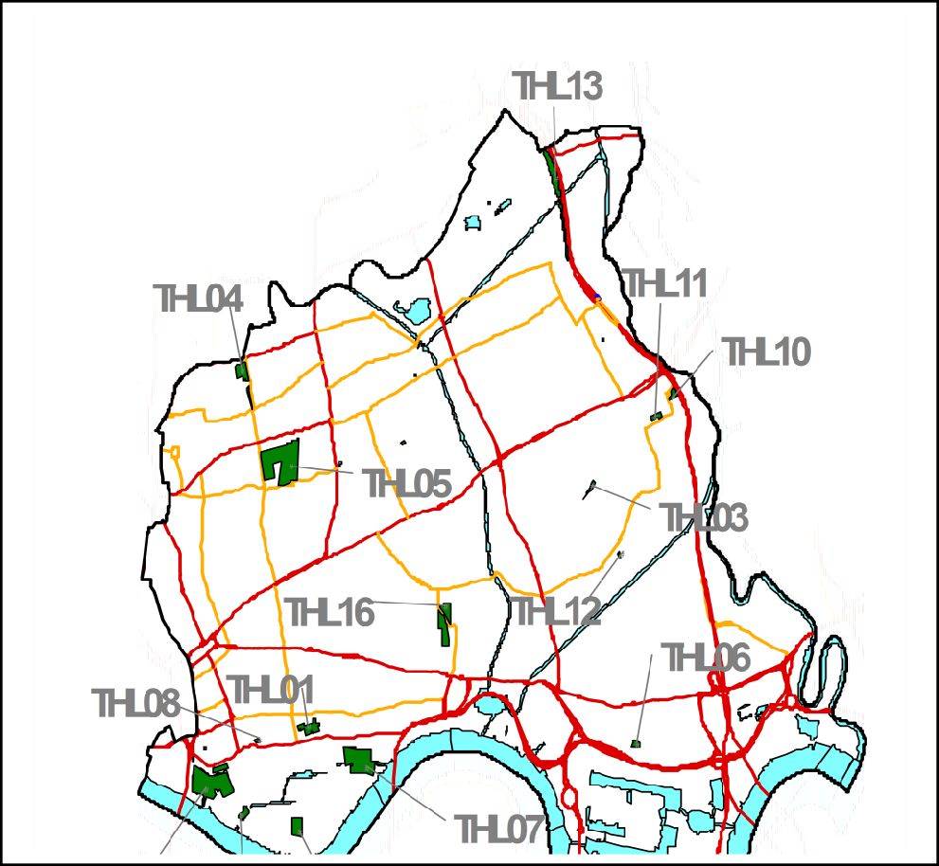

Table 5 Sites of Importance for Nature and Conservation
Site reference | Sites
 | Sites of metropolitan importance
M006 | London's Canals (includes Regent’s Canal, Limehouse Cut, LimehouseBasin, Hertford Union Canal)
M031 | The River Thames and Bow Creek
M071 | Lea Valley (includes River Lea and Lea Navigation)
M117 | Tower Hamlets Cemetery Park & Ackroyd Drive Green Link
M133 | Mudchute Park and Farm
M157 | Mile End Park
 | Sites of borough importance, Grade 1
THBI01 | The Greenway in Tower Hamlets
THBI02 | Victoria Park
THBI04 | East India Dock Basin
THBI09 | Spitalfields Farm and Allen Gardens
 | Sites of borough importance, Grade 2
THBIl01 | Millwall and West India Docks
THBII03 | Bethnal Green Nature Reserve (St Jude’s Nature Park)
THBII04 | Cable Street Community Garden
THBII05 | Stepney City Farm
THBII07 | London Wall and the wall of the Tower of London
THBII11 | Pinchin Street Disused Railway
THBII12 | Weavers Fields
THBII13 | Shadwell & Hermitage Basins, Wapping Wood & Wapping Canal
THBII14 | Blackwall Basin
THBII15 | Millwall Park
THBII16 | Poplar Dock
THBII17 | Saffron Avenue Pond
 | Sites of local importance
THL01 | St George in the East Church Gardens
THL03 | Old Railway at Fairfoot Road
THL04 | Ion Square Gardens
THL08 | Swedenborg Gardens
THL12 | Perring Community Garden
THL13 | Disused railway Bow
THL15 | St Katharine Docks
THL17 | St Anne's Churchyard, Limehouse
THL23 | Cyril Jackson School Nature Area
THL26 | Robin Hood Gardens
THL27 | Meath Gardens
THL32 | King Edward Memorial Park
THL33 | Elf Green

There are approximately 40 conservation areas in Tower Hamlets, the largest of which is located around Victoria Park. Conservation areas are designated largely to protect and improve the Borough’s built environment as well as open spaces and trees within those areas.

The following are historical sites that are of national importance and are statutorily protected by virtue of their inclusion on the Schedule of Ancient Monuments:

The Tower Of London, Tower Hill West,
Section of London Wall running from Tower Hill Underground Station to Tower Hill,
Priory and Hospital of St. Mary Spital, Spitalfields.

The following standing structures are also on the schedule:

Bonner Hall Bridge, Regent's Canal, Three Colts Bridge, Gunmaker's Lane, Parnell Road Bridge, SS Great Eastern.

This strategy aims to protect such designated sites, which includes ancient monuments, listed buildings, parks and gardens and conservation areas. It is also recognised that other sites, which are not designated, may also require protection. The council’s conservation officer will be contacted to help identify such sites.

Local Geology

The Solid Geology (Refer to Figure 7) underlying Tower Hamlets consists of London Clay, which in some areas is in excess of 25 metres thick. Below the clay lies Chalk, which is a Principal Aquifer and supplies drinking water to the area. The clay is an aquitard (very low permeability) and therefore prevents contamination filtering from the overlying Secondary Aquifers. This is with the exception of the Isle of Dogs, which mainly consists of the Lambeth Group and a small area of Thanet Sands formations.
The superficial deposits (refer to Figure 8) are deposits, which have been formed by the River Thames and overlie the London Clay. These consist of alluvium, the youngest deposit, which covers the southern half of the borough; River Terrace Gravel called Taplow Gravel across the centre; and Hackney gravels in the northwest corner of the Borough. Up until the 18th Century the Isle of Dogs was marshland, which was frequently flooded. As a result, in some parts of the Isle of Dogs, deposits of Peat have formed.

Figure 7. Local Geology.

3.1.8 Local Hydrogeology

The groundwater source in Tower Hamlets has been designated by the Environment Agency as a Secondary Aquifer (River Terrace Gravels) of High Vulnerability. The ‘Secondary’ refers to the aquifer’s variable permeability. This means it cannot easily transport contaminants. The High Vulnerability indicates that the aquifer can be easily polluted because the overlying soil layers are likely to be very permeable and polluted especially in urban areas. As a result, mobile contaminants can migrate quickly through the superficial soils to contaminate the aquifer below.
It is also important to note that such aquifers can be important for local water supplies, abstractions and in supplying base flow to rivers and streams.

Figure 8. Superficial Geological Deposits.

Fourteen water abstraction licenses have been issued in Tower Hamlets by the Environment Agency (EA). Eight of these allow abstraction from groundwater while the remainder abstract from the river Thames and the docks. Most abstractions are for industrial use. Abstraction points or boreholes require careful consideration, as they are possible pathways through which contamination can migrate to the underlying aquifer. One abstraction license has been issued to Thames Water on the border of Tower Hamlets and Newham for public water supply. The Environment Agency has designated source protection zones around this abstraction point for the protection of the groundwater quality.

Local Hydrology

Surface water bodies include the river Thames, a number of Docks in Wapping and the Isle of Dogs along with a number of canals, mainly the Regent’s and Grand Union Canal and Hertford Canal (Refer to Figure 9). Rivers and surface water features are potential receptors for contamination and may also act as a pathway between contaminant sources and other receptors.

Figure 9 Local Hydrology

Implications for the Strategy

Tower Hamlets is comprised of a mixture of commercial and residential redevelopment on the Isle of Dogs and older residential areas in the north of the Borough.

The Council has adopted the ArcMap Geographic Information System (GIS to identify and analyse areas of contaminated land across the borough. The GIS works in conjunction with the GeoEnviron contaminated land database, in which site information is recorded.

Land in Tower Hamlets contaminated after March 2009 will be dealt with using its enforcing powers under the Environmental Damage (Prevention and Remediation) Regulations 2009.

APPROACH TO IDENTIFYING CONTAMINATED LAND

The Risk Assessment Approach

The Part 2A process of identifying and assessing land contamination uses a risk based approach throughout each stage. The risk is considered in relation to the current use of the land. The DEFRA statutory guidance defines ‘risk’ as:

- the likelihood that harm, or pollution of water will occur as a result of contaminants in, on or under the land; and
- the scale and seriousness of such harm or pollution if it did occur

For a risk to be relevant and warrant further assessment under Part 2A there needs to be one or more contaminant-pathway-receptor linkages – ‘contaminant linkage’ by which a receptor might be affected by contaminants in, on or under the land under investigation. This means that, for a risk to exist, there must be contaminant (s) present in, on or under the land in a form and quantity that poses a hazard, and also one or more pathways by which they might significantly harm people, the environment or property or controlled waters.

The statutory guidance defines:

  - A ‘contaminant’ as a substance which is in, on or under the land which has the potential to cause significant harm to a relevant receptor or to cause significant pollution to controlled waters.
  - A ‘receptor’ as something that could be adversely affected by a contaminant, for example a person, an organism, an ecosystem, property or controlled waters.
  - A ‘pathway’ as a route by which a receptor is or might be affected by a contaminant.

A contaminant linkage must exist in relation to a specific site before the land can be considered to be potentially contaminated land under Part 2A. This must be followed by a risk assessment to establish whether a “significant possibility of significant harm” (SPOSH) exists before a land may be determined as contaminated land.
Contaminant Linkage(s): for a risk to exist it must be significant for land to be designated as contaminated land.

The understanding of the risks is developed through a staged approach involving a preliminary risk assessment informed by desk-based study; a site visit and walkover; a generic quantitative risk assessment; and various stages of more detailed quantitative risk assessment to create a “conceptual site model”.

The process should normally continue until it is possible for the local authority to decide:

- that there is insufficient evidence that the land might be contaminated land to justify further inspection and assessment; and/or
- whether or not the land is contaminated land.

The council’s risk assessment approach starts with a site prioritisation exercise. The approach uses a decision support tool or risk model (See Section 4.3.6.) which assigns scores (risk ratings) to various sites based on suspected hazard from historical industrial uses on the land and the susceptibility of receptors currently using the land. This involves a series of stages which will act as filtering processes to allow contaminated land to be identified. The site prioritisation exercise will also help to assess, prioritise and manage the allocation of resources in the most cost-effective manner.

The council’s approach will also ensure that the highest risk sites are dealt with first and this is consistent with the broad objectives of the Part 2A regime.

In line with statutory guidance receptor types have been separated into four categories: Human, Groundwater, Surface Water and Ecology, they have been risk ranked and are treated separately. This has allowed us to identify sites where significant harm with respect to human health is likely to be occurring and to give these sites priority.

4.2 The Three-Stage Conceptual Model

Table 6. The Three-Stage Conceptual Model for Risk Assessment.

- Stage 1: Identify potential contaminant linkages.

- Stage 2: Establish actual contaminant linkage and

- Stage 3: Establish significant contaminant linkages.

Stage 1: Identify Potential contaminant Linkages

Stage 1 involves identifying ‘sources’ and ‘receptors’ of potential contamination.

Furthermore, a pathway which is a spatial relationship (correlation) between source and the receptor must also be identified for a contaminant linkage to be established. It is, however, only in the subsequent Stages 2 and 3 that the actual presence of a contaminant linkage can be established.

In LBTH the Stage 1 process was undertaken by combining sources of existing information held by the council and obtained from others such as the Environment Agency, British Geological Survey and Ordnance Survey which were obtained for this purpose.

The Use of a Geographical Information System (GIS)

GIS has been a key tool in the implementation of the various stages of this strategy. The extents of sources and receptors can be shown on a map, and the spatial relationship between the features examined. The relationship may be coincidence or influence, as shown in Figure 10 below:

Figure 10. Spatial Relationship between Source and Receptor.

The ArcMap GIS has been used to implement Stage 1 identification of potentially contaminated sites.

The key datasets required for the Stage 1 identification process were:

    - Sources – the location of sites, which may potentially contain elevated concentrations of contaminants of concern.
- Receptors – the location of receptors as defined by the statutory guidance.

Historical Industrial Land Use (Source) Dataset

The sources dataset represents areas of past or present industrial activity that may, by nature of the industrial process, have caused contamination. The primary datasets used to establish the location and type of historical and present land use are listed in Table 7 below.

Table 7. Origin and Format of Source Datasets.

Sources Dataset | Stage of use | Origin | Format
LBTH Historical Industrial  Sites | Stage 1 Pass 1 | LBTH | Digital
LBTH Landfill sites | Stage 1 Pass 1 | LBTH | Digital
Historical land use | Stage 1 Pass 1 | Landmark | Digital
EA Landfill sites | Stage 1 Pass 2 | EA | Digital
EA Waste Sites | Stage 1 Pass 2 | EA | Digital

The council undertook a study into the legacy of industrial development within the Borough. This was reported in March 1994 entitled “Dealing with the Legacy of Industrial Development”. This survey does not identify sites that are explicitly contaminated or polluted, but rather shows the location of land used for industrial purposes, where the processes used have had the potential to cause contamination. This involved reviewing historical maps held by the council and also other records such as those held by the former London Docklands Development Corporation and trade directories.

Receptor Datasets

The receptor datasets represent areas occupied by human, surface water, groundwater or ecological receptors. Like the source dataset, the human receptor dataset was compiled from a number of different primary data such as Ordnance Survey mapping, aerial photography and a three-day walk around the borough. The aim was to identify large areas of similar current land use that could then be digitised on the GIS. The controlled water dataset consists of rivers, surface water features and groundwater aquifers, which exist in digital form from a number of third parties including the Environment Agency. The ecological dataset represents areas designated for nature conservation. These primary datasets are listed below in Table 8 showing the relevant stage of use.

**Include OS MasterMap in GIS Layers** this identifies residential Council Schools layer

Table 8. Origin and format of receptor datasets.

Receptor Dataset | Stage of use | Origin | Format
Human receptors
OS Topographic mapping | Stage 1 Pass 1 | LBTH | Digital
LBTH UDP zones | Stage 1 Pass 1 | LBTH | Digital
LBTH Open space | Stage 1 Pass 1 | LBTH | Digital
Cities Revealed Air photo 1998 | Stage 1 Pass 1 | LBTH | Digital
LBTH Estate plans | Stage 1 Pass 2 | LBTH | Digital
Controlled waters
Aquifers | Stage 1 Pass 1 | BGS | Digital
Surface water | Stage 1 Pass 1 | BGS | Digital
Boreholes | Stage 1 Pass 1 | BGS | Digital
Groundwater Vulnerability | Stage 1 Pass 1 | BGS | Digital
Drift Geology | Stage 2 | BGS | Digital
Surface Geology | Stage 2 | BGS | Digital
Source Protection Zones | Stage 2 | EA | Digital
Water Abstraction Points | Stage 2 | BGS | Digital
Ecological receptors
SSSI/NMR/NNR | Stage 1 Pass 1 | Natural England | Digital
Site of Nature Conservation | Stage 1 Pass 1 | LBTH | Digital

Classification of the Source/Receptor Datasets

The historical data from Landmark and ‘The Interim Report on the Survey into Past Industrial Activity’ has been analysed and catalogued into potentially contaminative uses based on the classifications set out by the Department of the Environment in their 1st Consultation Paper (May 1991) on the former proposal for Section 143 Registers (supplemented by additional categories as appropriate). Where no classification is possible (e.g., unidentified works) then this has been identified separately as ‘unknown works’ or similar.
The list of contaminative uses has been divided into four hazard classes and given scores from 1 to 4 based on the contaminative potential. These hazard categories were devised by W.S. Atkins and are based on a group consensus, which consisted of senior contaminated land professionals.

The receptor dataset was divided into four components: human, surface waters, groundwater, and ecological. This enables the analysis of each to be undertaken independently and allowed risks of harm to human health to be prioritised in accordance with the statutory guidance. Properties, in the form of crops/livestock/animals and in the form of buildings, are also considered as receptors in the statutory guidance. These receptors were not considered at this stage as it was thought that any significant adverse effects would have become evident by now. The human health receptor datasets have been broken down into further categories including allotments, houses with gardens, flats complex, flats with gardens, open ground, parks, commercial etc.

Building and Applying the Risk Model

A GIS model was constructed and assigned numerical scores, 1 to 4, to sources depending on their hazard and, similarly, scores, 1 to 4, were assigned to receptors based on their susceptibility. Sources (industrial sites) have each been given a score according to their likely hazard. For example, a gas works site is allocated the highest score, 4, because it is likely to contain high concentrations of toxic contaminants. A receptor such as a house with garden is assigned the highest susceptibility score because there is a greater chance of people coming into direct contact with contamination in the soil by gardening, for example. On the other hand, car parks have been allocated a score of 1 because people cannot come into direct contact with any contaminated soil, as it will be contained beneath a tarmac or concrete surface.

The model was constructed for each receptor type (human health, surface waters, groundwater, and ecology) and gave an indication of the probability of a contaminant linkage being present, i.e., where there is an overlap between a source, (i.e., a former industrial site), and a receptor, (i.e., housing development). For example, a high source hazard score combined with high receptor susceptibility score equates to the highest likelihood of the existence of a significant contaminant linkage. This is illustrated by the risk matrix in Section 4.3.6 below. The values in the coloured matrix cells were the final risk scores allocated to each site that is likely to have a contaminant linkage present, i.e., both a receptor and a source (Appendix A contains a list of the risk classifications for the various industrial land uses and receptor classes).

The risk model is a method by which sites are prioritised for further detailed inspection. It is an indication that the site may contain elevated contaminant concentrations, which could be causing harm to a receptor. Stage 2 and Stage 3 investigations will allow a determination of the presence of contaminants which are causing or are likely to cause significant harm to human health and/or significant pollution of controlled waters. Land cannot be designated as contaminated land following the completion of Stage 1 assessment.

Matrix of Likelihood of Pollutant Linkage Being Present Table 9. Risk Score Matrix.
Risk Scores | Receptor Susceptibility | Receptor Susceptibility | Receptor Susceptibility | Receptor Susceptibility
Source Hazard | 4 (high) | 3 | 2 | 1 (low)
4 (high) | 7 | 6 | 5 | 4
3 | 6 | 5 | 4 | 3
2 | 5 | 4 | 3 | 2
1 (low) | 4 | 3 | 2 | 1

The model was then applied across the area of the Council using a geo spatial tool (ArcGIS) to classify each source and receptor according to the appropriate risk class based on spatial coincidence (i.e. where there is an overlap or influence between a source and a receptor). This has resulted in each site being allocated a ‘risk score’, which reflects the likelihood of existence of a significant contaminant linkage. Sites were selected for stage 2 assessment in order of their highest maximum risk score and highest intercept score.

4.10- Revision of the Risk Prioritisation Exercise- GeoEnviron/ArcGIS
The Environmental Health and Trading Standards Service have obtained a database management system called GeoEnviron to revise the earlier site prioritisation list which was generated by the Atkins GIS based model.

ArcGIS, together with GeoEnviron will allow new data (such as from development control on site remediation and change of use) to be incorporated into the site risk prioritisation exercise.

Stage 2: Identify Actual Contaminant Linkages

Where sites are found to have a potential contaminant linkage these progress on to Stage 2 which involves a desk-based study and a walkover survey to validate the information and risk classification identified during Stage 1.

The aim of the Stage 2 process is to:

- Determine the existence of actual contaminant linkage.

- Determine whether the contaminant linkage could either:
  - Result in significant harm to the receptor or present a significant possibility of significant harm to the receptor; or
  - Result in the significant pollution of controlled waters or are likely to result in such significant pollution.

At each stage of the process, the issue is whether or not there is sufficient evidence to progress the assessment of the site into the next tier within this Strategy.

It is useful to view the Stage 2 process at three levels:

Stage 2A: This involves a walkover survey that serves to validate the basic data and interpretation that has come from Stage 1. If it is concluded that there may be a contaminant linkage, the site will be progressed to Stage 2B for further consideration.

Stage 2B: A formal desk study is carried out which involves consultation with external bodies such as the Environment Agency and British Geological Society. The objective of Stage 2B process is to consider whether there is sufficient evidence for the identified potential contaminant linkages at Stage 2A to warrant further assessment at Stage 3 of this strategy.

Stage 2C- This involves consultation with other council departments e.g. Planning. Before sites are passed onto Stage 3, it is important to ensure that all available information has been collected, particularly on the actual presence or absence of contamination and/or remediation. The owners and occupiers of the site, the developer who built the development and any

identified appropriate persons will also be contacted and asked whether they hold any further information and will be advised that the next proposed action will be to carry out an intrusive investigation. However, this will not be carried out if information presented, as a result of the consultation, confirms that the site is unlikely to be contaminated land.

The Stage 2 inspection of sites began in 2001. As the Stage 1 and 2 work progressed, it became apparent that large volumes of information would be collected and that the use of GIS alone for the storage of data collected would be unsuitable. GeoEnviron, a database that links to ArcView GIS, was purchased to effectively store and manage this data. As more data is added to the system, for example, on sites remediated through the Development Control system, it is intended to re-run the risk prioritisation of sites periodically. A re-run of site risk prioritisation is currently on going. The site reprioritisation exercise will update the existing risk prioritisation information on the GeoEnviron database.

Stage 2 will result in the development of a conceptual model for each site, which will outline all possible potential pollutant linkages. Sites will then be reprioritised for Stage 3 inspection.

Stage 3: Identify Significant contaminant Linkage

This stage establishes whether there is a significant contaminant linkage present. This may require an intrusive investigation (i.e. sampling of soil, groundwater and/or ground gas) particularly if there are no previous ground investigation reports available.

The investigations will be designed on a site-specific basis taking account of all relevant information of the site including the potential for contamination or actual presence of elevated concentrations of contaminants from the preceding stages of the assessment.

Statutory powers of entry can be used (Environment Act 1995) if needed to gain access into properties where the council is of the opinion that there is a high likelihood of existence of imminent risk to health and access is denied. The same powers of entry will be granted for the Environment Agency for intrusive investigative works on Special Sites where they are the enforcing authority.

4.13 Risk Assessment to Identify Significant Contaminant Linkage

The process of risk assessment involves understanding the risks presented by land, and the associated uncertainties. The understanding of the risk is developed through a staged approach to risk assessment and the process should normally continue until it is possible for the council to decide:

- that there is insufficient evidence that the land might be contaminated land to justify further inspection and assessment; and/or

- whether or not the land is contaminated land.

In all cases the council will, subject to securing funding, carry out intrusive investigations by commissioning a suitably experienced and independent consultant to carry out the investigation.

Until the site has been determined as contaminated land the council will subject to securing funding, pay for all such investigations and, where possible, will apply for Government funding if available.

4.14. Summary of Stages 1 to 3

In summary, a conceptual model as part of risk assessment has been developed involving a three-stage identification process using GIS and a custom database (GeoEnviron) to manage the spatial data. This addresses the identification sequence of potential contaminant linkage, actual contaminant linkage and significant contaminant linkage.

Figure 11 below summarises the staged approach adopted by the council in the site prioritisation exercise.

Figure 11. Summary of the Stages of Identifying contaminated land.

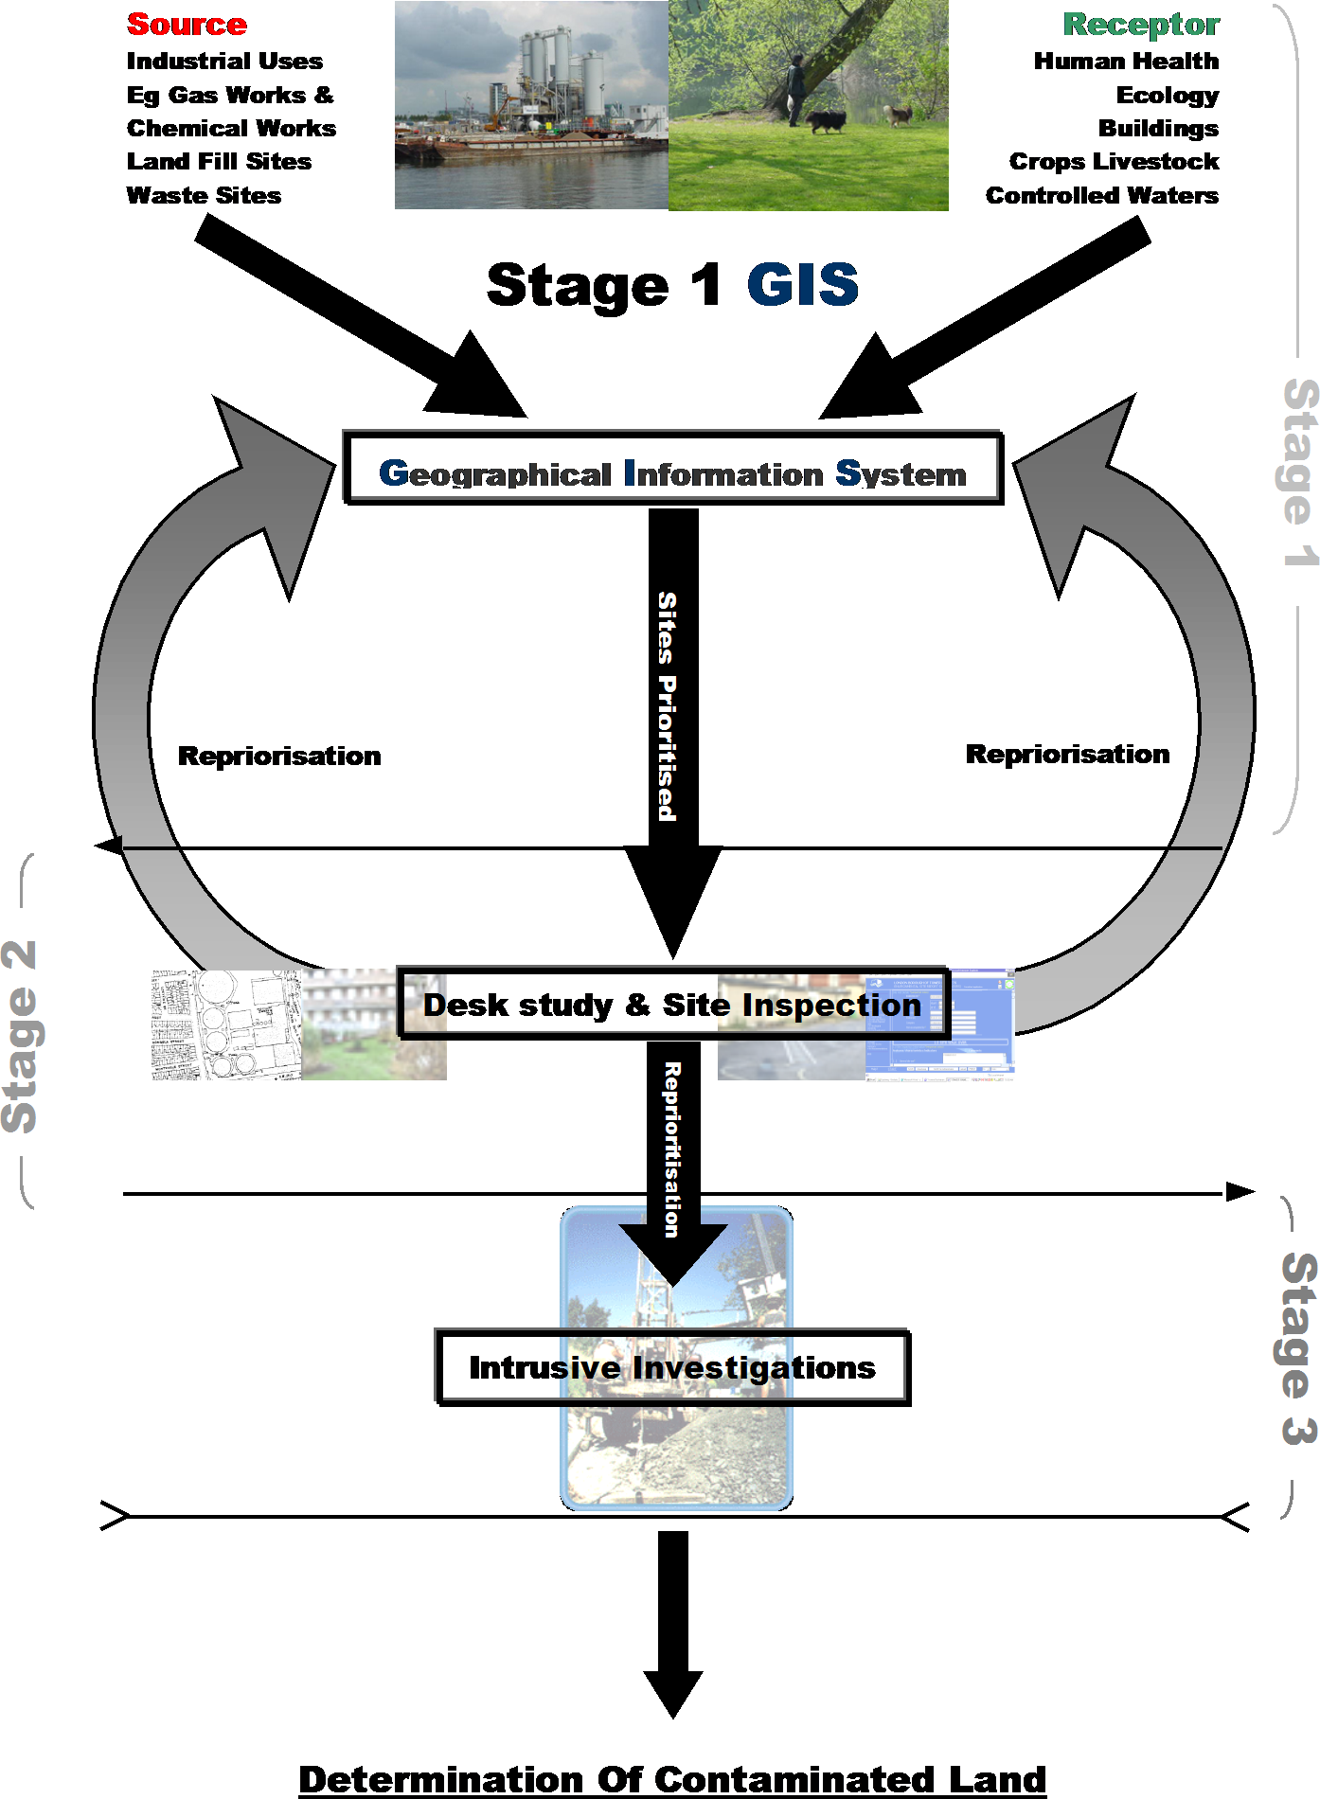

DETERMINATION OF CONTAMINATED LAND

The council has the sole responsibility for determining whether any land within its area appears to be contaminated land. This statutory responsibility cannot be delegated (except in accordance with Section 101 of the Local Government Act 1972. However, in making such decisions the council will rely on information or advice provided by other bodies such as the Environment Agency, or a suitably qualified experienced practitioner appointed for that purpose.

The council will consider the following four possible grounds for the determination of land as contaminated land (with regard to non-radioactive contamination) (Defra, 2012):

  - Significant harm is being caused to a human or relevant non-human, receptor.
  - There is a significant possibility of significant harm being caused to a human, or relevant non-human, receptor.
  - Significant pollution of controlled waters is being caused.
  - There is a significant possibility of significant pollution of controlled waters being caused

Before making any determination, the council would have identified one or more significant contaminant linkage(s), and carried out a robust, appropriate, scientific and technical assessment of all the relevant and available evidence. If at any stage of the assessment the council considers that conditions for considering land to be contaminated land do not exist, it would not determine that the land is contaminated land.

Before making a determination, the council will inform the owners and occupiers of the land and any other person who appears to the authority to be liable to pay for remediation of its intention to determine the land. This is to give such persons time to make representations (for example to seek clarification of the grounds for determination, or to propose a solution that might avoid the need for formal determination) considering: the broad aims of Part 2A regime; the urgency of the situation; any need to avoid unwarranted delay; and any other factor that the council considers to be appropriate.

6 LIAISON WITH OWNERS AND OCCUPIERS OF LAND

The adopted approach to identifying contaminated land within this strategy means that the council, or its consultants, will be required to visit and carry out a detailed inspection for only a small proportion of the land within the borough. This is land where the earlier stages of assessment suggest the possibility of the existence of contaminant linkages which could render the land as being contaminated land. The detailed investigations will be prioritised according to the risk of exposure to potential contaminants by residents and will include a visit to a particular area, and sampling of soil, groundwater and/or ground gas at a designated site.

The reasons why the council may need to liaise with owners and occupiers of land are as follows:

  - to carry out a walkover survey. This will allow a check of current receptors and, in some cases, may be sufficient for the council to decide whether or not further assessment is required
  - to request relevant information that the owner or occupier may hold. This could include historical information or previous studies (desk studies or intrusive investigations) and its availability may avoid the need to undertake independent intrusive investigations. Alternatively, the owner may offer to provide information on the condition of the land within a reasonable and specified timescale
  - to agree access and timing for the council or its consultants to carry out an intrusive investigation or take samples where considered necessary. In some circumstances an authorised person can ask other people questions, which they are obliged to answer, and make copies of written or electronic records
  - In response to enquiries from interested parties.

In each case, the purpose of liaising with owners/occupiers will be to assist the council in obtaining sufficient information to make a determination on whether land appears to the council to be contaminated land. If necessary, Section 108 of the Environment Act 1995 gives the council the power to authorise a person to exercise specific powers of entry.

The relevant officer, or their delegate, will also discuss with the owner/occupier the reasons for carrying out the intrusive investigation and communicate risk in accordance with the “Contaminated Land Risk Assessment Communication Strategy”.

The council will also liaise with the owner(s) and occupier(s) of land in the following circumstances:

  - where information has been received by business, voluntary organisations or members of the public on the possibility that the particular land might be contaminated land and the council considers that further investigations are warranted. How this information is to be dealt with and over what probable timescale will be agreed with the owner/occupier
  - where findings of the assessment show that there exists unacceptable risk, the council will inform the owners and occupiers of the land and any other person who appears to be liable to pay for remediation before making a determination of any land as contaminated land
  - where the owner or occupier is identified as an appropriate person, a remediation notice will be issued, specifying the most appropriate method of remediation selected by the council and a reasonable timescale for the completion of the required work. The issues of exclusion from liability apportionment are complex and are addressed in the Hardship and Cost Recovery Policy which is included as an addendum to this Strategy
  - where contaminated land has been determined, a written record of the determination will be provided to the landowner and occupier, providing a justification for the determination, including details on all the available site investigation reports and other assessments in accordance with the statutory guidance. Notice will also be given to each person who appears to be an appropriate person to bear responsibility for any remediation required in accordance with the tests for exclusion and apportionment of liability in the statutory guidance.

The general approach will be to seek to reach voluntary agreement in preference to serving a remediation notice. However, where negotiations are not successful and warning letters have not resulted in agreement, the council will issue the appropriate remediation notices, in accordance with its statutory duty, taking account of statutory guidance on liability apportionment and cost recovery issues. If the land is not considered contaminated using the legal definition, the person responsible for causing the contamination or the landowner could be responsible for dealing with the contamination.

7 CONSULTATION WITH OTHER AGENCIES

7.1 Environment Agency

A copy of this strategy and any subsequent revisions will be provided to the Environment Agency. Details of sites with a risk ranking and copies of site investigation reports and risk assessments will be sent to the Environment Agency. Notifications of the identification of contaminated land and remediation notices will also be provided to the Environment Agency.

Tower Hamlets will take account of any guidance and specific site information that may be issued by the Environment Agency in particular, the Environment Agency will be consulted for specific site information if potentially contaminated land, is likely to be so classified by virtue of pollution of controlled waters or is likely to be a Special Site. (See Appendix C for the definition of Special Sites).

The Environment Agency has provided specific information which has been included in the contaminated land identification process. This includes:

    - information on groundwater vulnerability, source zone protection maps
    - information on surface water quality, abstraction licences and specific pollution incidents
    - information on location of closed landfills and currently licensed waste management facilities; and,
    - details of the types of site that, if designated as contaminated land, would be categorised as Special Sites (including current and historic IPPC authorised sites).

As discussed earlier in Section 4, the data has been produced in digital format and incorporated into the GIS model (eg. groundwater vulnerability). Some of this data was also examined during the desk studies (eg. specific pollution incidents).

Information will also be provided to the Environment Agency to assist them in compiling a report on the state of contaminated land if required. The information could include this Strategy and information on all Tower Hamlets sites with a risk ranking and those sites designated as contaminated land.

Copies of notices, remediation statements and declarations will also be provided to the Environment Agency when issued.

7.2 Thames Water

Thames Water will be immediately notified where a potential contaminant linkage includes a public water supply source as a receptor.

8 HANDLING INFORMATION RECEIVED FROM THE PUBLIC, BUSINESSES,
VOLUNTARY ORGANISATIONS AND THE ENVIRONMENT AGENCY.

The purpose of this strategy is to adopt a systematic approach to the identification of contaminated land. However, this will take time to complete due to the complex nature of the risk assessment, continuous change in the technical guidance and uncertainty regarding securing funding from central government. In the meantime, it is important to be able to respond to and investigate specific concerns that are raised by members of the public, businesses and voluntary organisations.

Complaints

Complaints may be received from the public or other bodies regarding land contamination. Complaints will be dealt with following the same procedure as other complaints to Environmental Health. The complaint will be investigated in line with this inspection strategy and all efforts will be made to keep the complainant informed of progress and to resolve the complaint as efficiently and effectively as possible.

Obtaining/Receiving Information

Information may be provided by members of the public, site owners/occupiers, environmental organisations and the Environment Agency, which may be sufficient to identify land as contaminated land directly or to suggest that detailed inspection and possibly intrusive investigations are required.

Alternatively, following assessment, a decision may be made that no action is required because the concern does not appear to be well founded or the absence of receptors is sufficient to determine that land is not contaminated.

The council’s approach in assessing this information and deciding how to proceed will include taking account of the following factors:

- the strength of the evidence already available to suggest that the land is contaminated land (for example visual evidence, Stage 2 assessments, previous investigations and anecdotal information that is considered likely to be well-founded)
- the apparent urgency of the matter (priority will be given to concerns about human health in accordance with the council’s primary duty)
- whether or not the information is provided anonymously
- whether the information appears to be driven specifically by commercial considerations. A prospective purchaser may seek to be assured that land they are seeking to acquire will not be identified as contaminated land. In this context, the enquirer will be encouraged to employ his own independent advice to make a judgement, except where the request is consistent with complying with this strategy. Information available on former uses of land, site risk rating and records of investigations (if any) will be made available to the enquirer
- the apparent motivation of the person supplying information where there are grounds to suspect that information may not be well founded.

When information is received, the following steps will be taken to keep various parties informed:

- receipt will be acknowledged within 5 days
- the anonymity of the originator of the information will be preserved, where appropriate (normally until such time as legal action may be necessary)
- owners and occupiers of land to which the information relates, or potential appropriate persons, will be advised that it has been received and how it will be dealt with, with an indication of timescale
- other relevant regulatory authorities will be informed where the information received relates to matters outside Tower Hamlet’s statutory responsibilities (i.e. the Environment Agency, where powers under the Water Resources Act 1991 may applied);
- advising the person(s) who provided the information and owners/ occupiers/appropriate persons previously contacted of the final outcome of the council’s investigation.

Where land is determined as contaminated land, the details will be maintained on a public register. The council may be asked for information about land that has/has not been determined as contaminated land, whether as part of a ‘local search’ or for other reasons. The Environmental Information Regulations 2004 require that information on land contamination held by the Local Authority must be made available on request from 1 January 2005.

The council will provide all available information to the individual or body requesting the information. However, in circumstances where information is being collected and assessed, but is incomplete, only factual information will be provided and the council will take account of its own legal advice.

9 HANDLING REQUESTS FROM THE PUBLIC FOR
INFORMATION ON CONTAMINATED LAND

The process of implementing this strategy has, and will continue, to result in the collection and storage of a significant amount of data and information about the borough. In addition to the obligations set out in the Environmental Information Regulations (2004) governing the availability of environmental data, Tower Hamlets will adopt a transparent process, by the public, to factual data and information relating to the Part 2A legislation and statutory guidance including:

  - historical maps
  - historical land use
  - current land use
  - geological and hydrogeological data
  - ecological data
  - records of previous site investigations, remediation and validation (if available)

Interpretative information is that which is derived from the risk model input and output. The input data includes the individual hazard and susceptibility ratings of individual sites and risk ranking values. This type of information and any data that is derived through an interpretative process must also be disclosed to the public under the new regulations. However, this information must be qualified as interpretative when disclosed to the public in accordance with legal opinion obtained by the council.

9.1 Register of contaminated land

A register of land designated as contaminated with respect to Part 2A will be maintained by the Contaminated Land Officer and/or their delegate and will be available to the public. This public register, as required under Part 2A of EPA 1990 and the Contaminated Land (England) Regulations 2012, will only contain information on sites determined as contaminated land and where subsequent actions on the site have or will occur. The register also contains all data and information used to support the designation of the land as contaminated land. This will be available for inspection by contacting:
Environmental Health and Trading Standards
London Borough of Tower Hamlets
2nd Floor, Mulberry Place
London, E14 2BG

The Contaminated Land Register is maintained for public inspection on the council’s web site (contaminated land) along with a summary of the findings of the investigation(s), risk assessment and any recommended remedial works. There is currently no entry on the list.

10 LAND FOR WHICH THE COUNCIL IS DIRECTLY

RESPONSIBLE

The Stage 2 process has identified land where the council may have a responsibility due to its current or former ownership or occupation for the investigation and clean-up (if required) of that land. This includes council owned land, which has had former industrial use and/or land for which the ‘original polluter’ (Class A person as defined in the statutory guidance) may no longer be identifiable. Such land, if determined as contaminated land, will be addressed by the council.

The council may also be the owner of former (closed) landfill sites and may have responsibilities in this regard.

The council is committed to applying the same principles to contaminated land in its current or former ownership as those applied to any other contaminated land. In particular, the staged approach to identification described in Section 4 is equally relevant to land in council ownership. Should the council, as landowner, become aware of specific concerns, these will be progressed on a similar basis of priority and risk assessment as for land in other ownership.

11 REVIEW AND UPDATE PROCEDURES

The council recognises that its strategy for the identification of contaminated land is based on a probabilistic approach. The aim is not to prove the status of every piece of land within the borough but rather to adopt a logical, robust and defensible approach in which effort is proportional to risk and priorities are set appropriately. This approach is in line with the broad objectives of the Part 2A regime.

Periodic reviews of the strategy are therefore necessary, or at least every five years. The following types of review and update are likely to occur:

  - review of any amendments to, or publication of, new legislation and/or statutory guidance which may have an impact on the on-going implementation of this strategy
  - review of the scientific assumptions made in later stages of the assessment process (i.e. Stage 3 intrusive investigations and risk assessment). Such a review will focus on changes in the understanding of the behaviour of potential pollutants (changes in technical and authoritative guidance).
  - re-assessment of the inspection findings in relation to particular land. For example, there may be a change in the land use (the receptor) or because of reported health effects apparently associated with the land
  - review of any opportunities to increase the range of datasets used in the Stage 1 identification process. Additional datasets can be added to the GIS/GeoEnviron model at a later stage. There are also opportunities to add datasets maintained by other council departments (i.e. opportunities for residential and mixed-use development datasets created by Development Control for the new Local Plan). The addition of new datasets will help refine the risk-based model and increase accuracy;
  - update of the GIS/GeoEnviron model to reflect additional information that may become available (e.g. from the Environment Agency in relation to groundwater or surface water abstractions and information from development-related site investigations).

Information systems related to the identification of contaminated land are to be viewed as essentially ‘live’ systems. Although updates are expected to be made periodically for reasons of efficiency (about every 3 months), where any new information is expected to have potential implications for human health this will be reviewed as a priority and the implications to the risk model examined.

The objective of each update will be to ensure that the strategy remains relevant, up to date with current statutory and technical guidance and is efficient and effective in the application of resources to the identification of contaminated land. The update will seek to ensure that the approach taken remains consistent with current best practice.

ABBREVIATIONS

A.O.N.B. Area of Outstanding Natural Beauty.

C.L.E.A. Contaminated land Exposure Assessment.

D.E.F.R.A. Department of Environment, Food and Rural Affairs

D.F.T. Department for Transport

E.A. Environment Agency.

F.S.A. Food Standards Agency.

G.I.S. Geographical Information System.

Poplar H.A.R.C.A. Housing and Regeneration Community Association.

I.P.P.C. Integrated Pollution Prevention and Control.

L.B.T.H. London Borough of Tower Hamlets.

L.D.D.C. London Docklands Development Corporation.

S.A.C. Special Area of Conservation.

S.N.I.F.F.E.R. Scotland and Northern Ireland Forum for Environmental Research.

S.P.A. Special Protection Areas.

S.P.Z. Source Protection Zone.

S.R.B. Single Regeneration Budget.

S.S.S.I. Site of Special Scientific Interest.

      - Tower Hamlets Community Housing.

REFERENCES

DEFRA, (May 2002) Water Bill. Consultation on Draft Legislation: Government Response. DEFRA

Game, M. and Whitfield, J. (1996), Nature Conservation in Tower Hamlets. Ecology Handbook 27. London Ecology Unit.

London Borough of Tower Hamlets, (1994), Dealing with the Legacy of Industrial Development, Interim Report on the Survey into Industrial Activity. London Borough of Tower Hamlets.

London Borough of Tower Hamlets, (2005), Technical Guidance for Site Investigation and Remediation. London Borough of Tower Hamlets

National Groundwater and contaminated land Centre, Leaflet, Groundwater Source Protection Zones. Environment Agency.

Environment Agency, (1999) Communicating Understanding of contaminated land Risks SNIFFER.

Ander, E.L., Cave, M.R., Johnson, C.C. and Palumbo-Roe, B.(2011). Normal background concentrations of contaminants in the soils of England. Available data and data exploration. British Geological Survey Commissioned Report, CR/11/145. 124pp.

CL:AIRE/CIEH (2008) Chartered Institute of Environmental Health and Contaminated Land Application in Real Environmental, Guidance on Comparing Soil Contamination Data with a Critical Concentration. ISBN10 1-904306-79-9, ISBN13 978-1-904306-79-5

DEFRA (2006b) CLAN 6/06 Soil Guideline Values: The Way Forward. Assessing Risks from Land Contamination a proportionate Approach, November 2006.

DEFRA (2010) Consultation: Changes to the contaminated land regime under Part 2A of the Environmental Protection Act 1990, December 2010.

DEFRA (2012), Environmental Protection Act 1990: Part 2A Contaminated Land Statutory Guidance. April 2012, Her majesty’s stationery Office, 04/12 PB 13735

DCLG (2012) Department for Communities and Local Government, National planning policy Framework, March 2012 Her Majesty’s Stationery Office, London. ISBN: 978-1-4098-3413-7

Environment Agency (2004) Model Procedures for the Management of Land Contamination. Contaminated Land Report 11. Bristol ISBN: 1844322955.

Environment Agency (2008). Groundwater Protection: Policy and Practice (GP3), Part 4 – Legislation and Policies 2008 Edition 1. .Rio House Waterside Drive, Aztec West Almondsbury, Bristol BS32 4UD.

Environment Agency (2009a) Human Health Toxicological Assessment of Contaminants in Soil: SC050021/SR2Environment Agency, 2009. Bristol, ISBN: 978-1-84432-858-1.

Environment Agency, (2009b), Updated Technical Background to the CLEA Model: SC050021/SR3 :( Environment Agency, 2009. Bristol, ISBN: 978-1-84432-856-7)

Environment Agency, (2009c), Contaminated Land Exposure Assessment (CLEA) Software version 1.06

Environment Agency (2009d), CLEA Software (Version 1.05) Handbook Better Regulation Science Programme Science report: SC050021/SR4: (Environment Agency 2009, Bristol, ISBN: 978-1-84911-105-8)

HMSO (1972) Local Government Act 1972, Her Majesty’s Stationery Office London.

HMSO (1974) Health and Safety At Work Act 1974, Her Majesty’s Stationery Office London.

HMSO (1990) Environmental Protection Act 1990, Her Majesty’s Stationery Office London

HMSO (2000) ENVIRONMENTAL PROTECTION, ENGLAND, The Contaminated
Land (England) Regulations 2000, London. Statutory 2000 No. 227.

HMSO (2002) Control of Substances Hazardous to Health Regulations 2002 (as amended). Her Majesty’s Stationery Office London. The Stationery Office

HMSO (2006) ENVIRONMENTAL PROTECTION, ENGLAND, The Contaminated
Land England) Regulations2006, London. Statutory 2006 No. 1380

HPA (2006). Inorganic arsenic - toxicological overview. London: Health Protection Agency. http://www.inchem.org/documents/ehc/ehc/ehc224.htm
Ministry of Housing, Communities and Local Government (2021). National Planning Policy Framework. https://assets.publishing.service.gov.uk/government/uploads/system/uploads/attachment_data/file/1005759/NPPF_July_2021.pdf
Environment Agency (2021 - updated). Land contamination risk management (LCRM). https://www.gov.uk/government/publications/land-contamination-risk-management-lcrm

HMSO (2007) The Construction Design and Management Regulations 2007, Her Majesty’s Stationery Office, London. The Stationery Office

HMSO (2009) The Environmental Damage (Prevention and Remediation )England Regulations 2009, Her Majesty’s Stationery Office, London. The Stationery Office

Johnson CC, Ander E L, Cave MR and Palumbo-Roe (2012). Normal background Concentration (NBC) of Contaminants in English soils: Final Project Report.
Keyworth, Nottingham British Geological Survey 2012. CR/12/035. 40pp.

LBTH 2012; London Borough of Tower Hamlets, Research Briefing Note August 2010-13. Population Data: A technical Guide:

GLOSSARY

Apportionment Any determination by the enforcing authority, that is a
division of the costs of carrying out remediation action between two or more parties.

Building Any structure or erection, and any part of a building including any part below the ground, but not including plant or machinery comprised in a building.

Contaminant Any substance, which is in, on or under the land and which, has the potential to cause harm or to cause pollution of controlled waters.

Contaminated Land Any land which appears to the local authority in whose area
it is situated to be in such a condition, by reason of substances in, on or under, that –
        - significant harm is being caused or there is a significant possibility of such harm being caused, or
        - pollution of controlled waters is being, or is likely to be, caused.

Controlled waters Defined by reference to Part III (section 104) of the Water
Resources Act 1991, which includes territorial and coastal waters, inland fresh waters and ground waters.

Current use Any use which is currently being made, or is likely to be
made, of the land and which is consistent with any existing planning permission (or otherwise lawful under town and country planning legislation). This definition is subject to the following qualifications:
- The current use should be taken to include any temporary use, permitted under town and country planning legislation, to which the land is, or is likely to be, put from time to time
- The current use includes future uses or developments, which do not require a new or amended, grant of planning permission.
- The current use should, nevertheless, be taken to include any likely informal recreational use of the land, whether authorised by the owners or occupiers or, children playing on the land); however, in assessing the likelihood of any such informal use, the local authority should give due attention to measures taken to prevent or restrict access to the land; and
- In the case of agricultural land, the current agricultural use should not extend beyond the growing or rearing of the crops or animals, which are habitually grown or reared on the land.

Harm Harm to the health of living organisms or other interference with the ecological systems of which they form part and in the case of man, includes harm to his property.

Intrusive investigation An investigation of land (e.g. by exploratory excavations) which involves actions going beyond simple visual inspection of the land, limited sampling or assessment of documentary information.

Owner A person (other than a mortgagee not in possession) who, whether in his own right or a trustee for any other person, is entitled to receive the rack rent of the land, or where the land is not let at a rack rent, would be so entitled if it were so let.

Pathway One or more routes or means by which, or through which, a receptor:
- is being exposed to, or affected be a contaminant, or
- could be exposes or affected.

Pollutant A contaminant which forms part of a pollutant linkage.

Pollutant Linkage The relationship between a contaminant, pathway and a receptor.

Remediation defined as:
- the doing of anything for the purpose of assessing the condition of –
  - the contaminated land in question
  - any controlled waters affected by that land; or
  - any land adjoining or adjacent to that land
- the doing of any works, the carrying out of any operations or the taking of any steps in relation to any such land or waters for the purpose-
  - of preventing or minimising, or remedying or mitigating the effects of any significant harm, or any pollution of controlled waters, by reason of which the contaminated land is such land; or
  - of restoring the land or waters to their former state; or
- the making of subsequent inspections from time to time for the purpose of keeping review the condition of land or
waters.”

Significant Harm Any harm which is determined to be significant in accordance with Section 4.1 of Statutory Guidance (Defra, 2012).

Significant Possibility Of
Significant Harm Any possibility of significant harm as determined by four (4) Category test in Section 4.2 of the Statutory Guidance (Defra, 2012)
.

Appendix A – Risk Classification

Table A Source Classification

DOE  Class | Description | Hazard
C1 | Agriculture | 3
C1A | Agriculture: Burial of diseased livestock | 3
C2 | Extractive Industry | 3
C2A | Extractive Industry: Extracting, handling and storage of carbonaceous materials such as coal, lignite, petroleum, natural gas, or bituminous shale (not including the underground workings) | 3
C2Ai | Extractive Industry: Coal storage and depot | 2
C2Aii | Extractive Industry: Mining of coal/lignite | 3
C2Aiii | Extractive Industry: Oil, petroleum & gas refining & storage | 4
C2B | Extractive Industry: Extracting, handling and storage of ores and their constituents | 3
C2Bi | Extractive Industry: Mining/quarrying general | 3
C2Bii | Extractive Industry: General quarrying | 3
C2Biii | Extractive Industry: Mineral railway | 2
C2Biv | Extractive Industry: Sand/clay/gravel pits | 3
C2Bv | Extractive Industry: Heap of quarry waste | 2
C3 | Energy Industry | 4
C3A | Energy Industry: Gas manufacture & distribution | 4
C3B | Energy Industry: Reforming/purifing/refining of gas | 4
C3C | Energy Industry: Other processes | 4
C3D | Energy Industry: Thermal power station (inc nuclear) | 3
C3E | Energy Industry: Electricity production & distribution [inc large  transformers] | 2
C4 | Production of Metals | 4
C4A | Production of Metals: Production/refining/recovery(ex.mining) | 4
C4B | Production of Metals: Metal casting/foundries | 4
C4C | Production of Metals: Heavy product manufacture - rolling and  drawing of iron, steel and ferroalloys | 2
C4D | Production of Metals: Finishing treatments | 4
C5 | Prodn. Non-metals | 3
C5A | Prodn. Non-metals: Prodn/refining of ore | 3
C5B | Prodn. Non-metals: Prodn/processing of mineral fibres | 4
C5C | Prodn. Non-metals: Cement, lime and gypsum manufacture,  brickworks and associated processes | 2
C5Ci | Prodn. Non-metals: Clay bricks & tiles [manufacture] | 2
C5Cii | Prodn. Non-metals: Cement, lime & plaster products [manufacture] | 2
C6 | Glass & Ceramics | 3
C6A | Glass & Ceramics: Glass & glass products exc. flat glass [manufacture] | 2
C6B | Glass & Ceramics: Ceramics manuf | 2
C7 | Chemical prodn/use | 4
C7A | Chemical prodn/use: Plastic goods, all general manufacture, including building, packaging and tubing | 4
C7B | Chemical prodn/use: Production, refining and bulk storage of organic or inorganic chemicals, inc. fertilisers, pesticides, pharmaceuticals, cosmetics, dyestuffs, pyrotechnic materials or recovered chemicals | 4
C7Bi | Chemical prodn/use: Paints, varnishes, printing inks, mastics &  sealants [manufacture] | 4

C7Bii | Chemical prodn/use: Animal by-products [i.e. gelatine, soap, glue etc.] | 2
C7Biii | Chemical prodn/use: Chemical manufacturing general | 4
C7Biv | Chemical prodn/use: Dyes & pigments [manufacture] | 4
C7C | Chemical prodn/use: Industrial gases | 4
C8 | Engineering and Manufacturing Processes | 4
C8A | Engineering and Manufacturing Processes: Manufacture of metal goods, including mechanical engineering industrial plant or steelwork, motor vehicles, ships, railway or tramway vehicles, aircraft, aerospace equipment or similar equipment | 2
C8Ai | Engineering and Manufacturing Processes: Construction materials | 2
C8Aii | Engineering and Manufacturing Processes: Transport : light  manufacture | 2
C8Aiii | Engineering and Manufacturing Processes: Machinery: engines,  building and general industrial [manufacture] | 2
C8Aiv | Engineering and Manufacturing Processes: Transport manufacturing and repair | 3
C8B | Engineering and Manufacturing Processes: Storage, manufacture or testing of explosives, propellants, ordnance, small arms or  ammunition | 4
C8Bi | Engineering and Manufacturing Processes: Weapons/ammo | 4
C8Bii | Engineering and Manufacturing Processes: Military Land | 4
C8C | Engineering and Manufacturing Processes: Electrical equip. | 2
C8Ci | Engineering and Manufacturing Processes: Computer/office machines | 2
C8Cii | Engineering and Manufacturing Processes: Batteries etc. | 4
C8Ciii | Engineering and Manufacturing Processes: Domestic appliance | 2
C8Civ | Engineering and Manufacturing Processes: Insulated wire/cable | 2
C8Cv | Engineering and Manufacturing Processes:  Navigation/medical/general | 2
C9 | Food processing industry | 1
C9A | Food processing industry: Petfood/animal feed manufacture | 1
C9B | Food processing industry: Animal by-prod processing | 1
C9C | Food processing industry: Food processing - major | 1
C9D | Food processing industry: Spirit distilling & compounding | 1
C9E | Food processing industry: Animal slaughtering & basic processing of meat [other than poultry] | 3
C9F | Food processing industry: Brewing & malting | 1
C9G | Food processing industry: Sugar refine/tobacco | 1
C10 | Paper & Printing | 3
C10A | Paper & Printing: Making of paper pulp, paper or board, or paper or board products, including printing or de-inking | 3
C10Ai | Paper & Printing: Misc. printing (not newspaper) | 3
C10Aii | Paper & Printing: Newspaper printing | 3
C10Aiii | Paper & Printing: Paper packaging products [manufacture] | 3
C10Aiv | Paper & Printing: Packaging | 3
C10Av | Paper & Printing: Recycling/photo processing | 3
C11 | Timber & Products | 4
C11A | Timber & Products: Chemical treatment and coating of timber and timber products | 4
C11Ai | Timber & Products: Sawmill | 1
C11Aii | Timber & Products: Sawmilling, planing & impregnation [i.e. | 4
 | treatment of timber]
C12 | Textile Industry | 4
C12A | Textile Industry: Leather working | 4
C12B | Textile Industry: Natural and man-made textile manufacture and  products | 3
C12C | Textile Industry: Floor coverings | 3
C13 | Rubber Industry | 4
C13A | Rubber Industry: Natural & synthetic inc. tyres | 4
C14 | Infrastructure | 3
C14A | Infrastructure: Railways | 3
C14B | Infrastructure: Transport support & cargo handling | 3
C14C | Infrastructure: Dismantling, repairing or maintenance of road  transport or road haulage vehicles | 4
C14Ci | Infrastructure: Road haulage | 4
C14Cii | Infrastructure: Retail sale of fuel | 4
C14Ciii | Infrastructure: Motor vehicles: maintenance & repair e.g. garages | 3
C14D | Infrastructure: Air & space | 3
C14E | Infrastructure: Pipelines | 3
C15 | Waste Disposal | 4
C15A | Waste Disposal: Treating of sewage or other effluent | 3
C15Ai | Waste Disposal: All outfalls | 2
C15Aii | Waste Disposal: Sewage | 3
C15B | Waste Disposal: Sludge storage/treatment/disposal | 4
C15C | Waste Disposal: Treating, keeping, depositing or disposing of waste,  including scrap (to include infilled canal basins, docks, or river courses) | 4
C15Ci | Waste Disposal: Refuse disposal inc. incinerators | 4
C15Cii | Waste Disposal: Unknown Filled Ground (Pond, marsh, river,  stream,dock etc)(seeWF) | 3
C15Ciii | Waste Disposal: Metal/scrap recycling | 3
C15Civ | Waste Disposal: Unknown Filled Ground (Pit, quarry etc) | 4
C15D | Waste Disposal: Storage/disposal of radioactive materials | 4
C16 | Miscellaneous | 3
C16A | Miscellaneous: Dry cleaning | 3
C16B | Miscellaneous: Education/research laboratories | 3
C16C | Miscellaneous: Demolition of buildings/plant | 2
C16D | Miscellaneous: Hospitals | 3
C16E | Miscellaneous: Airshafts | 1
C16F | Miscellaneous: Cemetery or Graveyard | 1
C16G | Miscellaneous: Factory or unspecified works | 3

Table B. Human -Receptor Susceptibility Classification.
Type | Susceptibility | Description
Allotments | 4 | Small plots of land that are farmed and kept by local people.
Building Site | 3 | Construction area, with open ground and semi-  finished structures (e.g. Buildings.
Canal/River &  Embankment | 3 | Water features other than lakes.
Car Park | 1 | Multi-storey or single level- includes non-  tarmac car park.
Church | 2 | The building itself plus ground and graves.
College | 2 | Educational Facility plus some grass areas and  open space.
Commercial | 2 | Business areas (e.g. IT, Consultancy) and Shops. Some shops are on ground level with  residential above.
Community  Centre | 2 | Community buildings (e.g. Islamic Centres).
Council  Buildings | 2 | Council-run establishments.
Emergency  Services | 2 | Hospitals, police stations, Fire Stations.
Flats | 2 | Multi-storey building owned as flats, with very  little grass or open space.
Flats Complex | 2 | A collection of flats often with small parks, a  playground and communal gardens.
Flats With Gardens | 4 | Multi-storey buildings, which may have originally been single occupancy, housed, with  gardens, rear or front.
Garages | 1 | To park cars. Mostly in residential areas.
Gas Works | 1 | Heavy industrial area based around gasworks. Probably of open spaces surrounding the  buildings and machinery.
Grass | 3 | Areas of open grass other then parks.
Health Centre | 2 | Health service buildings, generally non-  emergency (e.g. Doctors Surgery).
Houses | 2 | Houses often several stories, no garden.
Houses with  Gardens | 4 | Houses with gardens, front or rear
Industry | 1 | Industrial areas (e.g. Textile manufacturers,  metal work, recycling plants).
Lake | 3 | Closed area of water.
Library | 2 | Library Building.
Open Ground | 3 | Non-grassed areas, often revealing underlying superficial rocks/soil, or possibly tarmaced.  Often in disuse.
Park | 3 | Grass areas open to public, often with trees,  recreational facilities.
Park (Island) | 3 | Island on a lake, in a park.
Playground | 2 | Children’s play area, grassed or covered (e.g.  Tarmac).

Type | Susceptibility | Description
Playing Fields | 3 | Grassed area for sport activities.
School | 2 | Educational facilities with playground, almost  always some grassed areas.
Stables | 3 | Areas where horses are kept.
Swimming Pool | 2 | Recreational facility.
Tennis Courts | 1 | Recreational facility (majority tarmaced).
Tower Block | 2 | Very tall, freestanding building.
Tower Block Complex | 2 | Area, often with other residential building such as flats and houses, that contains at least one  tower block. Similar in susceptibility to flats Complex with its grassed area and open spaces.
Tower of London | 3 | Mixture of commercial, residential and grassed  areas.
Transport | 2 | London Underground Tube Stations, train  station, bus stations.
Vegetation | 3 | Grassed area with shrubs and trees.
Water | 3 | Mostly dock area.

Table C. Groundwater Classification.

Type | Susceptibility
Major High | 6
Major Middle | 5
Major Low | 4
Minor High | 3
Minor Middle | 2
Minor Low | 1
Non-aquifer | 0

Table D Ecology Classification.
Type | Susceptibility | Description
International | 3 | e.g. Ramsar
National | 2 | e.g. SSSI
Local | 1 | e.g. Sites of Nature Conservation  Importance. Local Plan

Appendix B -
Definition of Significant Harm(SH) & Significant possibility of Significant Harm

(SPOSH)

1.0 Significant harm to human health

The paragraphs below set out categories of harm that should be considered to be significant harm to human health (Defra, 2012). In all cases the harm should be directly attributable to the effects of contaminants in, on or under the land on the body(ies) of the person(s) concerned.

Conditions for determining that land is contaminated land on the basis that significant harm is being caused would exist where: (a) the local authority has carried out an appropriate, scientific and technical assessment of all the relevant and available evidence; and (b) on the basis of that assessment, the authority is satisfied on the balance of probabilities that significant harm is being caused (i.e. that it is more likely than not that such harm is being caused) by a significant contaminant(s).

The following health effects would always be considered to constitute significant harm to human health: death; life threatening diseases (e.g. cancers); other diseases likely to have serious impacts on health; serious injury; birth defects; and impairment of reproductive functions (Defra, 2012).

Other health effects may be considered by the Council to constitute significant harm. For example, a wide range of conditions may or may not constitute significant harm (alone or in combination) including: physical injury; gastrointestinal disturbances; respiratory tract effects; cardio-vascular effects; central nervous system effects; skin ailments; effects on organs such as the liver or kidneys; or a wide range of other health impacts. In deciding whether or not a particular form of harm is significant harm, LBTH would consider the seriousness of the harm in question: including the impact on the health, and quality of life, of any person suffering the harm; and the scale of the harm. LBTH would only conclude that harm is significant if it considers that treating the land as contaminated land would be in accordance with the broad objectives of the regime as described in Section 1 of the Statutory Guidance (Defra, 2012).

If the Council decides that harm is occurring, but it is not significant harm, it would consider whether such harm might be relevant to consideration of whether or not the land poses a significant possibility of significant harm (SPOSH). For example, this might be the case if there is evidence that the harm may be a precursor to, or indicative or symptomatic of, a more serious form of harm, or that repeated episodes of minor harm (e.g. repeated skin ailments) might lead to more serious harm in the longer term (Defra, 2012).

2.0 Significant possibility of significant harm to human health (SPOSH)

In deciding whether or not a significant possibility of significant harm to human health exists, LBTH would first understand the possibility of significant harm from the relevant contaminant linkage(s) and the levels of uncertainty attached to that understanding; before it goes on to decide whether or not the possibility of significant harm is significant (Defra, 2012).

Possibility of significant harm to human health

In assessing the possibility of significant harm to human health from the land and associated issues, the council would act in accordance with the advice on risk assessment in Section 3 of the Statutory Guidance (Defra, 2012).

The term “possibility of significant harm” as it applies to human health, for the purposes of this guidance, means the risk posed by one or more relevant contaminant linkage(s) relating to the land. It comprises:

- The estimated likelihood that significant harm might occur to an identified receptor, taking account of the current use of the land in question.
- The estimated impact if the significant harm did occur i.e. the nature of the harm, the seriousness of the harm to any person who might suffer it, and (where relevant) the extent of the harm in terms of how many people might suffer it.

In estimating the likelihood that a specific form of significant harm might occur the Council would, among other things, consider:

- The estimated probability that the significant harm might occur: (i) if the land continues to be used as it is currently being used; and (ii) where relevant, if the land were to be used in a different way (or ways) in the future having regard to the guidance on “current use” in Section 3.
- The strength of evidence underlying the risk estimate. It should also consider the key assumptions on which the estimate of likelihood is based, and the level of uncertainty underlying the estimate. Having completed its estimation of the possibility of significant harm, the council would produce a risk summary in accordance with Section 3 of Defra (2012).

Deciding whether a possibility of significant harm is significant (human health)

The decision on whether the possibility of significant harm being caused is significant is a regulatory decision to be taken by the council. In deciding whether the possibility of significant harm being caused is significant, consideration would be given as to whether the possibility of significant harm posed by contamination in, on or under the land is sufficiently high that regulatory action should be taken to reduce it, with all that would entail.

In deciding whether or not land is contaminated land on grounds of significant possibility of significant harm to human health, the council would use the four categorisations test described in paragraphs 4.17 of the Statutory Guidance (Defra, 2012). Categories 1 and 2 would encompass land which is capable of being determined as contaminated land on grounds of significant possibility of significant harm to human health. Categories 3 and 4 would encompass land which is not capable of being determined on such grounds. Below are the definitions of the four-category test in the Statutory Guidance:

Category 1: Human Health

The local authority should assume that a significant possibility of significant harm exists in any case where it considers there is an unacceptably high probability, supported by robust science-based evidence that significant harm would occur if no action is taken to stop it. For the purposes of the Guidance, these are referred to as “Category 1: Human Health” cases. Land should be deemed to be a Category 1: Human Health case where:

  - the authority is aware that similar land or situations are known, or are strongly suspected on the basis of robust evidence, to have caused such harm before in the United Kingdom or elsewhere; or

  - the authority is aware that similar degrees of exposure (via any medium) to the contaminant(s) in question are known, or strongly suspected on the basis of robust evidence, to have caused such harm before in the United Kingdom or elsewhere

  - the authority considers that significant harm may already have been caused by contaminants in, on or under the land, and that there is an unacceptable risk that it might continue or occur again if no action is taken. Among other things, the authority may decide to determine the land on these grounds if it considers that it is likely that significant harm is being caused, but it considers either:

    - that there is insufficient evidence to be sure of meeting the “balance of probability” test for demonstrating that significant harm is being caused; or
    - that the time needed to demonstrate such a level of probability would cause unreasonable delay, cost, or disruption and stress to affected people particularly in cases involving residential properties.

Category 4: Human Health

The local authority should not assume that land poses a significant possibility of significant harm if it considers that there is no risk or that the level of risk posed is low. For the purposes of the Statutory Guidance, such land is referred to as a
“Category 4: Human Health” case. The authority may decide that the land is a Category 4: Human Health case as soon as it considers it has evidence to this effect, and this may happen at any stage during risk assessment including the early stages.

The local authority should consider that the following types of land should be placed into Category 4: Human Health:

- Land where no relevant contaminant linkage has been established.

- Land where there are only normal levels of contaminants in soil, as explained in Section 3 of the Guidance.

- Land that has been excluded from the need for further inspection and assessment because contaminant levels do not exceed relevant generic assessment criteria in accordance with Section 3 of the Guidance, or relevant technical tools or advice that may be developed in accordance with paragraph 3.30 of the Guidance.

  - Land where estimated levels of exposure to contaminants in soil are likely to form only a small proportion of what a receptor might be exposed to anyway through other sources of environmental exposure (e.g. in relation to average estimated national levels of exposure to substances commonly found in the environment, to which receptors are likely to be exposed in the normal course of their lives).

The local authority may consider that land other than the types described as category 4 should be placed into Category 4: Human Health if following a detailed quantitative risk assessment, it is satisfied that the level of risk posed is sufficiently low.

Categories 2 and 3: Human Health

For land that cannot be placed into Categories 1 or 4, the local authority should decide whether the land should be placed into either: (a) Category 2: Human Health, in which case the land would be capable of being determined as contaminated land on grounds of significant possibility of significant harm to human health; or (b) Category 3: Human Health, in which case the land would not be capable of being determined on such grounds.

It should also be mindful of the fact that the decision is a positive legal test, meaning that the starting assumption should be that land does not pose a significant possibility of significant harm unless there is reason to consider otherwise. The authority should then, in accordance with paragraphs 4.26 to 4.29 of the Guidance, decide which of the following two categories the land falls into:

- Category 2: Human Health. Land should be placed into Category 2 if the authority concludes, on the basis that there is a strong case for considering that the risks from the land are of sufficient concern, that the land poses a significant possibility of significant harm, with all that this might involve and having regard to Section 1. Category 2 may include land where there is little or no direct evidence that similar land, situations or levels of exposure have caused harm before, but nonetheless the authority considers on the basis of the available evidence, including expert opinion, that there is a strong case for taking action under Part 2A on a precautionary basis.

- Category 3: Human Health. Land should be placed into Category 3 if the authority concludes that the strong case described in 4.25(a) does not exist, and therefore the legal test for significant possibility of significant harm is not met. Category 3 may include land where the risks are not low, but nonetheless the authority considers that regulatory intervention under Part 2A is not warranted. This recognises that placing land in Category 3 would not stop others, such as the owner or occupier of the land, from taking action to reduce risks outside of the Part 2A regime if they choose. The authority should consider making available the results of its inspection and risk assessment to the owners/occupiers of Category 3 land.

Appendix C - Definition of Special Sites

Definition of Special Sites

When land is designated as contaminated land, the Council must determine whether the contaminated land should be designated as a special site and thus be passed to the Environment Agency for regulation and enforcement. The rules on what land is to be regarded as special sites, and various rules on the issuing of remediation notices, are set out in the Contaminated Land (England) Regulations 2006.

APPENDIX D HARDSHIP & COST RECOVERY POLICY

Non-Technical Summary

This policy has been written to set out how the council intends to recover the cost of cleaning up or making safe land (remediating) that has been determined as Contaminated Land.

In the first instance, the council will attempt to ensure the company or person responsible for the contamination, pay the costs of cleaning up the land under the ‘polluter pays principle’. However, in cases where the company has stopped trading or the person has died and the liability for any clean up may pass to the present owner/occupier of the land. The council has a duty to be reasonable and fair when recovering these costs and this policy sets out how we will do this.

If the owner/occupier has an insurance policy in place to cover the costs of any clean up works, then this should be used to cover the costs in the first instance.

The council, subject to funding being secured may pay for the cost of clean-up works up front (i.e. works in default) and recover costs at a later date by securing a charge on the land in question. Any action to allocate funding would have to be subject to approval from senior management and relevant committees.

In line with the statutory guidance on contaminated land, the Council will apply the following tests when recovering costs:

- Reasonable and Fairness Tests

  - Any person(s) who bought land/property before June 2001(which is the date the council adopted in the Contaminated Land Strategy) will not be considered liable for the cost of any necessary clean up works.

  - Any person(s) who bought land/property after June 2001 will not be considered liable providing they took reasonable precautions to check for contaminated land before buying it. For example, by having environmental searches undertaken and any such information acted upon.

- Hardship Test

Any person(s) who does not meet the criteria set in (1)(b) above can apply for ‘hardship’ if costs are to be recovered. Hardship is considered to mean hardness of fate or circumstance or severe suffering. The council will assess all such applications in line with this policy and decide whether the costs should be waived or reduced.

The council will only pay for any clean-up costs if it has caused the contamination or owns the land, and no original polluter can be found. Again, this can only be done if funding can be secured.

Introduction

1.1 This ‘Statement of Policy’ sets out London Borough of Tower Hamlets’ (hereafter referred to as the “council”) position in regard to the possibility of it waiving or reducing the costs associated with the remediation (clean up or making safe) of contaminated land. The policy is based on the relevant sections of the primary legislation, regulations and associated statutory guidance. However, it is recognised that there is likely to be a wide variation in the circumstances associated with potentially contaminated land (including its history, ownership and liability for its remediation) therefore the adopted approach is to view nationally published guidance in terms of principles and approaches rather than set rules. This policy statement defines how these principles and approaches will be interpreted and applied by the council.

Purpose

  - To clearly set out the council’s policy on the recovery of costs and consideration of hardship.

  - To provide a consistent, transparent, fair and equitable approach to the recovery of costs from persons who have to meet the cost of remediation including the national taxpayers.

  - The policy should be in accordance with both the primary, secondary legislations and any associated statutory guidance as set out in section 4 of this policy document.

  - To ensure, wherever possible, that the cost of remediation is borne by the original polluter or the one who knowingly permitted the pollution (Class A appropriate persons) under the “polluter pays” principle.

  - The policy applies to any remedial action(s), both retrospective and proposed, for the purposes of remediating “Contaminated Land”. The policy applies to the following parties (not exhaustive):
    - Owner/Occupiers of residential properties – both freehold and leasehold
    - Owners of land
    - Commercial enterprises
    - Charities
    - Trusts
    - Registered Providers of Social Housing Landlords

  - The policy applies to person(s) who have originally caused or knowingly permitted
the pollution (“the polluter”, Class A persons) and current owners of the land (Class B persons) who were not responsible for the pollution.

  - Class B parties are only liable for remediation of contamination within the boundaries of their property and cannot be held liable for any pollution of controlled waters. In these instances, the council will seek to secure funding if available fund any necessary remedial works.

  - Responsibility for cleaning up of contaminated land will only fall on the council when no liable parties can be found for the site in question; so termed “orphan site” (this is only the case when the council is not regarded as a potential Class A or B party). Should this be the case, the council will only carry out any necessary remedial works if it can secure funding.

  - This policy places no requirement on the council to pay for remediation for which it is not itself liable, only to consider reducing or waiving cost recovery.

Legislative Review

  - Primary Legislation

    - Part 2A (Section 78) of the Environmental Protection Act 1990 (as inserted by Section 57 of the Environment Act 1995) introduced a duty for all authorities to identify and remediate land where contamination is causing unacceptable risks to human health or the wider environment.

    - Relevant Sections

      - Section (78E) of the above Act covers the “Duty of enforcing authority to require remediation of contaminated land etc.”
      - Section (78P) of the above Act covers the “Recovery of, and security for, the cost of remediation by the enforcing authority “

    - Please refer to the following website addresses for the entire Acts: The Environmental Protection Act 1990 http://www.opsi.gov.uk/ACTS/acts1990/ukpga_19900043_en_1
Section 57 of the Environment Act 1995 http://www.opsi.gov.uk/acts/acts1995/ukpga_19950025_en_1

Statutory Regulations

    - The Contaminated Land (England) Regulations (2006) set out provisions relating to the identification and remediation of contaminated land under Part 2A of the Environmental Protection Act 1990 (”the 1990 Act”).

    - Relevant Sections

Grounds of appeal against a remediation notice

- — (1) The grounds of appeal against a remediation notice under section 78L(1) are any of the following—

  - that the enforcing authority, in considering for the purposes of section 78N(3)(e) whether it would seek to recover all or a portion of the cost incurred by it in doing some particular thing by way of remediation—
    - failed to have regard to any hardship which the recovery may cause to the person from whom the cost is recoverable or to any guidance issued by the Secretary of State for the purposes of section 78P(2); or
    - whether by reason of such a failure or otherwise, unreasonably determined that it would decide to seek to recover all of the cost

    - Please refer to the following website addresses for the complete regulations: http://www.opsi.gov.uk/si/si2006/20061380.htm

Statutory Guidance

    - The Defra Contaminated Land Statutory Guidance came into force on 6th April 2012 and replaced Defra Circular 01/2006 which came into force on the 4th August 2006.

    - Relevant Sections of the Guidance

The Meaning of the Term “Hardship”
[8.2] The term “hardship” is not defined in Part 2A, and therefore carries its ordinary meaning – hardness of fate or circumstance, severe suffering or privation. The term has been widely used in other legislation, and there is a substantial body of case law about its meaning. For example, it has been held appropriate to take account of injustice to the person claiming hardship, in addition to severe financial detriment although each interpretation is subject to the particular facts of the case.

[8.6] In general the enforcing authority should seek to recover all of its reasonable costs. However, the authority should waive or reduce the recovery of costs to the extent that it considers this appropriate and reasonable, either
(i) to avoid any undue hardship which the recovery may cause to the appropriate person or
(ii) in making such decisions, the authority should bear in mind that recovery is not necessarily an “all or nothing” matter (i.e. where reasonable, appropriate persons can be made to pay part of the authority’s costs even if they cannot reasonably be made to pay all of the costs).

[8.7] In deciding how much of its costs it should recover, the enforcing authority should consider whether it could recover more of the costs by deferring recovery and securing them by a charge on the land in question under section 78P. Such deferral may lead to payment from the appropriate person either in instalments (see Section 78P(12) of the Act) or when the land is next sold.

    - Please refer to the following website addresses for the complete statutory guidance document:
http://www.defra.gov.uk/publications/files/pb13735cont-land-guidance.pdf

The Policy

Underlying Principles

The recovery of costs incurred by the Council for remediation works shall:

      - where possible be sought from the original polluter or the one who knowingly permitted the contamination under the “polluter pays” principle
      - be recovered in full where reasonable
      - be fair and equitable
      - have due consideration to hardship where the decision to waive or reduce costs to the appropriate person(s) will be to the extent needed to ensure that the appropriate person(s) in question bears no more of the cost of remediation than it appears reasonable to impose.
      - not normally consider waiving or reducing cost recovery from Class A appropriate person(s)
      - be in accordance with all relevant acts, regulation, and guidance.
      - where the recovery of costs is undertaken the Council shall provide suitable opportunities for the appropriate person to provide evidence for their need of financial support.

Assessment Criteria

Decisions relating to the recovery of costs for remediation will have regard to the following:

      - the estimated cost of remediation in relation to the value of land
      - the estimated cost of remediation in relation to the income, capital and outgoings of an appropriate person(s).
      - whether at the time the land was acquired reasonable precautions were taken by the purchaser to ensure that the land was not likely to be blighted by contamination.
      - the burden on local/national taxpayers.
      - the estimated cost of remediation in relation to the solvency of a business and the associated effect on the local community and economy should a business be rendered insolvent as a result of recovering costs for remediation.

6 The Procedure
SITE IDENTIFIED AS CONTAMINATED LAND
CLEAN UP WORKS DEEMED NECESSARY – DECIDE ON TOTAL COST OF REMEDIATION and pro rata cost for each ap (appropriate person)
KP1

CAN THE ORIGINAL POLLUTER (CLASS A PERSONS) BE FOUND?
Yes

KP2
ARE THE AP’S HOME OWNER/ OCCUPIERS ?
No
Yes

LIABILITY PASSES TO CLASS B PERSONS

TEST 1 [see Box]
No
No
TEST 2 [see Box]
No
Yes
KP3
ASSESS SPECIFIC CIRCUMSTANCES AND ANY SUBMITTED EVIDENCE OF HARDSHIP AND RECOVER COSTS AS APPROPRIATE
TEST 3 [see Box]
Yes
Yes

TEST 4 [see Box]
No
No

TEST 5 [see Box]
Yes
No
TEST 7 [see Box]
TEST 6 [see Box]
Yes
Yes
Yes
KP3
No
SUBJECT TO CONSIDERATION OF EVIDENCE FOR A WAIVER OR REDUCTION OF COSTS FROM THE AP THEN PERSUE AP FOR VOLUNTARY CLEAN UP OR SERVE A REMEDIATION NOTICE
PURCHASER INSURED AGAINST FINANCIAL RISKS?
No

COSTS OF CLEAN UP WORKS WAIVED OR REDUCED.SEEK FUNDING IF AVAILABLE
COSTS RECOVERED IN FULL FROM APPROPRIATE PERSON
INSURANCE POLICY SHOULD COVER COSTS

OPTIONS APPRAISAL

Test 1 - Was land acquired prior to June 2001?
Test 2 - Were reasonable precautions taken in respect to previous industrial uses?
Test 3 - Was contamination identified?
Test 4 - Was the information acted on by the purchaser?
Test 5 - Would the appropriate person(s) suffer hardship if costs recovered?
Test 6 - Is the land value less than the cost of clean-up works?
Test 7 - Is non recovery a burden to national taxpayers?

KP1- Establishing reasonable costs in carrying out remediation works

The main purpose of this is to establish the pro rata cost of the remediation works for each appropriate person to enable TESTS 5, 6 & 7 to be applied for all appropriate person(s)

The Council will ensure that the following is carried out:

- identification of a minimum of three feasible remedial options for any necessary remediation works; and
- evaluation of a minimum of two feasible remedial options for any necessary remediation works sufficient to obtain a budget estimate for the cost of remediation; and
- selection of one remedial option proposed for implementation on the site to refine costs and finalise a budget: and
- utilise at least one environmental consultant to propose and estimate remediation costs.

The output of the above should be an outline remediation cost for the project. This cost should be broken down to the individual pro rata for each appropriate person(s). Costs should be fairly distributed across the liability group i.e. for a residential scenario this could be based on the area of land being determined (for example three gardens where two are 100m² and one is 200m² the costs would be apportioned as 25% of costs for the two 100m² gardens and 50% of costs for the 200m² garden)

KP2 - Individual Home/Landowner/Occupiers(s) – Class B Appropriate Person(s)

The council will consider waiving or reducing the recovery of costs incurred where the appropriate person(s) meets one of the TESTS 1 – 4 (Reasonable & Fairness Tests) and/or TEST 5 & 6 (Financial Hardship Tests) and/or TEST 7 (Burden on Taxpayers Test):

TEST 1 LAND / PROPERTY BOUGHT PRIOR TO JUNE 2001

An acquisition of land made prior to publication of the Contaminated Land Strategy (June 2001) will not be required to be accompanied by evidence of reasonable precautions being taken to identify contaminated land prior to purchase of the land or property. This is because prior to its publication it could be reasonably argued that enquiries made to the council about contaminated land issues would not have been dealt with in the same manner as such enquiries made after this publication date.

TEST 2 – REASONABLE PRECAUTIONS TAKEN

That steps were taken prior to acquiring the land as would have been reasonable at that time to establish the presence of any pollutants. This would normally involve the commission of a conveyancing company or independent solicitors to obtain the necessary searches which should have included the previous uses of the land that may be potentially contaminative. To rely on the criteria the landowner/occupiers(s) must not have been aware of any previous industrial uses that may have caused contamination at the time they purchased the property or land. Conveyancing companies/solicitors should have been aware of the issues relating to contaminated land liabilities after the issue of a Law Society Warning Card on the matter on Friday the 1st June 2001. Owner/occupier(s) are not considered responsible for the conveyancing company being negligent in so far as not commissioning such an environmental search after this date.

TEST 3 – CONTAMINATIVE PAST USE INDENTIFIED

An environmental search undertaken as part of TEST 2 should have identified whether or not the land/property in question was likely to be affected by contamination due to historic industrial land use(s). These searches normally issue a pass/fail certificate to the purchaser depending on the outcome of the search. The purchaser may also have undertaken a search directly with the council, which would also have to be assessed in a similar manner and would normally include an indication of previous uses, potential for contamination and a level of risk.

This information would normally be included in the property deeds which would need to be provided.

TEST 4 – INFORMATION ACTED UPON BY THE PURCHASER

Where initial enquiries raise a potential concern, further appropriate research should be shown to have been undertaken i.e. discussions with the council responsible officer or team dealing with contaminated land; obtaining suitable insurance to indemnify themselves against the financial risks of any future action under Part 2A of the EPA 1990. The information from the research/initial enquiry should not have been disregarded.

TEST 5 – FINANCIAL HARDSHIP

If is proved that the appropriate person(s) would suffer financial hardship by:
- Making an assessment of the financial resources of the appropriate person(s) by employing an appropriate ‘Means Test’ methodology. Currently, the most appropriate methodology appears to be referring to the Private Sector Housing Grant.
- The result of the assessment will determine whether the appropriate person has sufficient financial resources in order to fund the identified pro rata cost of the proposed remediation works. No upper limit has been set for this exercise because of the potential relatively high costs associated with remediation work.
- The council will be responsible for communicating the result of this assessment to the appropriate person(s). There shall be no appeal mechanism against the findings of the Means Test unless it can be demonstrated that:
  - the information submitted for assessment was erroneous; or
  - the circumstances of the appropriate person have substantially changed between the time of the selection of the remediation methodology and completion of the works in a way that would require a re-test.

TEST 6 – LAND VALUE

Where it is conceivable that the cost of remediation may exceed the property, land or business value (value based on post remedial value with no perceived/actual blight from contamination issues) the council will request the appropriate person to obtain an independent valuation of the
If there is any doubt over the validity of the submitted valuation the council retains the right at its own expense to obtain a separate independent valuation of the land/property.

In general, the extent of the waiver or reduction in costs recovery will be sufficient to ensure that the costs of remediation borne by the Class B person do not exceed the value of the land. However, the council will seek to recover more of its costs to the extent that the remediation would result in an increase in the value of any other land from which the Class B person would benefit.

ADDITIONAL CONSIDERATIONS

- Where the contaminated land in question extends beyond the dwelling and its curtilage and is not owned and occupied by the same appropriate person(s) the above principles will be applied to the dwelling and its curtilage only.

- Where the appropriate person(s) has inherited the dwelling or received it as a gift the above principles will be applied to the time at which the person(s) received the property or land.

KP3 – Non Home/Land Owner/Occupier(s) Class A and Class B Person(s) Commercial Enterprises¹

The council will normally seek to recover in full any reasonable costs incurred where:

- It is clear that an enterprise has deliberately arranged matters so as to avoid responsibility for the cost of remediation.

¹ Commercial enterprises are considered to be public corporations, limited companies (whether public or private), partnerships (whether limited or not) or an individual operating as a sole trader.

; or
- It appears that the enterprise could be kept in or returned to business even if it does become insolvent under its current ownership.

The council may choose to take account of such adopted policies relating to the economic prosperity / development of the district when determining cost recovery decisions.

In case of small or medium sized enterprises² the council will consider:
- Whether recovery of the full cost attributable to the appropriate person(s) would mean
- that the enterprise is likely to become insolvent and thus cease to exist; and
- If so, the cost to the community of such a closure.

Where the cost of remediation would force an enterprise to become bankrupt or insolvent, the council will consider waiving or reducing its costs recovery to the extent needed to avoid making the enterprise insolvent.

The above will be determined in consultation with legal and accountancy departments as business accounts would have to be submitted for assessment by the council. This would normally include a financial assessment.

If no funding can be found, the council should undertake an appraisal of options available at that particular time. This is likely to include determination of the land as contaminated land and not being able to remediate the land until such time as the financial circumstances improve or voluntary clean up can be negotiated i.e., through its redevelopment.

2 For these purposes, a “small or medium-sized enterprise” is defined as an independent enterprise with fewer than 250 employees, and either an annual turnover not exceeding €50 million, or an annual balance sheet total not exceeding €43 million. Source: Section 8.17 of Defra Part 2A Contaminated Land Statutory Guidance April 2012

Trusts

Where the appropriate persons include persons acting as trustees, the council will assume that such trustees will exercise all powers which they have, or may reasonably obtain, to make funds available from the trust, or from borrowing that can be made on behalf of the trust, for the purpose of paying for the remediation. The council will, nevertheless, consider waiving or reducing its costs recovery to the extent that the costs of remediation to be recovered from the trustees would not exceed the amount that can be made available from the trust to cover these costs.

However, the council will not waive or reduce its costs recovery:

- Where it is clear that the trust was formed for the purpose of avoiding paying the costs of remediation; or
- To the extent that trustees have personally benefited or will personally benefit from the trust.

If no funding can be found, the council should undertake an appraisal of options available at that particular time. This is likely to include determination of the land as contaminated land and not being able to remediate the land until such time as the financial circumstances improve or voluntary clean up can be negotiated i.e. through its redevelopment.

Charities

The council will consider the extent to which any recovery of costs from a charity would jeopardise that charity’s ability to continue to provide a benefit or amenity. Where this is the case, the council will consider waiving or reducing its costs recovery to the extent needed to avoid such a consequence. This approach applies equally to charitable trusts and to charitable companies.
If no funding can be found, the council should undertake an appraisal of options available at that particular time. This is likely to include determination of the land as contaminated land and not being able to remediate the land until such time as the financial circumstances improve or voluntary clean up can be negotiated i.e., through its redevelopment.

Registered Providers of Social Housing

The council will consider waiving or reducing its costs recovery if:
- The appropriate person is a body eligible for registration as a social housing landlord under section 112 of the Housing and Regeneration Act 2008 (for example, a housing association);
- Its liability relates to land used for social housing, and
- Full recovery would lead to financial difficulties for the appropriate person(s), such that the provision or upkeep of the social housing would be jeopardised.

The extent of the waiver or reduction will normally be sufficient to avoid any financial difficulties.

If no funding can be found, the council should undertake an appraisal of options available at that particular time. This is likely to include determination of the land as contaminated land and not being able to remediate the land until such time as the financial circumstances improve or voluntary clean up can be negotiated i.e., through its redevelopment.

Where Other Potentially Appropriate Person(s) have Not Been Found

In some cases where a Class A person has been found, it may be possible to identify another person who caused or knowingly permitted the presence of the significant pollutant in question, but who cannot now be found for the purposes of treating the person(s) as an appropriate person. For example, this may apply where a company has been dissolved.

The council will consider waiving or reducing its costs recovery from a Class A person if that person demonstrates to the satisfaction of the council that:

- Another identified person, who cannot now be found, also caused or knowingly permitted the significant pollutant to be in, on or under the land: and
- If that other person could be found, the Class A person seeking the waiver or reduction of the council’s costs recovery would either:
  - Be excluded from liability by virtue of one or more of the exclusion tests set out in Defra Circular 01/2006, or
  - The proportion of the cost of remediation which the appropriate person has to bear would have been significantly less, by virtue of the guidance on apportionment set out in Defra Circular 01/2006.

Where an appropriate person(s) is making a case for the council’s costs recovery to be waived or reduced by virtue of sections (a) and (b) above, the council will expect that person to provide evidence that a particular person, who cannot now be found, caused or knowingly permitted the significant pollutant to be in, on or under the land. The council will not regard it as sufficient for the appropriate person concerned merely to state that such a person must have existed.

If no funding can be found, the council should undertake an appraisal of options available at that particular time. This is likely to include the determination of the land as contaminated land and not being able to remediate the land until such time as the financial circumstances improve or voluntary clean up can be negotiated i.e., through its redevelopment.

KP4 – Cost Recovery

When the council either does not serve a Remediation Notice or where a Remediation Notice has been served and not complied with the council will bear the costs of remediation (subject to funding being secured). The council is entitled to recover ‘reasonable’ costs where it has carried out remediation works.

Note 1: The council is unable to recover costs associated with the investigation of a site.

The council will seek to recover costs either in full or in part in line with the outcome of the hardship and fairness tests detailed in KP1 to KP3.

Glossary
The ‘Act’ | The Environmental Protection Act, 1990
The  ‘Regulations’ | The Contaminated Land (England) Regulations, 2006
The ‘Guidance’ | Defra; Environmental Protection Act 1990: Part 2A Contaminated Land Statutory Guidance April 2012
Apportionment | As defined by the Act, means: -  Any determination by the enforcing authority under section 78F(7) (that is, a division of the costs of carrying out any remediation action between two or more appropriate persons).
Appropriate Person | As defined by section 78A(9) of the Act, means:-  Any person who is an appropriate person, determined in accordance with section 78F of the Act, to bear responsibility for anything which is to be done by way of remediation in any particular case.
CLCPP | Contaminated Land Capital Projects Programme
Class A Person | As defined by Section 7.3(a) of the Guidance, is a person who is an appropriate person by virtue of section 78F (2) of the Act (that is, because he has caused or knowingly permitted a pollutant to be in, on or under the land).
Class B Person | As defined by Section 7.3(a) of the Guidance, is a person who is an appropriate person by virtue of section 78F(4) or (5) of the Act (that is, because he is the owner or occupier of the land in circumstances where no Class A person can be found with respect to a particular remediation action).
Contaminant Linkage | As defined by Section 3.9 The term “contaminant linkage” means the relationship between a contaminant, a pathway and a receptor. All three elements of a contaminant linkage must exist in relation to particular land before the land can be considered potentially to be contaminated land under Part2A, including evidence of the actual presence of contaminants.
Significant Contaminant Linkage | As defined by Section 3.9 The term “significant contaminant linkage”, as used in this Guidance, means a contaminant linkage which gives rise to a level of risk sufficient to justify a piece of land being determined as contaminated land.
Contaminant/ Pollutant | As defined by Section 3.8(a) of the Guidance, is a substance that is in, on or under the land and which has the potential to cause significant harm to a relevant receptor or to cause significant pollution to controlled waters.

Controlled Waters | As defined by section 78A(9) of the Act by reference to Part III (section 104) of the Water Resources Act 1991, which includes territorial and  coastal waters, inland fresh waters, and ground waters.
Cost Recovery Decision | Any decision by the enforcing authority whether:  - to recover from the appropriate person all reasonable costs incurred by the authority in carrying out remediation; or  - not to recover those costs or to partially recover costs
Council | London Borough of Tower Hamlets
Enforcing Authority | For land not designated as being a ‘special site’, the enforcing authority within is London Borough of Tower Hamlets.  For land designated as being a ‘special site’, the enforcing authority is the Environment Agency.
Exclusion | Any determination by the enforcing authority under section 78F(6) of the Act as defined by Section 7.3(e) of the Guidance (that is, that a person is  to be treated as not being an appropriate person).
Hardship | A factor underlying any cost recovery decision made by an enforcing authority under section 78P(2) of the Act
Orphan Linkage | A significant contaminant linkage for which no appropriate person can be found, or where those who would otherwise be liable are exempted by one  of the relevant statutory provisions.
Owner | As defined by section 78A (9) of the Act as being: “a person (other than the mortgagee not in possession) who, whether in his own right or as trustee for any other person, is entitled to receive the rack rent of the land,  or where the land is not let at a rack rent, would be so entitled if it were so let.”
Part 2A | Means Part 2A of the Environmental Protection Act, 1990
Pathway | As defined by Section 3.8 (c) of the Guidance, is a route by which a receptor is or might be affected by a contaminant.
Precautionary Principle | Article 130 of the “Treaty on European Union” places the basis for environmental protection upon the ‘Precautionary Principle’. Where, in the absence of firm scientific evidence regarding the effects of a particular substance or activity, the protection of the environment should be the first concern. Furthermore, there is no need for scientific proof before preventative action is taken. In summary, the reduction of risks to the environment by taking avoiding action before any serious problem arises.
The Polluter Pays Principle | Article 130 of the “Treaty on European Union” looks to ensure that the costs of environmental damage caused by polluting activities are borne in full by the person responsible for such pollution (the polluter). The principle accepts that (i) the polluter should pay for the administration of the pollution control system, UNLESS they are no longer in business; and (ii) the polluter should pay for the consequences of the pollution (e.g. compensation and remediation).
Receptor | As defined by Section 3.8 (b) of the Guidance is something that could be adversely affected by a contaminant, for example a person, an organism, an ecosystem, property, or controlled waters.
Register | The public register maintained by the Authority under section 78R of the Environmental Protection Act, 1990.
Remediation | As defined by section 78A(7) of the Act, means:-  (a) The doing of anything for the purpose of assessing the condition of (i) the contaminated land in question; (ii) any controlled waters affected by that land; or (iii) any land adjoining or adjacent to that land; (b) The doing  of any works, the carrying out of any operations or the taking of any steps

 | in relation to any such land or waters for the purpose: - (i) of preventing or minimising, or remedying or mitigating the effects of, any significant harm, or any pollution of controlled waters, by reason of which the contaminated land is such land; or (ii) of restoring the land or waters to their former state; or (c) The making of subsequent inspections from time to time for the purpose of keeping under review the condition of the land or waters; Cognate expressions shall be construed accordingly.
Remediation | As defined by Section 78A(7) is “(a) the doing of anything for the purpose of assessing the condition of – (i) the contaminated land in question; or (ii) any controlled waters affected by that land; or (iii) any land adjoining or adjacent to that land; (b) the doing of any works, the carrying out of any operations or the taking of any steps in relation to any such land for the purpose – (i) of preventing or minimising, or remedying or mitigating the effects of, any significant harm (or significant pollution of controlled waters), by reason of which the contaminated land is such land; or (ii) of restoring the land or waters to their former state; or (c) the making of subsequent inspections from time to time for the purpose of keeping under  review the condition of the land or waters.
Remediation Action | As defined by Section 7.3(c) of the Guidance, a “remediation action” is  any individual thing which is being, or is to be, done by way of remediation.
Remediation Package | As defined by Section 7.3(c) of the Guidance a “remediation package” is  all the remediation actions which relate to a particular contaminant linkage
Remediation Scheme | As defined by Section 7.3(c) of the Guidance a “remediation scheme” is the complete set of remediation actions (relating to one or more contaminant linkages) to be carried out with respect to the relevant land or  waters.
Risk | As defined by Section 3.1 of the Guidance, risk means the combination of  (a) the likelihood that harm or pollution of water, will occur as a result of the contaminants in on or under the land; and (b) the scale and  seriousness of such harm or pollution if it did occur.
Special Site | Land that has been designated as such by virtue of sections 78C(7) and 78D(6) of the Act, and that further defined within regulations (2), (3), and  schedule (1) of the Regulations.
Substance | As defined by section 78A(9) of the Act, means any natural or artificial substance, whether in solid or liquid form or in the form of a gas or vapour.

Census 2021
https://apps.london.gov.uk/population-projections

