JSNA Factsheet: Environmental Health/Trading Standards and Public Health
Tower Hamlets Joint Strategic Needs Assessment 2022

Contents
Introduction 2
Summary 3
Food Safety 14
What is the health issue? 14
What is the situation in Tower Hamlets? 14
Relevant policies 14
Effective Interventions 14
Infection Control 15
Unhealthy food environment & obesity 17
Smoking and secondhand smoking 23
Illicit Tobacco Trade 26
Unsafe living conditions 28
Noise pollution 35
Underage alcohol consumption 41
Acid Attacks/Corrosive Substances 43
Psychoactive Substance Misuse 44
Key Contacts and Stakeholder involvement 47
References 48
Appendix A: Background Information 52
Appendix B: National Policy Context 60
Appendix C: Local Policy Context 72

Introduction

Environmental Health (EH)

Local authorities have a duty to promote the health of their population. Environmental health teams within local authorities have specific powers and apply these to ensure that the physical environments in which we work, eat, live and play are safe and healthy. Public Health is at the centre of all environmental health action, protecting individuals and communities from harm, preventing ill health and improving health and wellbeing. Furthermore, environmental health promotes good practices and enforces regulations.

Environmental Health has:
- A health protection role keeping the public safe from hazards and threats. It focuses on prevention rather than cure to keep people out of doctor’s surgeries and hospitals by ensuring the water we drink, the food we eat, the air we breathe and the places we live and work in are safe.
- A health improvement role, taking action to tackle public health issues such as smoking and obesity through creating smoke-free environments and encouraging businesses to develop healthier menus. (CIEH, 2020).

Trading Standards (TS)

Trading Standards have a considerable contribution to make to fulfill the environmental health duty of promoting and protecting health (CTSI, 2020).

The main aims of Trading Standards are (CTSI, 2017):
- Safeguarding vulnerable people from scams and fraud which affect their financial, physical and mental health.
- Protecting young people's health and welfare by preventing underage sales of harmful products.
- Helping businesses to grow and thrive through expert advice on regulation.

Summary

Public Health Issue | What are the key statistics? | Who is affected? | What is currently in place in Tower Hamlets? | How can we further tackle the issue?
Unsafe/unhygienic food environment  Wider determinants: Neglect of food safety regulations and food standards by producers and businesses | There were 17.4 cases per 100.000 of non-typhoidal salmonella in Tower Hamlets in 2017. | Those eating out or ordering takeout. | Food Hygiene Rating Scheme including unannounced inspections assessing compliance to food hygiene standards.  Food Hygiene Training  Provision of proactive support to businesses rated less than broadly compliant.  Food Safety Audits | - Continue enforcing Food Safety regulations in Tower Hamlets.  - Continue promoting Food Hygiene Training to businesses.  - Continue to offer/provide additional proactive support to food business rated less than broadly compliant.
Infectious Diseases and Infection Control | There were a total of 66,481 via PCR test confirmed Covid-Cases in LBTH between 3rd March 2020 and 16th August 2021.  There were 0.31 per 100.000 cases of Listeria in Tower Hamlets in 2018.  There were a total of 616 cases of gastrointestinal infections between April 2019 and March 2020 in Tower Hamlets. There was a total of 144 cases between April 2020 and January 2021 in Tower Hamlets. | BAME, people on low income and the elderly are more likely to be affected by infectious diseases such as Covid-19. | Covid-19  Supporting settings to have good IPC policies / procedures (preventive)  Management of individual cases/outbreaks – eg supporting people to understand isolation etc.  Reactive:  Tracing cases of infectious disease, such as E.coli, and exclusion of individuals in risk groups (doubtful hygiene, Children 5yrs and under, food handler, direct patient contact)  Preventative:  Infection control check of Massage and Special Treatment Premises (e.g. Tattoo Shops, Massage Premises, Nail Bars etc.).  Risk-based audits of cooling towers to prevent legionella infection. In addition, audits are carried out in spa pools, and other premises where intelligence suggests a problem. | - More research is needed to understand the impact of EH and TS in reducing the cases of infections and infectious diseases in Tower Hamlets.
Unhealthy food environment & Obesity  Wider determinants:  Over-proliferation of hot food takeaways that serve food high in fat, salt and sugar (HFSS). This type of food is often cheap and ultra-processed which can have a damaging affect on health.  Unhealthy menu options. | 53.7 per cent of adults over 18 are classified as overweight/obese in Tower Hamlets (2019/2020).  25.9 per cent of children in Year 6 are overweight or obese in Tower Hamlets (2019/2020).  More than one quarter (27.1 per cent) of adults and one fifth of children eat food from out-of-home food outlets at least once a week in the UK. | People on a low-income and children. | Food for Health: The scheme recognises the cafes, takeaways, restaurants, staff canteens and market traders that have made changes to the way that they prepare and cook their food to make it healthier for their customers – therefore making healthy choices easier  Local Plan / London Plan policies, Town centre policies including link to HCC | - Strengthen the monitoring of the FFH programme to ensure mainly fast-food businesses are targeted.  - Evaluate FFH to strengthen evidence on its impact on the health of children and young people.  - Continue to invest in FFH to improve the food environment in Tower Hamlets (with a focus on Fast Food Businesses in close proximity to schools).  - Restrict opening hours of take away shops next to school i.e. closed after the school rush.
Smoking and secondhand smoking  Wider determinants: Individual smoking habits and  lack of smoking regulation in outdoor public spaces, lack of capacity and robust monitoring of existing regulation on smoking in indoor public places | 15.1 per cent of Tower Hamlets residents over the age of 18 are smokers (2019). | Children and Young People | Smokefree Activities  Over 2019/20 358 smoke free compliance enforcement inspections of public premises including Pubs, Clubs, Workplaces and indwelling premises such as Houses in Multiple Occupation were carried out. 19 shisha venues reviewed. 107 vehicles inspected to ensure that appropriate no smoking signs were in place and no evidence of smoking within the vehicle. | - Pilot a smokefree playground initiative.  - Explore smokefree HMOs through the selective licensing scheme.  - Work with housing associations to explore smokefree playgrounds and common areas.
Illicit Tobacco  Wider determinants: Prevalence of illicit and underage tobacco sale. | In 2019/2020 there were 106 underage sales of illicit tobacco in Tower Hamlets. | Children and Young People | Operation Stromboli  Operation Stromboli was set up in Tower Hamlets to target business traders and individuals involved in the sale and supply of illicit and fake cigarettes, hand rolling tobacco and alcohol in Tower Hamlets. This aims to disrupt the sale of counterfeit, incorrectly labelled and non-duty paid tobacco and alcohol using trained sniffer dogs and handlers from BWY Canine and Wagtail UK Ltd. | - Continue funding Operation Stromboli.
Unsafe living conditions  Wider determinants: Hazards in the home such as damp and mould, a lack of repair, fire hazards and pest infestations. | Four in ten (3.3 million) private rented tenants live in bad housing, approximately 845,000 children living in private rented housing are living in bad housing.  Over 975,000 children living in social rented housing are living in bad housing. | Those living in private rented accommodation and social housing. Those on a low income/living in deprived areas.  Children | Licensing Schemes  Property licensing helps Tower Hamlets Council regulate privately rented properties to ensure they are safe for their occupants and that any anti-social behaviour of tenants is dealt with effectively. | - More research is needed into the relationship between living conditions and health in LBTH.  - More research is needed into the conditions of social housing and Temporary Accommodation in LBTH.  - Renew the Selective Licensing Scheme.
Noise pollution  Wider determinants: Noise caused by industries, neighbors or events. | There are an average of 6000 domestic noise complaints each year in Tower Hamlets. | Those living near busy roads and construction sites. | Selective Licensing  Responding to noise complaints | - Train up Environmental Health Officers to be able to signpost individuals complaining about noise to appropriate mental health services.
Alcohol harm (physical and psychosocial). including underage alcohol consumption  Wider determinants: Prevalence of unlawful underage alcohol sales. | There were 16.5 per 100.000 hospital admission for alcohol-specific conditions in the under 18s in Tower Hamlets (2019/2020).  There were 493 per 100.000 admissions for alcohol related conditions (2018/2020). | Children and Young People | Responsible Trader Scheme | - Launch the Responsible Retailer Scheme and evaluate and monitor progress regularly.  - More research is needed on the root causes of underage alcohol consumption in the borough.
Acid Attacks/Corrosive Substances  Wider determinants: Antisocial behaviour | Tower Hamlets has the second highest rate of acid attacks of any London borough in the past three years.  Metropolitan Police data shows that between January 2015 and October 2017 there were 98 violent offences involving corrosive fluids in the borough. Of these, 23 were committed in 2015, 35 in 2016 and 40 in the first 10 months of 2017 | Those working with corrosive substances.  Victims of acid attacks. | Responsible Trader Scheme | See 17.
Psychoactive Substance Misuse  Wider determinants: Availability of psychoactive substances over the counter legally or illegal substances. | LBTH has seen an increase in the illicit sale of psychoactive substances over the past years. | Those susceptible to drug abuse. | Responsible Trader Scheme | - More research is needed to understand the extent of the problem in the borough and who is affected.  - Prioritise enforcing the outright ban on selling psychoactive substances for recreational use including test purchase action, seizures and prosecutions.  - Raise public awareness of the dangers of psychoactive substances.

Recommendations

Theme | Recommendation | Owner | Next steps
Governance | Establish Task and Finish Group to take recommendations forward. | Public Health
Commissioning | Strengthen the monitoring of the FFH programme to ensure mainly fast-food businesses frequently visited by children and young people are targeted. | Public Health | Continue with quarterly monitoring meetings.
Commissioning | Continue to invest in FFH to improve the food environment in Tower Hamlets (with a focus on Fast Food Businesses in close proximity to schools). | Public Health | Renew the SLA for 2022/2023.
Commissioning | Continue funding Operation Stromboli/Tobacco SLA | Public Health
Commissioning | Launch the Responsible Retailer Scheme and evaluate and monitor progress regularly. | Trading Standards | Work with Trading Standards on regular updates. This has been launched.
Strategy and Innovation | Review Service Level Agreement between Environmental Health and Public Health to understand opportunities for improved impact of outcomes:  - Work with housing associations to explore smokefree playgrounds and common areas.  - Pilot a smokefree playground initiative.  - Explore smokefree HMOs through the selective licensing scheme.  - Renew the Selective Licensing Scheme.  - Raise public awareness of the dangers of psychoactive substances. | Environmental Health  Public Health  Trading Standards  Comms
Planning Policies | Restrict opening hours of take away shops next to school i.e. closed after the school rush. | Planning | Influence the new Local Plan to include this.
Research and Evaluation | Evaluate FFH to strengthen evidence on its impact on the health of children and young people. | Public Health/Environmental Health/External Research Partner
Research and Evaluation | More research is needed to understand the impact of EH and TS in reducing the cases of infections and infectious diseases in Tower Hamlets. | Public Health/Environmental Health/External Research Partner
Research and Evaluation | More research is needed into the relationship between living conditions and health in LBTH with a particular focus on overcrowding and the private rented sector.. | Public Health/Environmental Health/External Research Partner
Research and Evaluation | More research is needed into the conditions of social housing and Temporary Accommodation in LBTH. | Public Health/Environmental Health/External Research Partner
Research and Evaluation | More research is needed on the root causes of underage alcohol consumption in the borough. | Public Health/Environmental Health/External Research Partner
Research and Evaluation | More research is needed to understand the extent of psychoactive substance misuses in the problem in the borough and who is affected. | Public Health/Environmental Health/External Research Partner
Training | Train up Environmental Health Officers to be able to signpost individuals complaining about noise to appropriate mental health services. | External training provider/Internal Training
Statutory Duty | Continue enforcing Food Safety regulations in Tower Hamlets. | Environmental Health | This is already happening.
Statutory Duty | Continue promoting Food Hygiene Training to businesses. | Environmental Health
Statutory Duty | Continue to offer/provide additional proactive support to food business rated less than broadly compliant. | Environmental Health
Statutory Duty | Prioritise enforcing the outright ban on selling psychoactive substances for recreational use including test purchase action, seizures and prosecutions. | Trading Standards

Food Safety

What is the health issue?

A scientific review by the Food Standards Agency (FSA) estimates that around 2.4 million cases of foodborne illness occur every year in the UK (FSA, 2020).

Common public health risks related with food safety include
- microbial contamination of foods
- chemical contamination of foods
- food adulteration
- misuse of food additives
- mislabeling
- genetically modified foods (GM foods)
- outdated foods or foods past their use-by dates (Gizaw, 2019).

What is the situation in Tower Hamlets?

In 2021, 88 per cent of inspected food premises in LBTH were broadly compliant with food hygiene law. The steady influx of new food businesses accounts for some of the premises which are not broadly compliant.

Relevant policies

National | Local
- Food Safety Act 1990  - Food Standards Act 1999  - Food Safety and Hygiene (England) Regulations 2013  - Consumer Rights Act 2015 | - Food Law Enforcement Service Plan 2019/2020

Effective Interventions

- Food Safety/Standards Controls
Mitigating risks from microbiological, chemical, physical, radiological or allergen contamination that could render the food unsafe for human consumption. Covering labelling on allergen content, food composition or the nutritional quality of food leading to access to safe to eat food and a reduction of food-borne illness (FSA, 2018a; National Audit Office, 2019)

- Food Hygiene Rating Scheme
The scheme gives businesses a rating from 5 to 0 which is displayed at their premises and online so consumers can make more informed choices about where to buy and eat food.
Ratings are a snapshot of the standards of food hygiene found at the time of inspection. It is the responsibility of the business to comply with food hygiene law at all times leading to access to safe to eat food and a reduction of food-borne illness (FSA, 2018b)

This includes:
- handling of food
- how food is stored
- how food is prepared
- cleanliness of facilities
- how food safety is managed

Local Actions

Food hygiene training scheme
67 members of the Tower Hamlets Food Business Community undertook Food Safety/Hygiene Training at Foundation/Level 2 between April 2019 and March 2020.

Food Safety Inspection

In 2018/2019 there were:
- 1073 written warnings issued to food premises
- 10 food premises successfully prosecuted for breaching regulations
- 48 Hygiene Emergency Prohibition Notices issued
- 3 Hygiene Improvement Notices issued
- 5 Remedial Action and Detention Notices issued

Recommendations

- Continue enforcing Food Safety regulations in Tower Hamlets.

- Continue promoting Food Hygiene Training to businesses.

- Continue to offer/provide additional proactive support to food business rated less than broadly compliant.

Infection Control

What is the health issue?

A number of environmental factors influence the spread of communicable diseases that are prone to cause epidemics such as the pollution of indoor and outdoor air. Furthermore, the continued movement of people and animals through international travel has the potential to increase the probability of the introduction of global infections like pandemic influenza, together with the speed and reach of further spread (PHE, 2020).

Burdens relating to climate change, which currently are modest, are expected to increase substantially over time (Health Knowledge, 2020; WHO, 2020).

What is the situation in Tower Hamlets?

There were a total of 66,481 via PCR test confirmed Covid-Cases in LBTH between 3rd March 2020 and 16th August 2021.

There were a total of 616 cases of gastrointestinal infections between April 2019 and March 2020. There was a total of 144 cases between April 2020 and January 2021.

Relevant Policies:

National | Local
- Public Health (Control of Disease Act) 1984  - Health and Social Care Act 2008  - Coronavirus Act 2020 | - Multi-agency Viral Pandemic Plan 2020  - Local Covid-19 Outbreak Control Plan 2020

Effective Interventions

Enforcement Activities
Public health laws may authorize the isolation of individuals and groups who may have been exposed to an infectious disease, as well as the closure of businesses and premises and the confiscation of property. The exercise of these powers must be based on public health considerations, without discrimination on grounds of race, gender, tribal background, or other inappropriate criteria. Public health laws should provide for the fair compensation of those who have suffered economic loss due to a public health order affecting their property or facilities. This will reduce the spread of an infectious disease to avoid/control a possible epidemic/pandemic (WHO, 2017).

Local Actions

Covid-19:
- Supporting businesses to become Covid-19 secure and enforce Covid-19 Regulations
- Management of individual cases/outbreaks – eg supporting people to understand isolation
Additional Covid-19 related Activity:
- LBTH Trading Standards has been leading on a London-wide campaign highlighting their work during the pandemic and providing advice on issues such as travel and event cancellation and Covid-related fraud.
- Product Safety: Ensuring Covid-19 PPE is safe and up to standards.
- Price gouging/profiteering: This is not illegal in the UK but caused distress and difficulty in the first lockdown, with some unable to afford basic food and pharmaceutical items. It was particularly prevalent in Tower Hamlets, with more than 85 individual retailers (mostly local independent businesses) named in complaints.
- Fraud: Fraud has increased throughout the pandemic due to fraudsters making use of emergencies and isolation for their own gain. Investment fraud has risen noticeably, because many are experiencing financial difficulty or uncertainty so are looking for other forms of income. Victims of fraud – particularly older people – often suffer adverse effects on their health.

Between 21st April and 14th December 2020
- LBTH Trading Standards have visited 1077 businesses to advise on and enforce compliance with Covid-19 Regulations. In addition, there have been daily checks throughout the Borough during all of the periods of significant restrictions on businesses, in order to monitor compliance. 1976 contacts have been made with businesses giving Covid-19 advice.
- Prohibition Notices (for failure to close etc.) – 28.
- Fixed Penalty Notices – 4, each for £1000.
- Prosecutions – 2 Companies + 2 Directors.

Reactive:
Tracing cases of infectious disease, such as E.coli, and exclusion of individuals in risk groups (doubtful hygiene, children 5yrs and under, food handler, direct patient contact)

Preventative:
- Annual infection control check of Massage and Special Treatment Premises (e.g. Tattoo Shops, Massage Premises, Nail Bars etc.).
- Risk-based annual audits of cooling towers to prevent legionella infection. In addition, audits are carried out in spa pools, and other premises where intelligence suggests a problem.

What more do we need to know?
What proportion of notified cases / contacts of infectious disease are contacted, risk assessed and have appropriate advice provided? | This could be answered by an audit of EH management of ID cases.

Recommendations

- Research impact of EH and TS in reducing the cases of infectious diseases in Tower Hamlets.

Unhealthy food environment & obesity

What is the health issue?

The Health Survey for England 2018 estimates more than half of adults (56 per cent) were at increased, high or very high risk of chronic disease due to their waist circumference and BMI. 26 per cent of men and 29 per cent of women were obese. 2 per cent of men and 4 per cent of women were morbidly obese. Obesity is usually defined as having a body mass index (BMI) of 30 or above. BMI between 25 and 30 is classified as ‘overweight’ (NHS Digital, 2019b).

This JSNA focuses on how an unhealthy food and drink environment contributes to rising numbers in obesity, creating an obesogenic environment in which the less healthy choice becomes the default leading to excess weight gain and obesity.

The increasing consumption of out-of-home meals that are often cheap and readily available at all times of the day has been identified as an important factor contributing to rising levels of obesity. More than one quarter (27.1 per cent) of adults and one fifth of children eat food from out-of-home food outlets at least once a week. These meals tend to be associated with higher energy intake; higher levels of fat, saturated fats, sugar, and salt, and lower levels of micronutrients (PHE, 2017).

Analysis from PHE shows the density of fast-food outlets varies per local authority, ranging from 26 to 232 outlets per 100,000 population, with the average across England being 96.5. It provides evidence highlighting the availability of fast-food outlets in some of the country’s most disadvantaged areas (PHE, 2018).

What is the situation in Tower Hamlets?

Indicator | LBTH | London | England
Reception: Prevalence of overweight (including obese) | 12.2 per cent | 10 per cent | 9.9 per cent
Year 6: Prevalence of overweight (including obese) | 25.9 per cent | 23.7 per cent | 21 per cent
Proportion of the population meeting the recommended ‘5-a-day’ on a “usual day” (adults) | 52.2 per cent | 55.8 per cent | 55.4 per cent
Percentage of adults (aged 18+) classified as overweight or obese | 53.7 per cent | 55.7 per cent | 62.8 per cent

A variety of factors contribute to the high rates of childhood obesity in Tower Hamlets including deprivation, lack of green space, lack of physical activity and the extremely high density of fast-food outlets. Nicknamed “Chicken Mile”, Mile End road in White Chapel is just one example of many streets in Tower Hamlets overpopulated by fast food businesses (Caraher et. al., 2014; PHE, 2014).

A study of children in Tower Hamlets found more than 50 per cent purchased food or drinks from fast food/ takeaway outlets twice or more a week, with about 10 per cent consuming it daily (Patterson et. al., 2012).

The map below illustrates the number of fast-food outlets per 100,000 population by local authority, and the variation across England. Tower Hamlets has 125 fast food outlets to 100,000 people, or 41.8 “junk food outlets” for every school (compared to a national average of 25) Caraher et. al., 2014; PHE, 2014).

Obesity is a complex problem that requires action from individuals and society across multiple sectors. One important action is to modify the environment so that it does not promote sedentary behaviour or provide easy access to energy-dense food. The aim is to help make the healthy choice the easy choice via environmental change and action at population and individual levels. This provides the opportunity to build the partnerships that are important for creating healthier places, and around which local leaders and communities can engage (PHE, 2014).
Relevant Policies

National | Local
- Obesity and the environment: regulating the growth of fast food outlets 2014  - Healthy and Safe Communities 2014  - Tackling obesity: empowering adults and children to live healthier lives (Policy Paper 2020) | - Tower Hamlets Health and Wellbeing Strategy 2017-2020  - Tower Hamlets Manifesto (2018)  - Tower Hamlets Local Plan 2031: Managing Growth and Sharing Benefits (Policy D.TC5)

Effective Interventions

- Labelling (menu items)
Encouraging businesses to label each item on a restaurant’s menu with the consisting calories.
This intervention has the potential to:
- Nudge individuals to choose a low-calorie item
- Reducing number of visits to fast food restaurants
- Increasing consumer knowledge to guide decisions
- Nudge restaurants to create healthier menus

However, it could potentially be mentally distressing for those suffering from disordered eating (PHE, 2017a; PHE, 2017b; Sisnowski et. al., 2017).

- Healthy Catering Scheme
Initiatives to encourage outlets to switch to healthier ingredients, menus and cooking practices, focused particularly on reductions in salt, fat and sugar, smaller portions, and inclusion of more fruit and vegetables and the provision of calorie information. Some local practice examples suggest that outlets will make small changes to menus and catering practices when they can see clear business benefits. Targeted initiatives focusing on a small number of changes, such as salt reduction and healthier frying practices, tend to be more effective in securing the participation of fast-food outlets. There is no hard evidence that proves the effectiveness of these schemes. This intervention would make the healthier choice the easier one (PHE, 2017a; PHE, 2017b; Sisnowski et. al., 2017).

Healthy Catering Commitment
The Healthier Catering Commitment (HCC) is a voluntary scheme for food businesses developed by the Association of London Environmental Health Managers and the Chartered Institute of Environmental Health and supported by Greater London Authority, Mayor of London office. The scheme is designed to support fast food or café businesses, to help them make simple and affordable changes to the food they sell, to make it healthier.

- Advice and Training Initiatives
Advice that is likely to increase trade can encourage implementation. For example, marketing and store layout advice for convenience stores – designed to encourage the increased provision and purchasing of fruit and vegetables or healthier snacks. Interventions involving a few simple changes can be most effective. Financial incentives can increase uptake, for example, grants towards new chiller cabinets and ‘healthier’ food vouchers for customers. Accessible, focused, short training courses are likely to improve outlet success are most frequently taken up by small independent food outlets. Support from specialist groups can make a difference, for example, short courses on healthier frying practices run by the Federation of Fish Fryers. When there is a personal connection to diet-related health issues, outlet owners are more likely to be interested in healthy eating training. This intervention has the potential to nudge consumers to choose healthier options and making food eaten out of the home healthier (PHE, 2017a; PHE, 2017b; Sisnowski et. al., 2017).

- “Nudge” Strategies to influence behaviour change
Interventions should make behaviour change Easy, Attractive, Social and Timely (EAST framework). Outlets can make changes to the context or environment that encourage (‘nudge’) customers to choose healthier options, without removing choice. For example, using lower fat milk in hot beverages unless people specify otherwise (PHE, 2017a; PHE, 2017b; Sisnowski et. al., 2017).

Local Actions

Tower Hamlets Public Health commissions the EH Team to deliver a Healthy Catering Scheme called Food for Health. The FFH award scheme has been running since 2009 and aims to improve the provision of healthy food options across the borough as part of a system wide approach to combat childhood obesity. The award has 3 levels; bronze, silver and gold and encourages food businesses to make positive changes to the food and drinks they cook and sell.

Delivered by the EH team the scheme has engaged with over 400 businesses across the borough. EH are the best placed service to provide this programme due to their close relationship with food businesses within food health and safety. By engaging with the scheme, food businesses are able to also receive free nutrition and food safety training and support, free marketing advice and local TH publicity and HCC web pages, incentivizing business to sign up

In April 2021 there are 42 businesses signed up to the Food for Health Awards (This number has heavily reduced due to disruption to the hospitality sector caused by Covid-19) This includes 12 fast food/chicken & chips takeaway type premises. These businesses have transformed in several ways for the better. These changes may include:

- Businesses offering grilled chicken items alongside fried chicken. (Nanrose PeriPeri, Royal PFC)
- Advertising menu choices that suggest rice as an alternative to chips (Taste Bite)
- Meal deals that include salads as part of the deal. (Shalamar Kebab House and Chicken and Chips, Stroudly PFC)
- Meal items offering salads within the food item such as salad in the wraps are a healthy addition at no extra charge (Original Fried Chicken)
- An increase in offering salads with meals has been evidenced during visits.
- Compliance checks that are carried out by our team consistently show a reduction in portion sizes

In 2018 an award ceremony was held that was attended by 80 members of the FFH Awards with representing 60 percent of our businesses including the local councillor. 50 percent of new businesses each quarter are chicken and chip type premises; however, these premises frequently lose their rating or are affected by the economy and close down. The Food for Health Team continue to work on raising awareness with these businesses. A newly developed map (showing fast-food businesses, schools, and deprivation data) will see visits targeted at high-density areas for takeaways.

An evaluation of Tower Hamlet’s Food for Health Scheme carried out by Shift in 2018 found that:
- Calories per 100g - this is where the FFH outlets perform the best compared to similar businesses not on the scheme. Calorie densities are notably lower among the kebab and greasy spoons sampled, and also in the fries/chips and cakes sampled.
- Total calories - the FFH outlets’ meals typically have lower calorie densities than the market norm, the higher portion sizes means that there is more of a mixed picture when it comes to total calories within a meal. Total calories of the sampled fried chicken and Indian FFH awardees are lower than the rest of the market, but higher among the sandwich and greasy spoon FFH awardees.
- FFHA accredited food businesses skew heavily (47 per cent) to categories less frequented by families with children
- The FFHA is currently held by 89 takeaway outlets in Tower Hamlets, 22-24 per cent of all total food outlets

What more do we need to know?
How effective is FFH in improving diets and reducing obesity across the borough? | Evaluate FFH.

Recommendations

- Strengthen the monitoring of the FFH programme to ensure mainly fast-food businesses are targeted.
- Evaluate FFH to strengthen evidence on its impact on the health of children and young people.
- Continue to invest in FFH to improve the food environment in Tower Hamlets (with a focus on Fast Food Businesses in close proximity to schools that are frequently visited by children and young people).
- Restrict opening hours of take away shops next to school i.e. closed after the school rush.

Smoking and secondhand smoking

What is the health issue?

In the UK, in 2019, 14.1 per cent of people aged 18 years and above smoked cigarettes, which equates to around 6.9 million people in the population, based on an estimate from the Annual Population Survey (APS). The proportion of current smokers in the UK has fallen significantly from 14.7 per cent in 2018 to 14.1 per cent in 2019 (ONS, 2020). Smoking is the biggest cause of preventable deaths in England, accounting for nearly 80,000 deaths each year. One in two smokers will die from a smoking-related disease.

Shisha Smoking
Shisha smoking is covered by the UK smoking ban, meaning it is illegal to smoke the pipes inside cafes and bars (BHF, 2020). Shisha usually contains cigarette tobacco as well as nicotine, tar, carbon monoxide and heavy metals, such as arsenic and lead. As a result, shisha smokers can be at risk of the same kinds of diseases as cigarette smokers, such as heart and circulatory diseases, cancer, respiratory diseases and problems during pregnancy.

Vaping
Even though vaping is a public health harm reduction intervention that can be used as part of smoking cessation programmes, it is, like smoking and shisha smoking, also covered by the UK smoking ban (Harvard Health Publishing, 2019).
E-cigarettes use a battery-powered device that heats a liquid to form vapours — or, more accurately, aerosol — that the user can inhale (thus “vaping”). These devices heat up various flavourings, nicotine, marijuana, or other potentially harmful substances. Vaping can have a number of health effects:
- Nicotine is highly addictive and can affect the developing brain, potentially harming teens and young adults. Even some “nicotine-free” e-cigarettes have been found to contain nicotine.
- Some substances found in e-cigarette vapor have been linked to an increased risk of cancer.
- Teens who vape are more likely to begin smoking cigarettes.
- Explosions and burns have been reported with e-cigarettes while recharging the devices, due to defective batteries.
- Accidental exposure to liquid from e-cigarettes has caused acute nicotine poisoning in children and adults.
- Vaping during pregnancy could harm a developing fetus

Smokeless Tobacco

Smokeless Tobacco constitutes a wide range of tobacco containing products that are non-combustible but may be chewed, inhaled or placed in the mouth.
Chewing smokeless tobacco, such as paan or gutkha, is popular with many people from south Asian communities, but all forms of tobacco can harm your health.
Research has shown that using smokeless tobacco raises the risk of mouth cancer and oesophageal (food pipe) cancer. Studies have also found that betel itself can raise the risk of cancer, so chewing betel quid without tobacco is still harmful (ASH, 2020a; NHS, 2020b).

What is the situation in Tower Hamlets?
In Tower Hamlets, 15.1 per cent of adults are smokers and 317.9 per 100.000 deaths are attributable to smoking. An average of 1698 per 100.000 hospital admissions in the borough are attributable to smoking.

Relevant Policies

National | Local
- Tobacco Advertising and Promotion Act 2002  - The Health Act 2006  - Smokefree England 2007  - The Health Act 2009  - The Tobacco Advertising and Promotion (Display of Prices) (England) Regulations 2010  - Children and Families Act 2014  - The Tobacco Product Directive 2014  - Tobacco Display Ban (2012 for larger stores, 2015 for smaller stores)  - Tackling illicit tobacco: From leaf to light 2015  - The Standardised Packaging of Tobacco Products Regulations 2015 & The Tobacco and Related Products Regulations 2016  - Towards Smokefree Generation: A Tobacco Control Plan for England 2017 | - Tower Hamlets Tobacco Control Strategy 2013-2015  - Local Government Declaration on Tobacco Control (signed by LBTH January 2015)

Effective Interventions

- Enforcement Activities
Local Environmental Health/Trading Standards Teams are responsible for enforcing national policies (i.e. Smokefree England 2007) around smokefree public places. This protects the general population from secondhand smoke in indoor public places (ASH Scotland, n.a.)

- Smokefree Parks
Banning smoking in parks and squares could support healthier decision making. This protects the general population from secondhand smoke in parks. However, this intervention raises ethical considerations around restricting individual freedom (Darzi et.al., 2015).

- Smokefree Playgrounds
Banning smoking in and around public play areas to improve child health. Young children are more vulnerable to the harmful effects of second-hand smoke because they breathe faster, their lungs are still developing, and they can’t move away from smoky environments. This would mean children are protected from secondhand smoke on playgrounds. Environments like playgrounds, schools and homes that are smoke-free and free from second-hand smoke encourage a tobacco-free culture for children to grow up in, making it less likely that they themselves will become smokers when they grow up (RSPH, 2019).

Local Actions

Over 2019/20 358 smoke free compliance enforcement inspections of public premises including Pubs, Clubs, Workplaces and indwelling premises such as Houses in Multiple Occupation were carried out. This ensured that commercial businesses complied with the Health Act, preventing smoking within premises and the enforced the display of appropriate no smoking signage for their businesses. 19 shisha venues were reviewed. 107 vehicles inspected to ensure that appropriate no smoking signs were in place and no evidence of smoking within the vehicle.

As a result of the smoke free compliance and illicit tobacco activities EHTS officers (Smoke free and trading standards) were able to make 40 viable referrals to the Tower Hamlets Quit Right Service in 2019/2020. Helping to protect the public from point of sale to smoking inhalation prevention and smoking cessation.

What more do we need to know?
What is the extend of the problem of smoking in parks and playgrounds? | Research
How many adults and children are affected by secondhand smoke in the borough? | Research

Recommendations

- Pilot a smokefree playground initiative.

- Explore smokefree HMOs through the selective licensing scheme.

- Work with housing associations to explore smokefree playgrounds and common areas.

Illicit Tobacco Trade

What is the health issue?

Increasing tobacco prices is the number one policy lever to encourage smokers to quit and to discourage young people – who are particularly price sensitive – to start smoking. The illegal trade undermines all of this. In the UK, progress has been made in recent years to reduce smoking rates to their lowest level yet. However, the existence of an illicit trade in tobacco products reduces the effectiveness of tobacco control measures because:

- Illicit tobacco is often available at cheaper prices, undermining the effectiveness of taxation, making it harder for smokers to quit. Cheap tobacco also makes it easier for non-smokers to start and ex-smokers to relapse.
- Illegal tobacco is available from a range of sources within some local communities, making it easier for children to start smoking and enabling them to become hooked at a young age.
- The illicit tobacco trade is often part of organised criminal activity and is linked to a range of other illegal trades including alcohol and DVD production, people-trafficking and drug smuggling.
- Illicit tobacco includes all forms of tobacco such as cigarettes and shisha but also smokefree tobacco products

Data from HM Revenue & Customs show a long-term, sustained decline in the size of the illicit tobacco market since 2000, which is backed up by research carried out in a number of English regions (Illicit Tobacco Partnership, 2020)

What is the situation in Tower Hamlets?

In 2018/2019 there were 100 reported underage sales of tobacco products in Tower Hamlets compared to 2019/2020 where there were 106 reported underage sales of tobacco products. High numbers of illicit products have been seized by enforcement officers through Operation Stromboli in the borough.

Relevant Policies:
See section above.

Effective Interventions

- Enforcement Activities
Local Trading Standards Teams have a responsibility to enforce tobacco-related legislation including age-of-sale regulations, point of sale legislation and packaging and labelling requirements.

Operation Henry

Operation Henry, 2014
Operation Henry was the first large scale coordinated action by trading standards to tackle the local supply of illicit tobacco products across England.
The operation was developed and managed by CTSI on behalf of the Department of Health. Tobacco detection dog search teams were provided by Wagtail UK Ltd.
The total value of the seized tobacco products was £753,499.

Operation Henry 2, 2016
Operation Henry 2 was the second large scale coordinated action by Chartered Trading Standards Services to tackle the local supply of illicit tobacco products across England, it follows the successful Operation Henry delivered in 2014.
The operation was developed and managed by CTSI on behalf of the Department of Health. Tobacco detection dog search teams were provided by Wagtail UK Ltd.
The total value of the seized tobacco products during OH2 was £919,045.68 this is £165,546 more than the value of tobacco seized during Operation Henry (2014).

This reduces tobacco related harm and protects under 18-year-olds from tobacco.

- Responsible Retailer Scheme
These schemes aim to protect local traders from falling foul of the law by providing support and advice on important trading legislation concerning the responsible sale of alcohol, cigarettes, knives and harmful substances and the consequences of selling these products to minors. This reduces opportunities to buy illicit tobacco/harmful products.

Local Actions

Tower Hamlets Public Health commissions the EH Team to deliver tobacco control activities with the aim to reduce the harm caused by tobacco (and related tobacco / smokefree products) to the individual, the family and wider community as well as the local economy.
Key Objectives:
- Reduce access to tobacco products including illicit tobacco
- Motivate tobacco users to stop and to sign post and support users to change behaviours
- Protect the community from the harmful effects of tobacco use i.e. secondhand smoke, counterfeit tobacco, littering and anti-social behaviour

Operation Stromboli was set up in Tower Hamlets to target business traders and individuals involved in the sale and supply of illicit and fake cigarettes, hand rolling tobacco and alcohol in Tower Hamlets. This aims to disrupt the sale of counterfeit, incorrectly labelled and non-duty paid tobacco and alcohol using trained sniffer dogs and handlers from BWY Canine and Wagtail UK Ltd. In 2020/2021 a total of 9,100 illicit and 2,024 counterfeit cigarettes, 6,180g of hand-rolling tobacco, 140 shisha packs and 347 pots/sachets of chewing tobacco were seized with combined retail value of more than £8,000.

Test Purchasing:
106 test purchases for underage tobacco sales; 58 enforcement checks for all premises that stock / supply smokeless and vape tobacco products took place to ensure compliance with the Product Directive in relation to electronic cigarettes by checking e-cigarettes products on sale and sharing best practice. 495 premises inspections for point of sale display compliance and enforcement, including Tobacco Markings, Advertising, Promotion, Statutory Notices and Pricing.

Responsible Retailer Scheme: The RRS has been launched – it covers all age restricted products for which we have an enforcement responsibility e.g. alcohol, tobacco, nicotine inhaling products, fireworks, knives and corrosive substances.

Recommendations

- Continue funding Operation Stromboli.

Unsafe living conditions

What is the health issue?

Housing is a wider determinant of health that can influence mental and physical health.
- Overall: three in ten people in England live in bad housing (3.6 million children, 9.2 million working age adults and 2 million pensioners)
- Private Rented Sector: bad housing is more common among those in private rented properties: four in ten (3.3 million) private rented tenants in England live in bad housing, approximately 845,000 children living in private rented housing are living in bad housing, living in non-decent housing is more common among those in the private rented sector
- Social Rented Sector: over 975,000 children in England living in social rented housing are living in bad housing, overcrowding is more likely to affect those in social rented properties
- Owner occupied housing: over 1.7 million children in England living in owner occupied housing are living in bad housing
- Overcrowding: Children are most likely to live in overcrowded housing compared to working age adults and pensioners. Overcrowding is also more common among those living in London (Shelter, 2013).
- Pest Infestations: Rising international travel has supported the spread of bedbugs and increases in housing density have made it easier for pests to spread from one property to another. The overall rate of pest callouts per 1,000 people in the UK was 6.56 in 2016. Furthermore, England's pest call-out rate per 1,000 people was 6.29, representing a decrease of 22 per cent compared to the previous year (from 8.05 to 6.29) and a 34 per cent decrease since 2011/12 (9.54 to 6.29).

The impact of housing on health (Krieger and Higgins, 2002; Shelter, 2013):
- Studies have shown impacts on physical health. Poor conditions such as overcrowding, damp, indoor pollutants and cold have all been shown to be associated with physical illnesses including eczema, hypothermia and heart disease. Respiratory health has been shown to be particularly affected in both adults and children.
- Features of substandard housing, including lack of safe drinking water, absence of hot water for washing, ineffective waste disposal, intrusion by disease vectors (e.g., insects and rats) and inadequate food storage have long been identified as contributing to the spread of infectious diseases
- Physical features of housing can also impact on mental health as families try to cope with the stress of living in cold, damp conditions.
- It is not just the physical aspect of housing but also the security it brings – or lack of it - which can have an impact. Children in families who have to move frequently are at particular risk of poor outcomes. Studies highlighting the experience of families in temporary accommodation report a range of health problems such as depression, eczema and asthma.
- Although there is little specific evidence on health and private renting, there is strong evidence on the health impacts of bad housing, particularly on children.
- Many pests can harm humans. Dust mites and cockroaches can cause allergies, asthma, and other respiratory problems. Cockroaches can carry and spread diseases, including salmonella. Fire ant stings can cause serious allergic reactions. Fleas can bite, causing allergies. Flies can carry bacteria, viruses, and several diseases. Mosquito bites can cause infections, allergies, pain, and itching.

Rats can carry and spread diseases, including:
    - Hantavirus, an often-deadly respiratory disease
    - Plague, a contagious bacterial disease marked by fever and delirium
    - Rat-bite fever, a bacterial illness
    - Salmonella, a bacterial infection in the intestine that is usually caused by food poisoning

Ticks can carry and spread serious diseases such as Lyme disease and Rocky Mountain spotted fever. Wasp stings can cause pain, itching, swelling, and allergies that can even cause death.

What is the situation in Tower Hamlets?

In 2011 (based on Census data) there were 26,935 owner occupied households, 40,106 households living in social housing and 34, 216 households in the private rented sector (PRS) in Tower Hamlets.
In 2020, there are 41,634 households in social housing and 97,241 in private housing of which an estimated 39,612 are in the PRS in Tower Hamlets.

The most noticeable difference between 2001 and 2011 has been the fall in the relative share of social housing from 51 per cent to 39 per cent and the relative increase in the PRS from 18 per cent to 33 per cent of all residential properties over the period. Whereas the number of social housing units fell by 2.7 per cent between 2001 and 2011, owner occupation grew by 18.4 per cent and the PRS by a massive 135.1 per cent, from 14,552 units to 34,216 units.

Housing Hazards:
Housing Hazard Reports from Jan 2016 to Nov 2019:
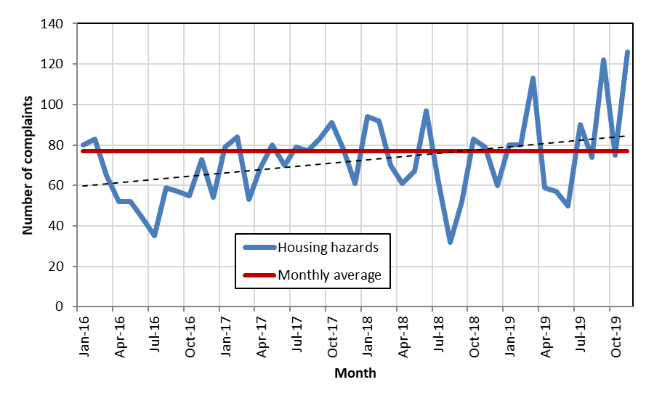
Comparison on housing hazard reports by hazard type 2015 and 2018:

Category | 2015 | 2018
Hazards - general | 183 | 432
HMO complaint | 66 | 224
General advice/information | 121 | 214
Public health nuisance | 0 | 52
Damp & mould | 148 | 37
Overcrowding | 5 | 23
Filthy and vermin infested | 9 | 5
Fire safety | 21 | 4
Overcrowding | 11 | 3
Water supply | 30 | 2
Domestic hygiene | 27 | 2
Electrical hazard | 23 | 1
Other | 66 | 11
 | 710 | 1010

Overcrowding in LBTH
Between 2009 and 2018, there has been nearly a 15 per cent reduction in the number of households classified as “overcrowded” on the Common Housing Register. Of the 7,078 overcrowded households, over two-thirds are Bangladeshi families and 79 per cent of overcrowded households require 2 or more additional bedrooms.

Temporary Accommodation in LBTH
In June 2020, 2572 people were placed in in temporary accommodation outside of LBTH.

Relevant Policies

National | Local
- Housing Act 2004  - Housing health and safety rating system (HHSRS)  - The Electrical Safety Standards in the Private Rented Sector (England) Regulations 2020 | - Tower Hamlets Housing Strategy 2016-2021  - Private Sector Housing Strategy 2016-21  - Tower Hamlets Local Plan 2031  - Tower Hamlets Private Renters’ Charter

Effective Interventions

- HHSRS Housing Inspections
Local Environmental Health Teams must monitor housing conditions in the area. This includes private rented properties, council and housing association homes and owner-occupied housing.
In practice, it's usually private rented properties that are inspected under HHSRS. Environmental health works out if there's a risk of harm due to hazards in the home.
They consider:
- the chance of harm
- how serious it would be
- any extra risk to children or older people

This reduces harm from hazards in the home such a damp and mould and a lack of repair (Department for Business Innovation and Skills, 2013)

- Selective Licensing Schemes
Part III of the Housing Act 2004 gives councils the power to implement a selective licensing scheme covering almost all private rented properties within a defined geographical area. Some schemes cover the whole borough whereas others cover smaller geographical areas. Most private rented properties that fall within the scheme boundary will need to be licensed by the council – not just HMOs. Failure to comply is a criminal offence that can result in prosecution and a hefty fine or a civil penalty of up to £30,000.

A Government commissioned study, supportive of Selective Licensing, noted that there is broad support for such schemes and that they are increasing in number. It states that of the 44 Selective Licensing schemes implemented at January 2019, 91 per cent were either ‘very effective’ or ‘fairly effective’ (MHCLG, 2019)

Licensing Schemes contribute to reduced anti-social behaviour which creates a safer place to live (London Property Licensing, 2019).

- Safe as Houses (Jersey)
Safe as Houses is an environmental health initiative for the States of Jersey, facilitated by a private sector agency which is working in close association with local regulators and other services. The programme is an initiative to raise the profile of poor housing conditions and their contribution to ill-health. If a health professional believes that a patient or client’s home is contributing to his or her ill-health, a system is now in place to prioritise a full inspection with enforcement action taken where this is appropriate. If occupants of privately rented housing apply for social housing and give poor housing conditions or overcrowding as the reason for application, the Environmental Health Team will carry out a full inspection and enforcement action will be taken, where appropriate, in some cases obviating the need for the social housing application.

The programme also facilitates hospital discharge and reduces readmissions. Where a GP or Hospital Doctor believes that any patient over 70 would benefit from a Home Safety Check, the patient is referred to Environmental Health and a full housing survey is carried out. As a result, onward referrals may be made to Occupational Therapists for adaptations and equipment, or to the Fire Service for the fitting of Smoke detectors.

Any disrepair issues in rented accommodation are also dealt with (Shelter, 2020).

Local Action

Housing Inspections as part of reactive role (based on HHSRS guidance)

Pest Control Activities

Licensing Schemes:
- Selective Licensing Scheme
This covers all privately rented property in areas which suffer or are likely to suffer from low housing demand and also to those that suffer from significant and persistent anti-social behaviour (ASB). The three designated areas are: Spitalfields and Banglatown, Weavers, and Whitechapel, situated on the eastern boundary of the borough. Selective Licensing came into force in October 2016. It covers three wards designated by pre-2014 ward boundaries mentioned above. It applies to all private rented properties with the exception of Mandatory HMOs. Some properties may be exempt from licensing, for example where the landlord is a university. Currently a licence costs £542 and is valid for five years.
- Additional Licensing Scheme (covering smaller HMOs)
Where a council can impose a licence on other HMOs in its area which are not subject to mandatory licensing, but where the council considers that poor management of the properties is causing problems either for the occupants or the general public.
- Mandatory HMO Licensing Scheme
This applies borough-wide and was the first licensing scheme to be introduced from 2006 following the Housing Act of 2004. An HMO is defined as private rented accommodation with five or more occupiers living in two or more households who share some amenities such as a kitchen or bathroom.

The following figure is a map of Tower Hamlets showing locations of licensed properties under the three licensing schemes and pre-2014 ward boundaries:
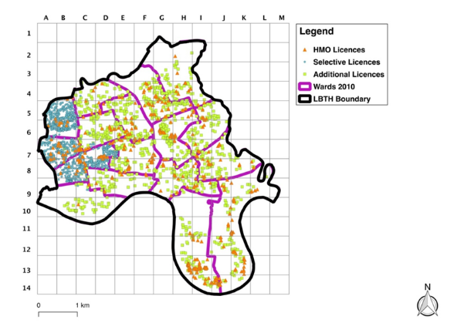

Selective Licensing Scheme:

- The take-up of licenses stands at over 5,000. This process also has further to go with the number of PRS in the three wards estimated to be at least 6,500 but possibly much higher.

- Home inspections have identified a range of problems which have or are being corrected and that the prospect of an inspection or losing a license has compelled landlords to make improvements, but this process still has further to go.

- Ward ranking based on Council reported ASB have slightly improved between 2015 and 2019 based on old ward boundaries. Spitalfields and Banglatown improved two places from 7 to 9 (rank 1=highest ASB); Weavers from 1 to 2; Whitechapel unchanged at 5. However, overall levels of ASB are up. The picture is more or less stable if we use new ward boundaries instead.

- Police reported ASB levels across the borough are, on the other hand, slightly down (although crime is up) but rankings in the three designated wards have slightly worsened from 3 to 2, 5 to 4 and 4 to 1 respectively. Noise complaints across the borough are significantly down and two of the Selectively Licensed wards have substantially improved their rankings.

- Taking all indicators into account, we find small differences in ward rankings in the pre-introduction and post implementation phases. Spitalfields and Banglatown was ranked 3 in 2015 and 2 in 2018 and so one position worse, Weavers was 4 in 2015 and 4 in 2018, and Whitechapel 2 in 2015 and 3 in 2018. But comparing rankings in both years using new ward boundaries rankings were unchanged.

Additional Licensing Scheme:
The Additional Licensing Scheme came into force in April 2020 and has not yet been formally reviewed. Since April 2020, 4000 properties were licensed.

Expected Benefits include but are not limited to:
- Responsible landlords would gain from improved clarity of their role in raising property and tenancy management standards while action is taken to tackle
those who flout their legal responsibilities.
- Tenants would be clear on what they can expect from both the homes that
they rent and the landlord that they rent it from.
- Both tenants and landlords will be clear on the minimum standards expected
within multi-occupied premises if the rental standards are adopted.
- It is expected that communities would benefit from a consistent approach
towards proactively assessing and improving housing conditions across the
private rented sector.
- A simpler enforcement regime covering all HMOs

Mandatory Licensing Scheme:
National Government has reviewed this scheme to change the definition regarding Mandatory Licensing to include more building types, such as removing the story/level of a building so flats and bungalows can be included as long there are two households with five or more individuals. This has expanded the pool of HMOs within the Mandatory Scheme. This came into effect October 2018.

There are currently 650 Licensed MHMOs in LBTH.

What more do we need to know?
How many adults and children live in unsafe housing in the borough? | Research
What are personal experiences of living in unsafe housing for residents in LBTH? | Research
What do social landlords do to ensure safe living conditions? | Research
What are the conditions like in TA and how is that monitored (especially if it is out of borough placements)? | Research

Recommendations

- More research is needed into the relationship between living conditions and health in LBTH.

- More research is needed into the conditions of social housing and Temporary Accommodation in LBTH.

- Renew the Selective Licensing Scheme.

Noise pollution

What is the health issue?

Exposure to prolonged or excessive noise has been shown to cause a range of health problems ranging from stress, poor concentration, productivity losses in the workplace, and communication difficulties and fatigue from lack of sleep, to more serious issues such as cardiovascular disease, cognitive impairment, tinnitus and hearing loss (European Commission, 2015).

WHO found that there is sufficient evidence from large-scale epidemiological studies linking the population’s exposure to environmental noise with adverse health effects. Therefore, environmental noise should be considered not only as a cause of nuisance but also a concern for public health and environmental health (WHO, 2011).

Noise complaints can usually be sourced to specific residential addresses and like housing hazards provide useful evidence of trends on one specific type of ASB, in this case general noise disturbance.

What is the situation in Tower Hamlets?

The figure below covering the period January 2015 to November 2019 shows a decline in complaints over the period with strong seasonal peaks in the summer months in Tower Hamlets.

Domestic and related noise complaints in 2015 and 2018:

Noise category | 2015 | 2018
Domestic | 3,400 | 2,595
Music | 278 | 356
Vehicles | 103 | 28
Animals | 9 | 0
Neighbours | 282 | 206
Other | 482 | 509
Total | 4,554 | 3,694

Anecdotal evidence from LBTH Environmental Health Team shows that many individuals raising noise complaints could benefit from referral to mental health services. Currently, Environmental Health Officers are not trained up to provide this.

Relevant Policies

National | Local
- Control of Pollution Act 1974  - Environmental Protection Act 1990  - The Noise Act 1996  - Anti-Social Behaviour Act 2003  - Clean Neighborhoods and Environment Act 2005  - Environmental Noise (England) Regulations 2016 | - LBTH Code of Construction

Effective Interventions

- Enforcement Activities
Local Environmental Health Teams are responsible for looking into complaints about noise that could be a ‘statutory nuisance’. EH are responsible for looking into complaints about noise from:
- premises including land like gardens and certain vessels (for example, loud music or barking dogs)
- vehicles, machinery or equipment in the street (for example, music from car stereos)

If they agree that a statutory nuisance is happening or will happen in the future, councils must serve an abatement notice. This requires whoever’s responsible to stop or restrict the noise. The notice will usually be served on the person responsible but can also be served on the owner or occupier of the premises (DEFRA, 2015; National Collaborating Centre for Healthy Public Policy, 2012).

This reduces harm from excessive noise.

- Traffic Calming Measures
Traffic calming consists of physical design and other measures put in place on existing roads to reduce vehicle speeds and improve safety for pedestrians and cyclists and reduce noise.

Local Actions

Tower Hamlets Health Impact Assessment (HIA) Guidance includes two specific criteria assessments regarding noise. A HIA can be used as a tool to assess noise levels both from an expert/modelling perspective and from the community perspective through consultation. In Tower Hamlets, new developments seeking planning permission and requiring HIA according to local plan policy D.SG3 need to consider the following questions connected to noise:

- Which land uses on the site are most impacted by different negative environmental factors, including poor air quality, overshadowing and high noise levels?
- Does the layout ensure the least sensitive uses face the poorest air quality sources or the high ambient noise level to then allow new homes, new schools and alike to be set to some degree sheltered from such hostile environmental site features?
- Does the construction phase have the potential to result in significant improvement in air quality, noise, traffic, contaminated land, changes to flood risk?

There are a number of strategies that Environmental Protection Team and the Housing Team have worked on to curb complaints from licensed residential properties:
- The Environmental Protection (Noise) Team have developed a Noise and ASB strategy with the Health and Housing Team. Where properties in Tower Hamlets have a license in place the teams work in partnership to share information on noise reports from licensed properties. After an initial warning letter and where no action is taken by the landlord after 14 days, a further letter is sent advising that the property License may be reviewed due to the reported breach of license conditions. Once there is compliance at that point the matter is monitored and closed but if there is no compliance, a strategy has been developed for steps such as panel interview, review, or revocation of the property license and or prosecution.

- A framework is also set up to deal with nuisance Air BnB properties with colleagues in the ASB team at Tower Hamlets.

- Environmental Protection work closely with the Licensing (premises) Team at Tower Hamlets and Officers respond to applications, license reviews and committee hearings.

- The Team review and comment on Planning Applications. The Team also process Control of Pollution Act 1974 section 61 applications for construction sites in the borough. The Construction Code of Practice is currently under review with colleagues in Planning, Pollution and Highways to create a document which is more reflective of current practices and with more emphasis on partnership working throughout the life of the development.

- Noise mapping – LIF (Local Infrastructure Fund) funding has been approved for the delivery of a Noise mapping database. The Noise mapping database will provide Tower Hamlets staff and residents with an interactive visual representation (via an acoustic map - image) of the local borough/defined localities and supports the Local Plan. It is hoped that the project will be live in September 2021. The map will initially cover construction and transport noise and provide a visual reference regarding noise in the Borough for residents and staff. It is hoped that we can develop the map further to incorporate other noise types such as licensed premises and community impact zones.

- An Out of Hours Noise Response Service is in place since April 2020. Out of Hours Officers provide a proportionate response to residents’ reports of noise and disturbance. Out of Hours Noise Response Officers witness reported issues and provide evidence in the event of prosecution. The Officers can be tasked to monitor noise from licensed premises, carry out pro-active noise nuisance visits and provide accurate information on the Night-time economy in Tower Hamlets.The Out of Hours Noise Response Officers have delegated authority under the Covid 19 Regulations. Alongside noise response duties Officers have been tasked to provide advice to and intelligence on; compliance from licensed premises regarding current covid 19 regulations. OOH officer(s) attend the LEF meeting with Licensing and Environmental Protection Teams every Tuesday to provide feedback on their visits. The Officers have also been tasked to provide intelligence on; compliance from licensed residential properties – whether properties visited are licensed or if the properties may require a license to be rented. This information is shared with our colleagues in the Health and Housing Team. The Noise Response Officers work independently and with the police (where required) to address reports from residential and commercial premises regarding parties and loud amplified music and illegal raves.

Complaints average over 500 per month but that the trend for this particular indicator has been downward over the period since January 2015.
Whilst the downward trend seems to have affected most wards it can be also seen from that Selectively Licensed wards have also fallen down the rankings relative to other wards. For example, Spitalfields and Banglatown was ranked 7th in 2015 out of 17 wards and 11th in 2018, falling 4 places; Weavers which was ranked 1st in 2015 has fallen to 4th place; Whitechapel, however, was unchanged.
This can be seen in the figures below which show the density of noise complaints overlaid with pre-2014 ward boundaries. It is easily noticeable that complaints have subsided considerably both in Weavers (cells B5 and B6) and Spitalfields and Banglatown (cell B7); other hotspots such as Bow East have moved up the rankings as have some wards to the south.

The density of residential noise complaints in 2015 overlaid with pre-2014 ward boundaries:

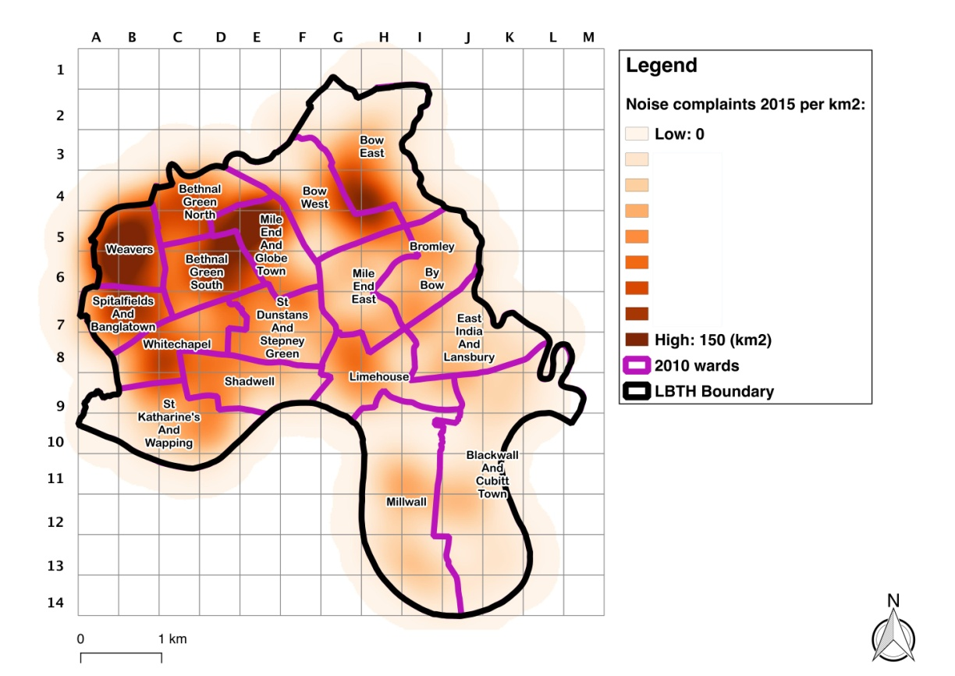

The density of residential noise complaints in 2018 overlaid with pre-2014 ward boundaries:

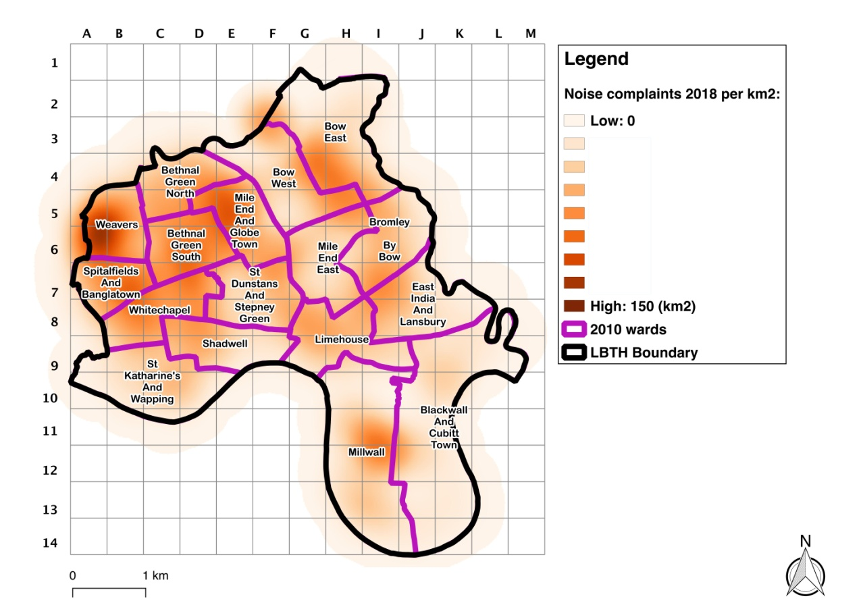

Recommendations

- Train up Environmental Health Officers to be able to signpost individuals complaining about noise to appropriate mental health services.

Underage alcohol consumption

What is the health issue?
Underage drinking remains fairly prevalent: according to the most recent data, 44 per cent of English 11–15-year-olds have tried alcohol in 2018. 6 per cent of all pupils said they usually drank alcohol at least once per week. A further 11 per cent of pupils said they usually drank between once a fortnight and once a month; meaning a total of 17 per cent who said they usually drank alcohol at least once a month.
The proportion usually drinking once a week increased with age, from 1 per cent of 11-year olds to 14 per cent of 15-year olds (NHS Digital, 2019). 1 per cent of 15-year-olds are regular drinkers in Tower Hamlets and 14.6 per cent of 15-year-olds in the borough have had an alcoholic drink before.

What is the situation in Tower Hamlets?

In 2018/2019 there were 77 reported underage alcohol sales in Tower Hamlets. This has decreased slightly in 2019/2020 to 68 reported underage alcohol sales.

Relevant Policies

National | Local
- Licensing Act 2003  - Alcohol and Young People  - Challenge 25 | - Tower Hamlets Partnership Substance Misuse Strategy 2020-2025

Effective Interventions

- Test Purchases
A test purchase is when Trading Standards employ an underage customer who will visit a bar or shop and try to purchase alcohol. These tests are conducted to check compliance with the law and with age verification policies (e.g. Challenge 25 schemes). When an underage sale occurs, it is a criminal offence which both the seller and business owner can be liable for - subject to any statutory defences. Any subsequent investigations will be carried out in accordance with the Police and Criminal Evidence Act and outcomes could include the issuing of advice and informal warnings, a Simple Caution, or ultimately prosecution in the Courts. For alcohol a fixed penalty notice can be issued, and a licence review may also be instigated. This is proteceting under 18s from alcohol protected harm (Department for Business Innovation and Skills, 2013).

- Community Alcohol Partnerships
Community Alcohol Partnerships bring together local retailers and licensees, trading standards, police, health services, education providers and other local stakeholders to tackle the problem of underage drinking and associated anti-social behaviour. Community Alcohol Partnerships are community interest companies with an independent Chair and an expert Advisory Board that includes retailers, members from the voluntary and charity sectors, the police and trading standards. This partnership approach recognises that retailers and licensees are part of the solution.
Focusing on engagement ensures that local businesses are supported in their efforts to be compliant. In addition, other specific local activities will involve a mix of education, enforcement, public perception, communication and diversionary activities. Improving the local environment for businesses and improved the health and wellbeing of young people (London Trading Standards, 2020).

- Responsible Retailer Scheme
See above.

Local Actions

Test Purchasing
Number of test purchases: under review (LBTH test purchase programme recommenced on 01/06/21 –resulting in 4 under sales of alcohol. We have also received a case from the police following an underage sale of alcohol in one of their operations in May 21. All of the above cases will now be reviewed for possible prosecution action).
Number of premises signed up to RRS: yet to be launched
Number of premises prosecuted: on hold

Responsible Retailer Scheme (see above)
What more do we need to know?
Why do young people choose to consume alcohol? | Research
Is there a correlation between underage alcohol consumption and wider determinants of health i.e. deprivation, ethnicity, socioeconomic status etc? | Research

Recommendations

- Launch the Responsible Retailer Scheme and evaluate and monitor progress regularly.
- More research is needed on the root causes of underage alcohol consumption in the borough.

Acid Attacks/Corrosive Substances

What is the health issue?

The use of acid and other corrosives as a weapon in violent attacks can inflict serious harm and life changing injuries. Acid attacks are a form of violence that transcends geographical boundaries. Often, it’s a crime that goes unreported and unpunished. In many cases, survivors of attacks live in fear of reprisals. The UK has one of the highest rates of acid attacks per capita in the world, according to Acid Survivors Trust International (ASTI). In 2016 there were over 601 acid attacks in the UK based on ASTI figures, and 67 per cent of the victims were male, but statistics from ASTI suggest that 80 per cent of victims worldwide are women. In the UK, unlike many countries, men make up the majority of victims (ASTI, 2020). A voluntary data return from 39 forces showed 408 cases of corrosive attacks between November 2016 and April 2017. It also showed that a fifth of offenders using corrosives were under 18 (where the age of the offender was known). The collection also showed that bleach, ammonia and acid were the most used substances in attacks. There is no one single motivation but a range of different motivations, including robbery, organised criminality, gang related, domestic abuse, hate crime and honour-based violence (House of Commons Library, 2017).

What is the situation in Tower Hamlets?
Tower Hamlets has the second highest rate of acid attacks of any London borough in the past three years.
Metropolitan Police data shows that between January 2015 and October 2017 there were 98 violent offences involving corrosive fluids in the borough. Of these, 23 were committed in 2015, 35 in 2016 and 40 in the first 10 months of 2017 (East London Advertiser, 2018).

Relevant Policies

National | Local
- Poisons Act 1972  - Deregulation Act 2015  - Serious Violence Strategy 2018  - Responsible sales of acid and corrosive substance: voluntary commitments 2018  - Offensive Weapons Act 2019 | - Tower Hamlets Community Safety Partnership Plan 2017 – 21

Effective Interventions

- Enforcement Activities
Local Trading Standards Team are responsible for enforcing legislation around the unlawful sale of corrosive substances.

Note: there is a split responsibility in this area with the police being responsible for enforcing the controls on the sale of certain corrosive substances under the Poisons Act 1972 (Explosive Precursors)(Amendment)Regulations 2018; whilst Trading Standards will be given responsibility for enforcing the new underage sales offence when this is comes into force. Reduced opportunity to get hold of corrosive substances

- Responsible Retailer Scheme
See above.

Local Actions

Responsible Retailer Scheme (see above)

The Tower Hamlets Voluntary Agreement on Corrosive Products (‘Acid Charter’) Encouraging businesses to ask for proof of ID when selling acids/corrosive substances. It is envisaged that in line with planned changes to the law to create an underage sales offence for certain corrosive substances The Tower Hamlets Voluntary Agreement on Corrosive Products will be incorporated into the local Responsible Retailer Agreement which will cover all age restricted goods sold at retail level.

Recommendations

See 17.

Psychoactive Substance Misuse

What is the health issue?

Psychoactive Substance Misuse is the use of a substance for a purpose not consistent with legal or medical guidelines, as in the non-medical use of prescription medications. Psychoactive substance use can lead to dependence syndrome - a cluster of behavioural, cognitive, and physiological phenomena that develop after repeated substance use and that typically include a strong desire to take the drug, difficulties in controlling its use, persisting in its use despite harmful consequences, a higher priority given to drug use than to other activities and obligations, increased tolerance, and sometimes a physical withdrawal state (WHO, 2020b).

The Scottish Drugs Forum carried out a survey of drug services in 2013 (SDF, 2013) which summarised some of the key reported harms during intoxication and comedown:

- Overdose and temporary psychotic states and unpredictable behaviours;
- Attendance at A&E and some hospital admissions;
- Sudden increase in body temperature, heart rate, coma and risk to internal organs (PMA);
- Hallucination and vomiting;
- Confusion leading to aggression and violence;
- Intense comedown that can cause users to feel suicidal.

Use was also associated with longer term health issues:
- Increase in mental health issues including psychosis, paranoia, anxiety, ‘psychiatric complications’;
- Depression;
- Physical and psychological dependency happening quite rapidly after a relatively short intense period of use (weeks)

What is the situation in Tower Hamlets?
In 2019 there were no reported underage sale of psychoactive substances in Tower Hamlets. In 2019/2020 4 underage sales of psychoactive substances in Tower Hamlets were reported. In the month of September 2020, 500+ incidences were reported where more than 5 or more laughing gas canisters were located by frontline staff in the borough.

Relevant Policies

National | Local
- Psychoactive Substances Act 2016 | - Tower Hamlets Partnership Substance Misuse Strategy 2020-2025

Effective Interventions

  - Enforcement Activities
Action Alexander (Scotland)

The action was in response to the growth in evidence showing the harm that unsafe NPS products can cause to people who consume them for their psychoactive effects. It was endorsed and funded by the Scottish Government and jointly co-ordinated by SCOTSS (the Society of Chief Officers for Trading Standards in Scotland) and Trading Standards Scotland. 53 premises were targeted over 19 local authorities, with 7,323 products seized or sampled worth £146,460.

Statistics released by the registered charity, Scottish Families Affected by Alcohol and Drugs (SFAD), now reveal that there has been a significant reduction in the number of callers to their helpline, citing NPS as the substance being used. Across Scotland, NPS is currently the 15th most mentioned substance that callers to the SFAD helpline are concerned about; this is a drop of 10 places from 2015-2016.

Following the actions taken by Trading Standards, only 1 call to the SFAD helpline was received in Q1 of 2016-2017. Given that the total prohibition on sales of NPS only took effect on 26th May 2016, when the Psychoactive Substances Act 2016 came into force, this indicates both the impact and effectiveness of co-ordinated action by the local authority regulators.

  - Responsible Retailer Scheme
See above.

Local Actions

Responsible Retailer Scheme (see above).

What more do we need to know?
How large is the extent of the problem in the borough? | Research

Recommendations:

- More research is needed to understand the extent of the problem in the borough and who is affected.
- Prioritise enforcing the outright ban on selling psychoactive substances for recreational use including test purchase action, seizures and prosecutions.

- Raise public awareness of the dangers of psychoactive substances.

For more information on any of the above topics please refer to the Background Section in Appendix A.

More details on relevant policies can be found in Appendix B and C.

Key Contacts and Stakeholder involvement

This JSNA was written by Lisa Harris, Public Health Programme Officer for Healthy Environments.

Comments have been received and addressed from:
- Matthew Quin, Public Health Programme Lead for Healthy Environments
- Natalie Lovell, Public Health Programme Manager for Healthy Environments
- Liam Crosby, Associate Director of Public Health
- Alice Bimpong, Food for Health Team Leader
- Rita Craddock, Environmental Protection Team Leader
- Sean Rovai, Trading Standards Team Leader
- Tom Lewis, Licensing and Safety Team Leader
- Julie Liu, Health and Housing Team Leader
- David Tolley, Head of Environmental Health and Trading Standards

Approved by Liam Crosby, Associate Director of Public Health (Healthy Environments)

References

Acid Survivors Trust International (ASTI) (2020) A worldwide problem. Available at: https://www.asti.org.uk/ (Accessed: 19/08/2020)

Action on Smoking and Health (ASH) (2017) Illicit Trade in Tobacco. Available at: https://ash.org.uk/wp-content/uploads/2019/10/Illicit-Trade-Tobacco.pdf (Accessed: 28/07/2020)

Action on Smoking and Health (ASH) (2020a) Second-hand Smoke. Available at: https://ash.org.uk/wp-content/uploads/2020/03/SecondhandSmoke.pdf (Accessed: 28/07/2020)

Action on Smoking and Health (ASH) (2020b) Evidence into practice: Smokeless tobacco products. Available at: https://ash.org.uk/wp-content/uploads/2020/03/smokelesstobaccoeip.pdf (Accessed: 12/08/2020)

Action on Health Scotland (ASH Scotland) (n.a.) Scotland’s Charter for a
tobacco-free generation. Available at: https://www.ashscotland.org.uk/media/6377/Charter per cent20Brochure.pdf (Accessed: 04/08/2020)

British Heart Foundation (2020) Shisha. Available at: https://www.bhf.org.uk/informationsupport/risk-factors/smoking/shisha (Accessed: 12/08/2020)

Bonnie, R.J. and O’Connell M.E. (2004) Reducing Underage Drinking. Available at: https://www.ncbi.nlm.nih.gov/books/NBK37591/ (Accessed: 10/08/2020)

Caraher, M., Lloyd, S. and Madelin, T. (2014) ‘The “School Foodshed”: schools and fast-food outlets in a London borougg’, British Food Journal, 116(3), pp. 472-493. doi: 10.1108/BFJ-02-2012-0042

Chartered Institute of Environmental Health (CIEH) (2020) What is Environmental Health? Available: at: https://www.cieh.org/what-is-environmental-health/# (Accessed: 08/06/2020)

Chartered Trading Standards Institute (CTSI) (2016a) Trading standards success in reducing the prevalence of new psychoactive substances (NPS). Available at: https://www.tradingstandards.uk/news-policy/news-room/2016/trading-standards-success-in-reducing-the-prevalence-of-new-psychoactive-substances-nps (Accessed: 24/06/2020)

Chartered Trading Standards Institute (CTSI) (2016b) Tobacco Control – Operation Henry. Available at: https://www.tradingstandards.uk/news-policy/tobacco-control/operation-henry (Accessed: 24/08/2020)

Chartered Trading Standards Institute (CTSI) (2017) The Impact of Trading standards. Available at: https://www.tradingstandards.uk/news-policy/news-room/2017/the-impact-of-trading-standards (Accessed: 01/06/2020)

Chartered Trading Standards Institute (CTSI) (2020) Tobacco Control. Available at: https://www.tradingstandards.uk/news-policy/tobacco-control (Accessed: 01/06/2020)

Darzi, A., Keown, O. and Chapman, S. (2015) ‘Is a smoking ban in UK parks and outdoor spaces a good idea?’, BMJ, 350(feb25 7), pp.958-958.

Department for Business Innovation and Skills (2013) Exploring the Links Between
Regulatory Activity and Health Outcomes. Available at: https://assets.publishing.service.gov.uk/government/uploads/system/uploads/attachment_data/file/262885/13-941-regulation-and-health.pdf (Accessed: 24/08/2020)

Department for Environment, Food & Rural Affairs (DEFRA) (2015) Noise nuisances: how councils deal with complaints. Available at: https://www.gov.uk/guidance/noise-nuisances-how-councils-deal-with-complaints (Accessed: 04/08/2020)

DrugWise (2020) New psychoactive substances. Available at: https://www.drugwise.org.uk/new-psychoactive-substances/ (Accessed: 24/08/2020)

East London Advertiser (2018) Tower Hamlets has second highest rate of acid attacks in London. Available at: https://www.eastlondonadvertiser.co.uk/news/crime/tower-hamlets-has-second-highest-rate-of-acid-attacks-in-3580600 (Accessed: 13/09/2021)

European Commission (2015) Noise Impacts on Health. Available at: https://ec.europa.eu/environment/integration/research/newsalert/pdf/47si.pdf (Accessed: 28/07/2020)

Food Standards Agency (FSA) (2018a) Food Safety Inspections and Enforcement. Available at: https://www.food.gov.uk/business-guidance/food-safety-inspections-and-enforcement#:~:text=and per cent20distribution per cent20process.-,Inspections,your per cent20premises (Accessed: 04/08/2020)

Food Standards Agency (FSA) (2018b) Food Hygiene Rating Scheme. Available at: https://www.food.gov.uk/safety-hygiene/food-hygiene-rating-scheme

Food Standards Agency (FSA) (2020) FSA research suggests new higher estimates for the role of food in UK illness. Available at: https://www.food.gov.uk/news-alerts/news/fsa-research-suggests-new-higher-estimates-for-the-role-of-food-in-uk-illness#:~:text=A per cent20scientific per cent20review per cent20by per cent20the,the per cent20UK per cent20has per cent20been per cent20published.&text=The per cent20overall per cent20estimate per cent20for per cent20this,each per cent20year per cent20in per cent20the per cent20UK. (Accessed: 22/07/2020)

Gizaw, Z. (2019) ‘Public health risks related to food safety issues in the food market: a systematic literature review’, Environ Health Prev Med, 24(01) doi: 10.1186/s12199-019-0825-5

Harvard Health Publishing (2019) Can vaping damage your lungs? Available at: https://www.health.harvard.edu/blog/can-vaping-damage-your-lungs-what-we-do-and-dont-know-2019090417734 (Accessed: 12/08/2020)

Health Knowledge (2020) Environmental determinants of disease. Available at: https://www.healthknowledge.org.uk/public-health-textbook/disease-causation-diagnostic/2f-environment/environmental-determinants-disease (Accessed: 24/08/2020)

Home Office (2018) Drug Misuse: Findings from the 2017/18 Crime Survey for England and Wales. Available at: https://assets.publishing.service.gov.uk/government/uploads/system/uploads/attachment_data/file/729249/drug-misuse-2018-hosb1418.pdf (Accessed: 24/08/2020)

House of Commons Library (2017) Acid Attacks. Available at: http://researchbriefings.files.parliament.uk/documents/CBP-8041/CBP-8041.pdf (Accessed: 20/08/2020)

House of Commons Library (2019) Obesity Statistics. Available at: https://commonslibrary.parliament.uk/research-briefings/sn03336/#:~:text=The per cent20Health per cent20Survey per cent20for per cent20England,is per cent20classified per cent20as per cent20'overweight'. (Accessed: 28/09/2020)

Illicit Tobacco Partnership (2019) Guidance to support Trading Standards in complying with article 5.3 of the Framework Convention on Tobacco Control. Available at: http://www.illicit-tobacco.co.uk/wp-content/uploads/2019/01/Guidance-for-Trading-Standards-.pdf (Accessed: 04/08/2020)

Illicit Tobacco Partnership (2020) Undermining efforts to cut smoking. Available at: http://www.illicit-tobacco.co.uk/problem/undermining-tobacco-control/ (Accessed: 28/07/2020)

Krieger, J and Higgins, D.L. (2002) ‘Housing and Health: Time Again for Public Health Action’, American Journal of Public Health, 92(5), pp.758-768.

London Property Licensing (2019) Understanding selective licensing. Available at: https://www.londonpropertylicensing.co.uk/selective-licensing#:~:text=Can per cent20any per cent20council per cent20introduce per cent20a,rented per cent20homes per cent20in per cent20that per cent20area. (Accessed: 10/08/2020)

London Trading Standards (2020) Test purchasing of Age Restricted Products. Available at: http://www.londontradingstandards.org.uk/underage-sales/test-purchasing/ (Accessed: 04/08/2020)

Medline Plus (2020) Risks of underage drinking. Available at: https://medlineplus.gov/ency/patientinstructions/000528.htm (Accessed: 10/08/2020)

MHCLG (2019) An Independent Review of the Use and Effectiveness of Selective Licensing. Available at: https://assets.publishing.service.gov.uk/government/uploads/system/uploads/attachment_data/file/833217/Selective_Licensing_Review_2019.pdf (Accessed: 09/12/2020)

National Audit Office (2019) Ensuring food safety standards. Available at: https://www.nao.org.uk/wp-content/uploads/2019/06/Ensuring-food-safety-and-standards.pdf (Accessed: 31/07/2020)

National Collaborating Centre for Healthy Public Policy (2012) Urban Traffic Calming and Environmental Noise: Effects and Implications for Practice. Available at: https://www.ncchpp.ca/docs/Bruit-Noise_TrafficCalming_En.pdf (Accessed: 20/08/2020)

NHS Digital (2019a) Smoking, Drinking and Drug Use among Young People in England 2018. Available at: https://digital.nhs.uk/data-and-information/publications/statistical/smoking-drinking-and-drug-use-among-young-people-in-england/2018/part-5-alcohol-drinking-prevalence-and-consumption (Accessed: 28/07/2020)

NHS Digital (2019b) Health Survey for England 2018. Available at: https://digital.nhs.uk/data-and-information/publications/statistical/health-survey-for-england/2018 (Accessed: 28/07/2020)

NHS (2020a) Obesity. Available at: https://www.nhs.uk/conditions/obesity/ (Accessed: 10/08/2020)

NHS (2020b) Paan, bidi and shisha. Available at: https://www.nhs.uk/live-well/quit-smoking/paan-bidi-and-shisha-risks/ (Accessed: 12/08/2020).

Office for National Statistics (ONS) (2020) Adult smoking habits in the UK: 2019. Available at: https://www.ons.gov.uk/peoplepopulationandcommunity/healthandsocialcare/healthandlifeexpectancies/bulletins/adultsmokinghabitsingreatbritain/2019 (Accessed: 28/07/2020)

Patterson R., Risby A., Chan, M. (2012) ‘Consumption of takeaway and fast food in a deprived inner London Borough: are they associated with childhood obesity?’,
BMJ Open, doi: 10.1136/bmjopen-2011-000402

Public Health England (PHE) (2014) Obesity and the environment: regulating the growth of fast food outlets. Available at:https://assets.publishing.service.gov.uk/government/uploads/system/uploads/attachment_data/file/296248/Obesity_and_environment_March2014.pdf (Accessed: 10/08/2020)

Public Health England (PHE) (2017a) Health matters: obesity and the food environment. Available at: https://www.gov.uk/government/publications/health-matters-obesity-and-the-food-environment/health-matters-obesity-and-the-food-environment--2#how-local-authorities-can-help-businesses-offer-healthier-food-and-drink (Accessed: 29/07/2020)

Public Health England (PHE) (2017b) Strategies for Encouraging Healthier ‘Out of Home’ Food Provision. Available at: https://assets.publishing.service.gov.uk/government/uploads/system/uploads/attachment_data/file/832910/Encouraging_healthier_out_of_home_food_provision_toolkit_for_local_councils.pdf (Accessed: 31/07/2020)

Public Health England (PHE) (2018) Fast food outlets: density by local authority in England. Available at: https://www.gov.uk/government/publications/fast-food-outlets-density-by-local-authority-in-england (Accessed: 28/07/2020)

Public Health England (PHE) (2020) PHE Infectious Diseases Strategy 2020-2025. Available here: https://assets.publishing.service.gov.uk/government/uploads/system/uploads/attachment_data/file/831439/PHE_Infectious_Diseases_Strategy_2020-2025.pdf (Accessed: 14/09/2021)

Public Health England Fingertips (2021) Obesity Profile. Available at: https://fingertips.phe.org.uk/profile/national-child-measurement-programme

Royal College of Physicians (2010) Passive Smoking and Children. Available at: https://cdn.shopify.com/s/files/1/0924/4392/files/passive-smoking-and-children.pdf?15599436013786148553= (Accessed: 28/07/2020)

Royal Society for Public Health (RSPH) (2019) Smokefree Communities. Available at: https://www.rsph.org.uk/our-work/policy/drugs/smokefree-communities.html (Accessed: 05/08/2020)

Scottish Drug Forum (SDF) (2013) NPS in Scotland – Health Impacts. Available at: http://www.sdf.org.uk/wp-content/uploads/2017/03/NPS_Health_Impacts_April_2013.pdf (Accessed: 24/08/2020)

Shelter (2013) People living in bad housing – numbers and health impacts. Available at: https://england.shelter.org.uk/__data/assets/pdf_file/0010/726166/People_living_in_bad_housing.pdf (Accessed: 28/07/2020)

Shelter (2020) Health and safety standards for rented homes (HHSRS). Available at: https://england.shelter.org.uk/housing_advice/repairs/health_and_safety_standards_for_rented_homes_hhsrs#:~:text=home per cent20is per cent20unsafe.-,The per cent20Housing per cent20Health per cent20and per cent20Safety per cent20Rating per cent20System per cent20(HHSRS),if per cent20serious per cent20problems per cent20are per cent20found. (Accessed: 04/08/2020)

Sisnowski, J., Street, J.M. and Merlin, T. (2017) ‘Improving food environments and tackling obesity: A realist systematic review of the policy success of regulatory interventions targeting population nutrition’, PloS One, 12(08), doi: 10.1371/journal.pone.0182581

Smokefree Action (2020) The Local Government Declaration on Tobacco Control. Available at: https://smokefreeaction.org.uk/declarationsindex-html/ (Accessed: 08/06/2020)

World Bank Group (2019) Confronting Illicit Tobacco Trade: A global review of country experiences – United Kingdom. Available at: http://pubdocs.worldbank.org/en/248361548435105081/WBG-Tobacco-IllicitTrade-UnitedKingdom.pdf (Accessed: 04/08/2020)

World Health Organisation (WHO) (2011) Burden of disease from
environmental noise. Available at: https://www.who.int/quantifying_ehimpacts/publications/e94888.pdf (Accessed: 28/07/2020)

World Health Organisation (WHO) (2017) Advancing the right to health: The vital role of law. Available at: https://www.who.int/healthsystems/topics/health-law/health_law-report/en/ (Accessed: 20/08/2020)

World Health Organisation (WHO) (2020a) Environmental factors influencing the spread of communicable diseases. Available at: https://www.who.int/environmental_health_emergencies/disease_outbreaks/communicable_diseases/en/ (Accessed: 19/08/2020)

World Health Organisation (WHO) (2020b) Substance abuse. Available at: https://www.who.int/topics/substance_abuse/en/ (Accessed: 19/08/2020)

Appendix A: Background Information

Food Safety
Food safety is important for the following reasons:
- Every day people get ill from the food they eat. Bacteria, viruses and parasites found in food can cause food poisoning.
- Often, there's no way of telling if food is contaminated because it might not look, taste or smell any different from normal.
- Food poisoning can lead to gastroenteritis and dehydration or potentially even more serious health problems such as kidney failure or on rare occasions death
- Food poisoning can be more serious in babies, children, older people and pregnant women because they have a weaker immune system.

Infectious Diseases and Infection Control
Recent estimates of the global burdens of disease from environmental factors shows that the greatest burdens relate to:
- Unsafe drinking water: Contaminated water can transmit diseases such as diarrhoea, cholera, dysentery, typhoid, and polio. Contaminated drinking water is estimated to cause 485 000 diarrhoeal deaths each year
- Poor sanitation & hygiene: Poor hygiene increases the risk for bacterial, viral, and parasitic infections. Serious medical conditions that can develop on behalf of poor hygiene include gastroenteritis, food poisoning, hepatitis A, influenza, common cold, giardiasis, roundworm, and threadworm.
- Pollution of the indoor and outdoor air: There is increasing evidence that high levels of air pollution make individuals more susceptible to infection.

Unhealthy Food Environment and Obesity
Obesity can lead to several serious and potentially life-threatening conditions such as:
- type 2 diabetes
- coronary heart disease
- some types of cancer, such as breast cancer and bowel cancer
- stroke.
- psychological problems, such as depression and low self-esteem (NHS, 2020a).

The following graph shows adult overweight and obesity prevalence by age and sex:

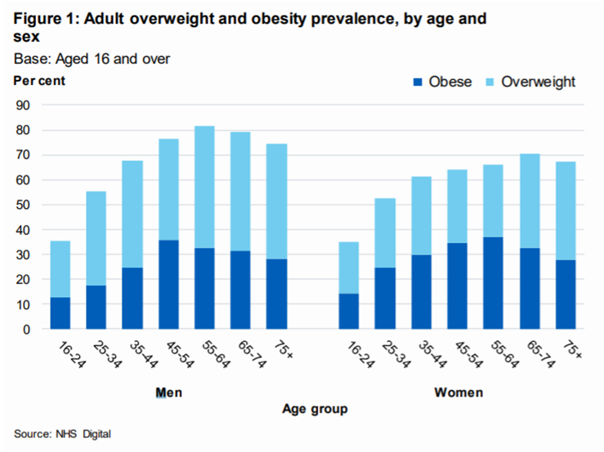
Tower Hamlets has some of the highest rates of childhood obesity in both London and England. More than 21 per cent of children of Reception age (4-5 years) and more than 42 per cent of children of Year Six age (10-11 years) are classified as overweight or obese, increasing into adulthood where 58 per cent of adults are classed as overweight or obese.

There are several factors that put individuals at higher risk of becoming obese such as deprivation, mental health problems and long-term conditions. For example, in the most deprived areas in England, prevalence of excess weight is 11 percentage points higher than the least deprived areas (House of Commons Library, 2019).

School children make purchases from a variety of food outlets in the school at lunchtime (if there is a no stay on site policy), and during their journeys to and from school. Popular purchases include confectionery, sugar sweetened drinks, and hot food takeaways. Many outlets have price promotions on these items particularly targeted at children and young people. Food outlets, particularly grocers, takeaways and convenience stores, increasingly cluster around schools. However, it is not only the food environment around schools that influences food purchases and consumption patterns, the whole journey environment needs to be considered. A number of studies, prevalence of and mapping exercises suggest that there is a greater number of hot food takeaways and obesity in deprived areas (PHE, 2017b)

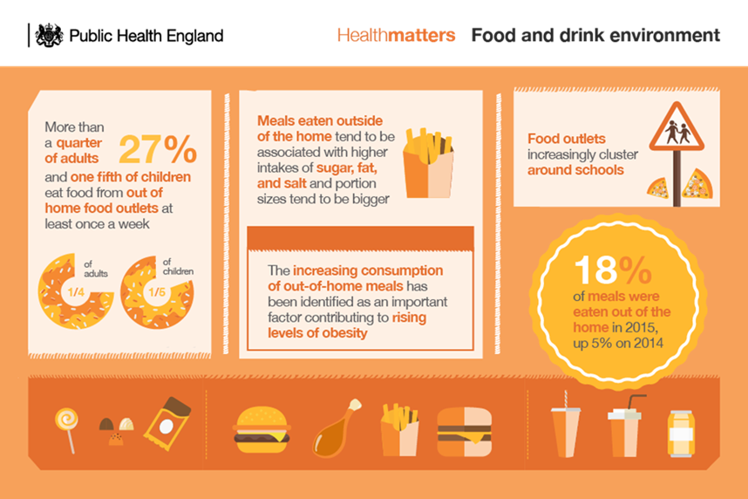

Smoking and secondhand smoking
Breathing in other people’s cigarette smoke is called passive, involuntary or
secondhand smoking (SHS).

The Royal College of Physicians (2010) has estimated that every year in the UK children’s exposure to secondhand smoke results in:
- over 20,000 cases of lower respiratory tract infection
- 120,000 cases of middle ear disease
- at least 22,000 new cases of wheeze and asthma
- 200 cases of bacterial meningitis
- 40 sudden infant deaths – one in five of all SIDs

People can be exposed to secondhand smoke in a range of different settings such as parks, playgrounds, transport hubs and high streets. Smokefree legislation covers some but not all outdoor settings.

Other ways of smoking and using tobacco are shisha smoking, vaping and smokeless tobacco such as chewing tobacco. These ways of smoking can also have a detrimental health effect on the consumer.

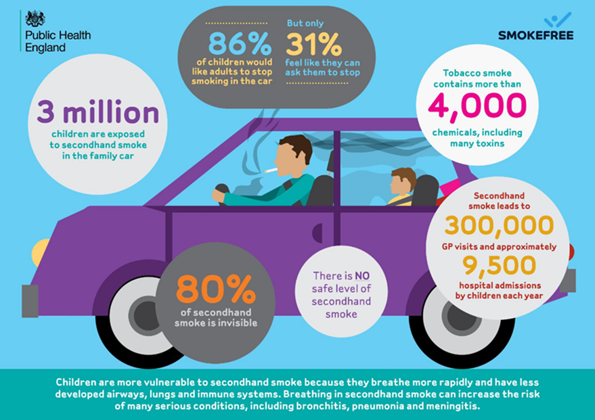
Secondhand smoke, also called “environmental tobacco smoke”, comprises “sidestream” smoke from the burning tip of the cigarette and “mainstream” smoke which is smoke that has been inhaled and then exhaled by the smoker.
Short-term effects of exposure to secondhand smoke (SHS) include eye irritation, headaches, coughs, sore throat, dizziness and nausea. Adults with asthma can experience a significant decline in lung function when exposed, while new cases of asthma may be induced in children whose parents smoke. Short term exposure to tobacco smoke also has a measurable effect on the heart in non-smokers. In the longer-term, passive smokers suffer an increased risk of a range of smoking-related diseases. Exposure to other people’s smoke increases the risk of lung cancer in non-smokers by 20-30 per cent and coronary heart disease by 25-35 per cent. There is existing evidence of secondhand smoke being associated with a myriad of conditions linked to regular smoking. Studies have found heightened risks of heart disease, lung cancer, breast cancer, other cancers, lung function, stroke, dementia and others such as diabetes and TB (ASH, 2020a).
According to the Health Survey for England (NHS Digital, 2019b) 28 per cent of men and 24 per cent of women reported at least some exposure to secondhand smoke. The following graph demonstrates self-reported levels of exposure to secondhand smoke by sex and age.
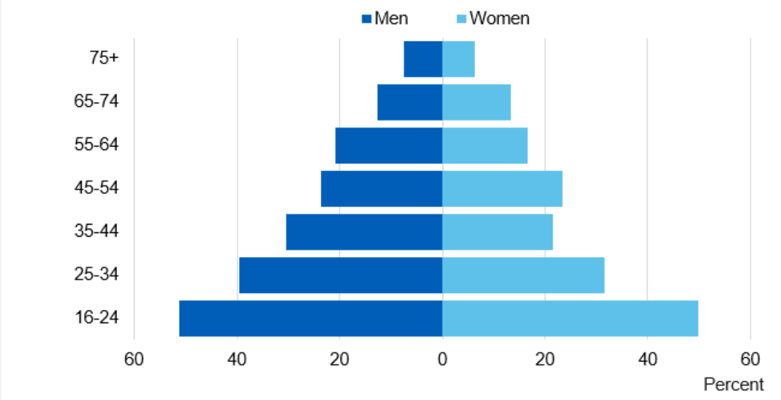

Exposure was highest among those aged 16-24 with half of this group reporting at least some exposure.

Exposure was most likely to occur in outdoor smoking areas of pubs, restaurants, cafes, followed by at work and home. The following graph shows where individuals have been exposed to secondhand smoke.
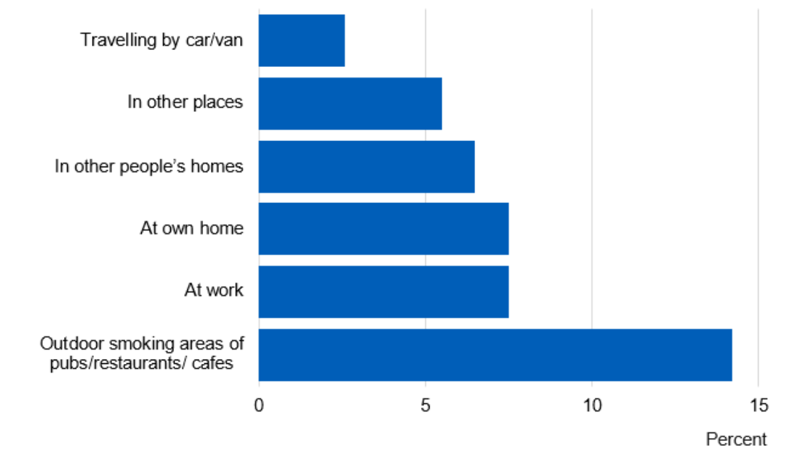
Shisha Smoking
Smoking shisha involves burning wood, coal or charcoal to heat up specially prepared tobacco (shisha). Flavoured tobacco (commonly called ‘maassel’) is often used. When the tobacco is heated up, it produces smoke. The smoke bubbles through a bowl of water or other liquid and into a long hose-like tube or pipe. Smoke is inhaled through a mouthpiece fitted to the end of the pipe. Shisha smoking is popular in Southeast Asian, Middle Eastern, and North African communities, especially among young people. It’s becoming increasingly popular in the UK. Even when tobacco-free shisha is used, there is still a risk from the carbon monoxide and any toxins in the coal or charcoal used to burn the shisha.

Smokeless Tobacco
This includes tobacco with or without characterising flavours and sweeteners (eg. Mishri and Qiwam), with alkaline modifiers (eg. Khaini, Naswar and Gul) to increase nicotine absorption and addictiveness and tobacco with areca nut and slaked lime (eg. Gutkha, Zarda, Mawa). Tobacco that you do not smoke (including paan, betel quid and chewing tobacco) is not a 'safe' way to use tobacco. It causes cancer and can be as addictive as smoking. Betel quid, paan or gutkha is a mixture of ingredients, including betel nut (also called areca nut), herbs, spices and often tobacco, wrapped in a betel leaf.

Illicit Tobacco
In relation to tobacco products, “illicit trade” can cover a wide range of activities. Key categories include (ASH, 2017):

- Smuggling
This covers the unlawful movement of tobacco products from one jurisdiction to another, without applicable tax being paid. Therefore, smuggling may involve the movement of otherwise lawfully manufactured tobacco products, as for example when cigarettes are “diverted” from their stated target market to another.

- Cheap/Illicit Whites
Cigarettes are lawfully produced in one country, with tax often paid in that country, but are intended for smuggling into countries with higher tax rates. “Cheap whites” commonly have brand names and pack designs, but the brands produced have no lawful market in the destination country.

- Counterfeiting
This covers the illegal manufacturing of an apparently lawful and well-known
product, with apparent “trademarks”, but without the owners’ consent. Tax is rarely, if ever, paid on such products.

- Bootlegging
This covers cases where tobacco products are legally bought in one country and then transported to another with a higher tax rate, in amounts beyond those reasonable for personal use.

- Illegal Manufacturing
This covers cases where tobacco products are manufactured without declaration to the relevant authorities. In some cases, they may be manufactured in approved factories, unrecorded and/or produced out of normal hours; in others they will be manufactured in unlawful covert operations

Underage Alcohol Consumption

Underage drinking, especially heavy drinking and frequent, heavy drinking is associated with numerous negative consequences. The consequences of alcohol use can be acute and immediate outcomes of a single episode of alcohol-impaired functioning, such as accidental death and injury, or they can be the accumulated and diverse effects of a chronic pattern of drinking, such as poor school performance and fractured relationships secondary to alcohol abuse and addiction (Bonnie and O’Connell, 2004). The effects of long-term alcohol use on the brain may be lifelong. Drinking also creates a higher risk for depression, anxiety, and low self-esteem.
Drinking during puberty can also change hormones in the body. This can disrupt growth and puberty (Medline Plus, 2020).

The following graph shows the percentage of underage drinkers by regularity of alcohol consumption.
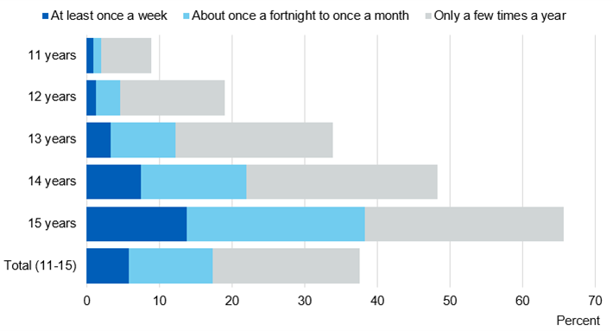

Of pupils who obtained alcohol in the last four weeks, they were most likely to have been given it by parents or guardians (71 per cent). Other common sources were to be given it by friends (49 per cent), or to take it from home with permission (48 per cent).
9 per cent of pupils said they had bought alcohol from a shop or pub in the last 4 weeks, with 15-year olds the most likely to have done so (NHS Digital, 2019). The following graph shows where underage individuals have obtained alcohol.

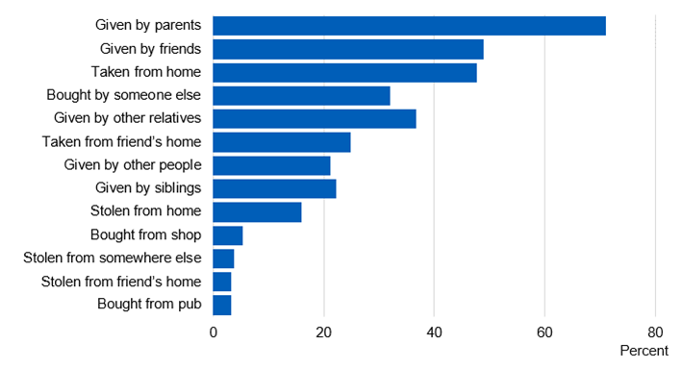

24 per cent of current drinkers said they usually bought alcohol from friends or relatives, the most common source. 19 per cent said they usually bought alcohol from any retailer or licenced premises, though this was higher for older pupils; 26 per cent of 15-year olds, compared to 12 per cent of 11 to 13-year olds (NHS Digital, 2019). The following graph shows where underage individuals have bought alcohol.
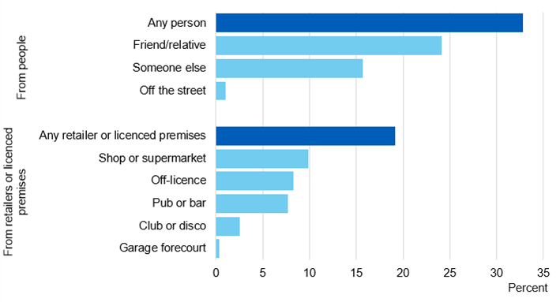
Psychoactive Substance Misuse
New psychoactive substances (NPS) are drugs which were designed to replicate the effects of illegal substances like cannabis, cocaine and ecstasy whilst remaining legal. NPS began to appear in the UK drug scene around 2008/09. They can fall into one of four categories (DrugWise, 2020):

- Synthetic cannabinoids – these drugs mimic cannabis and are traded under such names as Clockwork Orange, Black Mamba, Spice and Exodus Damnation. They bear no relation to the cannabis plant except that the chemicals which are blended into the base plant matter act on the brain in a similar way to cannabis.

- Stimulant-type drugs – these drugs mimic substances such as amphetamine, cocaine and ecstasy and include BZP, mephedrone, MPDV, NRG-1, Benzo Fury, MDAI, ethylphenidate.

- ‘Downer’/tranquiliser-type drugs – these drugs mimic tranquiliser or anti-anxiety drugs, in particular from the benzodiazepine family and include Etizolam, Pyrazolam and Flubromazepam.

- Hallucinogenic drugs – these drugs mimic substances like LSD and include 25i-NBOMe, Bromo-Dragonfly and the more ketamine-like methoxetamine.

According to 2018 statistics from the Home Office on drug use in England and Wales in 2018 (Home Office, 2018):
- Approximately 0.4 per cent of adults aged 16 to 59 had used NPS in the last year (equivalent to around 121,000 adults). While this was the same level as in the 2016/17 CSEW, it was lower than the 0.7 per cent found in the 2015/16
survey
- As in previous years, around half of all NPS users were aged 16 to 24. In the last year 1.2 per cent of adults aged 16 to 24 used NPS (equivalent to around 70,000 young adults)
- People who had visited a pub or nightclub, consumed alcohol, or used another drug, were more likely to have used NPS in the last year than those who had not. This was true for young adults aged 16 to 24 as well as the wider 16 to 59 age group.
- Herbal smoking mixtures were still the most commonly used NPS in the last year, although there was an increase in the use of liquids. A third (33 per cent) of last year users aged 16 to 59 had smoked a herbal mixture on the last occasion that they used NPS. One in four (25 per cent) ingested a liquid, which was twice as high as the previous year (12 per cent)
- NPS were still more likely than other illicit drugs to be obtained from shops and the internet. Around 30 per cent of last year NPS users aged 16 to 59 had obtained the last NPS they used from either a shop (15 per cent) or the internet (15 per cent), compared with 5 per cent for other illicit drugs (4 per cent from a shop, 1 per cent from the internet)

Appendix B: National Policy Context

Public Health Issue | National Policy Context
Unsafe/unhygienic food environment | Food Safety Act 1990  The Food Safety Act 1990 sets out environmental regulations for all businesses involved in selling food and buying with a view to sell, supplying food, consigning or delivering it, and in preparing, presenting, labelling, storing, transporting, importing or exporting food.  Food Standards Act 1999  This act established the Food Standards Agency. Its function is to provide the agency with functions and powers and to transfer certain functions in relation to food safety and standards.  The Act was introduced in the House of Commons in 1999.  It sets out the main goal to protect public health in relation to food. It gives the food standards agency the power to act in the consumer's interest at any stage in the food production and supply chain.  Food Safety and Hygiene (England) Regulations 2013  These regulations provide for a presumption that food is food intended for human consumption until the contrary is proved. They also provide for the issue of the following notices by authorised officers; hygiene improvement notices, hygiene prohibition orders, hygiene emergency prohibition notices and orders, remedial action notices and detention notices.  Consumer Rights Act 2015  The Consumer Rights Act came into force on 1 October 2015. This Act gives Trading Standards the power to enter premises, to inspect them and to secure or seize material that might be required in evidence. For routine inspection, trading standards must give 2 days written notice.
Infectious Diseases and Infection Control | Public Health (Control of Disease Act) 1984  This act allows the appropriate minister to make provisions to prevent or control the spread of infection. These provisions include requiring children to be kept away from school and prohibiting or restricting events or gatherings. The minister may also make regulations to detain vessels or aircraft or persons on board them. A magistrate has the power under the act to make a person submit to a medical examination, detain them in hospital, hold them in quarantine, and make them abstain from working or trading.  Health and Social Care Act 2008  This act made amendments to the Public Health (Control of Diseases) Act 1984 to expand the powers of the secretary of state for health, local authorities and magistrates to order compulsory health measures. These include medical examinations, detention and quarantine of individuals.  Coronavirus Act 2020  The three main aims of the Act are:  - to give further powers to the government to slow the spread of the virus  - to reduce the resourcing and administrative burden on public bodies  - to limit the impact of potential staffing shortages on the delivery of public service.  The Act increases the powers of the government to restrict or prohibit events and gatherings and to close educational establishments beyond those set out in the Public Health (Control of Disease) Act 1984. Police and immigration officials will have the power to detain an individual who may be infectious.
Unhealthy food environment & Obesity | National Child Measurement Programme 2006/2007  A mandated programme which measures the height and weight of children in reception class (age 4-5 years) and year 6 (age 10 – 11 years) annually, to track trends in child weight in primary schools.  Tackling obesities: future choices - Foresight Report  A DH funded project to investigate how we can respond to rising levels of obesity in the UK.  Change for Life programme 2009  A social marketing campaign to tackle obesity. Encourages families to adopt healthy behaviours such as 5 fruit and veg a day.  Public Health Responsibility Deal 2011  The Responsibility Deal has been established to tap into the potential for businesses and other organisations to improve public health through their influence on food, alcohol, physical activity behaviours and health in the workplace. The Deal was launched in March 2011.  Healthy Lives, Healthy People: A Call to Action on Obesity in England 2011  Outlines government’s ambitions for a downward trend in excess weight in both children and adults by 2020, including the new ‘calorie reduction challenge’  Obesity and the environment: regulating the growth of fast food outlets 2014  This guidance highlights the fact that planning authorities can influence the built environment to improve health and reduce the extent to which it promotes obesity. It lays out ways in which local authorities can work with takeaway restaurants to improve the local food environment.  Healthy and Safe Communities 2014  This guidance lays out how healthy and inclusive communities can be achieved through the built and natural environment, highlighting the importance of collaboration between planning and health. This includes influencing the food environment through considering the following in planning policies and proposals:  - proximity to locations where children and young people congregate such as schools, community centres and playgrounds  - evidence indicating high levels of obesity, deprivation, health inequalities and general poor health in specific locations  - over-concentration of certain uses within a specified area  Sugar reduction: the evidence for action 2015  PHE recommends sugar should not exceed 5 per cent of dietary energy. Proposed 8 action points to support this.  Childhood Obesity Plan 2016  The plan lays out how the government aims to tackle childhood obesity including a levy on the soft drinks industry and taking out 20 per cent of the sugar found in foods. Furthermore, the plan encourages businesses to make healthier options available and includes ways to increase children’s physical activity.  Soft Drinks Industry Levy 2016  To encourage producers of added sugar soft drinks to; reformulate their products to reduce the sugar content and reduce portion sizes for added sugar drinks.  Sugar reduction and wider reformulation programme 2017  Public Health England (PHE) is leading on a sugar reduction and wider reformulation programme. They will engage with all sectors of the food industry to reduce the amount of sugar in the foods that contribute most to children’s intakes by 20 per cent by 2020, with a 5 per cent reduction in the first year.  The initial focus will be on the top 9 food categories that contribute the most to children’s sugar intakes (yogurts, biscuits, cakes, morning goods (such as croissants, buns and waffles), puddings, ice-cream, breakfast cereals, confectionery, sweet spreads and sauces).  Tackling obesity: empowering adults and children to live healthier lives (Policy Paper 2020)  This paper lays out the government’s roadmap to tackle obesity in 2020 and beyond. It includes further bans on advertisement of high calorie foods, better nutrition labelling and a plan on legislating to end promotion of products high in fat, salt and sugar by volume (for example, buy one get one free) and location both online and in store.
Smoking and secondhand smoking  Illicit Tobacco | Tobacco Advertising and Promotion Act 2002  This act prohibits most advertising and sponsorship from February 2003 (e.g. on billboards and in printed publications) and a ban on tobacco sponsorship of international sport introduced from July 2005. All tobacco brand advertising and displays of tobacco products at the point of sale have been prohibited since April 2015.  The Health Act 2006  This law prohibits smoking virtually in all indoor workplaces with very limited exemptions for workplaces that are also places of residence. It makes provision for the prohibition of smoking in certain premises, places and vehicles and for amending the minimum age of persons to whom tobacco may be sold.  Smokefree England 2007  This law makes it illegal for anyone to smoke in an enclosed public place and within the workplace. This ensured that everyone could use the train station, eat in a restaurant or shop without suffering the negative effects of second-hand smoke.  The Health Act 2009  This act prohibits tobacco product display at retail shops, restrict product displays on websites, and prohibit tobacco vending machines.  The Tobacco Advertising and Promotion (Display of Prices) (England) Regulations 2010  These regulations prohibit the display and advertising of tobacco products in most retail shops  Children and Families Act 2014  This Act enables the Government to implement regulations to prohibit smoking in vehicles when children are present.  The Tobacco Product Directive 2014  In particular, the Directive:  - prohibits cigarettes and roll-your-own tobacco with characterising flavours  - requires tobacco industry to report to EU countries on the ingredients used in tobacco products  - requires health warnings on tobacco and related products: combined health warnings (picture, text and information on how to stop) must cover 65 per cent of the front and back of cigarette and roll-your-own tobacco packages  - sets minimum dimensions for warnings and prohibits small packages for certain tobacco products  - bans promotional and misleading elements on tobacco products, e-cigarettes and herbal products for smoking  - introduces EU-wide tracking and tracing to combat the illicit trade of tobacco products  - allows EU countries to prohibit internet sales of tobacco and related products  - sets out safety, quality and notification requirements for electronic cigarettes  - obliges manufacturers and importers to notify EU countries about novel tobacco products before placing them on the EU market  Tobacco Display Ban (2012 for larger stores, 2015 for smaller stores)  This ban made it illegal to display tobacco products in shops and businesses in England except to people over the age of 18 in limited circumstances  Tackling illicit tobacco: From leaf to light 2015  The aims of this strategy are to:  - Create a hostile global environment for tobacco fraud through intelligence sharing and policy change.  - Tackle the fraud at all points in the supply chain from production to retail.  - Change perceptions - Raising public awareness of the links between illicit tobacco and organised criminality to reduce tolerance of the fraud in the UK.  Optimise the use of the sanctions we have and, where we need to, develop tougher ones.  The Standardised Packaging of Tobacco Products Regulations 2015 & The Tobacco and Related Products Regulations 2016  These rules include, for example, minimum sized health warnings on all retail tobacco packaging, and herbal products for smoking. They also require standardised packaging, or plain packaging, for individual cigarette sticks, cigarette packs and hand rolling tobacco packs for retail.  Towards Smokefree Generation: A Tobacco Control Plan for England 2017  This plan lays out actions for central government to create a smokefree environments for this generation and the ones to come. Actions include:  1. Prevention first  To achieve a smokefree generation we will:  - Ensure the effective operation of legislation such as proxy purchasing, and standardised packaging designed to reduce the uptake of smoking by young people.  - Support pregnant smokers to quit. NICE has produced guidance on how pregnant smokers can be helped to quit. Public Health England and NHS England will work together on the implementation of this guidance.  2. Supporting smokers to quit  To achieve a smokefree generation we will:  - Provide access to training for all health professionals on how to help patients - especially patients in mental health services - to quit smoking.  - NHS Trusts will encourage smokers using, visiting and working in the NHS to quit, with the goal of creating a smokefree NHS by 2020 through the 5 Year Forward View mandate14.  3. Eliminating variations in smoking rates  To reduce the regional and socio-economic variations in smoking rates, we need to achieve system-wide change and target our actions at the right groups so we will:  - Promote links to "stop smoking" services across the health and care system and full implementation of all relevant NICE guidelines by 2022.  - Support local councils to help people to quit by working with Directors of Public Health to identify local solutions, particularly where prevalence remains high.  4. Effective enforcement  To reduce the demand for tobacco and continue to develop an environment that protects young people and others from the harms of smoking we will:  - Maintain high duty rates for tobacco products to make tobacco less affordable.  - Ensure that sanctions in current legislation are effective and fit for purpose, using lessons from HMRC’s work on sanctions to stop illicit tobacco.
Unsafe living conditions | Housing Act 2004  This act lays out new standards of housing conditions to ensure the health and safety of tenants introducing the HHSRS.  Housing health and safety rating system (HHSRS)  The housing health and safety rating system (HHSRS) is a risk-based evaluation tool to help local authorities identify and protect against potential risks and hazards to health and safety from any deficiencies identified in dwellings. It was introduced under the Housing Act 2004 and applies to residential properties in England and Wales.  This assessment method focuses on the hazards that are present in housing. Tackling these hazards will make housing healthier and safer to live in.  This guidance is aimed at non-specialists, in particular private landlords, to help them understand the requirements under the Housing Act 2004 in relation to the HHSRS and help them identify the type of work that is needed on their properties to conform with the HHSRS.  The Electrical Safety Standards in the Private Rented Sector (England) Regulations 2020  The regulations require landlords to have the electrical installations in their properties inspected and tested by a person who is qualified and competent, at least every 5 years. Landlords have to provide a copy of the electrical safety report to their tenants and to their local authority if requested.
Noise pollution | Control of Pollution Act 1974  The Act enables the use of noise abatement zones by local authorities. Exceeding the stipulated noise level will lead to action from the local authority. The Act controls noise on construction sites. Local authorities can issue a notice imposing requirements on the way in which construction works are carried out.  Environmental Protection Act 1990  This act defines certain noise as a statutory nuisance.  For the noise to count as a statutory nuisance it must do one of the following:  - unreasonably and substantially interfere with the use or enjoyment of a home or other premise  - injure health or be likely to injure health  The Noise Act 1996  The provisions of the Noise Act 1996 are intended to provide an alternative means of addressing disturbances caused by excessive noise. Previously, excessive noise could only be dealt with if it was thought to create a statutory nuisance. It is not always easy to establish such a case. Under the Noise Act 1996 an offence is committed if a person fails to ensure that any noise emitted from their premises does not exceed the permitted level.  Anti-Social Behaviour Act 2003  The Anti-social Behaviour Act 2003 also grants powers to local authorities in England and Wales to investigate night noises whether or not they have adopted the provisions of the Noise Act 1996. Causing excessive noise at night, or in residential premises, can be a form of anti-social behaviour.  Clean Neighborhoods and Environment Act 2005  The Clean Neighbourhoods and Environment Act 2005 contains a range of measures to improve the quality of the local environment by giving local authorities and the Environment Agency additional powers to deal with:  - fly-tipped waste  - litter  - nuisance alleys  - flyposting and graffiti  - abandoned and nuisance vehicles  - dogs  - noise  - nuisance from artificial lighting and insects  - other issues affecting the local environment.  Environmental Noise (England) Regulations 2016  The regulations require regular noise mapping and action planning for road, rail and aviation noise and noise in large urban areas (agglomerations).  They also require producing Noise Action Plans based on the maps for road and rail noise and noise in agglomerations.
Underage alcohol consumption | Licensing Act 2003  This Act makes provision about the regulation of the sale and supply of alcohol, the provision of entertainment and the provision of late-night refreshment, about offences relating to alcohol and for connected purposes.  Alcohol and Young People  You can be stopped, fined or arrested by police if you’re under 18 and drinking alcohol in public.  If you’re under 18, it’s against the law:  - for someone to sell you alcohol  - to buy or try to buy alcohol  - for an adult to buy or try to buy alcohol for you  - to drink alcohol in licensed premises (such as a pub or restaurant)  However, if you’re 16 or 17 and accompanied by an adult, you can drink (but not buy) beer, wine or cider with a meal.  Challenge 25  Challenge 25 is a policy whereby anyone buying alcohol who appears to be below the age of 25, seven years above the age required to buy alcohol in the UK, can be asked to provide an acceptable form of ID.
Acid Attacks/Corrosive Substances | Poisons Act 1972  This Act draws a distinction between “regulated” substances and “reportable substances”:  Regulated substances – which contain high concentrations of certain chemicals – are now restricted from sale to the general public. If a member of the general public wants to buy any of the regulated substances, they need to apply to the Home Office for a licence to acquire and, from 3 March 2016, to possess and use.  Reportable substances can be bought without a licence, but retailers are required to report suspicious transactions and significant losses and thefts.  The aim of the 1972 Act is to strengthen the control of chemicals that can be used to cause harm while still allowing those with a legitimate need for the chemicals to continue their activities.  Deregulation Act 2015  Changes made in this act scrapped an obligation on sellers of dangerous substances, including acids, to be registered with their local council. Reportable substances can be bought without a licence, but retailers are required to report suspicious transactions and significant losses and thefts.  Serious Violence Strategy 2018  It is now a criminal offence for members of the public to possess sulphuric acid above 15 per cent concentration without a licence, with offenders facing a 2-year prison sentence and an unlimited fine.  Responsible sales of acid and corrosive substance: voluntary commitments 2018  This document outlines the voluntary set of commitments on the responsible sales of corrosive substances. The intention is to restrict access to products containing acid and other corrosive substances which are being used as weapons to threaten or to attack people and inflict life-changing injuries.  The government is encouraging retailers to sign up to these commitments.  Offensive Weapons Act 2019  This Act introduces new legislative measures to control the sale of knives and corrosive substances and introduces new offences on their possession and use.  The Act creates a new criminal offence of selling a corrosive product to a person under the age of 18. It creates a new criminal offence of possessing a corrosive substance in a public place. There is a defence where the person can prove that they had good reason or lawful authority for having the corrosive substance with them.
Psychoactive Substance Misuse | Psychoactive Substances Act 2016  The Psychoactive Substances Act 2016 ('the Act'): defines 'psychoactive substance' and makes it an offence to produce, supply, offer to supply, possess with intent to supply, import or export psychoactive substances (the maximum penalty is seven years' imprisonment).

Appendix C: Local Policy Context

Public Health Issue | LBTH Policy Context
Unsafe/unhygienic food environment | Food Law Enforcement Service Plan 2019/2020  This is the Council’s mandatory annual plan for the effective enforcement of food safety legislation. This plan fulfils the Council’s obligations under the Framework Agreement on Local Authority Food Law Enforcement with the Food Standards Agency (FSA). The objective of this plan is to ensure that a programme of food enforcement activity is carried out, providing public confidence that food is produced without risk and sold under hygienic and safe conditions in Tower Hamlets. This plan is a public document and will be published on the Council’s website. The layout of the plan is dictated by the Framework Agreement between the Food Standards Agency and Local Authorities. The plan sets out the aims and objectives of the Environmental Health & Trading Standards (EHTS) Service’s Food Team and links team priorities to the Council’s core themes. The plan also gives an up to date profile of the Borough, a review of our activities in 2018/19 and our programme of work for 2019/20.
Infectious Diseases | Multi-agency Viral Pandemic Plan 2020  This plan provides the framework for coordinating London Borough of Tower Hamlets’ multi-agency response to a viral pandemic. The information within this plan is designed to both complement individual agencies’ own arrangements and support integrated preparedness and response and is aligned to the London Resilience Partnership Pandemic Influenza Framework version 7.0. The principles within this plan should be relevant to planning and responding to a variety of pandemic viral infections e.g. Coronavirus. However, any planning assumptions need to be carefully reviewed to ensure the routes of infection, incubation periods and responses reflect the nature of the specific pandemic.  Local Covid-19 Outbreak Control Plan 2020  This plan is owned by partners across Tower Hamlets and is accountable to the people of the borough through the Tower Hamlets Health and Wellbeing Board. It sets out what needs to be done to ensure that how Tower Hamlets is a place where coronavirus infection is kept as low as possible, those who are most at risk from impacts of COVID-19 are protected and people can get on with their lives free from disruption.
Unhealthy food environment & Obesity | Tower Hamlets Health and Wellbeing Strategy 2017-2020  LBTH is committed to reducing obesity by improving access to healthy food, parks and play areas and to support a range of programmes that promote healthy weight, good nutrition and physical activity.  Tower Hamlets Manifesto (2018)  Outlines plans to reduce childhood obesity, including reducing the amount of sugar in school meals by 50 per cent. There are a number of pledged initiatives to encourage children to live more active lifestyles for example increasing the number of play areas in the borough.  Tower Hamlets Local Plan 2031: Managing Growth and Sharing Benefits (Policy D.TC5)  This policy restricts the opening of fast food restaurants within 200m of a school/leisure centre.
Smoking and secondhand smoking & Tobacco Control | Tower Hamlets Tobacco Control Strategy 2013-2015  This strategy lays out how Tower Hamlets Council can control tobacco use in the borough. It covers all commonly used forms of tobacco in Tower Hamlets, in its smoked (cigarettes, pipe, shisha, cigars) and smokeless (paan/zarda, snus) forms.  Local Government Declaration on Tobacco Control (signed by LBTH January 2015)  The Local Government Declaration on Tobacco Control was developed by Newcastle City Council. It is a statement of a council’s commitment to ensure tobacco control is part of mainstream public health work and commits councils to taking comprehensive action to address the harm from smoking (Smokefree Action, 2020).
Unsafe living conditions | Tower Hamlets Housing Strategy 2016-2021  This strategy outlines Tower Hamlet’s commitment to safe and affordable housing.  Tower Hamlets Local Plan 2031  The local plan lays out housing standards and quality including a commitment to safe living conditions.  Tower Hamlets Private Renters’ Charter  This charter sets out standards the law demands from all private landlords and agents. The council and every organisation signed up to the charter aims to make sure that your landlord meets those standards.
Noise pollution | LBTH Code of Construction  The Code of Construction sets out standards and procedures for managing the environmental impacts of constructing major projects and small-scale construction alike within LBTH.
Underage alcohol consumption | Tower Hamlets Partnership Substance Misuse Strategy 2020-2025  This strategy outlines the importance of early intervention to reduce alcohol related harm including creating high quality safe places and reducing underage alcohol sales.
Acid Attacks/Corrosive Substances | Tower Hamlets Community Safety Partnership Plan 2017 – 21  The council has set up a Task and Finish Group to bring key partners together to develop an action plan to address other emerging weapon enabled crimes including the use of acid and corrosive substances in robberies in the borough.
Psychoactive Substance Misuse | Tower Hamlets Partnership Substance Misuse Strategy 2020-2025  This strategy outlines the importance of early intervention to reduce harm caused by psychoactive substances including creating high quality safe places and reducing underage/illegal sale of harmful products.

