Appendix 6

DRIVERS GUIDE

This Guide is designed to help you, as a driver, navigate your daily routines with ease and confidence. It summarises the key points you need to be aware of when driving on behalf of Tower Hamlets Council. Below, you will find essential information on the key aspects of a driver's routine, along with guidance on how to locate the necessary information to assist you. This guide serves as a go-to reference to ensure a safe, efficient, and compliant driving experience.

- Always ensure:

- You are aware of your responsibilities as a driver: Refer to Sections 3 and 6 of the Policy for extra guidance.

- You are Eligible to Drive: Ensure you are fit, legal and authorised. Always check with your manager if unsure.

- Start of Day Checks

- Vehicle Condition: Ensure your vehicle is in good condition. Familiarise yourself with the vehicle's controls and equipment. See Sections 31 - 35 of the Policy for a detailed checklist and always ask for help and advice if you feel it's needed. Below is a visual example of the checklist book required in every Tower Hamlets (TH) vehicle:

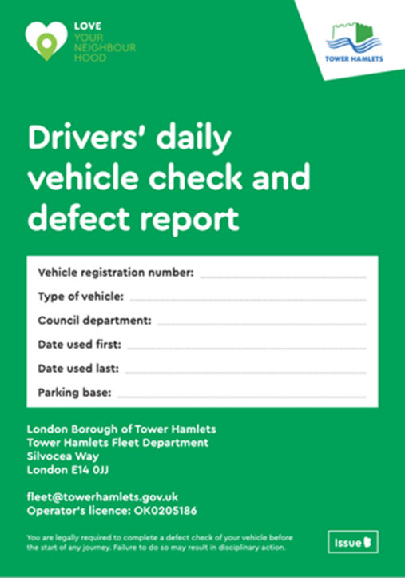

- Licence and Documents: Verify that your driving licence and any necessary documents are with you. Remember to be familiar with your breakdown and accident procedures and know who to contact in case of emergencies. Below are the visual examples of what you might need to have:

- Driving License. Refer to Section 10 for further guidance.
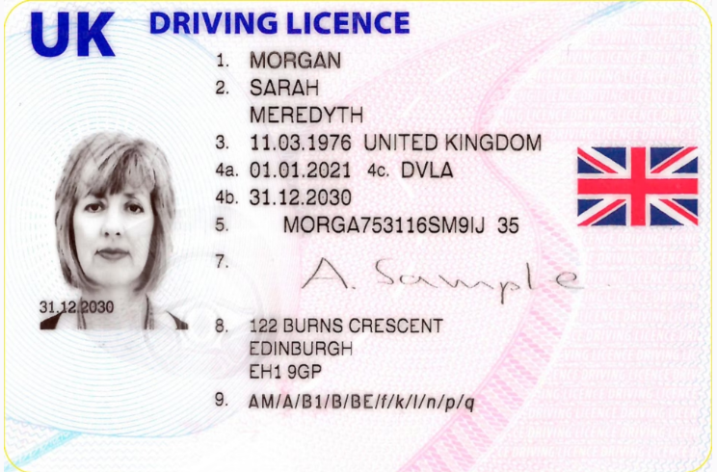

- Driver CPC Card (if you have one). See Section 11 of the Policy.
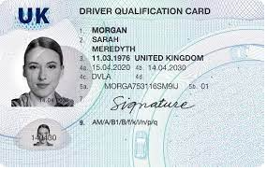

- Digital Tachograph Card (if you have one). Section 13. 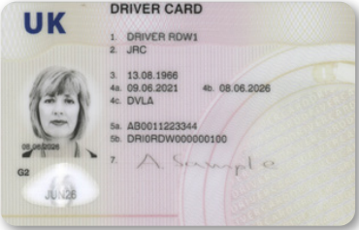

- Logbook (if required). Section 13.
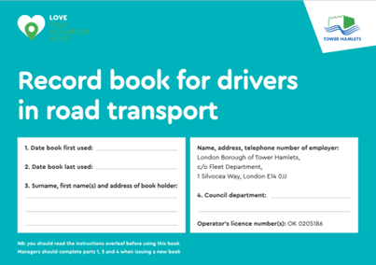

- Bump Card: To be used in case of accidents. Further guidance in Section 17 and Appendix 3 of the Policy.

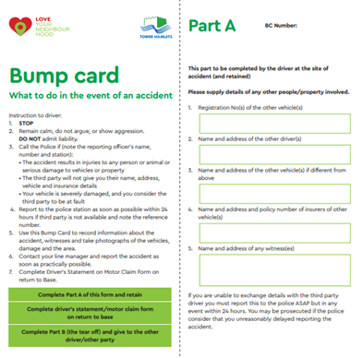

- During the Day

- Safe Driving Practices: Familiarise yourself with our driving policies in Sections 16, 19, 20 and 25 for a safer journey.

- Breaks and Rest: Adhere to the driver hours regulations described in Sections 12 and 14 to avoid fatigue.

- Speed Limits: Be vigilant as many roads in the borough have a 20mph speed limit.
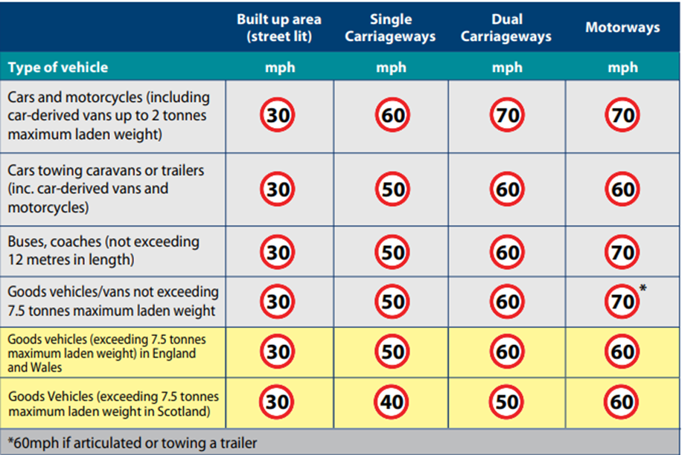

- Handling Emergencies: For vehicle breakdowns or accidents, consult Sections 33 and 17 respectively for immediate steps.

- Vehicle Security: Familiarise yourself with guidelines in Sections 26, 28, and 29 for vehicle security.

- End of Day Procedures

- Report Defects: Any vehicle issues should be reported following the instructions in Section 32.

- Refuel / AFV recharging: If required, refuel your vehicle or put it on charge if it is an AFV (Alternative Fuel Vehicle). See your manager for specific instructions and refer to Section 39 for further guidance.

- Report Back: Ensure you return the keys and all necessary documentation as per the procedure in your department. Download your digital tachograph data at the required intervals if you are using it, or hand your logbook to your line manager for verification. An example of the downloading machine is below; refer to Sections 13 and 15 for further guidance.
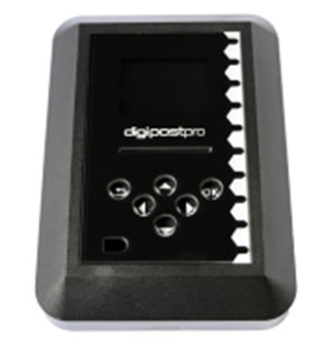

- Special Considerations

- Environmental Care: Keep environmental considerations in mind, detailed in Section 8.

- Health & Safety: Always prioritise safety, including adhering to rules around mobile phone use (Section 20) and the prohibition on alcohol and drugs (Section 21).

- Spot Checks: Be aware that you may be subject to routine vehicle inspections by either management or enforcing authorities. Please familiarise yourself with Section 38 of the Policy. Always cooperate, and by following the recommendations of the policy and this guide, you can ensure these checks are issue-free. Regardless of the outcome, ensure you notify your line manager and the Fleet Department following any roadside check by enforcing authorities.

- Additional Resources

- Parking and Penalties: For guidance on parking and managing penalties, see Sections 26 and 27.

- Vehicle Cleanliness: Keep your vehicle, including cabs, clean and free from litter, referring to Section 36 for expectations.

This guide is part of the Fleet Safety Policy & Procedures. It simplifies but does not replace the detailed information found in the main policy text. If you have any questions or need further clarification, please do not hesitate to contact the Fleet Department.

Fleet Department can be contacted at fleet@towerhamlets.gov.uk – for all compliance, policy and motor insurance-related matters, or at workshop@towerhamlets.gov.uk – for all technical and vehicle maintenance-related matters. The Tower Hamlets Workshop can also be contacted on 0207 364 1069 during normal office hours.

Stay safe and thank you for your commitment to driving safely and responsibly as part of the London Borough of Tower Hamlets team.

