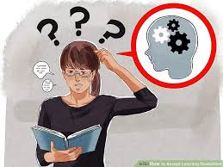
Mr D had a learning disability.

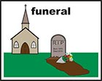

Mr D died in 2015 after being taken to hospital.

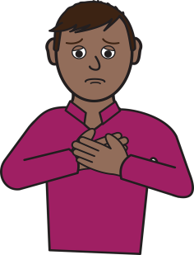

Everyone involved in Mr D’s care would like to express their sympathy and condolences to Mr D’s loved ones.

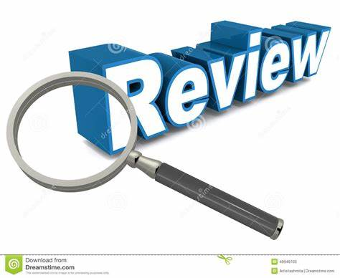

The Safeguarding Adults Board did a review to find out if we could have done anything differently to help Mr D.

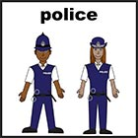

The Board is made up of the council, NHS, the Police and other local organisations.
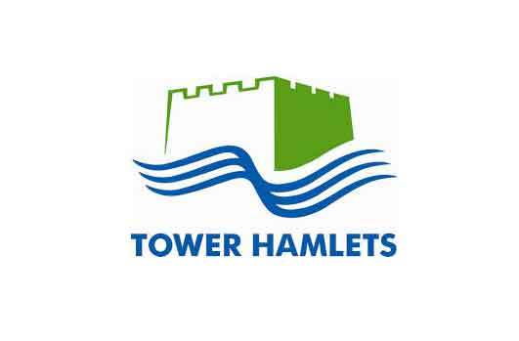

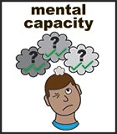

We found that staff did not always understand mental capacity properly.

We found staff did not speak to each other about Mr D as well as they might have done.

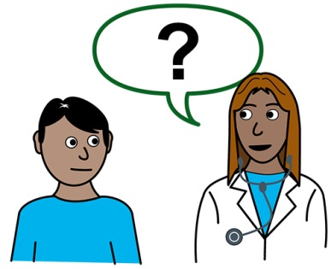

We also found staff focused too much on Mr D’s learning disabilities instead of his physical health problems.

We asked everyone to make some changes.

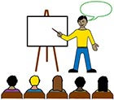

We asked everyone to train staff around learning disabilities and mental capacity.

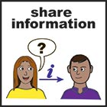

We asked everyone to speak and share information better.

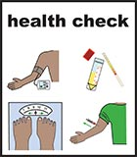
We are trying to get everyone with a learning disability to have a check-up each year with their GP. This is getting better: 34% had one at the start of 2017 but 74% had one at the end.

