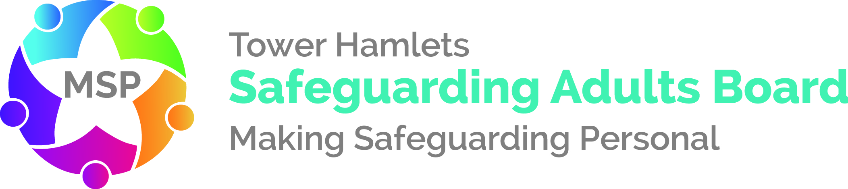

Safeguarding Adults Review

Executive Summary

Tower Hamlets Safeguarding Adults Board

Title: Miss E
Author: Tim Bishop
Date of publication: 28 September 2020

Executive summary

1.1 This Safeguarding Adults Review has considered the care and support Miss E received from the London Borough of Tower Hamlet’s (LBTH) adult social care service and The East London NHS Foundation Trust (ELFT), as well as local partners, commissioned both directly and indirectly including the housing and care provider.

1.2 The review primarily focused on the care and support Miss E received for the two years prior to her death (February 2015 to February 2017) but does also include relevant information from before that time, to assist in giving a wider context to the events.

1.3 Miss E was a 73-year old woman who was described by her niece as an intelligent woman, who loved animals and the garden. Her family say that she had worked for the Metropolitan Police Service in London.

1.4 Miss E had a long-standing history of mental ill health and latterly was diagnosed with a Bipolar Affective Disorder. Reportedly, Miss E had her first admission to a general hospital ward due to an overdose in 1986 and is also reported to have become unwell after the death of her mother in 1993. She had received support from ELFT’s Stepney and Wapping Community Mental Health Team until 2010 when Miss E’s support was transferred to ELFT’s Tower Hamlets Community Mental Team for Older People (ELFT). This team was a multi-disciplinary team and was staffed by Mental Health Nurses, Social Workers, Occupational Therapists, Psychiatrists, Support Workers and Psychologists.

1.5 Miss E was under the care of ELFT from 2011 until her death in February 2017. The LBTH had delegated the discharge of its statutory adult social care functions to the ELFT.

1.6 Miss E was in a residential care home (RCH) placement arranged by LBTH from July 2014 until February 2017.

1.7 Miss E’s health and social care was care co-ordinated from 2011 to January 2016 by three successive staff members in ELFT under the Care Programme Approach (CPA). Two of these were nursing members of the team until July 2014 when Miss E was allocated to a social worker. It was at about this time that Miss E agreed to move from sheltered accommodation to a 24-hour residential care home.

1.8 The residential placement was arranged by the ELFT social worker and the placement at the RCH was commissioned by the LBTHs Adults’ Brokerage team on behalf of LBTH.

1.9 Throughout this period the ELFT team managed Miss E’s treatment and support under the CPA or via the out-patients clinic. They were also responsible for undertaking risk assessments and for providing a care plan that was reviewed regularly across both health and social care.

1.10 LBTH’s duties under the National Health Service and Community Care Act 1990 were integrated into the CPA documentation but this did not include reference to the financial (FACS) eligibility thresholds.

1.11 With the introduction of the Care Act in 2015, LBTH established an explicit framework for recording Care Act Assessments/Reviews and Support Planning and all ELFT and LBTH staff undertaking LBTH functions under the Care Act were trained in this.

1.12 There was no formal section 75 agreement in place between the LBTH and the ELFT at this time. However, there was an expectation on the part of LBTH that staff working in ELFT services would meet all Care Act requirements in terms of Assessment, Review and Support planning using the LBTH’s Care Act documentation alongside the CPA work. Care Coordinators, whether ELFT or LBTH employees, were effectively undertaking duties in regard to both Social Care on behalf of LBTH, and NHS duties on behalf of ELFT.

1.13 There was no evidence of a formal assessment of Miss E’s capacity; but there was reference to Miss E having capacity within the ELFT records.

1.14 Care co-ordination was discontinued via a decision made by Miss E’s Care Co-ordinator and her manager (Team manager) in supervision in January 2016 and not via a Care Programme Approach meeting with Miss E and the Multi-Disciplinary Team.

1.15 There was no evidence that LBTH’s responsibilities in regard to a minimum annual review under the Care Act were considered and Miss E was not herself involved in the decision to discharge herself from the CPA.

1.16 There was no evidence that Miss E receive holistic assessments, focusing on her strengths and looking at the outcomes she desired.

1.17 The residential care home was not supported by mental health professionals to work effectively with Miss E and find strategies to ease the symptoms of her mental ill health and unhappiness.

1.18 The placement at the residential care home was not reviewed to establish whether it was meeting Miss E’s needs.

1.19 Miss E died on 4th February 2017, taking her own life.

1.20 After Miss E’s death the residential care home closed, and they destroyed all their care records.

1.21 The report makes recommendations for health and social partners on:

- the governance arrangements between the LBTH and ELFT;
- monitoring the quality of work undertaken under The Care Act;
- ensuring people receive an appropriate holistic strengths-based assessment to support their needs;
- reviewing the CPA process and its alignment with The Care Act;
- ensuring the CPA is properly implemented and audited at regular intervals;
- ensuring that health and social care legal duties and responsibilities and perspectives are fully understood with ELFT;
- ensuring that providers have access to specialist mental health support for their residents; and
- the retention of records.

1.22 The finalised report was shared and discussed with the family by the author in September 2020 prior to publication. Miss E’s niece and great nephew were keen to ensure that there had been learning particularly in the areas of: training for care home staff; communication between agencies; and care plans being up-to-date and shared.

During the whole of her life Miss E referred to herself as ‘Miss’ and was known to ask others to do so – we have respected this wish within this report.
Section 75 of the National Health Service Act 2006 is used between local authorities and NHS bodies to make joint agreements that can include arrangements for pooling resources and delegating certain NHS and local authority health-related functions to the other partner/s

