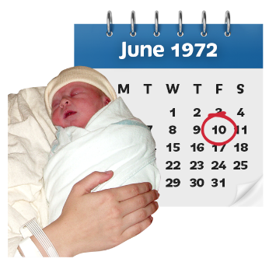
Mr B had complex disabilities since birth.

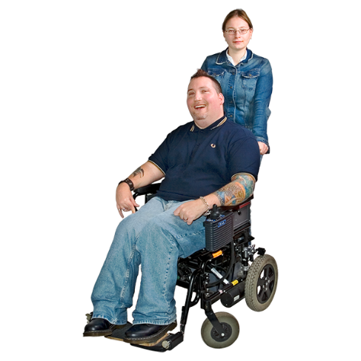

Mr B also had a learning disability and received care and support. His family provided excellent care for him at home.

It was unsafe for Mr B to take enough food and drink by mouth to keep him healthy.

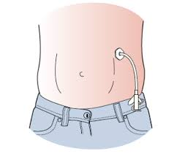

Mr B had a feeding tube in his stomach. Liquid food and drink went through this tube.

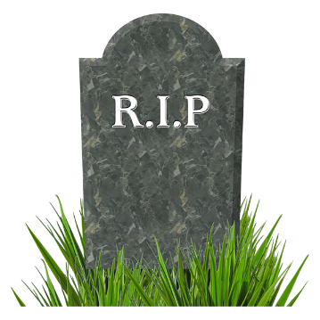

Mr B died in 2016 in hospital.

Everyone involved in Mr B’s care expressed their sympathy to Mr B’s loved ones.

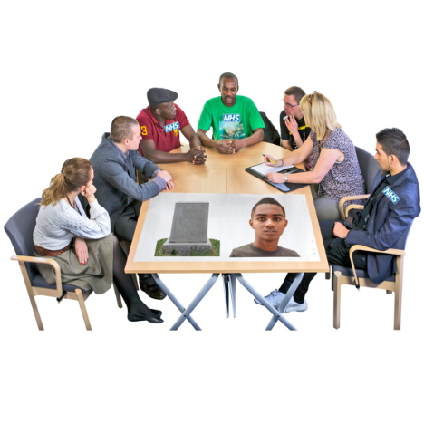
The Safeguarding Adults Board did a review to find out if we could have done anything differently to help Mr B.

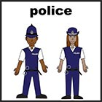
The Board is made up of the council, NHS, the Police and other local organisations.

We found that staff from different services didn’t work together to help Mr B as much as they could have.

We found that Mr B didn’t always get the best care from the home care provider.

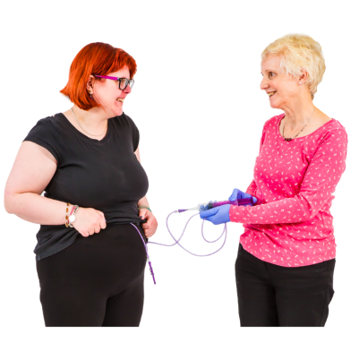

We found that there wasn’t any guidance explaining the best way to feed people with a tube.

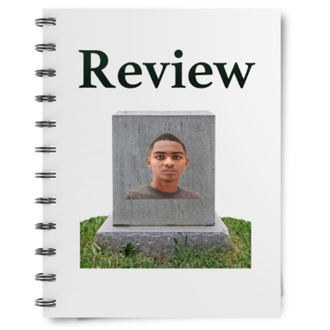

We asked everyone to make some changes.

We asked everyone to work together better when providing care.

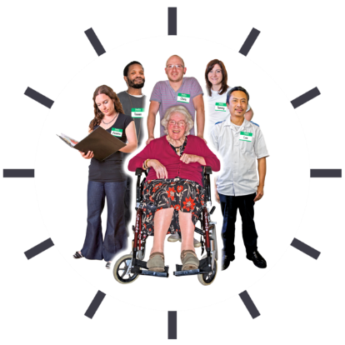

We asked carers to get more support.

We asked health professionals to give training and guidance, explaining the best way to feed people with a tube.

.

