Tower Hamlets Safeguarding Adults Partnership Board Safeguarding Adult Reviews (SAR)
A Guide for Staff

This leaflet tells you what happens when a SAR is required to be undertaken, and what you should expect.

What is a Safeguarding Adult Review?
One of the key functions of the Local Safeguarding Adult Board is to conduct a Safeguarding Adult Review (SAR) in specific circumstances, as required in Chapter 14 of Statutory Guidance: Care and Support Statutory Guidance 2016. The circumstances are: -
- When an adult in the area dies as a result of abuse or neglect, whether known or suspected, and there is concern that partner agencies could have worked more effectively to protect the adult.
- Where the same circumstances apply if an adult is still alive but has experienced serious neglect or abuse.

The purpose of the Review is to:
- Establish whether there are lessons to be learned, including good practice, from the case about the way in which local professionals and organizations safeguard and promote the welfare of adults with care and support needs
- Identify clearly what those lessons are, how and when they will be acted on, and what is expected to change as a result
- to disseminate and embed good practice and any required improvements
- to promote a continuous learning and improvement culture which improves outcomes for adults with care and support needs and their families

What it is not
- A SAR is not a criminal investigation to determine who is responsible – that is for the police to determine if necessary
- It is not seeking to establish how a person died - that is for the Coroner to investigate
- It is not a disciplinary investigation - that is for each individual agency to deal with if necessary

What happens in the Review?
In Tower Hamlets a SAR Panel with an Independent Chairperson oversees the Review. The Panel includes senior staff representing key agencies. They may co-opt additional experts if circumstances require.
Agencies will need to secure all case files relating to the adult, but copies will be made as necessary in order for staff to carry out their work.

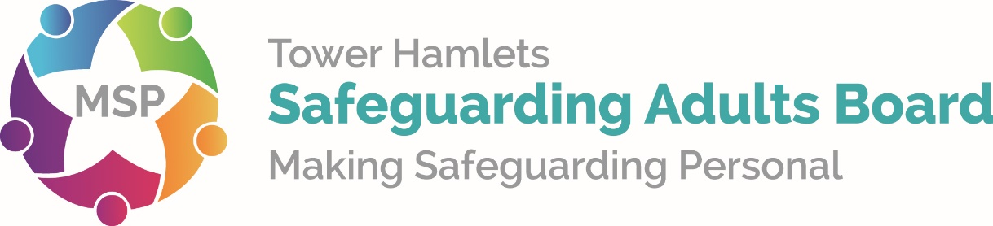

The Panel will draw up the terms of reference to determine the scope of the Review, which will include the main issues to look at, the time period under review, who should be involved and when the review will be completed.
There are a number of ways in which information may be collected from agencies and professionals depending on the methodology being used for the Review. Usually each identified agency will produce a chronology of interaction with the subject of the SAR and either a short report or an Individual Management Review (IMR) which involves reviewing their own agency’s involvement with the case, looking openly at individual and organizational practice to see if there are lessons to be learnt.
They will read the files and may speak with key staff and managers who were involved in the case. The IMR author will also ensure that that their report reflects the perspectives of front line staff by consulting them about the author’s findings.
The SAB will commission an independent Lead Reviewer to review all of the evidence and produce the Overview Report. The Lead Reviewer may also consult front line staff and their managers to inform the final report. This is achieved through multi agency feedback or consultation events.

Will I be interviewed during the Review?
If you had contact with the adult who is relevant to the review, you may be asked to attend an interview with the IMR author for your agency and / or to attend a multi-agency learning event.
Staff may have a range of emotions around what happened to the adult, so you can have someone with you for support during the interview (who must
not be your manager or anyone involved in the case – and they must be able to respect confidentiality in relation to the case). You will receive a written record of the interview, so that you can check the accuracy of your responses.

Will I be at risk of disciplinary action?
This is not a disciplinary process. Your agency may, in some cases, need to make investigations under disciplinary procedures, but these are separate to the SAR process.

What happens at the end of the Review?
A multi-agency action plan will be produced based on recommendations from the IMRs and the Overview Report. The implementation of actions will be monitored by the SAR Sub Group to ensure that the learning from the review makes a positive difference to adults with care and support needs in Tower Hamlets.
The SAB will ensure that those involved in the Review are debriefed and relevant findings are also disseminated across all agencies e.g. through training or briefing events.
The final report and Executive Summary will be published on the Tower Hamlets website and progress against actions and improvements will be in the Annual Report for the following year.

