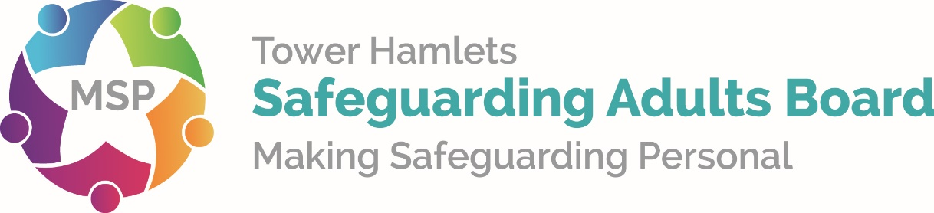

Safeguarding Adult Reviews: Information for families, friends and carers

Introduction
The Tower Hamlets Safeguarding Adults Board, a multi-agency partnership set up by the Care Act 2014, has produced this leaflet to assist families and friends to understand what the purpose is of a Safeguarding Adults Review.
When an adult at risk who needs care and support either dies or suffers serious harm, and when abuse or neglect is thought to have been a factor, Tower Hamlets Safeguarding Adults Board may need to review what has happened. This is called a Safeguarding Adults Review or SAR for short. Cases where suicide has taken place may also be considered for a SAR.
These reviews are to see whether any lessons can be learned about the way organisations worked together to support and protect the person who suffered harm. The reviews want to learn as much as possible about how to do things better in the future. A key aim is to prevent such situations from occurring again.
We would welcome your involvement in the process as much as possible. We believe families, friends and carers should have the opportunity to discuss any concerns you may have and to share your thoughts and opinions.
This leaflet tells you what happens when a SAR is required to be undertaken, and what you should expect.

What are Safeguarding Adult Reviews?
Safeguarding Adult Reviews are one way to improve responses to keep adults who need care and support safe from abuse or neglect and aim to prevent what happened, happening to others.
They will try to ensure that public bodies like social services, the NHS, police and other community based organisations and care providers understand what happened and identify where responses to the situation could be improved.
From this, the public bodies hope to learn all the right lessons including those which impact how they work together. These reviews will not seek to lay blame but to consider what happened and what could have been done differently. They will also recommend actions to improve responses to keep adults with care and support needs safe from abuse or neglect in the future. The emphasis is on learning and each agency has responsibility for examining its own actions and taking internal actions as appropriate.
Safeguarding Adult Reviews are part of the Care Act 2014 and became law from 1st April 2015. They do not replace, but may be in addition to the inquest or any other form of inquiry or review.

How will we undertake the review?
In Tower Hamlets, we have agreed to ensure that there is an independent person, not involved with any of the agencies, to oversee the review, to make contact with families and carers, and write the report.
There are different ways in which a SAR can be done, but they involve gathering as much information from as many sources as possible. We can then try to work out exactly what happened, and why. We will consider whether things could or should have been done differently, and ask how things could be done better in the future.

Your involvement in this review
We think family, friends and carers are the best people to help us understand what happened. Your contribution will be valuable and may help change the way the community, including public bodies, respond to keeping adults with care and support need safe from abuse or neglect.
We acknowledge this will have been a very difficult time for you and we do not want to add to your distress but it is important we inform you the review is taking place and to give you an opportunity to be involved. If you do decide to take part in the review, we will ask you to share your understanding of what happened and why.
You can give your thoughts and views in all or some of the following different ways:
- face-to-face meeting with the reviewer
- via a telephone conversation or skype if possible
- in writing or via a recording

What happens to the information you share?
The information you share will help us to build a comprehensive picture of what happened and in turn will help us identify recommendations for change. These recommendations will then be put into an action plan. Your input will be confidential and you will not be named in the final report and personal details of the individual involved and any individual professionals will also be anonymised.

How long will the review process take?
The review should be completed within approximately six months but could be longer depending on the outcomes of other inquiries or reviews. You will be kept informed of progress.

What does the review produce?
A report identifying the findings will normally be published on the Safeguarding Adult Board’s website. As mentioned above the report will be anonymised and will not contain any identifying details. The findings will also be detailed within Safeguarding Adult Board’s annual report as this is a statutory requirement.

Next Steps
The decision to take part in this review is entirely yours and if you do not wish to take part your decision will be respected. We will notify you when the review is completed and the report is available.
If you would like to take part or have any further questions about the review process please contact Shohel Ahmed. They will either answer your questions or direct you to someone who can.

Further information and support
Ranjit Matharu
Tower Hamlets Safeguarding Adults Board Manager
Email: Ranjit.matharu@towerhamlets.gov.uk

