Tower Hamlets
Education Safeguarding Service

GUIDANCE ON CHILDREN MISSING FROM EDUCATION (CME), MISSING CHILDREN AND THE MISSING CHILDREN REGISTER

September 2023

CONTENTS

INTRODUCTION AND BACKGROUND 3

- CHILDREN MISSING FROM EDUCATION (CME) 5

- What is a CME? 5

- What are the Categories of CME? 5

- Referrals to the CME Team 6
  - Schools 7
  - Tower Hamlets Social Care 7
  - Other Agencies 7
  - CME Solutions 8

- THE MISSING CHILDREN REGISTER 8

- What is the Missing Children Register? 8

- What is the Definition of a Missing Child? 8

- How are referrals made to the Missing Children Register 9
  - Schools 9
  - Children Centres, Day Nurseries, Playgroups and
Childminders 9
  - Other Agencies 10
  - The Attendance & Welfare support provision Responsibility 10
  - Out of Borough Children 11

- What happens to referrals to the Missing Children Register 11

- What happens next? 12

- Enquiries from other Local Authorities 12

- Contacts for enquiries 12

Appendices 13

Appendix A - School non-standard starters (joiners) form 13
- September 2023
Appendix B - Notification to Local Authority of child out of school 15
Appendix C – Procedure for Schools and their Attendance & Welfare support provision to follow in relation to Runaways 16

Appendix D - Tower Hamlets Missing Children Register –

Guidance for Childminders 17
Appendix E - Referral form for when a pupil goes missing from school 18

INTRODUCTION AND BACKGROUND

In ‘Keeping children safe in education: Statutory guidance for schools and colleges – 1 September 2023” (DfE, Sept 2023) it is recognised that Children Missing Education (CME) are at significant risk of underachieving, being victims of abuse, and becoming NEET (not in education, employment or training) later on in life.

Section 436A of the Education Act 1996 (added by section 4 of the Education and Inspections Act 2006) places a duty on local authorities’ to ensure that arrangements are in place to enable them to establish the identities of children of statutory school age in their area who are not registered pupils at a school, and are not receiving suitable education otherwise than at a school.

The Department for Education guidance on ‘Children missing education: Statutory guidance for local authorities’ (DfE, September 2016) specifies that local authorities should have robust procedures and policies in place to enable them to meet their duty in relation to these children, including appointing a named person that schools and other agencies can make referrals. Local authorities should undertake regular reviews and evaluate their processes to ensure that these continue to be fit for purpose in identifying and dealing with CME in their area.

In addition, The Education (Pupil Registration) (England) (Amendment) Regulations September 2016 (DfE, 2016) specify that from 1st September 2016 schools are legally required to seek to track and confirm the destination of any pupil taken off roll. Any child who stops attending school and about whom following enquiries by the school no formal confirmation is received about their destination, engagement in education or their safety must be referred to Tower Hamlets Education Safeguarding Service (THESS). Such children should only be taken off roll with the formal agreement of THESS once the appropriate follow-up has been undertaken to seek to establish their whereabouts, engagement in education and wellbeing.

Schools are also legally required to notify their respective Local Authorities within 5 days about every non-standard joiner and leaver i.e. of any pupils who join or leave the school at any time other than standard transitions. This requirement applies to all schools - Maintained Schools, Academies, Free Schools and Independent Schools.

These requirements are reinforced in the guidance ‘Children missing education: Statutory guidance for local authorities’ (DfE, September 2016).

Local Authority related duties and powers
The Local Authority (LA) is able to use other duties and powers to support its work on CME including:

- Providing suitable full-time education to permanently expelled pupils from the sixth school day of suspension;
- Safeguarding children’s welfare, and their duty to cooperate with other agencies in ensuring children’s safety;
- Serving notice on parents requiring them to satisfy the LA that their child is receiving suitable education when it comes to the local authority’s attention that a child might not be receiving such education;
- Issuing School Attendance Orders (SAOs) to parents who fail to satisfy the local authority that their child is receiving suitable education, and in the opinion of the authority it is appropriate that the child should attend school;
- Prosecuting parents that do not comply with an SAO;
- Prosecuting or fining parents who fail to ensure their school-registered child attends school regularly;
- Applying to court for an Education Supervision Order for a child.

This particular LA guidance supersedes that of September 2021 and provides schools, nurseries, children's centres/settings, services and relevant local agencies in Tower Hamlets with comprehensive guidance on the referral process for:

- children who are out of school; and
- children who go missing from a local school, nursery or children’s centre.

The aim is to increase information sharing between schools, nurseries and children’s centres/settings and Tower Hamlets agencies and other Local Authorities (LAs) on children out of school and children who go missing so that action can be taken to engage them in education and safeguard their welfare.

Named Person

The named person for CME in Tower Hamlets is:

Brendan Mulcahy
Specialist Advisor for CME / Missing Children.

- CHILDREN MISSING FROM EDUCATION (CME)

- WHAT IS A CME?

  - When a child is identified in the local area as being vulnerable as a result of not being on any school register, (s)he is considered to be a child missing from education (CME). Sometimes CME are also described as children out of school (COOS).

  - The Specialist Advisor for CME in Tower Hamlets receives referrals of such CME cases from all children’s agencies and services in the Borough. Direct assessment with the child and family takes place to support a smooth pathway to an appropriate educational placement.

- WHAT ARE THE CATEGORIES OF CME?

  - Typical examples of CME referrals from statutory agencies and include the following: -

- Children in families who are victims of domestic violence and have moved into Tower Hamlets.
- Families living in temporary accommodation/ refuges/ etc. in the local area.
- Children who have been offered a school place in Tower Hamlets, but the family are refusing to admit the child because the offered school is not the preferred school.
- Physical disability or mental health issues, preventing access to education.
- Exclusions from independent schools, academies or free schools in Tower Hamlets.
- Home educated children where the standard of education has been found to be ‘unsuitable’.
- Children from the Gypsy, Traveller and Roma communities.
- New arrivals from other countries.
- Children who arrive from another LA and have had previous Social Care involvement or who are the subject of a Child Protection Plan.

  - Children out of school are monitored and tracked on the Pupil Services Admissions database. This includes permanently excluded pupils and children who are home educated

- REFERRALS TO THE CME TEAM

  - Schools

    - At the beginning of the academic year a letter is sent to all Tower Hamlets schools (i.e. LA Maintained, Academies, Free Schools and Independent Schools) advising them of the steps to take once a pupil has been off-rolled, or has gone missing.

    - It is a statutory requirement that the Local Authority is notified of any children that have been taken onto or taken off the school admissions and/or attendance registers at non–standard times i.e. times in the school year other than normal school transition points.

    - All schools now have access to Gateway as an electronic means of sharing information with the Local Authority and should submit leaver notifications through Gateway. For further information about this please email: cis@towerhamlets.gov.uk

    - With the exception of independent schools, all schools should also have access to the Schools Admissions Module (SAMs) which must be used to confirm the attendance start dates for children (joiner notifications). Independent schools will submit the relevant joiner notification form to cme@towerhamlets.gov.uk.

    - For further information about Gateway or SAMs please contact: cis@towerhamlets.gov.uk or call 020 7364 6687 / 020 7364 0802.

    - Please note the statutory timescales for submitting these notifications: within 5 days of a pupil joining the school (joiners), and as soon as the child’s name is removed from the school roll (for leavers).

    - Schools not signed-up to use the Gateway Admissions Module are advised that they should use:
- School non-standard starters (joiners) form - September 2023.
(ii) All schools now have access to Gateway as an electronic means of sharing information with the Local Authority and should submit leaver notifications through Gateway.

    - A similar letter with a template (see Appendix B) is sent to all of the voluntary agencies that work with young people in Tower Hamlets asking them to contact the Pupil Services or the CME Team, if they come across any pupils out of school.

    - The CME team also contacts all nurseries and children’s centres/settings in Tower Hamlets, to inform them about Missing Children procedures.

  - A letter/template is also sent to the Royal London Hospital asking for the relevant information on any children found to be missing from education (CME). The information is subsequently disseminated to all of the appropriate staff in the hospital asking them to contact the Pupil Services or the CME Team if they come across any pupils who report as being completely out of school.

  - Tower Hamlets Children’s Social Care

    - All Tower Hamlets Children’s Social Care sections are also alerted at the beginning of each academic year of what to do if they come across children who are completely out of education. Referrals of CME’s are regularly reported by the following departments: -

- Multi-Agency Safeguarding Team (MAST)
- Advice and Intervention Teams
- Family Support and Protection Teams
- Permanency and Adoption Support Teams

    - Once the child found to be out of education has been supported by the Specialist Advisor for CME with being admitted to a suitable school/education provision, the ‘lead professional’ role is transferred back to the allocated social worker for the family, who has on-going contact with the young person.

  - Other Agencies

    - Regular referrals of CME’s are also received by the Specialist Advisor for CME from the following agencies:

- CAMHS
- Special Educational Needs Section (SEN)
- Pupil Services Team
- Education Departments from other LA’s
- Parents Advice Centre (PAC)
- Tower Hamlets Police Missing Persons Section (TH MISPERS)
- Local GP’s.
- Tower Hamlets & City of London Youth Justice Service

    - Many children move into Tower Hamlets mid-way through the year, often coming from other local authorities or other countries. Some of these children may have experienced disruption in their previous educational placements. Such pupils are referred to the Specialist Advisor for CME by the previously mentioned children’s agencies. When a child has been referred to the Specialist Advisor for CME as being out of school and vulnerable, an Early Help Assessment (EHA) can be carried out with the family and young person to support a successful return to education.

  - CME Solutions

    - The following steps are taken to support CME in returning to education:

- A home-visit is conducted to meet the family at their home and an Early Help Assessment (EHA) is completed in partnership with the child and her/his parents/carers.
- Recommendations in relation to suitable educational provision are made to the Chair of the Fair Access Protocol Panel (FAPP) and the Head of School Admissions (who may consider offering financial support for the identified school under the Fair Access Protocol [FAP] or to fund a period of reintegration support [RIG].
- In most cases where a pupil had been excluded from a mainstream school, a period of Re-integration (8 weeks) at the London East Alternative Provision (Tower Hamlets Pupil Referral Unit [PRU]) is recommended before a return to mainstream education.
- A Team around the Child (TAC) meeting is established once the young person has started at the new school.
- The ‘lead professional’ role is handed over to a more appropriate professional who will have on-going day to day contact with the young person.

- THE MISSING CHILDREN REGISTER (MCR)

- WHAT IS THE MISSING CHILDREN REGISTER?

  - The Tower Hamlets Missing Children Register (MCR) is an electronic database created solely for the purpose of actively tracking down children aged 18 and under who have gone missing from the borough and once they have been found, making sure that they are referred on to the appropriate agencies. Missing children from other LA areas are recorded and checked against the Register.

  - The Missing Children Register records and logs the details of the child concerned and also has an active information seeking and sharing component which links up with local Tower Hamlets agencies and with London wide databases.

- WHAT IS THE DEFINITION OF A MISSING CHILD?

  - The whereabouts of children who are defined as missing are unknown to statutory agencies and include the following: -

- Children in families who are victims of domestic violence who have to go into sudden hiding.
- Children in families who have disappeared without leaving a forwarding address.
- Children in families who have gone on extended leave and have failed to return when due to do so.
- Runaways (See Appendix C for detailed guidance for schools and their Attendance and Welfare support provision).

- HOW ARE REFERRALS MADE TO THE MISSING CHILDREN REGISTER?

  - Schools

    - The designated member of staff with responsibility for attendance should make enquiries about children who are not attending school AND refer them to their Attendance and Welfare support provision.

    - For the majority of schools and providers this will be Tower Hamlets Behaviour & Attendance Support Service (THBASS) but other schools and providers will have their own arrangements in place. The Attendance & Welfare Advisor (AWA) for the school or provider will then seek to further investigate the reasons for the child’s absence.

    - In seeking to track a missing child, a school and their Attendance and Welfare support provision should have made the following checks before referring to the Children Missing Education Officer:

- Contact all the emergency contact numbers on the missing child's file.
- If the missing child is the subject of a Child Protection Plan, or is a Looked After Child (LAC), or Children's Social Care are known to be actively involved, refer the matter straight away to Children's Social Care.
- Write to the family at the last known address, including e-mail address.
- Check for rumours in the school of the possible whereabouts of the pupil. This will be most effective by asking known friends of the missing child.
- If the child has not been found after these checks, refer to the CME Team.

  - Children’s Centres, Day Nurseries, Playgroups and Childminders (See Summary version of guidance at Appendix D)

    - Enquiries should be made and the following checks undertaken:

- Telephone all the contact numbers available for the child.
- If the missing child is on a Child Protection Plan, or is a looked after child, or Children's Social Care are known to be actively involved, refer the matter straight away to Children's Social Care.
- Write to the family at the last known address, including e-mail address.
- Check for rumours of the possible whereabouts of the child with friends of the child and family. (i.e. Is there anybody in contact by e-mail, Social Media Accounts, etc.).

    - If the child has not been found after these checks, contact the Children Missing Education Officer responsible for the Missing Children Register for a referral form.

    - If the child turns up after the referral is made or information is received on the child’s whereabouts, contact the Missing Children Register on 020 7364 3426.

  - Other Agencies

    - Statutory and voluntary services working with children in Tower Hamlets concerned that a child's whereabouts is unknown should contact the child's last known school.

    - The majority of children living in the borough will be accounted for on schools' or the Pupil Services databases. For children who have gone missing and are not attached to any school (e.g. Under 5 children not in any provision and Home Educated children) Tower Hamlets professionals should exhaust their enquiries and can then contact the Missing Children Register direct.

    - When a child has moved out of borough, or is missing, the school still has responsibility for referring the pupil to their Attendance & Welfare support provision if the destination is unknown. The Attendance and Welfare Adviser undertakes the checks above and if necessary, refers to the Missing Children Register.

    - The requirement for agencies to refer first to the child's last educational placement should prevent searches being made for a child who is not, in fact, missing. By following the filtering process of the school and their Attendance & Welfare support provision checks, the children who are truly missing will be the cases that are actively sought through monitoring by the Register.

  - The Attendance and Welfare Support Provision Responsibility

    - When a child is not attending and his / her whereabouts cannot be determined by the school, there are certain checks required on the part of their Attendance and Welfare Advisor support provision to see if the child can be located. The checks must be undertaken for children living in Tower Hamlets in the following order:

- Check what actions the school have undertaken and what contacts have already been attempted.
- Pupil Services check.
- Local Housing Office check.
- Local Housing Benefit Office check.
- Children's Social Care Duty Officer check.
- Home-visit to last known address.

    - After these standard checks have been completed and the child still remains missing, the AWA should complete the Missing Child referral form (Appendix E) and forward it to the Children Missing Education Officer - Missing Children Register, Tower Hamlets Education Safeguarding Service, The Professional Development Centre, 229 Bethnal Green Road, London E2 6AB. The AWA should also complete referrals to the Missing Children Register for children resident in other boroughs.

    - Schools and their Attendance & Welfare support provision should also follow the procedure for Runaways at Appendix C.

  - Out of Borough Children

    - Children who do not reside in Tower Hamlets and who go missing from Tower Hamlets schools and other provision are subject to the same procedures.

    - After completing the checks in paragraphs 3.1.2 or 3.2.1 a referral should be made to school’s Attendance & Welfare support provision. Other providers should refer to the Tower Hamlets Missing Children Register, which will notify the home LA.

- WHAT HAPPENS TO REFERRALS TO THE MISSING CHILDREN REGISTER?

  - When a child is referred to the Missing Children Register there will be a number of checks and searches undertaken to match the details of the missing child with other records and databases. Some of these databases are national, London-wide or just locally based.

  - The Missing Children Register does on-going checks with the following agencies:

- SYNERGY: School Admissions Database
- The s2s online register on the DfE web-site with databases for Missing Pupils and Unique Pupil Numbers (UPNs)
- Mosaic – Tower Hamlets Children’s Social Care Database
- The GIAP [Get Information About Pupils]/ DFE website provides a termly census snapshot of where every pupil in England and Wales is attending a school at any given moment.
- Tower Hamlets Health (National Tracking System - NSTS). We request for access to this search engine when there is a specific child protection concern about a pupil.
- MISPERS: Tower Hamlets Police Missing Persons Database. We request for access to this search engine when there is a specific child protection concern about a pupil.

- WHAT HAPPENS NEXT?

  - If the child is located as a result of these checks, the AWA will be informed and will notify other relevant professionals. Children who are not located will be placed on the Missing Children Register (MCR).

  - The Children Missing Education Officer will notify the AWA who will advise the school by e-mail that a child's name has been placed on the Missing Children Register for a note to be made in the school's Admission Register.

  - Any information in the future received by the MCR will be relayed to the school AWA.

  - Missing children's details remain on the Register, if necessary, until the age of 18yrs.

- ENQUIRIES FROM OTHER LOCAL AUTHORITIES

  - Enquiries about missing children from other local authorities will be dealt with by the Children Missing Education Officer responsible for the Missing Children Register (MCR).

- CONTACTS FOR ENQUIRIES:

Brendan Mulcahy, Specialist Advisor for CME / Missing Children
Tel: 020-7364 3426
Email: brendan.mulcahy@towerhamlets.gov.uk

Saadia Anwer, Children Missing Education Officer
Tel: 020-7364 3426
Email: saadia.anwer@towerhamlets.gov.uk

Sharifa Chowdhury, Education Safeguarding Manager
Telephone 0207 364 3431
email: sharifa.chowdhury@towerhamlets.gov.uk

Appendix A: School non-standard starters (joiners) form –
September 2023

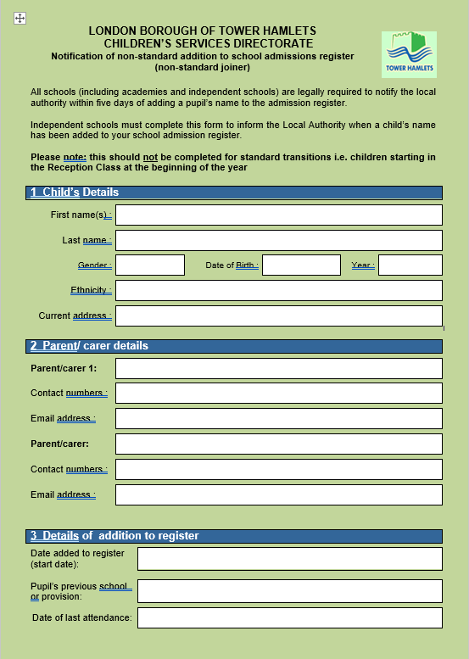
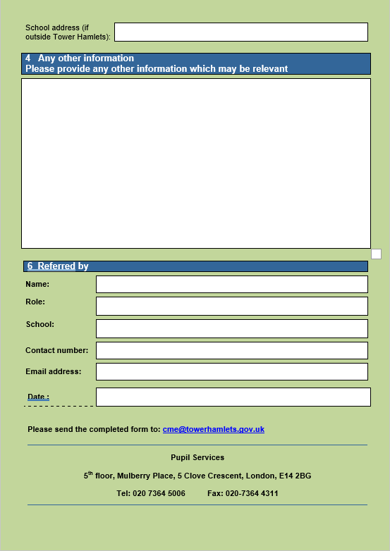

Appendix B

LONDON BOROUGH OF TOWER HAMLETS

Notification to Local Authority of child out of school

Date / /

Tower Hamlets Education Safeguarding Service
The Professional Development Centre
229 Bethnal Green Road,
London
E2 6AB

The following child is believed to be out of school:

Name:
Date of Birth:
Address:
Parent/Carer

Telephone:

E-mail:

Referrer’s Name and Job Title:
Address:
Contact Details:

Please send this form to: Tower Hamlets Education Safeguarding Service, The Professional Development Centre, 229 Bethnal Green Road, London E2 6AB

CME Team: -
Brendan Mulcahy - 075075 63946 - brendan.mulcahy@towerhamlets.gov.uk
Saadia Anwer - 07562 431817 - saadia.anwer@towerhamlets.gov.uk
CME Team Email - cme.enquiries@towerhamlets.gov.uk

Appendix C - PROCEDURE FOR SCHOOLS AND THEIR ATTENDANCE & WELFARE SUPPORT PROVISION TO FOLLOW IN RELATION TO RUNAWAYS

Once it comes to notice that a child or young person has run away the Head Teacher must be informed and the following done:

The Head Teacher or responsible senior member of staff must inform their Attendance & Welfare support provision/ AWA and social worker or team manager and placement immediately where a child or young person is:

- the subject of a Child Protection Plan (or subject to a Child Protection referral)

- a Looked After Child or young person who runs away or is removed (i.e. abducted)

- known to a statutory agency, or social worker, because there are developing concerns for their safety.

For others not in the above categories, schools should seek to confirm with the parent / carer that the child or young person has been reported missing to the police and must refer to their Attendance & Welfare support provision as soon as possible. The AWA must undertake the checklist listed on Paragraph 3.4 of this guidance.

- The AWA should carry out a home visit and confirm that the child or young person has been reported missing to the police and liaise with Children's Social Care. The school should be kept informed in writing.

- Where practicable, the AWA will exhaust enquiries within 2 working days of receipt of the referral. If there is no further information the AWA will inform a manager and Children's Social Care, the Missing Children Register for Tower Hamlets LA and the Police Child Protection Unit in writing.

- The AWA will liaise with Tower Hamlets Education Safeguarding service (THESS) who will advise when a child or young person's name may be removed from the school roll. A missing pupil's name must remain on roll for a minimum of 20 school days.

- Most runaways will return to their schools. The child or young person's school records should be kept at the school until they are requested from a new school. The school / AWA should inform the THESS of the new school.

- If the school/AWA becomes aware the child or young person has moved to another school they must ensure that the THESS and all relevant agencies are informed.

- The school/their AWA must report runaways to the Missing Children Register in the THESS in accordance with the procedure in the Tower Hamlets guidance on the Missing Children Register (September 2023). All agencies concerned with the care and protection of children should therefore ensure that schools and the Tower Hamlets Behaviour & Attendance Support Service (THBASS) are informed of all children and young people who are missing from home.

Appendix D - Tower Hamlets Missing Children Register – Guidance for Childminders

Introduction

This guidance advises Childminders of what to do if a child they have been minding goes missing and it is not known where they may be. This can happen, for example, when families move suddenly without telling anyone. It also informs Childminders about how and when to refer missing children to the Missing Children Register.

What is the Missing Children Register (MCR)?

The Tower Hamlets Missing Children Register is an electronic database. It keeps all the details of children who go missing from Tower Hamlets. Ongoing checks are made with local agencies such as Children's Social Care and the Pupil Services team and also with other databases.

What you should do if you do not know where a child you have been minding is?

- Telephone all the contact numbers available for the child.
- If the missing child is the subject of a Child Protection Plan, or is a Looked After Child (LAC), or Children' Social Care are known to be actively involved, contact Children's Social Care straight away.
- Write to the family at the last known address, and e-mail address.
- Check for rumours with friends of the child and family.

Referring to the Missing Children Register

If the child has not been found after you have made these checks, telephone the Missing Children Register on 020-7364 3426 and ask for a referral form. Complete it and send it to the address on the form. If you need advice on completing the form the Children Missing Education Officer responsible for the MCR will help.

If the child turns up after you have sent the form or you get information on where the child might be, telephone the Administrative Officer for the Missing Children Register and pass the information on.

Contact for Enquiries

If you have any queries or would like a copy of the full guidance, contact: -

Children Missing Education Officer - Missing Children Register
Tel: 020-7364 3426
Email: Saadia.anwer@towerhamlets.gov.uk

