## House Rules in Pictures

# We eat and drink at the table

j0232066

j0355357

✓

# We treat the furniture with respect

✓

j0356937

We take our shoes off indoors

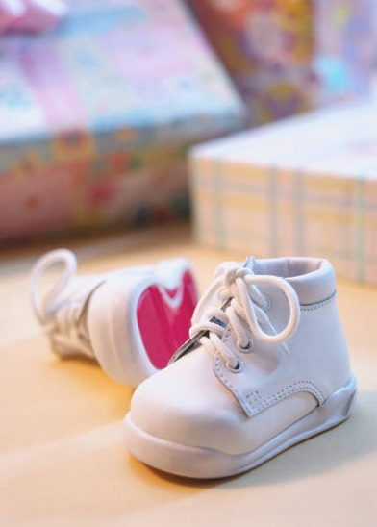

✓

j0232883

# We play nicely with the toys, share and are polite

j0232107j0232143 j0232150

✓