London Borough of Tower Hamlets
Children’s Information Systems
Provider Portal - User Guide

Author: Paul Smith
Logging in to Provider Portal
To login in to Provider Portal please visit the following link:
https://education.towerhamlets.gov.uk/Synergy/Default.aspx
1. One of two pages will appear. If this is what you see, then click the login text here.
1
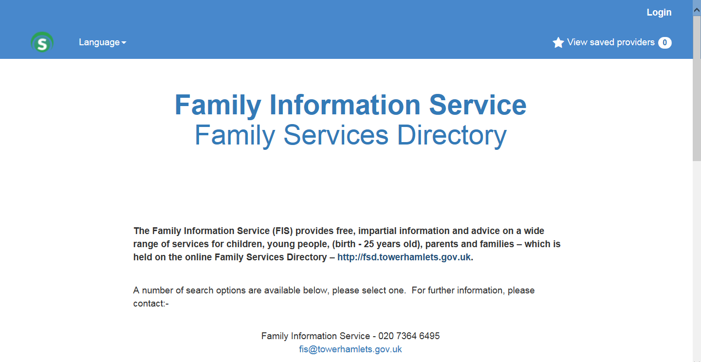

That will bring you to this page. If you were brought here in the first place then continue from here.
1. Your username and password should initially be provided to you by the local authority. When your details have been entered
2. Select sign in.
Additionally if you forget your password for any reason, or new a new user set up please contact the local authority.
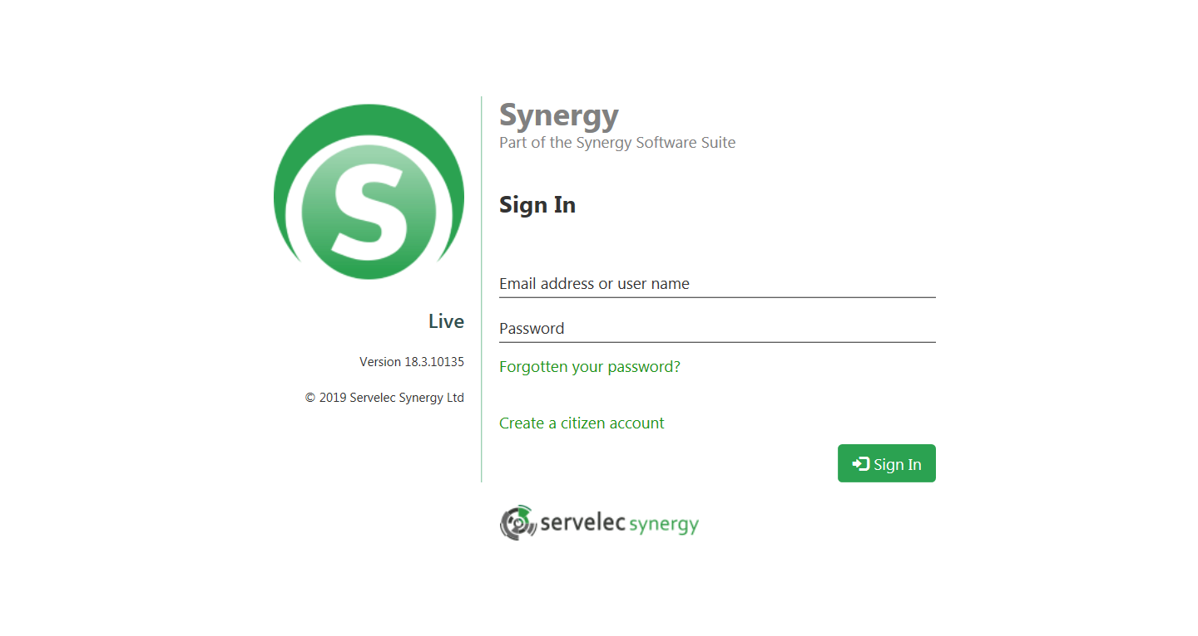
2
1

Changing Passwords
Once you have logged in you will be taken to this page.
1. To change your password, click on your username here.
1
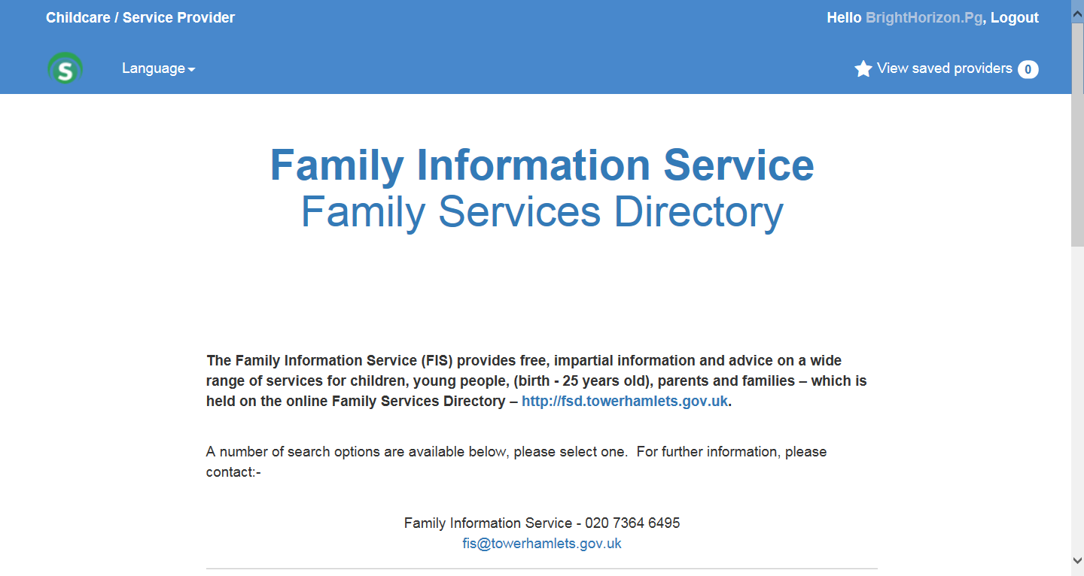

1. Now in the current password field type the password you just used to login. Then in the new and confirm password fields type in the new desired password
2. Select change password.
Note: if you do not enter the old password correctly, or the password entered in the new and confirm fields are not the same the password change will fail.
3. Now click on the Childcare / Service Provider button.
3
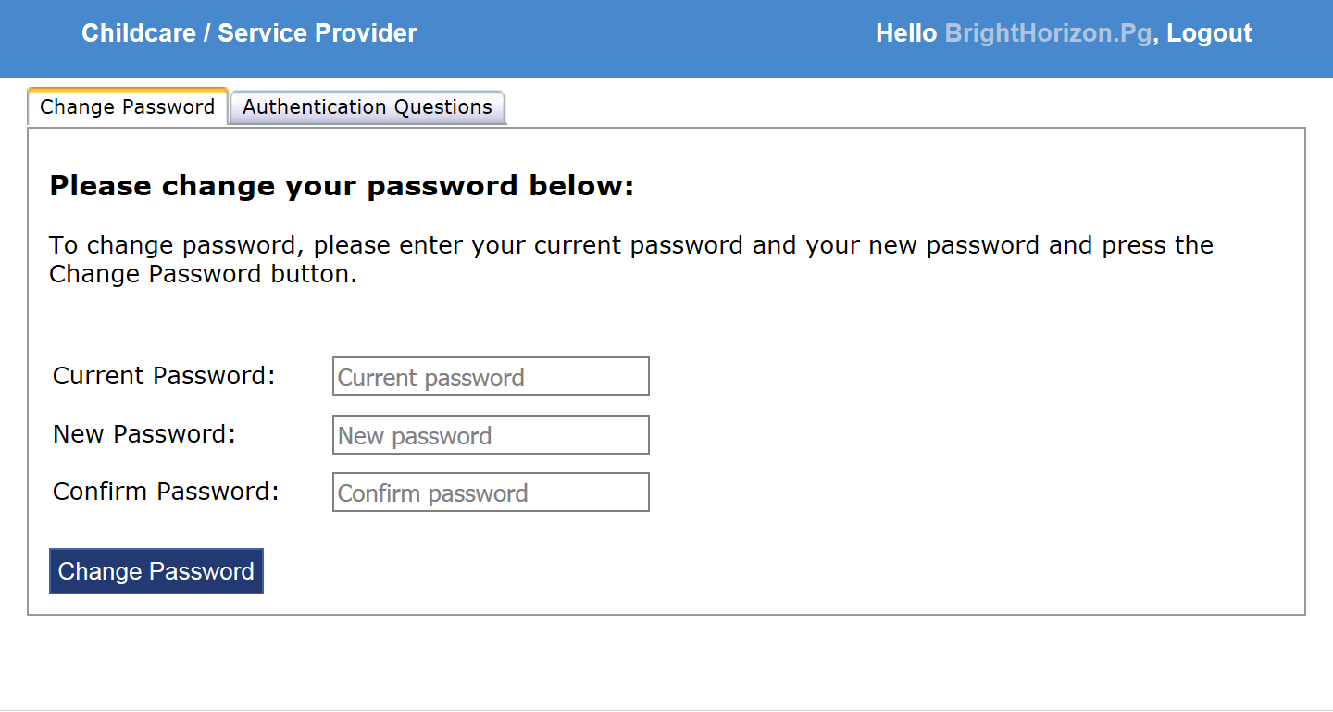
2
1

Funding
You now will be taken to the F I S provider portal welcome page.
1. Select the funding tab.
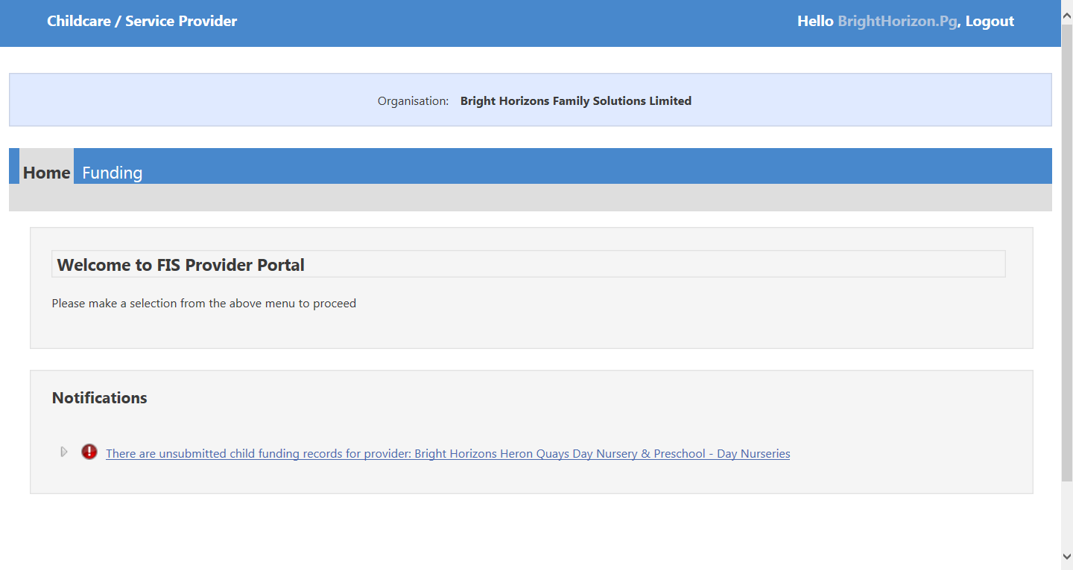
1

1. Select the relevant year, term and funding type.
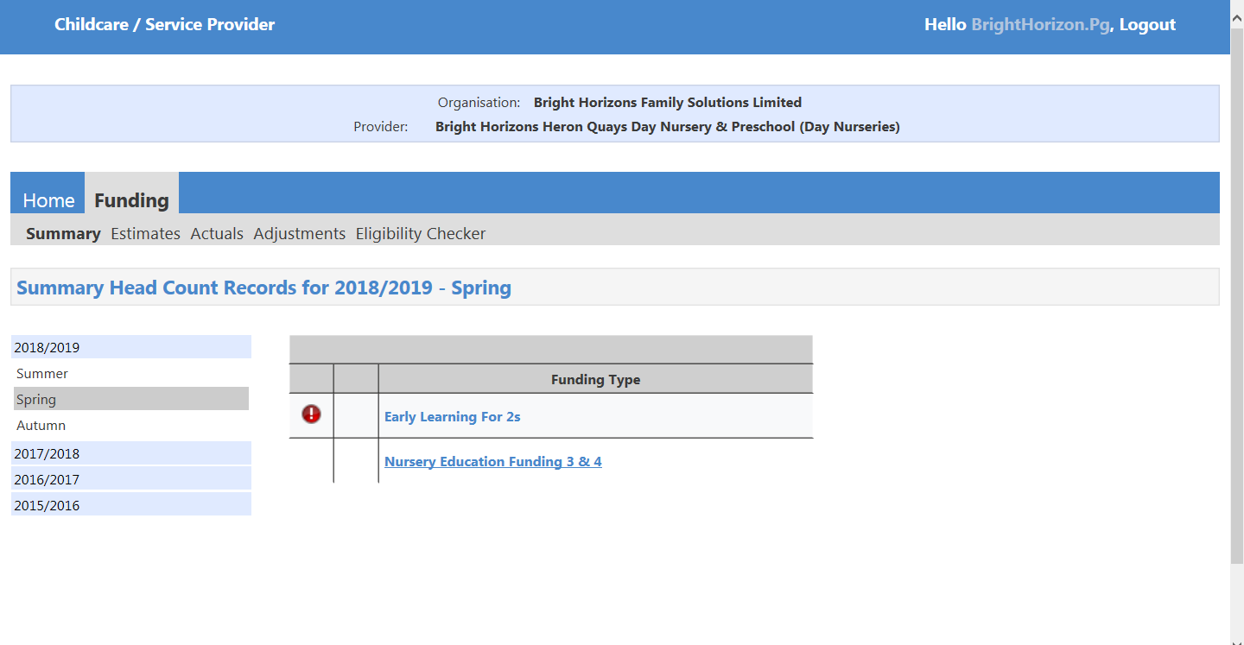
1

Summary
1. To change the funding type after you have selected it, select the change text here.
This page is the summary page. This gives you a summary of the financial detail of the selected provider.
2. Select the estimates page.
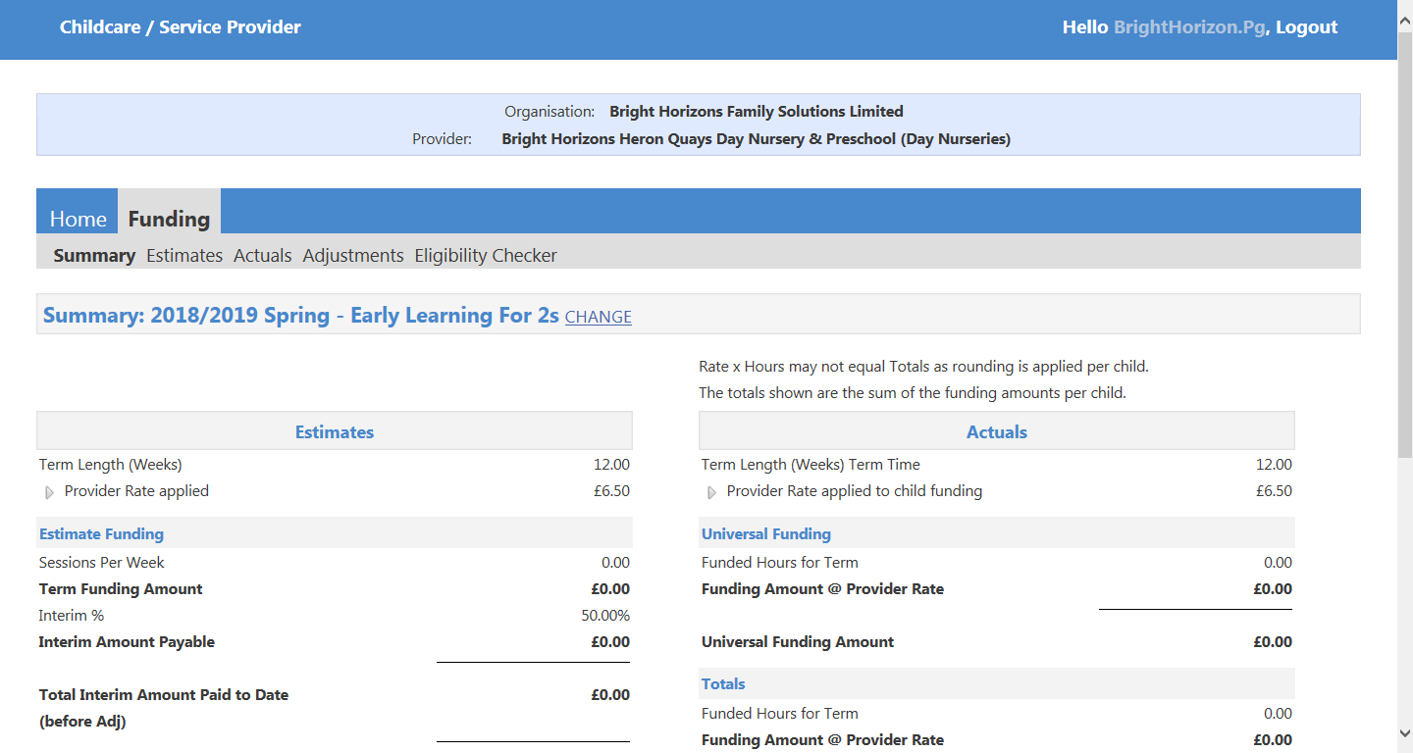
2
1

Estimates
This page is for local authority use only. You do not need to use it.
1. Please select the actuals tab.
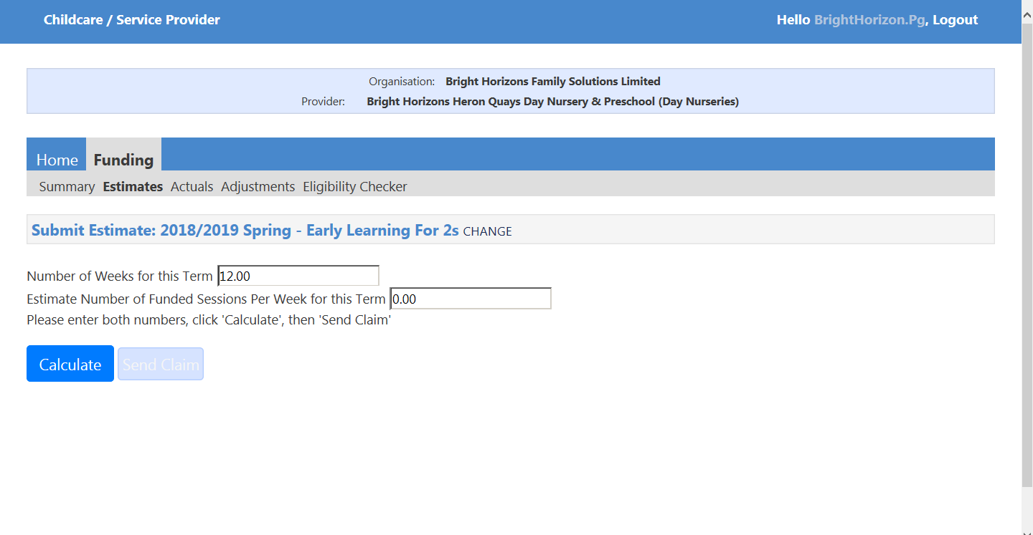
1
Actuals
This tab allows you to add the children to the provider.
1. Select the add child button, this will take you to the add child form page.
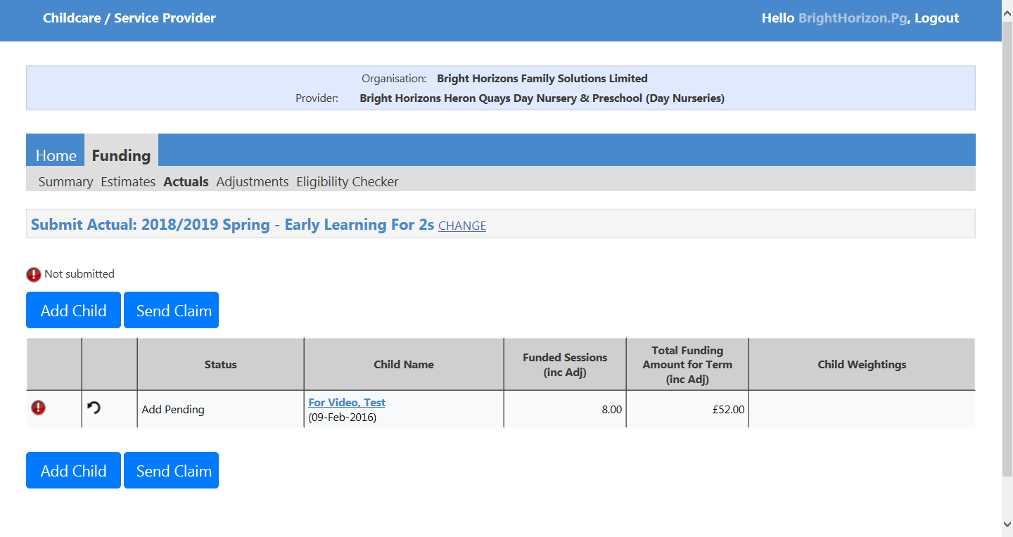
1
1

Enter the relevant information in all three of these tabs: “child details”, “parent/carer details” and “funding details”. Please fill in as much information as you can, the more information entered the better. Note: Fields with a star next to them must be entered before you can save the child.
1. This is the Child details tab:
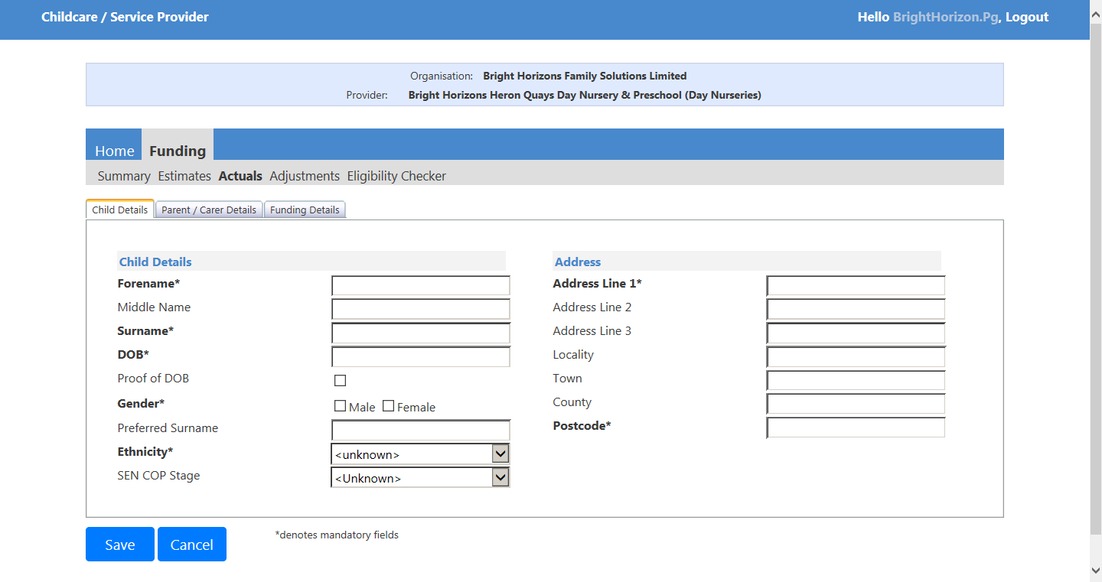
1

1. This is the Parent/Carer tab:
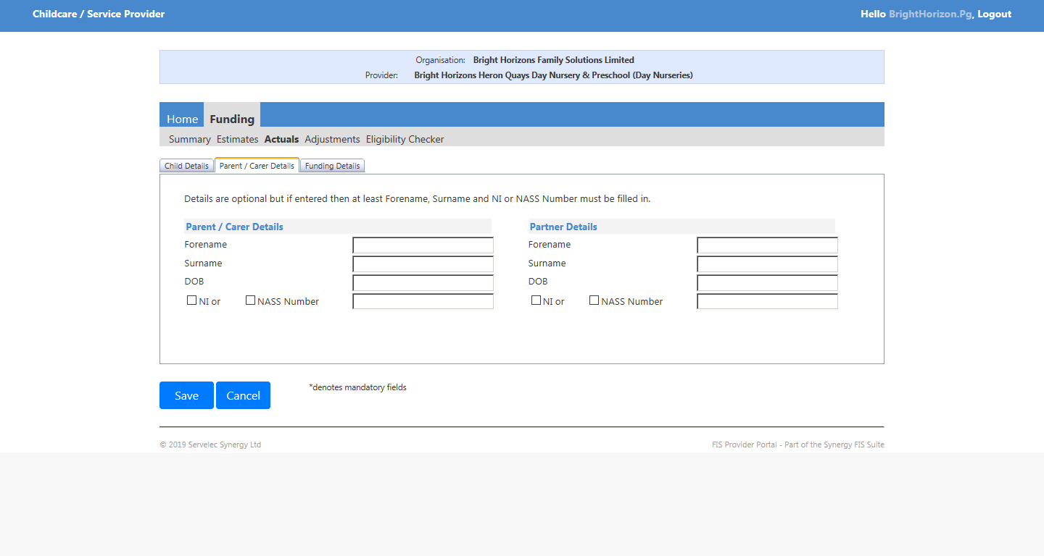
1

1. This is the Funding Details tab:
2. Once you are happy with the information entered select ‘save’ to save the details or ‘cancel’ to cancel adding the child. Whichever you choose, you will end up back at the actuals front page.
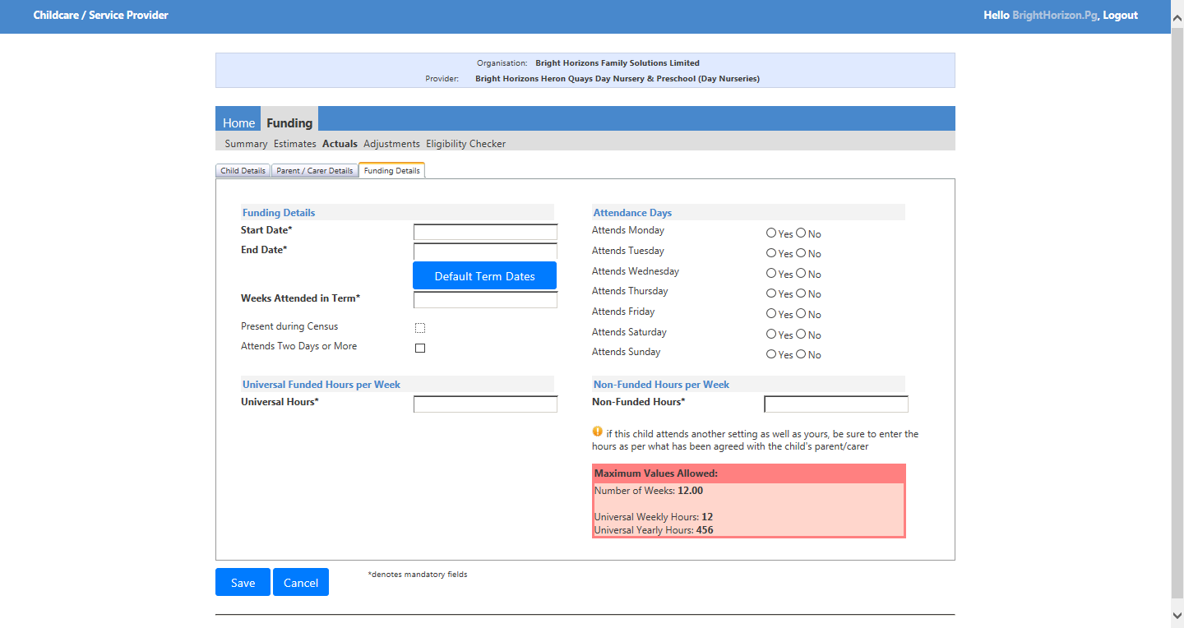
1
2

1. If you need to edit the information of a child, select the name of the child.
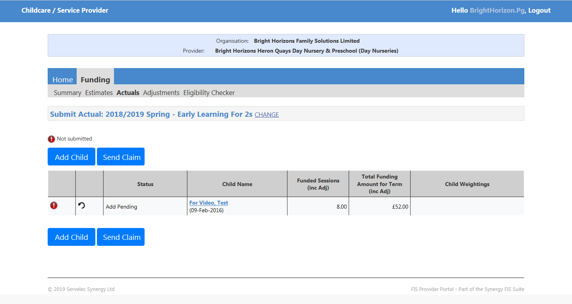
1

1. Edit what you need from the child details, parent/carer details and funding details tabs.
2. Then save, or cancel to undo the changes.
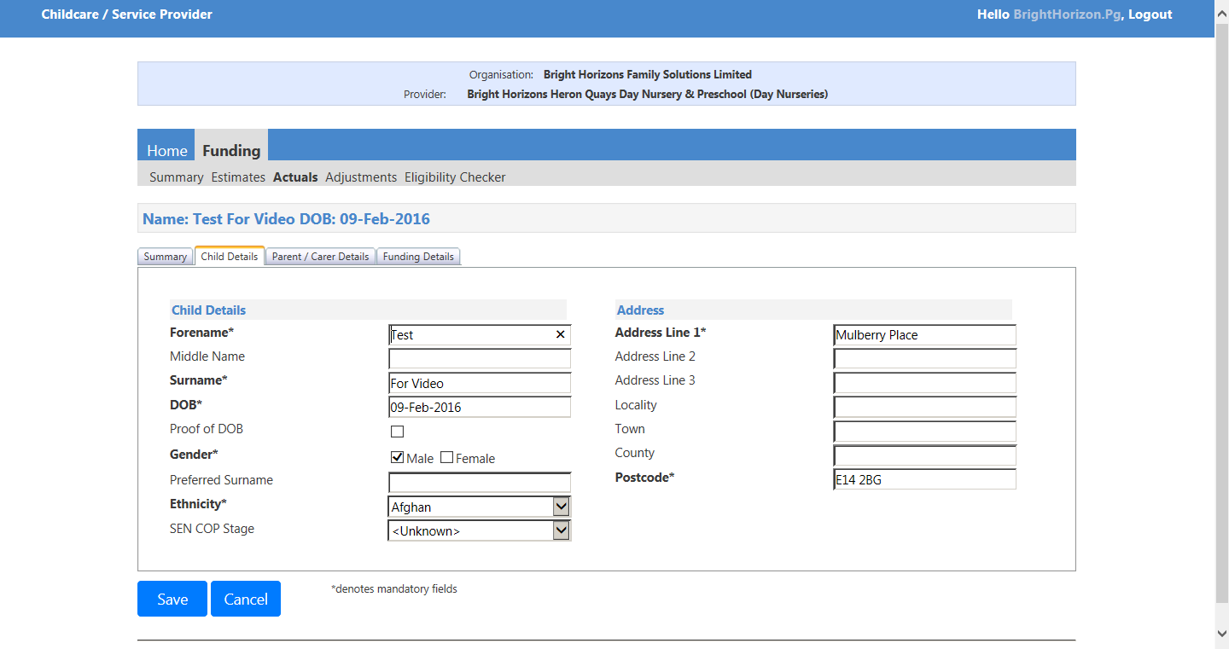
1
2

1. If you need to delete the child for any reason, select the undo button.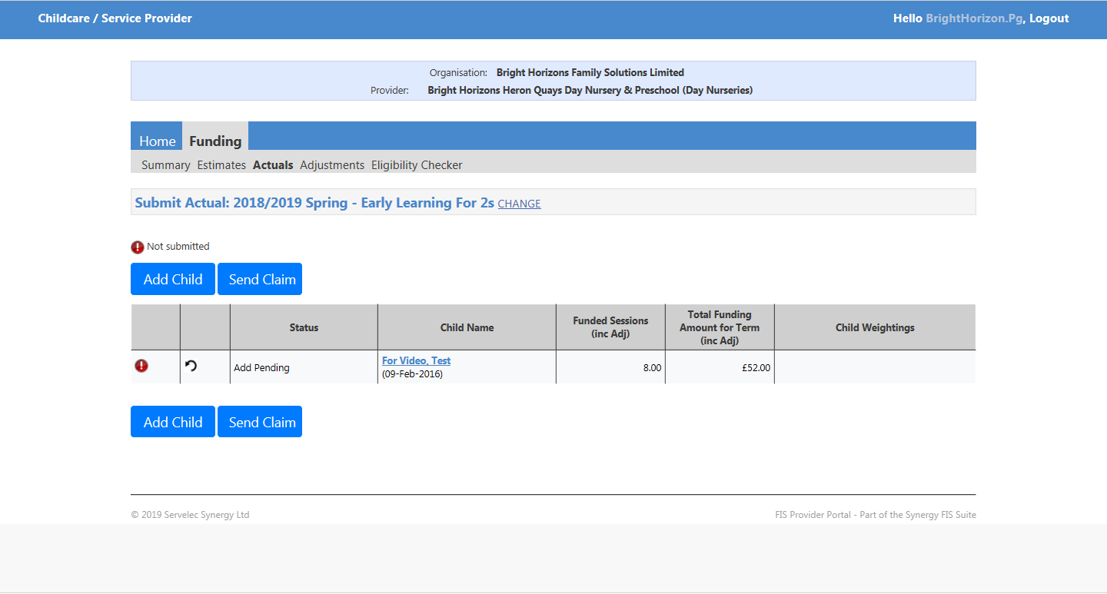
1

1. It will give you a prompt asking if you are sure. Select the yes if you are and no if not.
1

1. If you are happy with the added child/children, select send claim to notify the local authority of the attendees.
2. Next select the adjustments tab.
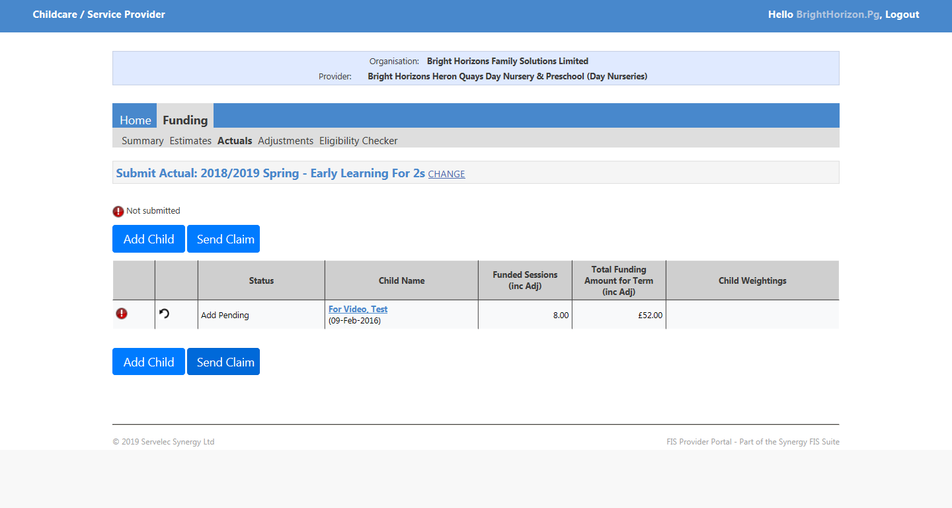
2
1
1

Adjustments
For adjustments email the authority to make these changes.
1. Lastly select the eligibility checker.
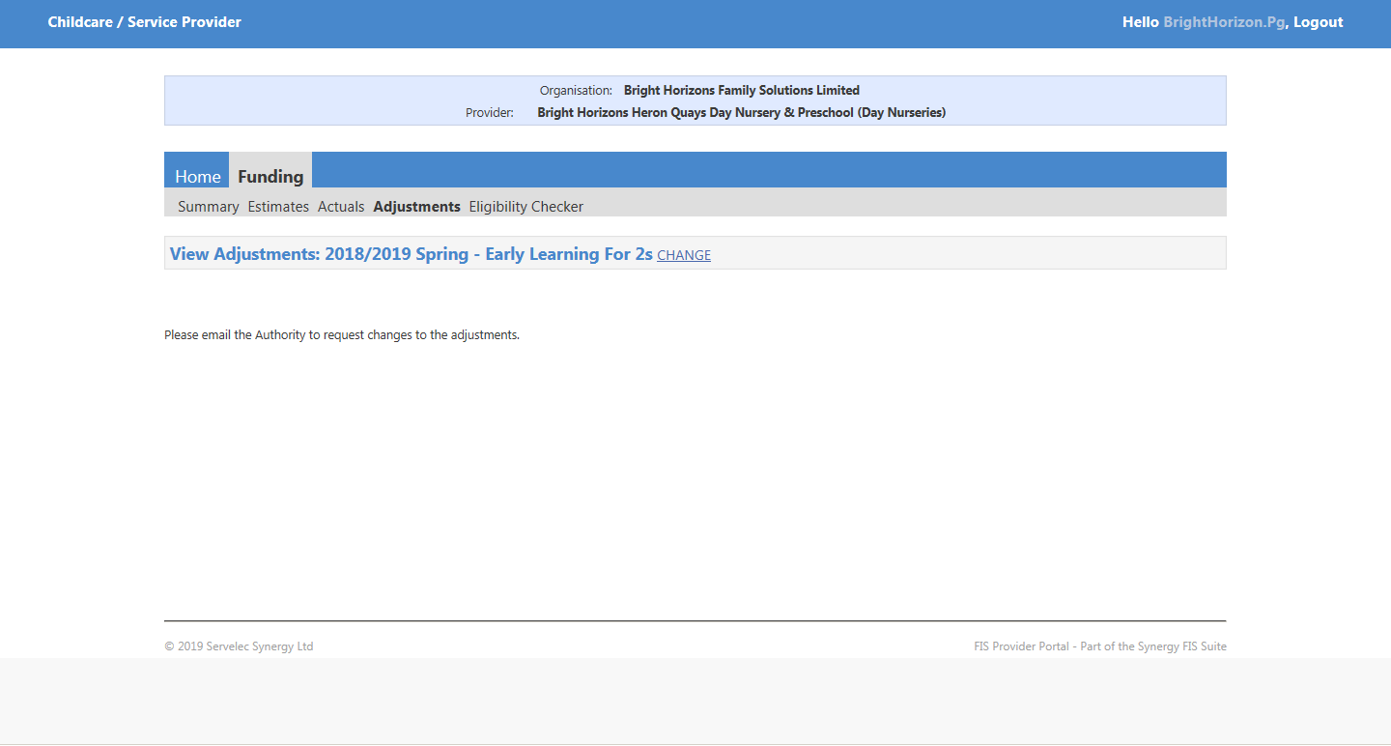
1
Eligibility checker
Eligibility checker allows you to check a child is eligible for extended hours.
1. Select the 30 hours free childcare button
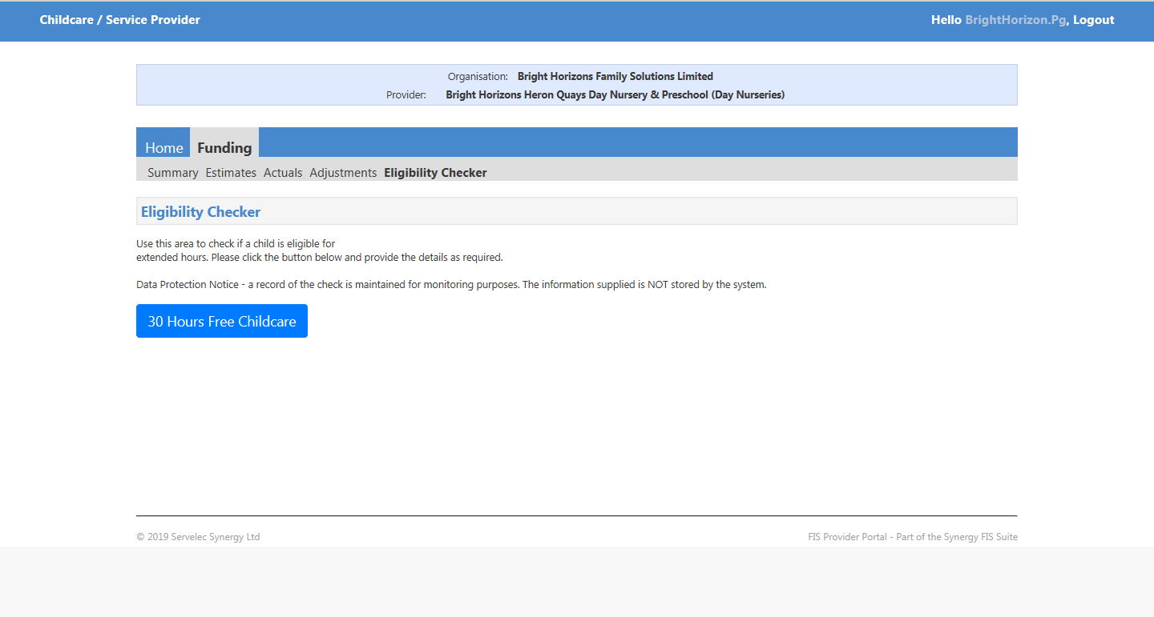
1

1. Then input the information in this window that pops up.
2. Then select submit, or cancel to go back to the eligibility checker main page.
2
1

For technical issues: Password resets, link requests, system is not doing what it supposed to call: 0207 364 6687, or email: CIS@towerhamlets.gov.uk
For process related Issues: Questions on the various aspects like why, how, if, who, should, etc. then contact: 0207 364 1553

