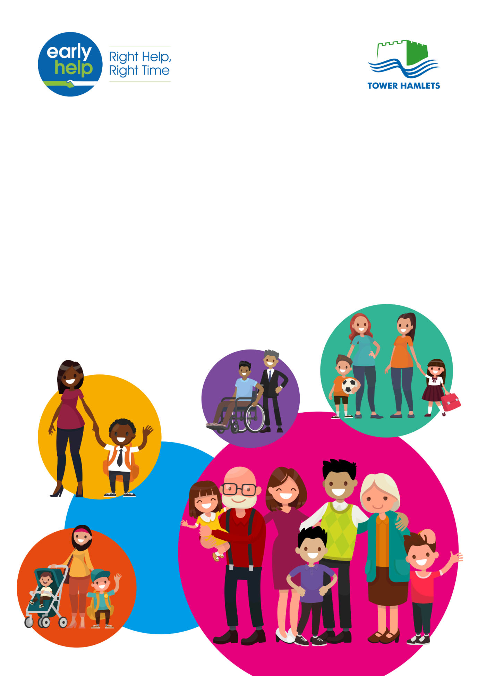

London Borough of Tower Hamlets

Early Help Strategy

2018 - 2021

**October 2018**

Table of Contents

1. Foreword 3

2. The context in Tower Hamlets 4

3. The vision for Early help and its’ links to strategic plans 6

4. What we mean by Early Help 7

5. Empowering Families 9

6. Early Help is partnership and it is everyone’s responsibility 9

7. The statutory framework for Early Help 10

8. The Early help continuum of need and thresholds of support 12

9. The Early Help offer 14

10. Early Help governance arrangements 15

11. How success will be measured and evaluated 16

Appendix 1 Early Help Pathway in Tower Hamlets 19

Appendix 2: List of strategies - plans linked to the Early Help Strategy 2018 – 2021 20

Appendix 3 List of relevant legislation and guidance 21

# Foreword

Following the 2017 Ofsted inspection the council undertook a review of Early Help which revealed that the right families were not being consistently supported by services; that the Early Help offer was fragmented and not well understood by partners; and that resources were not being used to the maximum effect or impact.

Ensuring that children and their families have access to early help is a priority in Tower Hamlets. Our vision is that children and their families will have access to the right help at the right time and from the right person.

Well-delivered Early Help can stop small problems from escalating and delivery of the right Early Help Services can result in a reduced subsequent need for statutory services

We believe that Early Help is most effectively delivered through an integrated partnership of stakeholders that are best placed to deliver the right support at the earliest opportunity in order to stop problems escalating and to improve life chances.

The Children and Families Partnership Board and the Local Safeguarding Children’s Board will be responsible for driving this strategy forward whilst ensuring that challenge, impact and quality are at the heart of our approach to Early Help.

John Biggs

**Executive Mayor of Tower Hamlets**

Councillor Danny Hassell

**Lead Member Children’s Services and Education**

Steve Ashley

**Chair of the Local Safeguarding Children’s Board**

# The context in Tower Hamlets

Tower Hamlets has the 4th youngest population in the United Kingdom, with growth of 26% for the age group 0-19 during the years 2006 to 2016. More than two thirds of residents belong to minority ethnic groups and life expectancy at birth and healthy life expectancy is generally lower than that of London and the rest of England as a whole.

**People**

* + Since 1986, the population has more than doubled; making Tower Hamlets the fastest growing local authority in the United Kingdom.
  + An estimated 125,900 households live in the borough and 20% of households are made up of more than one family. This is higher than the London average (14%) and the second highest proportion in the country.
  + 31% of children live in families below the poverty line which the highest rate in the country
  + There are an estimated 74,400 children and young people aged 0 to 19 living in the borough.
  + There are 137 languages spoken in Tower Hamlets schools and the top 3 first languages spoken by pupils are Bengali (54%), English (27%), and Somali (4%).

**Pregnancy and being born**

* + 8.3% of babies in the borough had low birth weight in 2015, similar to the rest of London (7.6%) but higher than England (7.4%).
  + The infant mortality rate was 4.8 per 1,000 live births in 2014. This is higher than the rates of our immediate neighbouring boroughs and of London as a whole.
  + Approximately 10% of pregnancies in Tower Hamlets are complicated by diabetes, compared to 5% nationally
  + There is an increased risk of domestic violence to women during pregnancy and there were 3101 reports of domestic crime to the Police in 2015/16.

**Early Years**

* + The proportion of early years pupils achieving a good level of development has increased from 46% (2013) to 68% (2017).
  + 43% of children in year 6 were overweight (including those who are clinically obese) in 2017, compared with 39% in London and 34% nationally.
  + Almost four out of five children in the borough live in families reliant on tax credits which is the highest rate in the United Kingdom
  + In 2015, Tower Hamlets had the 3rd highest rate in London (35.5%) for children with one or more decayed, missing or filled teeth
  + Vaccination coverage in 2017 (86.8%) falls beneath the recommended threshold of 95% of children immunised with two MMR doses by the age of 5. However, this rate was significantly higher than the rest of London (79.5%)

**Children and Young People**

* + 6% of 16-17 year olds were ‘not in education, employment or training’ at the end of 2016, which is the same as the national average and slightly higher than the rest of London as a whole (5%)
* 40% of secondary pupils are eligible for free school meals; this is higher than the London average (17%) and the national average (13%)
* The rate of first time entrants coming in to the youth criminal justice system is higher than for London with 158 new entrants in 2016
* Accident and Emergency attendances for 15-17 year olds in 2016-17 was 332.2 per 1,000. This is lower than the rest of London; however, hospital admissions for Asthma for 10-18 year olds were higher than rates in the rest of London and England as a whole.

In serving a diverse community there is a need to ensure that in delivering Early Help the requirements of the Equality Act 2010 are followed. The Act requires us to eliminate discrimination and promote equality of opportunity in order to:

* Promote equality of opportunity and eliminate discrimination in the planning and delivery of services in terms of age, disability, ethnicity, gender, sexual orientation, gender-reassignment, marriage and civil partnership, religion or belief, pregnancy and maternity, health and income status
* Promote good relations between partners and communities in order to address negative stereotyping of any groups
* Ensure that all residents have equal opportunity access and to participate in Early Help services.

# The vision for Early help and its’ links to strategic plans

***Our approach***

“*Early Help in Tower Hamlets will work in partnership with families, children and young people to overcome difficulties and to build the resilience that will equip them to address challenges and seize opportunities in the future.”*

***Debbie Jones, Corporate Director of Children’s Services***

Our vision for Early Help is that every family should get the right support at the right time to ensure that needs are addressed quickly; thus, preventing further escalation or crises; and ensuring that resources are put to the best possible use.

Tower Hamlets’ Children and Families Plan (2016 – 2019) highlights the strategic aims and priorities for all agencies working with children and young people across the Borough. Tower Hamlets Early Help strategy is integral to the delivery of the plan and it cuts across all the objectives agreed by the Children and Families Partnership. In addition to this the Children and Families Plan seeks to ensure that poor outcomes are prevented and escalation into statutory services is avoided through the provision of a robust Early Help service.

The objective of delivering Early Help is also set out in a number of other strategic plans and strategies that are focused on children and young people (see appendix 2).

Our vision supports the delivery of the three cross-cutting priorities that are set out in our Children and Families Plan 2016 – 2019 which promote:

* Help at an early stage;
* Holistic support that is easy to access;
* Protecting and promoting the right of the child.

This approach will enable us to deliver our ambition for every child and young person in Tower Hamlets; that they should be able to:

* Reach their full potential
* Live well
* Play a part in freedoms;
* Be free from Harm.

Our vision for Early Help is also underpinned by five key objectives:

* The ***early identification*** of those vulnerable children and their families who are at the highest risk of poor outcomes and who would benefit from early support through the development of joint plans that address need;
* To ***empower families*** by building positive professional relationships with them and by making a clear, non-stigmatising offer of support that enables them to develop the capacity to resolve their problems and build resilience;
* To deliver Early Help through ***partnership*** and a dedicated workforce thus, enabling the development of a shared understanding, vision and professional practice around Early Help;
* To deliver ***improved outcomes*** for children and families through the provision of effective, evidence-based interventions and support that reduce the numbers of families referred to specialist services;
* To deliver high quality Early Help services that improve outcomes, have impact and make a positive difference to the lives of families. The ***performance*** and ***impact*** of Early Help services will be regularly measured and monitored.

# What we mean by Early Help

Our understanding of Early Help is built upon seminal publications[1] which all made a compelling case for early help and prevention. Early Help therefore means providing support to children, and their families, at any point in a child's life, including the prenatal stages and up to the age of 25 years (for those with learning difficulties and or disabilities) as soon as needs emerge that do not meet the threshold for specialist, statutory, services such as those provided by Children’s Social Care.

Early Help includes:

* Universal services - that all children and families can access like General Practitioners, early years settings and schools; and
* Targeted services – for children and families that have multiple needs which require a multi-agency intervention.

Our approach to Early Help is founded on the belief that if addressed early enough the emergent needs of children and their families can be prevented from escalating. We have therefore developed a clear and co-ordinated pathway (see appendix 1) for accessing Early Help that will support children who have a variety of needs or risk factors including:

* **Educational needs**: Children at risk of missing education; children with poor attendance; children not in education, training or employment; children at risk of exclusion; children with SEND who do not meet the threshold of an EHCHP; children with a learning difficulty or disability;
* **Exploitation**: Children at risk of sexual exploitation; children at risk of gang involvement; children at risk of modern slavery, trafficking, and the national referral mechanism;
* **Violence or abuse:** Children at risk of domestic abuse/violence; children at risk of serious youth violence; children at risk of Female Genital Mutilation (FGM);
* **Radicalisation**: Children at risk of radicalisation

**C*ase study***

*Tom has just started secondary school and is 11 years old. His teacher is increasingly concerned about Tom’s poor school attendance and dishevelled appearance. The teacher telephoned the Early Help Hub (EHH) to seek advice. The EHH advised that the case met the threshold for Early Help. However, they needed more information about the family and asked for a full Early Help Assessment (EHA) to be completed. The EHA revealed that Tom’s mother had on-going mental health needs and was not coping. The case was passed on to the Social Inclusion Panel for additional family support.*

* **Early abuse or neglect**: Children and young people at risk of suffering early abuse or neglect; children and young people at risk of suffering delayed physical development; children and young people at risk of suffering delayed cognitive development;
* **Health**: Children at risk of substance misuse/abuse; children at risk of sexual health issues; risk of teenage pregnancy
* **Emotional wellbeing/mental health**: Children at risk of self-harm or suicide; children at risk from bereavement;
* **Crime/antisocial behaviour**: Children at risk of involvement in crime and/or anti-social behaviour; children with socially unacceptable behaviours; children at risk due to parental financial difficulties/debtsT0we
* **Homelessness**: Children at risk of homelessness; children at risk from family breakdown;
* **Other issues**: Children at risk of other issues which have necessitated a referral to Early Help e.g. concerns about Young Carers; privately fostered child(ren); risk of honour based violence

# Empowering Families

We recognise that in the majority of cases children in need of Early Help will live with their families. So, we will empower families to get back on to a positive path as soon as possible by supporting them to understand, care for and nurture their children so that they can regain control of their circumstances and improve their outcomes.

Some adults within the family may have their own needs e.g. substance abuse, mental health needs, parental learning disabilities and/or domestic violence which may impair their parenting capacity. It therefore makes sense to assess the needs faced by the whole family and to provide them with targeted support using a multi-agency approach.

Early Help will be provided to families who would benefit from a co-ordinated early response to prevent escalation.

# Early Help is partnership and it is everyone’s responsibility

***Substance Misuse Services***

*Will offer Early Help by:*

* *Working with the whole family*
* *Identifying early substance misuse in families to prevent escalation*
* *Identifying children at risk of harm from substance misuse*
* *Develop clear pathways into the service*
* *Offer specialist substance misuse training to partners in assessment, identification and impact.*

***Early Help stakeholder workshop feedback***

***April 2018***

Early Help is not a single service or agency responsibility or activity. Early Help is most effective when delivered in collaboration with partners who have an interest in providing early support to vulnerable children and families. It is the responsibility of everyone that works with children and families to support the identification of emergent problems and potential unmet needs so that Early Help can be provided at the earliest opportunity.

Our Early Help partners include, amongst others, schools, General Practitioners, Health Visitors, the Police, the Fire Service, Day Care Providers, Community and Voluntary Sector Organisations and, in the council, Children’s Services and Adult Social Care, to name but a few. Professionals in these types of services are often best placed to identify children and families who may be at risk of poor outcomes.

Significant amounts of Early Help work are already being delivered by our partners and across council services. It is important that we work together to create a more coherent and cohesive approach to engaging with children and families by building on the existing good practice.

# The statutory framework for Early Help

There is a strong statutory framework and guidance that has been issued to support the delivery of Early Help. It clearly sets out how services and partners, regardless of sector, must work together to support vulnerable children and their families at the earliest opportunity. There is a broad range of legislation that underpins the work of Early Help (see appendix 2 for the list). In particular, duties accrue, but are not limited to, the following legislation and/or guidance:

* **The Children Act (1989 and 2004) and Working Together to Safeguard Children (2018)**:Under section 10 of the Children Act 2004, local authorities have a duty to promote inter-agency co-operation to improve the welfare of all children in the local authority area.

Section 11 of the Children Act, 2004 places a duty on key persons and bodies to make arrangements to ensure that in discharging their functions they have regard to the need to safeguard and promote the welfare of children. The statutory guidance sets out how partners must work together to protect vulnerable children and young people.

***Early Help and education***

*“Schools and colleges should work with social care, the police, health services and other services to promote the welfare of children and protect them from harm. This includes providing a coordinated offer of early help when additional needs of children are identified.”*

***Keeping Children Safe in Education (revised) page 19***

* **Keeping children safe in education for schools and colleges – guidance from 3 September 2018**: This statutory guidance sets out how the governing bodies of maintained schools and colleges, the proprietors of independent schools and non-maintained special schools including academy trusts and the management committees of pupil referral units should ensure that mechanisms are in place to ensure that staff in schools discharge their responsibilities.

* **The Children and Families Act (2014)**:Section 19 of the Act places a duty on the local authority to have due regard to the views, wishes and feelings of children, their parents/carers and young people; ensuring that they participate in decision making; the provision of information and support; and are supported to achieve the best possible educational and other outcomes.
* **The Special Educational Needs and Disability Code of Practice 0-25**:Promotes Early Help for children with special educational needs. It requires universal and specialist agencies to work together, using a whole-family approach, to assess, plan and deliver support to meet the educational, health and social needs of children with Special Educational Needs and Disabilities.

# The Early help continuum of need and thresholds of support

Children and families that need Early Help often have a range of needs that have different levels of severity across a continuum. The diagram below demonstrates the continuum of needs that might apply to children and their families.

A close up of text on a white background showing the four levels of London Borough of Tower Hamlets Continuum of Need



Early Help uses the Continuum of Need in order to understand the needs, strengths and risks associated with vulnerable children, young people and families.

Early Help will focus on the delivery of support and interventions to children and their families who have needs at level 1 and level 2 of the continuum. The Continuum of Need used in Tower Hamlets is based on the pan-London Threshold document[2].

Where appropriate, a joint approach will be taken, with partners, to the assessment of need and the application of agreed thresholds which will ensure that the right levels of services are offered to children, young people and their families. In addition to this, new threshold guidelines have been issued by the Tower Hamlets Local Safeguarding Children's Board (LSCB) and these will be used in Early Help as the basis for our joint understanding of thresholds. There are four thresholds in the LSCB guidance as described below:

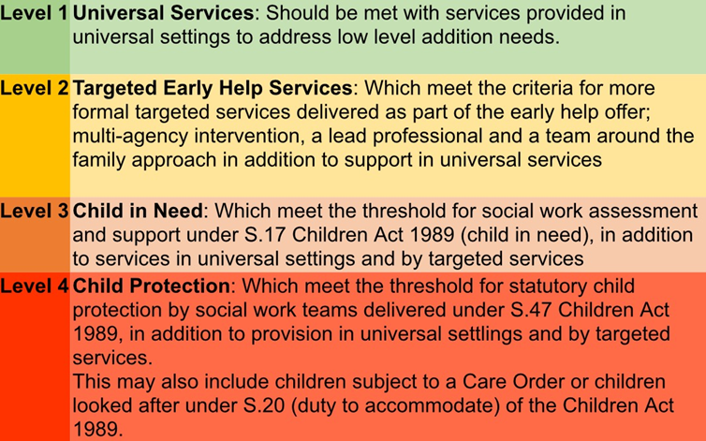

**Source**: Multi-agency Safeguarding September 2017 Threshold Guidelines

The LSCB's threshold levels will be used to determine the type of interventions that will be offered to address need.

Early Help will provide services and support to children, young people and their families that have problems or issues at level one through the provision of information, advice and guidance about where and how universal services can be accessed; and at level two through the provision of targeted Early Help support and whole family interventions based on integrated working[3].

The universal and targeted services that will be offered through Early Help are described below:

* **Universal Services**:Unite key stakeholders and partners in the delivery of a preventative approach to improving outcomes for children and young people and their families where there is typically only a single issue of concern. The services provide a range of support and interventions for those children and young people who need some low level help, usually provided when a parent or professional has a concern about a child or young person’s needs. Services delivered at the universal level meet the needs of the majority of children and young people. These ‘universal services’ are provided or are routinely available, to all children and their families.
* **Targeted Early Help Services**:Are for those children, young people and their families with more targeted needs where there are two or more issues that require integrated targeted support. Because of the targeted nature of those needs, especially around behaviour and parenting, a multidisciplinary/agency coordinated plan, developed in partnership with the family, is needed.

For targeted services an Early Help Assessment (EHA) will be completed with the family and child, or young person, in order to determine the right intervention and support.

The priority is for Early Help to provide support to families, at Level 2, and to embed the principles of whole family working where key issues[4] are manifest such as:

1. Parents or children involved in ***crime or anti-social behaviour***
2. Children who are ***not attending school regularly***
3. ***Children who need help***: children of all ages, who need help, are identified as in need or are subject to a Child Protection Plan
4. Adults out of work or ***at risk of financial exclusion*** or young people at ***risk of worklessness***
5. Families affected by ***domestic violence*** or ***domestic abuse***
6. Parents or children with a range of ***health problems***.

All families that are offered support at Level 2 interventions will also have:

* A named lead professional;
* A whole family assessment; and
* A whole family action plan.

Through Early Help all children, young people and their families will have the opportunity to access universal and/or targeted services, at Level 1 and Level 2 which they will be encouraged to access and use independently.

Upon referral to the MASH, a statutory assessment will be undertaken for those children, young people and their families who have complex additional unmet needs and who are experiencing significant issues that require a statutory intervention. Early Help will work with the MASH to ensure that children, young people and their families receive the right support.

# The Early Help offer

Most families do well in life and universal services will meet their needs. However, some families will need additional support and, following a whole family assessment, access to interventions will be available from the Early Help offer which will be set out in a plan. There are a number of Early Help interventions which together constitute the Early Help offer.

Early Help interventions include some of the following:

Early Help Example Offer

|  |  |
| --- | --- |
| **Level 1 - Universal offer open all children and families** | **Level 2 – Targeted offer to families following assessment** |
| Interventions might include for example:   * Employment support sessions for parents * Job Centre Plus/Workpath * Functional skills – English, Maths * Play activities for children aged under 5 * Early Years Parent Forum * Under 5s music and play | Interventions might include for example:   * Transition into secondary school support * Work with vulnerable families * Education, training and employment support/ Young Workpath * Accredited parenting programmes * One-to-one Mentoring |

Where Early Help interventions are not delivered internally services may be commissioned, with external providers, on the bases of changing demographic profiles and identified needs as set out in, for example, a Joint Strategic Needs Assessment. In addition to this, commissioned Early Help interventions will support the delivery of this Strategy through improved outcomes; the achievement of best value; identification of commissioning gaps and opportunities.

Up-to-date information about the Early Help offer can be found at [www.towerhamlets.gov.uk/earlyhelp](http://www.towerhamlets.gov.uk/earlyhelp).

# Early Help governance arrangements

Strategic governance of Early Help will be provided through the Local Safeguarding Children's Board Early Help and Thresholds sub-board. Operational oversight will come from the Early Help Operational Board. The diagram below sets out the governance arrangements:

**LSCB Early Help and Threshold Sub-Board**

**Early Help Forum**

**Local Safeguarding Children’s Board (LSCB)**

**Children and Families Partnership Board**

The LSCB Early Help and Threshold sub-board is chaired by the Chair of the LSCB and the Early Help Forum is chaired by the Divisional Director for Youth and Commissioning. Together these boards will serve to provide operational and strategic challenge to the work of Early Help.

# How success will be measured and evaluated

Good, effective, Early Help should result in a reduction in demand for specialist statutory services and an improvement of other key indicators of inequality. The effectiveness of this Early Help Strategy will be measured using an Outcomes Based Accountably performance framework that will show the progress being made across the following key areas:

|  |  |
| --- | --- |
| Early Help Outcomes Based Accountability Framework |  |
| How much did we do? | **How well did we do?** |
| Number of Early Help Assessments (EHA) that were completed | Percentage of EHAs that were completed within 30 working days. |
| Number of Early Help enquiries that met criteria for level 2 EHA | Percentage of Early Help enquiries that met criteria for level 2 EHAs. |
| Number of families re-referred to Early Help | Percentage of families re-referred to Early Help. |
| Number of Team around the Child/Family completed | % of Team Around the Child/Family (TAC/F) completed within 4 weeks |
| Number of eEHAs that were whole family assessments | Percentage of EHAs that are whole family assessments. |
| Is anyone better off? |  |
| Percentage increase in children and their families who find Early Help services satisfactory or better in annual survey. | Percentage increase of children and young people accessing Early Help with improved attendance (90% or more).[5] |
| Percentage reduction in young people who are NEET in Early Help families.[6]4 | Percentage reduction in Early Help young people and families involved in ASB.4 |
| Number of families with improved EHA scores between the initial (previous review) EHA and the last review EHA - Overall score. | Percentage of Early Help reviews where cases audited were found to be of good or outstanding quality. |
| Baseline indicators |  |
| Number of Children in Need (CIN). | CIN - rate per 10,000 |
| Number of children subject to Child Protection Procedures (CPP). | CPP - rate per 10,000 |
| Number of Looked After Children (LAC). | LAC - rate per 10,000 |

This Outcomes Based Accountability performance framework has been specifically developed for Early Help. It will enable the impact of Early Help work to be regularly monitored and reported on through the Early Help governance arrangements.

In addition, to the Outcomes Based Accountability performance framework we will also be:

* Using Early Help information to identify what works in terms of intervening with children and their families; and to monitor whether the ambition for improved outcomes is being realised through the strategy;
* Ensuring continuous learning will be used from data to ensure that we achieve improvements across the partnership;
* Using attainment data from our Children’s Centres to identify vulnerable children who are not making progress. The data will primarily focus on early years foundation stage and primary stages;
* Working with partners to better understand predictive indicators of vulnerability using their expertise and knowledge.

The Early Help strategy will be underpinned by a dedicated action plan which will ensure that the principles of whole family working are embedded into our Early Help practice and that all other objectives and outcomes are being met.

From this, we will develop a set of predictive indicators to support professionals to identify vulnerable families.

# Appendix 1 Early Help Pathway in Tower Hamlets

A diagram with text on a white background showing the Early Help Pathway in Tower Hamlets

# Appendix 2: List of strategies - plans linked to the Early Help Strategy 2018 – 2021

* + - The London Borough of Tower Hamlets Strategic Plan
    - The Special Education Needs and Disability (SEND) strategy
    - The Children's Social Care Sufficiency Strategy
    - The Multi-Agency Safeguarding Threshold Guide
    - Looked After Children Strategy
    - The Health and Wellbeing Plan
    - The Children and Young People's Mental Health Transformation Plan
    - The Community Safety Plan
    - The 2016 Tower Hamlets Community Engagement Strategy
    - The 2016-19 Carer Strategy
    - The London Borough of Tower Hamlets Local Plan
    - The Violence towards Women and Girls Plan
    - The 2015 Ending Groups, Gangs and Serious Youth Violence Strategy
    - The Child Sexual Exploitation Strategy
    - The Neglect Strategy
    - The Tower Hamlets Drug and Alcohol Strategy
    - The Annual Prevent Delivery Plan
    - The Annual Youth Justice Plan
    - The London Borough of Tower Hamlets Adult Learning Disabilities Strategy
    - The Joint Health and Wellbeing Commissioning action plan for Children and Young People 2018–2021

# Appendix 3 List of relevant legislation and guidance

* Children Acts 1989
* Crime and Disorder Act 1998
* Children Act 2004
* Equality Act 2010
* Working Together to Safeguard Children 2018
* Keeping children safe in education for schools and colleges September 2018
* Counter Terrorism and Security Act 2015
* The Children and Families Act 2014
* The Special Educational Needs and Disability Code of Practice 0-25

1. These key publications reinforce the case for early help:

   a) The Field Review (2010) - *The Foundation Years: preventing poor children becoming poor adults*

   *The report of the Independent Review on Poverty and Life Chances*

   b) The Marmot Review (2010*) ‘Fair Society, Healthy Lives’*

   c) The Allen Review (2011) *Early Intervention: The Next Steps An Independent Report to Her Majesty’s Government*

   d) The Munro Review (2011) of *Child Protection: Final Report A child-centred system* Professor Eileen Munro

   e) The Tickell (2011) *Review of the Early Years Foundation Stage*

   f) Ofsted (2015) Thematic Review – *‘Early Help: Whose responsibility?’*

  
2. www.londoncp.co.uk/files/revised_guidance_thresholds.pdf
3. Tower Hamlets Multi-Agency Safeguarding Board Threshold Guidance
4. The six key issues listed are the National Troubled Families indicators.
5. This indicator applies to children and families that meet the Supporting Stronger Families criteria.
6.