eEHA Self Service Reporting

You can now raise a request online for the anything related to the eEHA system via the Self Service IT Service Desk on The Bridge (intranet). Please follow the instructions below to guide you to raise the request.
Please go to the homepage of the Intranet (https://www.thebridge.towerhamlets.gov.uk/) and select the IT Self Service Icon option on Home page as shown on the screen shot image below:
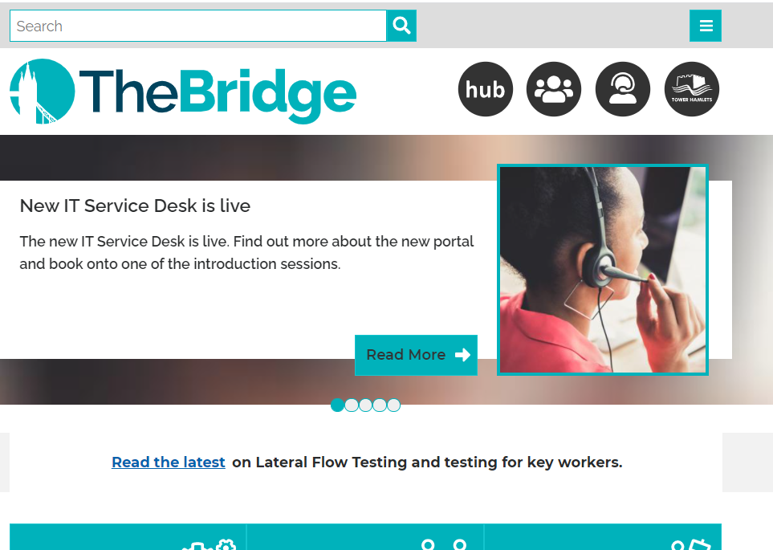
Click on the IT Self Service Icon

You will be then taken to the service desk homepage.
This is a screenshot image showing the service desk homepage. Type eEHA into search criteria and click search.
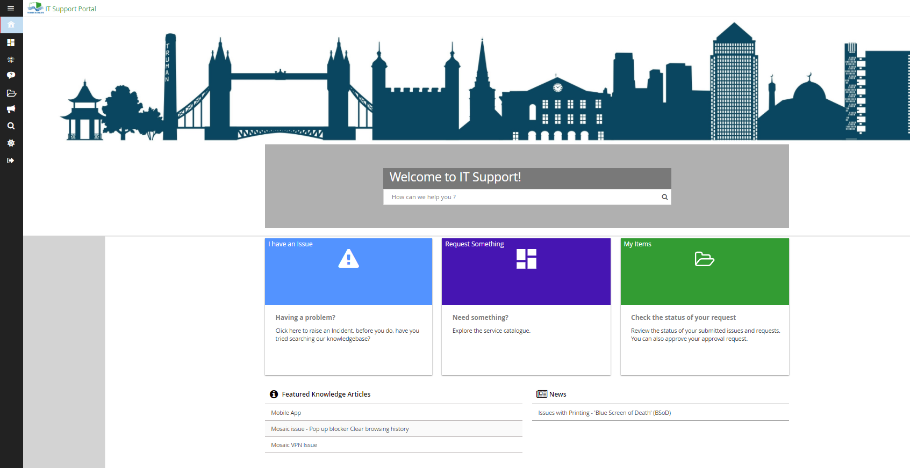
Type EHA into search box here and click search button.

You will be presented with following screen giving you 2 options with forms:
- Incident Form (First Form) – Use this form to report any problems you are having with the Holistix Early Help Assessment (EHA) System
- Service Request Form (Second Form) – Use this form for all general enquiries such as password resets, case access requests or for exceptional requests such as deleting an assessment.
Click and Select the appropriate form as required

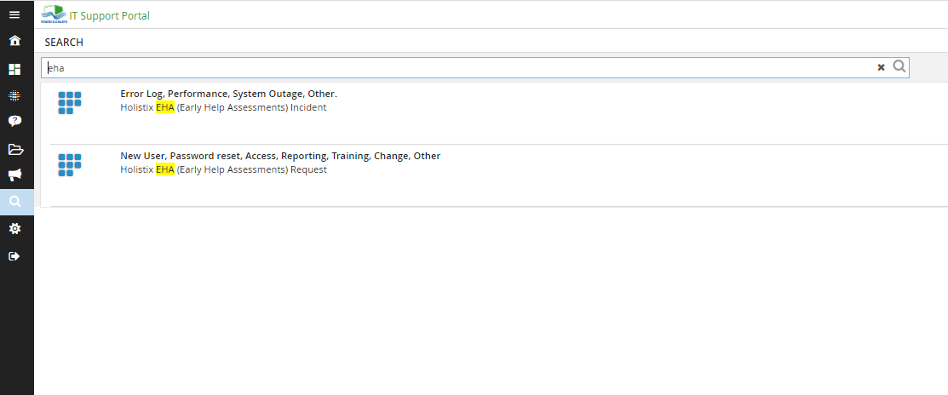

EHA Incident Reporting: This form is used for reporting issues and problems with the EHA system and usually actioned by the Early Help IT team within 24 hours.
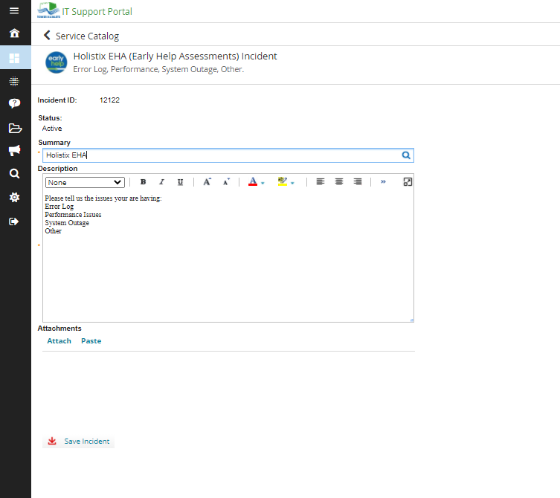
Fill in the form with as much information as possible

Click the button to save the incident

EHA Service Request: This form is used for more general queries and request and usually acknowledged by the Early Help IT team with 24 hours and may take longer to resolve depending on the type of request.
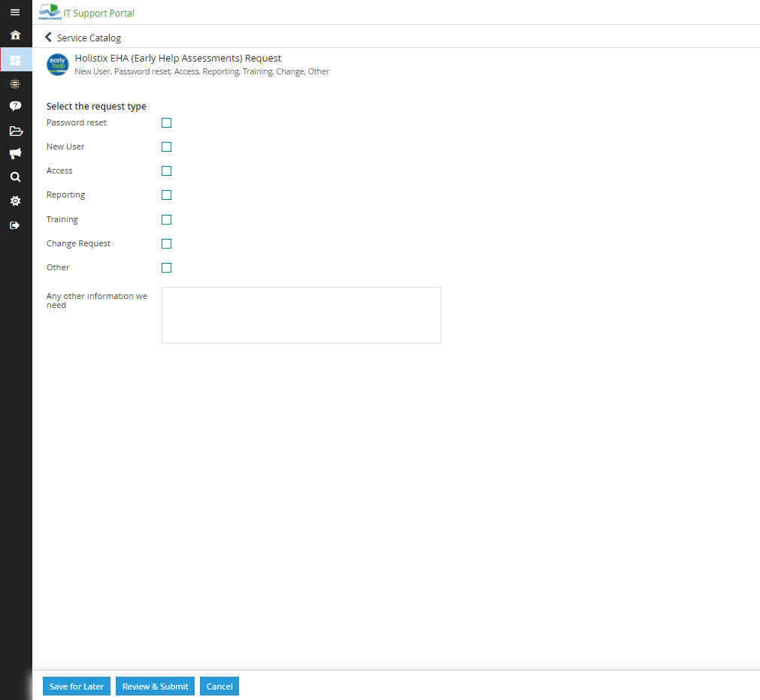
Click the button to save your request for later (it will not be submitted at this stage)

Click the button to review and submit your request

Fill in the form with as much information as possible

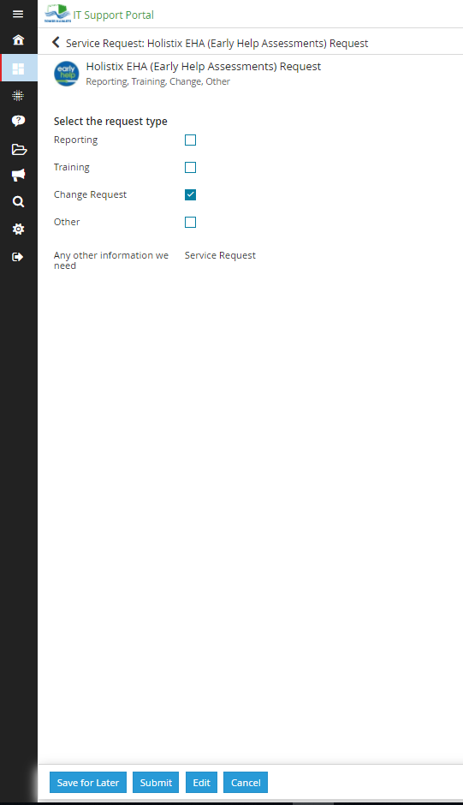
Click the button to submit your request

