

Parenting & Adult Education

Directory

# Welcome:

Spring Term January – March 2022 **V4**

As part of the Ealry Help, Children and Families Service, the Parenting and Adult Education (PAE) teams work is to coordinate courses, programmes and employment pathways for families with children pre-birth – 19 years old. We focus our offer on enabling Early Steps into Parenting and Education which includes:

* Increasing parenting capacity and knowledge
* Access to education and training
* Employability & good job opportunities

We offer a variety of courses and programmes which are delivered on a termly basis and work with a range of different training providers and organisations for which we have an eligibility criteira. Further information on this is available in the *How to apply* section.

Exclusive to our service, our offer includes crèche provision on site which means you can bring your child and leave them with the Nursery Nurses whilst you learn. It is important to note that spaces are limited and provided on a first-come first-served basis.

This directory outlines in detail the programmes and courses on offer, course content, time and duration of programmes and how to apply. If however you need further information please speak to a member of staff at your local Children and Family Centre.

**Eligibility & How to Apply:**

All our courses and programes are **Free** if you have lived in Tower Hamlets for the last 3 years or more, are registered with a Children and Family Centre, Unemployed on Benefits or if your household income is less than £21,157.50 per annum. Further information on this is available in the *How to apply* section.

We look forward to working with you and receiving your booking requests.

**Parenting & Adult Education Team**

Early Help, Children and Family Service

# Parenting Programmes:

Below is a list of information for all scheduled parenting programmes. If you would like to apply for any of the programmes, please follow the instructions on the *How to apply* section.

|  |  |  |  |  |  |  |  |
| --- | --- | --- | --- | --- | --- | --- | --- |
| Programme: | Delivery Type: | Venue: | Crèche: | Duration: | Start Date: | Session Day & Times | End Date: |
| Understanding Autism | Classroom | MG-CFC | Yes | 12 Weeks | 7th January 2022 | Fridays  9:00am-2:00pm | 28th March 2022 |
| *Positive Change | Classroom | JS-CFC | Yes | 12 Weeks | 13th January 2022 | Thursdays  10:00am-12:30pm | 31st March 2022 |
| Managing Challenging Behaviour | Classroom | MO-CFC | Yes | 12 Weeks | 12th January 2022 | Wednesdays 9:00am-2:00pm | 30th March 2022 |
| Safeguarding & Prevent | Classroom | CS-CFC | Yes | 12 Weeks | 18th January 2022 | Tuesdays  12:00pm-3:00pm | 29th March 2022 |
| Children & Young Peoples Mental WellBeing | Classroom | OC- CFC | Yes | 12 Weeks | 13th January 2022 | Thursdays  9:00am-2:00pm | 31st March 2022 |
| Common Childhood Illness | Classroom | MA- CFC | No | 12 Weeks | 12th January 2022 | Wednesdays 9:00am-2:00pm | 30th March 2022 |
| *Mums Matter | Classroom | JS-CFC | Yes | 6 Weeks | 11th January 2022 | Tuesdays  10:00am-12:00pm | 15th February 2022 |
| Healthy Eating | Online | Online | No | 6 Weeks | 10th January 2022 | Mondays  6:00pm-7:30pm | 14th February 2022 |

*Please note when booking onto these parenting programmes, you will need to apply via the Children and Family Centres and you will need to complete a Provider Referral Form. Information on the type of referral form required is available on the *How to apply* [section](http://www.hemingwayapp.com/#_How_to_Apply?).

# Parenting Programmes: *continued…*

|  |  |  |  |  |  |  |  |
| --- | --- | --- | --- | --- | --- | --- | --- |
| Programme: | Delivery Type: | Venue: | Crèche: | Duration: | Start Date: | Session Day & Times | End Date: |
| *Tackling Healthy Habits | Classroom | OC-CFC | Yes | 6 Weeks | 23rd February 2022 | Wednesdays  10:00am-12:30pm | 30th March 2022 |
| *Healthy Cultural Living | Classroom | OG-CFC | Yes | 6 Weeks | 23rd February 2022 | Wednesdays  12:30pm-3:00pm | 30th March 2022 |
| *Change for Good | Classroom | MO-CFC | Yes | 10 Weeks | 17th January 2022 | Mondays  10:00am-11:30am | 28th March 2022 |
| First Aid | Classrom | AP- CFC  OV-CFC  MO-CFC  OC-CFC | Yes | 1 Day | Dates TBC | 9:00am-1:00pm | - |

*Please note when booking onto these parenting programmes, you will need to apply via the Children and Family Centres and you will need to complete a Parenting Referral Form. Information on the type of referral form required is available on the [*How to apply* section](http://www.hemingwayapp.com/#_How_to_Apply?).

# Parenting Programmes: *continued…*

The information provided below gives you a brief overview on each programme. This is to enable you to decide which programme is best suited for you to apply for, based on your needs.

|  |  |  |  |
| --- | --- | --- | --- |
| Programme: | Duration: | Learning Hours: | Course Content: |
| Positive Change | 12 Weeks | 3 hours per week. | Programme is for mothers who have experienced domestic abuse. It supports mums to build on their relationship with their children. Raise awareness of conflict within their home. Classes will give mothers the opportunity to meet and share with other mums who have had similar experiences. You will explore the impact of conflict and strengthen the bond between you and your family. |
| Strengthening Families Strengthening Communities (SFSC) | 13 Weeks | 3 hours per week. | Programme is for parents with children 0-18 years old and is designed to promote effective behaviour management with children. As well as encouraging community involvement with parents. You will learn new skills for communicating with children. You will discuss and practice positive discipline and setting boundaries. You will explore ways to reduce conflict and challenge behaviour. You will also learn about child development. |
| Understanding Autism | 12 Weeks | 4 hours per week. | Programme is for all parents who wish to increase their knowledge and understanding of autism. You will learn what autism means and how it is diagnosed. Understand the characteristics that may be present in people with autism. Learn about conditions that commonly co-occur with autism and understand common misconceptions surrounding autism. |
| Incredible Years | 12 Weeks | 3 hours per week. | Incredible Years programme aims to strengthen the relationship and bond between the parent and the child, improve parent - child interaction, reduce behavioural difficulties through increasing the use of positive parenting and behaviour management strategies and build and promote the child’s social and emotional skills |
| Managing Challenging Behaviour | 12 Weeks | 4 hours per week. | Programme looks at behavior that challenges. Learn how to support positive behaviour. You will learn the importance of effective communication and management of challenging behaviour. Understand how to support those involved in incidents of challenging behaviour. |

# Parenting Programmes: *continued…*

|  |  |  |  |
| --- | --- | --- | --- |
| Programme: | Duration: | Learning Hours: | Course Content: |
| Mums Matter | 6 Weeks | 3 hours per week. | Programme aimed at any mother who has become unwell with mental health during the post natal period. This programme is early intervention care for those in need teaching them resilience and ways to manage their wellbeing and development. CBT techniques are used as part of each session. |
| Safeguarding & Prevent | 12 Weeks | 3 hours per week. | The purpose of this qualification is to increase learner’s knowledge and awareness of their duty and safeguarding. This includes online safety. By completing this qualification, learners will develop knowledge of safeguarding in an environment where they have a duty of care. |
| Made of Money | 4 Weeks | 2 hours per week. | This workshop covers topics on how to spend and save money and explores how to manage debt and the different types of finances. |
| Children and Young Peoples Mental Health | 12 Weeks | 3 hours per week. | If you want to learn about mental health issues to support children and young people that you work with, or those you care for in your own life, this course is perfect for you. IT will teach you about supporting children and young people’s mental health and emotional well-being. You will learn about issues facing children and young people like depression, anxiety and conduct disorder, as well as factors that affect their mental health and the impact mental health problems can have on them and their |
| First Aid | 2 Weeks | 3 hours per week. | This is a non accredited pediatric first aid course which covers various kinds of serious injuries and how to assess them before getting medical attention. Choking, CPR, head trauma, bleeding and broken bones are some of the topis covered. |
| Healthy Eating  Tackling Healthy Habits  Healthy Cultures  Change for Good | 6 Weeks  6 Weeks  6 Weeks  12 Weeks | 2 hours per week. | These courses are for people who would like to learn to cook healthy, tasty and budget friendly meals using minimum equipment. The different workshops touch on cultural differences, sharing good practice and advise on how to improve standards of health at home. If you have little or no cooking experience, you will learn basic techniques. There will be many resources for you to access: recipes, nutritional and health related information. |

# Adult Education:

Below is a list of information for all scheduled adult learning courses. If you would like to apply for any of the programmes, please follow the instructions on the *How to apply* section.

|  |  |  |  |  |  |  |  |  |
| --- | --- | --- | --- | --- | --- | --- | --- | --- |
| Course: | Delivery Type: | Venue: | Crèche: | Duration: | Assessment Date: | Start Date: | Session Day & Times: | End Date: |
| *Childcare L1 | Classroom | MO-CFC | No | 10 Weeks | 13th January 2022 | 20th January 2022 | Thursdays  9:00am-2:00pm | 31st March 2022 |
| *Heath & Social Care L1 | Classroom | CS-CFC | No | 10 Weeks | 13th January 2022 | 20th January 2022 | Thursdays 9:00am-2:00pm | 31st March 2022 |
| *Advice & Guidance L1 | Classroom | OV-CFC | No | 10 Weeks | 10th January 2022 | 17th January 2022 | Mondays  9:00am-2:00pm | 28th March 2022 |
| *Business Admin L1 | Classroom | MO- CFC | No | 10 Weeks | 7th January 2022 | 14th January 2022 | Fridays  9:00am-2:00pm | 25th March 2022 |
| *Helping in Schools L2 | Online | Online | No | 10 Weeks | 11th January 2022 | 18th January 2022 | Tuesdays  9:30am-1:30pm | 29th March 2022 |
| *Community Interpreting L2 | Online | Online | No | 10 Weeks | 10th January 2022 | 17th January 2022 | Mondays  9:30am-1:30pm | 28h March 2022 |
| *Functional Skills Maths E3-L1 | Classroom | MG-CFC | No | 22 Weeks | 11th January 2022 | 18th January 2022 | Tuesdays  9:00am-1:00pm | 29th March 2022 |
| *Functional Skills English E3-L1 | Classroom | CW-CFC | No | 22 Weeks | 13th January 2022 | 20th January 2022 | Thursdays  9:00am-1:00pm | 31st March 2022 |
| Personal Development | Classroom | TBC | No | 4 Weeks | - | 21st February 2022 | Mondays 10:00am-12:00pm | 14th March 2022 |

*Please note when booking onto these adult education courses,you will need to ensure you meet course entry requirements and an eligibilty criteria to qualify for free funding. Further information is available on the *How to apply*  section.

# Adult Education: *continued…*

The information provided below gives you a brief overview on each course. This is to enable you to decide which course is best suited for you to apply for, based on your needs.

|  |  |  |  |  |
| --- | --- | --- | --- | --- |
| Course: | Levels: | Duration: | Learning Hours: | Course Content: |
| Community Interpreting | 1, 2, 3 | L1-8 Weeks L2- 12 Weeks  L3- 22 Weeks | 3 hours per week. | Aimed at learners who speak fluent English and another community language. Learners who want to develop their linguistic skills and knowledge to develop a career as a community interpreter. |
| Health and Social Care | 1, 2 | L1- 12 Weeks  L2- 12 Weeks | 5 hours per week. | Health and Social Care qualifications provide learners with the knowledge and skills needed to work with some of society’s most vulnerable people including the elderly, children, and adults with learning difficulties. |
| Childcare | 1, 2, 3 | L1-12 Weeks L2- 12 Weeks  L3- 22 Weeks | 5 hours per week. | This qualification is to help learners to build the knowledge and skills needed when working with children and young people from pre-birth to 19 years of age. It covers a diverse range of job roles and occupational areas working in children’s settings including early years and social care. Levels on offer are 1 and 2. Level 3 requires learners to apply for an Advanced Learner Loan. |
| Helping in Schools (Teaching Assistant) | 1, 2 | L1- 10 Weeks  L2- 12 Weeks | 4 hours per week. | A short course to explore how literacy and numeracy is fundamental in primary schools. How to manage behaviour. Develop knowledge and understanding that all those working in a school and college will need. Cover areas such as children and young people’s development, safeguarding, communication, equality and diversity. Understanding the school and college context. |
| Functional Skills English | E3- L1 | 22 Weeks | 3 hours per week. | GCSE equivalent accredited qualification for those learners who are looking to gain English accreditation. Levels on offer are 1 and 2. |

# Adult Education: *continued…*

|  |  |  |  |  |
| --- | --- | --- | --- | --- |
| Course: | Levels: | Duration: | Learning Hours: | Course Content: |
| Personal Development/ Aspirations | - | 4 Weeks | 2 hours per week. | Short workshops on gaining confidence and understanding employment setting protocols. Discuss career plans and how to achieve goals and targets. |
| Business Admin | 1, 2 | L1- 12 Weeks  L2- 12 Weeks | 5 hours per week. | This qualification covers a wide range of administrative functions. For individuals looking to develop their skills and knowledge to work in an office. |
| Customer Service | 1, 2, 3 | L1-12 Weeks L2- 12 Weeks  L3- 22 Weeks | 5 hours per week. | This qualification provides the underpinning knowledge required by employees to work in a range of customer service roles. Learners will get essential knowledge on how to carry out tasks such as managing information and supporting events. |
| Information Advice & Guidance | 1, 2 |  | 5 hours per week. | If you give information, advice, or guidance as part of your role, this course can help you brush up on your skills and make sure you're aware of the fundamental rules for successful information sharing. This course covers communication techniques, interpersonal skills, and group interactions, as well as how to store and retrieve information in a way that complies with the law. |
| Functional Skills Maths | E3- L1 | 22 Weeks | 3 hours per week. | GCSE equivalent accredited qualification for those learners who are looking to gain their maths accreditation. Levels on offer are 1 and 2. |

# ESOL - English for Speakers of Other Languages:

Below is a list of information for all scheduled ESOL courses. If you would like to apply for any of the courses, please follow the instructions on the *How to apply* section.

|  |  |  |  |  |  |  |  |  |
| --- | --- | --- | --- | --- | --- | --- | --- | --- |
| Session Title | Delivery Type: | Venue: | Crèche: | Duration: | Assessment Date: | Start Date: | Session Day & Times: | End Date: |

|  |  |  |  |  |  |  |  |  |
| --- | --- | --- | --- | --- | --- | --- | --- | --- |
| ESOL | Classroom | JS-CFC | Yes | 10 Weeks | 10th January 2022 | 17th January 2022 | Mondays 1:00pm-3:00pm | 28th March 2022 |
| ESOL | Classroom | OG-CFC | No | 10 Weeks | 5th January 2022 | 19th January 2022 | Wednesdays 9:30am-11:30am | 30th March 2022 |
| ESOL | Classroom | CW-CFC | Yes | 10 Weeks | 7th January 2022 | 21st January 2022 | Fridays  9:30am-11:30am | 25th March 2022 |
| Pre-Entry ESOL | Classroom | SH- CFC | No | 10 Weeks | 17th January 2022 | 24th January 2022 | Mondays  10:00am-12:00pm | 28th March 2022 |

# ESOL - English for Speakers of Other Languages: *continued…*

|  |  |  |  |  |
| --- | --- | --- | --- | --- |
| Course: | Levels: | Duration: | Learning Hours: | Course Content: |
| ESOL (Family Learning) | E1-L1 | 10 Weeks | 2 hours per week. | ESOL stands for English for Speakers of Other Languages. It’s aimed at non-native English speakers looking to take up a new language or confirm their skills. If you would like to improve your speaking, listening and writing skills but struggle, ESOL is the best starting point. Levels on offer are E1, E2, E3 and L1. Please note the level for each course is set following results from the assessments. |
| Pre Entry ESOL | PE-E1 | 10 Weeks | 2 hours per week. | Pre-Entry ESOL is the most basic entry level ESOL aimed at those learners with no or very little knowledge and understanding of speaking, listening and writing English. This course is an introduction level enabling learners to access entry level courses. ESOL stands for English for Speakers of Other Languages. It’s aimed at non-native English speakers looking to take up a new language or confirm their skills. If you would like to improve your speaking, listening and writing skills but struggle with English now, Pre-Entry ESOL is the best starting point. |
| Conversation Clubs | E1-E3 | 6 weeks | 1 hours per week. | Conversation Club will provide language practice to parents/carer's who couldn’t access ESOL classes (due to long waiting list or COVID-19 restrictions). Sessions will provide English practice and some basic English teaching together with quite a lot of orientation, cultural input. We encourage communication in the group and provide advice to parents about support and services provided by IEYS and TH council. Along with developing English skills this course will fight isolation and ease the building of network in the community. |

# How to Apply:

All our programmes and courses are delivered in partnership with training providers and organisations. As a result of which for some there may be a set application process, a selection criteria or entry requirements which you will need to meet to be eligible. For details on eligibility please see the detailed chart below.

To access any of our parenting programmes you will need to meet all the criteria in section 1 in **Blue:**

**Section 1**

|  |  |  |
| --- | --- | --- |
| **Tower Hamlets Resident** | **Have a Child Pre Birth – 19 Years Old** | **Registered with a Children and Family Centre** |

All our parenting programmes are free to attend providing you live in Tower Hamlets and have a child pre-birth - 18 years old. Parenting programmes highlighted with a * will require you to **consent to completing a Referral Form** at the Children and Family Centre which is **mandatory**. Depending on the programme the relevant referral form will be provided at the centre when you apply.

Adult education & ESOL courses are fully funded, providing you meet all the criteria in **Blue** in section 1 & 2 in addition to **one** of the set criteria’s below in **Orange**

**Section 2**

|  |  |  |  |
| --- | --- | --- | --- |
| **Lived in the UK/EU 3 Years or More** | **Unemployed** | **Household Income less than £21,157.50 Per Annum** | **In receipt of Out of Work Benefits.** |

Please note for some programmes you are also required to meet entry requirements which are course dependent and vary accordingly. If you have any questions in relation to your criteria status or to discuss this further please contact the Parenting Adult Education Team.

# How to Apply: *continued…*

Do you meet the relevant criteria above for your selected programme/course?

|  |  |
| --- | --- |
| **YES** | Follow instructions below on how to apply for your chosen programme or course. |
| **NO** | Contact the PAE team to discuss your individual circumstances and receive further guidance & support. |

**How to Apply:**

**Attend your local Children and Family Centre and book your name onto the course?**

Once you attend a Children and Family Centre, a member of the team will take your EISi ID number and add you onto the relevant programme/course booking waiting list. In the instance this is a parenting programme, you will be required to provide consent to complete a Parenting Referral Form. Staff at the centres will confirm your personal details now to ensure our information is up to date and you will also have the opportunity to highlight any support needs. Please don’t forget to mention if you will need the use of crèche.

**Complete an online Parenting Adult Education Course Enquiry Form?**

You can access our enquiry form here <https://forms.office.com/r/GLiv8sDXnt>

Once completed and submitted your information will be sent to the PAE team to process and add to the relevant waiting list.

**How will I know I have been offered a place?**

A member of staff from the Early Help and Children and Family Service will contact you two weeks before the programme/course assessment or start date to invite you in and confirm your place on the course.

**What should I do if I have not received a call or been offered a place?**

If you do not receive a call it may mean you do not have a place on the course due to our long waiting lists, nonetheless you will remain on the waiting list until we deliver the course again and you will be contacted then. You can contact the PAE team to discuss further and to check your status.

# How to Apply: *continued…*

**What happens if I turn up to a programme/course without booking or confirmation?**

It is your responsibility to ensure that you have a place before you arrive at one of our programmes/courses. Our venues hold a specific number of people and these are allocated via our booking system. If they are overfilled, we are in breach of Health and Safety Regulations. So, people turning up on the day without prior booking may be turned away.

**Waiting list**

For all our programmes/courses we have a waiting list. If you are not offered a place for your preferred date, you will remain on the list until the next date becomes available. In certain cases, places may become available due to cancellations and we will make every effort to contact you to book you in. Please note in cases where we have long waiting lists, we make every effort to arrange more programmes/courses to meet the needs of our families.

**Refreshments**

Refreshments are not provided as part of our programmes/courses. But, certain venues have their own arrangements. We request families to make their own arrangements in relation to refreshments for themselves and their children (if they are placed in the crèche).

**Parking**

The venues we use do not have parking facilities. All our centres may have resident/pay-and-display on-street parking. Please plan well ahead when travelling to the venues.

# Employment Support:

Children and Family Centres have a range of dedicated employment services available for families looking to access and discuss their employability needs. Below we have outlined our service providers and their outreach schedule, eligibility criteria and how to access the service.

**Supporting Stronger Families**

Supporting Families Employment Advisers are here to support you and your family overcome barriers to work and prepare you to be job ready. Their aim is to help you discover, develop, and reach your goals. The support is tailored depending to your needs and what you want to achieve.

In order to access the support the family must have meet an eligibility criterias, to discuss this further please contact your local outreach team advisor.

To refer please complete the [Inquiry Form](https://gbr01.safelinks.protection.outlook.com/?url=https%3A%2F%2Fforms.towerhamlets.gov.uk%2Fservice%2Fehenquiries&data=04%7C01%7CZubair.Ahmed%40towerhamlets.gov.uk%7Cb0f5d47e6bd44252bcae08d9b57a8ef6%7C3c0aec87f983418fb3dcd35db83fb5d2%7C0%7C0%7C637740360252113974%7CUnknown%7CTWFpbGZsb3d8eyJWIjoiMC4wLjAwMDAiLCJQIjoiV2luMzIiLCJBTiI6Ik1haWwiLCJXVCI6Mn0%3D%7C3000&sdata=wEvOVf%2BPWSn2d6tlzdahSa%2F%2FdwD9xPG9GJkSoqCcrQM%3D&reserved=0) or contact Early Help Hub on 0207 364 5006 Option 2.

To discuss your circumstances or if you have any questions please contact the outreach advisor based at your local centre.

# Employment Support: *continued…*



**WorkPath**

WorkPath is a unique employment service for all Tower Hamlets residents, providing support for people at all levels of work, skill or experience. They can provide employment support tailored to your needs, whether you need basic skills or advanced training; access to work experience, apprenticeships or graduate schemes; CV help, interview preparation and more.

Their job is to give you the right mentoring, support and helping hand that you need, so you can move forward on your path to employment and realising your full potential.

WorkPath is available to all residents who live in Tower Hamlets, if you would like to access their service please contact your local your local Children and Family Centre who will assist you complete a referral to your local advisor.

If you have any questions or queries please contact:

Tel: 020 7364 5000  
[workpath@towerhamlets.gov.uk](mailto:workpath@towerhamlets.gov.uk)

# Employment Support: *continued…*

**NHS Talking Therapies Employment Service**

The NHS Talking Therapies Employment Team is part of the NHS psychological treatments service for mental health and emotional problems like stress, anxiety and depression.

The structure and routine of employment can help reduce mental health difficulties faced by our patients. The team strives to ensure that patients encountering common mental health difficulties can access employment opportunities and enjoy working life.



Working closely with our patients and employers we can help reduce stress and anxiety associated with finding work, returning to work and remaining in work.

Eligibility

To be eligible for the service, patients must be:

* Aged 18 years or over
* A resident of Tower Hamlets
* Regsitered with a GP
* Open to receiving IAPT talking therapies

To discuss referrals please speak to the local advisor based at your local centre.

If you have anyother questions related to employment support that you need advice and guidance on, please liaise with the PAE team direct.

# Interested in Becoming a Childminder?

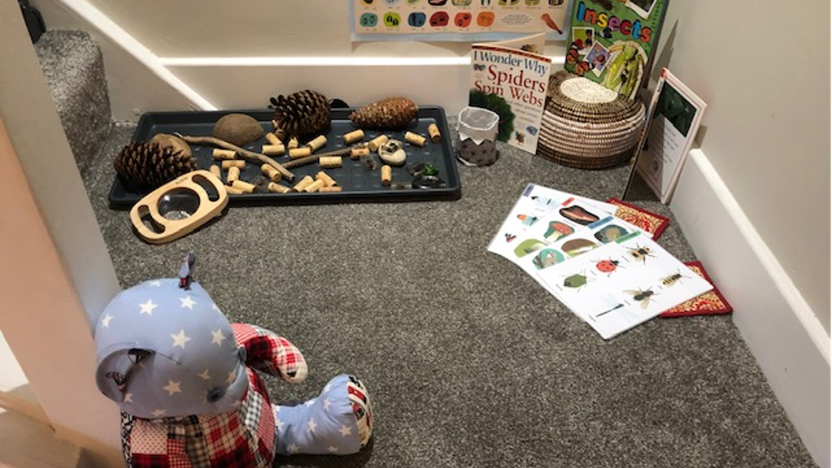

Registered childminders are self-employed and run their own business from their home, caring for other people’s children. They provide a home-based childcare setting for small groups of children of different ages.

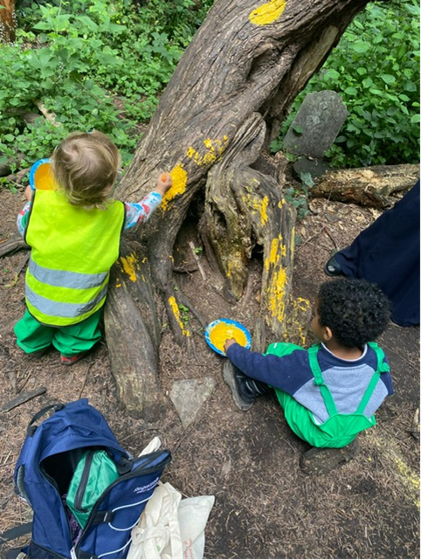

Working as a childminder is a very rewarding career especially when your own children are young. This gives you the opportunity to be able to care for your own children while you work from home.

The Early Years Advisors provide Tower Hamlets residents with guidance into childminding through our information session which is delivered monthly over a 2 hour period.

They offer group information sessions led by the Early Years Advisors who will provide in-depth advice on the process of becoming a registered childminder, including details on how to register with Ofsted, costings involved and if this is the correct career path for you.

For further information and details on how to book onto the next session please contact:

Julie Ulla:  07961 831 660/ Brenda Lubrun: 07966 089 251

[early.years@towerhamlets.gov.uk](mailto:early.years@towerhamlets.gov.uk)

# Free Childcare Information:

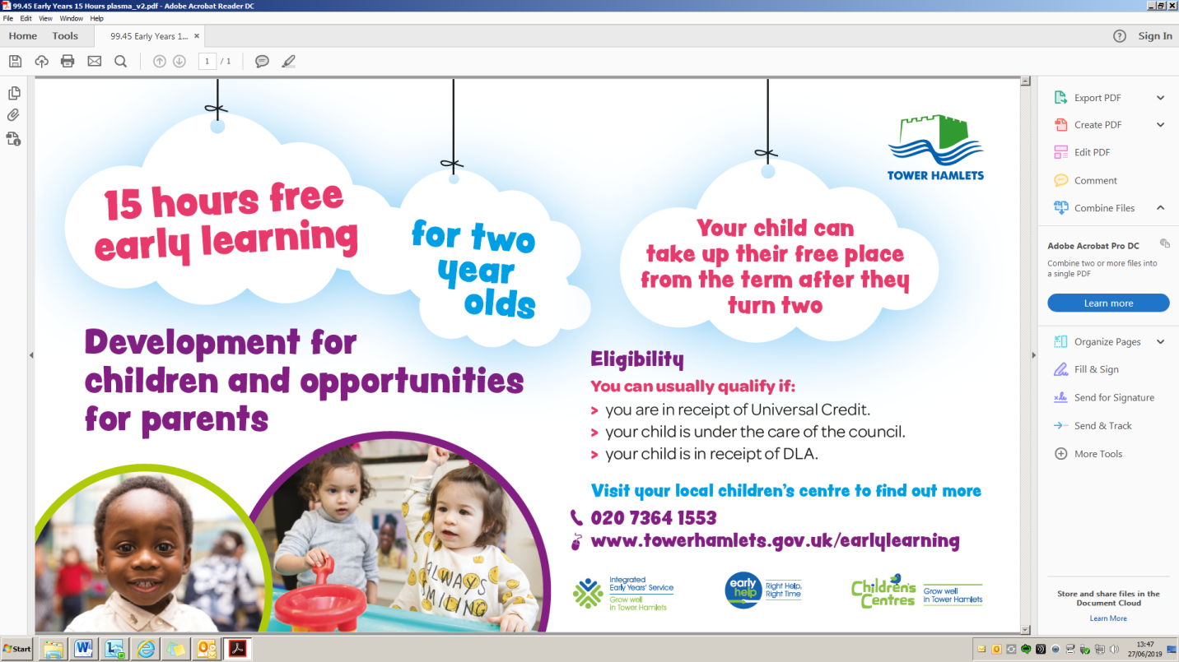

# Venue Information and Contact Details:

Below is a list of addresses and contact details for all the Children and Family Centres in Tower Hamlets.

|  |  |  |
| --- | --- | --- |
| Venue Key Code: | Venue Address: | Venue Contact Details: |
| AP-CFC | Around Poplar, 115 Three Colt Street, London E14 8AP | 020 7364 0540 |
| CS-CFC | Chrisp Street, 45 Kerbey Street, London E14 6AW | 020 7364 2856 |
| IOD-CFC | Isle of Dogs, Millwall Park, Stebondale Street, London E14 3BX | 020 7364 1179 |
| MA-CFC | Marner, Devas Street, London E3 3LL | 020 7364 3534 |
| ME-CFC | Mile End, 9 Bede Square, Joseph Street, off Bow Common Lane, London E3 4GY | 020 7364 7557 |
| OV-CFC/ OG-CFC | Overland, 60 Parnell Road, London E3 2RU  Olga, 25 Medway Road, London E3 | 020 7364 1925/ 3100 |
| JS-CFC | John Smith, 90 Stepney Way, London E1 2EN | 020 7364 0537 |
| OC-CFC  SH - CFC | Ocean, Whitehorse Road, London E1 0ND  Shadwell, 418-412 Cable Street, London E1 0AF | 020 7364 6605/0544 |
| WA-CFC | Wapping, 15 Richard Street, London E1 2JP | 020 7364 0423 |
| MG-CFC | Meath Gardens, 1 Smart Street, London E2 0SN | 020 7364 0349 |
| MO-CFC | Mowlem Children’s Centre, Wadeson Street London E2 9DL | 020 7364 7935 |
| CW-CFC | Collingwood, St Bartholomew Gardens, Buckhurst Street, London E1 5QT | 020 7364 0539 |
| IS- CS | Idea Store Chrisp Street, 1 Vesey Path, East India Dock Road, London E14 6BT | 020 7364 4332 |

If you would like to discuss our courses or to receive information and advice, please contact the

**Zubair Ahmed**

020 7364 2240

077 7338 4947

**Syeda Pasha**

020 7364 0421

079 8427 7662

[PAE@towerhamlets.gov.uk](mailto:PAE@towerhamlets.gov.uk)