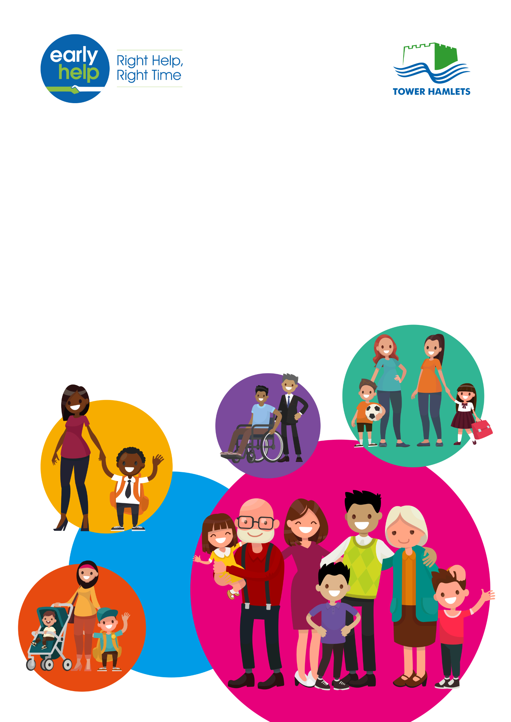

**Schools Guide to Early Help**

**October 2018**

For updates and more information on Early Help please go to [www.towerhamlets.gov.uk/earlyhelp](http://www.towerhamlets.gov.uk/earlyhelp)

**Table of Contents**

Part 1: Early Help and Schools 3

1. Introduction 3

2. What we mean by Early Help 5

3. Tower Hamlets Vision for Early Help 7

4. Legislation, Schools and Early Help 7

5. Ensuring that pupils and their families have access to Early Help 7

6. Early Help Hub (EHH) 10

7. Early Help Enquiry Form 11

Part 2: Advice for schools on Early Help best practice 12

Part 3: Advice for schools on developing an Early Help offer 13

Appendix 1: Early Help Pathway in Tower Hamlets 14

Appendix 2: Who is the named Early Help key decision maker in the school? 15

Appendix 3: Is at least one member of staff in the school trained in the use of the eEHA System? 16

Appendix 4: What is the school’s Early Help offer? 17

Appendix 5: Do pupils, parents/carers and staff know how to access Early Help support within school? 18

Appendix 6: Developing a schools Early Help Offer 19

**Part 1: Early Help and Schools**

1. **Introduction**

Children and young people deserve to achieve the best possible outcomes. This is a key objective set out in Tower Hamlets Children and Families Plan 2016 – 2019; and in its Early Help Strategy 2018 - 2021.

Most children do very well in the borough, but too many experience significant disadvantages which are not always addressed as soon as problems emerge. Instead problems are, all too often, left until they become more serious.

This document is intended to be a guide to Early Help for schools and other educational settings. It has been compiled by a task and finish group comprised of head teachers nominated by the Tower Hamlets schools consultative forum. In addition to this we have looked at good practice across a number of local authorities and in particular Leicestershire.

The objective of this guide is to ensure that:

* Pupils, parent/carers and staff are clear on the Early Help support available to the school from Tower Hamlets and the Early Help Hub;
* Partners, that work alongside schools to support families, have clarity regarding the Early Help offer to schools;
* There is effective multi-agency working;
* Schools are supported to recognise that much of the work that they already do can be described as Early Help
* Schools are supported around the delivery of statutory duties in relation to Early Help;
* Schools are able to evidence their commitment to the personal development and wellbeing strand of the Ofsted Framework.

It is necessary for both schools and the local authority to have a mutual understanding of what actions each will take in response to Early Help in order to ensure that pupils are effectively safeguarded.

We recognise that schools already put in a huge amount of support to pupils, which forms Early Help support. In a school setting, Early Help might include support to improve attendance, or behaviour, or to increase engagement with families with the aim of making school life a more positive experience for the pupil; or it could involve nurture groups, breakfast or after school activities, social skills groups or family learning opportunities.

Where families require early support or intervention, as schools already have regular contact and good relationships with pupils and their families they can often be the most suitable place for some Early Help to take place. However, we recognise that different sized schools have different challenges and different levels of funding which affects their Early Help offer to families.

The ultimate goal is to ensure all children, young people and families receive the right support, at the right time so that they get the best possible school experience and reduce the need for referral to statutory services.

In part two of this Guide schools are provided with descriptions of activities, practical suggestions and actions that schools are likely to already be taking or may want to consider and which all form part of Early Help.

**What we mean by Early Help**

Children and families that need Early Help often have a range of needs that have different levels of severity across a continuum. The diagram below demonstrates the continuum of needs that might apply to children and their families.

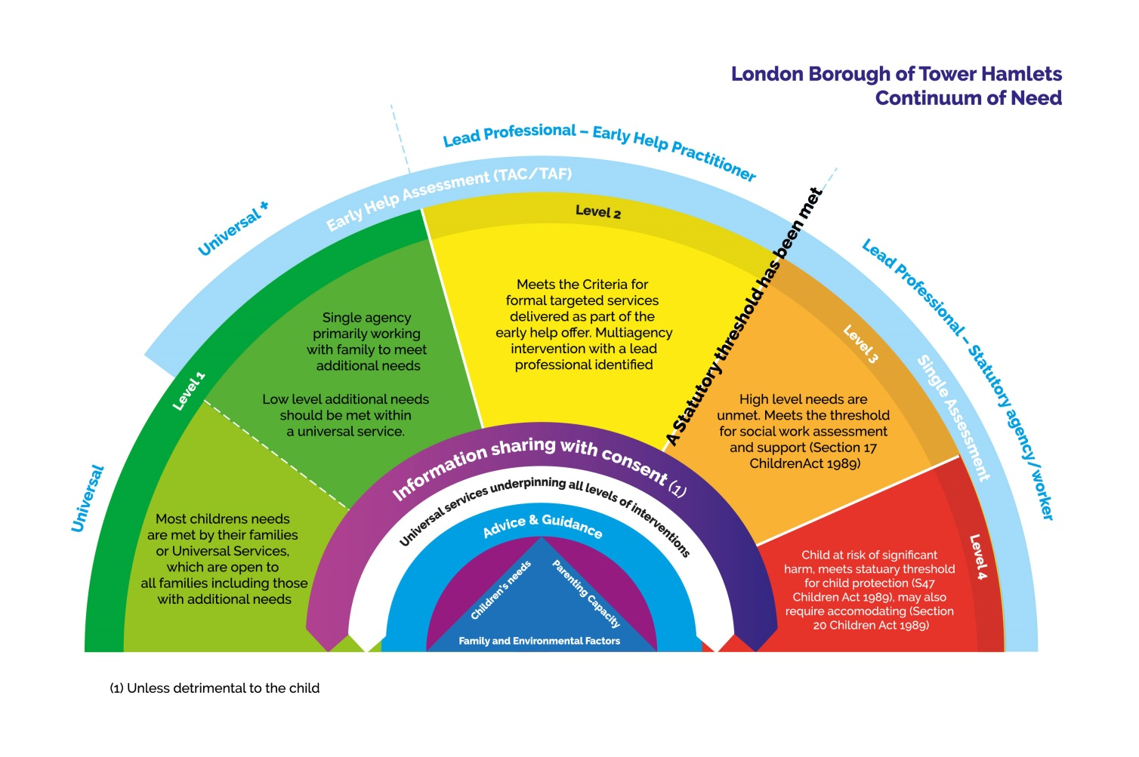

Early Help uses the Continuum of Need in order to understand the needs, strengths and risks associated with vulnerable children, young people and families.

Early Help means providing help to children and families as soon as needs emerge at any point in a child's life, including the prenatal stages and up to the age of 25 years for those with learning difficulties and or disabilities.

Early Help includes:

* Universal services - that all children and families can access like General Practitioners, early years settings and schools; and
* Targeted services – for children and families that have multiple needs which require a multi-agency intervention.

Our approach to Early Help is founded on the belief that if addressed early enough the emergent needs of children and their families can be prevented from escalating. We have therefore developed a clear and co-ordinated pathway (see appendix 1) for accessing Early Help that will support children who have a variety of needs or risk factors including:

* **Educational needs**: Children at risk of missing education; children with poor attendance; children not in education, training or employment; children at risk of exclusion; children with Special Education Needs and/or Disability (SEND) who do not meet the threshold of an Education Health Care Plan (EHCP); including children with a learning difficulty or disability.
* **Exploitation**: Children at risk of sexual exploitation; children at risk of gang involvement;
* **Violence or abuse:** Children at risk of domestic abuse/violence; children at risk of serious youth violence
* **Early abuse or neglect**: Children and young people at risk of suffering early abuse or neglect; children and young people at risk delayed physical development; children and young people at risk of delayed cognitive development;
* **Health**: Children at risk of substance misuse/abuse; children at risk of sexual health issues; risk of teenage pregnancy;
* **Emotional wellbeing/mental health**: Children at risk of self-harm or suicide;
* **Crime/antisocial behaviour**: Children at risk of involvement in crime and/or anti-social behaviour; children with socially unacceptable behaviours;
* **Homelessness**: Children at risk of homelessness; children at risk from family breakdown;
* **Other issues**: Children at risk of other issues which have necessitated a referral to Early Help e.g. concern about a young carer

The Local Authority in Tower Hamlets recognises that Early Help is a term that describes much of the everyday work of schools.

***The approach to Early Help***

“*Early Help in Tower Hamlets will work in partnership with families, children and young people to overcome difficulties and to build the resilience that will equip them to address challenges and seize opportunities in the future.”*

***Debbie Jones, Corporate Director of Children’s Services***

Effective Early Help is all about partnership and it relies upon local organisations and agencies working together in order to:

* identify children and families who would benefit from Early Help;
* undertake assessments of the need for Early Help;
* provide targeted Early Help services to address the assessed needs of a child and their family which focuses on activity to improve the outcomes for the child[1].

1. **Tower Hamlets Vision for Early Help**

Every family should get the right support at the right time to ensure that needs are addressed quickly; thus, preventing further escalation or crises; and ensuring that resources are put to the best possible use.

The approach is based on the belief that:

* Children and their families develop resilience if there are protective factors in place such as: a positive relationship with an adult, such as a teacher; good literacy and communication skills; good school attendance; and, parents in or actively seeking/ready for work;

* Children’s needs are best met when help is offered in a universal setting, such as a school, within a socially mixed group and early on when problems start to emerge;
* Children and young people’s needs are best met when addressed in the context of the whole family, meaning that parents/carers/siblings’ needs are addressed with consent as part of a holistic and integrated Early Help response

Early Help services should support and strengthen families so that they can thrive.

1. **Legislation, Schools and Early Help**

‘Working together to safeguard children’ (updated 2018) and ‘Keeping children safe in education for schools and colleges – guidance from 3 September 2018’ make it our joint responsibility to safeguard children; and to ensure that we take a coordinated approach to Early Help. Everyone who comes into contact with a child has a role to play in identifying concerns, sharing information and taking prompt action.

‘Keeping Children Safe in Education’ 2018[2] identifies clearly the role schools and colleges need to carry out in relation to Early Help. All school and college staff should be prepared to identify children who may benefit from Early Help. In the first instance, staff should discuss Early Help requirements with the designated safeguarding lead in the school. Staff may be required to support other agencies and professionals in producing an Early Help assessment.

1. **Ensuring that pupils and their families have access to Early Help**

All staff in schools should be aware of the Early Help process, and understand their role in it. This includes identifying emerging problems, liaising with the designated safeguarding lead, sharing information with other professionals to support early identification and assessment and, in some cases, where appropriate act as the lead professional in undertaking an Early Help assessment.

The following processes and structures have been identified as examples of best practice, which are already in place in many schools:

- **Identification of pupils with Early Help needs:** Schools have in place strategies to ensure that they are able to identify pupils that might benefit from Early Help e.g. inclusion panels within school;

* **Clear listing and publicising provision of day-to-day Early Help support:** Setting out your Early Help offer can improve how families work with you at the earliest opportunity.
* **Focused pastoral support:** Schools play a role in supporting families to address these difficulties through more focused pastoral support, which might include bringing in support via an external agency.
* **Early Help assessments:** Schools know the pupil and the family best and they are often best placed to contribute to Early Help Assessments. Schools need to have systems and processes in place so that they are able to contribute to assessments.

The local authority will work in partnership with schools to provide support to enable pupils to be safeguarded.

The Local Safeguarding Children’s Board (LSCB) also has an interest in working to support schools around Early Help. The table below explains the LSCB’s levels of need, and how this will be assessed in Early Help; who is responsible; and where support can be found. There are four thresholds in the LSCB guidance as described below:

**This picture describes the Tiers of need.

Level 1 - Universal Services
Level 2 - Targeted Early Help Services
Level 3 - Child in Need
Level 4 - Child Protection**

**Source**: Multi-agency Safeguarding September 2017 Threshold Guidelines

The LSCB's threshold levels will be used to determine the type of interventions that will be offered to address need.

The table below provides more detail on the application of the Early Help levels 1 and 2 in schools settings:

|  |  |  |  |
| --- | --- | --- | --- |
| **Identification of need Early Help need and support** |  |  |  |
|  | **Level 1** | **Level 1** | **Level 2** |
| **Level of Need** | **Universal**  Pupils with no additional needs or pupils whose developmental needs can be met through universal services. | **Universal*+***  Pupils with low level additional needs that are likely to be short-term but which are not being met. | There is a specific concern but the pupils’ additional needs are not clear, or are not fully known, or are not being met.  Pupils with additional needs that requires multiagency intervention |
| **Level of Need** |  | Your professional judgement is to be used to decide if single agency referral or coordinated multi-agency support is appropriate for the pupil. If in doubt contact the Early Help Hub or the designated safeguarding lead in the school | Your professional judgement is to be used to decide if single agency referral or coordinated multi-agency support is appropriate for the pupil. If in doubt contact the Early Help Hub or the designated safeguarding lead in the school |
| **How do you assess need?** | Schools will be expected to have their own method for assessing universal need. A suggested tool, which you can adapt is the Enquiry Form found in Appendix 7. The Early Help Service will work with schools to support a review of their Early Help Assessment processes to ensure that there is a consistent approach to assessing need. | Early Help Enquiry Form 1 | Early Help Assessment |
| **How do you access this stage of intervention** | At this level services are ‘open access’ or ‘universal’ meaning that they are generally available to all children and young people.  Universal services are those such as schools, leisure centres, GP surgeries, Youth Centres, Children’s Centres etc. and are accessible without either a referral or an assessment. | At this level services can only be accessed with consent:   * obtain consent from the parent or carer to share their information * complete the Early Help Enquiry Form 1 referral form and submit as directed on the form. | At this level:   * obtain consent from the parent or carer to share their information * complete an Early Help Assessment * bring together a Team Around the Family (TAF) to identify a Lead Professional and agree a support plan with clear objectives, outcomes, timescales and understanding |
| **Who is responsible for providing support at this stage?** | Universal services such as schools, leisure centres, GP surgeries, Youth Centres, Children’s Centres etc. | Universal services working with one other service, for example, a Children’s Centres, a school, a Youth Centres, Day-care, Early Help Hub etc. | Universal and targeted services working together to form a Team Around the Family. The Lead Professional will be identified from the TAF. |
| **Where do schools get advice?** | [http://www.localoffertowerhamlets.co.uk/ Tower Hamlets Family Information Service 020 7364 5006](http://www.localoffertowerhamlets.co.uk/Tower%20Hamlets%20Family%20Information%20Service%20020%207364%205006) (Option 4) | Single Point of Contact/Early Help Hub 020 7364 5006 (Option 2)  For MASH Team and out of hours Emergency Duty please press option 3. | Single Point of Contact/Early Help Hub 020 7364 5006 (Option 2)  For MASH Team and out of hours Emergency Duty please press option 3. |

1. **Early Help Hub (EHH)**

Calls to option 2 of the Children Services Hotline (0207 364 5006) are directed through to the Early Help Hub (EHH). The primary role of the hub is to provide a single point of access for the public, and all those working with children, young people and their families within the local community and across the local authority. The aim of the hub is to improve communication and information sharing across the local authority area, including internal and external partners and to support more effective delivery of services where there is a need for multi-agency response. The EHH has four main functions:

1. Providing information, advice and guidance to the public and professionals who have queries about children who may need a coordinated early help response.
2. Screening early help enquiries to ensure an appropriate level of response for children, young people and their families which include those cases referred across or redirected from children’s social care.
3. Where necessary, the exception rather than the rule, undertaking direct work with families to assess need before identifying the most appropriate lead-professional who can carry out the EHA, co-ordinate the family action plan.
4. Support practitioners to complete assessments and convene TAF meetings.

Upon enquiry the EHH practitioner should assess the case and inform you of the action required. This could be:

* If an EHA has already been completed or there is an existing TAF, you will be asked to share your information and join the TAF
* Single agency response for a specific piece of work – Lead Professional identified
* EHA required – Lead Professional identified
* No further action
* Escalation to Children’s Social Care if this case is already known to them or the information gathered during screening indicates escalation is required.

The Practitioner will also

* Offer Advice/Guidance
* Create an enquiry/contact record
* Triage requests for services (which may include contact with families as well as other professionals)
* Allocate enquiries/contacts to the most appropriate service (internal and external services and agencies)
* Inform the referrer of the outcome of the request by email or letter

The EHH only undertakes triage or discusses cases with consent however anyone can make a general enquiry and ask for advice without consent, as long no names are given.

The EHH does not replace the existing ‘Safeguarding Arrangements’ for Children’s Social Care in Tower Hamlets. If at any stage you have any concerns that a child is at risk of harm you must follow your agency’s safeguarding procedure and make a referral to the Multi Agency Safe Guarding Hub.

1. **Early Help Enquiry Form**

A generic Early Help Enquiry Form is used across the Early Help Services to ensure that enquiries/concerns are directed to the right service at the point of contact. This is in order to ensure that children, young people and their families receive the help they need at the earliest possible opportunity.

The form is primarily a screening tool which collects the basic demographic information of all family members alongside the initial identified concerns from which an appropriate service or services will be identified. It will be completed following an enquiry from a member of the public; a family member self-referring themselves for support or from a professional making contact on behalf of a family with **consent**; except where an enquiry is anonymous and/or where consent is overridden.

If contact is made over the phone the EHH Practitioner will go through the Early Help Enquiry form with you and complete this on your behalf alternatively there is an online form which schools, members of the public, family members and other professionals can complete directly. The benefit of an online form is that it allows an enquiry to be made outside of normal working hours. The system provides a receipt and a PDF copy of the submitted enquiry. The online form requires consent from families where their information is being shared.

It is anticipated that all internal agencies and external partners will use the enquiry form as a screening tool in the future and that this will be used in conjunction with the EHA. External agencies may be able to use the Early Help Enquiry Form to gain access to support for families in need of universal services and for advice and guidance through the Early Help Hub however, the **EHA will remain the main source of referral to targeted Level 2 Early Help Services**.

The Early Help Enquiry Form can be found online at [www.towerhamlets.gov.uk/earlyhelp](http://www.towerhamlets.gov.uk/earlyhelp) or through this link: https://bit.ly/2AA2WNy

**Please see Appendix 8 for more information on Early Hub and information poster.**

**Part 2: Advice for schools on Early Help best practice**

The questions below will help schools to ensure that they are delivering best practice in Early Help:

1. Does the school have an Early Help decision maker? (see appendix 2)
2. Is at least one member of staff in the school trained in the use of the electronic Early Help Assessment (eEHA) System? (see appendix 3)
3. Does the school have a clear, documented Early Help offer?
4. Do pupils, parents/carers and staff know how to access Early Help support within school? (see appendix 5)

By ensuring that there is a robust response to the above questions your school can ensure that:

* Pupils, parent/carers and staff are clear on the Early Help support available through the school
* That there is clarity for partners, supporting improved multi-agency working
* That there is evidence of the school’s commitment to the personal development and wellbeing strand of the Ofsted Framework

**Part 3: Advice for schools on developing an Early Help offer**

Schools may want to consider developing their own Early Help offer. The example lists presented at appendix 6 are intended to support schools in the development of their Early Help offer in the following areas:

1. Attendance
2. Transition
3. Social, Emotion and Mental Health
4. Staying Safe
5. Supporting Families
6. The Community

Schools can use the example lists at appendix 6 to:

* Define your schools Early Help offer (feel free to add your own provision – the list is not exhaustive).
* Identify data sources from which you can evidence the impact for Personal Development, Behaviour and Welfare Support services which have an impact on improving outcomes for students and their families.

Best practice would suggest that the list is signed off and dated and a review date agreed.

**Appendix 1: Early Help Pathway in Tower Hamlets**

This picture is a diagram, showing how the Early Help Pathway Works. It starts from a concern about a child to escalation to child protection.   

**Appendix 2: Who is the named Early Help key decision maker in the school?**

|  |  |  |  |
| --- | --- | --- | --- |
| **What** | **Who** | **Advice/Ideas for Implementation** | **Measurable Outcomes** |
| A key decision maker should have responsibility for Early Help as part of their understanding regarding the appropriate response to concerns about a child. | This could be your   * + Head   + Deputy   + Assistant   + SENCO   + Senior Leadership Team | They should familiarise themselves with their schools Early Help offer  They should ensure they are familiar with the LSCB Thresholds and Pathways Document.  They should ensure they are familiar with the Social Care Referral Process/EHA Referral Process and Early Help Hub arrangements.  As appropriate they should receive Early Help Assessment (EHA) guidance or access bespoke support to improve the improve understanding of:  The EHA aims and principles.   * The lead practitioner’s role. * The team around the family meeting. | They have attended the briefing and training  They can confidently articulate their School’s Early Help offer  They are able to ensure the school can lead EHA’s and TAF meetings.  They understand the local authority’s thresholds and Early Help Practice Guidance, including the pathways.  They are clear on how referrals for social care and Early Help are made and understand the function of the Early Help Hub in this process. |

**Appendix 3: Is at least one member of staff in the school trained in the use of the eEHA System?**

|  |  |  |  |
| --- | --- | --- | --- |
| **What** | **Who** | **Advice/Ideas for Implementation** | **Measurable Outcome** |
| The electronic Early Help Assessment system (eEHA) is an electronic recording system for Early Help Assessments.  Attending the training will enable partners to access the eEHA on a read and write basis, which will enable them to:   1. See if pupils within their school have previously received or are currently receiving support. Why this was and what if any support is currently being provided 2. View reviews which have been carried out with the family and see what the outcomes were | This could be your:   * + DSLs   + Pastoral Support   + Family Link/Support Worker   + Behaviour Mentor | Training programmes on the use of the EHA and regularly published on the LSCB website, for the appropriate staff to have attended the training and gain access to the eEHA system. | Relevant staff have attended the eEHA Training.  Individual login received and working. |

**Appendix 4: What is the school’s Early Help offer?**

Setting out your Early Help offer can improve how partners work with you to make sure support offered to families begins at the earliest opportunity and in the best way possible.

|  |  |
| --- | --- |
| **Step One - define your offer**  This is the School stating their commitment to Early Help and working in partnership to identify concerns/unmet needs quickly and seeking to put appropriate arrangements/provision in place to address/meet them. Often defining your Early Help Offer i.e. what your school does to prevent problems from escalating. | **Step two – communicate your offer** |

**Appendix 5: Do pupils, parents/carers and staff know how to access Early Help support within school?**

Students, parents/carers and staff should have an awareness of the schools Early Help Offer and know how to access Early Help support within the school.

Awareness raising routes, and key staff who are likely to be involved might include:

|  |  |  |
| --- | --- | --- |
| **Group** | **Suggested awareness raising routes** | **Key staff that will need an awareness in order to support this group** |
| **Children and Young People** | * + Assemblies   + Theme weeks   + Display information on school notice boards | Any trusted adult within the school environment e.g.   * + Class teacher   + Behaviour mentor   + Nurture leader   + Lunch supervisor   + Teaching assistant   + Educational Psychologist   + Other agency support worker   + Office staff   + School nurse |
| **Parents / Carers** | * + Include information in newsletters   + Display information on school notice boards   + Have copies of Early Help leaflet available for parents | Any trusted adult in school e.g.   * + Class teacher   + Behaviour mentor   + Nurture leader   + Lunch supervisor   + Teaching assistant   + Educational Psychologist   + Other agency support worker   + Office staff   + School nurse |
| **Staff** | * + Include as standing item in staff meetings   + Include in staff briefings   + Share the Early Help leaflet with staff   + Through safeguarding training | * + Designated Safeguarding Lead   + Family support / link worker   + SENCo   + Pastoral support worker |

**Appendix 6: Developing a schools Early Help Offer**

1. **Attendance**

|  |  |
| --- | --- |
| **Primary Offer** | **Secondary Offer** |
| ***For example:***   * + 100% attendance rewards   + Attendance data monitored by assigned staff   + Late detentions and letters home treated as a measure of disadvantage   + Letter home at 95% attendance   + Educational Welfare Officers who attend relevant meetings   + Family liaison officer   **First day calling**   * Home visits * Meet and greets   **Monitoring groups in high mobility or absence requests**   * + Organising transport or walking bus to enable young people to attend   + Personal attendance plans   + Reward charts for good attendance and on time   + School nurse (where there’s a medical condition)   School Gateway/ Truancy calls   * + Wrap around care breakfast and after school clubs | ***For example:***   * + Attendance data reviewed and actioned   + Education Welfare Officer   + Detentions and letters home as interventions   + Opportunities for meet and greets of pastoral staff   **Certificates/Trophies linked to attendance**   * + Transport freely available to access School   + Personal attendance plans   + School nurse if applicable |
| **Measurable outcomes across key stages** |  |
| ***For example:***   * + Overall and individual pupil attendance improves   + Improvement in Persistent Absence data   + Reduction in number of leave of absence requests | * + Reduction in number of penalty notices issues   + Lateness data shows reduction in number of interventions   + Whole school targets are met |

1. **Transition**

|  |  |
| --- | --- |
| **Primary Offer** | **Secondary Offer** |
| ***For example:***   * + Stories of moving from School to School   + Extra visits/induction for vulnerable students   + Early Years Support   + Health visitors / school nurse   + Induction Day   + Open evening   + Pupil passport   + Speech and language therapists   + Support online application for parents   + Transition programme with designated link teacher   + Visits for prospective families   + Work with key partners | ***For example:***   * + Young Workpath worker for Looked After Children students (education, training employment advice)   + Careers library   + Dedicated careers advisor * Open evening   + Pupil passport   + Social Emotional and Mental Health   + Social stories in an engaging manner   + Support with post-16 UCAS Progress applications   + Link between educational phases   + Visits for prospective families |

**Measurable outcomes across key stages**

For example:

- Pupils obtain a place at their chosen school

- Support families with appeals

- Family needs are met whilst awaiting placements

1. **Social, Emotion and Mental Health**

|  |  |
| --- | --- |
| **Primary Offer** | **Secondary Offer** |
| ***For example:***   * + Charity links such as Barnardo’s   + Bereavement counselling / groups   + Emotional Health and Wellbeing and links to Child and Adolescent Mental Health Services   + Drawing and Talking Therapy   + Educational Psychologist   + Emotions in motions   + Family link worker   + 'Get out' cards   + Mentors and Nurture groups   + Pastoral Support Programme   + Play Therapy   + Staff training in dyslexia, ADHD   + Virtual school team | ***For example:***   * + Behaviour mentor   + Bereavement counselling / groups   + Emotional Health and Wellbeing and links to Child and Adolescent Mental Health Services   + Family link worker   + 'Get out' cards   + Lunch clubs   + Sports Co-ordinator (inclusive sports leading to achievements for a wide range of students)   + Anger management programmes |

**Measurable outcomes across key stages**

For example:

- Pupil learning data shows improvement

- Reduction in number of safeguarding disclosures

- Reduction in number of high / low level behaviour incidents

- Increase in pupils self-help skills

- Reduction in fixed term exclusions

1. **Staying Safe**

|  |  |
| --- | --- |
| **Primary Offer** | **Secondary Offer** |
| ***For example:***   * + ‘Bikeability’   + Relevant policies and procedures e.g. Data Protection   + Advice point and Early help response   + Anti-bullying champion and award   + Assemblies   + Care plans   + E-safety   + Home visits   + Library leaders   + Link Police Community Support Officer   + Literacy champion   + Parent workshops   + PEP/LAC meetings   + Personal Health Social Education Or Personal Development Curriculum   + Prefect system   + Prevent e.g. Female Genital Mutilation / Forced marriages   + School nurse Health Shop   + Tracking of incidents   + Whole school safeguarding training | ***For example:***   * + Relevant policies and procedures e.g. Data Protection   + Anti-bullying champion and award   + E-safety   + Newspaper club   + Library leaders   + Link Police Community Support Officer   + NHS stop smoking   + Pastoral leader meetings and training   + Personalised pathways (ASDEN, Future Pathways, college courses)   + Personal Health Social Education Or Personal Development Curriculum   + Student partners and/or Student Counsellor   + Support group for Students with additional support needs |

**Measurable outcomes across key stages**

For example:

- Anti-bullying award achieved leading to a greater awareness of bullying within the community and a zero tolerance approach to bullying incidents

- Increase in turn-over of families accessing Children’s Social Care/Family Support Worker

- Welfare and neglect issues on Social Services caseload is reduced

- Quality displays evidence pupils new learning

- An increasing percentage of parental engagement

- An up-to-date rolling programme of Continued Professional Development in relation to Safeguarding / Training for all staff

1. **Supporting Families**

|  |  |
| --- | --- |
| **Primary Offer** | **Secondary Offer** |
| ***For example:***   * + Bereavement counselling   + Community lunch   + Curriculum days / evenings   + Family link / support worker (available at parents evenings or drop ins)   + Support for form completion Inc. financial support and housing   + Home visits   + Parents evenings   + Pastoral support   + SENCo   + Signposting to external agencies and training   + Workshops   + Wrap around care | ***For example:***   * + Noticeboards for awareness raising   + SENCo   + Bereavement counselling   + Community lunch   + Curriculum days / evenings   + Family link / support worker (available at parents evenings or drop ins)   + Support for form completion Inc. financial support and housing |

**Measurable outcomes across key stages**

For example:

- Pupil learning data shows improvement

- Uptake of support services increases

- Reduction in number of Did Not Attend to appointment

- An increasing percentage of parental engagement

1. **The Community**

|  |  |
| --- | --- |
| **Primary Offer** | **Secondary Offer** |
| ***For example:***   * + Partnerships with 3rd Sector   + Community events – fairs, choirs,   + Complementary Schools   + Donations from community for Parent Teacher Association   + Governors   + Community Links such as Fire, Police Community Support Officer and businesses   + Religious groups   + Supporting charities | ***For example:***   * + Community events – fairs, choirs, lantern parade   + Governors   + Community Links such as Fire, Police Community Support Officer and businesses   + Religious groups   + Supporting charities   + Youth group |

**Measurable outcomes across key stages**

For example:

- Families have a better understanding of the wider community

- Reduction in the percentage of anti-social behaviour incidents

- Reduction in Police Community Support Officer call outs

1. **The Curriculum**

|  |  |
| --- | --- |
| **Primary Offer** | **Secondary Offer** |
| ***For example:***   * 1:1 / group work * Assemblies * Booster classes * Citizenship delivery * Inter-school events * Subsidised school trips / visits * Theme weeks | ***For example:***   * + Alternative provision   + Careers education   + interventions   + Personal Health Social Education |

**Measurable outcomes across key stages**

For example:

- % of children attending a school club

- Pupil learning data shows improvement

**Signed and agreed by:**

|  |  |
| --- | --- |
| Head Teacher  *Date* | Chair of Governors  *Date* |
| SENCo  *Date* | Designated Safeguarding Lead  *Date* |
| *Insert Date*  Date Completed | *Insert Date*  Review Date |

**Appendix 7: Early Help Enquiry Form to Assess Universal Need**

**Early Help Enquiry Form (EHEF1)**

**Purpose of EHEF1** – If you have identified a child or a family that has additional / unmet needs and would benefit from early help. This form should be used to identify needs to make a decision as to the services that family could benefit from. All decisions should be made in line with London Borough of Tower Hamlets threshold guidance.

**SECTION (A) ENQUIRY/CALLER DETAILS**

Record details of contact (Agency or Self-Referral) so that so we can get back to them with any clarifications. How the enquiry was made e.g. Phone/Email/Self-Referral etc

|  |  |  |
| --- | --- | --- |
| **How is this form being completed?** |  | **Action Steps** |
| Self-referred - completed over the phone by practitioner | 🞏 | If public/parent/other, move straight to SECTION (B) MAIN CONTACT – Person(s) of Interest |
| Practitioner / Professional enquiry - completed over the phone | 🞏 | Complete Enquiry/Caller Details |
| Practitioner / Professional enquiry - email | 🞏 | Complete Enquiry/Caller Details |
| Practitioner / Professional enquiry - online | 🞏 | Complete Enquiry/Caller Details |
| Multi-Agency Safeguarding Hub (MASH) | 🞏 | Complete Enquiry/Caller Details |
| Anonymous Caller | 🞏 | Cannot complete contact details but continue with screening section |

|  |  |  |
| --- | --- | --- |
| **Form Pathway** |  | **Action Steps** |
| Advice & Guidance | 🞏 | Complete caller details and go straight to outcomes unless anonymous |

|  |  |
| --- | --- |
| **Enquiry/Caller Details** |  |
| Full Name |  |
| Role *(if applicable)* |  |
| Agency / Organisation |  |
| Email |  |
| Telephone No |  |
| Date & Time |  |

**SECTION (B) MAIN CONTACT – Person(s) of Interest**

|  |  |
| --- | --- |
| **Details of Child or Young Person (One)** |  |
| First Name |  |
| Family Name |  |
| Home Address |  |
| Post Code |  |
| DOB |  |
| Age or Estimated Age |  |
| Gender |  |
| Is this gender identity the same as the one they were prescribed at birth? | Yes / No / Don’t know / Prefer not to say |
| What is the child's sexual orientation? | Gay / Lesbian / Bisexual / Prefers to self-identify / I don't know / Prefer not to say |
| Ethnicity |  |
| Is an interpreter required? | Yes / No |
| If yes, which language? |  |
| What is the child's religious belief? |  |
| Is anyone pregnant, if so what is their due date? |  |
| Does the child have a disability according to the terms given in the Equality Act 2010? | Yes / No / Don’t know / Prefer not to say |

|  |  |
| --- | --- |
| **Setting Details** |  |
| Setting 1 |  |
| Setting phone number |  |
| Key Contact |  |
| Year/Setting |  |

|  |  |
| --- | --- |
| **Details of Child or Young Person (Two)** |  |
| First Name |  |
| Family Name |  |
| Home Address |  |
| Post Code |  |
| DOB |  |
| Age or Estimated Age |  |
| Gender |  |
| Is this gender identity the same as the one they were prescribed at birth? | Yes / No / Don’t know / Prefer not to say |
| What is the child's sexual orientation? | Gay / Lesbian / Bisexual / Prefers to self-identify / I don't know / Prefer not to say |
| Ethnicity |  |
| Is an interpreter required? | Yes / No |
| If yes, which language? |  |
| What is the child's religious belief? |  |
| Is anyone pregnant, if so what is their due date? |  |
| Does the child have a disability according to the terms given in the Equality Act 2010? | Yes / No / Don’t know / Prefer not to say |

|  |  |
| --- | --- |
| **Setting Details** |  |
| Setting 1 |  |
| Setting phone number |  |
| Key Contact |  |
| Year/Setting |  |

|  |  |
| --- | --- |
| **Details of Child or Young Person (Three)** |  |
| First Name |  |
| Family Name |  |
| Home Address |  |
| Post Code |  |
| DOB |  |
| Age or Estimated Age |  |
| Gender |  |
| Is this gender identity the same as the one they were prescribed at birth? | Yes / No / Don’t know / Prefer not to say |
| What is the child's sexual orientation? | Gay / Lesbian / Bisexual / Prefers to self-identify / I don't know / Prefer not to say |
| Ethnicity |  |
| Is an interpreter required? | Yes / No |
| If yes, which language? |  |
| What is the child's religious belief? |  |
| Is anyone pregnant, if so what is their due date? |  |
| Does the child have a disability according to the terms given in the Equality Act 2010? | Yes / No / Don’t know / Prefer not to say |

|  |  |
| --- | --- |
| **Setting Details** |  |
| Setting 1 |  |
| Setting phone number |  |
| Key Contact |  |
| Year/Setting |  |

|  |  |
| --- | --- |
| **Details of Parent/Carer 1 & 2** |  |
| First Name |  |
| Family Name |  |
| Home Address |  |
| Post Code |  |
| Telephone No |  |
| Email |  |
| Relationship to child or young person |  |
| Parental responsibility? | Yes / No |
| Is an interpreter required? | Yes / No |
| If yes, which language? |  |
| Is anyone pregnant, if so what is their due date? |  |
| What other relevant information should be considered? |  |

|  |  |
| --- | --- |
| **Details of Parent/Carer 1 & 2** |  |
| First Name |  |
| Family Name |  |
| Home Address |  |
| Post Code |  |
| Telephone No |  |
| Email |  |
| Relationship to child or young person |  |
| Parental responsibility? | Yes / No |
| Is an interpreter required? | Yes / No |
| If yes, which language? |  |
| Is anyone pregnant, if so what is their due date? |  |
| What other relevant information should be considered? |  |

**SECTION (C) SCREENING**

|  |  |
| --- | --- |
|  |  |

**GUIDANCE: Tell us your reasons for the enquiry and state what you are worried about.**

|  |
| --- |
| **Story Telling - What has happened -** Tell us in your own words what has happened to prompt this enquiry, what was happening before, what were you/the family thinking and feeling at the time what do you/the family think about it now |
|  |
| **Who has been affected by this - Impact -** How are you/the family feeling now, who else has been affected, how have others been affected, what has been the hardest thing for you/the family, anything else to add? |
|  |
| **What Needs to Happen Now – Solution Focus** - What support is already available, what will help you/the family to move on from this. What would you like to see happen as a result of this enquiry? |
| *Guidance on question: If already not selected brief details of any relevant work previously provided? (Include any early intervention, social care, school, health parenting courses, counselling, service interventions including any voluntary engagement in yoga, coffee mornings etc.* |

|  |  |
| --- | --- |
| **Is there a Lead professional?** | Yes/No (if yes, please provide details) |

|  |  |
| --- | --- |
| **Details of the Lead professional** |  |
| Name |  |
| Organisation |  |

**SECTION (D) CONSENT**

The early help enquiry form is a voluntary process and consent from the child and family is required before the information is shared outside your agency. If details of the child and family have been recorded then this enquiry will not be accepted without verbal consent.

|  |  |
| --- | --- |
| Has consent been obtained from the parent/carer? | Yes / No |
| Has consent been obtained (if appropriate) from the child/young person? | Yes / No |
| If No, is child/young person aware of the enquiry? | Yes / No |

Link to your schools Privacy and GDPR statement – “I have read the terms and conditions and agree”

If you need further help or advice in relation to help for a child or a family you can call the local Authority Early Help Hub on 020 7364 5006 (Option 2).

If you are concerned that a child is at risk you should contact the Tower Hamlets Multi Agency Safeguarding Hub (MASH) on 020 7364 5601, or if it is an emergency then please call 999.

This form should be used adapted to meet the needs of your school

**Appendix 8: Early Help Contact Information**



**EARLY HELP HUB**

The Early Help Hub is a service provided as part of Tower Hamlets Children’s Services Directorate’s Single Point of Access. This service is available to schools and children’s centres, education support staff, parents/carers and pupils, other agencies and professionals and to voluntary and community organisations in Tower Hamlets.

If there is a concern about the welfare of a child or young person and you would like to talk it through then you should contact the Child Protection Advice Line.

The primary role of the Hub is to provide a single point of access for the public, and all those working with children, young people and their families within the local community and across the authority. The aim of the Hub is to improve communication and information sharing across the authority, including internal and external partners and to support more effective delivery of services where there is a need for multi-agency response. The EHH has four main functions:

1. Providing information, advice and guidance to the public and professionals who have queries about children who may need a coordinated early help response.
2. Screening early help enquires to ensure an appropriate level of response for children, young people and their families which include those cases referred across or redirected from Children’s Social Care.
3. Where necessary, the exception rather than the rule, undertaking direct work with families to assess need before identifying the most appropriate lead-professional who can carry out the Early Help Assessment (EHA) and co-ordinate the family action plan.
4. Support practitioners to complete assessments and convene Team around the Family (TAF) meetings.

The Early Help Hub operates between 9am and 5pm except at weekends and on public holidays. If the concern arises outside of the hours operated by the Hub and it is believed the child may be at immediate risk the Children’s Social Care Emergency Out of Hours Duty Team or the Police should be contacted without delay.

Important contact information:

|  |  |
| --- | --- |
| Children’s Social Care Emergency Out of Hours Duty Team (5pm onwards) | 020 7364 5006 – choose Option 3 |
| Police Child Abuse Investigation Team  (CAIT) | 020 8217 6484 (or use 999 if not available) |



**Early Help Hub**

The Early Help Hub is a service provided as part of Tower Hamlets Children’s Services Directorate’s **Single Point of Access**. This service is available to schools and children’s centres, education support staff, parents/carers and pupils, other agencies and professionals and to voluntary and community organisations in Tower Hamlets.

**020 7364 5006**

**(Option 2)**

**Operational Hours 9am – 5pm weekdays**

**(not including public holidays)**

The Early Help Coordinators will support, plan and co-ordinate Early Help services in Tower Hamlets. They will provide advice and guidance to Early Help practitioners and their managers around the Early Help Assessment process, attendance at multi-agency meetings and offer information and advice on best practice and how to engage with families. They also overall responsibility for the coordination of Early Help Service in the borough.

The Early Help Coordinators are:

|  |  |  |  |
| --- | --- | --- | --- |
| **Tanya Rajfeld** | **East of the Borough** | **020 7364 2975** | [**Tanya.Rajfeld@Towerhamlets.gov.uk**](mailto:Tanya.Rajfeld@Towerhamlets.gov.uk) |
| **Karen Simpson** | **West of the Borough** | **020 7364 3939** | [**Karen.Simpson@Towerhamlets.gov.uk**](mailto:Karen.Simpson@Towerhamlets.gov.uk) |

**Early Help Lead:**

For more information about Early Help please go to [www.towerhamlets.gov.uk/earlyhelp](http://www.towerhamlets.gov.uk/earlyhelp)

from where you can also be directed to the online Early Help Enquiry Form: https://bit.ly/2AA2WNy

1. Working together to safe Guard Children – July 2018 update
2. <https://assets.publishing.service.gov.uk/government/uploads/system/uploads/attachment_data/file/737289/Keeping_Children_Safe_in_Education_Sept_2018.pdf>