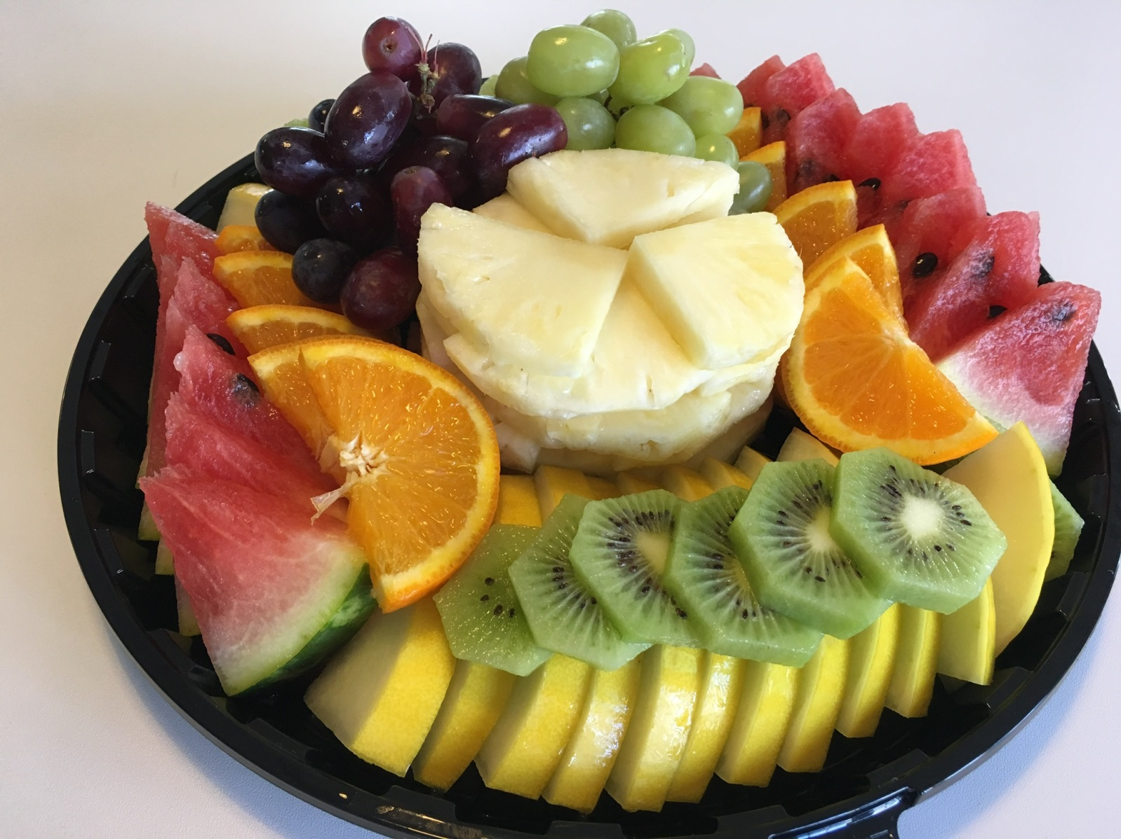

**Professional Development Centre**

**Event catering brochure**

***For external clients***



**Event details**

|  |  |
| --- | --- |
| Event title | Title. |
| Date | Click here to enter a date. |
| Room | Room. |

**Event organiser details**

|  |  |
| --- | --- |
| Full name of requester | Name. |
| Company name | Company name. |
| Invoice address  *(including post code)* | Invoice address. |
| Telephone number | Telephone. |
| Email address | Email address. |
| Purchase Order Number / Reference | PO / reference. |

**Drinks and snacks**

We require a minimum order of 10 people.

Drinks and snacks can be arranged from 8am and will be delivered to your room.

We use Flavia machines for hot drinks. The machines are easy to use and allow your breaks to be scheduled as often as you want them.

Disposable plates, cutlery and cups will be provided.

|  |  |  |  |  |  |  |  |
| --- | --- | --- | --- | --- | --- | --- | --- |
| **Item** | **Price** | **Serving 1** | | **Serving 2** | | **Serving 3** | |
| Time | Quantity | Time | Quantity | Time | Quantity |
| Tea – per cup | £0.85 | Time. | Qty. | Time. | Qty. | Time. | Qty. |
| Coffee – per cup | £1.25 | Time. | Qty. | Time. | Qty. | Time. | Qty. |
| Carafe of water – 1 litre | £0.75 | Time. | Qty. | Time. | Qty. | Time. | Qty. |
| Fruit juice – 1 litre | £2.50 | Time. | Qty. | Time. | Qty. | Time. | Qty. |
| Biscuit pack | £0.55 | Time. | Qty. | Time. | Qty. | Time. | Qty. |
| Croissant with butter and preserve | £1.00 | Time. | Qty. | Time. | Qty. | Time. | Qty. |
| Large Danish Pastry | £1.00 | Time. | Qty. | Time. | Qty. | Time. | Qty. |
| Mini Danish Pastry | £0.75 | Time. | Qty. | Time. | Qty. | Time. | Qty. |
| Pain au chocolat | £1.00 | Time. | Qty. | Time. | Qty. | Time. | Qty. |

**Fruit and cake platters**

Disposable plates, cutlery and cups will be provided.

|  |  |  |  |
| --- | --- | --- | --- |
| **Item** | **Price** | **Serving** | |
| Time | Quantity |
| Fruit platter (serves 10) | £15.00 | Time. | Qty. |
| Black forest gateau – per cake (serves 14) | £17.50 | Time. | Qty. |
| Carrot cake – per cake (serves 14) | £24.50 | Time. | Qty. |
| Chocolate fudge cake – per cake (serves 16) | £17.50 | Time. | Qty. |
| Lemon drizzle cake – per cake (serves 14) | £17.50 | Time. | Qty. |
| Red Velvet cake – per cake (serves 14) | £22.50 | Time. | Qty. |

**Breakfast**

**Working breakfast buffet, £5.50 per person**

We require a minimum order of 10 people.

Breakfast can be arranged from 8am to 11am and will be delivered to your room. Disposable plates, cutlery and cups will be provided.

|  |
| --- |
| **Our working breakfast offers a selection of:** |
|
| * Tea * Coffee * Bottled water * Fruit juice * Fresh fruit * Flavoured yogurt pots, and, * Pastries (including, croissants, Danish pastries, and pain au chocolat). |

|  |  |
| --- | --- |
| Serving time | Time. |
| How many people are you catering for? | Qty. |

**Lunch**

**Sandwich platter buffet, £6.00 per person**

We require a minimum order of 10 people.

Catering can be arranged from 12pm and will be delivered to your room. Disposable plates, cutlery and cups will be provided.

Our sandwich platter buffet consists of one and a half sandwiches/wraps per person and is accompanied with:

* bottled water,
* fruit juice, and
* a fruit platter.

Sandwiches are made using a mix of white and wholemeal bread.

You can mix and match your order with any of the below options.

|  |  |  |
| --- | --- | --- |
| **Item** | Sandwich or wrap | Quantity |
| **Cheddar cheese salad** | Choose an item. | Qty. |
| **Cheddar cheese and pickle** | Choose an item. | Qty. |
| **Chicken salad** *(halal)* | Choose an item. | Qty. |
| **Free range egg mayonnaise** | Choose an item. | Qty. |
| **Ham and cheese** | Choose an item. | Qty. |
| **Ham salad** | Choose an item. | Qty. |
| **Hummus and roasted vegetables** *(vegan)* | Choose an item. | Qty. |
| **Mexican chicken with lettuce** *(halal)* | Choose an item. | Qty. |
| **Salmon and cucumber** | Choose an item. | Qty. |
| **Sweet chilli chicken with onion and mixed peppers** *(halal)* | Choose an item. | Qty. |
| **Tuna mayonnaise and cucumber** | Choose an item. | Qty. |

|  |  |
| --- | --- |
| Serving time | Time. |
| How many people are you catering for? | Qty. |

**Lunch**

**Fork buffet, £8.00 per person**

We require a minimum order of 10 people.

Catering can be arranged from 12pm and will be delivered to your room. Disposable plates, cutlery and cups will be provided.

Our fork buffet is made up of 4 items from the below options and is accompanied with:

* a mixed leaf salad
* coleslaw,
* bread rolls,
* bottled water,
* fruit juice, and
* a fruit platter.

|  |  |
| --- | --- |
| **Please select 4 choices** | |
|  | Chicken drumsticks – plain *(halal)* |
|  | Chicken skewers*(halal)* |
|  | Falafel with yogurt and mint dip *(vegetarian)* |
|  | Goujon chicken |
|  | Hummus with vegetable crudities *(vegan)* |
|  | Meat free sausage rolls *(vegetarian)* |
|  | Mini smoked salmon and cream cheese bagels |
|  | Mini vegetable spring rolls *(vegetarian)* |
|  | Pasta – spicy tomato *(vegetarian)* |
|  | Quiche *(vegetarian)* |
|  | Samosa *(vegetarian)* |

|  |  |
| --- | --- |
| Serving time | Time. |
| How many people are you catering for? | Qty. |

|  |
| --- |
| **Help us meet your needs**  If you are catering for anyone with allergens, or you any additional requirements, please feel free to contact our catering lead who will be happy to help.  Simply call 020 7364 6350 and ask to speak to our catering lead Gemma Mayho. |

|  |
| --- |
| **On site café**  Alternatively visitors can access our on-site café between 8am and 3pm.  Our café offers a variety of coffees made from our barista coffee machine and served by trained staff, along with a variety of other hot and cold drinks.  Hot and cold food is available to purchase, including, jacket potatoes, salad boxes, soup, paninis, sandwiches, wraps and baguettes.    We make your food to order using a selection of fillings, including halal, vegetarian, fish and meat options. We also offer a selection of pastries and muffins and a cake of the day.  Our guest can log on to one of our visitor PCs to check emails or browse the internet whilst enjoying their food and beverages.  Please note our café is open Monday to Friday during the school term. |

**CATERING TEAM USE ONLY**

**Catering charges**

|  |  |
| --- | --- |
| Drinks and snacks | **£** |
| Fruit and cake platters | **£** |
| Working breakfast buffet | **£** |
| Sandwich and wrap buffet | **£** |
| Fork buffet | **£** |
| **Total** | **£** |