Public Spaces Protection Order No 1 of 2023

# An extension of No 1 of 2020 – Alcohol Control Zone

## The Anti-Social Behaviour Crime and Policing Act 2014

1. WHEREAS the London Borough of Tower Hamlets ("the council") is satisfied that the requirements of sections 59 and 72 of the Anti-Social Behaviour Crime and Policing Act 2014 ("the Act") have been satisfied and that it is, in all the circumstances, appropriate to make this Order.
2. WHEREAS the council is satisfied that activities have been and will continue to be carried out in the Alcohol Control Zone referred to below which have had and will continue to have a detrimental effect on the quality of life of those in the locality, such activities being the consumption of alcohol in public places other than licensed premises, leading to anti-social behaviour.
3. WHEREAS the council is satisfied that the effect of the activities is, or is likely to be, of a persistent or continuing nature, and is, or is likely to be such as to make the activities unreasonable and the effect justifies the restrictions imposed by this Order.
4. WHEREAS the council is satisfied that the prohibitions imposed by this Order are ones that it is reasonable to impose to prevent the detrimental effect from continuing, occurring, or recurring or to reduce that detrimental effect or to reduce the risk of its continuance, occurrence or recurrence.
5. WHEREAS the council has had regard to the rights of freedom of expression and freedom of assembly set out in articles 10 and 11 of the European Convention on Human Rights and Equality Act 2010.
6. THE COUNCIL MAKES the following Order in exercise of its powers under section 59 of the Act.
7. This Order takes effect on 19 October 2023 and continues to have effect for a period of three years thereafter until 18 October 2026. This order is an extension of a previous order which expired on 18 October 2023 and was referred to as the London Borough of Tower Hamlets (Alcohol Control Zone) Public Spaces Protection Order No.1 of 2020 (an Extension of PSPO No.3 of 2017) ("the Order").
8. This Order applies to the land described in the schedule as follows ("the Alcohol Control Zone") and which is shown edged red on the attached plan ("the Order plan").
9. This Order applies to all persons in public places within the Alcohol Control Zone at all times of the day and night save on licensed premises.
10. This Order shall not apply where prior written notice that it does not apply is given by the council or the Police to facilitate Temporary Event Notices or other public events.
11. PROHIBITION: No person shall refuse to stop drinking alcohol or hand over containers (sealed or unsealed) which are believed to contain alcohol, when required to do so by an authorised officer

12.A Constable or authorised person may, under section 63 (2) of the 2014 Act, **require**, that person:

* + 1. Not to consume, in breach of the prohibition, alcohol or anything which the Constable or authorised person reasonably believes to be alcohol;
    2. To surrender anything in that person's possession which is, or which the Constable or authorised person reasonably believes to be alcohol or a container for alcohol.

13. A person commits an offence if they fail to comply with a request not to consume alcohol or a request to surrender anything in his/her possession which is reasonably believed to be alcohol or a container for alcohol and is liable a fixed penalty notice of up to £I00, or on summary conviction to a fine not exceeding level 2 (currently £500) on the standard scale.

14.A Constable or authorised person may dispose of anything surrendered to him or her because of a requirement imposed by him or her in whatever way he or she thinks appropriate.

15.A constable or an authorised person who imposes such a requirement must tell the person that failing without reasonable excuse to comply with the requirement is an offence.

16.A requirement imposed by an authorised person is not valid if the authorised person is asked to show evidence of his or her authorisation but fails to do so.

17. For the purposes of this Order:

* + 1. 'public place' means any place to which the public or an of the public has access, on payment or otherwise, as of right or by vi express or implied permission;
    2. 'alcohol' means any liquid intended for consumption by the person in possession of it, containing more than 0.05% alcohol by volume; and
    3. 'licensed premises' means:

i. premises (other than council-operated licensed premises) authorised by a premises licence to be used for the supply of alcohol; ii. premises authorised by a club premises certificate to be used by the club for the supply of alcohol; iii. a place within the curtilage of premises within paragraph C(i) & C(ii)

* + 1. premises which by virtue of Part 5 of the Licensing Act 2003 may at the relevant time be used for the supply of alcohol or which, by virtue of that Part, could have been so used within the 30 minutes before that time;
    2. a place where facilities or activities relating to the sale or consumption of alcohol are at the relevant time permitted by virtue of a permission granted under section 115E of the Highways Act 1980 (highway-related uses).
    3. council-operated licensed premises
    4. when the premises are being used for the supply of alcohol, or within 30 minutes after the end of a period during which the premises have been used for the supply of alcohol.

18. APPEALS

In accordance with Section 66 of the Act, any challenge to this order must be made

in the High Court by any interested person within six weeks of it being made. An

interested person is someone who lives in, regularly works in, or visits the

restricted area. This means that only those who are directly affected by the

restrictions have the power to challenge. The right to challenge also exists where

an order is varied by the council. Interested persons can challenge the validity of

this order on two grounds: That the council did not have the power to make the

order, or to include prohibitions or requirements; or that one of the

requirements of the legislation, for instance, consultation has not been complied

with when an application is made, the High Court can decide to suspend the

operation of the order pending the courts decision, in part or in totality. The High

Court can uphold the order, quash it, or vary it.

SCHEDULE

The Alcohol Control Zone to which this Order applies comprises of all public space

within the London Borough of Tower Hamlets, as set out on the Order Plan. This

Order does not extend to licensed premises within the Alcohol Control Area.

IN WITNESS WHEREOF THE COMMON SEAL OF

THE MAYOR AND BURGESSES OF

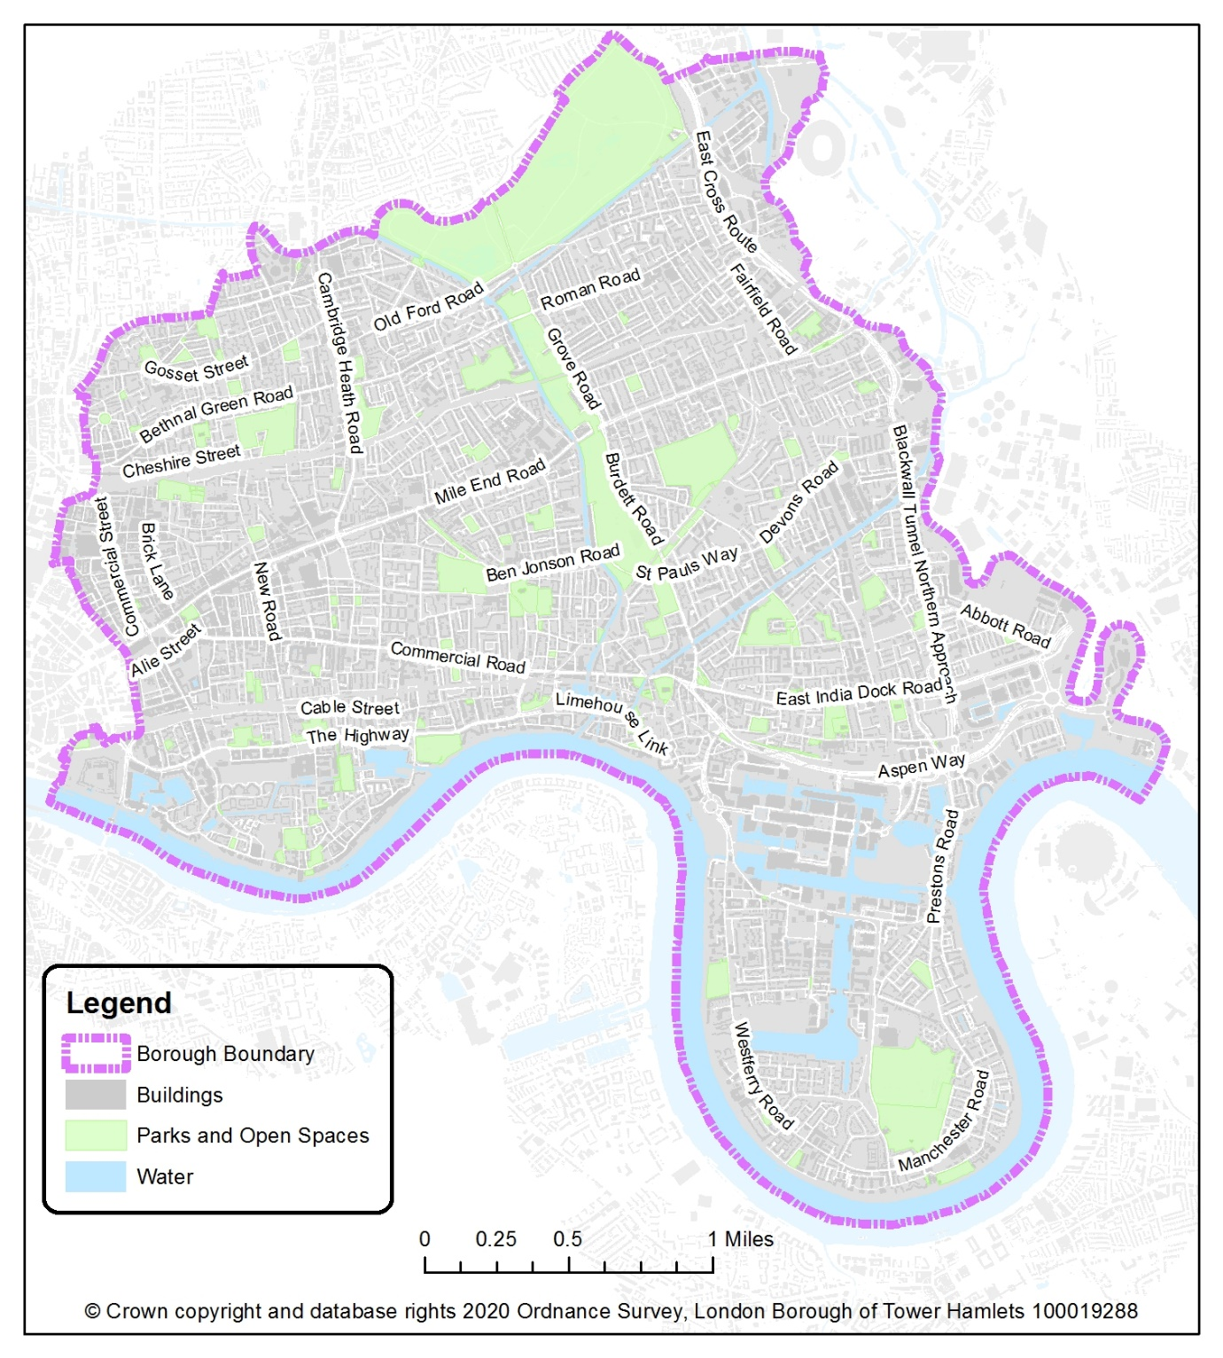

LONDON BOROUGH OF TOWER HAMLETS

Public Spaces Protection Orders. Anti-Social Behaviour Crime and Policing Act 2014.

OFFICER AUTHORITY

To: Janet FASAN – Director (Legal Services)

Date: 10 October 2023

Subject matter: LBTH – Borough-wide Responsible Drinking PSPO.

To seal the PSPO

Authority: Section 60 of the scheme of delegation. Please see attached signed delegated authority

Signed: 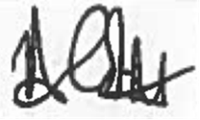

Name: Ann Corbett

Designation: Director – Community Safety