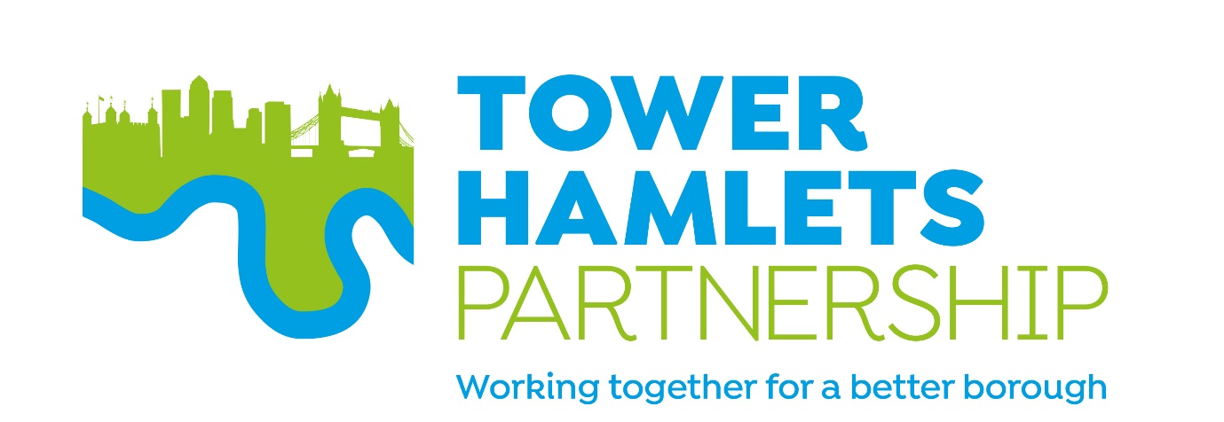

Tower Hamlets Partnership – Terms of Reference

Purpose
The Tower Hamlets Strategic Partnership is the borough's Local Strategic Partnership. It brings together key stakeholders to improve services and outcomes for local residents. It aims to provide residents with opportunities to shape, influence and inform the development of the borough’s main partnership plans. It seeks to improve the way services are designed and delivered as well as achieving key outcomes.

Partners want to work together to identify creative and innovative new ways of delivering effective and efficient services and providing strategic leadership on complex, cross-cutting issues.

Objective
In July 2018 the Partnership published the Tower Hamlets Plan. The five-year plan sets out the key objective which partners believe they can collectively influence:
tackling inequality by building a strong, inclusive and fair borough.

The Plan identifies four areas of focus through which it will be delivered:
- a better deal for children and young people: aspiration, education and skills
- good jobs and employment
- strong, resilient and safe communities
- better health and wellbeing

How it works
The Partnership is not a service provider in its own right. It works through the activities of all the partners, co-ordinating and facilitating improvements and joining up work where needed.

Our approach is to tap into the resources and expertise of individuals and organisations within the local community to develop creative solutions and to be ready to grasp the many opportunities available in Tower Hamlets.

The Tower Hamlets Partnership comprises a number of partner-groups: the Partnership Board, the Partnership Executive Group, and a number of thematic partnership groups (shown diagrammatically below).

Governance
The PEG, on behalf of the Tower Hamlets Partnership, will publish an annual report each year outlining activities, and performance against the Tower Hamlets Plan.

Each of the partnership boards (as below) relates to a theme of the Tower Hamlets Plan. These thematic boards are the bodies primarily responsible for the progress against the corresponding theme and delivering the partnership strategies within their portfolio area.

The thematic boards will provide regular updates of the work of their boards to PEG (including reporting against agreed targets on the Partnership’s plan and within pre-determined timescales), and the chair and co-chairs will attend at least two PEG meetings in a calendar year.
Where needed on an ad hoc basis, thematic boards may also bring items to PEG to be resolved.
All groups (Partnership Board, PEG, and thematic boards) will provide their work programmes (including meeting dates) for the upcoming year, by 30 June – and publish these on the Council’s partnership webpage. All groups will also publish agendas and minutes for their meetings.

The Partnership Board
The Partnership Board has an oversight role for the borough’s strategic partnership arrangements, ensuring that partner-members maintain good relationships, information-sharing and decision-making that is co-ordinated and integrated across the system leadership.

Purpose
- To provide leadership for local public services and act as the forum for developing borough wide strategies in response to national legislation and local needs
- To provide overall leadership, direction and steer to the Tower Hamlets Plan, key objective and areas of focus ensuring that a strategic approach is taken to focusing attention and resources on areas of concern
- To ensure sufficient resources are released or made available as required, ensuring efficient delivery of services across partners
- To formulate shared views on local issues of mutual interest and concern
- To co-ordinate communication across the Tower Hamlets Partnership and raise the visibility of the work of the partnership, highlighting progress and outcomes, in order to facilitate and deliver wider engagement

Principles of Membership
There are a number of principles that all Partners will adhere to as Members and in order to ensure momentum and continuous improvement in the delivery of the Tower Hamlets Plan.

The Council is only first amongst equals in having responsibility for the management and delivery of the Partnership. Participation and involvement in Partnership work is defined by a common and agreed set of principles:
- Partners will actively participate in tackling inequality, strengthening cohesion and building community leadership and personal responsibility
- The Partnership is open to all stakeholders who live, work, study and take part in leisure and cultural life in Tower Hamlets
- All partners have personal responsibility and a community leadership role in participating in Partnership arrangements and to leading on the delivery of Partnership work in their own organisations
- All partners are open to challenge and scrutiny

Membership
- The Council’s Cabinet:
- Executive Mayor (Chair)
- Statutory Deputy Mayor and Cabinet Member for Children, Youth Services, Education and Equalities
- Deputy Mayor and Cabinet Member for Adults, Health and Wellbeing
- Deputy Mayor and Cabinet Member for Work, Economic Growth and Faith
- Cabinet Member for Community Safety
- Cabinet Member for Housing
- Cabinet Member for Resources and the Voluntary Sector
- Cabinet Member for Culture, Arts and Sports
- Cabinet Member for Environment and Planning

- Cabinet Member for Social Inclusion (job share post as part of Social Inclusion and Public Realm portfolio)
- Cabinet Member for Highways and Public Realm (job share post as part of Social Inclusion and Public Realm portfolio)

- The Council’s Corporate Leadership Team:
- Chief Executive
- Place Corporate Director
- Health, Adults and Community Corporate Director
- Children's Services Corporate Director
- Resources Corporate Director
- Governance Corporate Director

- Senior representatives from:
- Barts Health NHS Trust
- Canary Wharf Group
- Department for Work and Pensions
- East London Business Alliance (ELBA)
- East London Mosque and London Muslim Centre
- East London NHS Foundation Trust (ELFT)
- London Fire Brigade
- Metropolitan Police
- North East London Clinical Commissioning Group (NEL CCG)
- New City College
- Queen Mary University
- Full Headteacher Consultative Tower Hamlets Council
- Tower Hamlets Council for Voluntary Service (THCVS)
- Tower Hamlets Housing Forum
- Tower Hamlets Interfaith Forum

Meetings and activity
The Partnership Board typically meets once a year to reflect on partnership working across the borough, and review progress in delivering the Tower Hamlets Plan.

The Partnership Executive Group

Purpose
- To deliver on the priorities, objectives and cross-cutting principles of the Tower Hamlets Plan, through agreed delivery arrangements including how we will review progress against targets and ensure a partnership approach to developing local solutions
- To support a powerful public through pro-active citizen and service user engagement in the delivery of local services
- To share resources and expertise in joint commissioning and delivery arrangements
- To operate in a transparent and accountable way by seeking external and peer challenge to assess and improve performance
- To share knowledge and learning by collecting and sharing data improve service delivery

Membership
Senior representatives from:
- Barts Health NHS Trust
- Canary Wharf Group
- Department for Work and Pensions
- East London Business Alliance (ELBA)
- East London Mosque and London Muslim Centre
- East London NHS Foundation Trust (ELFT)
- London Fire Brigade
- Metropolitan Police
- North East London Clinical Commissioning Group (NEL CCG)
- New City College
- Queen Mary University
- Full Headteacher Consultative Tower Hamlets Council
- Tower Hamlets Council for Voluntary Service (THCVS)
- Tower Hamlets Housing Forum
- Tower Hamlets Interfaith Forum

Meetings
The Chair is the Mayor of the London Borough of Tower Hamlets.

The frequency of meetings is dependent upon need, however this will range from monthly to bi-monthly and as agreed by the Chair.

If PEG members are unable to attend meetings, they may send a proxy with appropriate experience, knowledge and delegated authority to contribute towards discussion, in their stead.

Other individuals may be asked to attend meetings to present agenda item as required by the PEG.

Roles and responsibilities of members
Members are expected to have decision making capacity on behalf of their organisation

Reporting and action notes
Formal agendas and action notes will be issued by LBTH officers, acting as secretariat for the Partnership, It is the responsibility of member organisation’s representatives at the meeting to ensure that they use these to report back to their organisation, to maintain information flows.

Meeting agendas will be agreed by the Chair. Members will be invited to submit items for the agenda and any item which is so submitted will be guaranteed to be placed on the agenda, unless an agreement is reached with the proposer that the item is no longer required.

