Gambling Act 2005 – Additional profile maps

Figure 1 Map Location of Gambling Premises (Betting Shops and Adult Gaming Centres
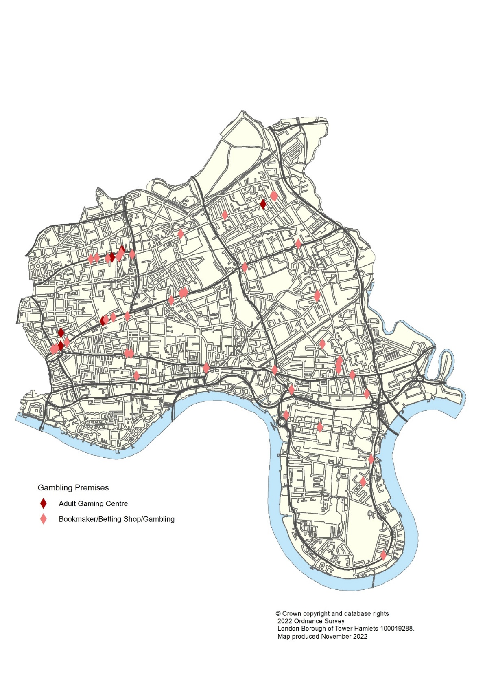

Figure 2 – Map of Vulnerable Person Premises and Gambling Premises
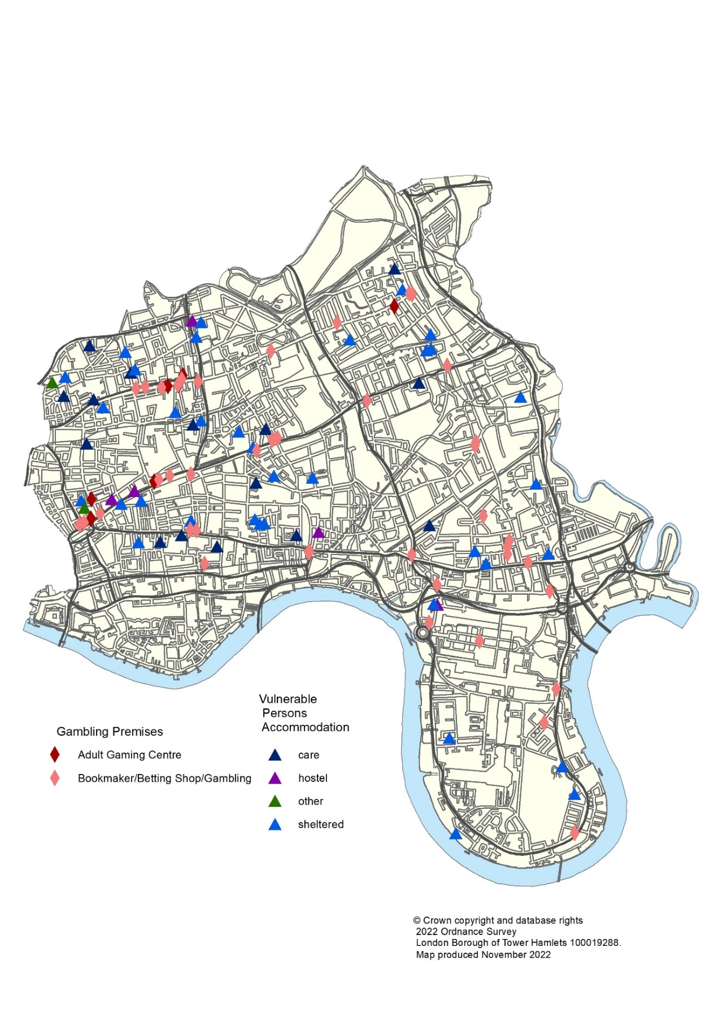
Figure 3 – Maps of Gambling Premises and deprivation data (2019)

