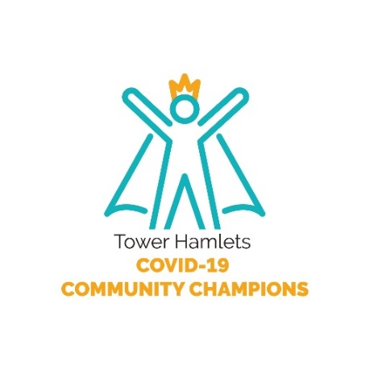
Horyaalka Bulshada ee Caabuqa Covid-19
Caabuqa Covid-19 iyo Talaabooyinka la qaaday si looga jawaabo loona joogteeyo raadka uu dhamaanteen inagu yeeshay degmadeena Tower Hamlets
Xidhiidhka Horyaaalka Bulshadeena ee caabuqa covid-19 waxaa loo abuuray in la xoojiyo lana taageero bulshada degan Tower Hamlets si ay ula socdaan talooyinka kama danbeytta ah mar walba ee caabuqa covid-19
Horyaalku waxay caawiyaan qoysaska, saaxiibada iyo guud ahaan bulshada si ay wax uga fahmaan talooyinka iyo warbixinaha ku saabsan caabuqa covid-19 si loo hubiyo bedqabka dhamaanteen iyo in laysaga soo baaqo khatarta caabuqa
Horyaal ahaan waxaad heli doontaa warbixin joogto ah oo ku saabsan caabuqa covid-19 fariinahaan,whattsapp email ama live webinars. Markaas ka dib waxaad la wadaagi doontaa bulshada kugu xidhan si kastoo aad jeceshahay inaad ku gaadhsiiso
Haynta iyo gudbinta xog waadix ah waxay adiga, saaxiibadaa, qoyskaaga iyo guud ahaan bulshada u samaynaysaa qaadashada goaano xog ku salaysan waxayna caawinaysaa bedqabka degmada Tower Hamlets

Ka mid noqoshada Horyaalka Bulshada ee Covid-19
Qof waliba wuu ka mid noqon karaa horyaalka Bulshada ee Caabuqa Covid-19
- Waad is diiwaan gelin kartaa inaad noqoto Horyaal waxayna qaadanaysaa laba ilbidhiqsi oo keliya
- Horyaalada waxaa loosoo gudbiyaa warbixinihii ugu danbeeyay caabuqa covid-19 waxaanay ku helaan warbixinahaas sida ay u doorbidaan (Tusaale email ama WhatsApp)
- Horyaaladu waxay u gudbiyaan warbixinaha cid kasta oo ka mid ah bulshadooda waxaanay ku gaadhsiiyaan sida ay ula haboonaato
- . Horyaaladu waxay nagu soo warceliyaan warbixinaha si sahlan u fulay iyo kuwa caqabado ka yimaadeen

Dhamaanteen waxaynu ku leenahay door
Abuuritaanka isku xidhka Horyaalkeena Bulsho waxaa barbar socda inaanu ognahay in bedqabka Degmadeena Towerhamlets iyo hubinteedu tahay ku negaansho adkaysi leh si loogu babac dhigo caabuqa covid-19, qof waliba oo degan ama ka shaqeeya degmada waa inuu doorkiisa ka qaataa xaqiijinta bedqabka bulshada
Tani waa sababta aanu u qaadanay shanta balamood kuwaasoo qeexaya hab usocodka iyo kaalmada ku saabsan covid-19 ee dadka degan degmada. Isla markaa waxaa loo sameeyay shan balamood bulshadeena iyo horyaaladab. Haddii aynu dhamaanteen si isku dhamo ah u raacno talaabooyinkaas waxaynu ilaalinaynaa bedqabka Xaafadeena.
Golaha Degaanka Towerhamlet Wuxuu:
- Joogtayn wargelinta talooyinka iyo tilmaamaha kama danbeysta ah oo loo soo bandhigo Bulshada xaafada degan iyo Horyaalladaba
- Gudbin Kulamo isku xidheed oo u dhaca qaab ismaqal ah(virtual) taasoo ay hogaaminayso bahda caafimaadku iyadoo lagaga hadlayo talooyinkii iyo tilmaamihii ugu danbeeyay iyo wixii suaalo ah ee caabuqa covid-19
- Diyaarin kala doorasho sheybaadh oo ogog leh
- Taageerid dadka xaafada degan eeisu xayira ama isu godoomiya sabab caabuqa covid-19 taakuladaa oo noqon karta in loo soo adeego cunto ama dawo ama in talooyin laga siiyo dhinaca dhaqaalaha haddii culays ka jiro
- Diyaarin warbixino ku baxa afka hooyo si cid waliba u gaadhi karto warbixinta caabuqa Covid-19
Bulshada degaankeenan iyo Horyaaladuba waxay
- Joogtayn doonaan nadaafada taasoo ay ka mid tahay maydhista/Dhaqida faraha si joogto ah ugu yaraan 20 ilbidhiqsi
- Sugida kala fogaanshaha dadka kale iyo xadididda xidhiidhka dhaqan si waafaqsan awaamiirta Dawlada iyo tilmaamaha degaanka. Xidhashada afsaarka ee Gaadiidka dadweynaha, Dukaamada iyo meelaha saxmada ah
- Hadaad isku aragto calaamadaha caabuqa covid-19, is xayir gurigaaga isla markaana dalbo sheybaadh bilaash ah kana dalbo Waaxda caafimaadka ee loo yaqaan NHS Test and Trace adoo si dhow ula soconaya waaxda xidhiidhka iyo dabagalka
- Haddii laguu aqoonsado inaad xidhiidh la lahayd kiis la xaqiijiyay oo ah covid-19 waa inaad is xayirtaa 14 Casho
- Kaalmee caawimada warbixineed taasoo ku wajahan saaxiibadaa iyo qoyska si ay u helaan talooyinka kama danbeysta ah iyo ogaanshaha baahidooda iyo waxay kuu biirin karaan Degmada Tower Hamlets

Taageero ayaa Jirta oo laguu hayaa
Waxaanu ognahay in ay adagtahay xaalada waqtiga ee dad badan oo degan xaafadan waxaanu doonaynaa inaanu idin xasuusino in taageero taalo. Fadlan booqo boga benefits and financial support, taasoo sidoo kale ay ku diiwaan gashan yihiin ururo kaa caawin kara taakulada dhaqaale iyo talooyin
Taageerada bulshada degaanku waqtiga is xayirka(gadoomintu) waxaa kaloo laga heli karaa Golaha degaanka

