**UK Parliamentary election for the Parliamentary Constituencies of Poplar & Limehouse and Bethnal Green & Stepney**

**Thursday 4 July 2024**

**Inspection of Election Expenses Returns**

The spending returns and declarations made by candidates and agents following the above polls may be inspected at Tower Hamlets Borough Council, Electoral Services, Room TH206, Town Hall, 160 Whitechapel Road, London, E1 1BJ between the hours of 10am and 12 noon and 2pm and 4pm for a period of two years.

This excludes public holidays and subject to any other restrictions or changes to office opening hours.

To inspect, contact the election office using the details below to make an appointment.

A member of staff will remain with any person during the inspection of these documents and handwritten notes may be taken or, on the payment of a fee of 20p for each side of each page, copies of or parts thereof of any return or declaration can be provided.

Date: 12 August 2024

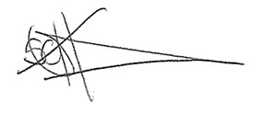

Stephen Halsey

(Acting) Returning Officer

Electoral Services

Room TH206

Town Hall

160 Whitechapel Road

London

E1 1BJ

[vote@towerhamlets.gov.uk](mailto:vote@towerhamlets.gov.uk)

020 7364 0872