Notice of Neighbourhood Planning Referendum

London Borough of Tower Hamlets
Thursday 13 October 2022
Roman Road Bow

- A referendum will take place in the Roman Road Bow Neighbourhood Planning Area on Thursday 13 October 2022 to decide the following question:
“Do you want the London Borough of Tower Hamlets to use the Neighbourhood Plan for Roman Road Bow to help it decide planning applications in the neighbourhood area?”
- Those registered local government electors who reside within the area as set out in the Neighbourhood Plan will be permitted to vote in the Referendum.
- The area of the Neighbourhood Plan is attached to this notice and can also be viewed here https://www.towerhamlets.gov.uk/lgnl/council_and_democracy/elections__voting/Roman-Road-Bow-NPR/Roman-Road-Bow-Neighbourhood-Planning-Referendum.aspx
- Applications from electors to apply to register to vote, who are not already on the Electoral Register, must be received by the Electoral Registration Officer at the Town Hall, 7th Floor, Mulberry Place, 5 Clove Crescent, London, E14 2BG by 27 September 2022.
- Applications to register to vote can be made at https://www.gov.uk/register-to-vote
- Applications, amendments, or cancellations of postal votes must reach the Electoral Registration Officer at Town Hall, 7th Floor, Mulberry Place, 5 Clove Crescent, London, E14 2BG by 5pm 28 September 2022.
- Applications to vote by proxy at this election must reach the Electoral Registration Officer at Town Hall, 7th Floor, Mulberry Place, 5 Clove Crescent, London, E14 2BG by 5pm 5 October 2022.
- Applications to vote by emergency proxy at this poll, applied for on grounds of physical incapacity, work reasons or for reasons related to COVID-19 and the emergency occurring after 5pm 5 October 2022 must reach the Electoral Registration Officer at Town Hall, 7th Floor, Mulberry Place, 5 Clove Crescent, London, E14 2BG by 5pm 13 October 2022.
To apply for an emergency proxy on the grounds of physical incapacity, work reasons or for reasons related to COVID-19, the person must have become aware that they cannot go to the polling station in person after 5pm 5 October 2022 and not before.
- Further information on the Neighbourhood Plan and the Referendum can be found here https://www.towerhamlets.gov.uk/lgnl/planning_and_building_control/planning_policy_guidance/neighbourhood_planning/Roman_Road_Bow.aspx

Roman Road Bow Neighbourhood Plan Area

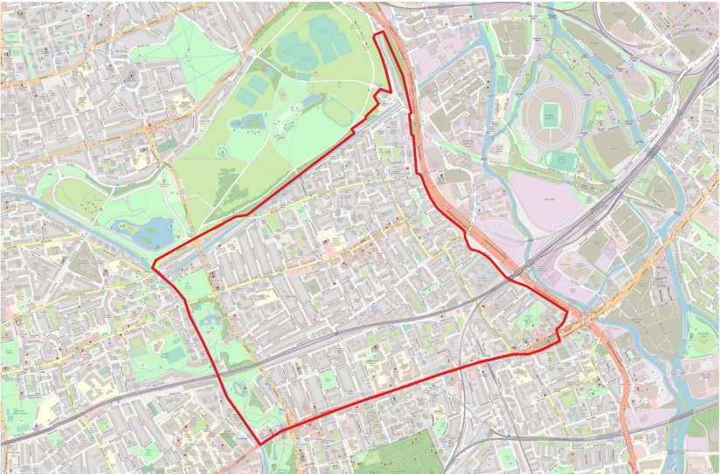

(To see if your address falls within the area you can search on our interactive map here)
https://towerhamlets.maps.arcgis.com/apps/instant/lookup/index.html?appid=f76a3134223c4a0aa3a9732cfdc90c2f

