AGENDA ITEM 4

Title of report: Dedicated Schools Grant Final Outturn 2021/22

Officer to present the paper to Schools Forum: Kay Goodacre

Details on who has been consulted with on this paper to date: N/A

Executive Summary
This report sets out the outturn position (excluding individual schools) for Tower Hamlets’ DSG Budget for 2021-22

The Dedicated Schools Grant (DSG) was overspent is 2021-22, with a net overspend of £3.09m is set out in Table 1 and detailed in the report.

Details of recommendations and timescales for decisions:
Schools Forum is asked to note the outturn position as reported to the Department of Education and included in the LBTH Note to the Accounts year end statement.

1. 2021/22 Dedicated Schools Grant Provisional Outturn - Overview.

  - The Dedicated Schools Grant (DSG) is distributed by the Department for Education (DfE) on a national formulaic basis. This specific grant is allocated to local authorities in four blocks: Schools Block (SB), Early Years Block (EYB), High Needs Block (HNB) and the Central Schools Services Block (CSSB).

  - Table 1 gives an overview of the outturn position for 2021-2022. DSG budgets are shown after deductions have been made for direct payments to academies and does not include the EYB accrual brought forward at the beginning of the year or carried forward at the end of the year (see 2.2.1 below).

  - The net expenditure reports schools delegated budgets as allocated, under or overspends on delegated budgets are not included in this annual statement but retained by schools as individual school balances.

Table 1: Net DSG Budgets, Net Expenditure and Under/Overspends per funding block as reported in the Section 251 Outturn statement.

Block | Allocated DSG funding | Expenditure | Net
Schools Block (schools) | 204,257,010 | 203,253,576 | -1,003,434
Schools Block (centrally managed) | 2,661,169 | 2,631,521 | -29,648
Central School Services Block | 3,887,172 | 3,314,947 | -572,225
High Needs Block | 60,615,299 | 65,769,956 | 5,154,657
Early Years Block | 28,174,976 | 27,721,137 | -453,839
Total | 299,595,626 | 302,691,137 | 3,095,511

  - In summary, the position of the total DSG spend shows a overspend with the major component of this being high needs spend offset by underspends in the other 3 blocks (see section 2 below).

  - The in-year position from Table 1 needs to be added to balances brought forward as shown in Table 2, resulting in a cumulative overspend of £14.4 million to be carried forward.

Table 2: Cumulative Position on Balances Brought Forward.

Block | B/F prior years | 2021-22 | Cumulative
 | £m | £m | £m
SB | 2 | 1.03 | 3.0
CSSB | 1.35 | 0.57 | 1.9
HNB | -15.56 | - 5.15 | - 20.7
EYB | 1.02 | 0.45 | 1.5
Total | -11.19 | - 3.09 | - 14.3

- Analysis of Year-end outturn for 2021/22 (as shown in tables 1 and 2).

  - Centrally Retained Schools Block and Central School Services Block.

    - The Schools Block (SB) underspend represents the agreed transfer of budget to the HNB agreed by School’s forum at the beginning of the year (£-0.891m), netted off against other variances, notably overspend against the de-delegated budget of £0.16m attributable to overspend in contingency and trade union supply cover. The school growth fund and de delegation for Education Services were fully spent. The delegated budget was adjusted in year to account for the conversion of Cyril Jackson to an academy.

    - Central School Services Block (CSSB). The budget of supporting restructures, and termination of employment costs in schools overspent by £0.59m. This is a high-risk budget, which will be monitored closely in future years, ensuring only those schools that have agreed support in advance will be reimbursed. The other budget headings in this block contribute to wider budget areas, which have benefitted from savings made across the council in those central services. The overall underspend of -£0.57m will contributed to the HNB overspend.

  - Early Years Block.

    - The EYB is funded according to termly census’ recording pupil take up in settings. It is the most volatile block, with retrospective adjustments made each year. The local authority estimated that -£0.953m would be recouped from the authority for reduce participation, however one all data cleansing was undertaken, only £0.74m was recouped, leaving a balance of £0.21m. At the end of 2021-22 the authority estimated a clawback adjustment of £0.16m, but this was not accrued for, given the difficulties in calculating the estimate.

    - Following the return to normal processes in 2021-22 after the disruption during the covid epidemic and the fluctuation in pupil participation, a one-off late funding adjustment of -£2.9 million was applied to the block budget at the end of the year. This reduction reflected the reduced spend across the phase and taking all the above into account the year end position was an underspend of -£0.45m.

  - High Needs Block.

    - The overspend on this block represents the increase in numbers and costs for delivering an education to pupils with High Needs in schools and other settings. It is also a consequence of local authorities having less freedom to manage the budgets within the DSG. The increase in direct provision costs puts pressure on the preventative support services managed by the authority and schools, which compound the expenditure risk in the future.

    - The DfE targeted additional funding to High Needs in response to the national overspending position, which is managing to reduce the in-year negative variance but has done nothing to redress the historic accumulated deficit.

    - The High Needs Block deficit has increased in-year by £5.14m. By using the underspends from other blocks, the overall impact on the DSG has limited this to £3.09m. The carried forward deficit also attributable to high needs costs pressures, is £11.19m, leading to an overall deficit of £14.3m

- DSG Note to the accounts

  - The DSG Note to the accounts (see table 3 below) forms part of the statutory reporting for each local authority published in the local authority accounts at year end. It demonstrates the high-level outturn of the grant.

  - It is also submitted to the DFE accompanying the Section 251 Outturn statement, which provides a line-by-line summary of the DSG and other children & families budgets for public information. These statements are published on each authority’s web site to allow public scrutiny and challenge

Table 3 DSG Note to the accounts 2021-22

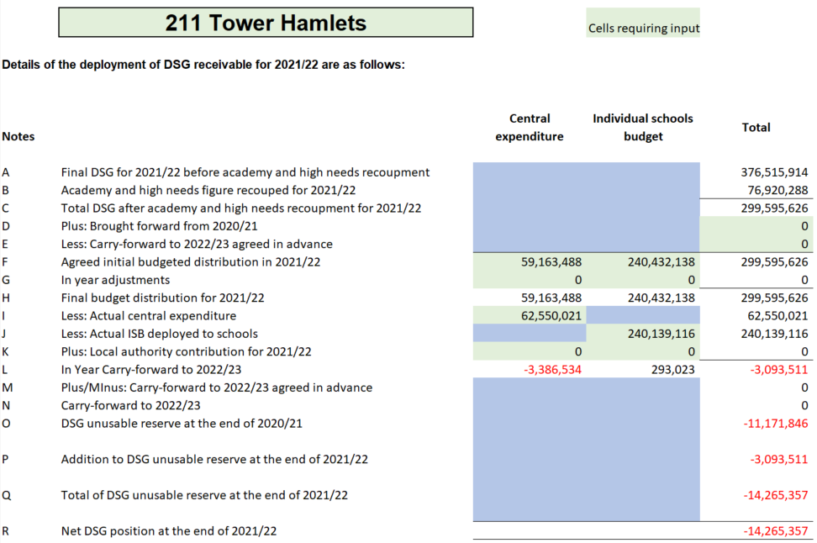

- Carry Forward/ Transfer of Balances

  - Introduced in 2020, a deficit must be carried forward to be dealt with from future DSG income, unless the Secretary of State authorises the LA not to do this. The impact of these statutory provisions means that an LA with a DSG deficit from the previous year must either:

(1) carry the whole of the deficit forward to be dealt with in the schools budget for the new financial year
(2) carry part of it forward into the new financial year and the rest of it into the following financial year
(3) carry all of it into the following financial year
(4) apply to the Secretary of State under for authorisation to disregard the requirements in Schedule 2 relating to deficits if it wishes to fund any part of the deficit from a source other than the DSG

  - Any local authority that has an overall deficit on its DSG account at the end of the 2020 to 2021 financial year, or whose DSG surplus has substantially reduced during the year, must co-operate with the Department for Education in handling that situation. In particular, the authority must:

- provide information as and when requested by the department about its plans for managing its DSG account in the 2021 to 2022 financial year and subsequently
- provide information as and when requested by the department about pressures and potential savings on its high needs budget
- meet with officials of the department as and when they request to discuss the authority’s plans and financial situation
- keep the schools forum regularly updated about the authority’s DSG account and plans for handling it, including high needs pressures and potential savings.

