Contigency fund update
De-delelgated Contingency Funding:
Outline School Organisation Work relating to Contingency Fund

11/06/2025

- Outline School Organisation work relating to contingency funding
This report provides a summary of the activities which it is proposed will be undertaken through the engagement of 2 consultants working with schools finance on a range of activities relation to our School Organisation Strategy:

Summer term | - Supporting with identification of schools meeting an ‘at risk trigger’  - Leading discussions with these schools to support risk, mitigation and sustainability planning in line with our Licensed Deficit Project.  - Initiating support to schools requesting LDA 2025-26  - Continuing to lead on monthly reviews with schools with LDA from 2024-25
Autumn/Spring term | - Leading on review of risk assessments and recovery plans where schools remain as a ‘cause for concern’  - Developing robust Licensed Deficit Applications with a focus on challenging and supporting financial planning and budget assumptions.  - Leading monthly reviews with the schools until such a time as the LDA is no longer required.  - Leading a termly feedback meeting with the LA to discuss schools’ progress. These measures remain ongoing until such time as the LDA is no longer required.  - Scrutinising Year End outcomes and receipt of three-year plans.  - Confirming the list of schools requiring LDAs with the LA.
- Additionally, the consultants provide advice and support around organisational changes (including federations and amalgamations) and formal partnerships, changes to curriculum, teaching and staffing models and new potential income streams.
- Attendance and Feedback to termly SOSG meetings, including sharing of best practice
- Delivery of workshops and the development of toolkits of support for schools as requested by the SOSG

Appendices

Appendix 1 School Sufficiency and Sustainability Reviews
Appendix 2 Licensed Deficit Project
Appendix 3 Consultant Projected Costs

Appendix 1

School Sufficiency & Sustainability Reviews

Identifying ‘at risk’ schools

The LA recognises that volatility in the population can place new strains on a school, despite governors working hard to ameliorate these. The LA has committed to conducting an annual review of school suffciency and sustainability to identify which schools meet any of the pupil outcomes, pupil place, or financial instability triggers set out below. This leads to a risk management discussion with the Chair of Governors and Headteacher for any school where any of the following are happening:

- the quality of education is falling.
- In year income does not meet expenditure and school surpluses are reducing and will “run out” within the next three years, with no matching organisational change plan (or have already).
- More than two year groups have 15% + vacancies, or more than 35 vacancies in a 1 FE school.
- a new school is planned in the immediate area.
- the Headteacher is considering retiring or moving.
- a new school building or area development is proposed.
- payment for a Licensed Deficit repayment plan is not met or an extension is being sought.

Sustainability review process summary

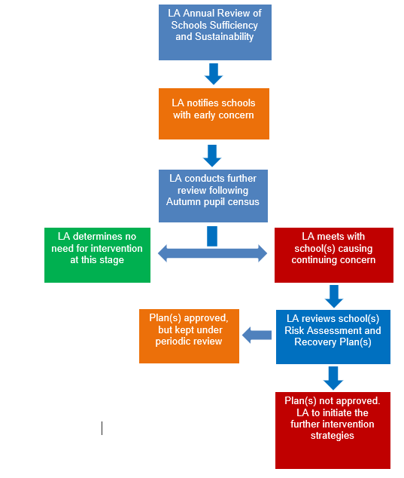

Appendix 2

Licensed Deficit Project

DfE Requirements

The DFE sets the following requirements for schools:
All LA schools (across the country) are required to submit 3 year budget plans to the LA by May 31st. Where the budget out-turn (taking into account revenue reserve) is negative, schools must also submit a recovery plan to the LA when their revenue deficit rises above 5%. LAs may set a lower threshold than 5% for the submission of a recovery plan if they wish. Tower Hamlets policy uses £10,000 or 4 %, cash flow challenges and requirement for cash loans, possible fraud, theft or other financial regularities as the trigger levels for informing the LA.
The Licensed Deficit Project (LDP) has been set up to support schools that may be in this position, and to establish financial assurance for any Licensed Deficit Applications, and that budget processes are robust in line with Schools Financial Value Standards (SFVS).

