AGENDA ITEM 4

Title of report: DSG Recovery Plan

Author of the paper: John O’Shea

Officer to present the paper to Schools Forum: John O’Shea

Details on who has been consulted with on this paper to date:
Steve Worth
Sandra Smith

Executive Summary
The High Needs Funding Block (HNFB) is part of the overall Dedicated Schools Grant and provides funding for education, support and services required by children and young people with Special Educational Needs (SEN). It also provides resource for those who have been excluded from mainstream school and require alternative provision.
Nationally, the pressure on the SEN HNFB is at crisis point with very few local authorities reporting underspends and those that are report that it is a case of when their budgets go into deficit, rather than if they go into deficit.
In 2018-19 the SEN section of the HNFB for Tower Hamlets reported a £7m deficit, the result of three years of accumulated pressure on this block. The total deficit meant that the DSG deficit was greater than 1%, requiring the council to submit a Recovery Plan to the Department for Education.
The recovery plan requires the agreement of Schools Forum and due to timescales this could not be sought prior to the end of the 2018-19 school year. The council was advised to submit the plan and seek approval of Schools Forum at the first meeting of the new school year.
The DSG Recovery Plan is unlikely to reduce the entire deficit in the timescales required and is presented to Schools forum with the following points to note:
1. The council has had no further feedback from the DFE on the proposed plan submitted
2. The government has announced a £700m increase in funding, without releasing details of the allocation, or the conditions for the use of any funding
3. Following the recent public consultation, the council has taken advice and will re- consult on top-up fee amounts prior to any final decision about top-up rates

Details of recommendations and timescales for decisions:
Schools Forum is asked to comment on the current form of the DSG Recovery Plan submitted to the DFE. Agree the DSG Recovery Plan in its current form as indicative of the council’s attempts to reduce spending on the SEN portion of the HNFB in a time of reduced funding for SEND nationally and in the knowledge that further funding has been announced by the government.

- Report

Background

The High Needs Funding Block (HNFB) is one part of the overall Dedicated Schools Grant (DSG). The HNFB provides funding for education, support and services required by children and young people with Special Educational Needs and Disabilities (SEND). It also provides resource for those who have been excluded from mainstream school and require alternative provision.

Of the SEND portion of the HNFB the largest amount, approximately 90% is spent on place-led funding and top-up fees for children and young people with Education, Health and Care Plans (EHCPs). The remaining 10% is retained by the LA and is spent on services which support inclusion in the mainstream schools, including a significant contribution to the Support for Learning Service (SLS), funding for hospital schooling, the Behaviour and Attendance Support Service (BASS), outreach services provided by local special schools, speech and language therapy, specialist equipment and a vulnerable pupils fund.
Nationally there has been a 34% increase in the number of EHCPs since the introduction of the 2015 SEN Code of Practice. Tower Hamlets (4.4%) has more EHCPs than nationally (3%) and Inner London (3.1%). This number reflects the significant need within the Local Area and is more comparable, though still higher than our near neighbours Hackney (3.5%) and Islington (3.9%).

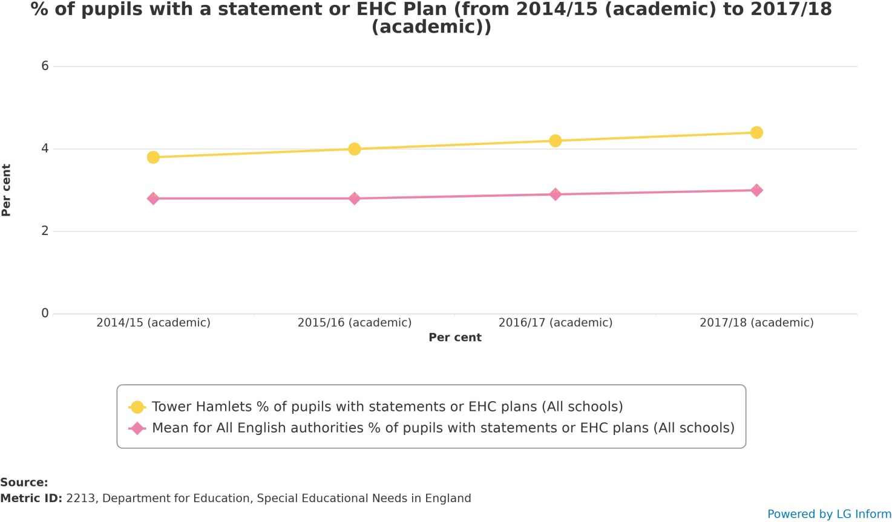

The pressure on the SEN HNFB is a national issue and very few Local Authorities are reporting underspends, or balanced budgets and where they are the view is that it is when their budgets go into deficit, rather than if they go into deficit.

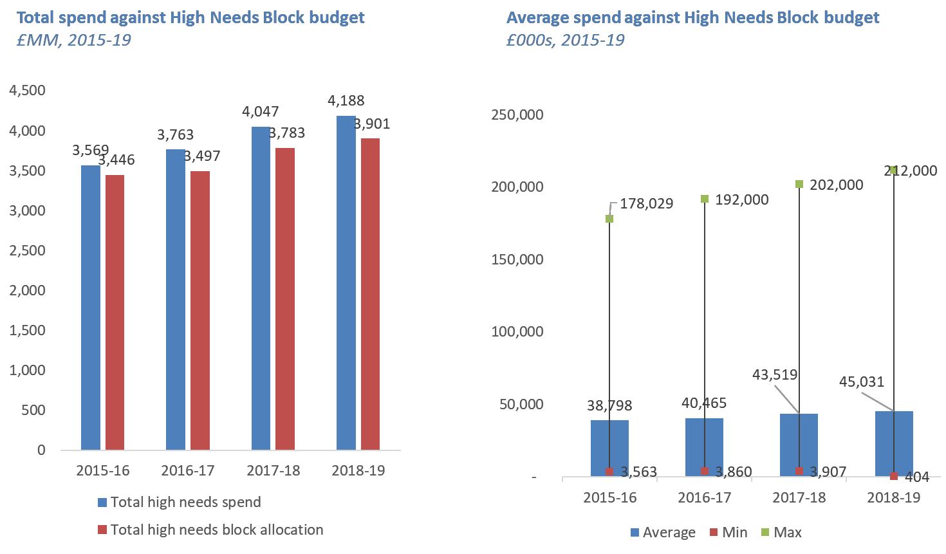
National Figures for HNFB spending across all authorities

Analysis of the Pressures on SEN portion of the HNB in Tower Hamlets

In Tower Hamlets accumulated growth pressures from the 2016/17 financial year have resulted in a cumulative £7m pressure identified in the 2018-19 budget. An analysis of each of the cost codes for the SEN HNBF shows that the combination of reducing budget size and increased demand for EHCPs by way of an 11-15% increase each year:

Table: Pressure based on growth in numbers of school attendance
 | Analysis | £
2015/16 | outturn variance | -871,561
2016/17 | Budget increase | -66,024
2016/17 | Growth | 1,843,409
2017/18 | Budget reduction | 613,824
2017/18 | Growth | 1,236,920
2018/19 | Budget reduction | 597,653
2018/19 | Growth | 3,661,613
Total |  | 7,015,834
2019/20 | Budget increase | -2,825,976

There was an underspend in 2015/16 and a subsequent budget increase in 2016-17, however, during 2016-17 there was £1.8m growth pressure caused by the increased numbers of EHCPs – this is a combination of an increased number of new plans being issued and the impact of the changes to the code of practice enabling plans to be maintained between the ages of 19-25.

In 2017-18 the HNFB budget was reduced by £613k and further growth resulted in an additional £1.2m pressure. At the end of 2017-18 the cumulative pressure was £2.8m.

Further budget reductions (£597k) and increased growth (£3.7m) has resulted in the cumulative £7m pressure.

For 2019-20 an additional £2.8m has been added to the budget, however, similar growth could see the pressure remaining at £7m at the end of the financial year.

The work related to the SEN HNFB Review carried out by officers and Schools Forum, including the SEMH Review, the AP Review and the consultation on SEN HNB Spending is on-going and will present long-term solutions to relieving the pressure on the SEN HNB. It would be unlikely that this work will produce significant reductions in 2019-20. As such there will need to be rigorous monitoring of the SEN HNB to ensure that forecasting is accurate and reflects any additional pressure caused by further growth.

The resulting deficit is significant and has meant that the total DSG deficit is greater than the 1% allowed by central government. The council were informed that a recovery plan would need to be submitted to the Department for Education and requested additional time as the notification occurred following the final Schools Forum for the 2018-19 school year.

Steps being taken
In addition to the areas outlined in the DSG Recovery Plan the following steps are being taken to ensure that on-going monitoring of the SEN HNB spend is improved:

- Budget realignment – Some spend is being miscoded – the clearest example is the changing picture in relation to spend on LBTH Academies and free schools.

- The system of scheduling and using the holding account needs to change so that this is cleared on a monthly basis in much the same way as has been done with school meals.

- Work to improve the systems around budget decision making and unpicking this initial analysis further – including further benchmarking with other Local Authorities. The SEN2 report for 2019 shows that although the number of EHCPs in Inner London has increased further, there are Local Areas where the demand for EHCPs has reduced. Looking closely at what our neighbours are doing to relive the pressures on their own

- Changes to SEN Panel monitoring and tracking of EHCPs, including improved tracking of outcomes for children and young people with EHCPs

- Submission and monitoring of the DSG recovery plan.

Potential Risks
Across the Local Area educational outcomes for children and young people with SEND are at, or above national averages, in almost all benchmarks at all key stages. This is a source of great pride for Tower Hamlets and is further reinforced by the fact that Tower Hamlets has the highest percentage of CYP with EHCPs in maintained mainstream schools across all London authorities:

Source: ALDCS Sector led improvement data (DfE SEN2 2018)

Strategies for relieving the pressure on the SEN HNB will have to be mindful that the top-up funding for Education, Health and Care Plans plays a significant role in supporting a key group of vulnerable children and young people to achieve these excellent educational outcomes.

The DSG Recovery Plan

Tower Hamlets were one of 32 Local Authorities across England required to submit a DSG Recovery Plan at the end of the 2018-19 financial year. This is one fifth of all local authorities. The plan must show how the council proposes to bring the DSG back into balance over the next three years. Although the plan is the council’s and decisions on the spending will be made by officers, the plan is required to be signed off by Schools Forum. Officers requested an extension of the time to submit a plan subsequent to the approval of Schools Forum, however, this was not forthcoming and the plan was submitted in the Summer given the information available at the time.

Subsequent to the plan being submitted the government has announced an increase in SEND funding and a review of SEND and the way it is funded.

The text of the DSG Recovery Plan can be found in appendix 1 and financial information is in appendix 2, and outlines the main pressures and the measures that the council proposed to take to reduce the deficit. At the time of writing the plan the HNFB Consultation had gone live and the figures used to inform the plan and submitted are based on a 7% reduction to the top-up fees for pupils in Tower Hamlets schools. This was not pre-empting a decision on the consultation and it should be noted that following the formal consultation, the decision has been taken to complete a further consultation on top-up fees.

The DSG Recovery Plan also included the transfer of £500k from the Central Schools Service agreed previously by Schools Forum in 2018/19 and assumed similar underspends in the Central Schools Service, which we would also ask Schools Forum to transfer to the HNFB.

Schools Forum is being asked to transfer the maximum that can be transferred from the Schools Block to the HNFB in 2021. This figure is £1.3m based upon 2019/20 figures.

A further transfer of £0.9m would be sought, however, this would require the approval of the Secretary of State.

The DSG Recovery Plan is being presented to Schools Forum as a requirement of the process but it is worth noting that at the time of writing this report:

- There has been no further contact, information or feedback about the proposed plan from the DFE.
- The government has announced a funding increase of £700m, however, the details of the allocation and the conditions for the use of this funding are unknown at this time.
- A decision has been taken to complete further consultation on the top-up funding rates for EHCPs in Tower Hamlets Schools.

Schools Forum is asked to:

- Comment on the DSG Recovery Plan in its current form
- Agree the DSG Recovery Plan in its current form as indicative of the council’s attempts to reduce spending on the SEN portion of the HNFB in a time of reduced funding for SEND nationally and in the knowledge that further funding has been announced by the government.

