AGENDA ITEM 3.1

Title of report: Schools Block Disapplication requests for 2023-24

Author of the paper: Sara Walsingham

Officer to present the paper to Schools Forum: Nikki Parsons

Details on who has been consulted with on this paper to date: Emdad Abul

Executive Summary
The Department of Education (DfE) allows for local authorities to dis apply elements of local formula by seeking agreement from the Secretary of state. This report outlines the proposals for 2023-24 that have been submitted. School Forum are asked to give a view on these proposals, which will be reported to the DfE

Recommendations
Forum are asked to consider and agree to on the proposals.

Background

  - To be eligible for exceptional circumstances funding a disapplication of the normal NFF funding rules should be applied for. A school variation is only allowed if the amount of funding applied for is more than 1% of the school’s budget and impact less than 5% of schools in your local authority.

  - The deadline date for local authorities to submit any application for exceptional circumstances is 18 November 2022. This is to ensure DfE decisions are communicated back to local authorities prior to the APT submission deadline.

  - The application process includes reporting to the DfE the views of the School Forum. Following this meeting, officers will relay the outcome and decision of the Forum to the department, which will be considered before issuing an official response in January 2023.

  - Two disapplication requests have been submitted by the deadline, both requests are attached in the appendices. If agreed, both outcomes will be incorporated into the Authority pro-forma tool (APT) for 2023-24

- Disapplication A school rents in the APT (appendix A)

The school funding formula includes provision for National Non-Domestic Rates (NNDR) funding automatically. This does not extend to rental costs, for which a disapplication must be applied.

  - Tower Hamlets currently receive exceptional rents funding for Bygrove Primary School which was last agreed in 2017/18. Such approvals can continue without a further request for 5 years. On this basis the council has been advised that should the LA wish for this to continue, a new disapplication would be required in 2023/24. The rental cost is in the region of £200k per year (2021-22 costs), approximately 12% of the budget share.

  - Oakland Secondary school is currently negotiating a rental agreement, allowing expansion of the upper school into a vacant school site. The lease agreement for the additional site is expected to be in the region of £150k per year, which represents a possible 2% of the budget share.

The details of the application is included as appendix A

- Disapplication B varying the MFG for historic anomalies (appendix B)

Following the expansion of St Paul’s Way Trust to include primary pupils, the funding per pupil built into the Minimum Funding Guarantee has applied the secondary rate to all pupils in the school, including the primary sector pupils. The local authority is requesting a disapplication to adjust the MFG baseline and resulting funding levels, using a calculator tool issued by the DfE for just this purpose.

The adjustment would be applied to the 2022-23 base rate used in the 2023-34 formula. On the current modelling the impact would be a reduction of -£28.92 per pupil, or -£44,764 in the value of the MFG.

The application is included as appendix B

Appendix A

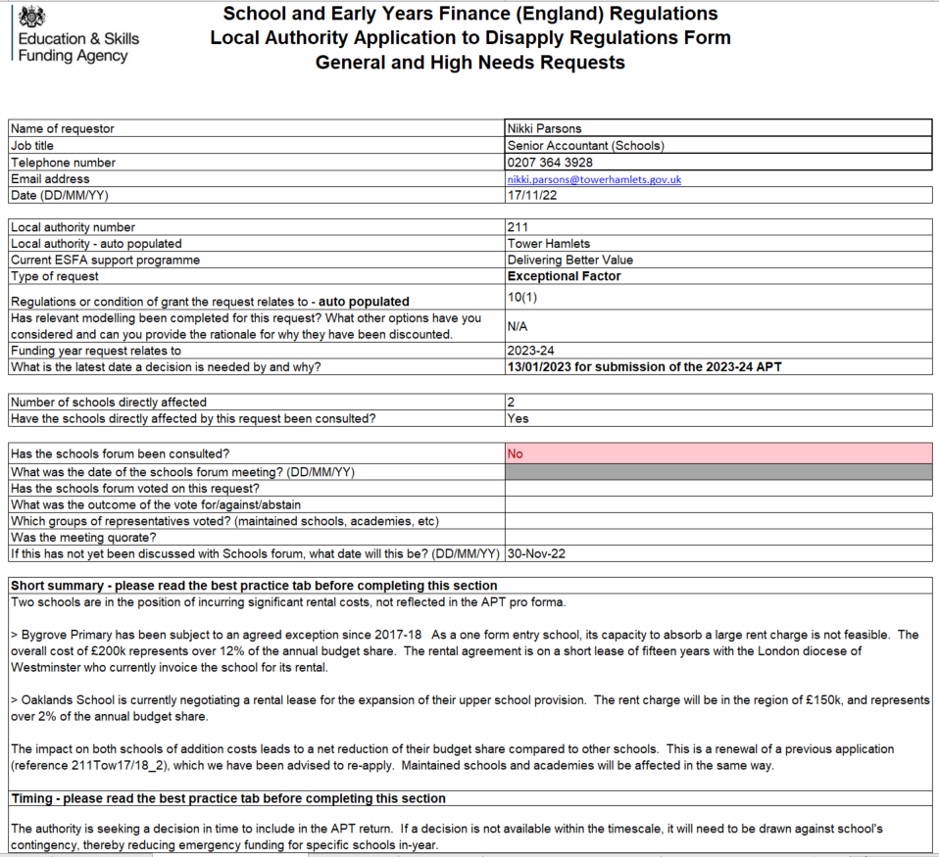

Appendix B

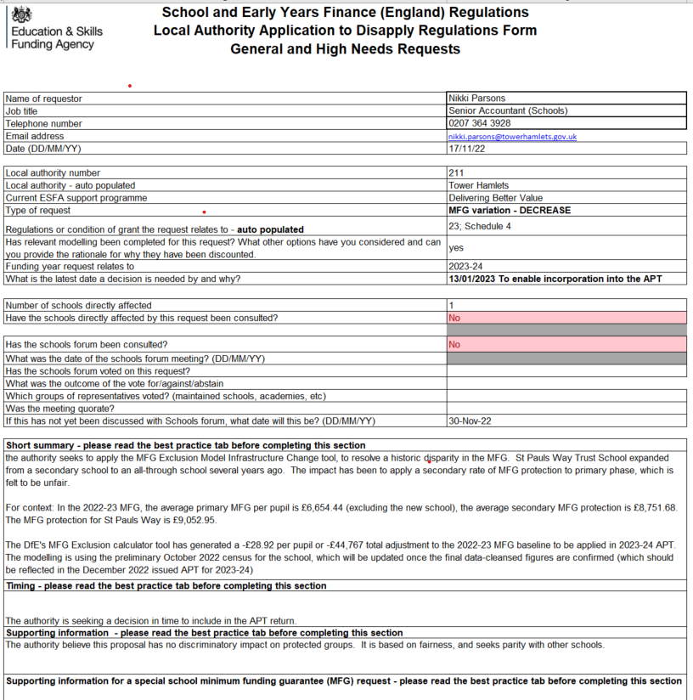

Copy of the DFE MFG Exclusion calculator:

