AGENDA ITEM 4

Title of report: DSG Monitoring Period 5

Date Prepared: 14 September 2026

Date to present paper to Schools Forum: 7 October 2026

Author of the paper: Kudzi Mambara

Officer to present the paper to Schools Forum: Kudzi Mambara

Consultation has taken place with relevant Education, SEND and Finance services in preparing this report.

Introduction

  - The Dedicated Schools Grant (DSG) is distributed by the Department for Education (DfE) in accordance with a nationally determined funding formula. The grant is allocated to local authorities through four funding blocks: the Schools Block (SB), Early Years Block (EYB), High Needs Block (HNB), and the Central Schools Services Block (CSSB).

  - This paper provides a breakdown of the projected expenditure forecast for the Dedicated Schools Grant (DSG) for FY 2026/27. Financial pressures are primarily concentrated within the High Needs Block (HNB), driven by increasing demand for Education, Health and Care Plans (EHCPs), rising costs of specialist placements, and insufficient funding to meet the increasingly complex needs of pupils.

Year End DSG Balances

All figures in £m | Schools Block | Early years Block | Central Schools Services Block | High needs Block | Total
Opening deficit balance 2026/27 | 0.0 | 0.0 | 0.0 | 35.2 | 35.2
In-year DSG (surplus) / deficit | (1.3) | 0.0 | 0.0 | 31.2 | 30.0
Closing deficit balance 2026/27 | (1.3) | 0.0 | 0.0 | 66.4 | 65.2

  - The DSG is currently projecting an in-year overspend of £30m, primarily within the High Needs Block. This reflects ongoing growth in demand for SEND support, including an increase in the number and complexity of EHCPs, higher top-up funding requirements, and rising placement costs, alongside inflationary and contractual fee uplifts. Compared with the 2025/26 outturn, High Needs expenditure is forecast to increase by approximately £8.0m. This reflects sustained growth in demand for SEND provision, including an increase in the number and complexity of EHCPs, greater use of specialist placements, higher top-up funding requirements, and ongoing inflationary and contractual cost pressures.

  - The cumulative Dedicated Schools Grant (DSG) deficit is currently projected to reach £65.2 million by 31 March 2027. In accordance with the statutory override, the deficit is held separately in an unusable reserve and does not currently impact the Council’s General Fund balance. However, the underlying High Needs Block remains significantly overspent and, without effective intervention to reduce demand and expenditure, the cumulative deficit is expected to continue increasing, as illustrated in the graph below.
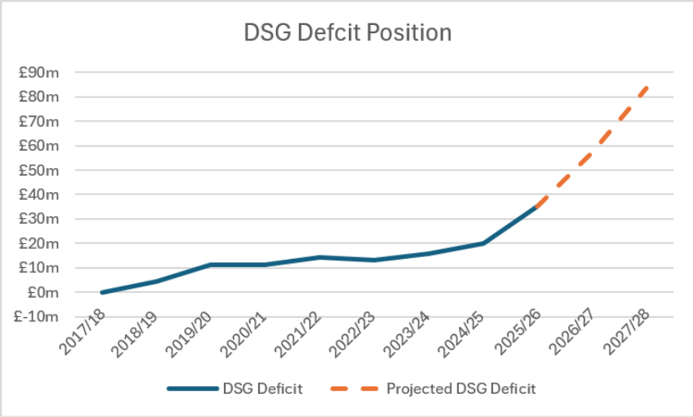

  - The Council has submitted its Local SEND Reform Plan to the Department for Education (DfE), but approval remains outstanding. Subject to approval, the Council would be eligible to receive a High Needs Stability Grant equivalent to 90% of its eligible DSG deficit as at 31 March 2026. Based on the reported 2025/26 deficit of £35.2 million, the indicative grant would be £31.7 million. Applying this to the projected £64.0 million balance would reduce the forecast cumulative deficit at 31 March 2027 to approximately £33.5 million. This calculation remains indicative because the DfE will determine the eligible deficit after considering the final accounts and excluding any expenditure it considers ineligible.

  - The High Needs Stability grant must be used exclusively to extinguish the eligible DSG deficit recognised at 31 March 2026; it does not provide funding for further deficits arising after that date. The Government has not yet clarified how additional DSG deficits accumulated from 2026/27 onwards will ultimately be addressed. Consequently, the Stability Grant would substantially reduce the historic deficit but would not resolve the continuing structural pressure within the High Needs Block.

- DSG Forecast for 2026-27

  - The table below sets out the Dedicated Schools Grant (DSG) budget for 2026/27, the projected year-end outturn position, and the forecast variance against budget as at the end of August 2026 (Period 5).

DSG Block | Budget | Projected Forecast to Year End | Projected Deficit / (Surplus) at Year End
 | £m | £m | £m
Schools Block | 205.4 | 204.1 | (1.3)
Central Schools and Services Block | 3.2 | 3.2 | 0.0
High Needs Block | 89.9 | 121.2 | 31.2
Early Years Block | 50.6 | 50.6 | 0.0
Total DSG | 349.1 | 379.1 | 30.0

  - Schools Block
There is a projected underspend of £1.3 million wholly attributable to the Growth Fund.

  - Central Schools and Services Block
The Central Schools and Services Block is projected to spend to budget.

  - High Needs Block
The forecast overspend of £31.2 million on the High Needs Block is primarily driven by sustained growth in demand for SEND provision and support. Key cost pressures include the expansion of local specialist provision, including new ARPs, continued growth in the Phoenix Project, increasing numbers of pupils with EHCPs, and rising demand for specialist placements and associated support services. These pressures have been compounded by inflationary increases in staffing and provider costs, the increasing complexity of need among children and young people, and a funding gap between growth in High Needs expenditure and available grant funding. Collectively, these factors have contributed to the projected overspend position.

Mitigating actions will be delivered through the Local SEND Reform Plan, focusing on earlier intervention, stronger inclusive practice and increased local provision. These measures are intended to improve outcomes and slow the growth in High Needs expenditure; further detail will be provided as the plan is approved and implemented.

  - Early Years Block

The Early Years Block is projected to spend to budget.

