London Borough of Tower Hamlets

Air Quality Action Plan

2022 – 2027

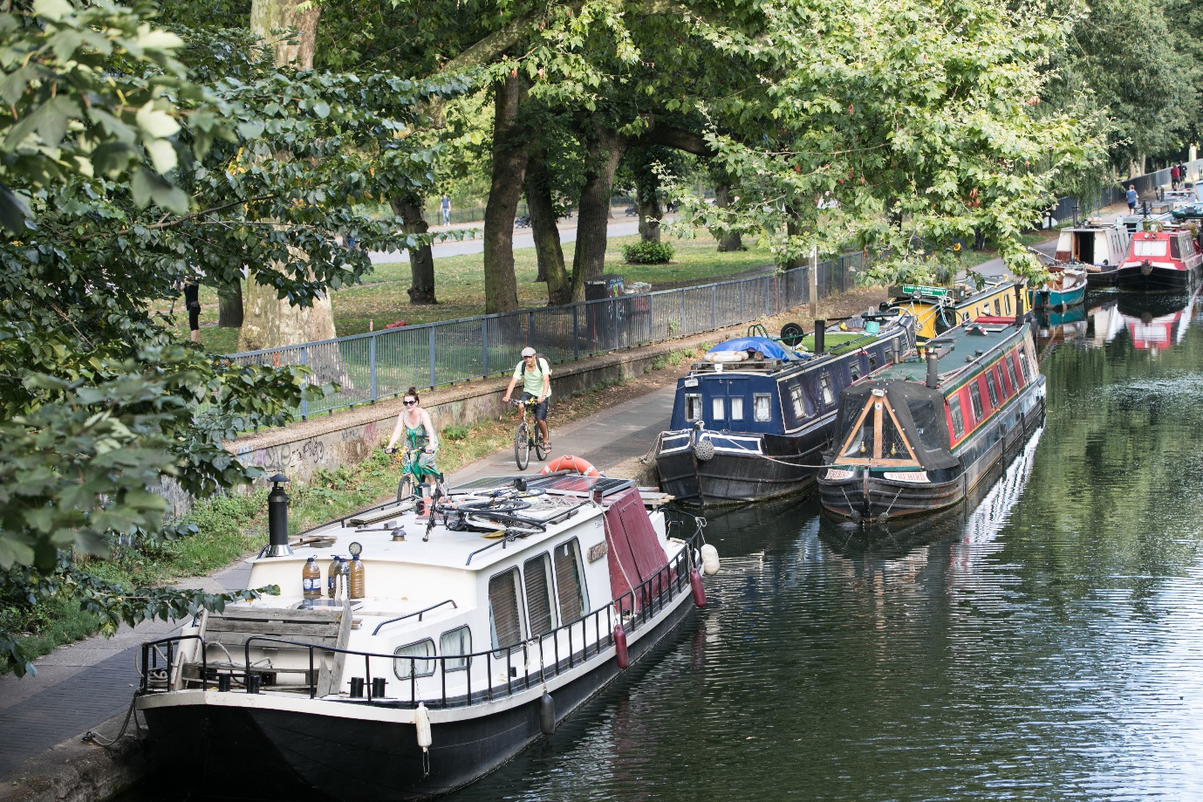

SUMMARY

This Air Quality Action Plan (AQAP) has been produced as part of our responsibility under London Local Air Quality Management. The AQAP outlines the action we will take to improve air quality in the London Borough of Tower Hamlets (LBTH) between 2022 – 2027.

This action plan replaces the previous action plan which ran from 2017 to 2022. Highlights of some of the successes delivered through the past action plan include:

- Achieved targets for sustainable travel through the Staff Travel Plan and School Travel Plans
- Maintained the Council’s Ambient Air Quality Monitoring stations and added two new real time PM2.5 monitors to the network and two new NO2 diffusion tubes
- Delivered 22 School Streets
- Funded 21 local community air quality projects from the Tower Hamlets Mayor’s Air Quality Fund
- Supported the GLA to undertake air quality audits at 4 primary schools
- Adopted anti-idling powers to issue fixed penalty notices to idling drivers and deployed idling signs to schools and hotspot locations
- All Council fleets are now Euro 6 or better
- Successfully delivered a DEFRA funded air quality project with Poplar HARCA
- Using LIF funding provided living green infrastructure at 3 primary schools exposed to high pollution levels
- Funded delivery of 24 ‘pollution solution’ workshops at 16 primary schools
- LGC (Local Government Chronicle) 2020 finalist for Environmental Services category

Air pollution is associated with several adverse health impacts, it is recognised as a contributing factor in the onset of heart disease and cancer. Additionally, air pollution particularly affects the most vulnerable in society: children and older people, and those with heart and lung conditions. There is also often a strong correlation with equalities issues because areas with poor air quality are also often the less affluent areas,.

The annual health costs to society of the impacts of air pollution in the UK is estimated to be roughly £15 billion. The London Borough of Tower Hamlets is committed to reducing the exposure of people in the Borough to poor air quality in order to improve health.

We have seen an improvement in air quality in the Borough over the lifespan of our current AQAP (2017-2022). According to modelling data from the Greater London Authority (GLA) known as London Atmospheric Emissions Inventory (LAEI), in 2016, 77% of Tower Hamlets population was living in areas that exceeded the UK legal limit for nitrogen dioxide (NO2) annual mean concentration of 40ug/m³ (micrograms per cubic metre). This has reduced to 7.5% of the Borough’s population according to the latest modelling projection, LAEI 2019, which is the most recent modelling data available. Also 41 of our primary schools were in areas above the legal limit for NO2 according to 2016 data but this has reduced to only 3 schools for the 2019 projections. There are several possible reasons for this including improvements in vehicle emissions standards, introduction of ULEZ and uptake of electric vehicles and also measures taken locally to improve air quality.

There is however no safe level for air pollution and, a particular concern is the health risks associated with particulate matters, PM10 and PM2.5. According to the Public Health Outcomes Framework (Public Health England), 7.6% of all deaths among people in Tower Hamlets in 2020 can be attributed to particulate matter (PM2.5). This is compared to 5.6% in England.

We have developed actions that can be considered under seven broad topics:

Monitoring and other core statutory duties: maintaining monitoring networks is critical for understanding where pollution is most acute, and what measures are effective to reduce pollution. There are also several other very important statutory duties undertaken by Boroughs, which form the basis of action to improve pollution.

Emissions from developments and buildings: emissions from construction accounts for approximately 35% of PM10 and 15% of PM2.5 across the borough. Therefore, our focus will be to tackle this through the planning process by recommending appropriate conditions and monitoring of these pollutants by developers.

Public health and awareness raising: increasing awareness can drive behavioural change to lower emissions as well as to reduce exposure to air pollution.

Delivery servicing and freight: vehicles delivering goods and services are usually light and heavy-duty diesel-fuelled vehicles with high primary NO₂ emissions.

Borough fleet actions: our fleet includes light and heavy-duty diesel-fuelled vehicles such as minibuses and refuse collection vehicles with high primary NO₂ emissions. Tackling our own fleet means we will be leading by example.

Localised solutions: such as expanding and improving green infrastructure, Low Emission Neighbourhoods (LENs) subject to securing funding, replacing boilers and implementing insultation schemes in schools and Council properties, etc.

Cleaner transport: road transport accounts for 47% of NOx emissions, 24% of PM10 and 26% of PM2.5 in the Borough. We want to improve cleaner transport within the Borough through transport and air quality policies, idling enforcement, car free days, pedestrianisation schemes project, installation of electric vehicle charging points, and supporting walking and cycling.

Our priorities are:

- Enforcing the Non-Road Mobile Machinery (NRMM) Low Emission Zone
- Promoting and enforcing smoke control zones
- Promoting and delivering energy efficiency retrofitting projects in workplaces and homes
- Supporting air pollution alerts services such as airText
- Reducing pollution in and around schools, and extending school audits to other schools in polluted areas
- Installing Ultra Low Emission Vehicle (ULEV) infrastructure (electric charging points)
- Improving walking and cycling infrastructure
- Promoting regular Car Free days/temporary road closures in high footfall areas
- Reducing emissions from Council fleets
- Implement campaigns to raise air quality awareness
- Enforcing unnecessary idling

You will see in this report that we have worked hard to engage with stakeholders and communities which can make a difference to air quality in the Borough. We would like to thank all those who have worked with us in the past and we look forward to working with them again as well with new partners as we deliver this new action plan over the coming years.

In this AQAP we outline how we plan to effectively use local levers to tackle air quality issues within our control.

However, we recognise that there are many air quality policy areas that are outside of our influence (such as Euro standards, national vehicle taxation policy, taxis, and buses), and so we will continue to work with and lobby regional and central government on policies and issues beyond the London Borough of Tower Hamlets’ influence.

RESPONSIBILITIES AND COMMITMENT

This AQAP was prepared by the Environmental Health and Trading Standards Service of Tower Hamlets’ Council with the support and agreement of the following officers and departments:
- Transportation and Highways
- Planning
- Fleet Management
- Public Health
- Procurement
- Sustainability/Climate Change
- Communications
- Parking

This AQAP has been approved by:

Mayor of Tower Hamlets- Mayor Lutfur Rahman

Cllr Kabir Hussain- Cabinet Member for Environment and Climate Emergency

Director of Public Health- Somen Banerjee

Corporate Director Place- Ann Sutcliffe

This AQAP will be subject to an annual review, appraisal of progress and quarterly reporting to the Air Quality and Net Zero Strategic Working Group. Progress each year will be reported in the Annual Status Reports produced by the London Borough of Tower Hamlets, as part of our statutory London Local Air Quality Management duties.
If you have any comments on this AQAP, please send them to:
Environmental Health and Trading Standards Service
Pollution Team
London Borough of Tower Hamlets
Town Hall, Mulberry Place
5 Clove Crescent
020 7364 5008
Environmental.Protection@towerhamlets.gov.uk

CONTENTS
Abbreviations 7
Foreword 8
Introduction 9
1 Summary of current air quality in the London Borough of Tower Hamlets 9
1.1 Air Quality Modelling .………………………………………………………………………………………………………………………………………………………………10
1.2 Air Quality Monitoring …………………………………………………………………………………………………………………………………………………………….13
1.3 AQMAs and Focus areas 14
2 The London Borough of Tower Hamlets’ Air Quality Priorities ……25
3 Development and Implementation of the London Borough of Tower Hamlets’ AQAP 26
3.1 Consultation and Stakeholder Engagement 26
4 Action Plan Table 28

Appendix A Response to Consultation 54
Appendix B Reasons for Not Pursuing Action Plan Measures (pending consultation) 56

Tables
Table 1 Air quality objectives for annual mean NO2, PM10 and PM2.5 9
Table 1.2 Tower Hamlets Air Quality Monitoring Stations ……………………………………………………………………13
Table 1.5 List of the Council documents reviewed for the AQAP…………………………………22
Table 3.1 Consultation Undertaken ………………………………………………………………………………………26
Table 4.1 Air Quality Action Plan 29
Table A.1 Summary of Responses to Consultation and Stakeholder Engagement on the AQAP …………………………………………………………………………………………………………………………………………………………………………………………………54
Table B.1 Action Plan Measures Not Pursued and the Reasons for that Decision – to be discussed with the GLA prior to finalisation 56

Abbreviations
AQAP | Air Quality Action Plan
AQMA | Air Quality Management Area
AQO | Air Quality Objective
BEB | Buildings Emission Benchmark
CAB | Cleaner Air Borough
CAZ | Central Activity Zone
EV | Electric Vehicle
GLA | Greater London Authority
LAEI | London Atmospheric Emissions Inventory
LAQM | Local Air Quality Management
LLAQM | London Local Air Quality Management
NRMM | Non-Road Mobile Machinery
PM₁₀ | Particulate matter less than 10 micron in diameter
PM_{2.5} | Particulate matter less than 2.5 micron in diameter
NOx | Oxides of nitrogen, includes nitric oxide and nitrogen dioxide
LEN/BLEN | Low emission neighbourhood and business low emission neighbourhood
TEB | Transport Emissions Benchmark
TfL | Transport for London

Foreword
We are very pleased to introduce the London Borough of Tower Hamlets’ updated Air Quality Action Plan which sets out the measures we will take over the next 5 years to improve air quality for all who live and work in the borough.
Poor air quality is a serious public health emergency. It affects everybody, especially our most vulnerable residents including children. It has a significant impact on the health and quality of life of all.
The London Borough of Tower Hamlets is determined to tackle poor air quality in the borough. Raising awareness and providing education about the causes and impacts of poor air quality are crucial to achieving this. We want to support our residents and businesses to make a difference to the air quality that is affecting all of us, to enhance our local environment.
Due to Tower Hamlet’s strategic location in London, most pollution in our jurisdiction is from traffic travelling through the Borough. Therefore, we will continue to work in partnership with the Greater London Authority and Transport for London, as well as lobby national government to improve air quality in Tower Hamlets.
This Air Quality Action Plan (AQAP) has been produced as part of our legal duty to London’s Local Air Quality Management strategy. It builds on the successes of our previous action plan and has developed actions to tackle the sources of air pollution locally over the next 5 years. It is important to take a comprehensive approach of air quality measures and associated issues, and that is why the Council fully embraces an approach across transport, planning, and development strategies. Therefore, the Council has put in place a clear set of priorities to manage the impact of air pollution and to tackle its negative impact.
Improving the quality of air in the borough is a priority for the Council to improve the health and well-being of our residents. While there are many factors contributing to poor air quality which can be beyond the control of the Council, we must do everything we can to address the air pollution situation locally.
We aim to implement air quality measures that are within our control and which we will take to create a borough that our residents are proud of and love to live in.
Mayor Lutfur Rahman
Executive Mayor of Tower Hamlets
Cllr Kabir Hussain
Cabinet Member Environment and Climate Emergency

Introduction
This report outlines the actions that the London Borough of Tower Hamlets will deliver between 2022 and 2027 to reduce concentrations of pollution, and exposure to pollution; thereby positively impacting on the health and quality of life of residents and visitors to the Borough.

It has been developed in recognition of the legal requirement on the local authority to work towards air quality objectives under Part IV of the Environment Act 1995 and relevant regulations made under that part, to meet the requirements of the London Local Air Quality Management statutory process.

1 Summary of current air quality in the London Borough of Tower Hamlets

The UK Clean Air Strategy released in 2019, provides the overarching strategic framework for air quality management in the UK and contains national air quality standards and objectives established by the Government to protect human health. The Strategy objectives consider EU Directives that set limit values which member states are legally required to achieve by their target dates.

The London Borough of Tower Hamlets is meeting all the national objectives other than for Nitrogen Dioxide (NO₂). The Borough is also meeting the current UK objectives for Particulate Matter (PM₁₀ and PM_{2.5}). However, for PM_{2.5,} the UK legal objective is far higher than the World Health Organisation (WHO) recommended health-based guideline value of 10 ug/m³. This is an interim target, based on the WHO 2005 guideline values. PM2.5 has the greatest potential to cause damage to health due to its size and has been shown to pass through the lungs into the bloodstream and into the organs.

In the London Environment Strategy, the Mayor has committed to meeting the WHO health-based interim guideline limits across London by 2030. As the Borough is still exceeding the WHO interim guideline for PM_{2.5}, a key area of focus in the AQAP will be to help the Mayor of London meet his 2030 target.

In 2021 the WHO updated the air quality guidelines and issued more stringent guidelines for all pollutants of concern. The council has aspiration to meet the updated 2021 WHO guideline value for PM2.5 in the shortest possible time using levers that are within our control but also lobbying regional and central government on policies and issues beyond our control and influence. The table below compares how the Borough is doing against the UK and WHO standards.

Pollutant | UK legal limit  (Annual mean)  ug/m³ | Is LBTH compliant? | WHO 2005 guideline  Annual mean)  ug/m³  (interim) | Is LBTH compliant? | WHO 2021 guideline  (Annual mean)  ug/m³ | Is LBTH compliant?
NO2 | 40 | No | 40 | No | 10 | No
PM10 | 40 | Yes | 20 | No | 15 | No
PM2.5 | 25 | Yes- except some major roads | 10 | No | 5 | No
Table 1. Comparison of air quality objectives for annual mean NO2, PM10 and PM2.5 in µg/m³ in the UK National Air Quality Objectives, WHO 2005 and 2021 guidelines.

1.1 Air Quality Modelling

The following visual representations show annual mean concentrations of pollutants NO₂, PM₁₀ and PM_{2.5} according to the London Atmospheric Emissions Inventory (LAEI) 2019 for the London Borough of Tower Hamlets. The LAEI has been developed by the GLA as part of the implementation of the Mayors Air Quality Strategy. The 2019 dataset was the most recent available at the time of writing this report. The most polluting roads in the Borough are along the arterial roads including A13, the Blackwall Tunnel Approach and the Highway. Exceedances occur along most of the major roads in the Borough. Larger annual mean concentrations are in the West of the Borough. These high concentrations are not only limited to the road centrelines but also spread to residential areas,

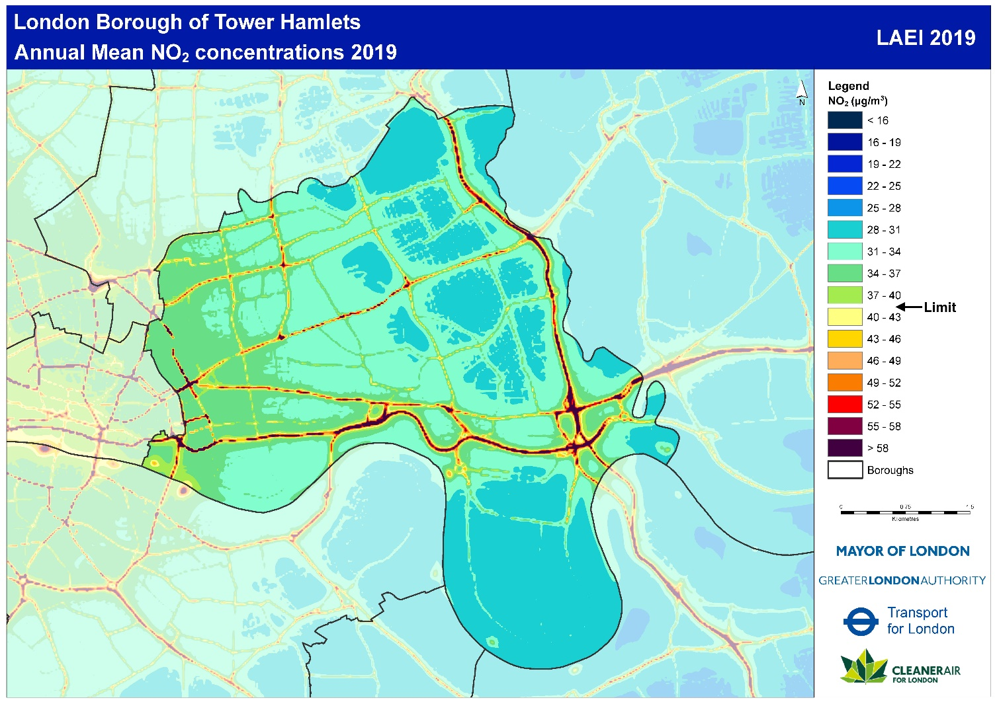
Figure 1. Modelled map of annual mean NO₂ concentrations (from the LAEI 2019) Exceedances of UK legal limit (> 40 µg/m³ ) occur along most of the major roads in the borough. Larger annual mean concentrations are in the West, East and the South of the borough. These high concentrations are not only limited to the road centrelines but also spread to residential areas.

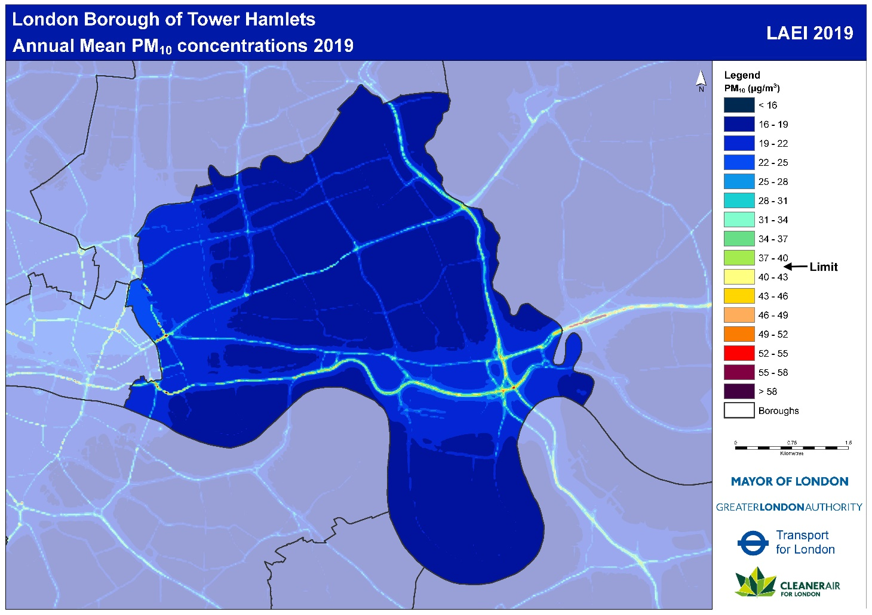
Figure 2. Modelled map of annual mean PM₁₀ (from the LAEI 2019). The annual mean concentration does not exceed the UK limit apart from some major roads, however exceedance of the WHO 2005 guideline ( 20 µg/m³ ) occur along the major roads and reaching building facades (e.g. Bethnal Green Road, Commercial Street, Mile End Road, Cambridge Health Road, the Highway etc.)

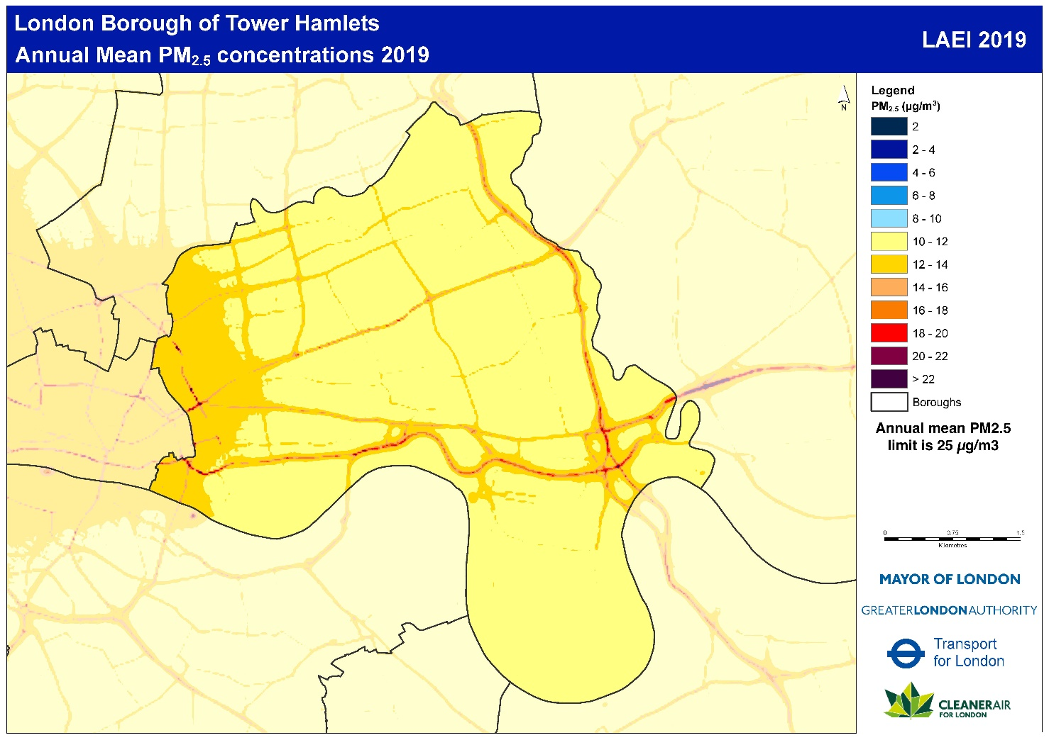

Figure 3. Modelled map of annual mean PM_{2.5} (from the LAEI 2019). Whole of the borough experience exceedance of the WHO 2005 limit (>10 µg/m³) but only a small number of major roads exceed the UK annual limit (25 µg/m³) and it remains mainly at the road centrelines (e.g. in East Smithfield, Aspen Way, the A12)

1.2 Air Quality Monitoring

Tower Hamlets has a comprehensive monitoring network including active and passive monitors. There are four active (automatic) continuous monitoring stations - two roadside and two background. The Blackwall tunnel monitoring station is managed by TfL and the other three are managed by Tower Hamlets. Location of these monitoring stations including the pollutants measured are given in the following table.

Location | Site type | Pollutants monitored
Mile End Road | Roadside | NOx, PM2.5
Blackwall Tunnel Northern Approach | Roadside | NOx, PM₁₀, PM_{2.5}, O₃, CO₂
Victoria Park | Background | NOx, PM₁₀, PM2.5
Millwall Park | Background | NOx, PM₁₀, O₃
Table 1.2 Tower Hamlets Air Quality Monitoring Stations
Passive monitoring is carried out with 92 NO₂ diffusion tubes spread across the Borough. These provide monthly average NO₂ concentrations.

1.3 AQMAs and Focus areas

In the London Borough of Tower Hamlets an Air Quality Management Area (AQMA) was declared covering the whole Borough in 2000.

The AQMA has been declared for the following pollutants:

- Nitrogen Dioxide - because we are failing to meet the EU annual average limit for this pollutant at some of our monitoring stations and modelling indicates it is being breached at several other areas across the Borough.

- Particulate Matter – Even though we are meeting EU limits for PM10, we are exceeding World Health Organisation air quality guideline for this pollutant and we have a formal responsibility to work towards reductions of PM2.5, which is a fraction of PM10. Concentrations of PM2.5 are measured at specific monitoring points throughout the Borough. The Council supports the London Mayor’s 2030 commitment to achieving the WHO 2005 guidelines levels for PM2.5 (10ug/m³).

An air quality Focus Area is a location that has been identified as having high levels of pollution and human exposure- residential properties, schools, hospitals, care homes and town centres. There are 7 focus areas in the Borough. The focus area names, and their location are below in figure 4. These focus areas are based on the LAEI 2016 data. The GLA have now revisited and reviewed the focus areas against the updated 2019 LAEI data. The conclusion is that problem remains at these focus areas, therefore, the 7 focus areas remain unchanged.

NO₂ Focus Areas LAEI 2016 – Tower Hamlets
Fig 4 chart Ref | NO₂ Focus Area Name | LAEI 2016 ID for each focus area
1 | Tower Hill/Tower Gateway/Cable St/The Highway | 157
2 | A11 Whitechapel Road to Mile End junction A1205 Burdett Road | 158
3 | Commercial Road from Aldgate East to junction with Jubilee Street | 159
4 | A107 Cambridge Heath Rd/Bethnal Green Rd to Mare St/Well Street | 160
5 | Blackwall A13 East India Dock Road/Aspen Way/Blackwall Tunnel | 161
6 | Commercial Street | 162
7 | Aldgate and Aldgate East | 163

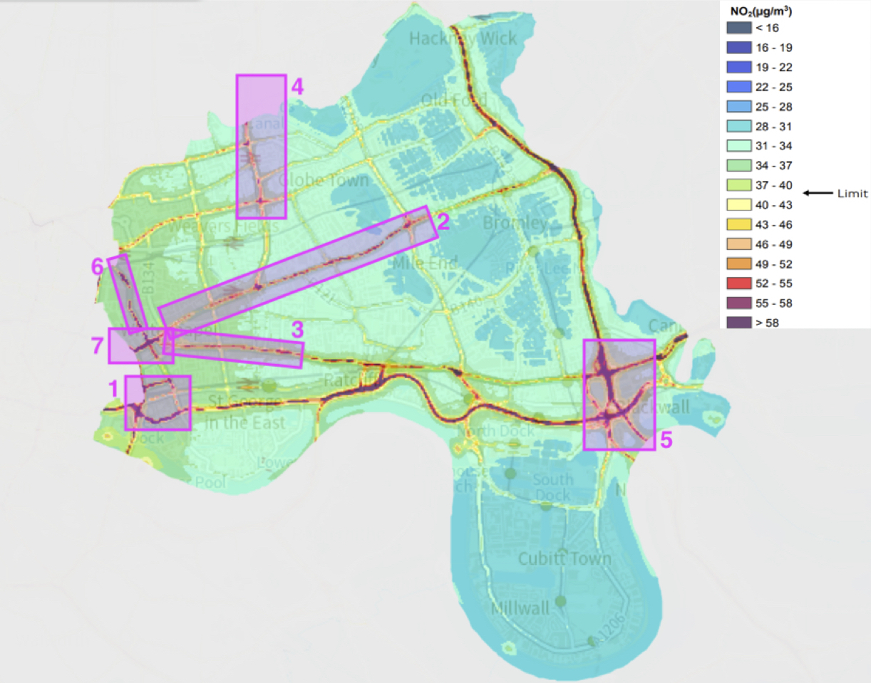Figure 4. Map of Air Quality Focus Areas for Nitrogen Dioxide.

1.3.1 Tower Hill/Tower Gateway/Cable St/The Highway

A brand-new real-time reference air quality monitoring station is proposed to be installed on the Highway. This monitor will provide live NOx and PM2.5 readings and will facilitate the work of the Borough’s air quality team to monitor air pollution in this location.

1.3.2 A11 Whitechapel Road to Mile End junction A1205 Burdett Road – Business Low Emissions Neighbourhood (BLEN)
A Business Low Emission Neighbourhood has been implemented in the area of Whitechapel Road and Mile End Road which consist of the following elements:
• Market trader storage site at Whitechapel
• Electric Vehicle charge points on housing estates
• Smarter workplace grants to local businesses
The aim is to encourage and support organisations, including businesses, to reduce emissions from their own operations, thereby reducing energy and fuel costs and to ultimately to see measurable improvements in air quality.

1.3.3. Commercial Road from Aldgate East to junction with Jubilee Street– THH electric vans and charging point initiative
Tower Hamlets Community Housing (THCH) have acquired 3 new electric vehicles for mobile estate cleaning teams with the possibility of acquiring 2 further electric vehicles. With the help of the Tower Hamlets Mayor’s Air Quality fund, charging points have been installed so that staff can charge the vehicles while going about their business on the estates. The aim of the project is to increase the number of electric vehicles in use within the Borough and reduce emissions. The vehicles are THCH branded to highlight they are electric and reducing emissions within the Borough.

1.3.4. A107 Cambridge Heath Rd/Bethnal Green Rd to Mare St/Well Street – Cargo Bikes
New electrically assisted cargo bikes are now available to rent from various docking stations in the Shoreditch Area. The scheme aims to help residents and businesses carry goods by bike and support them to reduce transport emissions. The Zero Emissions Network currently supports businesses and their employees to use cargo bikes with free trials, training, maintenance, and grants. The new Cargo Bike Share service will help even more people discover the efficiency of cargo bikes. Each of the e- cargo bikes can carry up to 80kg - and can be used for shopping, deliveries, and moving small items of furniture.

1.3.5. Blackwall A13 East India Dock Road/Aspen Way/Blackwall Tunnel – Aberfeldy Pocket Park
This project is an air quality intervention along the A12, focusing on greenspace design and green infrastructure, which can improve the local air quality, thus enhancing the well-being of school children, residents, and workers around the A12. It will create a new high quality green pocket park between the Culloden Primary School and the A12 pedestrian underpass linking to Brownfield estate. The pocket park will provide much needed planting and seating which will reduce exposure of school children and residents to poor air quality from the A12 and reduce the dominance of cars in the area and encourage more parents and children to walk and cycle to school thanks to a safer and improved public realm experience. The project is being funded from Local Infrastructure Fund (LIF)

1.3.6. Commercial Street -ZEN
The Zero Emissions Network (ZEN) is a multiple award-winning air quality business liaison initiative. The network helps businesses and residents in London's City Fringe area save money, reduce emissions, and improve local air quality. The scheme addresses the growing problems of air pollution by raising awareness and encouraging positive behaviour change. To date, the network has delivered over 800 emission reducing initiatives and continues to deliver improvements in air quality. The Zero Emissions Network is a partnership project between the London Boroughs of Hackney, Islington and Tower Hamlets and it is supported by the Mayor of London.

1.3.7. Aldgate and Aldgate East – Community Events
Community engagement events have been set up to engage and educate people in air quality initiatives and issues. An example of this is Green Week 2021, which was an event set up for residents in the Aldgate East area to understand what is being done on various fronts to make the Borough more sustainable and greener. The air quality stall was popular amongst the participants, providing leaflets about actions residents and businesses can take to improve air quality and games for children to help the upcoming generation understand more about air quality issues. Attendees seemed particularly interested in provision of sustainable modes of transport such as cycling.

1.4 Sources of Pollution in the London Borough of Tower Hamlets

Pollution in the London Borough of Tower Hamlets comes from a variety of sources. This includes pollution from sources outside of the Borough, and, in the case of particulate matter, a significant proportion of this comes from outside of London and even the UK.

Of the pollution that originates in the Borough, the main sources of NO₂ are transport and domestic emissions from heat and power, and the main sources of particulate matter are traffic emissions, resuspension of particles from traffic sources, such as brake or tyre wear and emissions from construction machinery (NRMM). The following charts provide a breakdown of the main pollutants (NO_{x}, PM₁₀, PM_{2.5}) and their various sources.

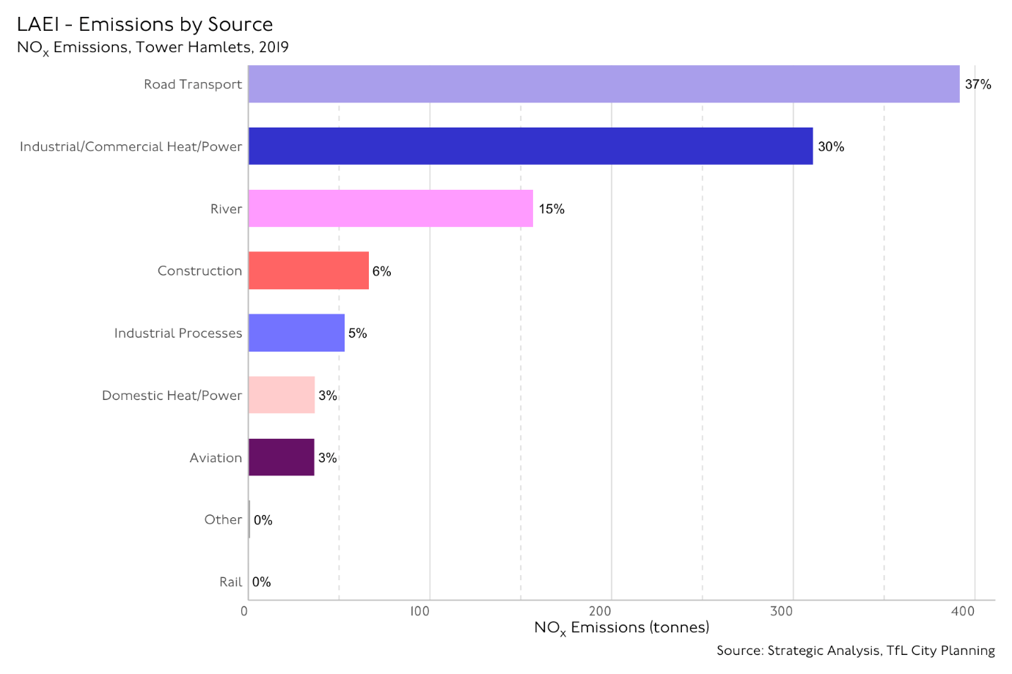
Figure 5. Distribution of NOx Emissions in Tower Hamlets (Source: LAEI 2019)

Figure 5 shows the sources of NOx emissions in the Borough. The chart shows that 37% of the Borough’s NOx emissions come from road transport. Other significant sources include industrial / commercial heat / power (30%), river transport (15%) and construction (6%). Industrial Processes: includes emissions from Part B processes and non-road mobile machinery (NRMM). Part B processes are controlled through a permitting system which controls releases to air. Construction: includes emissions from construction dust (PM) and NRMM exhaust on construction sites. There are controls over emissions from road transport and from construction sites. Emissions from commercial cooking and heating are controlled only through the planning process, by requiring adequate dispersion of flue gases and suitable filtration.

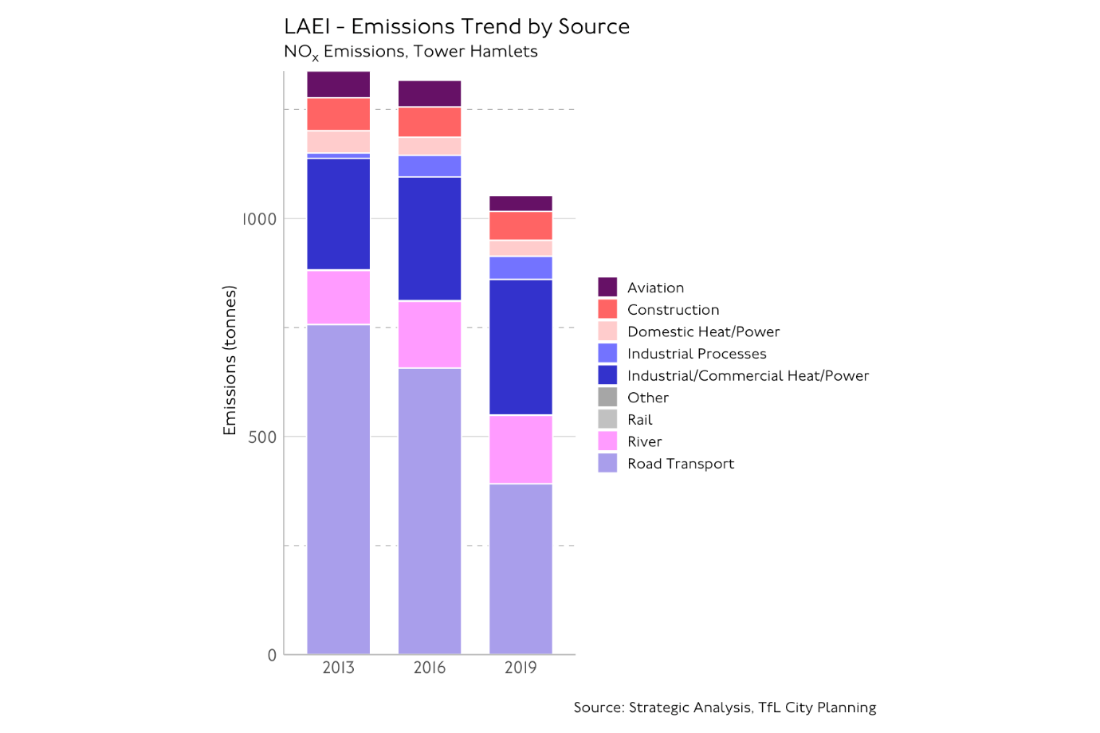

Figure 6. NOx Emissions by Source Type in tonnes per year in Tower Hamlets over three years 2013-2019 (Source: LAEI 2019)

Figure 6 shows the sources of NOx emissions by source type in tonnes per year in the Borough spanning 2013-2019. There has been a steady reduction over the period.

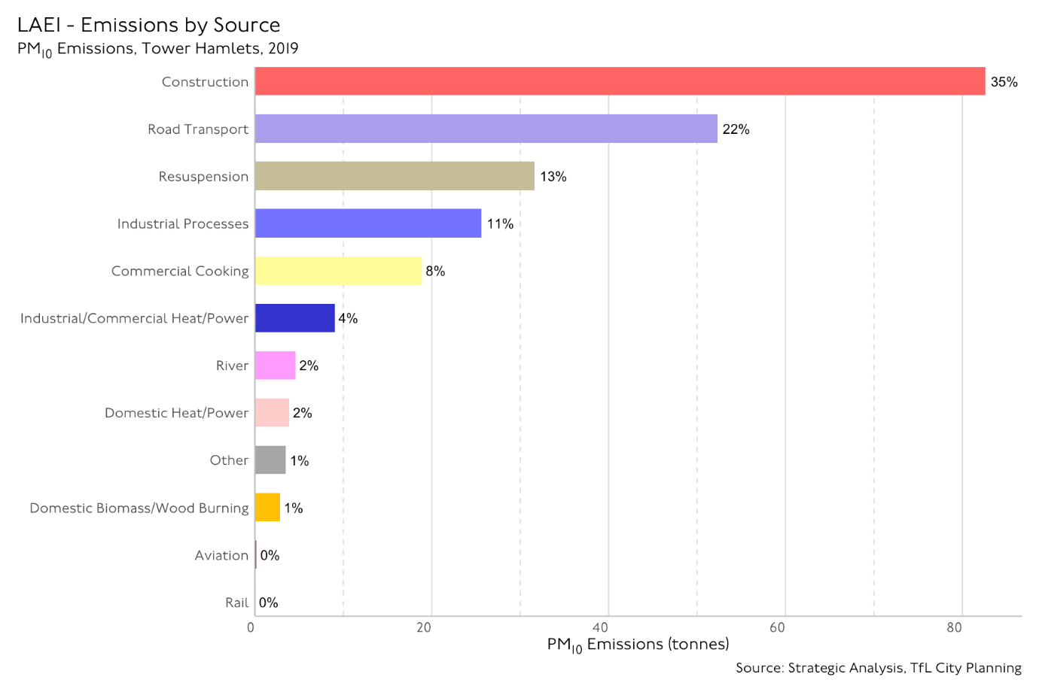

Figure 7. Distribution of PM₁₀ Emissions in Tower Hamlets (Source: LAEI 2019)

Figure 7 shows the sources of PM₁₀ emissions in the Borough. The major PM₁₀ emissions source in the Borough is construction (35%). 22% of the Borough’s PM₁₀ emissions also comes from road transport. Other significant sources shown in the chart are industrial processes (11%), resuspension (13%), and commercial cooking (8%). Industrial Processes: includes emissions from Part B processes and non-road mobile machinery (NRMM). Part B processes are controlled through a permitting system which controls releases to air. Construction: includes emissions from construction dust (PM) and NRMM exhaust on construction sites. There are controls over emissions from road transport and from construction sites. Emissions from commercial cooking and heating are controlled only through the planning process, by requiring adequate dispersion of flue gases and suitable filtration.

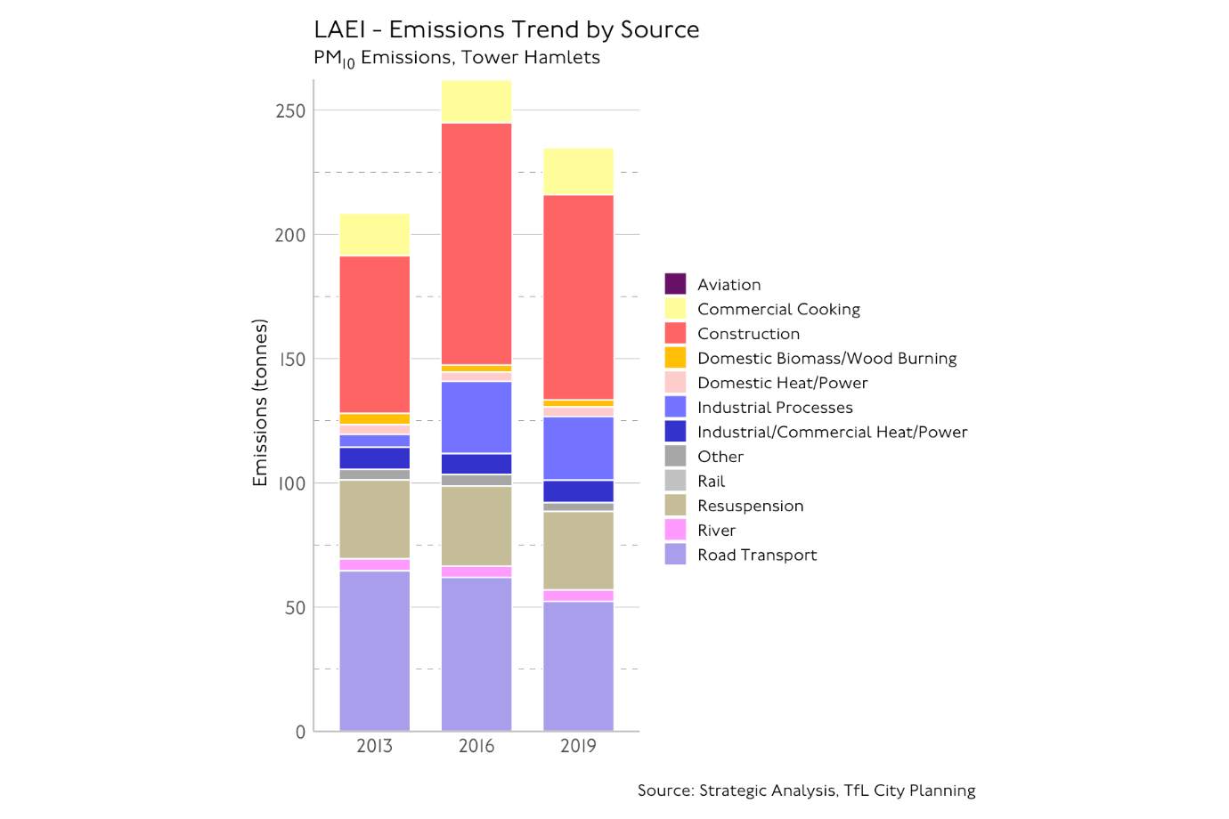

Figure 8. PM₁₀ Emissions by source type in tonnes per year in Tower Hamlets over three years 2013-2019 (Source: LAEI 2019)

Figure 8 shows the sources of PM₁₀ emissions by source type in the Borough spanning 2013-2019. There has been an upward trend in PM10 emissions with construction and road transport emissions contributing the most.

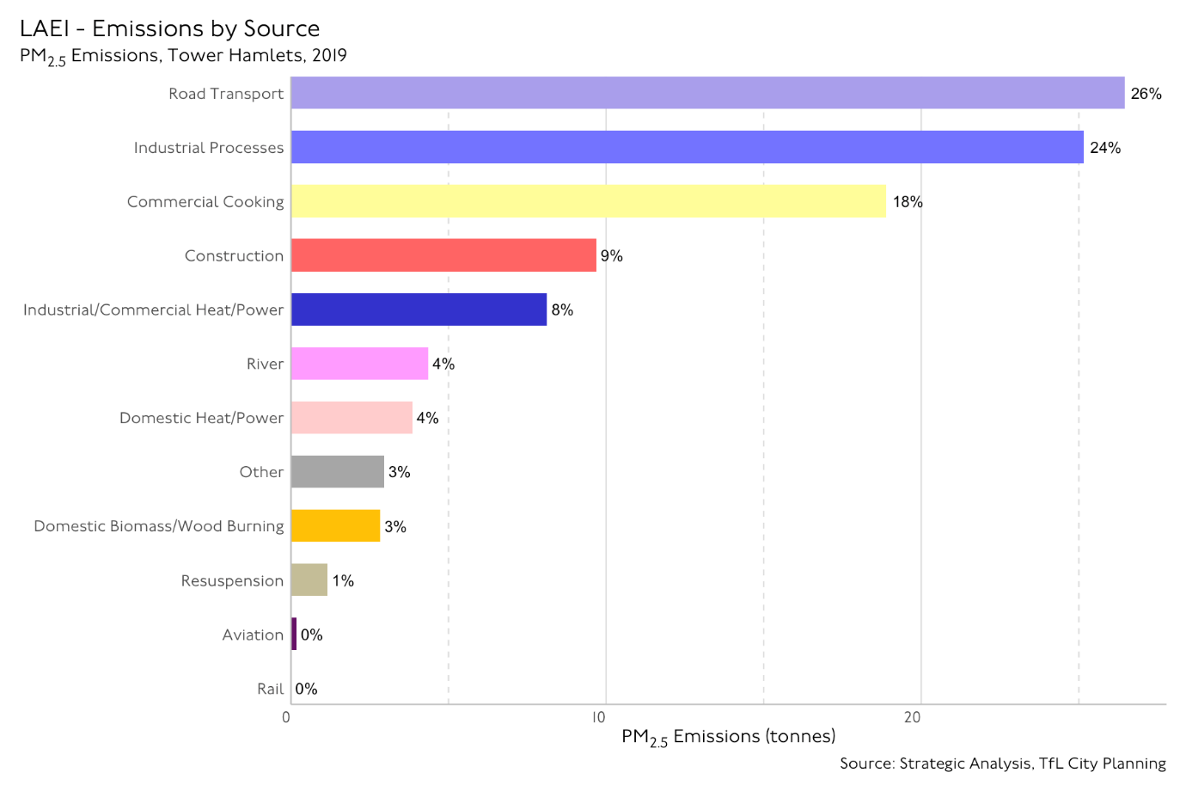
Figure 9. Distribution of PM_{2.5} Emissions in Tower Hamlets (Source: LAEI 2019)

Figure 9 shows the sources of PM_{2.5} emissions in the Borough. The major PM_{2.5} emissions source in the Borough is road transport with 26% emission. Other significant sources shown in the chart are industrial processes (24%), construction (9%), commercial cooking (18%), industrial / commercial heat / power (8%), Industrial Processes: includes emissions from Part B processes and non-road mobile machinery (NRMM). Part B processes are controlled through a permitting system which controls releases to air. Construction: includes emissions from construction dust (PM) and NRMM exhaust on construction sites. There are controls over emissions from road transport and from construction sites. Emissions from commercial cooking and heating are controlled only through the planning process, by requiring adequate dispersion of flue gases and suitable filtration.

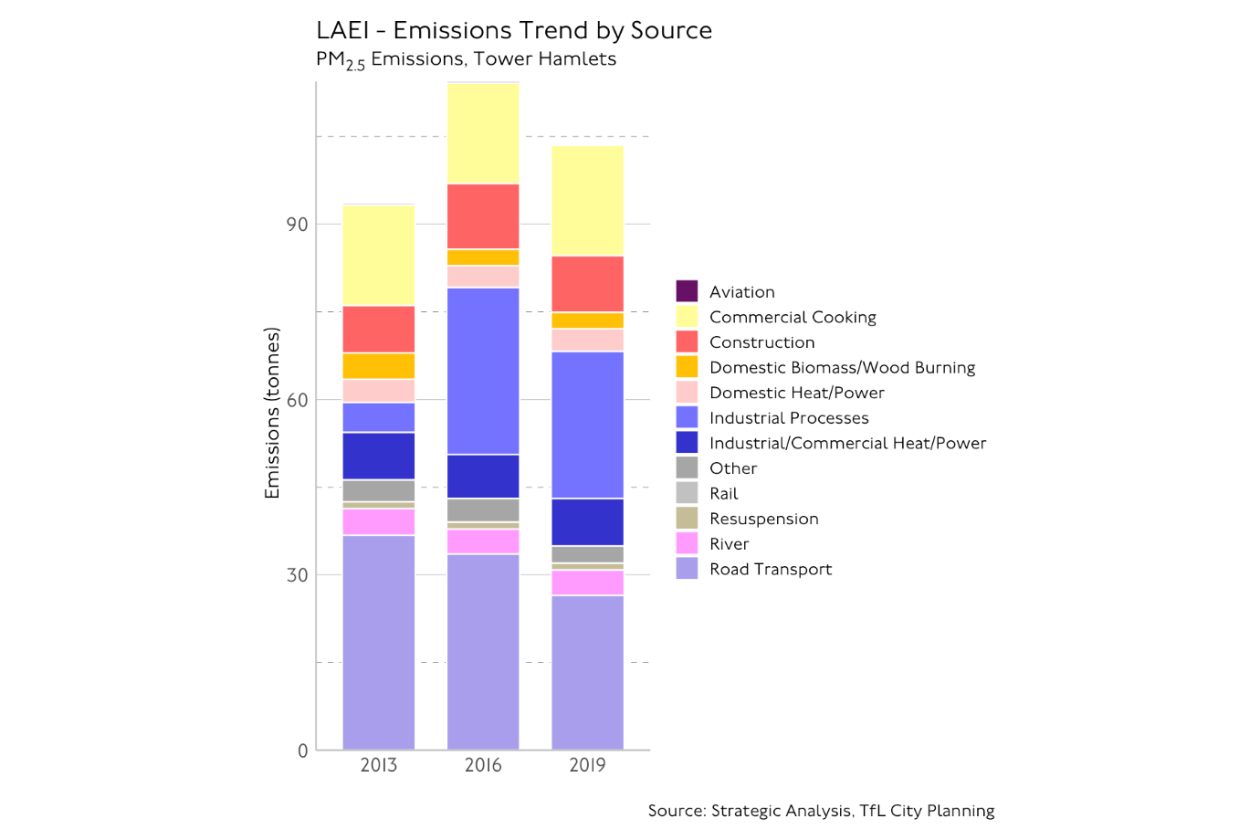

Figure 10. PM_{2.5} Emissions by source type in tonnes per year in Tower Hamlets over three years 2013-2019 (Source: LAEI 2019)

Figure 10 shows the sources of PM_{2.5} emissions by source type in the Borough spanning 2013-2019. There has been an upward trend in PM2.5 emissions with construction, road transport and commercial cooking and industrial emissions contributing the most.

1.5 How the AQAP links in with other key Council strategies/plans

Some of our other strategies/plans may also contribute to the improvement of air quality and therefore has a link with this AQAP and ensures coordinated actions across the different council services. These are listed in table below.

Document Name
Tower Hamlets Local Plan 2031: Managing Growth and Sharing Benefits
Tower Hamlets Transport Strategy 2019-2041
Tower Hamlets Green Grid Strategy: Update 2017
Tower Hamlets Net Zero Carbon Plan/Air Quality and Climate Change Strategy (2017-2022)
Table 1.5 List of the Council documents reviewed for the AQAP

Tower Hamlets Local Plan 2031: Managing Growth and Sharing Benefits

The Local Plan 2031 was adopted in January 2020. It sets out how the council will grow and develop from now until 2031. It provides a series of policies to ensure development is well-designed, accessible, safe and respects and enhances the environment, and can be delivered alongside new infrastructure and local services. The Plan also recognises large levels of carbon dioxide are emitted in the Borough primarily due to emissions from industrial and commercial uses. These sectors could also contribute to air quality concentrations in the Borough. In parts of the Borough, including the City Fringe and along all major roads, the levels of nitrogen dioxide and particulates (PM2.5 and PM10) exceed World Health Organisation guideline limits and, in the case of nitrogen dioxide, European Union safe legal limits/national air quality objectives. Among the policies listed in the plan, some of them focus on air quality. The key policies that could impact air pollution:
- Control of dust emission in construction (in policy D.SG4)
- A policy on air quality (D.ES2), tackling NO2, PM2.5 and PM10 pollution. This could include actions such as:
- Reducing vehicular traffic levels
- Encouraging sustainable movement patterns
- Methods of carrying out construction
- Actions to reduce emissions throughout the lifetime of the building
- Reducing emissions from associated plant equipment
- Improving or greening the public realm
- Ensuring decentralised energy facilities do not contribute to poor air quality.
A policy D.ES2 also includes mitigation such as:
- Maximising distance from pollutant source (the recommended distance would be over 50 metres from the pollution source)
- Considering proven ventilation systems
- Parking considerations (in accordance with their transport policies, i.e., developing sustainable transports and increasing the number of parking for bikes and cars, and adding more electric charging stations)
- The use of winter gardens, instead of balconies
- Internal layout and minimising internal pollutant emissions
- A Zero Carbon policy (D.ES7) focusing on improving the buildings regulations.

Tower Hamlets Transport Strategy 2019-2041

The transport strategy sets out the vision and priorities for travel in Tower Hamlets from 2020 to 2041. It clearly specifies the air quality issue is related to vehicle emissions, since it mentions Tower Hamlets has the highest levels of traffic flow in the UK. The majority of this is traffic passing through the Borough which has a significant impact on residents’ health. The Strategy sets out an ambitious set of proposals to encourage people to choose lower pollution alternatives to cars where possible. Several actions are listed such as: pedestrian enhancements on designated routes, increasing the number of vehicle charging points, issuing more parking permits, continuing to promote and support the Zero Emissions Network. To deliver the aims and outcomes in this Strategy it is planned to work with partners, stakeholders, and others. This strategy will be funded from a range of sources including Transport for London, Tower Hamlets Council, and developer contributions.

Tower Hamlets Green Grid Strategy: Update 2017
The green grid strategy is integrated with the AQAP and aims to “create a framework for the design and delivery of appealing walking routes and associated green infrastructure across Tower Hamlets, to secure a healthy and attractive environment for residents, workers and visitors”. With regards to air quality, the Green Grid has two overarching design principles, (i) installation of street trees, planting and other vegetation where appropriate, to provide access to nature, ameliorate poor air quality and deliver climate adaptation and (ii) promoting quiet streets and routes away from main roads and heavy traffic, to protect pedestrians from poor air quality.

Tower Hamlets Net Zero Carbon Plan/Air Quality and Climate Change Strategy
These air quality and climate change are interrelated; air pollution often originates from the same activities that contribute to climate change. The plan recognises the co-benefits of reducing carbon emissions on local air quality and states "phasing out of petrol and diesel powered vehicles on our roads and gas boilers in our buildings will reduce local air pollution”.

2 The London Borough of Tower Hamlets’ Air Quality Priorities

The London Borough of Tower Hamlets is determined to tackle poor air quality in the Borough. Raising awareness and providing education about the causes and impacts of poor air quality are crucial to achieving this. We want to support residents to make a difference to the air quality that is affecting all of us.

Due to Tower Hamlet’s strategic location in London, most pollution in our jurisdiction is from traffic travelling through the Borough. Tower Hamlets connects East and West London via the A11 and North and South London via the A12. Car ownership is relatively low in Tower Hamlets compared to other London Boroughs, with 46,694 vehicles registered in the Borough in 2020. Therefore, a key part of this action plan will aim to work in partnership with the Greater London Authority and Transport for London, as well as lobby other regional and national authorities to improve air quality in Tower Hamlets.

Tower Hamlets is experiencing unprecedented development and population increase. Over the last 10 years, the Borough population increased by 22.1 %, higher than the overall increase in England and the highest increase in London, The Borough also saw the largest percentage growth in population in England. Therefore, a key priority is ensuring new development does not hinder our progress on improving air quality. However, Tower Hamlets is striving to go beyond compliance with our commitment and responsibility to reduce emissions from our own operations and jurisdiction. We are committing to a range of projects and localised measures to improve air quality and work towards reducing exposure to air pollution.

The key priority work areas for Tower Hamlets include:

- Continue monitoring air pollutants and carrying out other core statutory duties to improve air quality within the Borough

- Reducing emissions from developments and buildings

- Increasing public health and awareness raising to reduce exposure to air pollution

- Working with businesses in delivery servicing and freight to decrease air emissions

- Reducing emission from Council fleet

- Localised solutions such as expanding and improving green infrastructure, Low Emission Neighbourhoods (LENs) (subject to securing funding), replacing boilers and implementing insulation schemes in schools and Council properties, etc.

- Improving cleaner transport within the Borough through transport and air quality policies, idling enforcement, car free days, pedestrianisation schemes projects, installation of electric vehicle charging points, and supporting walking and cycling.

3 Development and Implementation of the London Borough of Tower Hamlets’ AQAP

3.1 Consultation and Stakeholder Engagement

In producing the action plan, we have worked with other local authorities, agencies, businesses, and the local community to improve local air quality. Schedule 11 of the Environment Act 1995 requires local authorities to consult the bodies listed in Table 3.1. In addition, we have undertaken the following stakeholder engagement:
- Public consultation via our communications and engagement tool Let's Talk Tower Hamlets (main communications channel);
- Promoted to key equality networks;
- Promotion in council’s voluntary and community sector newsletter
- To residents who have signed up to our residents' panel

A summary of response to our consultation stakeholder engagement is given in Appendix A,

Table 3.1 Consultation Undertaken
Yes/No | Consultee
Yes | The Environment Agency
Yes | Secretary of State
Yes | Transport for London and the Mayor of London (who provided a joint response)
Yes | All neighbouring local authorities (Hackney, Newham, RB Greenwich, City of London)
No | Other public authorities as appropriate
No | Bodies representing local business interests and other organisations as appropriate
Yes | Members of the Public/Equality Networks/Voluntary and community sector

3.2 Steering Group

The overall responsibility for the implementation of the plan will sit with Environmental Health and Trading Standards (EHTS) service, however, the actions within the plan will be monitored by the Air Quality and Net Zero Strategic Working Group, chaired by the divisional director of public realm. The working group is made up of all the relevant council stakeholders and includes Transportation and Highways, EHTS, Planning, Fleet Management, Public Health, Procurement, Sustainability/Climate Change, Communications and Parking.

The strategic working group will monitor the progress of the AQAP through quarterly meetings. Furthermore, progress each year will be reported to the GLA in the Annual Status Reports produced by the London Borough of Tower Hamlets, as part of our statutory London Local Air Quality Management duties.

4 Action Plan Table

We have an action plan to show how we will address the air quality issues the Borough faces / our air quality priorities.

Table 4.1 shows the London Borough of Tower Hamlet’s’ AQAP. It contains:

- A list of the actions that form part of the plan

- The responsible individual and departments/organisations who will deliver this action

- Estimated cost to the Council

- Expected benefit in terms of emissions and concentration reduction

- The timescale for implementation

- The outputs, targets, and Key Performance Indicators

- How progress will be monitored.

In the action plan there are some measures identified as ‘GLA Key Selected Measure’. These are measures the GLA would like Boroughs to focus most strongly on. Other measures are identified as ‘GLA foundation’ measures, Boroughs ‘should be delivering all of these to the best of their ability’.

Key

Cost Description | Estimated cost range
Low | <£10,000
Low-Medium | £10,000-£50,000
Medium | £50,000 - £100,000
High | > £100,000

An explanation of how priority level has been worked out is given below

Ease of delivery | Magnitude of air quality benefits | Priority level  (Priority level score = Ease of delivery × Magnitude of AQ benefits)
Straightforward= 1-2  Medium =3-4  Most difficult = 5 | High = 1  Medium = 2  Low = 3 | High = 1-5  Medium = 6-10  Low = 11-15

Table 4.1 Air Quality Action Plan

The actions have been grouped into seven categories:
- Monitoring and core statutory duties
- Emissions from developments and buildings
- Public health and awareness raising
- Delivery servicing and freight
- Borough fleet actions
- Localised solutions
- Cleaner transport

Theme: Monitoring and other core statutory duties

ID | Action | Responsibility | Cost | Expected emissions/ concentrations benefit  Low=1; Medium=2; High=3 | Priority level | Timescale for implementation | Outputs, targets and KPIs | Further information
1 | (a) Maintaining, and where possible expanding monitoring networks, and fulfilling other statutory duties  (GLA Foundation Action) | Environmental Health & Trading Standards Service (EHTS) | Medium | Does not directly reduce emissions but is essential for understanding emissions & the impacts of measures to improve air quality.  Expected emissions/concentrations benefit = 1 | High | Ongoing | We will ensure all our monitors are fully calibrated & serviced annually.  KPI: 90% date capture at all sites  Subject to funding we will enhance our real time monitoring network, including installing PM2.5 monitors. We will prioritise new PM2.5 monitors in the west of the Borough which currently does not benefit from active monitors.  KPI: 2 additional monitors by end of 2023 | Air quality in Tower Hamlets is measured with an extensive monitoring network of NO2 diffusion tubes and automatic monitoring stations.  Our automatic monitoring stations measure a wide variety of pollutants, including NO2, PM10, PM2.5 and O3.  This work will address recommendations from the Coroner’s Prevention of Future Deaths report after the death of Ella Kissi-Debrah in terms of increasing the number of monitors.
1 | (b) Continue to ensure that all air pollution monitoring data is available to the public and the website is regularly updated with the latest available data | EHTS | Low | Important for monitoring trends and awareness raising  Expected emissions/concentrations benefit = 1 | High | Ongoing | We will submit our statutory annual status report on time each year | Details of our monitoring can be found here: https://www.towerhamlets.gov.uk/lgnl/environment_and_waste/environmental_health/pollution/air_quality/Advanced_information_on_air_quality/Monitoring.aspx
2 | Support the London Mayor’s 2030 commitment to achieving the WHO interim guideline level for PM2.5 annual mean concentration (10ug/m³) with an aspiration to achieving the new WHO target of 5 ug/m³ in the shortest possible time | EHTS  Fleet  Highways | Low - no direct cost apart from ongoing monitoring | No direct impact on emissions but useful for understanding the impacts of measures to improve air quality  Expected emissions/concentrations benefit = 1 | High | ongoing | We will report progress via the annual status report. | This is a new action introduced following public consultation.  The Mayor of London expects Boroughs to work towards reducing emissions and concentrations of PM2.5 in their areas  According to the Public Health Outcomes Framework, 7.6% of mortality in Tower Hamlets is due to long term exposure to PM2.5 https://fingertips.phe.org.uk/profile/public-health-outcomes-framework/data#page/3/gid/1000043/pat/6/par/E12000001/ati/401/are/E06000047/iid/93861/age/230/sex/4/cat/-1/ctp/-1/yrr/1/cid/4/tbm/1/page-options/car-ao-1_car-do-0  in 2021, the WHO updated their guideline level for PM2.5 annual mean concentration to 5ug/m³  DEFRA is proposing to set annual mean concentration target of 10 micrograms per cubic metre (µg/m³ to be met across England by 2040 https://consult.defra.gov.uk/natural-environment-policy/consultation-on-environmental-targets/  In our consultation response to DEFRA, we recommended the Government to adopt the WHO updated PM2.5 target in the Environment Act 2021 and will continue to lobby Government on this whenever the opportunity arises as the lever to reduce PM2.5 rests with the government.  We’re supporting the Mayor of London’s commitment to achieving the WHO interim target by 2030 and subject to emerging policies from the GLA regarding the 2021 WHO guidelines, have aspiration to meet the new WHO guideline level in the shortest possible time.

Emissions from developments and buildings

ID | Action | Responsibility | Cost | Expected emissions/ concentrations benefit  Low=1; Medium=2; High=3 | Priority level | Timescale for implementation | Outputs, targets and KPIs | Further information
3 | Ensuring emissions from construction are minimised  (GLA Foundation Action) | Development Control/Planning Policy  Pollution | Low | Minimises exposure of residents near developments & avoids unnecessary emissions associated with construction and demolition sites.  The amount of pollutant emissions that can be reduced will depend on the type and size of the development | High | ongoing | We will have a clear and regularly updated code of construction practice.  We will ensure all major development carry out an Air Quality Assessment including a dust assessment, in accordance with GLA guidance  KPI: 100% of major planning permissions required to monitor construction dust (PM10) | GLA’s guidance (The Control of Dust and Emissions during Construction and Demolition Supplementary Planning Guidance or successor documents). Similarly, developers are required to submit a transport logistics assessment in accordance with TfL’s (Construction Logistics Guidance).
4 | Ensuring enforcement of non-road mobile machinery (NRMM) air quality policies  GLA Key Selected Measure | Planning Enforcement (Lead)  Pollution | Low-Medium | NRMM used in construction in the Borough currently accounts for approx. 34% of PM10, 14.9% of PM2.5 and 7.1% NOx.  Minimises exposure of residents near developments.  Benefits potentially significant but not quantifiable  Expected emissions/concentrations benefit = 3 | High | ongoing | We will ensure that all major planning applications have the NRMM condition applied.  KPI: 100% of relevant developments registered on the NRMM database  KPI: 100% of relevant applications to include appropriate NRMM planning condition. | Compliance monitoring currently being carried out by London Borough of Merton as part of a pan London project funded by the GLA. This project was due to finish in March 2022 but has been extended for 3 years. Enforcement of NRMM planning condition is down to individual Boroughs.  Match funding contribution required to support the London wide project. Possible funding source could be s106.  The NRMM register can be found here: https://www.london.gov.uk/what-we-do/environment/pollution-and-air-quality/non-road-mobile-machinery-register/login/register
5 | Reducing emissions from Combined Heat and Power (CHP) (new developments only)  Ensure policy met.  (GLA Foundation action) | Sustainability (Lead)  Planning  Pollution | Low-Medium | Combustion-based Combined Heat and Power (CHP) can be a significant source of local emissions so tackling this is an important priority. This is part of day-to-day planning work.  Benefits potentially significant but not quantifiable. However, CHP systems produce up to 170 times the NOx emissions per kw hour unit of gas / electricity heat generated. We would therefore expect to see a significant reduction in NOx emissions as CHPs are replaced  Expected emissions/concentrations benefit = 3 | High | Annually | We will introduce a register of combustion-based and renewable technologies.  We will ensure that air quality as well as emissions is considered when assessing planning applications.  KPI: 100% of fossil fuel-based CHP / Biomass boilers refused. Noting that low-emission CHPs may be acceptable in accordance with Policy SI 3 of the London Plan and Policy LS14 of the emerging Leaside Area Action Plan.  We will investigate feasibility of introducing a new Borough level energy masterplan to identify opportunities for new heat networks as well as extending or inter-connecting existing networks to support cleaner, lower carbon heat supply. | The carbon content in electricity has reduced and therefore all new schemes meet their responsibilities for electricity. From 2025 no new gas connections (Govt future homes standard, heat, and energy strategy).  Planning applications must adhere to the zero carbon requirements. https://www.towerhamlets.gov.uk/lgnl/environment_and_waste/environmental_health/pollution/air_quality/Advanced_information_on_air_quality/Air-Quality-and-Planning.aspx
6 | Enforcing Air Quality Neutral policy or its successor  (GLA Foundation Action) | Planning | Low | · Reduce the contribution to pollution from new development.  · Minimise exposure to residents of new developments from the onset.  Benefits potentially significant but not quantifiable  Expected emissions/concentrations benefit = 3 | High | Ongoing | We will ensure that major applications meet the air quality neutral standard or its successor.  Target: 100% of major applications meeting the air quality neutral standards or its successor | We provide advice to developers on meeting air quality neutral standards: https://www.towerhamlets.gov.uk/lgnl/environment_and_waste/environmental_health/pollution/air_quality/Advanced_information_on_air_quality/Air-Quality-and-Planning.aspx
7 | Ensuring adequate, appropriate, and well-located green space and infrastructure is included in new developments | Planning | Low | It can be hard to quantify air quality exposure improvements from such schemes, but the green infrastructure schemes can transform urban areas and help to provide improved public spaces. Whilst it can be hard to quantify air quality exposure improvements from such schemes, it may therefore be useful to consider such schemes as part of the Healthy Streets approach or to look at the measures of success built into Green Infrastructure proposals. | Medium | Ongoing | KPI: 100% of major applications meeting the minimum London Plan UGF scores. | The London Plan acknowledges that the existing natural environment should be protected, enhanced, and new green space and infrastructure should be supported. Green walls, hedges, trees, and other green infrastructure may help to reduce people’s exposure to air pollution, when used as a well-designed buffer between emission sources and population. Extra consideration should be given to new developments containing sensitive receptors, such as schools and care homes. At the same time, green infrastructure can serve important amenity functions, such as children’s play parks or as traffic free walking and cycling routes. The council will aim to ensure that new development proposals integrate green space and infrastructure, and that they act as a barrier between roads and new developments.  https://www.towerhamlets.gov.uk/Documents/Planning-and-building-control/Strategic-Planning/Local-Plan/Green_Grid_Update_2017.pdf
8 | (a) Consolidate and update Tower Hamlets’ historic Smoke Control orders  (b) Delivering annual awareness campaigns  (c) Enforcement of smoke control zone breaches  GLA Key Selected Measure | EHTS  Communications  EHTS | Low-Medium | LAEI 2019 data shows domestic wood burning accounts for 1% PM10 and 3% of PM2.5 emissions in the Borough.  Though not a significant amount but  King’s College London estimate that between 23%  and 31% of the PM2.5 originating in London comes from wood burning. Reducing this would clearly have a huge impact on PM2.5 & PM10 emissions. | High | End of 2024  Annually | We will look at the feasibility of updating and declaring a single consolidated smoke control order by end of 2024.  We will participate in the GLA Wood Burning Working Group and contribute to the outcomes of the group.  We will re-visit all traders in the Borough to raise awareness and assess compliance  KPI: Estimated reach of awareness campaigns per year  KPI: Number of suppliers engaged  KPI: 100% of smoke/ dark smoke complaints investigated within 3 working days. | New regulations restrict the sale of certain solid fuels. We publish information relating to smoke controls on our website https://www.towerhamlets.gov.uk/lgnl/environment_and_waste/environmental_health/pollution/air_quality/Air_pollution/Smoke_control.aspx
9 | Promoting and delivering energy efficiency and energy supply retrofitting projects in workplaces and homes through EFL retrofit programmes such as RE:FIT, RE:NEW and through Borough carbon offset funds.  GLA Key Selected Measure | Sustainability | Low | Directly reduces emissions and has co-benefits for carbon emissions and reducing fuel costs | High | Ongoing | We will improve energy efficiency via our Carbon Fund programme of retrofitting activities such as boiler replacements, and solar power panels on housing stock and on domestic properties.  We will apply for external funding where practicable / available (for example the private sector decarbonisation fund).  We will continue to promote energy efficiency advice, guidance, and grant opportunities (subject to funding and eligibility criteria) to residents in council and private homes.  KPI: Number of organisations / individuals supported (funding dependent). | The council declared a climate emergency in March 2019. We are aiming to become a net zero carbon council by 2025 and a net zero carbon Borough by 2045 or sooner. https://www.towerhamlets.gov.uk/lgnl/environment_and_waste/Sustainability/Climate_emergency.aspx  In 2022, we agreed £3.7m worth of retrofit activities over the next three years. The intention is to add to this package (funding dependent). Note that delivery fluctuates depending on the number and scale of retrofit.  We offer a range of energy advice and information about energy efficiency, grants, and advice https://www.towerhamlets.gov.uk/lgnl/environment_and_waste/Sustainability/Tower_Hamlets_Energy/Energy_advice_and_information/Energy_advice_and_information.aspx
10  a | Planning policy is aligned with Air Quality Positive  (GLA Foundation Action) | Planning | Low | Air Quality Positive will rely on the selection of suitable measures on a case-by-case basis for developments, impacts on emissions and concentrations will vary from scheme to scheme. | Medium | Ongoing | We will undertake a review of the local plan to ensure policies promote air quality positive and healthy streets.
10b | Highway improvements to follow the Healthy Streets approach  (GLA Foundation Action) | Highways | High | The Healthy Streets approach encourages focus on several different factors; many different initiatives are undertaken under the Healthy Street umbrella. Quantification of emissions reductions is therefore difficult as it will depend on the scheme being undertaken. | High | Ongoing | We will undertake Healthy Street assessment against ten Healthy Streets criteria. We will re-design where necessary and then rescore to see level of improvement (subject to funding) | One of the ways we will deliver a key objective in our Local Plan: sharing the benefits of growth https://www.towerhamlets.gov.uk/Documents/Planning-and-building-control/Strategic-Planning/Local-Plan/Introduction.pdf
11 | Reduce the use of private cars by residents by encouraging car free developments and limiting number of parking spaces in new developments. | Planning  Highway | Low | Likely to be significant but not quantifiable  Expected emissions/concentrations benefit = 3 | High | Ongoing | We will review all major planning applications every year to ensure they meet the latest parking standards | Parking standards for new developments now included in the local plan

Public health and awareness raising

ID | Action | Responsibility | Cost | Expected emissions/ concentrations benefit  Low=1; Medium=2; High=3 | Priority level | Timescale for implementation | Outputs, targets and KPIs | Further information
12 | Public Health department will assist in the development of air quality communications / campaigns to ensure an evidence-based approach is followed to support behavioural change, whilst also advocating for improved air quality locally and regionally.  (GLA Foundation Action) | Public Health  EHTS  Communications | Low | Enables greater accountability to have public health leadership on the air quality agenda.  Provides a platform to advocate for health improvement and to protect vulnerable residents from the harms of air pollution  Expected emissions/concentrations benefit = 1 | High | Ongoing | The Director of Public Health will sign off the air quality action plan  We will develop and run an air quality communications campaign to embed key messaging to influence sustainable behaviour changes in health improvement.  We will identify a consultant to lead the public health agenda in Tower Hamlets. | Aim to include air quality within Health and Wellbeing Board priorities. JSNA will have a section on air quality.
13 | Develop an air quality focused Joint Strategic Needs Assessment (JSNA) and maximise opportunities for further research and evaluation. | Public Health | Low | A Health needs assessment will be underpinned by data, insight and intelligence to inform the health impacts around poor air quality. This will support understanding of the harms of air pollution in Tower Hamlets. The needs assessment will be used to inform decision making and local action.  Opportunities to explore potential financial health savings from improved health outcomes  Strengthens partnership working, coordination of efforts and achieving shared outcomes.  Helps to ensure air quality is prioritised and that work on this agenda is recognised and evaluated to support continuous learning.  Expected emissions/concentrations benefit = 1 | High | 2023 | We will develop an air quality JSNA by end of February 2023  We will work with partners to link service delivery leads with academic partners to maximise opportunities for research and evaluation.
14 | Supporting a direct alerts service such as airTEXT, and promotion and dissemination of high pollution alert services, such as the Mayor’s air pollution forecasts  (GLA Key Selected Measure) | Pollution (Lead)  Communications | Low | Early warning via text message to vulnerable people, especially those who may be digitally excluded. This enables people to take steps to protect their health.  This is an exposure reduction initiative, as opposed to targeting emissions.  Expected emissions/concentrations benefit = 1 | High | Ongoing | We will use social media to help disseminate the Mayor's alerts (high and very high) to raise awareness and reduce exposure amongst vulnerable residents.  KPI: number of sign-ups to air Text each year  Target: 100% of the Mayor’s Moderate and High pollution alerts disseminated via our social media channels. | air Text service is operated by Cambridge Environmental Research Consultants (CERC) on subscription basis for local authorities but free to use for residents https://www.towerhamlets.gov.uk/lgnl/environment_and_waste/environmental_health/pollution/air_quality/air_text_-_air_pollution_forec.aspx
15 | Encouraging schools to join the TfL STARS accredited travel planning programme  (GLA Foundation Action) | Highways | Low-Medium | Increases awareness of air quality as an issue and can increase support for measures to improve air quality and public health, for example smarter travel and reduced idling.  Activities can help reduce exposure of children to high levels of pollution which can have serious lifelong health and cognitive impacts, so any improvement centred around this demographic is significant.  Reduces car use and increases walking and cycling on the journey to school as well as more responsible use of public transport. We estimate that car use for drop off and pick up can be reduced by a third at STARS accredited schools. | High | Ongoing | We will work in partnership with schools in the Borough to maintain or apply for the TfL STARS accreditation.  We will encourage schools to share their good news stories and activities via the STARS website.  KPI: Number of schools engaged with the scheme.  KPI: 50% of schools joined the STARS programme (with current level of resources)  KPI: Number of schools at level Bronze, Silver and Gold accreditation | STARS (Sustainable Travel: Active Responsible Safe) is a TfL accreditation scheme. It rewards London schools and nurseries for rolling-out safer and sustainable travel activities.
16 | Extending schools air quality audits to all polluted schools  (GLA Key Selected Measure) | Pollution  (Lead)  Highways | Medium  High | Exposure to high levels of pollution in childhood can have serious lifelong health and cognitive impacts. As such, any improvement centred around this demographic is significant.  Taking cleaner routes to school can dramatically reduce exposure, several recent exposure studies suggest that switching from main roads to quiet back street can reduce exposure by up to 70 percent  School audits could help reduce exposure and emissions, and they could help some of our most polluted schools. School audits aims to identify measures to reduce pollution.  School streets can reduce air pollution at the school gate by as much as 70% | High | Ongoing  Ongoing | We will undertake three air quality audits per year at high polluted schools.  KPI: Number of schools engaged with the scheme  We will investigate funding sources that we can use to install living green walls at audited schools.  We will investigate funding sources that we can use to support behaviour change interventions.  We will install anti-idling signs to deter unnecessary idling and increase awareness of air pollution around schools.  Continue the school street programme enabling nursery and primary school pupils to have a cleaner, safer, and more pleasant environment around their schools. | We use the guidance and toolkits produced by TfL Mayor's School Air Quality Audit Programme to support local authorities undertaking air quality audits around schools https://www.london.gov.uk/sites/default/files/school_aq_audits_-_toolkit_of_measures_dr_v3.3.pdf  Links to information about the London-wide campaign against idling engines as a source of pollution can be found on our website: https://www.towerhamlets.gov.uk/lgnl/environment_and_waste/environmental_health/pollution/air_quality/Air_quality_information_and_campaigns/Anti-idling-action-days-and-volunteering.aspx  A list of schools in the scheme are English Martyrs, Bluegate Fields, Ben Johnson, Harry Roberts, Globe, Malmesbury, Culloden, Elizabeth Selby (Bethnal Green LS), Seven Mills (Barkenine LS), Virginia (Bethnal Green LS), Marner, Cayley, Old Palace, Cubitt Town, Bonner, St Luke's, Canary Wharf College, Chisenhale, Old Ford (Bow LS), Harry Gosling, John Scurr, Clara Grant, Arnhem Wharf, Lawdale, Phoenix Upper School, Stebon / St Pauls, Marion Richardson, Hague, Stuart Headlam, St Edmunds, Harbinger, St Saviours, Wellington with more to follow.
17 | Tackle issues with emissions from Canal Boats | Pollution | Low-High | LAEI 2019 data shows domestic wood burning accounts for 1% of PM10 and 3% of PM2.5 emissions in the Borough but it is a concern for residents and people using the canal towpaths.  No specific emission reduction but useful to raise awareness  Expected emissions/concentrations benefit = 1 | Medium | Ongoing | Subject to securing funding and outcome of public consultation, we will explore the feasibility of bringing moored vessels such as canal boats into scope of smoke control area (SCA).  We will carry out a public consultation and look at the feasibility of including canal boats into SCA scope by end of 2024. This will depend on when DEFRA produces guidance on this and whether funding could be secured.  We will carry out an annual winter awareness campaign for boaters to raise awareness of air pollution from burning wood  KPI: Number of boaters engaged per year | New action following public consultation  Changes brought in by the Environment Act 2021 will allow local authorities to bring moored or stationary vessels such as canal boats into the scope of smoke control areas. However, smoke emissions will be allowed from fuel used by an engine to move or provide electric power to the vessel.  Local authorities will be required to carry out a public consultation before bringing canal boats into scope of SCA. This is also likely to involve additional expenditure to local authorities as compensation to boat owners may be required to make ‘adaptations’ to boats to make them compliant with the new requirements. Funding source will need to be identified for this. A possible source could be DEFRA air quality fund. We will look at working jointly with our neighbouring Boroughs on this.  Defra will be producing guidance for local authorities on how to create or change a smoke control area and bringing moored vessels into scope of smoke control area.  A smoke control area is an area where people and businesses must not emit a substantial amount of smoke from a chimney, buy or sell unauthorised fuel for use in a smoke control area unless it’s used in an ‘exempt’ appliance (appliances which are approved for use in smoke control areas).  Links with action 8(a)
18 | Develop and implement a communications strategy for disseminating air quality information in the Borough to raise awareness of the impacts of poor air quality and encourage behaviour change | Communications | Medium | Indirect impact on emissions through awareness raising and model shift | High | Ongoing | We will carry out an annual awareness campaign. | New action following public consultation.  Addresses consultation feedback where majority of responders said the Council’s communication on air pollution is not ‘very well’ or ‘not well at all’ and that the Council should implement campaigns to raise air quality awareness.  Also addresses recommendations from the Coroner’s Prevention of Future Deaths report after the death of Ella Kissi-Debrah in terms of increasing awareness of air pollution

Delivery servicing and freight

ID | Action | Responsibility | Cost | Expected emissions/ concentrations benefit  Low=1; Medium=2; High=3 | Priority level | Timescale for implementation | Outputs, targets and KPIs | Further information
19 | Updating of procurement policies to reduce pollution from logistics and servicing  (GLA Foundation Action) | Procurement | Low-Medium | Moderate emission reductions | Medium | Data from procurement | We will update our procurement policy by end of 2023
20 | Reducing emissions from deliveries to local businesses and residents  (GLA Foundation Action) | Highways | Low-Medium | Reducing vehicle movements helps alleviate congestion and improves road safety | Medium | Ongoing | We will consider the feasibility of providing EV-only loading bays, ULEV only areas and Virtual Loading Bays.  We will work with BIDs and business groups to encourage local consolidation and last mile deliveries  We will use the TfL retiming deliveries guidance to assess application and benefit  We will communicate with our residents to raise awareness of the impact that home deliveries and missed deliveries has on air quality.  KPI: Number of consolidation/last mile delivery schemes in place  KPI: Percentage increase in Ultra Low Emission Vehicles to undertake deliveries

Borough fleet actions

ID | Action | Responsibility | Cost | Expected emissions/ concentrations benefit  Low=1; Medium=2; High=3 | Priority level | Timescale for implementation | Outputs, targets and KPIs | Further information
21 | Reducing emissions from Council fleets by replacing the council’s fleet with zero tail pipe emission vehicles  (GLA Key Selected Measure) | Fleet | High | Supports adoption of innovative technologies and is important in terms of leading by example.  All vehicles meet Euro 6 standards for NOx and PM emissions. Further reduction in emissions will be directly linked to phased introduction of ULEVs as part of fleet replacement plans to 2027. | High | Ongoing | Between 2023 and 2027 we will continue to invest in vehicle telematics and driver training to help improve vehicles utilisation and reduce the impact of poor driving habits on air pollution.  KPI: Percentage of local authority drivers who have undertaken ‘smart’ driver training  We will implement Phase 1 of our fleet management strategy:  >Replacing up to 117 of our fleet of small vans and cars  >Upgrading our depots with electrical infrastructure improvements including electrical vehicle charging points  We will plan the commencement of Phase 2 of our fleet replacement strategy relating to larger vehicles such as waste, recycling vehicles and passenger transport vehicles  KPI: Percentage of cleaner vehicles in the fleet  KPI: Achieve zero tail pipe emission fleet by 2025 | In 2020/21 we used 1,873 metric tonnes of CO2 emissions from our owned transport. A move to green fuels will substantially reduce the CO2 emitted.  https://www.towerhamlets.gov.uk/lgnl/environment_and_waste/Sustainability/carbon_reduction.aspx  It is important to note emissions still occur from brake and tyre wear  All our current vehicles meet the latest current standards for emissions [you said something more here]  In 2021 we obtained £4.9 million in capital funding for replacement of cars, vans and light commercial vehicles with Ultra Low Emission equivalents.  As part of our climate emergency pledge to become a net zero Borough by 2025, we have made a commitment to not buy new diesel vehicles (unless no other options exist) and to only purchase or lease Ultra Low Emission vehicles.

Localised solutions

ID | Action | Responsibility | Cost | Expected emissions/ concentrations benefit  Low=1; Medium=2; High=3 | Priority level | Timescale for implementation | Outputs, targets and KPIs | Further information
22 | Expanding and improving green infrastructure  (GLA Foundation Action) | Highways | High | Whilst hard to quantify effectiveness, we know that improving and increasing green infrastructure in the Borough is likely to reduce air pollution. As part of urban infrastructure, green infrastructure influences pollution dispersal and deposition. Green infrastructure interacts with pollution formation and removal at regional and local scales. If designed properly, green infrastructure can help to mitigate poor air quality on a local scale. | Medium | Ongoing | We will record new green infrastructure projects that we implement over the duration of the action plan.  Subject to funding, we will continue with our programme of improving our green infrastructure.  We will plant trees throughout the borough and line our streets and estates with newly planted trees (plant c1,000 trees over a three-year period) | Outcome four in our Infrastructure Delivery Plan focusses on public realm and environment improvements for cleaner and more attractive streets, open and green spaces https://www.towerhamlets.gov.uk/lgnl/community_and_living/Regeneration-in-Tower-Hamlets/Approach-and-delivery.aspx
23 | Low Emission Neighbourhoods (LENs) and Business Low Emissions Neighbourhoods (BLENs)  (GLA Foundation Action) | highways | High | LENs are air quality focused schemes and include a package of measures in a pollution hotspot location to reduce emissions and improve the pedestrian and cyclist environment. BLENs are business/organisation focused low emission neighbourhoods.  Examples include the City Fringe (LEN) Low Emission Neighbourhood | Zero Emissions Network jointly delivered by Hackney, Islington & Tower Hamlets. The council is currently delivering the BLEN Tower Hamlets Town Centres & Markets schemes. This project includes setting up an e-cargo bike home delivery service in Chrisp Street and Market trader storage site at Whitechapel Rd. | High | Ongoing | We will explore the feasibility of introducing more LENs/BLENs in the Borough (subject to funding and local support). We will prioritise and focus on introducing these in high polluting areas.  KPI: Number of LENs/BLENs introduced over the lifetime of this plan.
24 | Implementing a Carbon Emissions Reduction Programme for Council properties (i.e. council offices) including boiler replacements and insulation projects | Sustainability | Low | Since 2021, we have installed air source heat pumps (ASHP) in five buildings to reduce both CO2 emissions, by 109t, and NO2 from building emissions.  Future benefits could be significant depending on the scale of the programme | Medium | Annual | We will continue to improve the energy efficiency of council buildings by using external funding and the Carbon Fund to fund the install of ASHPs. | This project will utilise carbon offset funding and any external funding, in particular the Public Sector Decarbonisation Scheme (PSDS), to reduce both CO2 and NO2 from building emissions by replacing gas boilers with ASHPs.  Measure against carbon reduction target  Offset funding plus need for grants too.

Cleaner Transport

ID | Action | Responsibility | Cost | Expected emissions/ concentrations benefit  Low=1; Medium=2; High=3 | Priority level | Timescale for implementation | Outputs, targets and KPIs | Further information
25 | Discouraging vehicle idling  (GLA Foundation Action) | ETH  Parking  THEOs | Low | An easy action for people to take to reduce completely unnecessary emissions  Expected emissions/concentrations benefit = 3 | High | Ongoing | We will provide training and advice to Civil Enforcement Officers engaging with drivers about idling  KPI: Number / percentage of drivers complying with request.  We will ensure all THEOs are authorised to enforce idling.  KPI: Number of enforcement visits undertaken  We will continue to respond to idling complaints and continue to undertake enforcement visits to hotspot locations, deploying signage as appropriate.  KPI: All idling complaints responded to within 3 working days  KPI: Number / percentage of drivers complying with request.  We will support school and community no idling campaigns.  KPI: number of anti-idling campaigns held in schools and public events | We will liaise with London Councils for DfT approved ‘no engine idling’ signs. Once in place, we will investigate creating a Traffic Management Order under the Road Traffic Regulations Act 1984 to enable our CEOs to issue PCNs
26 | Regular temporary car free days and pedestrianisation schemes  GLA Key Selected Measure | Highways | Low | Where road traffic sources make up the main source of pollutant concentrations, temporary road closures will provide a big temporary improvement to air quality. For example, the road closures for the London Marathon in 2018, resulted in a reduced NO2 concentration on Upper Thames street of approximately 89% | High | Annually | We will implement at least 2 car free days per year in high footfall/iconic areas (for example World Car Free Day)  We will continue to support residents to close roads for special events such as street parties or community events by enabling residents to apply via an online application. | Pedestrianisation schemes links in with Council’s Low Emission neighbourhoods initiatives
27 | Using parking policy to reduce pollution emissions  (GLA Foundation Action) | Parking | Low(officer Time) | Hard to measure the emissions reductions from parking surcharges directly but it is expected that measures such as surcharges for diesel vehicles could lead to drop in the overall number of higher polluting vehicles  Could be used as method to encourage modal shift to cleaner healthier modes of transport such as cycling, public transport & walking  We expect to see an increase in low emitting / electric vehicles registered in the Borough and a resulting decrease in emissions. | High | Ongoing | We will use fees and charges to discourage heavily polluting vehicles in favour of greener vehicles. We have a surcharge for diesel cars and heavily reduced parking fees for electric vehicles, applying to both residents and visitors.  KPI: Reduction in number of surcharges issued for diesel cars.  We will encourage car clubs that use Hybrid or solely electric vehicles into the Borough. We will investigate using car clubs for council staff business use.  KPI: % increase in take up use of car clubs in the Borough | Information about parking, our policies and procedures can be found here: https://www.towerhamlets.gov.uk/lgnl/transport_and_streets/Parking/Parking.aspx  We will investigate the feasibility of obtaining management information to help us understand trends in move towards low/er emitters by analysing the proportion of vehicles by emissions type over time.
28 | Installation of Ultra-low Emission Vehicle (ULEV) infrastructure (e.g., electric vehicle charging points, rapid electric vehicle charging point and hydrogen refuelling stations)  (GLA Key Selected Measure) | Highways | High (funding available from TfL/OLEV) | Electric vehicle ownership in Tower Hamlets is forecast to rise rapidly with an estimated 3500 plus electric vehicles registered to Tower Hamlets  residents and businesses by 2025. This represents a huge rise in ownership levels in  the Borough from just 132 electric vehicles | High | Ongoing | Subject to available funding, suitable locations, and power supply capacity, we aim to install 20 rapid chargers by 2025/26  - install at least 150 slow charging point on lamp posts  - install at least 24 fast charging points  Install electric charging points on Petticoat Lane and Brick Lane, to serve market traders and electric vehicle users  KPI: Number of electric vehicles registered by residents in the Borough  KPI: Number of lampposts or equivalent infrastructure modified to enable EV charging. | We have commissioned a EV charging point delivery plan which projects the number and location of charging points and other infrastructure required to support the move towards cleaner transport.  https://democracy.towerhamlets.gov.uk/mgConvert2PDF.aspx?ID=112327#:~:text=This%20delivery%20plan%20estimates%20a,Tower%20Hamlets%20streets%20by%202025.&text=However%2C%20the%20ambition%20will%20be,across%20the%20borough%20by%202025
29  30 | Provision of infrastructure to support walking and cycling  (GLA Key Selected Measure)  Continue to encourage staff sustainable travel | Highways  Highways | Medium -High  Low -Medium | Difficult to quantify reduction in emissions or concentration but reducing car use is one of the best ways to cut both NO2 and PM emissions.  Expected emissions/concentrations benefit = 3  Benefits not quantifiable but essential in promoting modal shift | High  Medium | Ongoing  Annually | We will identify potential cycle routes on Borough roads and explore the feasibility of implementing them.  KPI: % of residents living within 400 metres of a 'high quality' cycle route.  We will continue to ensure new major developments provide sustainable transport infrastructure such as secure cycle parking facilities.  KPI: Number of secure cycle parking spots across the Borough  We will update our staff travel plan to ensure it remains relevant and proactive.  We will continue to encourage staff sustainable travel by providing Dr Bike services and staff subscriptions to the TFL cycle hire scheme for site visits.  KPI: Number of Dr Bike sessions run per year  KPI: Number of cycle hire trips | The Tower Hamlets Transport Strategy sets out an overall target for 90% of journeys in the Borough to be made by walking, cycling or public transport by 2041. Specific targets for cycling and walking will be set out in the walking and cycling plan to be published in 2022.  http://democracy.towerhamlets.gov.uk/documents/s160545/Appendix%20A%20Tower%20Hamlets%20Transport%20Strategy%202019-2041.pdf

Appendix A Response to Consultation
Consultation on the draft AQAP ran from 1st December 2021 to 30th June 2022. 159 responses were received. 95 per cent of respondents said they were residents of the Borough, 39.3 per cent of which live in Bow East, Bow West, and Weavers wards. Most respondents were aged between 25-44 years old. And just over half defined themselves as white British / Irish.
85 per cent of survey respondents perceived air pollution to be an important topic for us to tackle. 82.4 per cent of respondents agree we should work towards the more stringent limit of PM2.5 concentrations to match the World Health Organisation updated limit. Fewer than half of the participants (44 per cent) strongly agreed or agreed that the draft AQAP identified the areas of work needed to improve air quality in the Borough.
Awareness of air pollution sources and the potential for individuals to improve air quality varied by subject. A high proportion of respondents were aware that air pollution can be reduced by swapping car travel to walking, cycling or public transport (95 per cent) and by switching off vehicle engines whilst parked (97 per cent). However only 55 per cent of the survey respondents were aware that pollution levels can be higher in a car than outside. Further communication about the actions individuals can take to reduce air quality could improve the public awareness and help drive changes in behaviour.
When asked about priorities for the AQAP, survey respondents highlighted improving walking and cycling infrastructure as the top priority (76.7 per cent), followed by promoting regular car free days / temporary road closures in high footfall areas (46.5 per cent), reducing pollution in and around schools (almost 45 per cent), and reducing emissions from buildings and developments (almost 41 per cent).
Most of the survey respondents are in favour (strongly agree or agree, 76.1 per cent) of the proposal to install publicly accessible Electric Vehicle charging points across the Borough. This could help drive a switch from fossil fuel to electric vehicles which in turn will reduce air pollution.
Just 38 per cent of respondents knew that they could sign up to receive alerts when pollution levels are high. The participants highlight the 2022-27 Air Quality plan should implement campaigns to raise air quality awareness. When asked how good the communication by the council on air pollution around the Borough was, almost 77 per cent of survey respondents responded negatively (“not very well” or “not well at all”).
The results from the consultation show the survey participants are generally aware of air quality issues and would like more action to be taken limiting the emission of pollutants.
Respondents’ top priorities for the AQAP are:
- Improving walking and cycling infrastructure
- Promoting regular car free days / temporary road closures in high footfall areas and
- Reducing pollution in and around schools
New actions that been added to the AQAP following feedback and comments from public consultation have been identified in the further information column of the AQAP action matrix.

Appendix B Reasons for Not Pursuing Action Plan Measures (pending consultation)

Table B.1 Action Plan Measures Not Pursued and the Reasons for that Decision – to be discussed with the GLA prior to finalisation
Action category | Action description | Reason action is not being pursued (including Stakeholder views)
Public Health and Awareness Raising | Engagement with Businesses | Included in action 23 Low Emission Neighbourhoods (LENs) and Business Low Emissions Neighbourhoods (BLENs)
Delivery Servicing and Freight | Reducing emissions from deliveries to local businesses and residents | We have been delivering this through the ZEN project as a tri- Borough project with Hackney and Islington. However, with the third phase of the project completed we have been unable to obtain funding. We do have aspiration to continue this project if further funding could be secured in the future.

Environmental equity, air quality, socioeconomic status and respiratory health, 2010.
Air quality and social deprivation in the UK: an environmental inequalities analysis, 2006.
Defra. Air Pollution: Action in a Changing Climate, March 2010
https://fingertips.phe.org.uk/profile/public-health-outcomes-framework/data#page/3/gid/1000043/pat/6/par/E12000001/ati/401/are/E06000047/iid/93861/age/230/sex/4/cat/-1/ctp/-1/yrr/1/cid/4/tbm/1/page-options/car-ao-1_car-do-0
LLAQM Policy and Technical Guidance. https://www.london.gov.uk/what-we-do/environment/pollution-and-air-quality/working-boroughs
https://www.centreforlondon.org/reader/parking-kerbside-mangement/appendix-1/
https://www.ons.gov.uk/visualisations/censuspopulationchange/E09000030/

