Cockroaches

There are various types – if you are unsure click for advice on how we can help with identifying insects.

 | Oriental cockroach | German cockroach
Photos courtesy of Killgerm Group Ltd and Bayer Environmental Science | 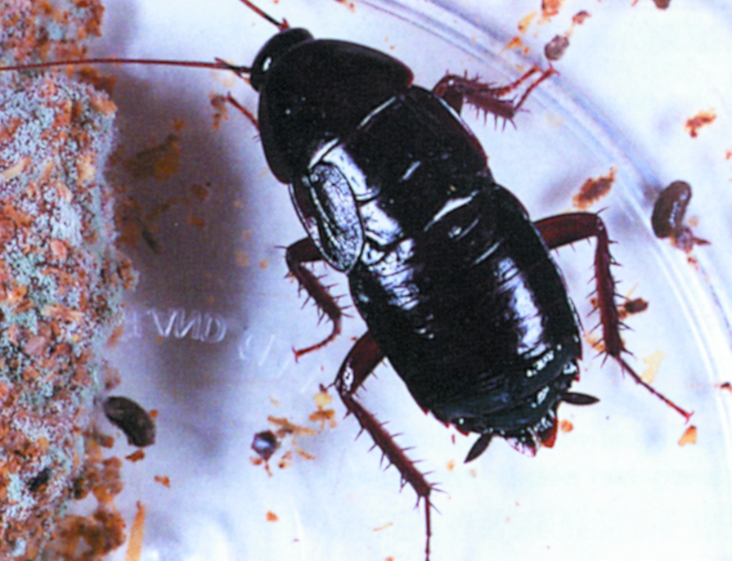 | 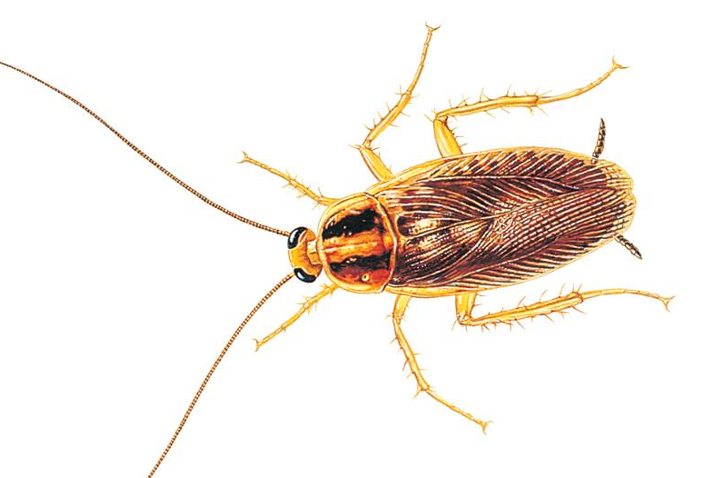
Colour | Dark reddish-brown | Yellowish-brown with a black patch on either side near the front
Size | Average 1 inch (22 mm) | Average ½ inch (12 mm)
Location | Cool areas including drains and basements | Warm areas, including boiler cupboards and behind fridges
Active | Usually at night | Usually at night

Treatment for cockroaches

Phone 020 7364 5007 (weekdays 8am to 8pm, Saturday 8am to 4pm) and we will make an appointment to visit you.
On the visit, we will survey your home to find the extent and location of the problem. We may lay monitoring traps to confirm which type of pest it is.
Depending on what we find, we will lay a gel-based poison bait and may also spray the affected areas.
We will make any follow-up appointments needed to make sure the home is clear of cockroaches – this usually requires two further visits about four weeks apart.

See if you qualify for a free service or find out how much we will charge

Dealing with cockroaches yourself

If you decide not to use our service or want to take action before your appointment, there are alternatives:
- You can buy specialist insecticides for crawling insects from supermarkets and hardware stores
- However, we recommend seeking professional advice and treatment.
- Please note that if you are aware of cockroaches in the property it is not acceptable to do nothing, you MUST either treat yourself, or use a Pest Control company to treat for you.

Preventing cockroaches coming into your home

- Take care when buying used furniture or electrical appliances, in case cockroaches are concealed inside.
- If you find cockroaches in anything you have purchased please report this to Environmental Health on 020 7364 5008, with details of where you bought the item.

