Mayor’s Community Grants Programme 2023-27
Guidance for completing online application forms

21/04/2023

Table of Contents

Introduction 3
Application process 3
Training and support from the council 3
Support from the council 3
Completing the forms 4
Step 1: Creating an account login 4
Step 2: Eligibility Quiz 5
Step 3: Completing the online forms 6
Page Headings 7
Word limits 7
Returning to your form 8
Attachments 9
Mayor’s Community Grants Programme Organisation Form 11
Page 1 - General Information 11
Page 2 - Organisation Information 12
Page 3 - Contact Details 13
Page 4 – Organisational and Administrative Details 15
Page 5 – Review my Application 17
Mayor’s Community Grants Programme Project Form 18
Quiz 18
Page 1 - General Information 18
Page 2 Contact Details for the Project 19
Page 3 – Project Proposal 21
Page 4 Project outcomes 23
Submit your form 24

Introduction

These guidelines are designed to help you to complete online applications for the Mayor’s Community Grants Programme using our online grants management system.

The information provided will tell you how to use the online application form and give you guidance on how to answer the questions on the forms.

Application process

All bids must be submitted using online forms via the council’s online portal, Blackbaud. The council cannot accept submissions by email, by post or by hand.

You will be required to complete an ‘Organisation Form’ and a separate ‘Project Form.’ You can access the forms by clicking on the following links:
- The Organisation Form
- The Project Form

You will only be required to submit one ‘Organisation Information Form’ and will need to submit a separate ‘Project Form’ for each project you are applying for.

Training and support from the council

Support from the council

The council is delivering three information events for organisations who are interested in applying.
In these sessions a council officer will guide you through the bidding process and show you how to complete the online forms.
The sessions will take place on following dates:

Session 1
Date: Wednesday 26 April 2023
Time: 1.30pm to 3pm
Venue: Council Chamber, Tower Hamlets Town Hall

Session 2
Date: Friday 5 May
Time: 10am – 11.30am
Venue: Online

Session 3
Date: Thursday 11 May
Time: 6 – 7.30pm
Venue: The Reach Community Hub, 11 Oliphant St, Blackwall, London E14 0GB

To book a place on any of these sessions, sign up via Eventbrite by clicking the link here.
Top tip! Once you have created a login to your online application form, you can save your online application at any point and return to it later.

Completing the forms

Step 1: Creating an account login

If your organisation does not already have a funding account, you will need to create one. This account is not the same as the council’s general online services account.]

When you click on this link LBTH Funding log in page or any of the direct links to the funding forms we have provided the first thing you will see is the screen shown in the following image.

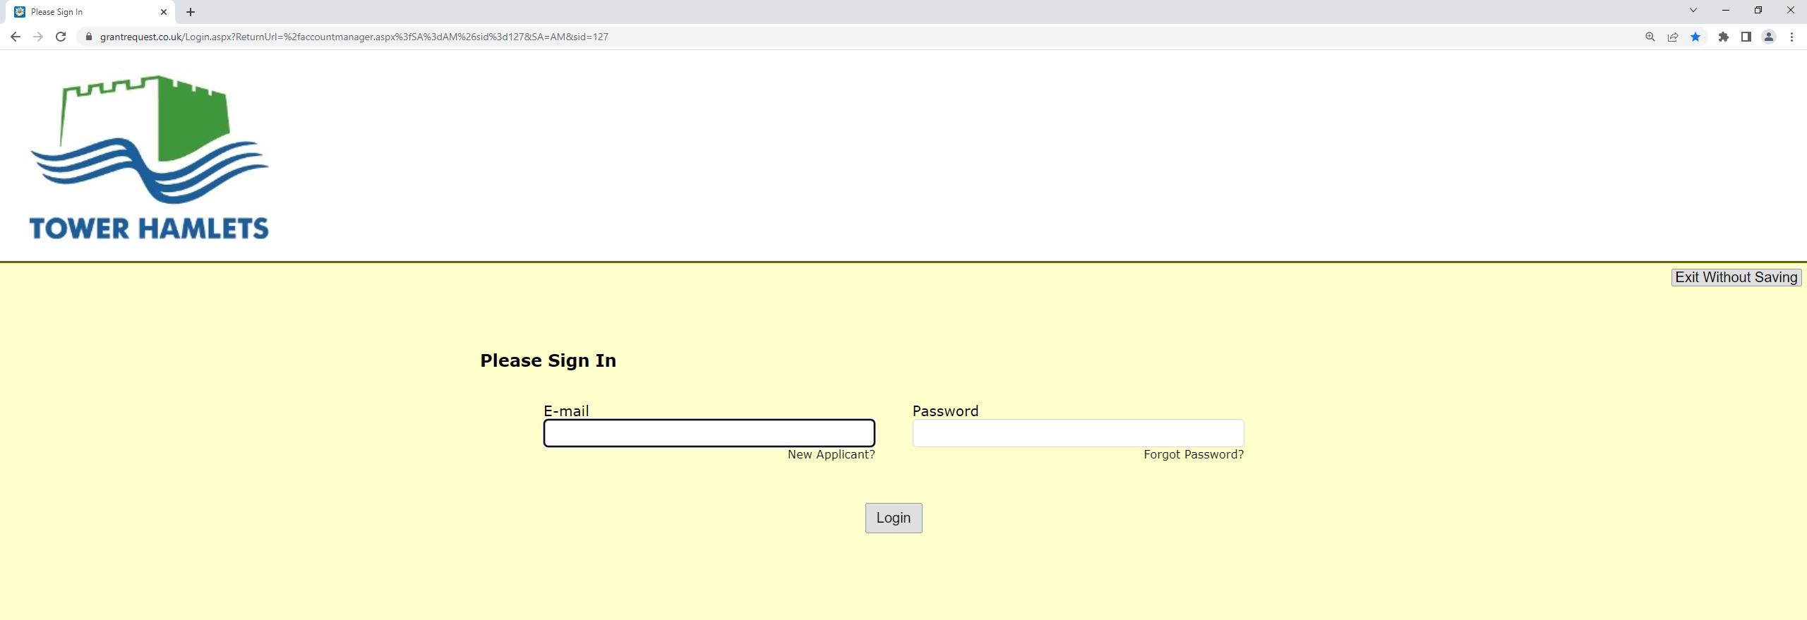

- Enter your email address.

- Click on ‘New Applicant’ (or, if you applied to the council for funding previously, simply enter your email address and password. If you have forgotten your password, please click on ‘Forgot Password’)

- Create a password. It must have at least 12 characters – for example ‘Towerhamlets!’

You must remember the email address you have used and your password as you will need them every time you log into your account.

You will be asked to create an account – this allows you to access your saved forms at any time.

Confirm your email and password exactly as on the previous screen.

- Click on ‘create an account’

- You should receive an email from London Borough of Tower Hamlets – email address vcs@towerhamlets.gov.uk.

The Subject field will say: Welcome Grantseeker

- The email message will confirm your login password. It will also give a link which you need to click on when returning to an application you have started to work on.

Step 2: Eligibility Quiz

Each form has an Eligibility Quiz.

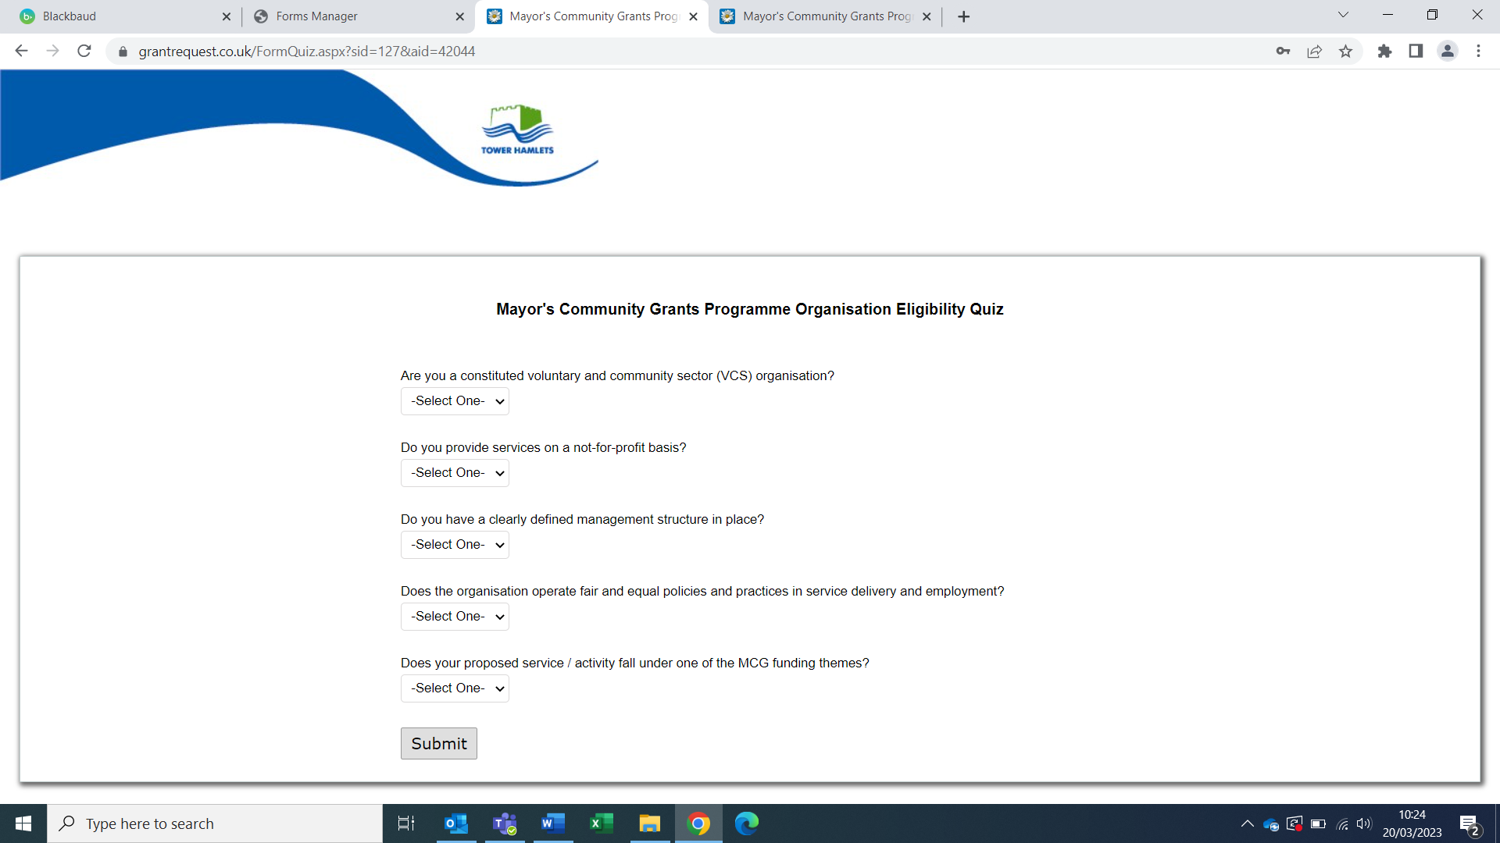

You will need to complete our simple eligibility quiz to make sure you are eligible to receive funding from us.

Click on the drop-down arrow. When you have responded to all questions, click ‘submit.’

Are you eligible?

If your answers DO NOT meet our requirements, you will not be able to proceed with the rest of the application.

If your answers DO meet our requirements, you will be taken to page 1 of the online application form.

You may find you have to complete the eligibility quiz each time you return to your form. Unfortunately, the system we use does not allow you to bypass this step.

Step 3: Completing the online forms

This section will take you through the technical elements of how to complete the online forms.

For most of the questions you are asked to simply type your answers into a box under the question. Click in the box you want to complete and use the tab key to move between boxes.

Sometimes you will be required to tick a box or select from options, and it will be explained later in this guidance exactly what you need to do.

You must answer all questions marked with a red asterisk *. These are ‘mandatory’ and if you do not answer these questions, you will not be able to submit your form. You will be given a warning before submitting the final form if you have failed to complete one of these questions.

More than one person can contribute to your organisation’s form. They must use the same account log in details to get access to the form. However, two people will not be able get access to the form at the same time. The person completing the declaration section is responsible for the content of the form regardless of who has contributed to it.

Top Tip!: Save regularly as you progress through the form or your answers may be lost.

Page Headings

There are tab headings at the top of your screen that we refer to as pages. For the organisation form they are:
- General Information
- Organisation Information
- Contact Details
- Organisation & Administrative Details
- Review My Application

You can click on each page to see that page of the form. You will not be able to submit until all the pages are completed.

The layout is similar for the Project Form but there are more pages.

Word limits

We have set word limits in various sections of the forms. The limits have been set to assist you as well as the assessment process.

Your answers must be within the maximum word limits specified. If you exceed the word limit, the additional information will not be taken into consideration in the assessment.

Please bear in mind that the limits have been set reasonably high to meet the needs of complex project proposals which may involve several partner organisations. It is not expected that you will need to use the full word limit to complete a good response.

Where a large amount of information/detail is required, your response should be as clear and concise as possible.

Top tip: You can use a separate Microsoft Word document to prepare your answer. You can then check your wordcount by going to the toolbar, selecting Tools and clicking Word Count.

Returning to your form

To return to your form you must click on the link that was sent to you in your confirmation email. Once you click on that link you then login using your email address and password. Do not use any other links as they may take you to a new blank form!

You should then see a screen headed ACCOUNT and your email address, which should have two yellow banners, one indicates whether you have any “In Progress Applications” still to be completed and a second banner indicating whether you have any “Submitted Applications.”

To go back to your un-submitted application go to the Open banner and click into the link to go back to your form.

Top tip: Before finally submitting your form you should print the ‘final draft’ and ask a colleague (who has not been involved in writing it) to read through it for you - get them to ask questions about any aspect of your answers that they don’t fully understand: (the person assessing your form may not fully understand it either) you can then edit the information to make things clearer.

If you have submitted your form, you can still view it under the submitted banner, but you will not be able to make changes – so be sure that you are happy with your form BEFORE you submit it.

Reviewing your form

Click Review My Application this allows you to review the information you have completed to date and make any necessary changes. It will also alert you if you have not completed a mandatory section of the form.

To print your form

Click on Printer Friendly Version and then the print button. To return to your form close the page.

Top tip: You must click save before printing your form so that your most up to date version prints out.

Attachments

Before you can attach the documents we require, you need electronic versions of them saved onto your computer.

If you don’t have electronic copies, then you can scan the paper copies and save them in a folder on your computer.

The maximum size for all attachments combined is 25 MB. You will not be able to upload files ending in: .exe, .com, .vbs or .bat

To upload a document

There are several sections under the “Organisational & Administrative Details” page where you will find the following two icons to attach documents.

- In the first drop down box you need to select from the list the type of document you wish to attach
- Using the second box, you upload the document in much the same way as attaching a document to an email

    - Click on the browse button and find document on your computer and click ‘open’

    - Click the ‘Upload’ button below the filename

The system will then automatically confirm whether the document has been uploaded and tell you the size of the document.

Mayor’s Community Grants Programme Organisation Form

This section will give you guidance on the information required to answer each question. You are also strongly advised to read this alongside the ‘Assessment Criteria’ set out in the Prospectus. This sets out the evidence we expect you to provide and tells you about the score for each question where they are assessed.

Page 1 - General Information

Please ensure that you read this page carefully as you will be required to complete the declaration at the bottom of this page.

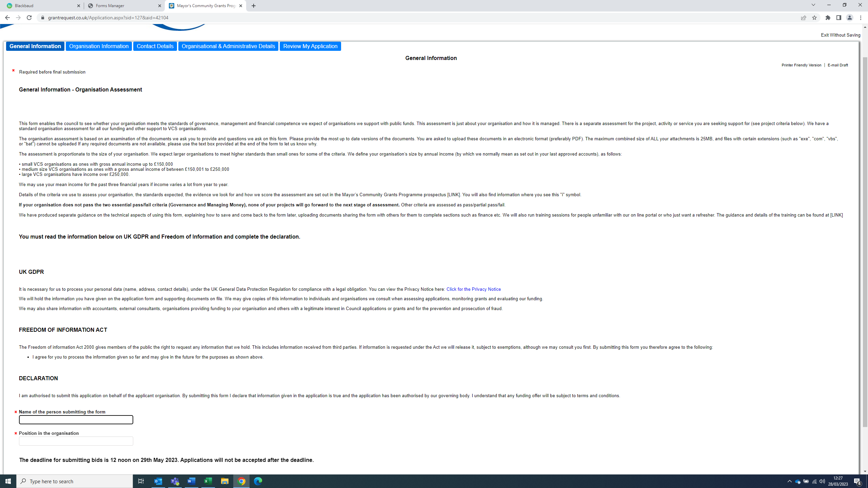

Page 2 - Organisation Information

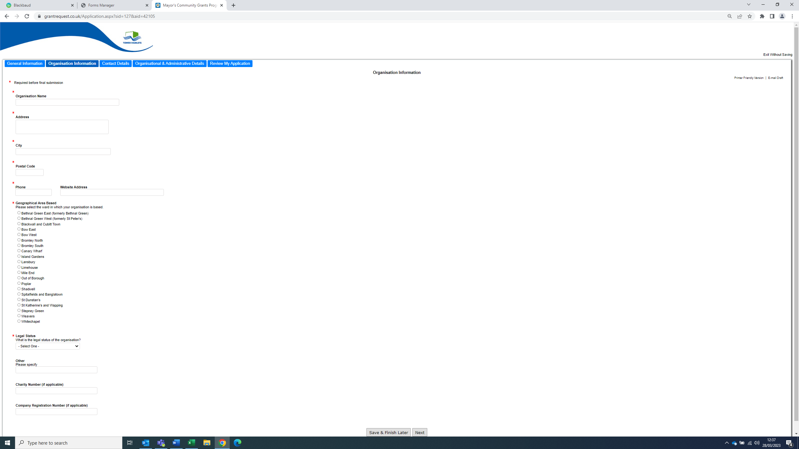

Organisation Name

Give the legal name of the organisation – this will be the name shown in your governing document.

Address

Give the address, city and postcode for the organisations base in Tower Hamlets. It is important that the correct details are provided as we will send correspondence to this address.

Phone number

Enter the organisations phone number if it has one.

Website Address

Enter the organisations website address if it has one.

Geographical Area Based

Select this from the drop-down box. Select the Ward area where your organisation is located. If you are unsure, you can use the Tower Hamlets Area Profiles.

Your organisation should be registered in Tower Hamlets, have a base in Tower Hamlets, or a demonstratable track record of successful service delivery within the borough.

Please either:
- Write your registered address which can be checked against public records in the text box provided
- If your organisation is based within the borough, please upload a copy of your lease or rental agreement
- Provide evidence that you have worked with a partner organisation or have had other arrangements to provide services in Tower Hamlets for two years in the text box

Legal Status

Select this from the drop-down box. Confirm the legal status of the organisation, if the legal status of your organisation is not in the drop-down list you should select ‘other’ then specify in the space provided.

Charity Number

If the organisation is a registered charity, please enter the charity number in the box provided.

Company Registration Number

If the organisation is registered as a company limited by guarantee, please enter your company number in the box provided.

Page 3 - Contact Details

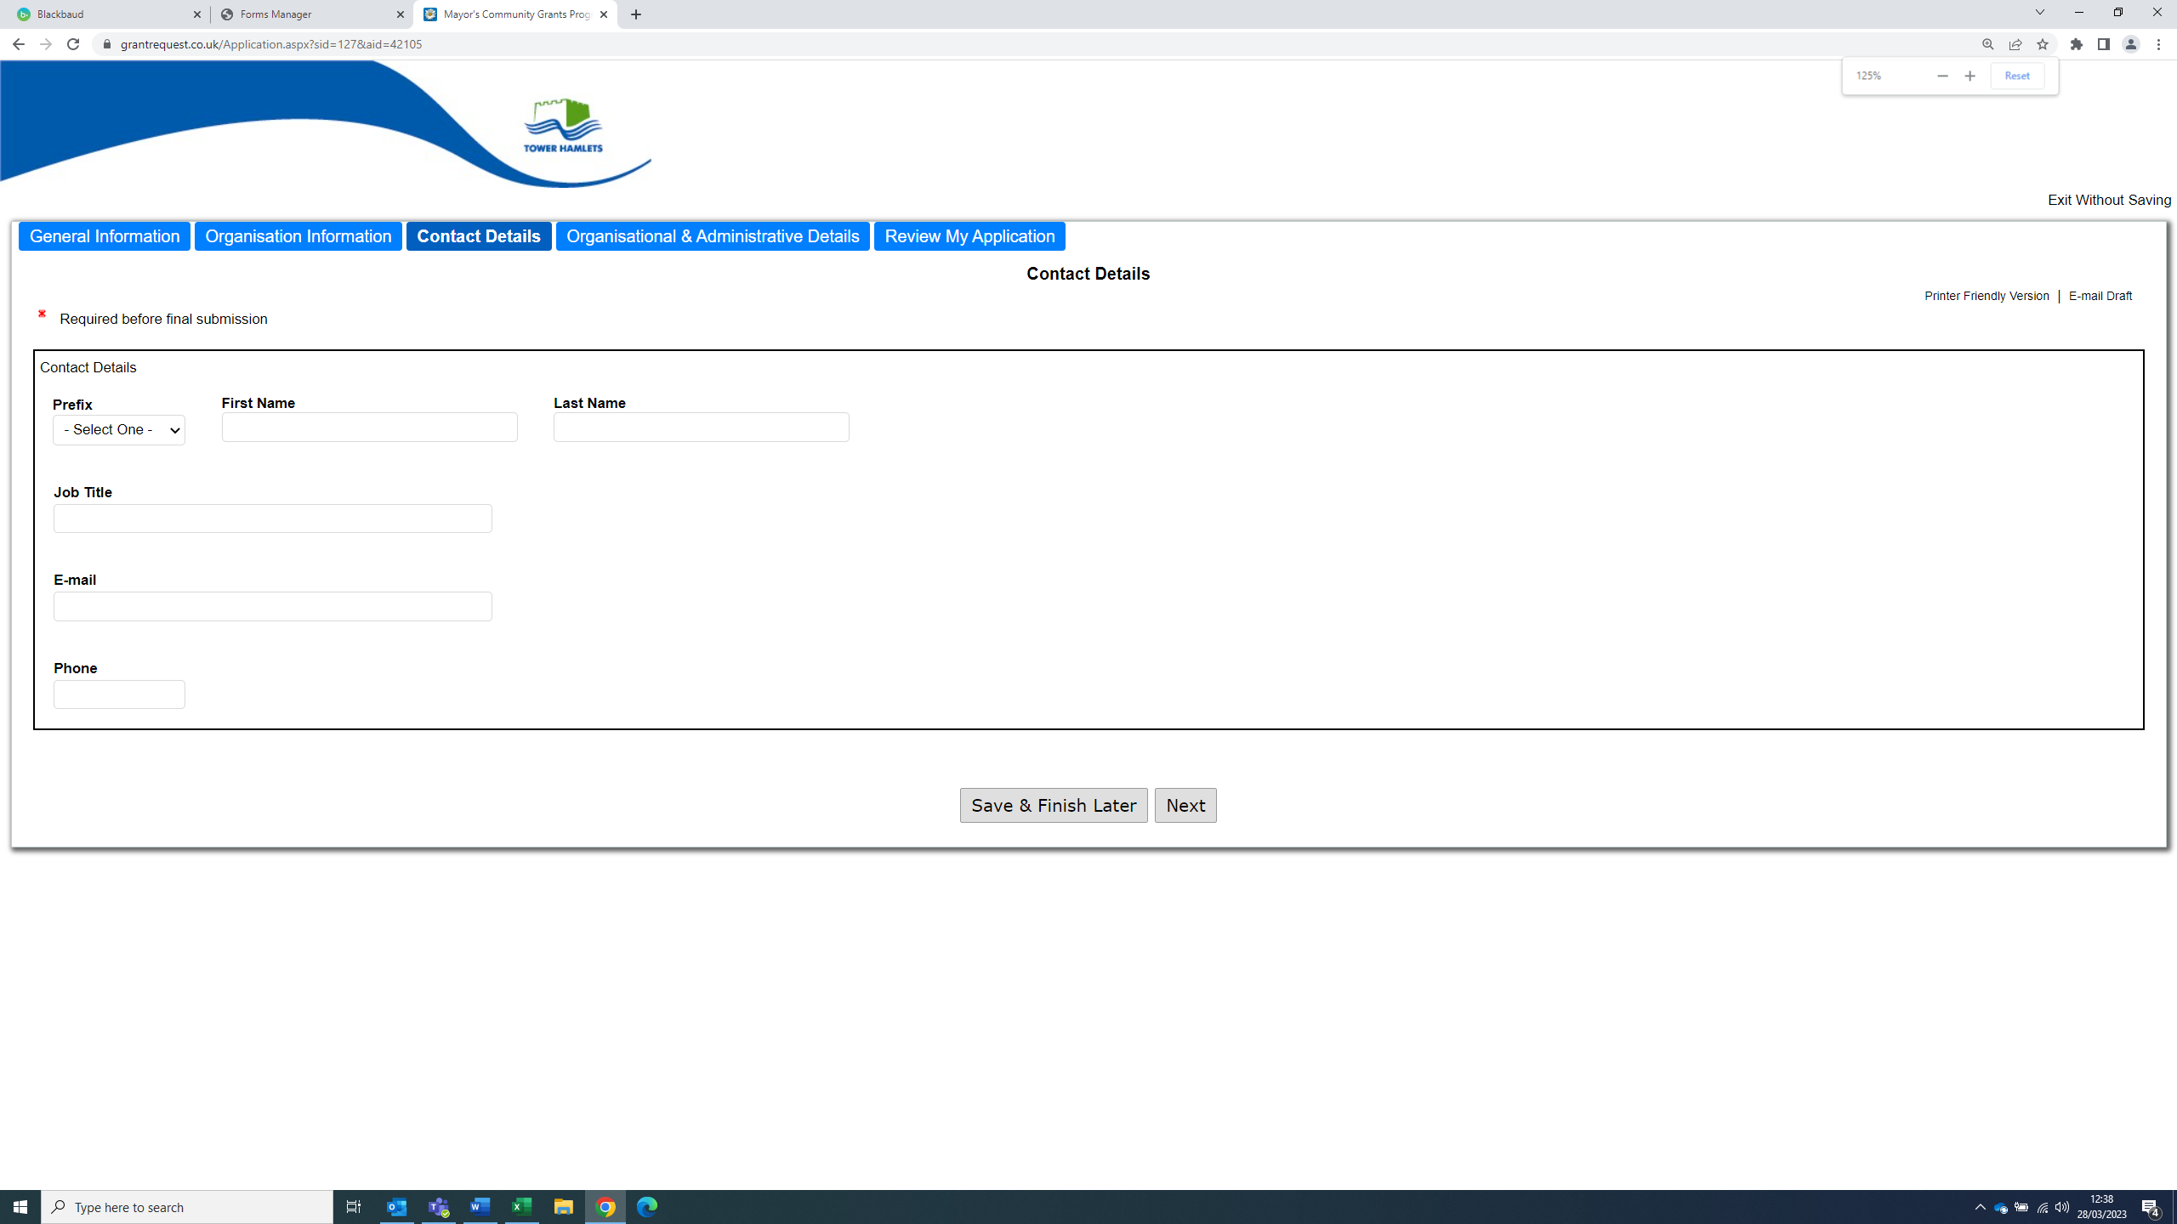

You should enter the relevant contact details for the person in your organisation that will be the primary contact for your organisation.

Where this is a consortium bid, this should be the details of the appropriate contact from the lead agency.

Page 4 – Organisational and Administrative Details

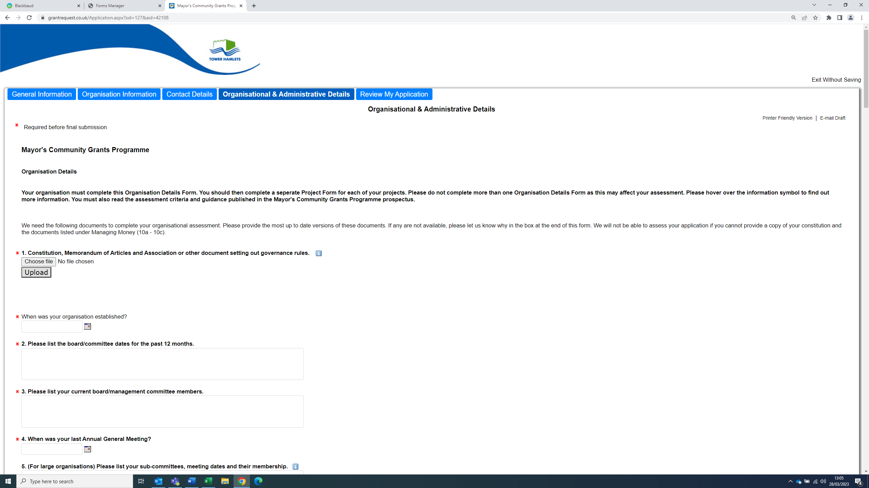

Constitution, Memorandum of Articles and Association or other document setting out governance rules
You must upload a copy of your constitution or other governance document.

Please list the board/committee dates for the past 12 months
Please type in the box dates of your management committee meetings.

Please list your current board/management committee members
Please list in the box your management committee/Board members.

When was your last Annual General Meeting?
Please select a date from the calendar.

(For large organisations) Please list your sub-committees, meeting dates and their membership.
Please list in the box.

Borough Connection
If you are registered in the borough, please enter your address in the text box provided or attach a copy of your lease or rental agreement or provide written evidence that demonstrates your organisation has delivered services in the borough for at least two years.

Business/strategic plan or equivalent
Please upload your organisation’s business or strategic plan.

Quality Assurance
You must upload at least one document related to your quality assurance. We have provided optional uploads for you to attach additional quality assurance documents if you need them. If you don’t have one to attach, then please use the text box provided to explain the processes your organisation uses to improve quality. The text box has a maximum word count of 400.

Managing People
Please upload your HR/staff policy document. If your document does not include all four required policy areas, please upload them separately.

Volunteers
If you use volunteers, please upload your volunteer policy and procedure document or adequate alternative documentation.

Managing Money
You must upload the documents we have requested under 10a-10c.

Please answer YES or NO under 10e and provide further details if answered YES in the text box provided.

Please provide your Equality and Diversity Policy
You must upload your Equality and Diversity policy.

Please provide your Safeguarding policy
You must upload your safeguarding policy. If your organisation does not work with children or vulnerable adults, you should upload a document stating this.

Please provide evidence of your insurance
You must upload a copy of your Public Liability Insurance Certificate. There are optional upload buttons for other insurance certificates. Please attach and upload as appropriate.

Page 5 – Review my Application

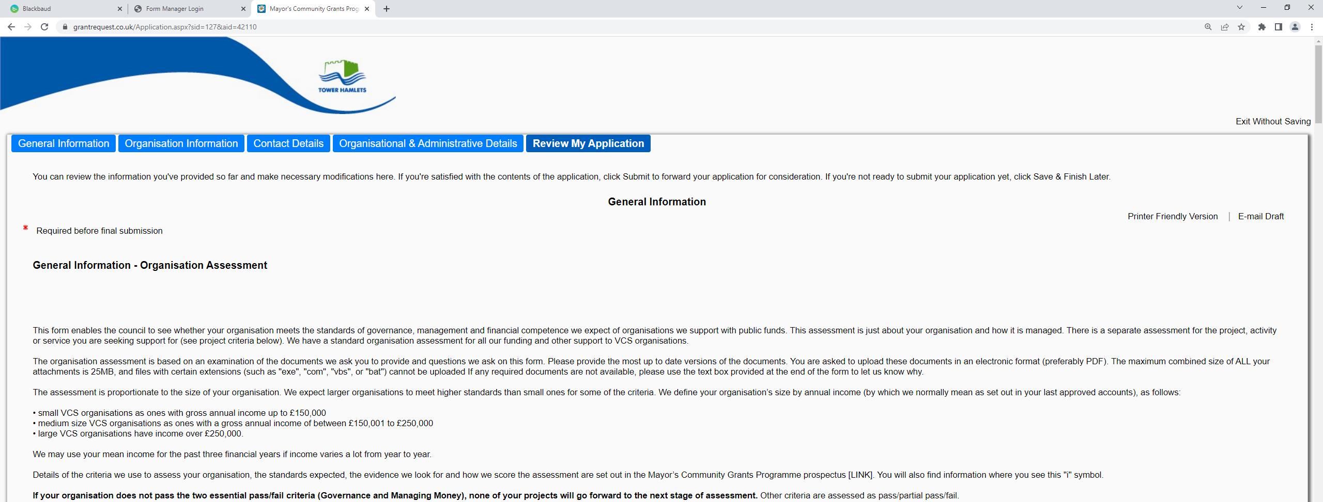

Review and Submit

When you click the above you will be taken to your review page.

Red text will appear if any mandatory fields have not been filled in or have been filled in incorrectly. You will need to go back into the application and complete the relevant question.

Check that you are happy with your application and when you are ready to send your application, go to the bottom of the page and click’ submit’.

IMPORTANT INFORMATION

You must click ‘submit’ to send each application. You will automatically be sent a confirmation email.

If you do not receive a confirmation email, this means that the application has not submitted correctly; in which case, please check and submit again.

Mayor’s Community Grants Programme Project Form

This section will give you guidance on the information required to answer each question. You are also strongly advised to read this alongside the ‘Assessment Criteria’ set out in the Prospectus. This sets out the evidence we expect you to provide and also tells you about the score for each question where they are assessed.

You must complete a separate Project Assessment Form for each of your projects.

Quiz

Once you log in, it will ask you if you have completed the organisation application form. If you have completed it or are in the process of doing so, select “YES”.

Page 1 - General Information

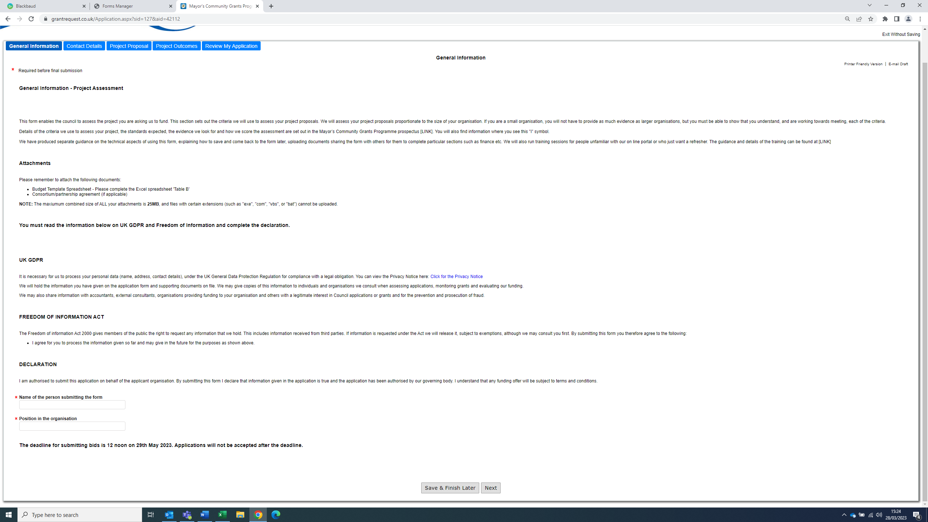

Please ensure that you read this page carefully as you will be required to complete the declaration at the bottom of this page.

Page 2 Contact Details for the Project

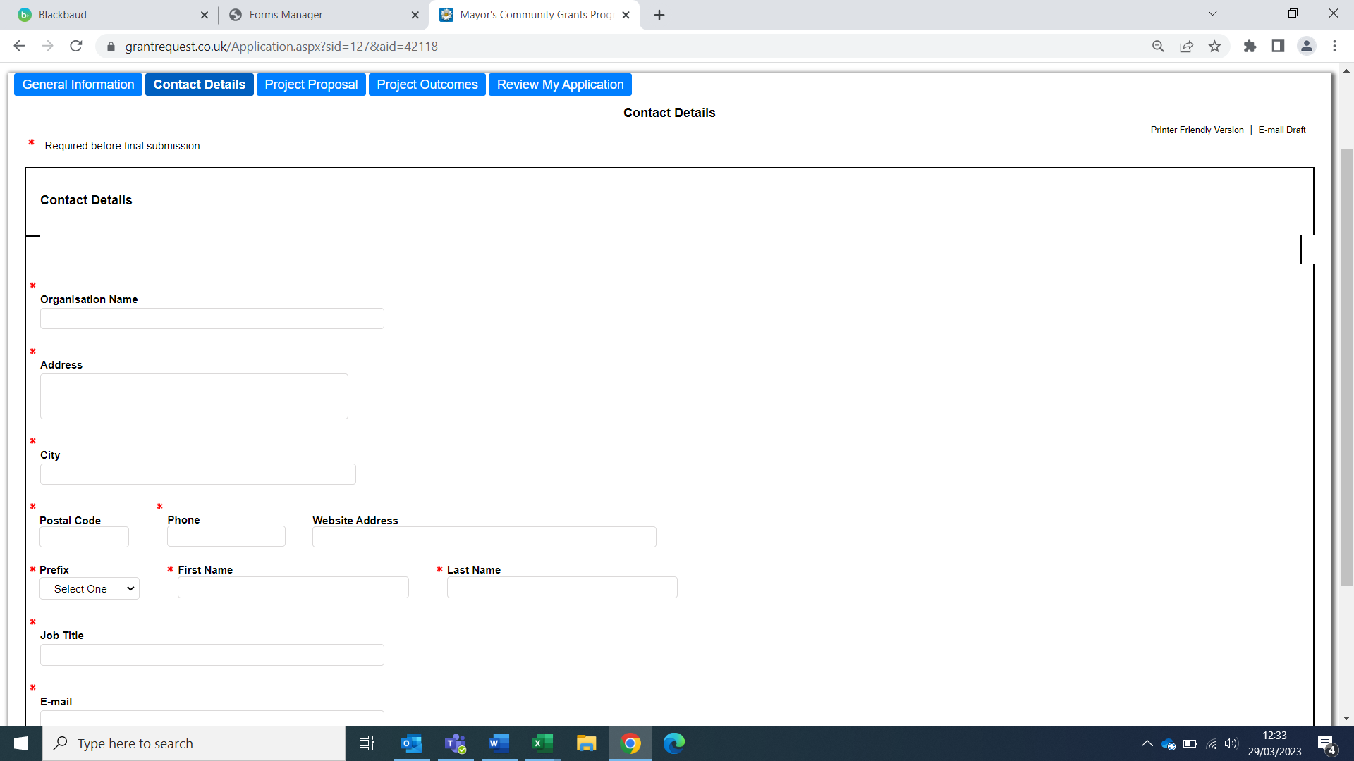

Please enter the organisation and contact details of the person who will lead on this project.

Page 3 – Project Proposal

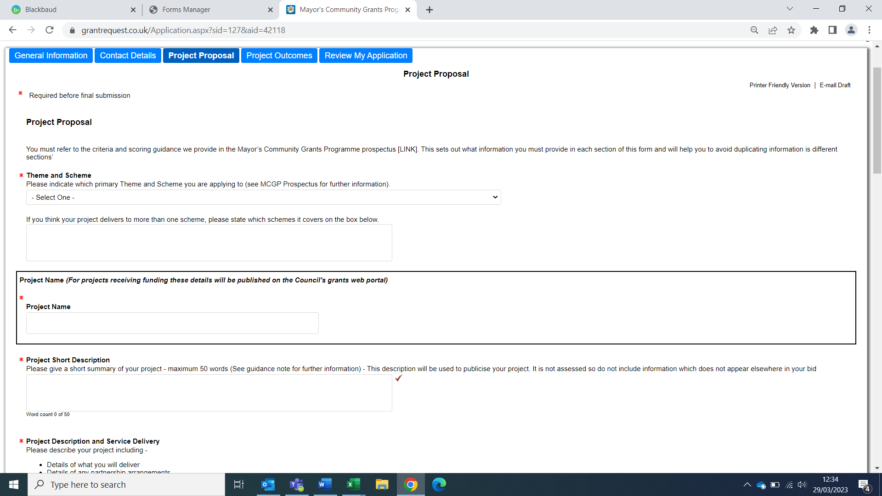

Theme and Scheme
Please select the funding scheme that this project relates to – select one item from the dropdown list.

Project Name
You must give your project a name - this should be easy to understand and relevant to the project. The project name will be used to identify your project.

Short Project Description
Provide a short summary of your project. This description will be used to publicise your project. There is a maximum word count of 50.

Project Description and Service Delivery
Please provide a clear description of your project, partnership arrangements and demonstration of need. There is a maximum word count 1,000.

Experience and Track Record
Please provide details of your experience and track record. There is a maximum word count of 400.

Consortium
Please tick the box if this application is being made on behalf of a consortium, if not leave it unticked.

Consortium/Formal Partnership Document
Please upload a consortium/formal partnership document if the application is being made on behalf of a consortium.

Local Connections
Please outline how your project will demonstrate local connections. There is a maximum word count of 400.

Service Co-Design
Please provide details on how you will co-design your project with residents. There is a maximum word count of 400.

Quality Assurance
Please provide details of quality assurance. There is a maximum word count of 400.

Community Cohesion and Equality and Diversity
Please provide details on how you will ensure that community cohesion and equality and diversity issues will be considered. There is a maximum word count of 400.

Value for Money
Please provide details on why you think your project will provide good value for money. There is a maximum word count of 400.

Budget Template Spreadsheet
Please upload your budget template spreadsheet

Geographical Area Served
Select this from the drop-down box. Select the Ward area(s) where your project is delivering and where your users will be primarily from.

Page 4 Project outcomes

In this section we ask you to set out your project outcomes with their indicators, the way you will measure the indicators and the targets you hope to achieve.

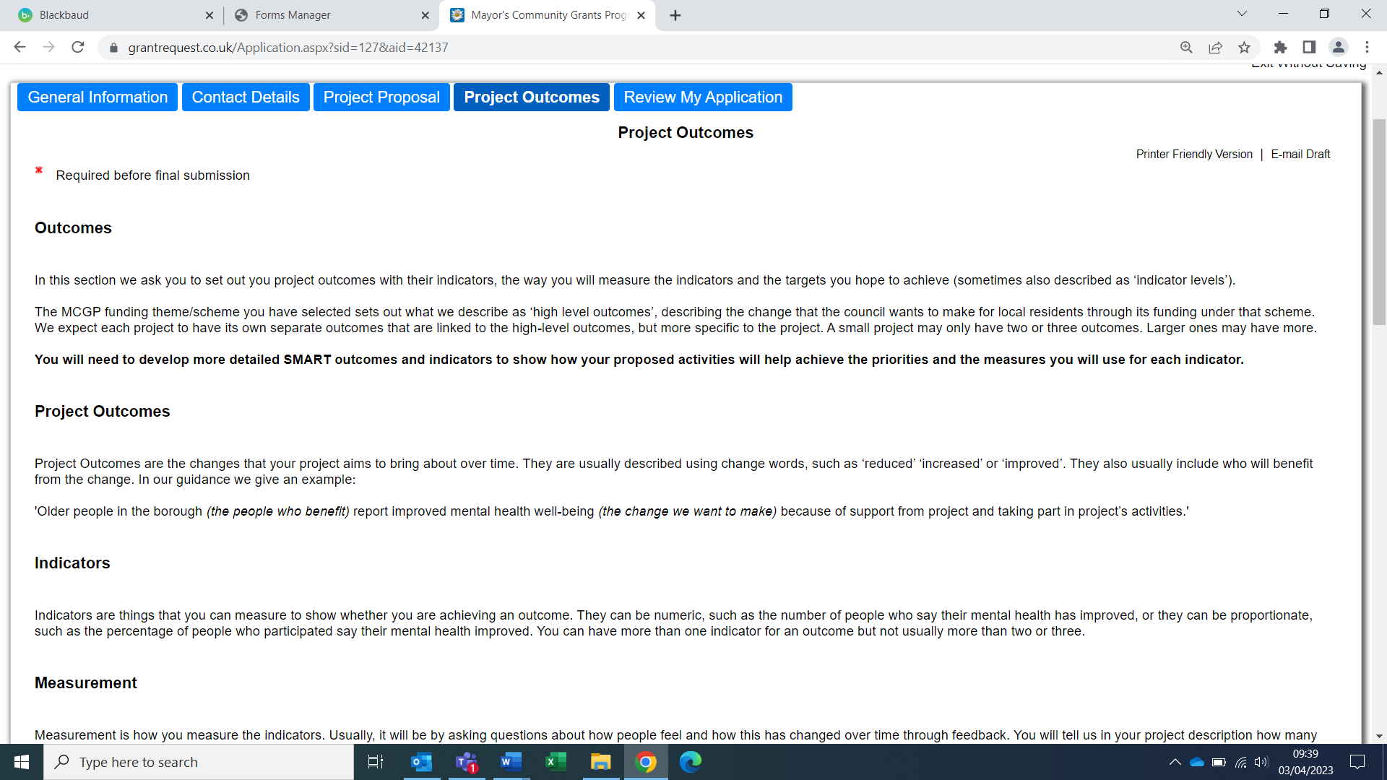

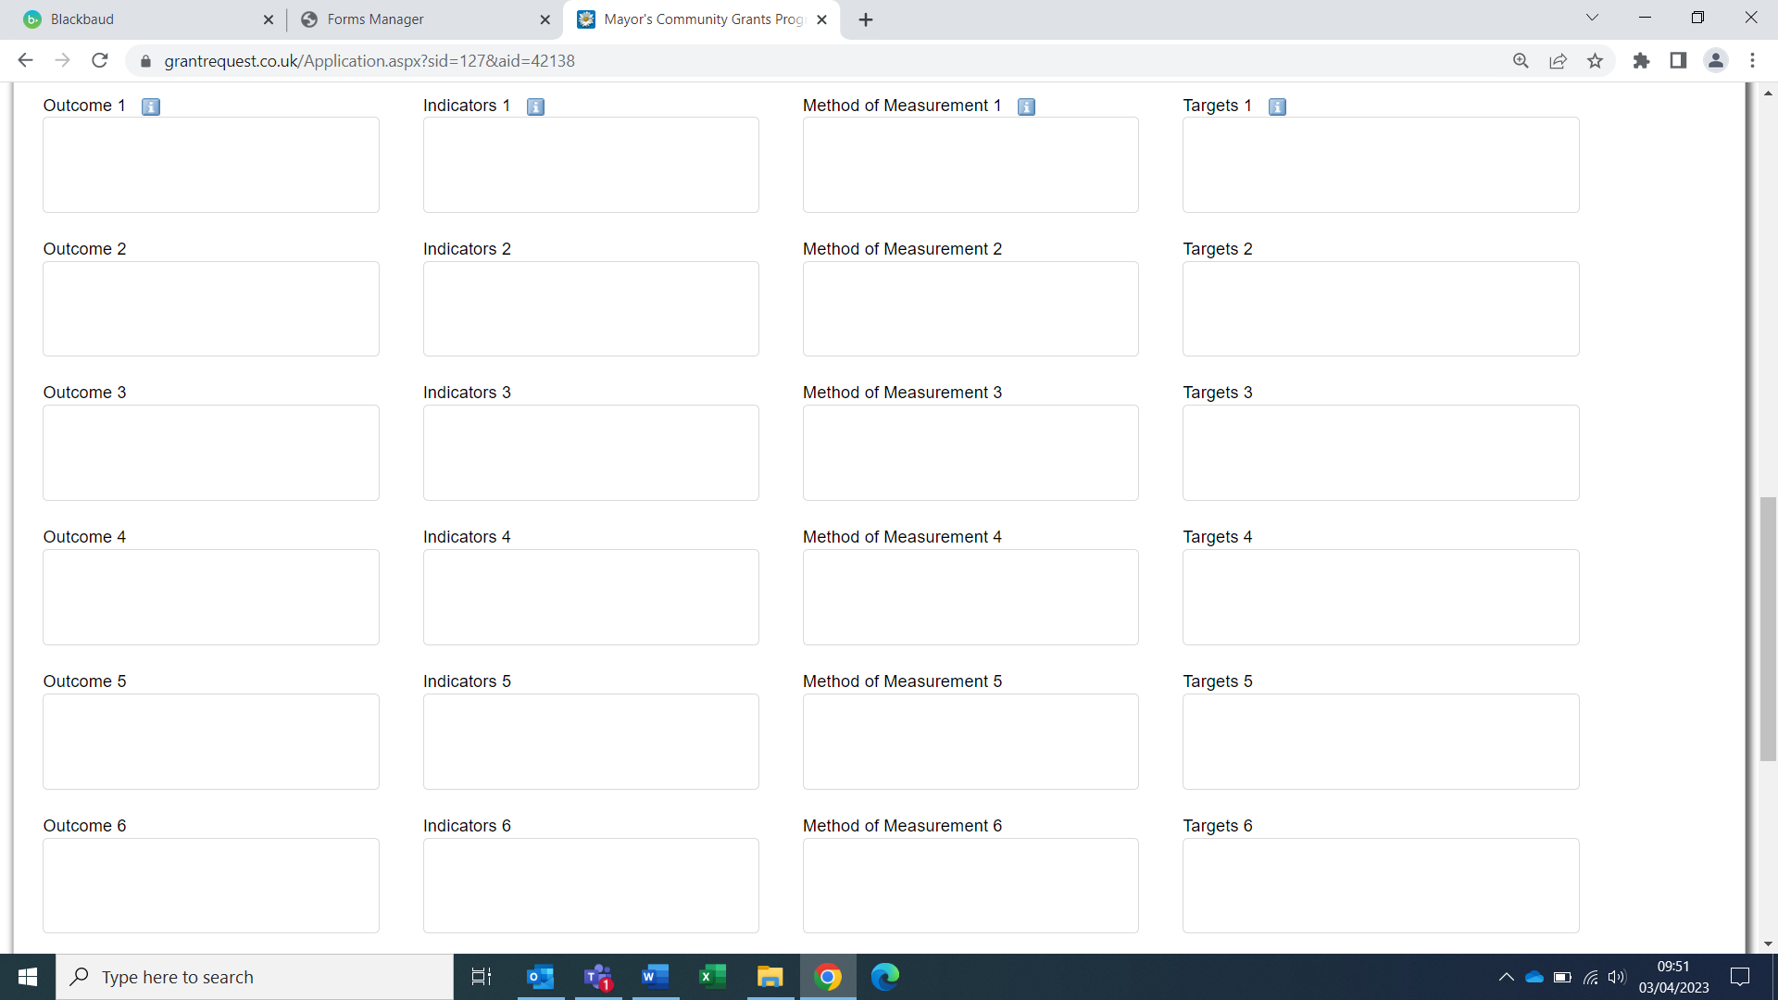

Submit your form

Now the form is complete and you have attached the relevant information you are ready to submit your form.

Review & Submit
When you click the above you will be taken to your review page.

Red text will appear if any mandatory fields have not been filled in or have been filled in incorrectly. You will need to go back into the application and complete the relevant question.

Check that you are happy with your application and when you are ready to send it to the council, go to the bottom of the page and click submit.

IMPORTANT INFORMATION

You must click ‘submit’ to send each application. You will automatically be sent a confirmation email.
If you do not receive a confirmation email, this means that the application has not submitted correctly; in which case, please check and submit a

