

London Borough of Tower Hamlets

Housing Management Data Strategy

Strategy

The guiding principles for the effective management of data.

Date edited: 12.08.25
Author: Chris Smith – Head of Housing Resources
Owner: Chris Smith – Head of Housing Resources
Approved by: Cabinet Sub-Committee – 05.11.25
Review cycle: 5 years
Next review date: 31.08.30

Regulatory Standards, Legislation and Codes of practice
Regulator: | The Regulator of Social Housing  The Building Safety Regulator
Legislation: | Data Protection Act 2018  UK GDPR
Codes of practice: | Housing Ombudsman Knowledge and Information Management
The policy also operates in the context of: | The council's Data Strategy, which is currently in development

Contents
1. Executive Summary 4
2. Introduction 4
2.1 Housing Management Data 5
2.2 Property data 5
2.3 Person data 5
3. Our key principles 6
4. Our strategic aims and how we will get there 6
4.1 Aim 1: Understanding our data needs 6
4.2 Aim 2: A structured approach to cleansing and maintaining the quality and robustness of our data 6
4.3 Aim 3: Building a culture of data awareness and responsibility 7
4.4 Aim 4: Improving data inputs across all touchpoints 7
4.5 Aim 5: Outputs and insight 7
5. Implementation Plan 7
5.1 Governance 7
5.2 Data Management Framework 7
5.3 Technology Roadmap 9
5.4 Engagement 9
5.5 Monitoring 9
6. How we will know when we’ve got there 9

Executive Summary
This strategy sets out the vision and framework for managing housing data across Tower Hamlets. Its aims are to improve data quality, governance, and analytical capability to support better decision-making, regulatory compliance, and resident outcomes.
Our vision is to establish a unified, transparent, and resilient data ecosystem that empowers staff, informs decision-making, and enhances resident outcomes across housing services. Through robust governance, integrated systems, and a culture of data responsibility, we aim to ensure data quality, accessibility, and compliance with regulatory standards—supporting Tower Hamlets’ commitment to providing homes for the future and being a council that listens and works for everyone.

Introduction
The importance of data for effective housing management services cannot be overstated. It guides our decisions, provides insights into our performance, and drives our service enhancements. While data is a powerful tool for service improvement, its value depends on how accurately and honestly it is collected, interpreted, and validated. We recognise that data alone cannot reflect the full lived experience of residents and must be complemented by direct engagement and qualitative feedback. Every member of the housing services teams use data, and it is essential that everyone understands how they are responsible for it, regardless of role.

In the wake of new legislation such as the Social Housing (Regulation) Bill 2023 and the Building Safety Act 2022, it is imperative that we recognise that our data is one of our most valuable assets and treat it accordingly.

The regulatory framework within which we operate increasingly recognises the importance of data. The Housing Ombudsman (HO) published their Knowledge and Information Management spotlight report, emphasising the impact gaps in data and information had on service delivery and customer service, which in some cases financially impact both tenants and landlords; whilst the Regulator of Social Housing (RSH) considers the management of data an important factor in its determinations, underpinned by a range of regulatory returns including the Tenant Satisfaction Measures (TSMs).

We start from a relatively strong base with our data and services centred around a common system which is well integrated with strategic partners and core council data sets. This strategy allows us to go further and meet the challenges of the new regulatory framework whilst improving our services, ensuring the safety of our residents, and aligning with the following Strategic Aims of the council:
- Providing homes for the future
- A council that listens and works for everyone.

Housing Management Data
In the context of this strategy 'Housing Management Data' refers to the records and information needed to effectively manage the council's housing stock and the tenancies and leases therein.
Our two key data objects will be the Person and Property records, and we will maintain the connections between them in terms of tenancies, leases, accounts etc. around which the majority of housing management interactions will be built.
The council has previously taken the decision to consolidate the management of its housing services and data through its integrated housing management system, NEC Housing, helping to reduce data duplication and drive service efficiency as a result. NEC Housing remains one of the market-leading housing management applications and continues to invest in new technology and functionality to meet the needs of the housing sector.
Whilst Housing Management shares its use of NEC Housing, and some of its data, with the Housing Options service this strategy focuses on the needs of the Housing Management functions from the allocation of a property through the tenancy and lease lifecycles, including the delivery of repairs and major investment programmes, right-to-buy purchases, up to and including disposals.
This strategy addresses how we will manage and improve the use of our data; it does not cover the ambitions or approach to develop our digital systems and channels.

Property data
NEC Housing, and in particular the Assets modules, will be the source of the golden thread that underpins the management of our housing stock, ensuring that we have an up-to-date and accurate view of the safety and condition of our buildings. We will use this data to improve resident experiences, ensure building safety, and make informed decisions about investment strategies - placing resident wellbeing and service quality at the heart of our data use.

Person data
End-to-end, from initial occupancy to ending their tenancy or selling their leasehold property, we will maintain accurate and proportionate records of the residents of our properties, including the tenants of non-resident leaseholders.
We will aim to hold accurate data on the full household composition to help better understand the needs of our communities and of each individual household, adapting our services where appropriate.
We will only collect personal data that is necessary, proportionate, and clearly explained to residents. We will respect residents’ right to privacy and ensure that data collection is transparent, consensual, and securely managed.

Our key principles
The Housing Management Data Strategy is based on five guiding principles.

People: To empower staff and residents through data literacy and transparency to make the most of our data and encourage ‘best practice’.
Processes: To standardise workflows for data collection, validation, and usage across all the housing management functions.
Systems: To ensure that we have a reliable and transparent foundation for decision-making centred around a robust core dataset.
Governance: To establish clear ownership, accountability, and compliance structures for the management of data.
Analytics: To use data to generate actionable insights and performance metrics that help to deliver better homes and services for residents.

Our strategic aims and how we will get there

Aim 1: Understanding our data needs
- Map data requirements across housing management services, engaging with staff to understand data usage and gaps
- Consult with residents about what we intend to use their data for
- Identify data categories which are critical for service delivery and outcome monitoring
- Identify gaps in the data we hold which would support service improvement.

Aim 2: A structured approach to cleansing and maintaining the quality and robustness of our data
- Strengthen data specialist resources within the housing division
- Developing a Knowledge and Information Framework to
- Establish governance mechanisms for reporting and monitoring of data quality
- Implement structured processes for validation and cleansing
- Programme external audits/checks to provide assurance of the robustness of data in key regulatory areas
- Consult residents on how we should maintain their data
- Programme activity to improve the data quality of what we currently hold.

Aim 3: Building a culture of data awareness and responsibility
- Complete a training needs analysis based on data skills
- Develop a learning and development programme to improve data skills across the housing division
- Ensure that the systems are fit for purpose, to prevent use of alternative methods and processes
- Promote data awareness and stewardship across teams
- Increase data curiosity by making reporting and outputs more visible to the wider staff base
- Create a clear channel for escalating and resolving data or system issues sustainably, to prevent in efficient workarounds becoming the norm
- Establish a governance mechanism for oversight of all data projects which have a system or data impact.

Aim 4: Improving data inputs across all touchpoints
- Review and enhance all data collection touchpoints across all services, building processes and responsibility for inputting
- Consult residents on how we should collect their data
- Map and strengthen links between data sources within housing, within the wider council and from external sources.

Aim 5: Outputs and insight
- Utilise corporate data resource to aid in the production of reporting and monitoring tools, and increase automation
- Ensure our data processes support the council's reasonable adjustments policy
- Design a structured programme of equitable outcomes assessments, to inform service improvement
- Adopt reporting solution which is accessible to all relevant staff
- Develop dashboards and reports to inform service delivery.

Implementation Plan

Governance
We will establish a Data Quality Working Group, formed of Data Champions nominated by all housing management service areas. This group will formulate and deliver an action plan to achieve the aims of this strategy.

Data Management Framework
We will adopt a Data Management Framework which will provide a systematic approach to the management of data, ensuring that data is collected, maintained and used effectively and ethically. The framework will encompass the following areas:
📊 Data Collection & Monitoring
The systematic collection of comprehensive data is the foundation of effective data management and prevents flawed insights from inaccurate data.
✅ Data Quality & Accuracy
Clean, correct, and complete data is essential for trustworthy analysis and reporting, preventing poor decision making based on bad data. A key component of this part of the framework will be staff training to reduce errors.
📈Data Analysis & Reporting
Raw data becomes meaningful when analysed and shared transparently. It can reveal patterns and disparities, drive improvements and promote accountability.
🧑‍🤝‍🧑 Tenant Engagement & Transparency
Trust is built by involving tenants and being transparent about data use. This in turn would help to improve data completeness and accuracy and improve Tenant Satisfaction Measures.
⚖️Compliance & Continuous Improvement
Legal compliance and adaptability ensure long-term success, legal adherence and accountability, and it mitigates risks to the council under the UK GDPR and the Equalities Act 2010. It requires regular review and update of our data quality standards and responsive planning to emerging requirements, particularly those from the Housing Ombudsman and the Regulator of Social Housing.

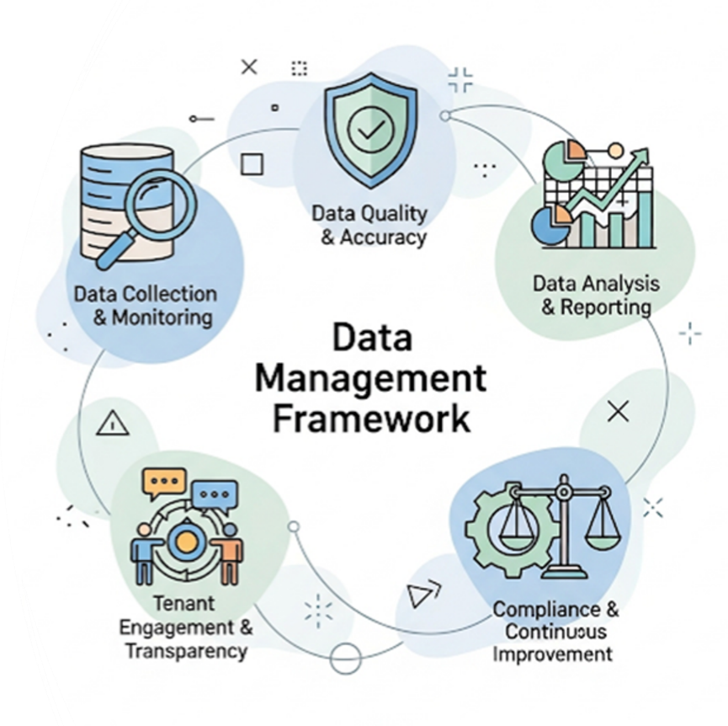

Technology Roadmap
Through the governance of the Housing & IT Steering Group we will leverage existing and new technologies to promote the aims of the housing management data strategy.
Leveraging the full potential of our current core housing management system will ensure that we have a robust core dataset, from which our analytics and insight will be gleaned. We recognise that our records will need validation, and the decisions we make based on them will remain subject to resident scrutiny.
The Housing & IT Steering Group will ensure that investment in systems supports these aims and delivers value for money for the Housing Revenue Account whilst conforming to the council's procurement rules.

Engagement
This strategy will be aligned with the Tenant & Leaseholder Engagement Strategy, and we will ensure that data governance does not become a gatekeeping mechanism, but instead supports transparency, co-production, and equitable decision-making.

Monitoring
The use of dashboards, audits and other reporting will be used to track progress with the aims of this strategy.

How we will know when we’ve got there
Aim | Measure/outcome
1. Understanding our data needs | - The data we require to inform and evidence service delivery, outcomes and improvement, is available to us  - Conduct a Data Maturity Assessment with support from Housemark  - Our residents are clear on what data we hold and why.
2. A structured approach to cleansing and maintaining the quality and robustness of our data | - We are able to consistently evidence the quality and robustness of our data and proactively respond to potential and material data quality issues  - Ensure 100% completeness of sex, age and race for all tenants, against a baseline of 99.9%, 99.4% and 96.2% respectively  - For leaseholders, ensure 95% completeness for sex, 80% for age, and 75% for race, against baselines of 92%, 71% and 60% respectively  - Our residents encounter less issues concerning record keeping and have higher satisfaction.
3. Building a culture of data awareness and responsibility | - Our systems enable our staff to feel confident and take responsibility for the data that they handle, and effectively consider the data implications in project proposals  - Staff surveys and training needs analyses are used to baseline and measure staff culture  - The range and volume of data available to residents to self-serve reduces the volume of FOI requests and the time taken to process them.
4. Improving data inputs across all touchpoints | - Our systems and processes enable data to be collected and updated across all services  - Integrating housing management data with other council services through the use of common identifiers such as UPRNs and NI Numbers  - Our residents do not have to repeat or duplicate the information they provide to us.
5. Outputs and insight | - We are able to easily find and analyse the data we hold to inform our service delivery and improve outcomes  - Our staff have more knowledge about the wider service delivery.

