
1. TSM Methodology 1

1.1 A) Summary Of Achieved Sample Size 1

1.2 B) Timing Of The Survey 1

1.3 C) Data Collection Methods 1

1.4 D) Sampling Methods 2

1.5 E) Assessment Of Representativeness Of Response 2

1.6 F) Details Of Applied Weighting 5

1.7 G) External Contractors Used 5

1.8 H) Households Excluded From The Sampling Frame Under Exceptional Circumstances 5

1.9 I) Reasons For Failure To Meet Required Sample Size Requirements 5

1.10 J) Incentives Used In The Survey To Encourage Response 5

1.11 K) Other Methodological Issues That Have A Material Impact On Satisfaction 5

1.12 Questionnaire Design 6

TSM Methodology
The Tenant Satisfaction Measures (TSMs) provide a core set of performance measures and from 1 April 2023, all registered providers that own relevant social housing stock must calculate and publish results on an annual basis following the requirements set out by the Social Housing Regulator and in accordance with the TSM Standard.
From July 2023, Kwest Research has undertaken a rolling telephone survey on behalf of Tower Hamlets, which meets the organisation’s TSM obligations.
The survey is designed to complete interviews with a representative sample of the organisation’s 11,598 LCRA households with the aim of providing information to meet the new requirements, and to gather data on customer satisfaction with services that will help to identify resident priorities and inform services for the future.
This document provides a summary of the survey approach used to generate the tenant perception measures to be published by Tower Hamlets. This is laid out using the headings specified in the Regulator’s ‘Annex 5: Tenant Satisfaction Measures, Tenant Survey Requirements’ document.

A) Summary Of Achieved Sample Size
Tower Hamlets has 11,598 LCRA households and to meet the new requirements, has to collect a minimum of 996 responses each year, to provide data with an overall accuracy of ±3% at 95% confidence interval.
The Council carried out telephone interviews on a monthly basis from April 2024 to March 2025. At the end of the data collection period, 1,022 LCRA interviews had been completed. This provides a level of data accuracy of ±3.0% for the tenant results overall.
In total, 1,012 customers answered TP01, overall satisfaction, ensuring the requisite data accuracy was reached for this question.

B) Timing Of The Survey
Interviews were carried out on a monthly basis between April 2024 and March 2025.
The number of responses collected was evenly divided across months.

C) Data Collection Methods
The survey was undertaken by telephone as this is a cost effective and efficient means of contacting households and allows the representativeness of the achieved sample to be easily monitored.
Kwest’s interviewers worked in shifts to provide maximum coverage. Calls were made at different times of the day, including morning, afternoon and evening and weekend attempts were available. Interviewers made up to 5 attempts to secure a survey response with each LCRA household.
Tower Hamlets has a number of customers who do not speak English and can only participate in surveys if a translation service is available. Kwest has a number of multi-lingual interviewers who are able to complete surveys in other languages, including Bengali. Carrying out the survey by telephone ensures these customers are able to participate.

D) Sampling Methods
A stratified sampling method was used, taking into account neighbourhood office, age group and ethnicity.

E) Assessment Of Representativeness Of Response
Kwest’s in-house software team has developed bespoke resources that allow representativeness to be monitored and achieved. For example:
- In telephone projects, Kwest’s sophisticated Telephone Management systems are designed so that quotas for multiple, individual groups of interest can be automatically set, managed and monitored to deliver required accuracy levels.
- Kwest’s TSM Representativeness Assessment ensures that the stringent requirements of the Regulator are adhered to in TSM surveys. This works in conjunction with the Telephone Management System and provides an adaptive, flexible tool for monitoring and adjusting interviewing approach throughout the survey, to ensure that the achieved sample perfectly matches requirements. Output via online reports allows Tower Hamlets to view progress versus targets at any time
To demonstrate representativeness of response in Tower Hamlets’ TSM survey, Kwest’s systems took into account and assessed multiple population sub-groups. These include neighbourhood office, ward, ethnicity, age, floor level and property type.
These categories were chosen to provide good coverage by geographical location, age and ethnicity characteristics and type of housing.
The following charts illustrate the proportion of respondents achieved for each group relative to the baseline data held by Tower Hamlets.

Age & Ethnicity
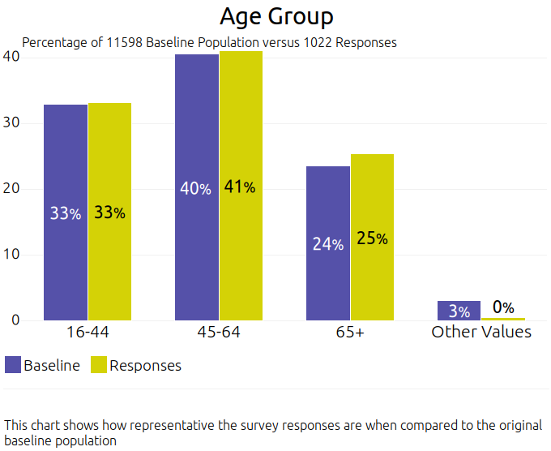  Figure 1.1 | 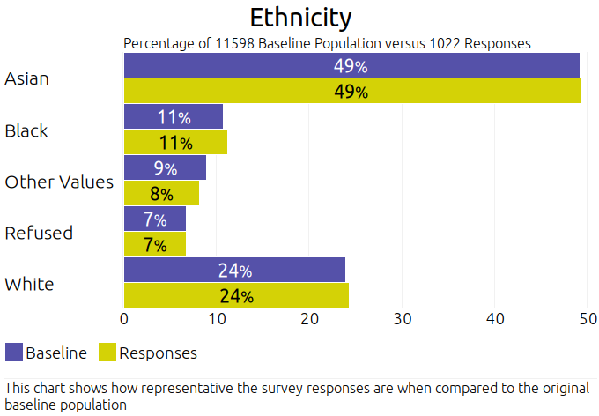  Figure 1.2

Type Of Housing
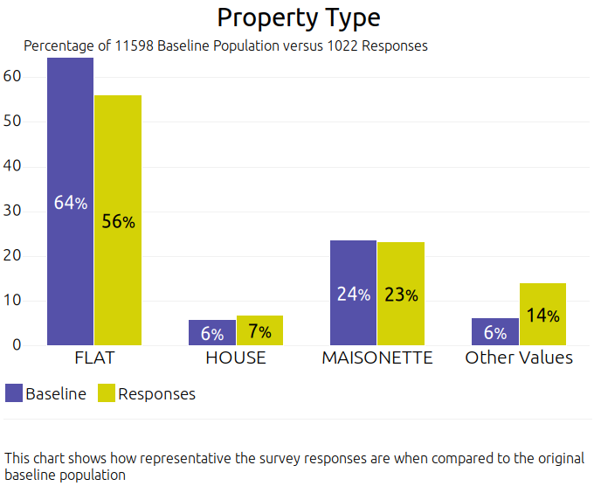  Figure 1.3 | 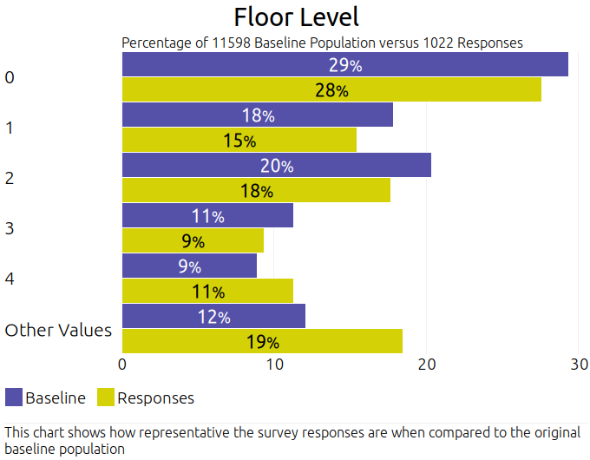  Figure 1.4

Geographical Area
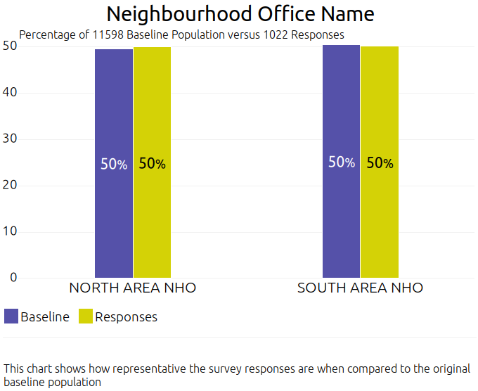
Figure 1.5

Ward
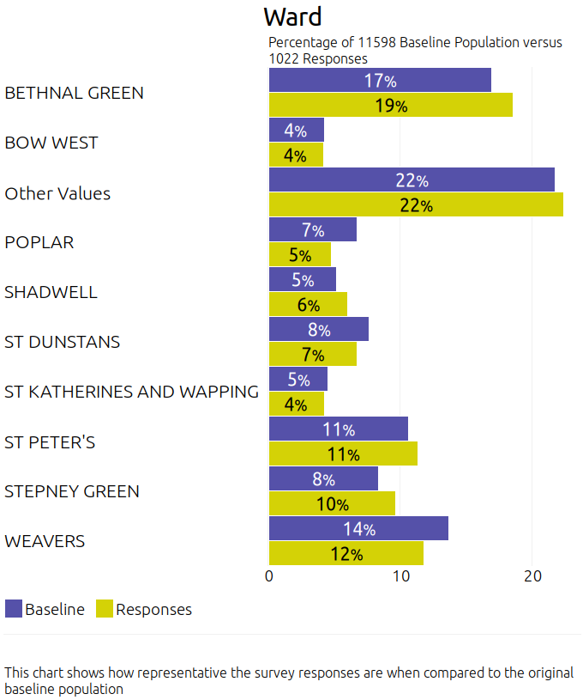
Figure 1.6

F) Details Of Applied Weighting
Not applicable; no weighting was applied. Due to the tools used to monitor response throughout data collection and the Kwest TSM Representativeness Assessment, excellent representativeness was achieved and therefore no weighting of data was required.

G) External Contractors Used
Kwest Research Limited is one of the longest standing research organisations in the country and works exclusively for social housing providers. Kwest undertook the Tenant Satisfaction Measures survey on behalf of Tower Hamlets and was responsible for all elements of the research.

H) Households Excluded From The Sampling Frame Under Exceptional Circumstances
326 of Tower Hamlets’ 11,598 LCRA properties were void at the time of the survey and so were automatically excluded from the sampling frame.
Due to the methods employed by Kwest that used carefully constructed quotas and which adjusted throughout the survey to ensure excellent representation, it is not believed that this will have any material impact on the results, which are still considered to be representative of all LCRA households.

I) Reasons For Failure To Meet Required Sample Size Requirements
Not applicable. A total of 1,012 responses has been achieved in the 2024 survey which exceeds the minimum requirements set by the Regulator.

J) Incentives Used In The Survey To Encourage Response
No incentives were used to encourage participation in the Tower Hamlets TSM survey.

K) Other Methodological Issues That Have A Material Impact On Satisfaction
There do not appear to be any other methodological issues that have a material impact on the tenant perception measures reported.

L) Questionnaire Design
The questionnaire was designed to include all the Regulator’s TSM questions, as required. In addition, an open ended question allowed customers to expand on reasons driving dissatisfaction with the overall service and the repairs service. The feedback from the latter qualitative question was classified by Kwest’s interviewing team at the end of the call to provide a graphical representation of key themes featuring in the comments. There was also an “any other comments” question at the end of the survey to ensure all customers had the opportunity to elaborate further on their views.
In addition, Tower Hamlets included an extra question, at the end of the call, asking tenants to rate the overall service from the organisation on a scale of excellent, good, fair, poor and terrible. This allows comparison with previous surveys carried out over the last ten years.



