London Borough of Tower Hamlets

Public Notice

Notice of Designation of Areas for Selective Licensing

This notice is published in accordance with section 83 of the Housing Act 2004 (“the Act”) and Regulation 9 of the Licensing and Management of Houses in Multiple Occupation and Other Houses (Miscellaneous Provisions)(England) Regulations 2006. Notice is hereby given that the London Borough of Tower Hamlets in exercise of their powers under section 80 of the Housing Act 2004 gives notice that it has designated for selective licensing the three areas described in paragraph 4.

CITATION, COMMENCEMENT AND DURATION

- The Designation may be cited as the London Borough of Tower Hamlets Council Designation for an Area for Selective Licensing.

- The Designation was made on the 28th April 2021 and shall come into force on the 1st October 2021.

- The Designation shall cease to have effect on the 1st October 2026 or earlier if the Council revokes the scheme under section 84 of the Act.

AREA TO WHICH THE DESIGNATION APPLIES

- The Designation shall apply to the Council ward areas of Weavers, Whitechapel, Spitalfields and Banglatown (pre 22nd May 2014 ward boundaries) of the London Borough of Tower Hamlets as delineated on the map below.

APPLICATION TO WHICH THE DESIGNATION APPLIES

- The Designation applies any house which is let or occupied under a tenancy or licence within the area described in paragraph 4 unless-
- The house is a House in Multiple Occupation (HMO) and is required to be licensed under Part 2 of the Act;
- The tenancy or licence of the house has been granted by a registered social landlord;
- The house is subject to an Interim or Final Management Order under Part 4 of the Act;
- The house is subject to a temporary exemption under section 86 of the Act; or
- The house is occupied under a tenancy or licence which is exempt under section 79(4) the Act or the occupation is of a building or part of a building so exempt as defined in The Selective Licensing of Houses (Specified Exemptions)(England) Order 2006.
- The tenancy or licence of the house has been granted by a student accommodation provider that is subject to ANUK accreditation (The Accreditation Network UK).

THE EFFECT OF THE DESIGNATION

- Subject to sub paragraphs 5 (a) to (e) above every house in the area specified in paragraph 4 that is occupied under a tenancy or licence shall be required to be licensed under section 85 of the Act.

- The London Borough of Tower Hamlets will comply with the notification requirements contained in section 83 of the Act and shall maintain a register of all houses registered under this designation, as required under section 232 of the Act.

- Upon the Designation coming into force, any person who operates a licensable property without a licence, is liable to prosecution under section 95(1) of the Act and upon summary conviction is liable to a fine of unlimited amount. A person who breaches a condition of a licence is liable upon summary conviction to a maximum fine of £5,000. As an alternative to prosecution, those operating without a licence or breaching any licence conditions may be subject to Civil Penalty Notices with a maximum fine of £30,000. In addition, such a person may be required to repay up to 12 months’ rent if the tenant or the Council, in the case of housing benefit payments, apply to the Residential Property Tribunal under the provisions of section 96 and section 97 of the Housing Act 2004 for a rent repayment order. No notice under section 21 of the Housing Act 1988 may be given in relation to an assured shorthold tenancy of the whole or part of an unlicensed house so long as it remains an unlicensed house.

Any landlord, managing agent or tenant within the designated area of the Borough should seek advice from the Council as to whether their property is affected by the Designation during normal office hours, which are 9am to 5pm, Monday to Friday.

General advice concerning the Designation may be obtained from the Environmental Health and Trading Standards Service at the London Borough of Tower Hamlets, Mulberry Place, Clove Crescent, London, E14 1BY (Tel: 0207 364 5008 and email housinglicensing@towerhamlets.gov.uk).

The Designation in respect of selective licensing in the Council wards areas of Weavers, Whitechapel, Spitalfields and Banglatown (pre 22nd May 2014 ward boundaries) in the London Borough of Tower Hamlets may be inspected at this address and a copy of the Designation can be obtained from the Council’s website.

The Designation was given general approval by the Mayor in Cabinet of the London Borough of Tower Hamlets.

The Designation falls within a description of designations in relation to which the Secretary of State has given a general approval under section 82 of the Act, namely The Housing Act 2004; Licensing of Houses in Multiple Occupation and Selective Licensing of Other Residential Accommodation (England) General Approval 2010 which came into force on the 20th March 2010.

A map of the Designated area:

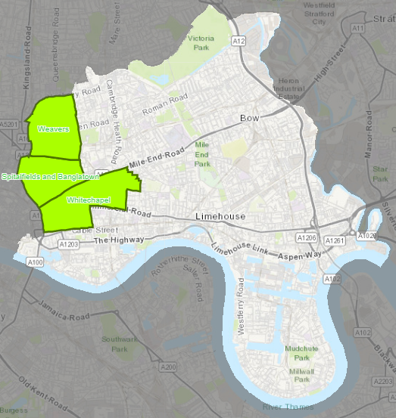

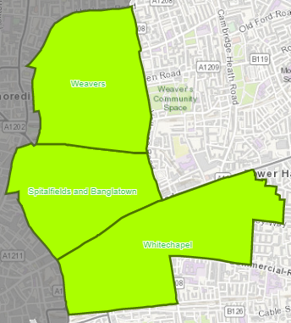

For the definition of “house” see sections 79 and 99 of the Act
Section 55 of the Act defines which Houses in Multiple Occupation are required to be licensed under the Act. See also The Licensing of Houses in Multiple Occupation (Prescribed Descriptions) (England) Order 2005 (SI 2006/371)
Section 79(3) of the Act. For the definition of a Registered Social Landlord see Part 1 of the Housing Act 1996

