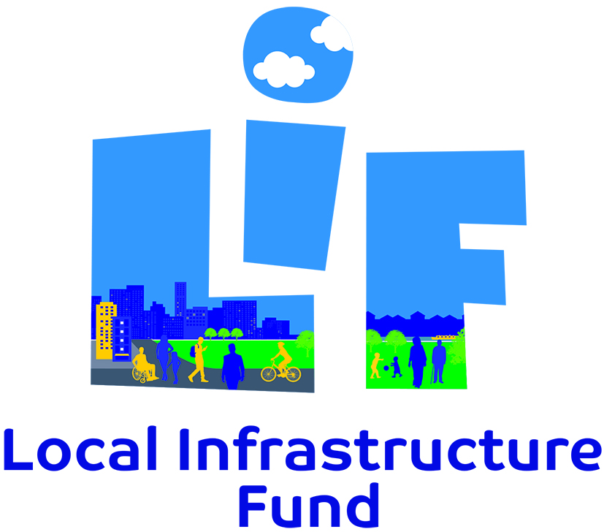

Consultation Statement
February 2022

INTRODUCTION
1.1 Tower Hamlets Council consulted on the Local Infrastructure Fund (LIF) between Monday 8th November 2021 to Monday 20th December 2021 (for a 6-week period). During this time, there were over 680 project nominations. The responses and project nominations were either added directly onto the “Let’s Talk Tower Hamlets” consultation platform by participants completing an on-line survey, or by participants completing identical surveys that were manually loaded onto the consultation platform by officers. Options were also given for telephone call-backs to assist participants with completing the surveys and to respond to any queries regarding the consultation.
1.2 The purpose of the LIF Consultation 2021 was to hear what you, our residents consider to be the priorities for infrastructure in your areas to enable direct spending of the Neighbourhood Community Infrastructure Levy – ‘NCIL’ branded Local Infrastructure Fund (LIF) in Tower Hamlets. This required that we engage with the local communities where development has taken place and to agree with them how best to allocate funding ensuring that the use of monies matched the priorities expressed by our local communities.
1.3 The LIF Consultation 2021 specifically asked local people on their priorities for infrastructure spending for LIF income collected in the financial year 2020/2021 expected to be approximately £3.9 million.
1.4 The LIF Consultation 2021 took a light touch ‘call for projects’ approach and a more detailed engagement including a borough wide Infrastructure Residents Survey will be undertaken later this year and every three years thereafter. This is in accordance with the revised LIF process agreed by the Mayor in Cabinet in 2021and it helps us to ensure we accord with our regulatory duty to engage and agree with local people on what to spend LIF on.
1.5 This Consultation Statement provides a summary of what you told us and the next steps the council will take in selecting projects suitable for delivery using LIF income collected in 2021/22. Therefore, the consultation undertaken informs the decision-making processes around what and where the LIF money should be spent on in the borough as required by government regulations.
1.6 In order to consult with people about their locality and not just on a borough wide- basis we have arranged the borough into four ‘LIF areas’. See Appendix 1 for a map showing the LIF areas. The arrangement of the areas is based on a mix of existing administrative and physical boundaries and represents fairly a scale at which to consider local infrastructure. The boundaries were agreed by the Mayor in Cabinet in 2016.

2. THE LIF PUBLIC ENGAGEMENT METHODS
- As part of the 2021 Local Infrastructure Fund (LIF) borough-wide consultation, we used a range of surveying methods to capture a representation of suggestions and feedback from the public. Due to Covid-restrictions at the time of engagement, we could not undertake any in-person face-to-face engagement methods. Nonetheless, we proactively sought to provide a range of opportunities for participation by deploying a range of methods and a flexible approach to engagement. These methods included:

- online GIS map-based survey via the “Let’s Talk Tower Hamlets” consultation platform
- online questionnaire survey
- hard copy questionnaire surveys
- virtual drop-in public events
- email/phone participation options

- The sections below describe the public engagement methods used during the 6-week consultation period.

- On-Line GIS map-based survey – a map-based survey was accessible via the main Tower Hamlets consultation website called “Let’s Talk Tower Hamlets” [talk.towerhamlets.gov.uk/LIF]. This survey method provided a GIS map-based interface where participants could pin-point their responses directly to one of the LIF Area maps of the borough. The same consultation questions were also asked as an online survey questionnaire (set out below), and this collected information on project suggestions for local infrastructure improvements in each respective LIF area. The key difference is that on the GIS map tool participants were able to spatially comment and visualise what others had said across the area. This enhanced public access, accuracy in responses and efficiency for data collation. The URL/QR Code of the survey was also posted on social media platforms and posters to ensure a wider audience was reached and that local people were able to access it from their mobile devices and personal computers.

- On-line questionnaire survey – An alternative format was also provided through the on-line survey that was also accessible via the main Tower Hamlets consultation website called “Let’s talk Tower Hamlets” [talk.towerhamlets.gov.uk/LIF]. This survey did not have the GIS map interface, but this collected the same information on project suggestions for local infrastructure improvements in each respective LIF area. It was offered as an alternative more user-friendly option to those who may find the GIS tool difficult to navigate.

- Hard copy questionnaire survey – participants had the option to request a copy of the survey and these were manually loaded onto the consultation platform by officers.

- Virtual drop in public events – Two virtual events were open to the public as drop-in events (see Table 1 below). The dates were made available on the “Let’s Talk Tower Hamlets” consultation webpage and participants needed to register and book ahead on one of the available time slots using Eventbrite. This was also promoted via social media in advance. The main objective of this was to offer members of the public/community groups an opportunity to drop in and ask any questions via a Question and Answer style - and for officers to respond and explain the purpose of the consultation and how to participate. This face to face (albeit virtual) approach was also an opportunity to gain buy in and support from the community. The emphasis of the drop-in was to help participants to identify local infrastructure projects e.g, in terms of what is needed and where.
Table 1: Virtual Drop-in Public Event Dates
Event | Format | Date
Virtual Drop-in event | Eventbrite | Wednesday 24th November 2021
Virtual Drop-in event | Eventbrite | Thursday 2nd December 2021

- Email/phone participation options – the consultation made available the option to call in, text or email options to participate, ask questions and/or request a physical copy of questionnaire should it be required.

- Through all the channels provided, participants were encouraged to suggest only new project ideas and they were advised that that they did not need to re-nominate any projects from previous LIF consultations.

- Targeted Community Group Engagement

  - The main form of participation was via online tools, though some alternative options were available for hard-to-reach community groups such as a telephone and/or email option to contact the IP Team officers for assistance should it be required. Copies of the questionnaire could be emailed to participants; or filled out for potential participants over the phone upon request. This approach would help accommodate those that did not have access to the internet and/or the appropriate level of access, IT, or language related literacy. Furthermore, whilst hard copies of the survey questionnaire were not generally available, people could request a copy via the IP email address.
  - A number of pre-identified community group representatives were targeted and invited to take part in a number of ways: to opt to fill in survey online and/or take part in the drop in events; ask them to circulate the digital questionnaire/survey link to local people. Key community/voluntary sector groups were targeted for this purpose.
  - We engaged our Neighbourhood Forums as required by the CIL regulations as well as our Ward councillors for their support. Additionally, targeted emails/letters were sent to consultees from the updated LIF database and using the councils’ existing service/staff networks internally. If you would like to be added to our LIF consultation database then please contact us at LIF@towerhamlets.gov.uk

- As part of our borough-wide public engagement process we undertook several promotional activities to reach out to our community. Table 2 below summarises in detail what we did:

Table 2: LIF 2021 Promotional Activities – Engagement Methods
How we publicised the Consultation
Council website – Registration of Interest – pre-consultation – November 2021
Direct mailing - letters to consultees in the Plan-making database - 474 in total – targeted LIF Areas 1 and 3
Emails to consultees in the Plan-making database - 1937 in total
Emails to various neighbourhood forums, ward forums and networks
LIF Posters (x40) displayed in various parks including Bethnal Green Gardens, Meath Gardens, Stepney City Farm, White Horse Park, Poplar Recreation Ground, Langdon Park, Bartlett Park, St John's Park, Mudchute, St John McDougall Gardens
Nextdoor (resident newsletter)
Social Media including Twitter, Facebook, Linkedin
Eventbrite drop-in events – Wednesday 24th November 2021 and Thursday 2nd December 2021
Member's only drop in events - Tuesday 16th November 2021 (5-7pm) and Thursday 18th November 2021
Tower Hamlets Parent and Carer Council (PCC) meeting – Saturday 16th October 2021
Emails to Members
Emails to Service Area Managers
Email to staff in Planning and Building Control Service
Idea Stores and council building plasma screens

FEEDBACK FROM THE 2019 LIF PUBLIC ENGAGEMENT

  - This section outlines some of the feedback you gave us during the 2020 LIF consultation between 8th November and 20th December 2021 which is broken down for your information.

  - As a result of our borough-wide public engagement process we received just over 680 project nominations for local infrastructure projects from the local community across the four LIF Areas.

  - Table 2 summarises the number of people using particular methods of engagement.

Table 2: Number of participants in each method of engagement:

 | Type of Activity | No of Participants
1 | Two Virtual Drop-in Events | 8 (registered attendees)
2 | Online Questionnaires (number of participants) | 167 (approx.)

3.4 It is worth noting that participants were not restricted to one project nomination and
were able to make multiple project nominations.

3.5 We found that a large portion of the those that participated (81%) were residents of
the borough. In addition, 13% were representatives of community organisations, 5%
were representing a business and 1% did not state who they were representing. This is
shown in Figure 1 below.

Figure 1: Breakdown of Borough Participants.

  - Furthermore, we found that a large portion of the participants were taking part for
the first time and they had not participated in any previous LIF consultations – see Figure 2.

Figure 2: Summary of previous participation (%)

  - The majority of respondents that participated in the 2021 LIF Consultation (78%) had not
participated before, 1% of respondents participated in the 2017 consultation, 5% in 2019, 9% in 2020, and 7% had participated in all 3 previous consultations.

  - As a result of the borough-wide public consultation using a combination of online surveys
and drop in events, we collectively received over 680 projects ideas suggested for us to consider further.

  - A breakdown of the percentage of projects within each LIF area is provided in Figure 3.
LIF Area 2 had the highest number of public responses at 29% and LIF Area 3 had the least responses out of all four areas at 21%.
Figure 3: Number of Project Nominations by LIF Areas (1-4)

  - The public responses have been gathered and presented from all of the consultation
activities. These have been analysed and grouped into broader themes both on a
borough-wide level and by LIF area. It is important to note that three additional
themes were added to the list of themes previously shown on the online mapping
tool in order to make it easier to assess for deliverability. This is based on the number of concerns cited by local people in their responses which specifically related to Bridges Infrastructure, Public Realm and Waterways Improvement themes.

  - Figure 4 below shows the project suggestions for each theme as a percentage of the
total project nominations received.
Figure 4: Summary of all projects across the borough by infrastructure themes

  - As shown in Figure 4, the top five project themes account for 67% of all projects
nominated. The top five themes across the borough were:

- Road Improvement – 22%
- Cycling/ Walking – 19%
- Parks and Open Spaces – 10%
- Public Safety – 8%
- Residential/ Estates Improvement – 8%

  - Figure 5 shows the number of projects in each theme within each of the four (4) LIF
areas (please also refer to the table in Appendix 2).
Figure 5. Summary of public responses by theme across each LIF Area

  - The colour coding in Figure 5 shows the respective breakdown for the number of
projects nominated for each theme by LIF area. For example, the blue coding shows
that 52 projects were nominated in LIF area 1 for Road Improvement, 19 for
Cycling/Walking routes and 11 for Parks and Open Spaces etc. Numbers of projects
nominated in LIF area 2 are depicted by the colour red, whilst LIF areas 3 and 4
green and purple respectively. If a theme shows less than four colour coded bars this
demonstrates that there has not been any project suggestions made which fall within
the missing LIF area.

  - Figure 6 below shows the top five (5) themes in the four LIF areas
represented as a percentage of the total projects. Any projects that fall outside of the
top 5 themes have been added together and are categorised as ‘All Other Projects’.
Figure 6: The Top (five) 5 project themes for LIF Areas 1-4 as a percentage of the total projects for each area

Figure 6.1 Top (five) 5 project themes for LIF Area 1 as a percentage of the total projects for LIF Area 1

Figure 6.3 Top (five) 5 project themes for LIF Area 2 as a percentage of the total projects for LIF Area 2

Figure 6.2 Top (five) 5 project themes for LIF Area 3 as a percentage of the total projects for LIF Area 3

Figure 6.4 Top (five) 5 project themes for LIF Area 4 as a percentage of the total projects for LIF Area 4

  - Since LIF project themes are very broad and do not necessarily give an indication of
the actual issues people raised in the consultation, the examples below give a flavour
of the type of concerns highlighted in the responses:

- Road Improvements - infrastructure for traffic calming measures; easing of traffic congestion by including one-way systems and junction improvements.
- Cycling and Walking – more pedestrian crossings, pavement/pathway improvements, provision of more cycle lanes and cycle storage facilities around the borough
- Parks and Open Spaces – improving existing parks by adding children’s play areas or outdoor play facilities for all and providing new parks and community allotments.

  - A full list of all the project suggestions grouped into their broader themes
is set out in Appendix 2. The project themes for 2020 and 2019 and how this
compare to 2021 can be found in Appendix 3.

The list of all the project suggestions from the 2020 LIF Consultation have been presented in detail in the accompanying excel document called “2021 LIF Consultation Statement Appendix”.

What you told us
“Install better lighting and more CCTV to deter criminal activity”

“Create a pedestrian bridge”

“Install charging points for electric cars”

“Increase the number of trees planted along the roadside”

“More evening events, pop ups, markets and managed spaces”

“Create food waste recycling and composting hubs”

“Resurface the towpath to make it accessible to all”

“Redevelop the community centre and youth club”

HOW WE ARE CONSIDERING YOUR FEEDBACK

  - We have now combined all the borough-wide public consultation responses into one database and are in the process of reviewing them to assess their deliverability. Phase 1 of our review process of the collected responses asks officers from different service areas across the council, to assess the deliverability of the nominated projects. In determining deliverability, officers will also carefully consider residents’ suggestions against existing council strategies, plans and capital programmes to determine alignment to existing or planned programmes. Some of the projects will not be appropriate for the allocation of 2021 LIF funding, due to several reasons. For instance, projects that already have secured funding and are being delivered will not require further funding, or projects that are budgeted for by other external bodies (such as Transport for London) will not require LIF funding.

  - Additionally in the shortlisting process, officers will consider whether the project suggestions in the first instance meet the eligibility for LIF, as prescribed by the Government’s CIL Guidance document which sets out how LIF can be spent:
‘a) the provision, improvement, replacement, operation or maintenance of infrastructure; or b) anything else that is concerned with addressing the demands that development places on an area’.

  - Phase 2 will further refine the ‘long list’ of projects resulting in a prioritised list for delivery. The decision on which projects will be delivered will be made by the Mayor in Cabinet. As this is an on-going work stream, delivery of projects using LIF income will be undertaken in close alignment to the council’s Capital Investment Programme. Appendix 5 highlights the key stages of the LIF annual process.

  - Due to the high level of public engagement and number of projects nominated, not all projects found desirable for delivery will be able to be funded using the LIF collected in 2021/22. LIF is however, collected every year by the council and therefore projects not agreed for delivery using 2020/21 funding may still be applicable for funding secured in future years.

NEXT STEPS

  - It is intended that the Mayor will approve the allocation of 2021/22 funding in summer 2022 through Cabinet. At this point the council will publish the final list of projects allocated LIF funding. The council will also consult on LIF again for 2022 around autumn as part of an annual process of public engagement. We will therefore invite members of the public to again take part and suggest projects for LIF spending.

PLEASE NOTE:
Further updates on the LIF programme will be regularly provided on:
https://talk.towerhamlets.gov.uk/lif

APPENDICES:
Appendix 1. LIF Area Map
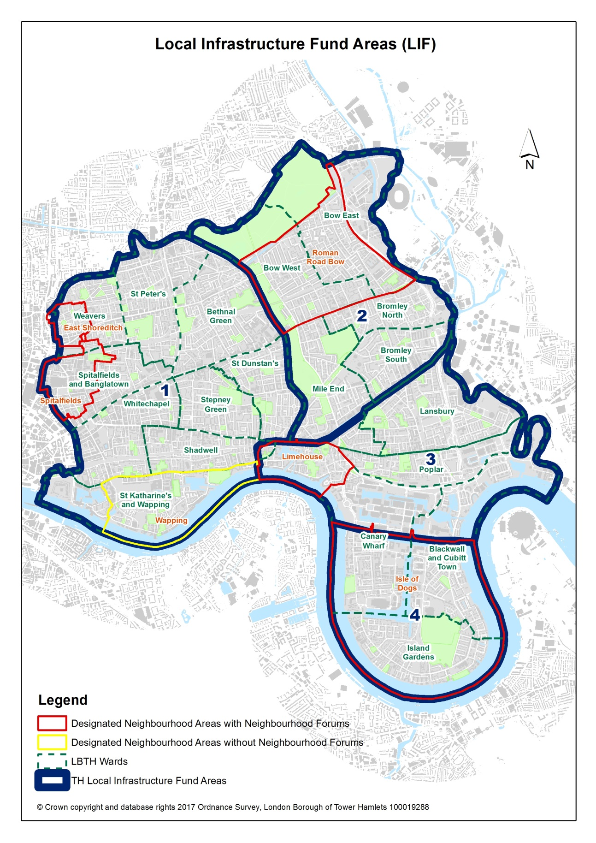
Appendix 2. 2021 Project suggestions grouped into broader themes across the four LIF areas of the borough.

Themes | LIF 1 | LIF 2 | LIF 3 | LIF 4 | TOTAL
Bridges Infrastructure | 0 | 2 | 10 | 7 | 19
Community Facilities | 3 | 9 | 13 | 10 | 35
Cycling/Walking | 19 | 47 | 29 | 32 | 127
Health | 1 | 0 | 2 | 0 | 3
Libraries/Idea Store | 0 | 0 | 0 | 4 | 4
Other | 2 | 0 | 1 | 1 | 4
Green Spaces | 11 | 28 | 13 | 18 | 70
Pollution Reduction | 7 | 8 | 5 | 2 | 22
Public Realm | 11 | 7 | 6 | 10 | 34
Public Safety | 16 | 14 | 14 | 8 | 52
Public Transport | 1 | 5 | 3 | 2 | 11
Recycling/Waste | 7 | 12 | 8 | 3 | 30
Residential/Estate Improvement | 46 | 2 | 7 | 2 | 57
Road Improvement | 52 | 44 | 22 | 31 | 149
Schools | 0 | 0 | 0 | 2 | 2
Shops/Town Centres | 0 | 11 | 6 | 3 | 20
Sports/Leisure Facilities | 6 | 4 | 3 | 8 | 21
Waterways Improvement | 1 | 1 | 4 | 10 | 16
Totals | 189 | 194 | 146 | 153 | 682

Appendix 3. 2020 Project suggestions grouped into broader themes across the four LIF areas of the borough.

Themes | LIF 1 | LIF 2 | LIF 3 | LIF 4 | TOTAL
Community facilities | 14 | 4 | 1 | 1 | 20
Cycling/walking | 71 | 33 | 13 | 9 | 126
Flood Defence | 2 | 0 | 0 | 0 | 2
Green spaces | 60 | 9 | 7 | 4 | 80
Health | 1 | 0 | 0 | 0 | 1
Other | 24 | 9 | 7 | 2 | 42
Pollution reduction | 12 | 4 | 2 | 2 | 20
Public safety | 11 | 3 | 0 | 0 | 14
Public transport | 6 | 11 | 1 | 1 | 19
Recycling/waste | 17 | 11 | 0 | 0 | 28
Residential/Estate improvement | 17 | 3 | 0 | 4 | 24
Road improvement | 79 | 20 | 7 | 9 | 115
Schools | 1 | 1 | 7 | 0 | 9
Shops/town centres | 50 | 11 | 2 | 0 | 63
Sports/leisure facilities | 3 | 0 | 0 | 2 | 5
Waterways improvement | 0 | 0 | 5 | 4 | 9
Totals | 368 | 119 | 52 | 38 | 577

Appendix 4. 2019 Public project suggestions grouped into broader themes across the four LIF areas of the borough.

Themes | LIF 1 | LIF 2 | LIF 3 | LIF 4 | TOTALS
Community facilities | 84 | 19 | 58 | 30 | 191
Cycling/walking routes | 19 | 28 | 27 | 17 | 91
Flood defences/prevention | 0 | 0 | 1 | 3 | 4
Health care facilities | 2 | 5 | 16 | 14 | 37
Libraries/idea store | 2 | 0 | 2 | 2 | 6
Measures to tackle pollution | 12 | 4 | 12 | 2 | 30
Parks/green space | 50 | 32 | 87 | 49 | 218
Public safety measures | 34 | 33 | 44 | 21 | 132
Public transport | 10 | 9 | 25 | 15 | 59
Recycling/waste management | 20 | 14 | 20 | 5 | 59
Residential/estate improvements | 8 | 1 | 2 | 5 | 16
Road network improvement | 34 | 36 | 56 | 29 | 155
Schools/School Places | 3 | 3 | 9 | 10 | 25
Sports/leisure facilities | 7 | 9 | 5 | 12 | 33
Sustainable energy schemes | 6 | 5 | 4 | 3 | 18
Town centre improvement | 76 | 17 | 23 | 5 | 121
Training/employment facilities | 7 | 4 | 6 | 4 | 21
Waterways improvement | 11 | 1 | 16 | 2 | 30
Other | 16 | 21 | 26 | 17 | 80
Totals | 401 | 241 | 439 | 245 | 1326

Appendix 5: Key stages of the Annual LIF programme

