SECTION 30 APPLICATION

(SPECIAL & TEMPORARY STRUCTURES)
London Building Acts (Amendment) Act 1939 (Part IV)

 |  |  |  |  |  |  |  |  |  |  |  |  |  |  |  | Application Number
Place Directorate, Building Control,  Mulberry Place , 5 Clove Crescent, London E14 2BG  Tel: 020 7364 5009 | Fax: 020 7364 5265 | Email: buildingcontrol@towerhamlets.gov.uk |  |  |  |  |  |  |  |  |  |  |  |  |  |  |  | 30 / /  Payment ref: AF
1 | Statement
 | I am submitting this application for the work described below under Part IV of the London Building Acts (Amendment) Act 1939. I enclose the necessary fee in pursuance of Part II of the Greater London (General Powers) Act 1982. Please refer to the attached notes before completing this form.
 | Title: |  |  | First name: |  |  |  |  |  | Last name: |  |  |  |  | Signature:
 | Owner/Occupier Agent Builder (please tick as applicable) Date:
2 | Location of structure
 | Address:
 |  |  |  |  |  |  |  |  |  |  |  |  |  |  |  |  | Postcode:
3 | Owner/Occupier commissioning building work
 | Title: |  |  |  | First name: |  |  |  |  |  | Last name:
 | Company name:
 | Address:
 |  |  |  |  |  |  |  |  |  |  |  |  |  |  |  |  | Postcode:
 | Tel: |  |  |  |  |  |  | Fax: |  |  |  | Email:
4 | Agent’s details (to whom correspondence relating to this application will be sent)
 | Title: |  |  |  | First name: |  |  |  |  |  | Last name:
 | Company name:
 | Address:
 |  |  |  |  |  |  |  |  |  |  |  |  |  |  |  |  | Postcode:
 | Tel: |  |  |  |  |  |  | Fax: |  |  |  | Email:
5 | Proposed Structure
 | Description:
 | Commencement date:
6 | Fee (see note 5)
 | Section 30 fee: VAT not applicable Total: |  |  |  |  |  |  |  |  |  |  |  | £
Method of payment: Cheque Postal Order BACS Credit/Debit card (please tick one)
To pay by credit/debit card or Bac’s please telephone us on 020 7364 5009 (press option 2 for Building Control).

You may also need permission under the Town and Country Planning Acts. Please contact the Tower Hamlets Planning Department on 020 7364 5009 for advice ( press option 1 for Planning).

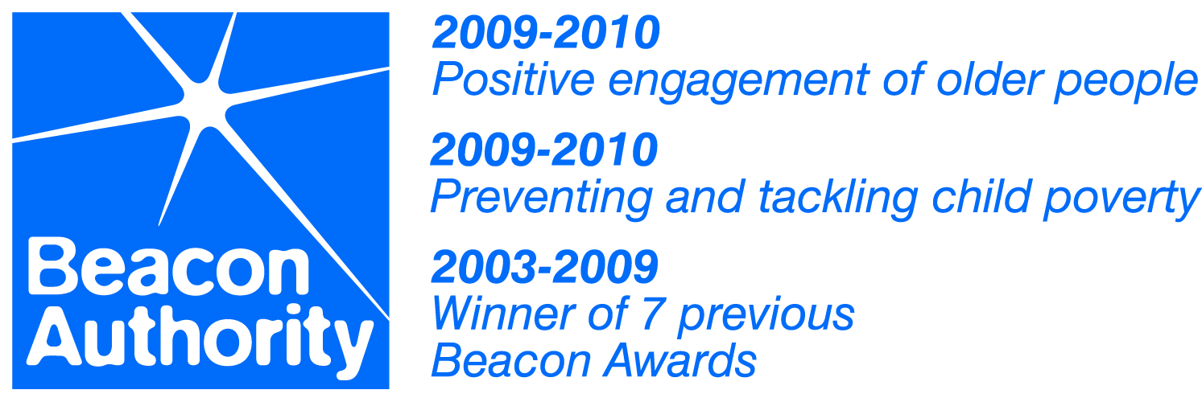

Section 30 Application (Special & Temporary Structures) Notes

- One copy of this notice should be completed and submitted with two copies of drawings containing the following information:
  - Block Plan to a scale of not less than 1:500, or such scale as may be necessary to identify the situation of the intended structure or structures which shall be coloured RED
  - The situation of adjacent buildings, roads, trees and other features.
  - Plans sections and elevations of the proposed structure or structures to a scale of not less than 1:100.
  - Such additional details as may be required to indicate clearly the method of construction and materials proposed the sizes of constructional parts, the weights and thickness of members, the size and pitch of rivets or other connections.
  - The North Point and the Scales used in the drawings.
  - Together with the necessary Fee under Part II of the Greater London Council General Powers Act 1982 (see attached Fees and Charges Guidance Note).

- The full name and address of the person on whose behalf the application is being made and the extent of their interest in the structure must be stated. Particulars must also be furnished as to the purpose for which the intended structure is required.
  - In the case of applications being made by a partnership or company (other than a limited company) the names of all partners or directors must be stated.
  - In the case of applications being made by a limited company, the full name of the Secretary and the address of the registered office shall be stated.

- The period during which such building or structure shall be permitted to be retained will be indicated in the Council’s consent, and at the expiration of that period such building or structure shall be removed.

- The Council may, at its discretion, extend the period for which consent has been granted, subject to payment of the necessary Fee as described above.

- PAYMENT - This application cannot be accepted until the correct Section 30 fee has been paid (see attached Fees and Charges Guidance Note). Payment methods accepted include BACS and credit/debit card. To pay by Bac’s or credit/debit card please telephone us on 020 7364 5009 (press option 2 for Building Control). We cannot accept cash payments.

- This Authority is under a duty to protect the public funds it administers and to this end may use the information you have provided on this form within this authority for the prevention and detection of fraud. It may also share this information with other bodies administering public funds solely for these purposes. The London Borough of Tower Hamlets also upholds the principles of the Data Protection Act. The information supplied on this form and in future by telephone, correspondence or verbally will be held on computer for the purpose of Building Control administration.

- Further information and advice on the Building Regulations may be obtained from our website www.towerhamlets.gov.uk, by telephoning us on 020 7364 5009. If you would like to visit in person please telephone us on 020 7364 5009 to make an appointment.

Under the Town and Country Planning Acts it is most important that any necessary planning permission is obtained before building works are commenced or change of use is implemented. If this is not done, the Council has the power of enforcement with a view to requiring the removal of unauthorised building work or the discontinuance of unauthorised changes of use. Please contact the Tower Hamlets Planning Department on 020 7364 5009 press option 1 for advice.

