Waste Infrastructure Survey Stage 1

Stage 1 Report

10/08/2022

Table of Contents

Definitions 3

1.0 Introduction 4

2.0 Opportunity Area and Flats Recycling Package Background 5

2.1 Isle of Dogs and South Poplar Opportunity Area 5

2.2 Flats Recycling Package 6

3.0 Methodology 9

3.1 Identification of flatted estates 9

3.2 Identification and liaising with landowners 9

3.3 Development of Survey and Weighted Matrix 9

3.4 Assessment of communal facilities 11

3.5 Cost Calculator 13

3.5 Challenges and Issues Faced 15

4.0 Survey Findings 17

4.1 Summary of KBT Survey 17

4.2 Levels of Intervention Required 17

4.3 Analysis of Results 19

4.4 Commentary 27

4.5 GIS 28

5. 0 Conclusions 29

6.0 Appendix 31

6.1 Flats Recycling Package Toolkit 31

6.2 Weighted Matrix and Evaluation Scoring 31

6.3 Survey Script 31

6.4 KBT Database 31

6.5 Landowners and Managing agents 31

# Definitions

Bin store/ Bin area: An individual bin store or an area where bins are stored, there may be multiple bin stores or bin areas for one block. These can be both inside and outside.

Capture rate: Capture rates are a measure of how much of the 'available' material collected for recycling (separately or co-mingled) are collected through a kerbside collection scheme.

Chute fed bins: Bins are placed at the bottom of chutes with waste falling directly into them. They would not have lids and residents should not be accessing the chute rooms and bins directly (though some bins may be stored outside the chute rooms to be rotated by the caretaker). The block would have hoppers on each floor for residents to dispose of their waste.

Contamination: Contamination is the action of polluting a waste stream with anything that should not be there. This includes general waste items going into a recycling bin, food and liquid waste and other potential issues including the presence of hazardous and clinical waste in non-specialist bins.

Estates: A group of blocks can make up one estate.

Fly tipping: Fly tipping is the illegal disposal of controlled waste – from a single bag of waste to large quantities of domestic, commercial or construction waste.

Recycling rate: The recycling rate is the percentage of material recycled compared to the total amount of waste collected.

Site: A block of flats under one UPRN.

UPRN: Unique Property Reference Number. A code which consists of numbers of up to 12 digits in length. Local governments in the UK have allocated a unique number for each land or property.

# 1.0 Introduction

Eunomia Research & Consulting Ltd (“Eunomia”) was commissioned by the London Borough of Tower Hamlets (“LBTH”) to undertake a Waste Infrastructure Study to inform and guide the implementation of the Flats Recycling Package[1] within the Isle of Dogs and South Poplar Opportunity Area. The study, split across two stages, provides an opportunity to address increasing disparities between new and existing communal estates. This is done by understanding the baseline condition on existing estates (undertaken as part of Stage 1) and providing an understanding of the cost implications for bringing waste infrastructure provision for these estates up to a comparable standard as required for new-build estates (undertaken as part of Stage 2).

The project has been split into two stages:

* **Stage 1** (the focus of this report): Focussed upon a survey undertaken by Keep Britain Tidy (“KBT”) to assess the bin store provision for communal estates within the Opportunity Area. The survey results were then quantified into different levels of intervention required to bring them up to a certain standard required by the Flats Recycling Package.
* **Stage 2**: Focussing on the overall cost and financial implications of implementing the Flats Recycling Package across the Opportunity Area, including a consideration of how best to engage with key stakeholders. As well as a breakdown of funding opportunities, an engagement and communications plan will be produced to go alongside the recommendations. It is worth noting that for the purpose of this Stage 1 report, a high-level overview of the financial implications of implementing the Flats Recycling Package per intervention level is provided in the Stage 1 report.

This Stage 1 report highlights the key survey findings and is set out in the following order:

* Further background to the Opportunity Area and the Flats Recycling Package;
* Methodology;
* Survey findings; and
* Conclusions.

# 2.0 Opportunity Area and Flats Recycling Package Background

## 2.1 Isle of Dogs and South Poplar Opportunity Area

The Mayor of London, and Transport for London have been working together to prepare an Opportunity Area Planning Framework (“OAPF”) for the Isle of Dogs & South Poplar in consultation with LBTH. The Greater London Authority’s (“GLA”) Infrastructure Coordination Service (“ICS”), in partnership with LBTH is piloting new and innovative approaches to planning infrastructure in the Isle of Dogs & South Poplar Opportunity Area to ensure that utility infrastructure, including waste, are of a scale and standard commensurate with the planned growth ambitions for the Opportunity Area and to recommend any necessary supportive interventions. This is required to support the planned growth coming forward to 2041 and to make recommendations in respect to the development and implementation of a Waste Infrastructure Strategy for the area, which will respond to the future needs of residents. This Study has taken place with the ongoing impact of COVID-19 which has impacted nature and quantities of waste. The Opportunity Area can be seen in Figure 1.

Figure 1: Map showing the location of the OA in Tower Hamlets and wider London

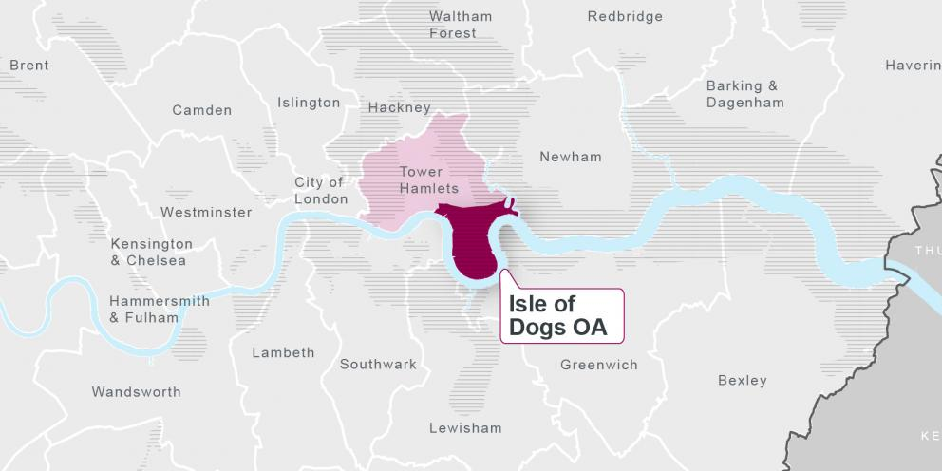

There is a large amount of new high-quality developments within the Isle of Dogs and South Poplar Opportunity Area. This area is underpinned by the Mayor of London’s principle of Good Growth, whereby new developments should benefit everyone who already lives in the area, and development should be sensitive to the existing local context. This is to prevent and reduce the increasing disparity between the new developments and the existing development, particularly in the case of flatted properties.

The aim of the Isle of Dogs & South Poplar OAPF is to provide greater certainty to the community on how they can influence development and to guide developers through the production of a coordinated planning document to manage pressures of growth and secure infrastructure delivery.

The planning framework can secure high-quality living conditions for future residents in terms of waste but has little power to leverage change for existing residents. Improving this infrastructure and concurrently increasing rates of recycling for existing estates and residents is key if the recycling target of 50% for households is to be reached by 2030 as set out in the London Environment Strategy[2]. Currently the LBTH recycling rate for 2021/22 stands at 19.6%[3]. It is worth noting that LBTH’s Mayor has a separate strategy which may feed into this discussion, with pledges relating to educating residents with regards to recycling[4].

## 2.2 Flats Recycling Package

Flatted properties have more barriers to recycling and typically have a lower recycling rate and higher contamination rate than kerbside properties[5]. Some of these barriers include a lack of signposting residents to the correct bin(s), bins being far away from residents’ properties, and poor waste infrastructure design.

The Flats Recycling Package (“FRP”) was developed by ReLondon as a toolkit for housing providers, building managers, and service providers who want to make improvements to the recycling and rubbish services at their flats[6]. The toolkit can be found in Appendix 6.1 Flats Recycling Package Toolkit.

The FRP was rolled out across 12 Peabody Housing Association estates in six London boroughs in 2018/19 and was successful in significantly improving recycling performance. Following this success, ReLondon recommended that the FRP be rolled out to all existing flats.

ReLondon research[7] shows that effective recycling is achieved when residents:

* have the correct knowledge – lack of easy access to accurate information can undermine confidence;
* find it sufficiently easy – services that fit with people’s existing routines will feel easier to use; and
* are motivated – poor experiences and an apparent lack of accountability can be demotivating.

The FRP can be used to improve the recycling and rubbish services in flats and provides assets and guidance ready for use.

Tower Hamlets was a part of the ReLondon & Peabody recycling project. As part of the project, in depth inventories on all 21 Peabody blocks and estates in LBTH were completed in February 2018. Three estates within LBTH were subsequently chosen to trial resident focussed interventions which were implemented during October 2018. These interventions included: smaller recycling bins, in-home storage solution, emotive messaging, tenant recycling information packs and feedback mechanism to residents. All three estates received improved communication materials, with clear and visible signage on recycling and residual bins and at the bin storage area being provided, alongside internal recycling posters and information on bulky waste removal options. The package of interventions is known as the FRP. Analysis and evaluation of the pilot was completed summer 2019. A review of inventories from non-trial blocks and implementation of improvements has not commenced.

The overall results of the pilot showed that, London-wide, the implementation of the FRP led to a 25% increase in recycling rates (from 10.7% to 13.4%) and a 24% decrease in contamination rates (from 30.7% to 23.4%). However, one of the three estates involved in the trial in LBTH had the lowest increase in recycling rate and capture rate of any estate; at 12% (from 11.1% to 12.4%) and 9% (from 38.2% to 41.7%) respectively. ReLondon note that the results may have been because the estate was quite new, and the rubbish and recycling bin areas were already of a reasonably high standard, so the introduction of the FRP had less of an impact[8].

Table 1, Table 2 and Table 3 provide the results of the three estates in Tower Hamlets respectively that were involved in the pilot[9].

Table 1: Estate 1 from the ReLondon & Peabody trial

|  |  |  |  |  |
| --- | --- | --- | --- | --- |
|  | Pre-trial actual | Post-trial actual | Maximum potential | Increase/ decrease |
| Recycling | 9.4% | 12.1% | 29.3% | 29% |
| Capture | 37.3% | 45.6% |  | 22% |
| Contamination | 32.8% | 26.2% |  | -20% |

Table 2: Estate 2 from the ReLondon & Peabody trial

|  |  |  |  |  |
| --- | --- | --- | --- | --- |
|  | Pre-trial actual | Post-trial actual | Maximum potential | Increase/ decrease |
| Recycling | 11.1% | 12.4% | 33% | 12% |
| Capture | 38.2% | 41.7% |  | 9% |
| Contamination | 34.4% | 25.7% |  | -25% |

Table 3: Estate 3 from the ReLondon & Peabody trial

|  |  |  |  |  |
| --- | --- | --- | --- | --- |
|  | Pre-trial actual | Post-trial actual | Maximum potential | Increase/ decrease |
| Recycling | 5.8% | 7.8% | 26.8% | 34% |
| Capture | 26.8% | 31.5% |  | 17% |
| Contamination | 42.7% | 29.8% |  | -30% |

# 3.0 Methodology

## 3.1 Identification of flatted estates

The first stage of the project involved LBTH providing a full list of all the bin stores on existing sites within the opportunity area. The LBTH Waste team then checked the list to remove any duplicates, non-residential properties, kerbside and Flat Above Shop (FAS) properties which were not in scope. Once out of scope properties were removed, there were a total of 833 sites passed over to KBT. The Waste team also provided collection frequencies for each property at the request of KBT. The data included the Unique Planning Reference Number (UPRN), easting and northing, and full address with the number of flatted properties in the parent building[10].This property data was provided to KBT for the development of the survey.

## 3.2 Identification and liaising with landowners

From KBT’s previous work in LBTH which was undertaken in 2015 and 2018, the licensing scheme for landlords and other internal sources, landowner and management data were used to identify landowners to allow KBT to contact relevant individuals should there prove to be access issues when carrying out the survey. Internal LBTH stakeholders helped in gathering this data which included:

* Landlord and managing agent data held on LBTH system.
* Tower Hamlets Housing Forum; and
* Desk-based research.

Through these methods, several landowners were identified, with further landowners being identified when the survey team were on the ground and were able to identify contact details on notice boards located at the estates themselves. Where required, KBT contacted the landowners and managing agents in order to resolve access issues at the estates following a first unsuccessful visit. In some instances, no response was received, and as such, it was not possible to gain access to the estates. A full list of bin stores which could not be accessed can be viewed in Appendix 6.3, with further details regarding access issues outlined in section3.6 Challenges and Issues Faced.

## 3.3 Development of Survey and Weighted Matrix

Prior to commencing the estate survey, KBT, LBTH and Eunomia held meetings to discuss the survey script that would be used when assessing estates to determine the current standard of bin store provision. The criteria for assessing an estate’s current provision were based upon the concept of what an ‘ideal’ bin store would look like. This was developed using ReLondon’s implementation and improvement plans to identify what each bin store should contain. This included, but was not limited to, the bin store having the correct bin capacity (for both residual waste and recycling), having clear signage and a suitably frequent cleaning schedule. Due to the fact that separate food waste collections are likely to become mandatory in the next few years a question was also included regarding whether there was sufficient space for a communal food waste bin. The full list of criteria can be found in Appendix 6.1. This ‘ideal’ bin store standard was shared with KBT and LBTH at working group meetings to confirm they were happy with the guidance on what a bin store should look like. The working group included Eunomia, officers from LBTH’s Growth and Infrastructure team, as well as the Waste team, an officer from the GLA’s Infrastructure Coordination Service and KBT.

The ‘ideal’ bin store was then transferred into a weighted matrix, where each of the key components was given a weighting out of five, based on professional judgement and research of the importance of each item. The use of the weighted matrix was a novel approach, with the purpose of using a matrix was to allow multiple issues to be assessed against each bin store and an overall “score” be arrived at to allow an assessment to be made as to how closely the bin store was to achieving the standards set out in the FRP. It is important to note that should a bin store have the correct facilities, such as the correct recycling capacity, it would receive a score of “0”, with higher scores being given for worse performance against each of the matrix elements. As such, the lower the score for each bin store, the better they performed against the standards set out in the FRP. The full list of matrix elements and the maximum weighting that could be applied to each can be seen in Table 4.For example, having the correct recycling capacity is very important in order to allow residents to properly recycle, as such, the maximum score for incorrect recycling capacity was “5”. Whereas the maximum score for bin store walls being clean and scratch free was “2”, although this criterion does have an effect on deterring recycling due to making the bin store an unpleasant place to visit, the impact is not as big as there being the incorrect capacity. These weightings were then agreed in the working group and can be found in Table 4.

Table 4: Weighted marix elements and their maximum weighting

|  |  |
| --- | --- |
| Matrix Element | Maximum Weighting |
| External Bin store signage | 2 |
| Bulky waste signage | 2 |
| Residual Waste Signage | 4 |
| Recycling Signage | 4 |
| Bin store is clean | 4 |
| Lighting in the bin store works | 4 |
| Bin store walls are clean and free of scratches | 2 |
| Recycling bins and residual bins are separated | 4 |
| Residual Waste bin stickers | 3 |
| Residual Waste Bins are in a good condition | 2 |
| Residual Waste Bins are clean | 4 |
| Recycling bin lids | 4 |
| Recycling bin stickers | 3 |
| Recycling bins are in a good condition | 2 |
| Recycling Bins are clean | 4 |
| Recycling Capacity | 5 |
| Residual Capacity | 5 |
| Total Maximum Weighting | **58** |

The purpose of this, was to allow the bin stores to be assessed against the key components, to determine the level of intervention required to bring them up to the standards set out in the FRP. The matrix can be found in Appendix 6.2. The matrix was then passed to KBT for the development of the survey script, which can be found in Appendix 6.3 Survey Script.

The survey incorporated standard information recorded against each site and bin store, including:

* Bin store type, location, and condition;
* The number, size and condition of residual waste and recycling bins; and
* The required number of bins (considering bin store size constraints and agreed policies).

The survey was split into three stages:

* The first stage collected information on the overall site, including whether the site could be surveyed in the first instance, whether it had both residual waste and recycling facilities and any details of the managing agents.
* The second stage collected information on the type of bin location, how many properties were served by it and the overall condition of the bin location, including the level of fly tipping and litter present, whether suitable signage was present and if adequate lighting was available, amongst other considerations.
* The third stage included information on each specific bin within the bin store, such as signage, lid type and if there were any major dents to the body of the bin, amongst other elements.

The full script used by KBT can be found in Appendix 6.3 Survey Script.

## 3.4 Assessment of communal facilities

Using the weighted matrix with the weightings that had been developed and agreed, an ‘evaluation model’ was created to allow the scoring of each bin store for the estates based upon the questions and answers contained within the survey completed by KBT. This evaluation model can be found in Appendix 6.1 Flats Recycling Package Toolkit

6.2 Weighted Matrix and Evaluation Scoring. The answers given for each relevant weighted element would then return a specific weighted score. The combined total score for that bin store then resulted in the bin store being graded into different levels of intervention required. Two sets of intervention levels were considered, one containing four levels of intervention and another containing five levels of intervention.

The four intervention levels included:

* Minimal intervention;
* Average intervention;
* Significant intervention; and
* Significant+ intervention.

Whilst the five intervention levels included:

* Minimal intervention;
* Minimal/average intervention;
* Average intervention;
* Significant intervention; and

Significant+ intervention.

For the purposes of analysing the survey findings, four intervention levels were utilised.

The total score of a bin location with residual waste and recycling facilities was 58; for a site with recycling facilities only, the maximum score was 40; and for a site with residual waste facilities only, the maximum score was 36. The total scores have been calculated using the maximum scores for each component in the Weighted Matrix found in Appendix 6.1 Flats Recycling Package Toolkit

## 

6.2 Weighted Matrix and Evaluation Scoring. Due to the difference in scores depending on what facilities the bin location contained, the final score for each location is shown as a percentage, as a bin store with both recycling and residual facilities will naturally have a higher score and therefore appear as a worse bin store compared to one with only one waste stream. If the bin store had both recycling and residual the score was divided by 58, if it was recycling only it was divided by 40 and if it was residual only the score was divided by 36. This is how the percentages were determined.

The lowest % for a bin store was 10% and the highest was 74%, with the difference between the two scores being 64. The 64 was then split into quartiles, to arrive at the different intervention levels with a range of 16% between the levels:

* Minimal intervention – 10-26%;
* Average intervention – 27-42%;
* Significant intervention – 43-58%; and
* Significant+ intervention – 59-74%.

## 3.5 Cost Calculator

Once the intervention levels were finalised for the bin stores, the next step in the methodology was to calculate the average costs for bringing the bin stores up to the FRP standard. These calculations were completed using the ReLondon cost calculator tool[11]. Whilst this technically sits within Stage 2, a high-level summary of the costs per intervention level were included in this Stage 1 report upon the request of LBTH.

Depending on the intervention level the bin store fell within, the assumptions used in the Cost Calculator differed. These assumptions were all agreed with the Working Group.

The assumptions were split into the following key areas within the cost calculator:

1. Setup cost scenario - Five setup cost scenarios can be selected within the cost calculator based on how easy or difficult users perceive it will be to treat the relevant estates:
   * **Low**: a low amount of change is needed to bring estate(s)/bin stores up to the FRP standard.
   * **Medium-low**: a medium-low amount of change is needed to bring estate(s)/bin stores up to the FRP standard.
   * **Average**: an average amount of change is needed to bring estate(s)/bin stores up to the FRP standard.
   * **Medium-high**: a medium-high amount of change is needed to bring estate(s)/bin stores up to the FRP standard.
   * **High**: a high amount of change is needed to bring the estate(s)/bin stores up to the FRP standard.
2. Ongoing cost scenario - Five ongoing cost scenarios can be selected within the cost calculator by users based on how easy or difficult users perceive it will be to maintain the relevant estates to the FRP standards:
   * **Low**: a low amount of maintenance will be required.
   * **Medium-low**: a medium-low amount of maintenance will be required.
   * **Medium**: an average amount of maintenance will be required.
   * **Medium-high**: a medium-high amount of maintenance will be required.
   * **High**: a high amount of maintenance will be required.
3. Benefit Scenarios:
   * **Waste volume diverted from residual to recycling scenario.** The impact of the FRP on recycling performance cannot be guaranteed. Based on the range of impacts experienced in the Peabody project, three scenarios can be selected to illustrate the range of impacts that could be experienced. High, average, and low represent 39%, 26% and 16% uplifts in recycling volumes, respectively. If the estate(s)/bin stores already have a good level of performance or good standard of service, then it can be expected that the impact of the FRP may be lower and therefore a low scenario could be chosen, and vice versa.
   * **Reduction in contamination rate scenario**. The impact of the FRP on the contamination rate cannot be guaranteed. Based on the range of impacts experienced in the Peabody project, three scenarios can be selected to illustrate the range of impacts that could be experienced. High, average and low represent 46%, 24% and 0% impacts on the contamination rate respectively. If the estate(s)/bin stores already have low contamination rates then the low scenario could be chosen, and vice versa.

When inputting the surveyed bin stores through the ReLondon Cost Calculator the different scenarios were altered depending on the intervention level they fell into. This was to allow the varying levels of resource that would be required to upgrade the bin stores to be reflected. These are outlined in Table 5 and Table 6 for the four and five intervention levels respectively.

Table 5: Assumptions for four intervention levels

|  |  |  |  |  |
| --- | --- | --- | --- | --- |
| Intervention level | Setup cost scenario | Ongoing cost scenario | Waste volume diverted from residual to recycling scenario | Reduction in contamination rate scenario |
| Minimal | Low | Average | Low | Low |
| Average | Average | Average | Average | Average |
| Significant | Medium High | Average | High | High |
| Significant+ | High | Average | High | High |

Table 6: Assumptions for five intervention levels

|  |  |  |  |  |
| --- | --- | --- | --- | --- |
| Intervention level | Setup cost scenario | Ongoing cost scenario | Waste volume diverted from residual to recycling scenario | Reduction in contamination rate scenario |
| Minimal | Low | Average | Low | Low |
| Minimal/Average | Medium Low | Average | Low | Low |
| Average | Average | Average | Average | Average |
| Significant | Medium High | Average | High | High |
| Significant+ | High | Average | High | High |

Additionally, there were certain cost allocations which varied between the housing provider and the London borough. These were also agreed with the working group. These allocations remained the same for all bin stores that were put through the cost calculator and can be seen in Table 7.

Table 7: Cost Allocations used within the FRP Cost Calculator

|  |  |
| --- | --- |
| Cost Allocations | Responsibility |
| New bin purchase/maintenance | London borough |
| Recycling bin rental to housing provider? | N/a |
| Bin area refurbishment | Housing provider |
| Stickers, posters, signage, leaflet (product) | London borough |
| Stickers, posters, signage, leaflet (design) | London borough |
| Project management | London borough |
| Regular cleaning | Housing provider |
| Monthly officer inspections | Housing provider |
| Additional recycling waste collections | London borough |

In total, 10% of all bin stores (88) were put through the cost calculator for both the four and five intervention level scenarios. This 10% was then split proportionally based on the number of bins stores which fell into the different intervention levels. An average cost was then calculated for each specific intervention level, the result of which are shown in section 4.5 Average Cost Implications of Upgrading Bin Stores.

## 3.6 Challenges and Issues Faced

During the project, certain issues were faced. This primarily included KBT not gaining access to certain sites, but also included certain sites being visited and subsequently not assessed due to them being out of scope. From the list of 833 sites provided by LBTH, 35 sites were not able to be surveyed (4.2%) Out of the 35 sites not surveyed, 25 were not in scope. Sites not in scope were either commercial properties or hotel buildings (seven in total), street level properties with individual bins (five in total), an unused mooring dock (one in total) or were still buildings under construction and did not have residents living there yet (12 in total).

The surveyors were unable to gain access to 9 sites (1% of all sites) and therefore could not survey them, this was either due to the bin stores being behind gates or doors which they did not have a key for, or due to a concierge or caretaker not wanting to provide access. Lastly, there was 1 site that was not surveyed due to safety reasons following the advice of the caretaker. The details of these sites can be found in Appendix 6.4 KBT Database. Unfortunately, no contact details for managing agents were recorded for these sites, and there appears to be no pattern tying the sites together. For the avoidance of doubt, those properties which could not be visited were excluded for the purpose of the analysis.

To resolve issues of blocked access, KBT attempted using fire access keys where suitable, or alternatively contacting the managing agents and landlords. However, in these limited 9 instances, either no response was received, or use of a fire access key was not possible. Full details of those sites which were not accessible can be found in the KBT database in Appendix 6.4 KBT Database.

Another issue noted by KBT, was that the automatic geolocation setting used in KBT’s survey script caused the survey to run slower than anticipated. Fortunately, this did not negatively impact the surveying team’s efficiency, and they were able to visit all sites within the allotted timeframe.

# 4.0 Survey Findings

## 4.1 Summary of KBT Survey

In total, KBT surveyed 876 bin stores across 833 sites with this including a total of 86 revisits, of which 81% were successful. These were completed over 5 weeks from 14th March to the 14th April 2022. This is summarised in Table 8. The KBT surveyors were able to gain access to the bin stores using either the fire safety key or chasing up with the management company in instances where revisits were undertaken. A full copy of KBT’s data can be found in Appendix 6.4 KBT Database.

Table 8: Summary table of KBT survey

|  |  |
| --- | --- |
|  | Number |
| Sites surveyed | 833 |
| Bin stores surveyed | 876 |
| Sites on sack collection | 34 |
| Sites not surveyed | 9 |

## 4.2 Levels of Intervention Required

As outlined in the previous section (3.4 Assessment of communal facilities), the bin stores visited by KBT were split into differing levels of intervention to bring them up to the standard required by the FRP. Of the 833 sites visited, a small minority required “minimal” levels of intervention, with the majority of the bin stores requiring either “average” or “significant” levels of intervention. On the opposite end, a minority of bin stores required “significant+” levels of intervention. A full breakdown by levels of intervention required is shown in Table 9 and Table 10 for four and five intervention levels respectively. As previously noted, for the purposes of analysing the survey findings, four intervention levels were utilised.

Table 9: Breakdown of the four Intervention Levels by number of bin store and % of total bin stores

|  |  |  |
| --- | --- | --- |
| Intervention Level | Number of bin stores | % of bin stores |
| Minimal Intervention | 56 | 6.39% |
| Average Intervention | 464 | 52.97% |
| Significant Intervention | 328 | 37.44% |
| Significant+ Intervention | 28 | 3.20% |
| Total | **876** | **100%** |

Table 10: Breakdown of the five Intervention Levels by number of bin store and % of total bin stores

|  |  |  |
| --- | --- | --- |
| Intervention Level | Number of bin stores | % of bin stores |
| Minimal Intervention | 35 | 4.00% |
| Minimal/average Intervention | 266 | 30.37% |
| Average Intervention | 414 | 47.26% |
| Significant Intervention | 154 | 17.58% |
| Significant+ Intervention | 7 | 0.8% |
| Total | **876** | **100%** |

While KBT visited 833 sites, there are a higher number of bin stores as some sites had multiple bin stores that came under the same UPRN, which is why the total number of bin stores stands at 876.There were an additional 34 sites that were on a sack collection, but these have been removed from the analysis as they cannot be quantified and assessed by the same standards as they had differing questions which focussed on what capacity of wheeled bins would be required, based upon the number of properties serviced by that bin store. The bin stores with a sack collection can be found in Appendix 6.4 KBT Database. As the bin stores on sack collection cannot be assessed in the same way as bin stores which contained wheeled bins, the majority of the scoring associated with the matrix would not be relevant. Whilst KBT has suggested the number of bins required at each site on sacks, the assumption is that these properties are on a sack collection for a reason and as such cannot accommodate wheeled bins. From reviewing the images which KBT’s surveyors provided, some bin stores were accessed via steps or the areas which may have accommodated wheeled bins would have been within a household’s property boundary. Therefore, sack collection properties have not been taken into consideration.

## 4.3 Analysis of Results

Minimal Intervention Level

56 bin stores fell into the minimal intervention level and they predominantly received poor scores for their signage and bin sticker provision.

Figure 2 Table showing percentage of bin stores that received each score in Minimal Intervention level

Table showing percentage of bin stores that received each score in Minimal Intervention Level

Average Intervention Level

The 464 bin stores that fell within the average intervention level also received poor scores for the signage, a similar theme to the minimal intervention level. Within this intervention level, more bin stores had the incorrect recycling capacity than those that did. A very small percentage of recycling bins received a perfect score of 0 for the recycling lid type.

Figure 3 Table showing percentage of bin stores that received each score in Average Intervention level

Table showing percentage of bin stores that received each score in Average Intervention levelSignificant Intervention Level

The 328 bin stores in the significant intervention level also scored poorly around signage and bin stickers, again showing a similar theme across intervention levels. The bin stores in this intervention level also did not have enough recycling capacity with only 23.76% having the correct capacity, and they also scored poorly recycling lid type/condition and lighting provision.

Figure 4 Table showing percentage of bin stores that received each score in Significant Intervention level

Table showing percentage of bin stores that received each score in Significant Intervention level

Significant + Intervention Level

28 bin stores fell into the significant+ intervention level. Most of these bin stores received the maximum score in almost all elements. Nearly 100% of the bin stores received the maximum score for bulky waste signage, residual and recycling signage, residual waste bin stickers and recycling bin cleanliness, as can be seen in the table below.

Figure 5 Table showing percentage of bin stores that received each score in Significant+ Intervention level

Table showing percentage of bin stores that received each score in Significant+ Intervention level

Landowners and Managing Agents

Whilst surveying, KBT collected data on Landlords and managing agents for blocks and buildings where the information was available, with this information being recorded as part of the survey (full details can be found in Appendix 6.5 Landowners and Managing agents. In total, 65 landlords and managing agents were recorded across 230 of the 833 sites. There were 10 landlords and managing agents which were the most prevalent across the surveyed sites, being responsible for 136 of all sites. The average scores for these landlords and managing agents are shown in Table 11, which for the avoidance of doubt is based on there only being four intervention levels.

Table 11: Number of bin stores and average bin store score for the 10 most prevelant landlords / managing agents across the 230 sites

|  |  |  |  |  |  |
| --- | --- | --- | --- | --- | --- |
| Landlord/ Managing Agent | Number of Bin Stores | Average bin store score | Average Intervention level | Number of bin stores in minimal intervention | Number of bin stores in significant+ |
| Kinleigh Folkard & Hayward | 14 | 34% | Average | 1 | 0 |
| Rendall and Rittner | 8 | 33% | Average | 3 | 1 |
| Swan Housing Association | 7 | 37% | Significant | 2 | 0 |
| First Port | 12 | 37% | Average | 2 | 0 |
| Ballymore | 19 | 41% | Average | 0 | 0 |
| Alliance Managing Agents | 10 | 40% | Average | 1 | 0 |
| One Housing Group | 40 | 42% | Average | 1 | 1 |
| East End Homes | 14 | 39% | Average | 0 | 0 |
| Southern Housing Group | 5 | 40% | Average / Significant | 1 | 0 |
| THH/ Council managed properties | 9 | 41% | Average | 0 | 0 |

London Residential Management had 15 sites, however, apart from one bin store, all were on a sack collection, and were subsequently not given a scoring as previously outlined. Of the most prevalent landlords, Kinleigh Folkard & Hayward and Rendall and Rittner both had the lowest average scores for their bin stores. The full list of properties with their managing agents and intervention level can be found in Appendix 6.5 Landowners and Managing agents.

Residual and recycling signage

Within the evaluation model, it was apparent that many sites did not have adequate provision of residual waste and recycling signage. In part, this was due to a number of bin stores not having a sufficient number of signs, or in some cases no signs, above the bins. There were also a number of high scores within the evaluation model indicating bin stores which had poor or no stickers on the bins themselves, with 99.7% of residual waste bins received the highest score for bin signage, meaning the residual waste bins had no signage on them. Of these residual waste bins, 27% were recorded as “unable to determine”, and as such were given the lowest score possible.

For the recycling bins, 50% received 2 out of 3 possible marks, again showing that a lot of the recycling bins had illegible stickers on the bins, or no stickers at all. Signage, both on the bin store walls and on the bins themselves in the form of stickers, is a critical component in signposting residents to the correct bin and reminding them what can and cannot go into the recycling bins. Correct signage will help prevent recycling from being disposed of in the residual waste bin, and from incorrect items being placed into the recycling bins and causing contamination. Of the total recycling bins, 13% were recorded as “unable to determine”, and as such were given the lowest score possible.

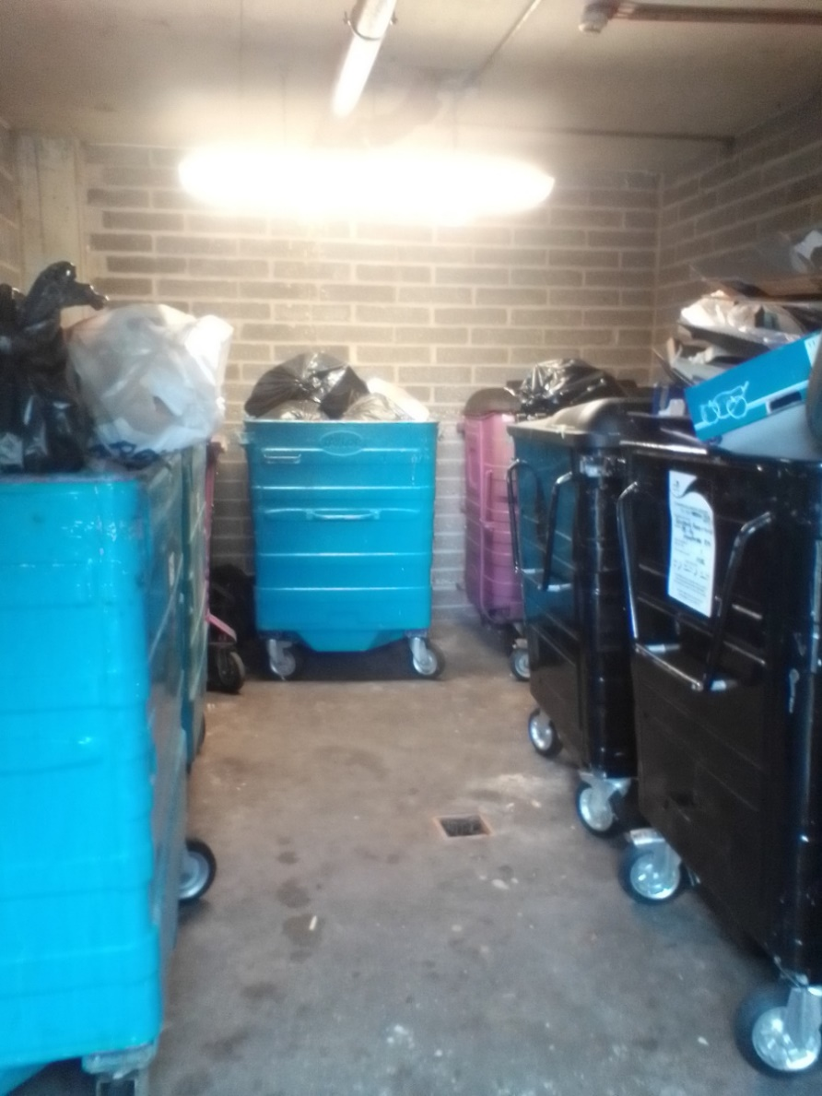

Figure 6 Image to show a bin store with lack of appropriate signage

Storage capacity

Of the total bin stores assessed, 39.4% had the correct number of recycling bins. However, 43.3% of the bin stores only had between 50-99% or the required capacity (90l per household per week). A further 17.3% of bin stores only had between 0-49% of the required capacity. This assessment was calculated using the requirement to have 90l per household per week for recycling as advised by the LBTH Reuse, Recycling and Waste SPD adopted 28th July 2021. Interestingly, this is above the level suggested by ReLondon, who only suggest 60l per household per week. For residual waste, 93% of the bin stores had the correct capacity or more than the capacity required, with only 5% having between 50-99% of the capacity required and 2% having below 50% of the capacity required. 75% of all bin stores had more capacity than required for residual waste. This provides landlords with a relatively quick means of increasing recycling capacity as residual waste bins can be swapped for recycling bins if required, though this would be worth discussing with the LBTH Waste team prior to making any changes. The capacity requirement for residual waste is 120l per household per week. As can be seen, the majority of the bin stores had the correct residual waste capacity, or more capacity than required, compared with less than 40% having the correct recycling capacity. It is important the correct capacity is provided to ensure residents are able to recycle as much as possible to ensure capture of all the desired materials. If recycling capacity is not sufficient, the bins may fill up too quickly and if there is no space available but there is space within the residual waste bins, residents may dispose of their recycling in these bins instead. Providing the correct residual and recycling capacity will maximise the diversion of recyclable material from the residual waste stream.

Fly tipping

Of the bin stores assessed, 245 had instances of fly tipping reported, with 210 of these being reported to contain some fly tipping, whilst a further 35 were reported as having a lot of fly tipping which would make it difficult to manoeuvre the wheeled bins. Of the total number of bin stores with reported instances of fly tipping, 43% had the incorrect recycling capacity and 20% had the incorrect residual capacity. If there is insufficient capacity within the bin store, they may subsequently become overfull, and this can increase the frequency of fly tipping and litter around bins and in bin stores. Of the total bin stores assessed, 78% of the bin stores received the maximum score for bulky waste signage, meaning there was no signage for bulky waste, which could further lead to an increase in fly tipping if residents are unsure of the correct way to dispose of their bulky waste. Of the bin stores with bulky waste present, 47% of them did not have any signage regarding bulky waste disposal, 39% had no signage above the residual waste bins and 36% had no signage above the recycling bins.

Lighting

Lighting of bin stores is also an important factor, with bin stores that are poorly lit or have no lighting possibly deterring residents from going into the bin store or spending extended periods within them to allow them to correctly dispose of their waste. Sufficient lighting is also needed so that the signage can be clearly read by residents and they know which bin is for which type of waste. 60% of the bin stores surveyed were given the best score of “0” for lighting, with 22% conversely receiving the highest score of “4”, indicating a lack of lighting or lighting which was not working or was insufficient. It is worth noting that some bin stores were marked as “unable to determine” (38% of bin stores) as they were tested in the daytime and it was not clear whether the lighting was adequate or not, particularly if the bin areas were outside and the outside lighting was not on.

Separation of bins

In the FRP, it is recommended that the residual waste and recycling bins are clearly separated to allow residents to more easily identify the correct bins to use. Out of the 362 bin stores which had both recycling and residual waste facilities, 8% of the bin stores had the residual waste and recycling bins mixed together, 59% had both bins in designated spaces where it was clear which was the area for recycling and which was the area for residual waste. Finally, 29% of bin stores had recycling and residual waste bins which were separate but were very close to each other. As such, this shows there is scope to improve the segregation of recycling and residual waste bins. 4% of bin stores had “unable to determine” as the survey answer, and as such, were given the lowest possible score.

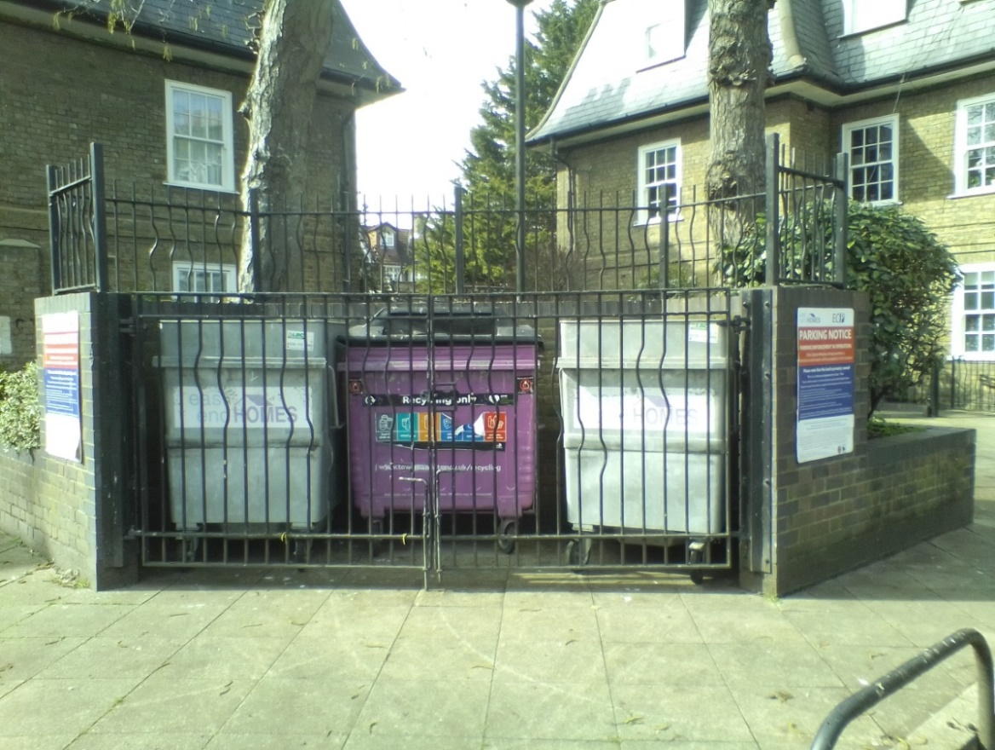

Figure 7 Image to show outdoor bin store with no separation of bins and poor signage

Cleanliness

From KBT’s survey, most bin stores scored averagely for cleanliness of the wheeled bins, with 94% of recycling bins receiving 2 out of a possible 4 marks, and 92% of residual waste bins also receiving 2 out of 4 marks. The majority of recycling (92%) and residual waste (95%) bins scored 1 out of 4 for their condition, which focussed upon the bin having dents or scratches or appearing to have working wheels. This is important as the condition and the appearance of a bin can deter residents from using them, particularly on the recycling bin where there is an aperture which they have to open. If apertures and lids are dirty, the “yuck” factor may mean residents may not use them and place their waste next to the bin instead, or in another bin which has an open lid, for example in a residual waste bin, where 54% had no lid. As advised by ReLondon, bins and bin stores should be cleaned on a weekly basis to ensure they are clean and not deterring residents from using them. With regards to cleanliness, the surveyors were unable to determine whether the wheels were working in 17% and 9% of instances, for the residual waste and recycling bins respectively.

Recycling lid type

The lid type on the recycling bins also varied a lot, with 26% of the recycling bins having no lid and being completely open, 43% had a normal lid, 28% had a lid with an aperture and only 4% had a reverse lid. The reverse lidded bins are recommended by ReLondon for recycling as they prevent the whole lid from being opened, and residents can only fit recycling through the aperture, which greatly reduces the incidents of contamination, particularly of bulky waste and large bags of rubbish. In addition, reverse lids can be retrofitted onto existing bins, eliminating the need to replace the whole bin in these situations which can prove to be a cost-effective option. Whilst assessing the recycling facilities, the surveyors also noted instances where excess cardboard was present. In total 9% of sites were recorded as containing excess recycling. Of these, 33% experienced their lids being unable to close due to the excess recycling.

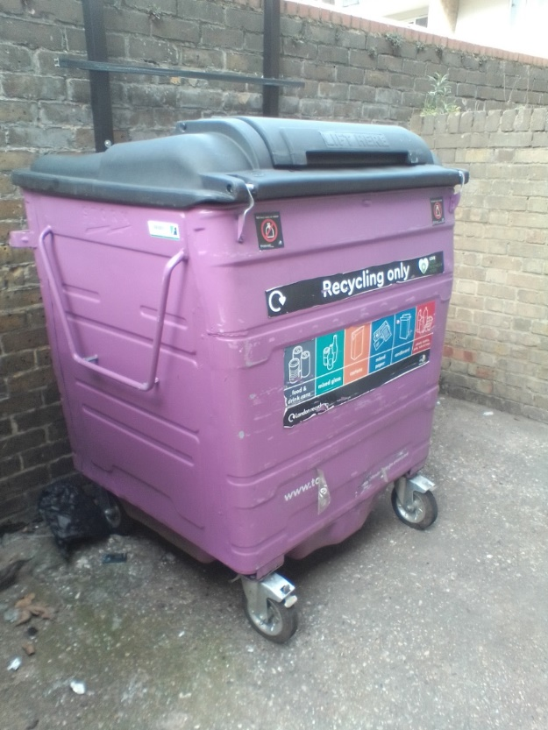

Figure 8 Image showing a recycling lid with a reverse lid.

Space for food waste bins

In the survey there was a question regarding space for a 240l wheeled bin. This was used to assess if there was space for a communal food waste bin within the bin store, as it is expected that food waste collections will become mandatory in the next few years due to the Environment Act (the exact date is still unclear). Out of all the bin stores assessed, 43% had enough empty space to accommodate one or more 240l wheeled bins, 50% did not have adequate space and in 7% of bin stores, the KBT surveyors were unable to determine if sufficient space was available. A breakdown of this can be found in Appendix 6.4 KBT Database. Of the 43% of bin stores with available space, 20% had space for one wheeled bin, 26% had space for two, 14% had space for three and 14% had space for 4. Typically, flatted properties often do not have space for additional wheeled bins within the bin stores as many were not built to hold three different waste collection streams, as such, the fact that 43% do have sufficient space is an interesting and unexpected finding. For the remainder of sites, LBTH should consider possible alternatives, such as siting communal food waste bins at alternative locations or utilising containers which can be mounted to the walls of bin stores.

## 4.4 Commentary

It is worth noting that for a number of matrix elements if the surveyor was unable to determine the answer, they were given a score of “0”, which is the score they would have achieved for an ideal bin store. Details of these instances are provided in the previous sections. This may mean that some bin stores received a lower score than they should have due to the fact that certain elements could not be surveyed fully. It was felt that it would be better to assume a lower score for the purposes of quantifying the bin stores. For lighting for example in 38% of the bin stores, the response was “unable to determine” due to it being light outside and therefore the surveyors could not tell if the outside lighting was working or if it was sufficient. Whereas when looking at the level of cleanliness of the bin store, only 6% of the answers were recorded as “unable to determine” by the surveyors. The full results can be found in Appendix 6.4 KBT Database.

## 4.5 Average Cost Implications of Upgrading Bin Stores

Using ReLondon’s cost calculator, the average costs of brining a bin store up to the FRP standard was calculated, both for the four and five intervention levels respectively. The average costs are shown in Table 5 and Table 6.

Table 12: Average costs for bringing bin stores up to the FRP standard based on four intervention levels

|  |  |  |  |  |
| --- | --- | --- | --- | --- |
| Intervention Level | Total set up cost (London Borough) | Total set up cost (housing Provider) | Annual ongoing cost (London Borough) | Annual ongoing cost (Housing Provider) |
| Minimal | £975.00 | £125.00 | £383.33 | £866.67 |
| Average | £1,771.74 | £250.00 | £386.96 | £819.57 |
| Significant | £1,828.03 | £875.00 | £418.18 | £793.94 |
| Significant+ | £900.00 | £1,300.00 | £300.00 | £900.00 |

Table 13: Average costs for bringing bin stores up to the FRP standard based on five intervention levels

|  |  |  |  |  |
| --- | --- | --- | --- | --- |
| Intervention Level | Total set up cost (London Borough) | Total set up cost (housing Provider) | Annual ongoing cost (London Borough) | Annual ongoing cost (Housing Provider) |
| Minimal | £1,075.00 | £125.00 | £450.00 | £825.00 |
| Minimal/Average | £923.11 | £288.00 | £281.48 | £918.52 |
| Average | £1,886.59 | £250.00 | £421.95 | £795.12 |
| Significant | £1,591.67 | £875.00 | £400.00 | £800.00 |
| Significant+ | £900.00 | £1,300.00 | £300.00 | £900.00 |

For the purposes of this report, analysis has not yet been done to calculate the cost of bringing all bin stores, depending on their intervention level, up the FRP standard. This analysis shall be included in the Stage 2 report.

It is worth noting that due to the set-up of the cost calculator, a small amount of manual editing of the calculations was required. This was as a result of the costs associated with the installation of signage within the bin stores, which are captured under the “project management” assumption which was set as “London Borough” for the purposes of the calculations. This assumption was chosen as it reflects the fact that the majority of project management would be undertaken by LBTH. However, the installation of signage would be paid for by the housing provider or landlord directly. As such, the following adjustments outlined in were made against the set-up costs.

Table 14: Adjustment to the average cost per intervention level based due to the installation of signage

|  |  |  |
| --- | --- | --- |
| Intervention Level | Total set up cost (London Borough) | Total set up cost (housing Provider) |
| Minimal | -£125 | +£125 |
| Minimal/Average | -£188 | +£188 |
| Average | -£250 | +£250 |
| Significant | -£375 | +£375 |
| Significant+ | -£500 | +£500 |

## 4.6 GIS

Using the data contained within Appendix 6.4 KBT Database, a GIS map was created to visually represent the information. This map shows the respective bin stores and provides a summary of the key information for each, including details such as the number of properties linked to that bin store, as well as the number of waste and recycling containers and the level of intervention which they fall into. Due to the size of the GIS file, this has been provided separately.

# 5. 0 Conclusions

Following the completion of KBT’s assessment of the bin store provision within the Opportunity Area, a total of 833 sites were visited and assessed. Of these, a total of 876 bin stores were quantified into the four and five different intervention levels, however the analysis was done on the basis of the four intervention level scenario:

* Minimal intervention – 7.08% of total bin stores;
* Average intervention – 53.31% of total bin stores;
* Significant intervention – 37.44% of total bin stores; and
* Significant+ intervention – 2.17% of total bin stores.
* A list of all the bin stores, their score and subsequent intervention level can be found in Appendix

6.6 Bin store list and scores

All bin stores across all intervention levels scored poorly around bin store and on bin signage, for bins that were in the minimal intervention level this is where the majority of the scores came from. For the following four intervention levels the bin stores scored worse on the cleanliness of bins, lighting and capacity.

Of the most prevalent landlords and managing agents, Kinleigh Folkard & Hayward and Rendall and Rittner had the lowest average scores for their respective bin stores. The worst performing bin stores however were managed by One Housing Group, followed by Southern Housing Group, East End Homes and Tower Hamlets Homes. It is worth noting that only 9 bin stores surveyed were managed by THH, and therefore this might not be representative for all bin stores/ sites managed by THH.

A lot of bin stores scored poorly for signage above the bins and on the bins themselves, which are key components to assist with ensuring residents use the correct bin, and all potential recycling is captured. Generally, all bin stores surveyed scored well around cleanliness of bins and bin store conditions.

The results from KBT also indicated that significantly more bin stores did not have the correct recycling capacity compared to residual waste capacity. It is important to ensure there is sufficient correct capacity to allow residents to engage productively with the recycling service and to allow them to recycle as much as possible, thereby improving the recycling rate.

This ties into an opportunity identified to increase the use of reverse aperture recycling bin lids, which ReLondon have shown to help reduce contamination. KBT’s assessment identified that only 4% of the recycling bins had reverse lids, showing there is significant opportunity for these to be installed. These lids can be retrofitted onto existing recycling bins, or where additional capacity is required, any new bins purchased can be the reverse lidded bins. With regards to residual waste bins, a large number (54%) did not have lids, however it is worth noting that any chute fed bin would not have a lid. Of the total bin stores, 20% were chute fed.

In summary, the KBT survey and quantification into differing levels of intervention has shown there are areas for improvements in most bin stores, with no bin stores achieving a score lower than 10%. However, it is promising that only 2% of bin stores fall under significant+ intervention as outlined in section 4.3 Analysis of Results.

# 6. Stage 2

Following completion of Stage 1, Stage 2 will commence which will involve the use the Re-London toolkit to determine the associated costs of bringing each bin store to the standards outlined in Re-London’s FRP. For the purposes of this report, the methodology for this approach is outlined in section 3.5 Cost Calculator, with the cost implications outlined in section 4.5 Average Cost Implications of Upgrading Bin Stores. Following this, potential funding options will be investigated and a bespoke tool kit will be designed which can be used by LBTH to work with landowners and managing agents to better understand the costs and benefits of bringing a bin store up the FRP standards. This toolkit will work with the engagement plan, that will also be developed and contain advice around engaging with landlords, to aide in the uptake of the FRP from landlords.

The final step of Stage 2 will involve the production of a communication plan which will utilise the 4 E’s behaviour change model. The 4 E’s in the behaviour change model are Educate, Encourage, Empower and Enforce.

# 6.0 Appendix

## 6.1 Flats Recycling Package Toolkit

## 

## 6.2 Weighted Matrix and Evaluation Scoring

## 6.3 Survey Script

## 6.4 KBT Database

## 6.5 Landowners and Managing agents

## 6.6 Bin store list and scores

1. As designed by ReLondon: <https://relondon.gov.uk/resources/toolkit-flats-recycling-package>
2. https://www.london.gov.uk/what-we-do/environment/london-environment-strategy
3. Recycling rate provided by LBTH.
4. https://lutfurrahman.co.uk/manifesto/
5. https://relondon.gov.uk/resources/case-study-the-flats-recycling-package
6. https://relondon.gov.uk/resources/toolkit-flats-recycling-package
7. https://relondon.gov.uk/wp-content/uploads/2021/02/Resource-London-Recycling-in-flats-toolkit-2020.pdf
8. https://relondon.gov.uk/wp-content/uploads/2021/02/LWARB-Making-recycling-work-for-people-in-flats-Case-Studies_200122.pdf
9. https://relondon.gov.uk/wp-content/uploads/2021/02/LWARB-Making-recycling-work-for-people-in-flats-Case-Studies_200122.pdf
10. A parent building is the whole block which represents all the flatted properties within it, a child property is a single flat within a the “parent” shell.
11. <https://relondon.gov.uk/resources/toolkit-making-recycling-work-for-people-in-flats-cost-benefit-analysis-tool>