Waste Infrastructure Strategy - Stage 2 report
Stage 2 Report

02/11/2022

Table of Contents

Definitions 3
1. Introduction 4
2. Opportunity Area and Flats Recycling Package Background 5
2.1. Isle of Dogs and South Poplar Opportunity Area 5
2.2 Flats Recycling Package 6
3. Stage 1 Summary 8
4. Methodology 11
4.1. Cost Calculator 11
4.2 GIS 17
5. Cost Implications of Upgrading Bin Stores 18
5.1. Funding Opportunities 18
5.2. Average Cost Implications of Upgrading Bin Stores 20
5.3. Cost of Upgrading all Bin Stores 21
5.4. Cost of Upgrading Bin Stores for Tower Hamlets Homes and the most prevalent Housing Providers 23
5.5. Analysis 25
6. Landlord Engagement 28
6.1 Encouraging Uptake 29
6.2 Monitoring Uptake 30
6.3 Monitoring Impact 30
6.4 Challenges with implementing the FRP 31
7. Behaviour Change and Communications Plan. 31
7.1. Behaviour Change 31
7.2. Introducing the Flats Recycling Package 33
7.3. Socio Economic considerations 34
7.4 Communications Plan 36
7.4.1 Communications in LBTH 38
8. Recommendations 40
9. Conclusion 41
9. Appendix 43
9.1. Flats Recycling Package Toolkit 43
9.2. Cost Calculator Assumptions 43
9.3 Set up and Ongoing costs breakdown 43
9.4. Weighted Matrix and Evaluation Scoring 43
9.5. FRP Cost Calculator Summary Table 43
9.6 Implementation Plan 43
9.7 Stakeholder Map 43
9.8. Landlord Excel 43
9.9 Landlord Tracker 43
9.10 London Borough of Lambeth Case Study 44
9.11 Communications plan timeline 44

Definitions

Bin store/ Bin area: An individual bin store or an area where bins are stored, there may be multiple bin stores or bin areas for one block. These can be inside or outside.
Capture Rate: Capture rates are a measure of how much of the 'available' material collected for recycling (separately or co-mingled) are collected through a kerbside collection scheme.
Chute fed bins: Bins are placed at the bottom of chutes with waste falling directly into them. They would not have lids and residents should not be accessing the chute rooms and bins directly (though some bins may be stored outside the chute rooms to be rotated by the caretaker). The block would have hoppers on each floor for residents to dispose of their waste.
Contamination: Contamination is the action of polluting a waste stream with anything that should not be there. This includes general waste items going into a recycling bin, food and liquid waste and other potential issues including the presence of hazardous and clinical waste in non-specialist bins.
Estates: A group of blocks can make up one estate.
Fly tipping: Fly tipping is the illegal disposal of controlled waste – from a single bag of waste to large quantities of domestic, commercial or construction waste.
Recycling rate: The recycling rate is the percentage of material recycled compared to the total amount of waste collected.
Site: A block of flats under one UPRN.
UPRN: Unique Property Reference Number. A code which consists of numbers of up to 12 digits in length. Local governments in the UK have allocated a unique number for each land or property.

Introduction

Eunomia Research & Consulting Ltd (“Eunomia”) was commissioned by the London Borough of Tower Hamlets (“LBTH”) to undertake a Waste Infrastructure Study to inform and guide the implementation of the Flats Recycling Package within the Isle of Dogs and South Poplar Opportunity Area.
The study, split across two stages, provided an opportunity to address increasing disparities between new and existing estates who receive their waste collection from a shared/communal area.
The project was structured as follows:
- Stage 1 – Understanding the Baseline Condition of Existing Estates: Focussed upon a survey undertaken by Keep Britain Tidy (“KBT”) to assess the bin store provision for communal estates within the Opportunity Area. The survey results were then quantified into different levels of intervention required to bring them up to a certain standard required by the Flats Recycling Package.
- Stage 2 - Understanding of the cost implications for bringing waste infrastructure provision for these estates up to a comparable standard as required for new-build estates (the focus of this report): Focussing on the overall cost and financial implications of implementing the Flats Recycling Package across the Opportunity Area, including a consideration of how best to engage with key stakeholders. As well as a breakdown of funding opportunities, an engagement and communications plan will be produced to go alongside these recommendations.

This Stage 2 report is structured as follows:
- Section 2: Further background to the Opportunity Area and the Flats Recycling Package.
- Section 3: Methodology.
- Section 4: Stage 1 Summary.
- Section 5: Flats Recycling Cost Calculator, including cost implications and funding opportunities.
- Section 6: Landlord Engagement.
- Section 7: Behaviour Change and Communications Plan.
- Section 8: Conclusion.

2. Opportunity Area and Flats Recycling Package Background

2.1. Isle of Dogs and South Poplar Opportunity Area
The Mayor of London, and Transport for London have prepared an Opportunity Area Planning Framework (“OAPF”) for the Isle of Dogs & South Poplar in consultation with LBTH. The Greater London Authority’s (“GLA”) Infrastructure Coordination Service (“ICS”), in partnership with LBTH is piloting new and innovative approaches to planning infrastructure in the Isle of Dogs & South Poplar Opportunity Area. The aim of this work was to ensure that utility infrastructure, including waste, are of a scale and standard commensurate with the planned growth ambitions for the Opportunity Area. This Waste Infrastructure Study focusses on existing developments to ensure they are of a scale and standard suitable for the Opportunity Area (“OA”), and to recommend any necessary supportive interventions.
The OAPF supports the planned growth going forward to 2041 and makes recommendations with respect to the development and implementation of a Waste Infrastructure Strategy for the area. This Waste Infrastructure Study has taken place with the ongoing impact of COVID-19 which has impacted nature and quantities of waste, however this is seen as a temporary impact and will not have lasting effects on nature and quantities of waste. Therefore, this should not have any impact on the implementation of the FRP going forward.
The OA can be seen in Figure 1.
Figure 1: Map showing the location of the OA in Tower Hamlets and wider London
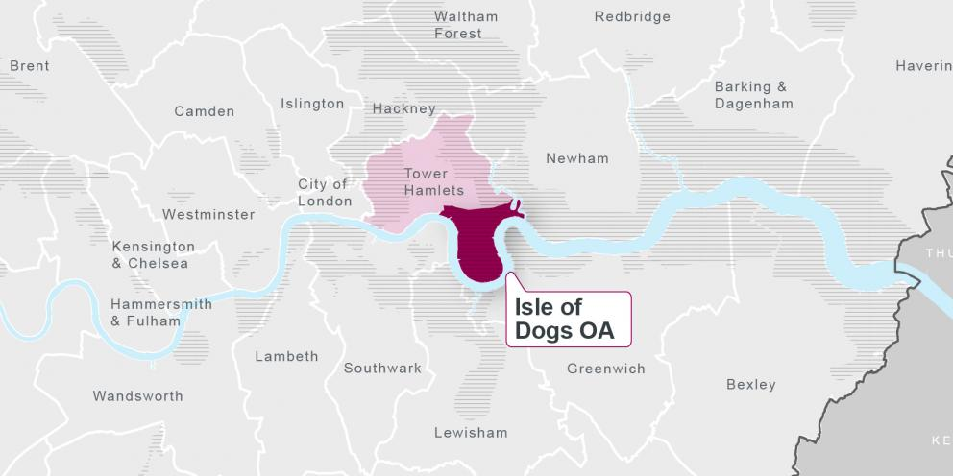
There is a large amount of new high-quality housing developments within the Isle of Dogs and South Poplar Opportunity Area. This area is underpinned by the Mayor of London’s principle of Good Growth, whereby new developments should benefit everyone who already lives in the area, and development should be sensitive to the existing local context. This is to prevent and reduce the increasing disparities between the new developments and the existing development, particularly in the case of flatted properties.
The aim of the Isle of Dogs & South Poplar OAPF is to provide greater certainty to the community on how they can influence development and to guide developers through the production of a coordinated planning document to manage pressures of growth and secure infrastructure delivery.
The planning framework (including the London Plan, Local Plan, OAPF and SPDs) can secure high-quality living conditions for future residents in terms of waste, but it has little power to leverage change for existing residents. Improving waste infrastructure and concurrently increasing rates of recycling for existing estates and residents is key if the recycling target of 50% for households is to be reached by 2030, as set out in the London Environment Strategy. Currently the recycling rate for LBTH stands at 19.6%. It is worth noting that LBTH’s Mayor has a separate waste strategy as part of their “Manifesto – My 8 Point Plan to Fix Tower Hamlets”, which may feed into this discussion, with pledges relating to educating residents with regards recycling. The council also has their separate Waste Strategy where it is highlighted that the borough needs to be ambitions and set challenging waste and recycling targets.
The Annual Residents (2021) survey has recently been released and it has found that 51% of residents were satisfied with in the recycling service in the borough. This would indicate that the recycling and waste facilities are generally in good condition, however for a lot of residents a satisfactory waste and recycling collection may just refer to collections being done on time and on the correct days. Additionally, if there are problems with the bin stores, this might be dealt with by the Landlords and the residents would be unaware of what has happened and subsequent issues this could cause. For example, if waste has been fly-tipped in the bin stores, the landlords would have had to report it and possibly pay for it to be collected. However, from the residents’ perspective some bulky waste has been presented and then collected.
In LBTH’s 2019 Annual Resident Survey 53% of residents were satisfied with their recycling service and in 2018 61% were satisfied with their recycling services. Accordingly, resident satisfaction with their recycling service has fallen over the last 3 years, which might indicate improvements are required to the waste and recycling services.

2.2 Flats Recycling Package
Residents living in flats/communal properties typically have more physical barriers to recycling, and as a result have lower recycling rates than properties with their own waste containers. They also have and higher contamination rates of recycling that is collected. ReLondon have assumptions on how the FRP will increase the recycling rate and decrease contamination, details of these assumptions are outlined in section 5.5.3. Some of these physical barriers include a lack of signposting residents to the correct bin(s), bins being too far away from residents’ properties, and poor waste infrastructure design.
The Flats Recycling Package (“FRP”) was developed by ReLondon as a toolkit for housing providers, building managers, and service providers who want to make improvements to the recycling and rubbish services at their flats. The toolkit can be found in Appendix 9.1. Flats Recycling Package Toolkit.
The FRP was rolled out across 12 Peabody Housing Association estates in six London boroughs in 2018/19, and was successful in significantly improving recycling performance. Following this success, ReLondon recommended that the FRP be rolled out to all existing flats.
ReLondon research shows that effective recycling is achieved when residents:
- Have the correct knowledge – lack of easy access to accurate information can undermine confidence;
- Find it sufficiently easy – services that fit with people’s existing routines will feel easier to use; and
- Are motivated – poor experiences and an apparent lack of accountability can be demotivating.
The FRP can be used to improve the recycling and rubbish services in flats and provides assets and guidance ready for use.
Tower Hamlets was a part of the ReLondon and Peabody recycling project. As part of the project, in depth inventories on all 21 Peabody blocks and estates in LBTH were completed in February 2018. Three estates within LBTH were subsequently chosen to trial resident focussed interventions which were implemented during October 2018, with these being outside the OA (John Fisher Street, Cambridge Crescent and Navigation Road). The interventions tested included: smaller recycling bins, in-home storage solution, emotive messaging, tenant recycling information packs and feedback mechanism to residents. All three estates received improved communication materials, with clear and visible signage on recycling and residual bins and at the bin storage area being provided, alongside internal recycling posters and information on bulky waste removal options. The final package of interventions is known as the FRP. Analysis and evaluation of the pilot was completed in summer 2019. A review of inventories from non-trial blocks and implementation of improvements has not commenced.
The overall results of the pilot showed that, London-wide, the implementation of the FRP led to a 26% increase in recycling rates (from 10.7% to 13.4%) and a 24% decrease in contamination rates (from 30.7% to 23.4%). However, one of the three estates involved in the trial in LBTH had the lowest increase in recycling rate and capture rate of any estate; at 11% (from 11.1% to 12.4%) and 9% (from 38.2% to 41.7%) respectively. ReLondon note that the results may have been because the estate was quite new, and the rubbish and recycling bin areas were already of a reasonably high standard, so the introduction of the FRP had less of an impact.
Table 1,
Table 2 and Error! Reference source not found. provide the results of the three estates in Tower Hamlets respectively that were involved in the pilot. These results show that using the FRP there can be improvements to the recycling rate, capture rate and a decrease in contamination. LBTH is therefore seeking to apply the FRP to other estates to influence rates across the OA.
Table 1: Estate 1 from the ReLondon & Peabody trial
 | Pre-trial actual | Post-trial actual | Maximum potential* | Increase/ decrease
Recycling | 9.4% | 12.1% | 29.3% | 29%
Capture | 37.3% | 45.6% |  | 22%
Contamination | 32.8% | 26.2% |  | -20%
* Assuming 100% capture of all dry materials currently collected for recycling. If 100% of food waste and dry materials currently collected were captured, maximum recycling rate achievable would be 60.1%.
Table 2: Estate 2 from the ReLondon & Peabody trial
 | Pre-trial actual | Post-trial actual | Maximum potential* | Increase/ decrease
Recycling | 11.1% | 12.4% | 33% | 11%
Capture | 38.2% | 41.7% |  | 9%
Contamination | 34.4% | 25.7% |  | -25%
*Assuming 100% capture of all dry materials currently collected for recycling. If 100% of food waste and dry materials currently collected were captured, maximum recycling rate achievable would be 60.7%
Table 3: Estate 3 from the ReLondon & Peabody trial
 | Pre-trial actual | Post-trial actual | Maximum potential* | Increase/ decrease
Recycling | 5.8% | 7.8% | 26.8% | 34%
Capture | 26.8% | 31.5% |  | 17%
Contamination | 42.7% | 29.8% |  | -30%
*Assuming 100% capture of all dry materials currently collected for recycling. If 100% of food waste and dry materials currently collected were captured, maximum recycling rate achievable would be 59%

3. Stage 1 Summary
In Stage 1, using the FRP, an “ideal” bin store was created to determine elements that every bin should have. This included elements such as ensuring the correct recycling capacity was available, separation of residual waste and recycling bins, and signage. Using this “ideal” bin store, a survey was developed by KBT along with a scoring matrix developed by Eunomia, so that each bin store received a score. The lower the score the better the bin store as measured against the elements that were deemed necessary by the FRP.
Prior to undertaking the survey, KBT received a list of flatted properties within the OA from LBTH that required surveying. Over 5 weeks KBT surveyed 876 bin stores. Once the survey was completed, the data and the scoring matrix were used (which can be seen in Appendix 9.4. Weighted Matrix and Evaluation Scoring) to give each bin store a percentage score. As noted above, the lower the percentage score, the better the bin store was performing against the FRP standards. Using these percentage scores, two scenarios were developed, one with four intervention levels and one with five intervention levels. Depending on the percentage scores the bin stores received, they were then placed into these intervention levels in the two different scenarios. The split of bin stores placed into the different intervention levels, for both four and five scenarios, can be seen in Table and Table 5 respectively.
Table 4: Breakdown of the four Intervention Levels by number of bin store and % of total bin stores
Intervention Level | Number of bin stores | % of bin stores
Minimal Intervention | 54 | 6.2%
Average Intervention | 442 | 50.5%
Significant Intervention | 362 | 41.3%
Significant+ Intervention | 18 | 2%
Total | 876 | 100%

Table 5: Breakdown of the five Intervention Levels by number of bin store and % of total bin stores
Intervention Level | Number of bin stores | % of bin stores
Minimal Intervention | 29 | 3.3%
Minimal/ average Intervention | 247 | 28.2%
Average Intervention | 459 | 52.4%
Significant Intervention | 138 | 15.8%
Significant+ Intervention | 3 | 0.3%
Total | 876 | 100%

The KBT survey data was also analysed, and any trends identified. All bin stores across all intervention levels scored poorly for bin store and on bin signage, for bins that were in the minimal intervention level this is where the majority of the scores came from. For the following intervention levels the bin stores scored worse on the cleanliness of bins, lighting and capacity. A full breakdown for each intervention level can be found in the Stage 1 report in section 4.3.
The most prevalent Landlords were Alliance Managing Agents, East End Homes, First Port, One Housing Group and Tower Hamlets Homes. They all had very similar average bin store scores. Alliance Managing Agents had one bin store in Significant+ and One Housing Group had four in Significant+. Tower Hamlets Homes, Alliance Managing Agents, First Port and One Housing Group all had a couple of bin stores in Minimal intervention level as well. Consideration of targeting bin stores for improvement based upon their managing agents is given in section 5.5. Analysis ... The breakdown of bin stores in each intervention level for these landlords can also be seen in Table 17 and 18.
A lot of bin stores scored poorly for signage above the bins and on the bins themselves, which are key components to assist with ensuring residents use the correct bin, and that all potential recycling is captured. Generally, all bin stores surveyed scored well around cleanliness of bins and bin store conditions.
The results from KBT also indicated that significantly more bin stores did not have the correct recycling capacity compared to residual waste capacity. It is important to ensure there is sufficient correct capacity to allow residents to engage productively with the recycling service and to allow them to recycle as much as possible, thereby improving the recycling rate. This is also important given the changes seen to waste volumes because of the pandemic and a shift to homeworking, where recycling tonnages have increased from pre-pandemic levels.
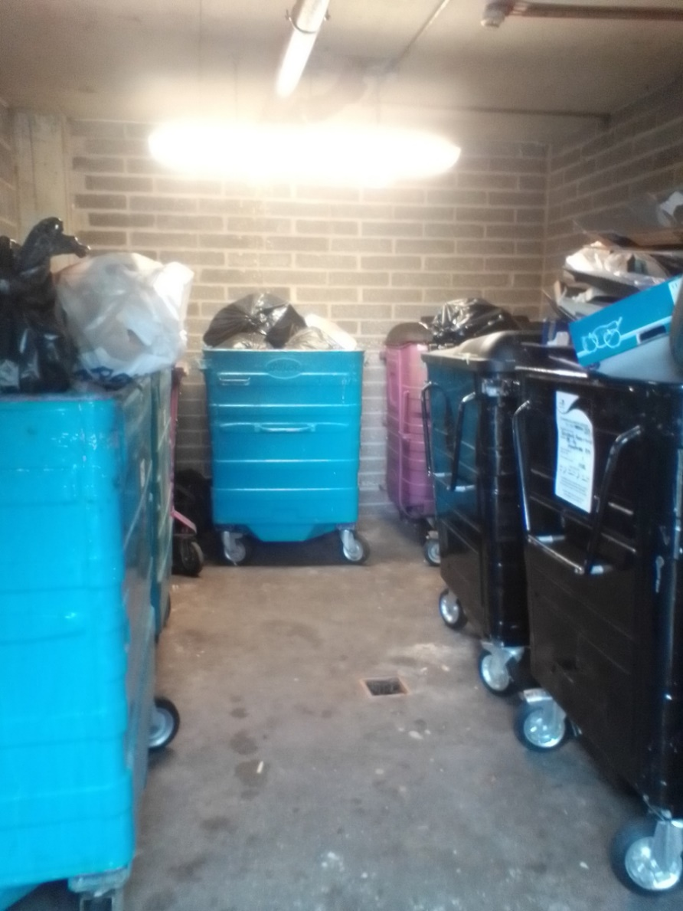
Figure 2 Bin store with insufficient capacity and overflowing bins

This ties into an opportunity identified to increase the use of reverse aperture recycling bin lids, which ReLondon have shown to help reduce contamination. KBT’s assessment identified that only 4% of the recycling bins had reverse lids, showing there is significant opportunity for these to be installed. These lids can be retrofitted onto existing recycling bins, or where additional capacity is required, any new bins purchased can be the reverse lidded bins. Reverse lids cost £20 and labour used refurbishing the bin would cost £69 using ReLondon’s cost assumptions. Compared to a new 1100L bin which costs £275 and a 1280L bin which costs £337, purchasing a new lid and retrofitting it is significantly cheaper.
With regards to residual waste bins, a large number (54%) did not have lids, however it is worth noting that any chute fed bin would not have a lid. Of the total bin stores, 20% were chute fed.
In summary, the KBT survey and quantification into differing levels of intervention has shown there are areas for improvements in most bin stores, with no bin stores achieving a score lower than 10%. However, it is positive that only 2% of bin stores fall under the Significant+ Intervention as outlined in section 5.0 in the Stage 1 report.
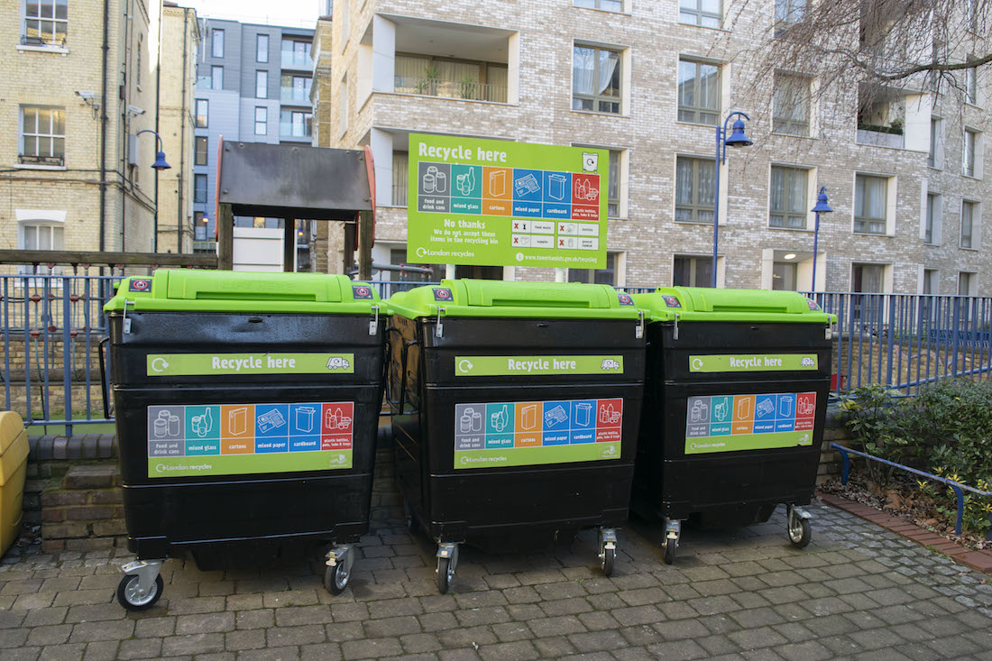
Figure 3 Image of an ideal bin store using the FRP
For an in-depth description of work and results from Stage 1, please refer to the Stage 1 Report.

4. Methodology

4.1. Cost Calculator
Within Stage 1 of the project, each bin store area was assessed by KBT against a set of key criteria. Each criteria contributes towards a bin store being ‘ideal’ and therefore matching the requirements of the FRP. Criteria included, but were not limited to, the bin store having the correct bin capacity (for both residual waste and recycling), having clear signage and a suitably frequent cleaning schedule.
The ‘ideal’ bin store was transferred into a weighted matrix, where each of the key components was given a weighting out of five, based on professional judgement and research of the importance of each item. The use of the weighted matrix was a novel approach, with the purpose of using a matrix being to allow multiple issues to be assessed against each bin store and an overall “score” be arrived at to allow an assessment to be made as to how closely the bin store was to achieving the standards set out in the FRP. It is important to note that should a bin store have the correct facilities, such as the correct recycling capacity, it would receive a score of “0”, with higher scores being given for worse performance against each of the matrix elements. As such, the lower the score for each bin store, the better they performed against the standards set out in the FRP. The full list of matrix elements and the maximum weighting that could be applied to each can be seen in Table.
Table 6: Weighted marix elements and their maximum weighting
Matrix Element | Maximum Weighting
External Bin store signage | 2
Bulky waste signage | 2
Residual Waste Signage | 4
Recycling Signage | 4
Bin store is clean | 4
Lighting in the bin store works | 4
Bin store walls are clean and free of scratches | 2
Recycling bins and residual bins are separated | 4
Residual Waste bin stickers | 3
Residual Waste Bins are in a good condition | 2
Residual Waste Bins are clean | 4
Recycling bin lids | 4
Recycling bin stickers | 3
Recycling bins are in a good condition | 2
Recycling Bins are clean | 4
Recycling Capacity | 5
Residual Capacity | 5
Total Maximum Weighting | 58

Using the weighted matrix with the weightings that had been developed and agreed, an ‘evaluation model’ was created to allow the scoring of each bin store for the estates based upon the questions and answers contained within the survey completed by KBT. This evaluation model can be found in Appendix 9.4. Weighted Matrix and Evaluation Scoring. The answers given for each relevant weighted element would then return a specific weighted score. The combined total score for that bin store then resulted in the bin store being graded into different levels of intervention required. Two sets of intervention levels were considered upon the request of LBTH, one containing four levels of intervention and another containing five levels of intervention.
The four intervention levels included:
- Minimal intervention - 10-26%;
- Average intervention – 27-42%;
- Significant intervention – 43 – 58%; and
- Significant+ intervention – 59-74%.
Whilst the five intervention levels included:
- Minimal intervention – 10-23%;
- Minimal/average intervention – 24-36%;
- Average intervention – 37-48%;
- Significant intervention – 49-61%; and
- Significant+ intervention – 62-74%.

The number of bin stores falling into the different intervention levels can be seen in Table 7: Number of bin stores in each intervention for 4 intervention levels and Table 8: Number of bin stores in each intervention for 5 intervention levels for the four and five intervention levels respectively.

Table 7: Number of bin stores in each intervention for 4 intervention levels
Intervention Level | Number of bin stores within each intervention level
Minimal | 56
Average | 464
Significant | 328
Significant+ | 28

Table 8: Number of bin stores in each intervention for 5 intervention levels
Intervention Level | Number of bin stores within each intervention level
Minimal | 35
Minimal/Average | 266
Average | 414
Significant | 154
Significant+ | 7

Based on these intervention levels, the average costs for bringing the bin stores up to the FRP standard was calculated using the ReLondon cost calculator tool. Where appropriate, cost assumptions specific to LBTH were made to inform this modelling, with all assumptions being agreed with the Working Group. The working group included Eunomia, officers from LBTH’s Growth and Infrastructure team, as well as the Waste team, an officer from the GLA’s Infrastructure Coordination Service and KBT. All modelling assumptions can be found in
Table and Table , as well as in Appendix 9.5. FRP Cost Calculator Summary Table.
The ReLondon cost calculator tool was developed to help local authorities understand what costs would be involved in improving bin stores so that they meet the standards set out in the FRP. Using cost assumptions and general assumptions ReLondon built the interactive tool, the assumptions can be found in Appendix 9.2. Cost Calculator Assumptions. When using the cost calculator tool, users input relevant details for the bin stores which they want to understand the cost implications for improving. Details that are inputted into the tool include how many additional residual waste and recycling bins are required, how many properties the bin store serves, capacity of bins, and who was responsible for cleaning, signage, amongst other elements. When using the tool, the user also has to select scenarios for the setup costs, ongoing costs and benefit scenarios. These three scenarios are broken down in further detail below:
- Setup cost scenario - Five setup cost scenarios can be selected within the cost calculator based on how easy or difficult users perceive it will be to treat the relevant estates:
- Low: a low amount of change is needed to bring estate(s)/bin stores up to the FRP standard.
- Medium-low: a medium-low amount of change is needed to bring estate(s)/bin stores up to the FRP standard.
- Average: an average amount of change is needed to bring estate(s)/bin stores up to the FRP standard.
- Medium-high: a medium-high amount of change is needed to bring estate(s)/bin stores up to the FRP standard.
- High: a high amount of change is needed to bring the estate(s)/bin stores up to the FRP standard.
- Ongoing cost scenario - Five ongoing cost scenarios can be selected within the cost calculator by users based on how easy or difficult users perceive it will be to maintain the relevant estates to the FRP standards:
- Low: a low amount of maintenance will be required.
- Medium-low: a medium-low amount of maintenance will be required.
- Medium: an average amount of maintenance will be required.
- Medium-high: a medium-high amount of maintenance will be required.
- High: a high amount of maintenance will be required.
- Benefit Scenarios:
- Waste volume diverted from residual to recycling scenario. The impact of the FRP on recycling performance cannot be guaranteed. Based on the range of impacts experienced in the Peabody project, three scenarios can be selected to illustrate the range of impacts that could be experienced. High, average, and low represent 39%, 26% and 16% uplifts in recycling volumes, respectively. If the estate(s)/bin stores already have a good level of performance or good standard of service, then it can be expected that the impact of the FRP may be lower and therefore a low scenario could be chosen, and vice versa.
- Reduction in contamination rate scenario. The impact of the FRP on the contamination rate cannot be guaranteed. Based on the range of impacts experienced in the Peabody project, three scenarios can be selected to illustrate the range of impacts that could be experienced. High, average and low represent 46%, 24% and 0% impacts on the contamination rate respectively. If the estate(s)/bin stores already have low contamination rates then the low scenario could be chosen, and vice versa.
A detailed breakdown of the specific elements that are included in the setup costs and ongoing costs can be found in Appendix 9.3 Set up and Ongoing costs breakdown.
When inputting the surveyed bin stores through the ReLondon Cost Calculator the different scenarios were altered depending on the intervention level they fell into. This was to allow the varying levels of resource that would be required to upgrade the bin stores to be reflected. These are outlined in
Table and Table for the four and five intervention levels respectively.
Table 9: Assumptions for four intervention levels
Intervention level | Setup cost scenario | Ongoing cost scenario | Waste volume diverted from residual to recycling scenario | Reduction in contamination rate scenario
Minimal | Low | Average | Low | Low
Average | Average | Average | Average | Average
Significant | Medium High | Average | High | High
Significant+ | High | Average | High | High

Table 10: Assumptions for five intervention levels
Intervention level | Setup cost scenario | Ongoing cost scenario | Waste volume diverted from residual to recycling scenario | Reduction in contamination rate scenario
Minimal | Low | Average | Low | Low
Minimal/Average | Medium Low | Average | Low | Low
Average | Average | Average | Average | Average
Significant | Medium High | Average | High | High
Significant+ | High | Average | High | High

All bin stores had an ongoing cost scenario of average. It was assumed that once the bin stores were all brought up to the same standard that they would then need the same amount of ongoing costs in order to maintain them.
Additionally, there were certain cost allocations which varied between the housing provider and the London borough. These were also agreed with the working group. These allocations remained the same for all bin stores that were put through the cost calculator and can be seen in
Table 113.
Table 113: Cost Allocations used within the FRP Cost Calculator
Cost Allocations | Responsibility
New bin purchase/maintenance | London borough
Recycling bin rental to housing provider? | N/a
Bin area refurbishment | Housing provider
Stickers, posters, signage, leaflet (product) | London borough
Stickers, posters, signage, leaflet (design) | London borough
Project management | London borough
Regular cleaning | Housing provider
Monthly officer inspections | Housing provider
Additional recycling waste collections | London borough

In total, 10% of all bin stores (88) were put through the cost calculator as it was felt that this would provide a representative sample of the bin stores. These bin stores were chosen at random. This this method was discussed with ReLondon who approved the approach of using a sample, as opposed to them running them all through the cost calculator. This 10% of bin stores (88) was split proportionally based on the number of bins stores which fell into the different intervention levels. For example, in the four intervention scenario, there were 464 bin stores which fell into the average intervention level, of which 46 (10%) were then run through the tool. As there were very few bin stores in significant + intervention level for both the four and five intervention scenarios, they were all put through the cost calculator to avoid the lower number of bin stores skewing the average costs for that category. As both four and five intervention levels were considered 88 bin stores were put through using the four intervention level ranges and 88 bin stores were also run through the tool for the five intervention level ranges. However, where there was an overlap, such as a bin store falling within the average intervention level in the four intervention scenario as well as in the five intervention level scenario, this was used in both cost calculator outputs. For example, if a bin store had a score of 15%, this would fall in the Minimal intervention level for both the four Intervention Level scenario (10-26%) and the five Intervention Level scenario (10-23%). An average cost was then calculated for each specific intervention level, the result of which are shown in Section 4.2 GIS
The bin stores and their intervention level have also been added to a map to show if there are any hot spots within the OA.
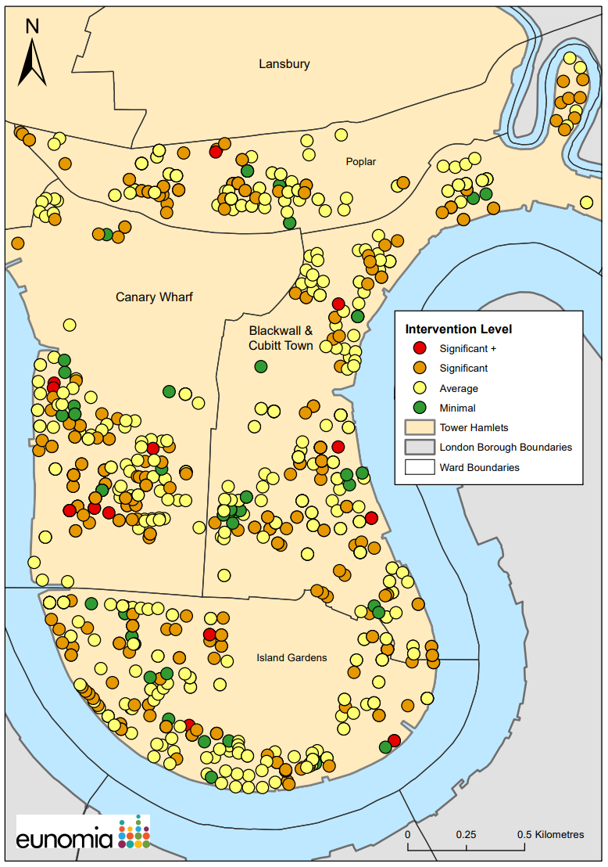
Figure 4 Map showing the bin stores and their intervention level in the OA
As can be seen from the map there are no particular “hot spots” where there are a large proportion of bins in the Significant+ intervention level. The Canary Wharf ward seems to have the most Significant + bin stores out of all the wards.
5. The inputs and outputs for the bin stores put through the cost calculator can be found in Appendix 9.5. FRP Cost Calculator Summary Table.

4.2 GIS
The bin stores and their intervention level have also been added to a map to show if there are any hot spots within the OA.
Figure 4 Map showing the bin stores and their intervention level in the OA
As can be seen from the map there are no particular “hot spots” where there are a large proportion of bins in the Significant+ intervention level. The Canary Wharf ward seems to have the most Significant + bin stores out of all the wards.

5. Cost Implications of Upgrading Bin Stores

5.1. Funding Opportunities
LBTH currently have £2.13 million of funding, a portion of Community Infrastructure Levy (CIL), for improving waste and recycling infrastructure in flatted properties, which covers the purchasing of signage, posters, leaflets, additional recycling and rubbish bins including reverse lidded recycling bins. This funding is for the whole of Tower Hamlets, not just the OA. However, this funding does not cover improvement to bin store areas and installation of signage. In securing this money it was estimated it would be used on just over 2100 blocks, however 876 bin stores alone were recorded in just the study area. This further demonstrates the need for LBTH to explore additional opportunities such as sponsorship and/or speaking to large businesses/landlords in the area and therefore research on further funding was undertaken as part of this study.
Funding opportunities through WRAP, ReLondon, Ecosurety, DEFRA and the GLA/ Mayor of London were researched. Unfortunately, at the time of writing this, there was no available funding through these organisations that could be identified. A further breakdown of what funding was looked at can be found in
Table 4.

Table 42: Funding opportunities investigated
Organisation | Fund | Open | Description
WRAP | Resource Action Funds | Closed | The Resource Action Fund was an £18million fund, provided by Defra to support resource efficiency projects, with the goal of diverting, reducing, and better managing waste.
ReLondon | No available funding | NA | NA
Ecosurety | Exploration Fund | Not accepting applications | The Ecosurety Exploration Fund was launched in 2019 to invest £1million in projects that could reduce the environmental impact of packaging, batteries or EEE through innovation or research in the UK.
DEFRA/GLA/Mayor of London | Community Renewal Fund and Shared Prosperity Fund | Closed | The government has launched the UK Community Renewal Fund (UKCRF) which has £220 million to invest across the UK. It will help to shape the UK Shared Prosperity Fund which will replace EU Structural and Investment Funds in 2022.  This Fund aims to support people and communities most in need across the UK to pilot programmes and new approaches and will invest in skills, community and place, local business, and supporting people into employment.

It is recommended that officers at LBTH regularly check the websites of the organisations in the table above to see if there are any new opportunities for funding. Speculative contact with the organisations should also be attempted as that may inform LBTH officers of potential funding streams coming on line in the future.
It is worth noting that The Mayor of London, Sadiq Khan, has recently stated that considerable improvement is needed in many of the London Boroughs to reach the 50% recycling target, additionally, he encouraged the roll out of the FRP to increase recycling in flats and estates. Using this information LBTH could lobby these organisations to provide specific funding to help with the roll out of the FRP in the OA and the wider borough. LBTH and GLA will continue to collaborate to identify funding opportunities. In particular, it would be worth lobbying the GLA given the comments made by Sadiq Khan.
The lack of external funding is considered and the impact upon the rollout of the FRP in the OA is considered in section 5.5. Analysis .

5.2. Average Cost Implications of Upgrading Bin Stores
Using ReLondon’s cost calculator, the average costs of bringing a bin store up to the FRP standard was calculated, both for the four and five intervention levels respectively. The average costs are shown in Table 5 and Table 6.
Table 53: Average costs for bringing bin stores up to the FRP standard based on four intervention levels
Intervention Level | Total set up cost (London Borough) | Total set up cost (housing Provider) | Annual ongoing cost (London Borough) | Annual ongoing cost (Housing Provider)
Minimal | £975.00 | £125.00 | £383.33 | £866.67
Average | £1,750.00 | £250.00 | £370.21 | £836.17
Significant | £1,828.03 | £875.00 | £418.18 | £793.94
Significant+ | £1,110.71 | £1,300.00 | £232.14 | £971.43

Table 64: Average costs for bringing bin stores up to the FRP standard based on five intervention levels
Intervention Level | Total set up cost (London Borough) | Total set up cost (housing Provider) | Annual ongoing cost (London Borough) | Annual ongoing cost (Housing Provider)
Minimal | £1,075.00 | £125.00 | £450.00 | £825.00
Minimal/Average | £923.11 | £288.00 | £281.48 | £918.52
Average | £1,886.59 | £250.00 | £421.95 | £795.12
Significant | £1,591.67 | £875.00 | £400.00 | £800.00
Significant+ | £ 957.14 | £ 1,300.00 | £ 300.00 | £ 900.00

5.3. Cost of Upgrading all Bin Stores
Using the average costs from the cost calculator, the total cost of upgrading all bin stores within each of the intervention level was determined. The average costs were multiplied by the number of bin stores that fell into each intervention level. This is shown in Table 7 and Table 8 for the four and five intervention levels.
Table 75: Cost for bringing all bin stores up to the FRP standard based on four intervention levels
Intervention Level (number of bin stores) | Total set up cost (London Borough) | Total set up cost (housing Provider) | Annual ongoing cost (London Borough) | Annual ongoing cost (Housing Provider)
Minimal (56) | £54,600.00 | £7,000.00 | £21,466.48 | £48,533.52
Average (464) | £812,000.00 | £116,000.00 | £171,777.44 | £387,982.88
Significant (328) | £599,593.84 | £287,000.00 | £137,163.04 | £260,412.32
Significant+ (28) | £31,100.00 | £36,400.00 | £6,500.00 | £27,200.00
Total | £1,497,293.84 | £446,400 | £336,907 | £724,129

Table 86: Cost for bringing all bin stores up to the FRP standard based on five intervention levels
Intervention Level (number of bin stores) | Total set up cost (London Borough) | Total set up cost (housing Provider) | Annual ongoing cost (London Borough) | Annual ongoing cost (Housing Provider)
Minimal (35) | £37,625.00 | £4,375.00 | £15,750.00 | £28,875.00
Minimal/Average (266) | £245,547.26 | £76,608.00 | £74,873.68 | £244,326.32
Average (414) | £781,048.26 | £103,500.00 | £174,687.30 | £329,179.68
Significant (154) | £245,117.18 | £134,750.00 | £61,600.00 | £123,200.00
Significant+ (7) | £6,699.98 | £9,100.00 | £2,100.00 | £6,300.00
Total | £1,316,037.68 | £328,333.00 | £329,010.98 | £731,881.00

The majority of the bin stores fell within the average intervention level in both scenarios and therefore this is where the greatest costs are. In the four Intervention level scenario, improving all bin stores would result in a total set up cost for LBTH of ~£1.5 million with an annual ongoing cost of ~£337,000. Housing providers will need to spend ~£446,400 in set up costs for the bin stores surveyed with an annual ongoing cost of ~£724,000 by comparison.
With five Intervention levels LBTH would need to spend ~£1.3 million in set up costs to bring the bin stores up the FRP level, with an annual ongoing cost of ~£329,000. Housing providers on the other hand will need to spend around ~£329,000 in set up costs and ~ £732,000 in annual ongoing costs. It is worth noting is a difference in the total costs to the Borough and Housing Provider between the two intervention level scenarios. This is due to certain bin stores falling within different intervention levels in the two scenarios depending upon their percentage score. For example, a bin store which received a score of 26% would be in the minimal intervention level in the four intervention level scenario, it would then be put through the cost calculator using the minimal level assumptions outlined in Table. However, in the five intervention level scenario it would fall in the minimal/average intervention level and would be put through the cost calculator with the minimal/average level assumptions as outlined in Table , and would therefore provide a higher cost compared to using the minimal level assumptions.
The borough does have £2.13 million to go towards recycling infrastructure in flats. Based on the costs of the four intervention-level scenario, if all this were to be spent on the FRP interventions in the OA, it would cover the set-up costs for all bin stores and provide ongoing costs for 1.8 years. However, as the funding is for the whole borough and not solely the OA, further breakdowns of the funding have been provided below:
Table 97: Coverage of bin stores with varying split of funding
Percentage of the funding spent on the OA | Amount | Coverage
25% | £532,500.00 | Borough set up costs all the bin stores in Significant+, and 84% of the bin stores in Significant
50% | £1,065,000.00 | Borough set up costs for all the bin stores in Significant+, all the Significant and 53% of the bin stores in Average
75% | £1,597,500.00 | Borough set up costs for all the bin stores in all intervention levels with ~ £100,000 left over to go towards any ongoing costs.

In all scenarios we have assumed that in terms of timing, funds will go first to Significant+ bin stores, then Significant, then Average and lastly Minimal. This is due to there being more impact on the recycling rate and the contamination through improving the bin stores in the worse condition.
There are also significant set up and ongoing costs for the Landlords/ Managing Agents in implementing the FRP. Landlords may be able to secure funding for this separately. Many Landlords and Managing Agents say they are committed to managing sustainable developments, this commitment could be used to encourage Landlords to help further with the funding and costs.

5.4. Cost of Upgrading Bin Stores for Tower Hamlets Homes and the most prevalent Housing Providers
THH were identified as managing 60 of the bin stores surveyed. Using the four intervention level scenario, six bin stores fell into significant and three bin stores into average intervention level. Using the average costs, the total costs for upgrading the nine bin stores were determined and is shown in the table below. The costs for the housing provider and the cost for LBTH were combined, as for the bin stores managed by THH these costs would both be assigned to LBTH.
Table 108: Cost of bringing the 9 bin stores managed by THH up to standard
Intervention Level | Number of bin stores | Average set up cost | Average ongoing cost | Total set up cost | Total ongoing cost
Minimal | 2 | £975.00 | £125.00 | £1,950 | £250
Average | 28 | £1,750.00 | £250.00 | £49,000 | £7,000
Significant | 30 | £1,828.03 | £875.00 | £54,841 | £26,250
Total | 60 | £4,553.03 | £1,250.00 | £105,790.90 | £33,500.00

As noted in the Stage 1 report, the bin stores surveyed were only a small percentage of the bin stores managed by THH and may not be representative of the standard of all bin stores managed by THH.
The total costs were also calculated for the four most prevalent landlords from the sites surveyed.
Table 119: The total costs for improving the bin stores from four of the most prevalent Landlords
Landlord/ Managing Agent | No. of Bin Stores | Intervention level | Total set up cost (London Borough) | Total set up cost (housing Provider) | Annual ongoing cost (London Borough) | Annual ongoing cost (Housing Provider)
Alliance Managing Agents Ltd | 3 | Minimal | £2,925.00 | £375.00 | £1,149.99 | £2,600.01
Alliance Managing Agents Ltd | 16 | Average | £28,000.00 | £4,000.00 | £5,923.36 | £13,378.72
Alliance Managing Agents Ltd | 11 | Significant | £20,108.33 | £9,625.00 | £4,599.98 | £8,733.34
Alliance Managing Agents Ltd | 1 | Significant + | £1,110.71 | £1,300.00 | £232.14 | £971.43
East End Homes | 25 | Average | £43,750.00 | £6,250.00 | £9,255.25 | £20,904.25
East End Homes | 17 | Significant | £31,076.51 | £14,875.00 | £7,109.06 | £13,496.98
First Port | 2 | Minimal | £1,950.00 | £250.00 | £766.66 | £1,733.34
First Port | 21 | Average | £36,750.00 | £5,250.00 | £7,774.41 | £17,559.57
First Port | 13 | Significant | £23,764.39 | £11,375.00 | £5,436.34 | £10,321.22
One Housing Group | 5 | Minimal | £4,875.00 | £625.00 | £1,916.65 | £4,333.35
One Housing Group | 57 | Average | £99,750.00 | £14,250.00 | £21,101.97 | £47,661.69
One Housing Group | 53 | Significant | £96,885.59 | £46,375.00 | £22,163.54 | £42,078.82
One Housing Group | 4 | Significant + | £4,442.84 | £5,200.00 | £928.56 | £3,885.72
Total | 228 |  | £395,388.37 | £119,750.00 | £88,357.91 | £187,658.44

Using the current funding that LBTH have, all bin stores managed by Tower Hamlets Housing, as well as the bin stores managed by the four most prevalent landlords recorded. Tower Hamlets Homes and the four most prevalent Landlords all had an average score of around 40% for their bin stores. Tower Hamlets Homes had an average score of 42%, as did East End Homes and One Housing Group. Alliance Managing Agents had an average score of 41% and First Port had an average score of 39%. Based on this, it would make sense to target the Landlords who had an average score of 42%, then Alliance Managing Agents and then First Port properties.
It is worth noting that managing agent details were only recorded for 68% of all bin stores surveyed. Therefore, the costs provided in Table 10 and Table 11 may be an under representation of the actual costs for upgrading the bin stores for the four landlords as they may have additional sites which they manage where their details were not identified.
The FRP cost calculator tool does not account for any additional residual bins that are required and primarily focuses on recycling. From the Stage 1 report there were 7% of bins stores which didn’t have correct residual capacity. As the funding is predominantly around recycling and provision of correct recycling capacity, the authority could ask the managing agents or landlords to pay for any additional residual bins that they require. Most authorities provide recycling bins to flatted properties for free, and they then have to pay for residual bins either through purchasing them from the authority or having a bin hire agreement.

5.5. Analysis
5.5.1 Set up and Ongoing Costs
Based on the cost calculator findings, the total set up cost for the bin stores could cost LBTH between ~£1.3-£1.5 million with an annual ongoing cost of between ~£330,000-£340,000. There are currently no external funding options identified to help in the implementation of the FRP. It is important to note that these costs are only indicative and are not absolute figures. The intention is that they will provide a good estimate of the size of investment that is required to bring all the bin stores in the OA up to the FRP standard.
It is interesting to note that the average setup and ongoing costs for the London Borough for the Significant+ bin stores were lower than the bin stores in the majority of the other intervention levels. It would be expected that the bin stores in the Significant+ level of intervention would require a higher level of investment as they would be in a worse state and require more work to bring them up to the FRP standard. The reason for this difference is likely due to the fact that there were fewer bin stores in the Significant+ Intervention level compared to other intervention levels. As such, the average costs for the Significant+ Intervention level may not be as representative as the other intervention levels.
It is also worth noting that the bin stores in Significant+ were often small and had 240L bins. As such, the addition of 240L bins required to provide the correct capacity required would be far less expensive to purchase than the addition of 1280L bins which larger bin stores typically required. A 240L bin costs £21 and a 1280L bin costs £337, which could have affected the average costs.
It is worth noting that due to the set-up of the cost calculator, a small amount of manual editing of the calculations was required. This was a result of the costs associated with the installation of signage within the bin stores, which are captured under the “project management” assumption which was set as “London Borough” for the purposes of the calculations. This assumption was chosen as it reflects the fact that the majority of project management would be undertaken by LBTH. However, the installation of signage would be paid for by the housing provider or landlord directly. As such, the following adjustments outlined in Table 20: Adjustment to the average cost per intervention level based due to the installation of signage were made against the set-up costs.
Table 20: Adjustment to the average cost per intervention level based due to the installation of signage
Intervention Level | Total set up cost (London Borough) | Total set up cost (housing Provider)
Minimal | -£125 | +£125
Minimal/Average | -£188 | +£188
Average | -£250 | +£250
Significant | -£375 | +£375
Significant+ | -£500 | +£500

5.5.2 Cost ammendments and exclusions
As noted in the Stage 1 report, certain elements of bin stores were not able to be assessed such as the lighting provision. If the lighting was outside and it was daylight, the surveyors were unable to determine if the lighting worked or if it was sufficient to light up the bin area. In these cases, the bin stores were given the best score as if it had good lighting. Therefore, there is likely to be an underestimate on bin stores that require better lighting and therefore an underestimate on the costs for lighting.
In the cost assumptions for the cost calculator, the set-up costs for lighting were £0 for the set-up scenario of Low, Medium/Low and Average. The cost calculator assumes that it would cost £122 for lighting in the set-up scenario of Medium High and £238 for High. In some cases, it could be that bin stores require either an additional £122 or £238 to bring the bin store up to the FRP standard.
In addition, whilst we had included availability of space for food waste bins in the survey and analysis in the Stage 1 report, the implementation of a food waste service has not been included in the costs outlined in this report as ReLondon’s cost calculator does not have this functionality at this time. It is also worth noting that the total costs calculated for the OA does not include all bin stores, as some were not able to be assessed, as outlined in the Stage 1 report. A total of 10 bin areas within scope were unable to be assessed. There were also some properties on sack collection which were not included in the assessment or the cost calculator. As stated in the Stage 1 report, the assumption is that these properties are on a sack collection for a reason and as such cannot accommodate wheeled bins, therefore the provision of wheeled bins for these properties has not been costed for.
5.5.3 Anticipated impact
Spending this money on the bin stores will provide better infrastructure and ensure residents are informed about their service and what can be recycled. Whilst this will encourage residents to recycle, and in turn reduce contamination of recycling bins and increase the recycling rate, there will still be hard to reach residents where it is not possible to change their behaviour with these measures.
ReLondon’s cost calculator provides useful information regarding the expected increase in the volume of dry recycling collected, as well as the reduction in contamination, following the implementation of the FRP at the bin stores. These figures provided by the cost calculator should be used as targets to reach when implementing the FRP. Based on the previous FRP project in Tower Hamlets this looks like the targets may be achievable. The figures provided by the cost calculator are based on the scenario on waste reduction and contamination selected in the cost calculator and will differ based on the intervention levels and the cost calculator assumptions used (further information is given in section 4.1. Cost Calculator regarding which scenarios were selected). Table 121: Benefits in recycled waste volumes and reduction in contamination shows the potential benefits to recycling from the FRP being introduced at the bin stores:
Table 121: Benefits in recycled waste volumes and reduction in contamination
Intervention level | Uplift in dry recycled waste volumes in treated flats from FRP (%) | Reduction in contamination rate of dry recycling in treated flats (%)
Minimal | 16% | 0%
Minimal/Average | 16% | 0%
Average | 26% | 24%
Significant | 39% | 46%
Significant+ | 39% | 46%

The Cost Calculator has assumed that the bin stores in Minimal and Minimal/Average will not have any improvements on the contamination rate. This is due to the assumption that bin stores in this intervention level already have relatively low rates of contamination. The improvements will help capture recyclable material that is being placed in residual bins and divert it to the recycling bins, hence the increase in the recycling rate. The figures provided in this report are predicated on the assumption that the FRP is rolled out across the OA at the same time. However, this may not be possible due to the budget available. Should LBTH decide to stagger the rollout, it would be advisable to target those bin stores which fall into the significant and significant+ intervention levels as they would see the greatest benefits of the scheme being introduced, as can be seen in Table 121: Benefits in recycled waste volumes and reduction in contamination. Consideration could also be given to targeting those landlords who manage multiple sites with bin stores which fall into the poorest performing intervention levels. This would have the benefit of allowing multiple sites to be dealt with via contact with one organisation.
5.5.4 Implementation
An implementation plan has been designed with three phases. The first phase involves engaging with the landlords and contacting them about the FRP and informing them of the work that has already taken place.
The second phase is then split into two stages, the first stage is targeting the bin stores that are in the Significant + and Significant intervention levels as a priority, and the second phase involves the bin stores in the Average and Minimal intervention level. The final phase is the monitoring phase where the impact of all the interventions on the recycling rate and contamination rate will be measured. The full implementation plan can be found in Appendix 9.6 Implementation Plan
By spending this money on the bin stores and bin areas, there should be significant improvements in the contamination and the recycling rates, however this is not to say that all recyclable material will be captured in the recycling bins once the FRP has been implemented.

6. Landlord Engagement
There are significant costs required for both LBTH and the housing provider in order to bring the bin stores in the OA up to the FRP standard. To aid the uptake of the FRP an excel model was developed to show landlords what cost savings they could make if they make there were improvements to the bin stores they manage. This model can be found in Appendix 9.8. Landlord Excel.
This excel model uses cost savings associated with the clearance of fly tipping, it also includes a section for the clearance of contaminated bins. Whilst LBTH does not currently charge for additional collections for contaminated bins, this has been included in case this policy is changed in the future. Private landlords can be difficult to engage with, particularly when asking them to spend money on improving facilities, which is why the excel model was developed to help show that through the improvements, cost savings can be made. The model was also intentionally made simple to use, to encourage it’s use by both LBTH and landlords.
The key landlords in the OA have already been identified through the survey, though it is worth noting only 68% of bin stores had a landlord identified as being responsible for their management. Usefully, ReLondon’s FRP toolkit contains implementation plans and site improvement plans which can be used to help Landlords understand what changes are to be made and where the obligations sit for the housing provider and the London Borough.
It is recommended that LBTH seeks to expand upon the list of managing agents identified by KBT to ensure a more holistic understanding of which landlords and managing agents manage which bin stores and estates. LBTH would then be well placed to contact landlords to discuss the option of improving the bin stores they manage, using the excel provided in Appendix 9.8. Landlord Excel.
We would suggest contacting landlords with the greatest housing first, as that will allow LBTH to start targeting a significant number of bin stores to receive upgrades likely managed by the same estate manager. In addition to this, details can be provided to landlords and managing agents as to how the split of costs for upgrading their bin stores would be managed. Guidance should be provided regarding how landlords can request additional signage and recycling bins amongst other key elements of the FRP.
LBTH should actively monitor contact made with specific managing agents to allow a log to be kept of which landlords have responded, and which ones may require further follow-up. The ReLondon cost calculator includes costs associated with undertaking regular site visits and project management, which this would monitoring activity fall under. These costs are based on the London Living Wage and an assumption on the amount of time required to undertake this.

6.1 Encouraging Uptake
As improving the bin stores will require funds from the landlord there may be some pushback on implementing the FRP. To prevent this we recommend that the Landlord Excel in Appendix 9.6 is used to show what cost savings can be made if they were to help with implementation of the RFP. It is worth noting that the excel provided has the mechanism to indicate cost savings to the landlords should LBTH decide in the future to charge for the collection of contamination recycling bins as residual waste. Should this policy be introduced, the cost savings to the landlords would likely be greater and therefore help LBTH convince landlords of the benefits of the scheme from a financial perspective. Additionally, we would encourage engaging with the residents of the buildings so that LBTH has buy-in from them, and they can apply pressure to the landlords and managing agents to make improvements to the bin stores. Often landlords are unaware of what support is available to them, particularly when it comes to communication material which can be provided to residents.
To aid the monitoring of uptake and to help with implementation landlords and LBTH can use two documents provided by ReLondon, which are the “Improvement Plan” and “Implementation Plan” (found respectively in Appendix Error! Reference source not found. Error! Reference source not found.).
The Improvement Plan contains:
- Contact information for the project manager of the FRP implementation, local authority lead, and the site managing agent.
- Information on what the obligations are for each of the stakeholders involved.
- Information on how bin areas should be maintained and whose responsibility it is.
- Details on collection frequency and capacity and their proposed changes.
- Suggested improvements to bins and the bin areas.
- Information on what signage is available and a section for the number of signs to be requested.
Implementation plan contains:
- A detailed list of actions that need to be undertaken for the FRP to be implemented.
It is recommended that both LBTH and landlords utilise the resources outlined above to assist them with the implementation of the FRP as this will help manage the timeline and key elements of the implementation.

6.2 Monitoring Uptake
In order to monitor the uptake an excel document can be created to keep track of which landlords have been engaged with and any communications between the waste team and landlords.
If there has been no response from a landlord or managing agent for a month, then chaser emails can be sent. Landlord tracker can be found in Appendix 9.11.

6.3 Monitoring Impact
The impact of the FRP can be measured by looking at the recycling rate and the contamination rate pre and post FRP. The recycling rate can be measured using bin weighing equipment. Both residual and recycling bins can be measured before collection to find out what tonnages are collected per building. The recycling rate can be ascertained by comparing the tonnages for residual and recycling. Frequency of collection will also need to be included as many buildings have multiple residual collections to one recycling collection per week.
Bin weighing equipment can be retrofitted onto existing vehicles, it often has geolocation technology which allows geofences to be created. Geofences can be created around buildings or estates so that any tonnages collected within that fence will be captured as from that estate.
If the authority does not have bin weighing equipment and cannot retrofit it to existing vehicles you can look at the overall tonnages from the weighbridge. It is likely that many of the properties in the OA are on the same collection round for residual and recycling, and so any improvements to the recycling rate should be reflected in the overall round tonnages. If improvements to the recycling rate are minimal then this may be hard to see in the round tonnages, additionally it relies on any other properties on that round to maintain their recycling rate. This could also be combined with looking at bin fill rates on the day before collection to see if more recycling is being produced and less residual is being produced. However, this is not an accurate method as it is observational.
Contamination can be looked at in a couple of ways. A quick method can be to just look at top level contamination in the recycling bins. This just involves looking in the bins and seeing how much contamination there is that is visible without looking through the whole bin. Whilst not completely accurate it does give a good sense of contamination levels. For a more accurate data you could empty any recycling bins and do a composition analysis to work out the contamination level, this is however much more time consuming. Lastly, the frequency of rejected loads from the rounds that the properties are serviced by could be looked at. Again, this method does rely on the contamination of any other properties within that round that are not in the FRP to remain the same.
Recycling and contamination should be measured before any intervention levels to find out the pre-FRP baseline, ideally this should then be measured monthly after all the interventions, however this could drop to every 3 months if this is too costly. The FRP cost calculator has included the costs of monitoring. ReLondon have stated that a monthly visit to each bin store will cost £168 a year per bin store, this is based on a cost of £14 per site per month with the officer on £11.70 starter salary/hour, inclusive of the employer's NIC and an assumed 5% pension contribution.

6.4 Challenges with implementing the FRP
It is worth noting that whilst the improvements and interventions will improve the recycling and contamination levels there will always be residents who will be hard to reach and engage with, and their behaviours are unlikely to change. This means that even though the correct behaviours have been communicated and there is correct and clean waste and recycling infrastructure, the end result and the impact of the FRP does heavily rely on the actions of the residents.
In addition, many of the older flatted buildings and estates would have been built when there was just one stream of waste and recycling wasn’t widely collected. As a result, older flatted buildings would have limited space to accommodate recycling bins, having been built at a time when recycling was not as prominent as today. In such sites, the recycling bins are often placed in locations where collection operatives can readily access them, which may not be as convenient for the residents themselves. Therefore, the FRP might address some of the barriers to recycling but it might not eliminate all. The main challenge will be if there isn’t sufficient space for the recycling bins required for correct capacity. The landlord will either have to increase the frequency of collections to meet this, which will usually come at an extra cost, or make structural changes, such as building new bin stores or getting curbs dropped.

7. Behaviour Change and Communications Plan.

7.1. Behaviour Change
As shown by ReLondon as part of their FRP work, it is important that the standard of bin stores across London, and the country, are improved to help residents more easily access and participate in their waste and recycling services. Alongside changes to physical infrastructure within the bin stores, such as providing new recycling bins, improving lighting and maintaining cleanliness standards, it is important to also provide communications to residents alongside such changes. If behaviours are to be changed as a result of the FRP, then a holistic approach must be taken.
Behaviour change in the context of waste management refers to all the efforts made to change an individual’s habits and attitudes to help them recycle more and reduce the volume of waste they create.
To positively influence residents to recycle more may require implementing operational changes, communicating these changes clearly, incentivising the correct behaviours and disincentivising unwanted behaviours, and finally, leading by example through robust policies. To ensure each behaviour change initiative is successful, it is helpful to use a behaviour change framework, such as the 4 Es illustrated in Figure 5, which identifies four factors that should be addressed to achieve a successful intervention and create a lasting change in behaviour.
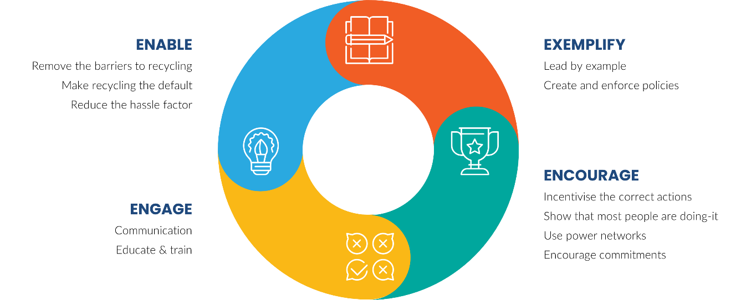

Figure 5: The 4 E's behaviour change model
The behavioural change model sets out a framework in which the desired behaviours can be achieved across Tower Hamlets in bin stores where the FRP is introduced. Figure 6 shows how the 4 E’s can be interpreted in the context of waste management. It is possible to create behavioural change strategies by following this model, which consists of four elements:
- Identifying changes that will make it easier to recycle or will improve the service offered to residents.
- Understanding those who will be affected by this change and identifying suitable means of communicating the change.
- Giving people a reason to interact with the new service through rewards or social pressure.
- Creating clear policies and guidance so residents understand exactly what they need to do.

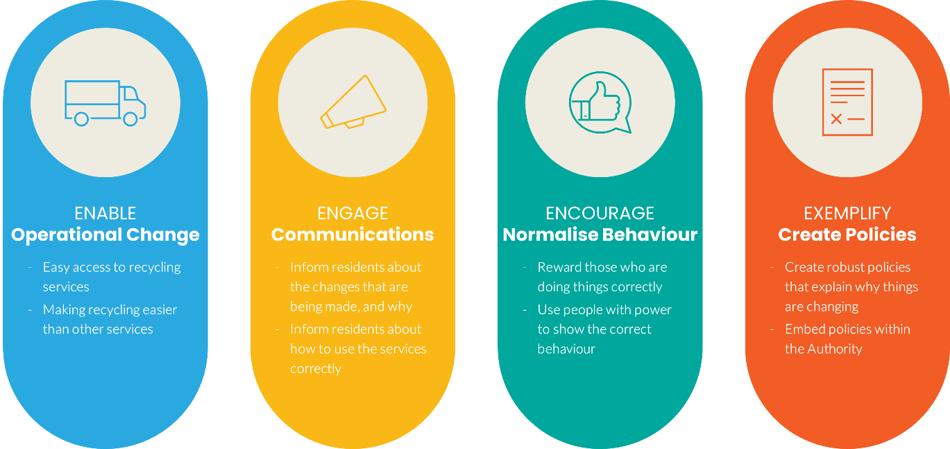
Figure 6: Behaviour change in waste management
It is important that changes to bin stores are viewed in the context of behavioural change models, and that any change incorporates all four factors, rather than tackling each individually. For example, should LBTH choose in the future to introduce food waste services as part of FRP upgrades, providing a food waste service will enable residents to recycle food waste. However, to create lasting behaviour change, the introduction of the service should be well communicated with clear policies in place, such as a possible restriction on residual waste capacity so that residents use the food service more effectively to manage the overall capacity of containment provided.

7.2. Introducing the Flats Recycling Package
Following the behaviour change principles outlined in section 7.1. Behaviour Change, introducing the FRP enables residents to participate in the recycling and residual waste services more fully. However, to achieve a high-performing service the remaining principles also need to be considered.
- Engage – Having good communication with residents before and during the roll out, and regular ongoing communication to remind users and engage with new residents. This communication could be in the form of:
  - Informational leaflets;
  - Door-knocking campaigns;
  - Website information;
  - “No Food Waste” stickers on residual bins (should LBTH introduce a food waste service in the future);
  - Posters in bin stores/in public places; and
  - Engagement events.
- Encourage – Through incentivising against the wrong action such as contaminating the recycling bin by putting residual waste into it, for example:
  - Warning stickers on sacks and bins; and
  - Not collecting contaminated sacks or bins.
- Exemplify – Creating new policies which put recycling (and potentially food waste should the service be introduced) at the top, by restricting residual capacity.
A case study from Lambeth has been provided in Appendix 9.10, to show how they implemented the FRP and how they communicated the changes.

7.3. Socio Economic considerations
7.3.1. Transient population
LBTH has a large transient population and, as of 2018, had the 11th highest population turnover out of all UK local authorities. This means that there is a constantly new residents who need to understand how waste and recycling is collected. Providing clear information that is easily accessible is key to supporting new and short-term residents to know how to engage in the service. As such, once the FRP has been introduced into relevant bin stores it will enable residents to engage in the services. Following this, the remaining three strands of the 4E model need to be implemented. Critically in this case it will require an ongoing engagement campaign to inform new residents of how they can successfully engage with the services. Methods to achieve this can be via including communication materials included within regular council notifications, such as annual council tax bills which are sent out annually. Alternative methods can include providing relevant communication materials to estate agents and landlords to distribute to new residents as part of a “welcome pack”, as outlined by ReLondon as part of their study. Once the residents have been engaged with, the following two strands would then come into effect, Encourage and Exemplify, as outlined in section 7.1. Behaviour Change
7.3.2. Language
When designing the communications approach to be utilised as part of a communications plan, it is important to consider the language spoken by local residents. LBTH has a particularly diverse population with regards to languages, and according to the 2011 census, was the fourth most linguistically diverse area in England and Wales, with over 90 languages being spoken. With 35% of the LBTH population not having English as their first main language, a key consideration of communicating changes to residents is to do it so via translation or pictorially. In cases where wording is used, clear and concise plain English is important, avoiding the use of uncommon vocabulary.
WRAP in their Target Audience Report highlight the importance of communicating effectively to populations that may not have English as their first language, with an example of Luton. Across Luton as a whole, residents originating from India, Pakistan, Bangladesh, Kashmir and Sri Lanka make up around 25% of the population, but concentrations in certain wards reach 70%23. Luton Borough Council therefore developed materials to communicate effectively with these groups as part of a campaign to promote recycling by using highly visual materials with very simple messaging in a variety of languages. The impact was an increase of participation by 8%23, demonstrating the use of more visual communications and translations can lead to success when language may pose as a barrier.
7.3.3. Culture
Coupled with any language barriers are cultural differences that may arise from the diverse demographic of Tower Hamlets. LBTH is the 16th most ethnically diverse local authority in England and has the largest Bangladeshi population in the country at 32%. A few of the cultural considerations which were considered in Luton (as described in section A case study from Lambeth has been provided in Appendix 9.10, to show how they implemented the FRP and how they communicated the changes.
7.3. Socio Economic considerations) are applicable to LBTH and include the following:
- Social conventions - e.g. in some cultures women will not talk to men that they do not know or men may not accept advice from women;
- Social attitudes - e.g. will environmental messaging resonate or would cost drivers have more impact? Do people care about the place they live?;
- Religious beliefs and practices - e.g. some religious groups do not drink alcohol so might not respond to images using wine bottles; and
- Differing waste practices in countries of origin - e.g. some residents may not have experienced recycling before or there may not be a translation for the word recycling;
Luton, to overcome some of the above challenges, introduced Bollywood themed recycling posters, billboards, advertising shells, a leaflet and roadshows to attract their Indian sub-continent communities.
Use of similarly targeted communications could ensure a focus of the attention from people who are normally ignored via standard recycling messages, especially when there are big cultural groups within the population (eg. Bangladeshi). However, an important consideration in evaluating cultural barriers and adapting communications is that too many different audiences may dilute the message and which may also has an impact on design and print costs.
7.3.4. Age
Tower Hamlets saw the largest percentage growth in population numbers out of all areas in England, increasing by 22.1% between 2011 and 2021. Of LBTH’s population, 48% are younger than 30 years old, 44% are between the ages of 30 and 60, and a small percentage (8%) are over the age of 60²⁴.
In general, the most suitable type of communications is age dependent. For older generations, use of technology is likely to be far more limited and therefore communication via print media is often better received. In contrast, for younger audiences, technological devices are often to hand and thus many sources including ReCollect note that focussing on online media is key to maintaining attention, particularly as being online is the most effective platform providing real-time and instant access to information. WRAP however can evidence that a council leaflet is still the main source for residents in terms of what can and cannot be recycled (cited by 29%) despite the increase in social media use. Therefore, leaflets are likely to still be impactful in LBTH despite the younger target audience.

7.4 Communications Plan
A detailed communications activity schedule is shown by Error! Reference source not found. to Error! Reference source not found.. This communications activity schedule anticipates that a programme of upgrades is planned to take place at once, or over a specific period of time.
Within this activity schedule, a key has been developed to show where the ownership of the communication element lies and which part of the 4E model it covers. As can be seen in Error! Reference source not found. to Error! Reference source not found., all elements are owned by LBTH, which means LBTH will develop the material and ensure it reaches residents. One element where the housing provider will have input will be in the Pre-Launch stage. We envisage that the housing provider will help with the distribution and putting up of leaflets around the building and in communal areas.
For the FRP to be successfully implemented, it is imperative that effective communications are developed to enable householders to understand what is changing and what they need to do to fully participate in the waste and recycling services. Consideration should also be given to food waste should this be introduced by LBTH at a later date, as communications would need to account for this service as well. Likewise, there will be several stakeholders who will need to be engaged with and kept informed on progress. Initially Members and Councillors will need to be informed of the plans to rollout the FRP and the communications along with it, including timelines. Input will be needed from the LBTH communication team and the waste team. The collection crew and waste operations team will also need to be informed of changes to the recycling infrastructure and can also be asked for anecdotal feedback on how the services appear to be working. Landlords and managing agents will also need to be engaged with early on in the process, and they may be asked to help spread correct recycling information to their residents, so will need to have the relevant and up to date information for this. Internal stakeholders such as LBTH officers will also need to be kept abreast of the rollout, in particular the call centre as they may receive a higher volume of calls due to the implementation. Lastly it is vital that residents be engaged with throughout the process, as this will help with buy-in and participation in the newly improved service.
A stakeholder map has been developed with all the key stakeholders involved, their stake in the project, potential concerns they might have and how best to communicate with them. This can be found in 9.7 Stakeholder Map.
A three-stage approach should be utilised to communicate the introduction of the FRP. The strategy has been split into Stage 1 – Pre-Launch, Stage 2 – Launch and Stage 3 – Post-Launch. The key aim of the communications strategy is to ensure householders in the OA understand how the newly upgraded bin store will affect them and encourage positive engagement. This would be met through the following objectives and strategy detailed by Figure 11 to Figure 13 found in Appendix 9.11:
- To deliver targeted communications to support the rollout of the FRP to specific estates to inform householders of the planned upgrades and provide information on how to participate and manage their waste and recycling effectively.
- To deliver internal communication updates and briefings to relevant members, staff and external stakeholders such as landlords and managing agents to inform them of the planned upgrades.

7.4.1 Communications in LBTH
It is important to use a range of communication materials to reach all residents. WRAP have again reported that residents prefer to receive their recycling information from communication materials provided directly by their local council. LBTH currently don’t send out regular recycling leaflets to all residents. It is recommended that to have the most impact when introducing the FRP, a specific leaflet is tailored to communal properties, a recycling leaflet should also be sent out on a regular basis, such as annually, as there is a high transient population in Tower Hamlets. As part of the FRP toolkit, ReLondon have a leaflet designed specifically for flatted properties, along with signage and bin stickers. This can be amended to be Tower Hamlets specific, as LBTH took part in the original FRP in 2018/19 this material should already be designed. As such, LBTH should utilise the communications already available for them when considering the rollout of the FRP.
Targeted letters can also be sent to residents, which would be recommend if there is a particular estate or bin store with persistent issues with contamination and certain items ending up in recycling. Letters can also be used to provide feedback to residents regarding any improvements to the recycling, and performance and provide a sense of ownership of the bins.
Based upon previous experience, leaflets can be sent out as addressed mail to specific properties or can be sent out to specific postcodes. Addressed mail costs £0.45 per household, and LBTH would have the ability to send different leaflets depending on the housing type. Postcode-based mail costs £0.03 per household but all properties under that postcode will receive the same leaflet, meaning it results in a blanket approach and would lose the nuances of addressed mail. In order to specifically target flatted properties with posted communications such as leaflets, the addressed mail option would have to be used. This would ensure that the relevant communications only went to the communal properties and avoided any non-relevant properties receiving the materials. It is worth considering the housing type in the OA as it is likely that kerbside properties are limited, and as such the postcode approach may be suitable. Furthermore, the approach to the rollout would also impact upon this decision, as if the rollout were to take place at all sites simultaneously, the postcode method would work. However, if the rollout were staggered, addressed mail would be more suitable to avoid residents being informed of a rollout that may not impact them for some time. Costs for each option based on the number of properties in the OA are provided in Table 13: Costs for different mailings the total number of properties surveyed as part of this project was 42,434.

Table 13: Costs for different mailings
Mailing | Total cost for OA
Addressed Mail | £19,095.30
Post Code Mail | £1273.02

Leaflets and other communication materials can be translated in other languages to help communicate to those where English isn’t their first language. However, this can take time and some words and phrases might not translate well in some languages. We recommend the use of imagery in communications to demonstrate recycling behaviours over text heavy descriptions. Other than English, the most common languages in Tower Hamlets are Bengali and Somali, if there are specific contamination or recycling issues then it might be beneficial to have some recycling information translated.
In addition to recycling leaflets, the “Our East End” quarterly magazine which LBTH publish is a good opportunity to reach out to residents. There are 153,000 copies published four times a year and it is delivered to 135,900 households in Tower Hamlets. The largest age ranges this reaches is 25-34 year olds (29%) and 35-49 year olds (22%).This could be used and could include information on what can and cannot be recycled and information on the FRP rollout. This could also help with buy-in from residents to increase uptake from the FRP. For a full page in the East End magazine it would cost £1450, for half a page it will cost £780 and for a quarter page it would cost £450 however typically if the magazine is council run or council sponsored then there is no cost.
Other local communication channels include LBTH’s weekly email newsletter and the Next Door app. The Next Door app can be used for highly localised communications and can target specific buildings if needed. For example, if there is a specific contamination issue in a block, then communications targeting this contamination can be used to educate the residents in that block. The weekly email newsletter has a high open rate and therefore would be an effective way of communicating correct recycling behaviour, or informing residents of specific recycling campaigns.
Alongside leaflets and physical communication material, information can be disseminated through social media. LBTH have Twitter, Facebook and Instagram which can be used to communicate to residents. LinkedIn is also good for business communications and could be used to reach out to Managing Agents and Landlords, particularly the larger organisations.
Social media campaigns can be run to educate residents, competitions can also be run on social media and offer incentives to residents for recycling. For example, the estate or building with the largest increase in their recycling rate could receive four planters for their communal areas. When considering social media, it would be worth utilising videos and GIFs to help increase engagement with residents. These could be utilised to demonstrate correct recycling behaviours and can be interpreted by all languages, which would benefit LBTH given the variety of languages spoken in the Borough, as outlined in section A case study from Lambeth has been provided in Appendix 9.10, to show how they implemented the FRP and how they communicated the changes.
7.3. Socio Economic considerations.
According to the LBTH communications team the age demographics reached through social media are;
- Facebook – 25yr to 50yr
- Instagram – 18yr to 30yr
- Twitter – 25yr to 35yr
Twitter has the biggest following with 30.4k followers, Facebook has 9.9k followers and Instagram has 6.9k followers. If any channel were to be prioritised for communications around waste and recycling we would recommend Twitter, due to its high following as it will have the most impact.
Many local authorities have digital notice boards around the borough in areas like libraries and community centres, some also have digital vehicle livery. These can be used to promote correct recycling behaviours and information on what can and cannot be recycled.
Lastly, there are in-person events, such as fairs and community events, that the council or waste team could attend in order to engage with residents and promote correct recycling behaviours.
A list has been provided on all the communication channels:
Recycling Leaflets
Letters
Social Media posts
Vehicle Livery
In person events
East End Magazine
Next Door app
Weekly Newsletter

8. Recommendations
To summarise the report, below are the key recommendations:
- Funding will be required to improve all the bin stores in the OA should LBTH decided not to use all available funding on bin stores in the OA.
- Funding opportunities should be looked for on a regular basis, and officers should proactively reach out to the suggested organisations.
- Due to lack of funding, bin stores in the Significant + and Significant intervention level should be prioritised. The indicative implementation plan provided should be utilised as a baseline and updated once funding levels are finalised.
- Food waste provision will likely need to be costed in the near future for flats due to upcoming legislative changes.
- Further research into expected costs be undertaken, as all costs provided are assumptions and would benefit from actual quotes being sought from relevant parties such as bin manufacturers.
- Members and landlords should be engaged with early on in the process, to get buy-in and support.
- A broad range of communications should be used to communicate with and engage residents. If mail and leaflets are to be sent to specific flatted properties then addressed mail will need to be used.
- Twitter should be prioritised as a social media channel due to the amount of followers.
- A successful FRP will require cooperation between the council, landlords and managing agents and residents.

9. Conclusion
There have been multiple stages throughout this project both in Stage 1 and Stage 2. A breakdown of them all has been provided below:
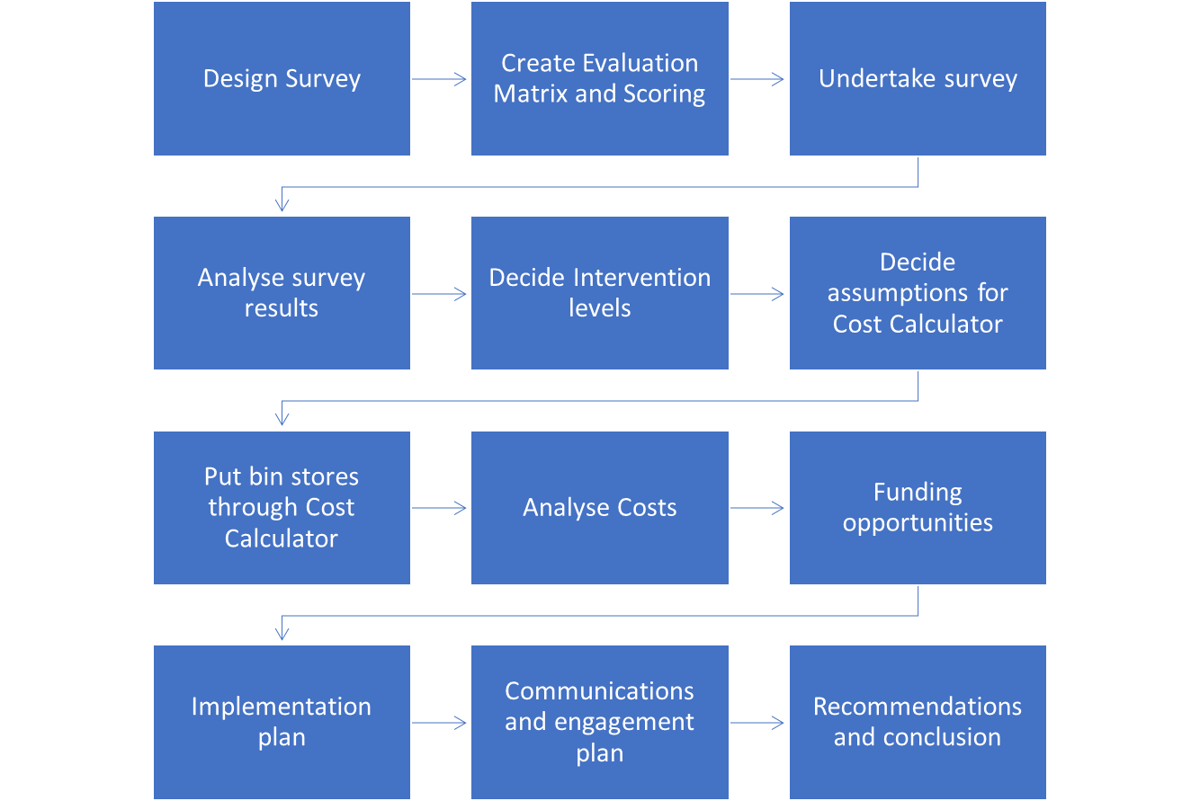
Figure 7 All stages of the project
As has been shown through the use of the cost calculator, in either scenario (of four or five intervention levels), there will be significant costs to bring the bin stores in the OA up to the standard of the “ideal bin store” that was outlined in the Stage 1 report. The setup costs for the housing provider are less than the costs for LBTH but the annual ongoing costs are greater for the Housing Provider. Due to the costs to the housing provider, a model showing potential costs savings after implementing the FRP has also been developed and can be found in 9.8. This will help with engagement and uptake and it is recommended that this issued when engaging with landlords and managing agents.
Unfortunately, there is no current funding available to help with the bin store improvements, however LBTH have already secured £2.13 million of funding to go towards some of the implementations required which will greatly help with the costs involved. As the funding LBTH already has is for the whole borough and only for certain improvements, there will be some improvements to the recycling rate, however the full extent of the benefits to the recycling rate will not be seen until all elements have been implemented.
The costs produced from the Cost Calculator are assumptions and not accurate figures, they are there to provide a guide on how much funding might be required to bring the flatted properties in the OA up to the FRP standard. As mentioned in 5.5 some cost elements might not be fully accounted for.
To aid in the implementation of the FRP a communications plan has been developed for LBTH, based on the 4 E’s behaviour change strategy of Enable, Exemplify and Encourage and Engage. Consideration was given to relevant socio-economic data, with elements such as age, transience of the population, language, and culture being taken into account. Using this and the 4 E’s a bespoke communications plan was developed focussing on three stages: Pre-Launch, Launch and Post-Launch.
The findings from the survey and subsequent use of the data to gather an understanding of the potential cost implications of introducing the FRP should prove a useful starting point for LBTH to consider further works. Engagement with key stakeholders such as landlords and managing agents will be critical in the implementation of the FRP, and as such the landlord excel has been designed to be as user friendly and simple to use as possible. Finally, the communications plan should provide a good starting point for LBTH to consider how to actively and successfully engage with local residents. Taken together, this should provide a holistic approach to implementing the FRP. Tower Hamlets and the Landlords should be providing the best service to their residents, and all should have the same level of service across the borough. Not just in service delivery but also in the quality of the bin stores and bin areas.
If the authority, with the help of landlords and managing agents, do not make improvements to the bin stores and the bin areas the borough will struggle to reach the Mayor of London’s recycling targets. Bin areas and bin stores in bad condition discourage residents from recycling correctly, this may cause the recycling rate to decrease further and contamination to increase. This would also lead to higher disposal costs as more material will end up being disposed of as waste rather than recycled and repurposed into new items. In order for the FRP package to work and have the maximum effect all elements of the FRP need to be addressed, and there needs to be cooperation between the authority, landlords and managing agents and residents.

9. Appendix

9.1. Flats Recycling Package Toolkit

9.2. Cost Calculator Assumptions

9.3 Set up and Ongoing costs breakdown

9.4. Weighted Matrix and Evaluation Scoring

9.5. FRP Cost Calculator Summary Table

9.6 Implementation Plan

9.7 Stakeholder Map

9.8. Landlord Excel

9.9 Landlord Tracker

9.10 London Borough of Lambeth Case Study

9.11 Communications plan timeline

As designed by ReLondon: https://relondon.gov.uk/resources/toolkit-flats-recycling-package
https://www.london.gov.uk/what-we-do/environment/london-environment-strategy
Recycling rate provided by LBTH.
https://lutfurrahman.co.uk/manifesto/
“Don’t let our future go to waste” Waste management strategy 2018-30.
https://www.towerhamlets.gov.uk/Documents/Borough_statistics/2019_ARS_Briefing_Paper.pdf
https://www.towerhamlets.gov.uk/Documents/Borough_statistics/Annual_Residents_Survey_results_2018.pdf
https://relondon.gov.uk/resources/case-study-the-flats-recycling-package
https://relondon.gov.uk/resources/toolkit-flats-recycling-package
https://relondon.gov.uk/wp-content/uploads/2021/02/Resource-London-Recycling-in-flats-toolkit-2020.pdf
https://relondon.gov.uk/wp-content/uploads/2021/02/LWARB-Making-recycling-work-for-people-in-flats-Case-Studies_200122.pdf
https://relondon.gov.uk/wp-content/uploads/2021/02/LWARB-Making-recycling-work-for-people-in-flats-Case-Studies_200122.pdf
https://relondon.gov.uk/wp-content/uploads/2021/02/LWARB-Making-recycling-work-for-people-in-flats-full-report_200128-1.pdf
https://relondon.gov.uk/resources/toolkit-making-recycling-work-for-people-in-flats-cost-benefit-analysis-tool
Mayor reviewing waste contracts over 50% target fears - letsrecycle.com
Estimated percentage increase in the volume of household waste sent to dry recycling as a result of implementing the FRP (driven by benefit scenario selected).
Estimated percentage point reduction in the contamination rate of household dry recycling volumes as a result of implementing the FRP (driven by benefit scenario selected).
https://relondon.gov.uk/resources/toolkit-flats-recycling-package
https://relondon.gov.uk/wp-content/uploads/2021/02/LWARB-Making-recycling-work-for-people-in-flats-full-report_200128-1.pdf
https://www.towerhamlets.gov.uk/lgnl/community_and_living/borough_statistics/Borough_profile.aspx
LWARB-Making-recycling-work-for-people-in-flats-full-report_200128-1.pdf (relondon.gov.uk)
https://www.towerhamlets.gov.uk/Documents/Borough_statistics/Diversity/Language_proficiency_in_Tower_Hamlets.pdf
WRAP-Target Audience.pdf
https://www.ons.gov.uk/releases/initialfindingsfromthe2021censusinenglandandwales
20 Ways To Be More Effective in Your Waste and Recycling Communications - ReCollect
https://wrap.org.uk/sites/default/files/2021-09/WRAP-Recycling-Tracker-2021-report.pdf
https://wrap.org.uk/resources/report/recycling-tracker-report-2021-behaviours-attitudes-and-awareness-around-recycling.
https://relondon.gov.uk/resources/toolkit-flats-recycling-package

