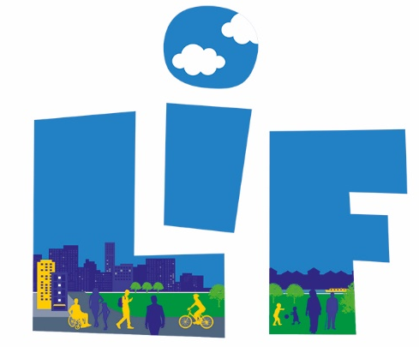

Local Infrastructure Fund
Consultation Statement

31/03/2021

Contents
1. Introduction 3
2. THE LIF PUBLIC ENGAGEMENT METHODS 4
3. FROM THE 2020 LIF PUBLIC ENGAGEMENT 7
4. HOW WE ARE CONSIDERING YOUR FEEDBACK 11
5. NEXT STEPS 11
6. APPENDICES: 12

Introduction

- The Local Infrastructure Fund (LIF) in Tower Hamlets is the name given to the Neighbourhood Community Infrastructure Levy – ‘NCIL’. Government Guidance on the Neighbourhood CIL requires that we engage with the local communities where development has taken place and agree with them how best to allocate the funding; making sure that the use of the monies matches the priorities expressed by our local communities.

- Tower Hamlets Council consulted on the Local Infrastructure Fund (LIF) between the 9th of November to 18th December 2020 consulting on LIF income for 2020/21. We received over 500 project nominations from more than 150 people mainly via responses on-line, through filling out an online traditional questionnaire; online GIS map-based survey or attending one of our online events – including options to SMS, telephone call in and email responses.

- The proposed consultation took a light touch ‘call for projects’ approach this year, with more detailed engagement on LIF projects and priorities to be undertaken in 2022/23 and every three years thereafter. Consequently, it did not ask residents for the priorities for infrastructure spending in each LIF Area, thus the priorities for spending will remain the same as those established in 2019. This is in accordance with the LIF process agreed by the Mayor in Cabinet in 2016 and will help to ensure we do not ‘over-consult’ local people.

- This Consultation Statement provides a summary of what you told us and the next steps the Council will take in delivering projects found suitable for the 2020/2021 LIF programme (also known as the ‘LIF 3’ Programme). Therefore, the consultation undertaken aids the decision-making processes around what and where the LIF money should be spent on in the borough.

- The LIF public consultation specifically asked public viewpoints on the income collected in the financial year 2020/2021 which is expected to be approximately £6 million (total value to be confirmed in April 2021). This consultation is part of the annual LIF programme cycle (see Appendix 1).

- In order to consult with people about their locality and not just on a borough wide basis, we have arranged the borough into four ‘LIF areas’. See Appendix 2 for a map showing the LIF areas. The arrangement of the areas is based on a mix of existing administrative and physical boundaries and fairly represents a scale at which to consider local infrastructure. The boundaries were agreed by the Mayor in 2016.

THE LIF PUBLIC ENGAGEMENT METHODS

- As part of the 2020 LIF consultation, we used a range of surveying methods to capture a representation of suggestions and feedback from the public. Due to Covid-19 restrictions at the time of engagement, we could not undertake any in-person face-to-face engagement methods. Nonetheless, we proactively sought to provide a range of opportunities for participation by deploying a variety of methods and flexible approach to engagement. These methods included:

  - online questionnaire survey
  - online GIS map-based survey
  - virtual drop-in public events
  - email/phone participation options
  - hard copy questionnaires

- The sections below describe the public engagement methods used during the 6-week consultation period.

- On-Line GIS map-based survey – a map-based survey was accessible via the main Tower Hamlets consultation website called “Let’s talk Tower Hamlets” [talk.towerhamlets.gov.uk/LIF]. This survey method provided a GIS map-based interface where participants could pin-point their responses directly onto one of the LIF Area maps of the borough. The same consultation questions were also asked as an online questionnaire (set out below) and collected information on project suggestions for local infrastructure improvements in each respective LIF area. The key difference between the two is that on the GIS map tool participants were able to spatially comment and visualise what others have said across the area. This enhances public access, accuracy in responses and efficiency for data collation. The URL of the survey was posted to social media outlets to enable local people to access it from their mobile devices and personal computers enabling greater outreach.

- On-Line questionnaire survey – An alternative format was provided through the on-line questionnaire (similar to the 2019 consultation) that was also accessible via the main Tower Hamlets consultation website called “Let’s talk Tower Hamlets” [talk.towerhamlets.gov.uk/LIF]. This questionnaire survey did not have the GIS map interface but collected the same information on project suggestions for local infrastructure improvements in each respective LIF area. It was considered to be more user-friendly to those who may have find the GIS tool difficult to navigate.

- Virtual public-drop in events – Two virtual events were open to the general public as a drop-in event which provided four 1-hour long slots. The dates were made available on the “Let’s talk Tower Hamlets” consultation webpage and participants needed to register and book ahead time slots using Eventbrite. This was also promoted via social media in advance. The main objective of this was to offer members of the public/community groups a drop in – Q&A style – session to ask any questions and for officers to be available to respond and explain the purpose of the consultation and how to participate. This face to face (albeit virtual) approach was an opportunity to gain buy in and support from the community. The emphasis of the drop-in was to help participants to identify local infrastructure projects e.g. in terms of what is needed and where.

Table 1: Virtual Drop-in dates
Event | Format | Date | Time (1 hour per slots)
Virtual Drop-in event | Teams online | Thursday 19th November 2020 | Session 1 - 1-2pm  Session 2 – 5.30-6.30pm
Virtual Drop-in event | Teams online | Thursday 3rd December 2020 | Session 1 - 1-2pm  Session 2 – 5.30-6.30pm

- Telephone/Email options – The consultation also made available on the webpage the option to call in, text or email to participate, ask questions and/or request a physical copy of questionnaire should it be required.

- Through all the channels provided, participants were encouraged to suggest only new project ideas and not to re-nominate the same projects from previous LIF consultations.

- Targeted Community Group engagement

  - The main form of participation was via online tools, though some alternative options were available for hard to reach community groups such as a telephone and/or email option to contact officers for assistance should it be required. Copies of the questionnaire could be emailed to participants; or filled out for potential participants over the phone upon request. This approach helped accommodate those that did not have access to the internet and/or the appropriate level of access, IT or language related literacy. Furthermore, whilst hard copies of the questionnaire were not generally available, people could request a copy via the IP email.
  - A number of pre-identified community group representatives were targeted and invited to take part in a number of different ways: to opt to fill in survey online and/or take part in the drop in events; ask them to circulate the survey link to local people. Key community/voluntary sector groups were targeted for this purpose e.g. Tower Hamlets Community and Voluntary Service (THCVS) to help promote the on-line survey through their newsletter and other similar activities. Thus, community group networks developed in 2019 were used to engage and access hard to reach groups as far as was feasible.
  - We engaged with our Neighbourhood Forums as required by the CIL regulations as well as our Ward councillors for their support. Additionally, targeted emails/letters were sent to consultees (comprising residents, community groups and businesses) from the updated LIF database and using the Councils’ existing service/staff networks.

- Thus, as part of our borough-wide public engagement process we undertook several promotional activities to reach out to our community. Table 2 below summarises in detail what we did:

Table 2: LIF 2020 Promotional Activities
Methods of Consultation | How we publicised the Consultation
Promotional activities | - LIF consultation promotional text placed in the weekly LBTH email newsletter  - Press release/media outlets  - Feature on the Council ‘s website – “Let’s talk Tower Hamlets” for 6 weeks  - Internal: Yammer  - Twitter - LIF dedicated announcements and other social media announcements  - Promotion of drop-in events via Eventbrite and other social media  - Email invites to residents/community groups from the LIF consultation database  - Briefing to councillors to publicise through their networks  - Email notifications to Neighbourhood Forums, Community Groups/Networks and Officers in other service areas, including schools.  - LIF webpage update

FROM THE 2020 LIF PUBLIC ENGAGEMENT

  - This section outlines some of the feedback you gave us during the 2020 LIF consultation between 9th November and 18th December 2020 which is broken down for your information below.

  - As a result of our borough-wide public engagement process we received just over 550 responses for local infrastructure projects from the local community across the four LIF Areas. It is estimated that over 160 people individuals participated to provide responses in the consultation.

  - Table 3 summarises the number of people using particular methods of engagement.

Table 3: Number of participants in each method of engagement:
 | Type of Activity | No. Participants
1 | Four Virtual Drop-in Events | 16 (registered attendees only)
2 | Online Questionnaires (individual completions online) | 36 (approx.)
3 | GIS Map based survey | 135 (approx.)
4 | Email | 10
5 | Telephone/SMS | 5

  - We found that a large portion of the those that participated were residents of the borough – see Figure 1.

Figure 1: Percentage Breakdown of Borough Participants.

  - Furthermore, we also found that a large portion of the participants were taking part for the first time and had not participated in any previous LIF consultations – see Figure 2.

Figure 2: Percentage of Previous Participation

  - A breakdown of the percentage of projects within each LIF area is provided in Figure 3. LIF Area 1 has the highest number of public responses and LIF Area 3 and 4 have the least number of responses out of all four areas.

Figure 3: Percentage of projects combined from different methods

  - The public responses have been collated and presented verbatim from the various consultation activities which have been grouped into broader themes. The broader groupings are set out for each LIF area in Figure 4 and numbers can also be seen in below - see also Appendix 3.
Figure 4: Number of Public Responses by Theme across each LIF Area

  - Figure 5 shows the percentage breakdown of the top three project suggestions by theme across the borough and across each LIF Area:
- Cycling/walking (22%)
- Road network improvements (20%)
- Green Spaces (14%)

  - These top three themes represent just over half of all the projects nominated during the 2020 LIF consultation and perhaps represent a growing need and importance amongst the public for an improved public realm and could be associated with the pandemic’s effects on communities.
Figure 5: Percentage of all the projects across the borough by themes

  - A full list of all the project suggestions from the 2020 LIF Consultation have been presented in detail in the accompanying excel document called “2020 LIF Consultation Statement Appendix”.

HOW WE ARE CONSIDERING YOUR FEEDBACK

  - We have combined all the responses into one database and are now in the process of reviewing them to assess their deliverability. Phase 1 of our review process of the collected responses asks officers from different service areas across the Council to the assess deliverability of nominated projects. In determining deliverability, officers will also carefully consider residents’ suggestions against existing Council strategies, plans and capital programmes to determine alignment to existing or planned programmes. It is anticipated that some of the projects will not be appropriate for 2020 LIF funding, due to several reasons. For instance, projects that already have secured funding and are being delivered will not require further funding, or projects that are budgeted for by other external bodies (such as TfL) will also not require LIF funding.

  - Additionally in the shortlisting process, officers will consider whether the project suggestions in the first instance meet the eligibility criteria for LIF, as prescribed by the Government’s CIL Guidance document which sets out how LIF can be spent:
‘a) the provision, improvement, replacement, operation or maintenance of infrastructure; or b) anything else that is concerned with addressing the demands that development places on an area’.
  - Phase 2 will further refine the ‘long list’ of projects resulting in a prioritised list for delivery. Notably, projects previously placed on the ‘Reserve List’ after the 2019 consultation and allocations process will be incorporated into the 2020 long list. The decision on which projects will be delivered will be made by the Mayor in Cabinet. As this is an on-going work stream, delivery of projects using LIF income will be undertaken in close alignment to the Council’s Capital Investment Programme. Appendix 1 highlights the key stages of the annual LIF process.

  - Due to the high level of public engagement and number of projects nominated, not all projects found desirable for delivery will be able to be funded using the LIF collected in 2020/21. LIF is, however, collected every year by the Council and therefore projects not agreed for delivery using 2020/21 funding may still be funded in future years.

NEXT STEPS

5.1 It is intended that the Mayor will approve the allocation of 2020/21 funding in the summer of 2021 through Cabinet. At this point the Council will publish the final list of projects allocated LIF funding. The Council will also consult on LIF again for 2021/22 from September 2021 as part of an annual process of public engagement. We will therefore invite members of the public to again take part and suggest projects for LIF spending.
PLEASE NOTE!
Further updates on the LIF programme will be regularly provided on:
https://talk.towerhamlets.gov.uk/lif

APPENDICES:

Appendix 1: Key stages of the Annual LIF programme cycle

Appendix 2. LIF Area Map
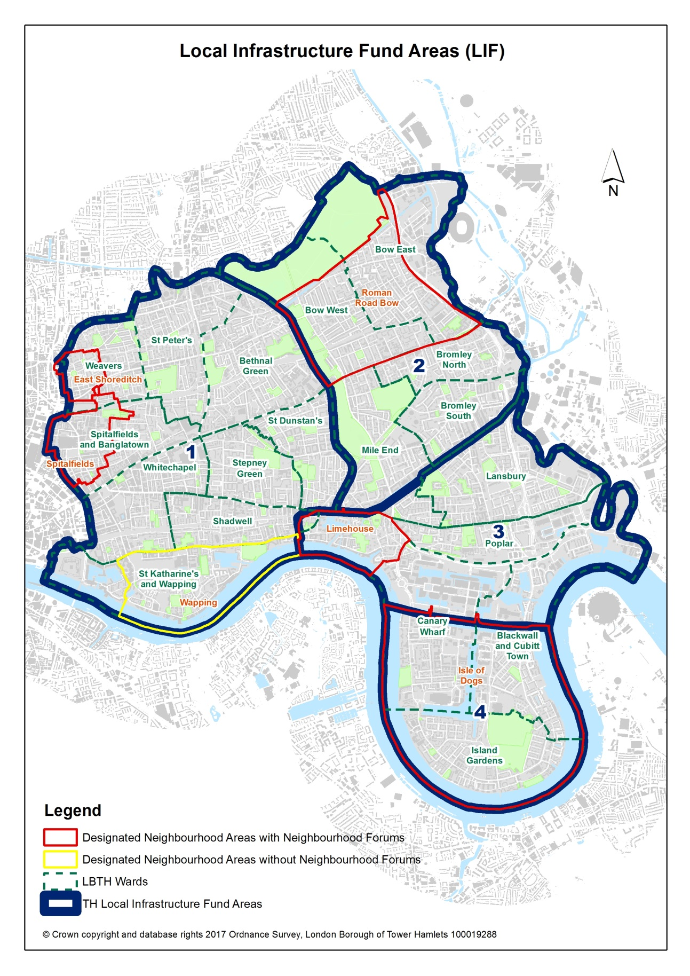

Appendix 3: 2020 LIF Public Consultation project suggestions grouped into broader themes across the four LIF areas of the borough.
 | LIF 1 | LIF 2 | LIF 3 | LIF 4 | TOTAL
Community facilities | 14 | 4 | 1 | 1 | 20
Cycling/walking | 71 | 33 | 13 | 9 | 126
Flood Defence | 2 | 0 | 0 | 0 | 2
Green spaces | 60 | 9 | 7 | 4 | 80
Health | 1 | 0 | 0 | 0 | 1
Other | 24 | 9 | 7 | 2 | 42
Pollution reduction | 12 | 4 | 2 | 2 | 20
Public safety | 11 | 3 | 0 | 0 | 14
Public transport | 6 | 11 | 1 | 1 | 19
Recycling/waste | 17 | 11 | 0 | 0 | 28
Residential/Estate improvement | 17 | 3 | 0 | 4 | 24
Road improvement | 79 | 20 | 7 | 9 | 115
Schools | 1 | 1 | 7 | 0 | 9
Shops/town centres | 50 | 11 | 2 | 0 | 63
Sports/leisure facilities | 3 | 0 | 0 | 2 | 5
Waterways improvement | 0 | 0 | 5 | 4 | 9
 | 368 | 119 | 52 | 38 | 577

Combines responses that were emailed, phone messages, online questionnaire, and GIS survey responses together to give 577 responses in total. At this stage it does not take account of any duplicate or repeat projects ideas and represents the raw data only.
Out of 161 estimated participants

