

**Health Needs Assessment:**

**Physical Activity in Tower Hamlets**

**Public Health**

**Lead Author: Elaine Londesborough-van Rooyen**

**Date: January 2025**

|  |  |
| --- | --- |
| **Chapter title:** | **Health Needs Assessment: Physical Activity in Tower Hamlets** |
| **Domain:** | Cross-division |
| **Prepared by:** | Elaine Londesborough-van Rooyen, Public Health Registrar |
| **Contributors:** | Hannah Choi, Senior Public Health Intelligence Analyst  Amelie Gonguet, Public Health Programme Manager  Alex Cheuk, Data Scientist  David Salman, Sports Medicine Registrar |
| **Sponsored by:** | Tower Hamlets Physical Activity Place Partnership  Matthew Quin, Acting Associate Director of Public Health  Jahur Ali, Director of Culture |
| **Approved by:** |  |
| **Suggested citation:** | Health Needs Assessment: Physical Activity in Tower Hamlets, Public Health, Tower Hamlets: London. 2025. |
| **Date of publication:** | 13/01/2025 |

Click or tap here to enter text.

Contents

Executive Summary 5

About this Health Needs Assessment 7

Introduction 7

Background 8

Aims and Purpose 9

Methods 10

Understanding Need 13

Population Overview 13

Tower Hamlets physical activity in comparison 22

Inequalities in physical activity 25

Understanding Best Practice 37

Active Systems 37

Active Society 38

Active Environments 41

Active People 47

Understanding the Local Picture 53

ActiveSystems 53

ActiveSociety 56

ActiveEnvironments 60

ActivePeople 72

Understanding Future Vision 80

Summary of findings 80

Recommendations 82

Summary table 85

References, Acknowledgements, and Feedback 94

Acknowledgements 94

References 97

List of figures 105

List of tables 106

Appendix 1 – Detailed methods 107

Appendix 2 – Summary of Place Partnership Engagement Workshop 11/06/2024 111

Appendix 3 – Tower Hamlets Health Promoting Leisure Logic Model 114

# Executive Summary

Introduction

Physical activity has many mental and physical health benefits. Increasing physical activity rates also supports important priorities on reducing loneliness and improving air quality. Being physically active is not just about sport. Any movement for any reason, whether it’s walking to the shops, gardening or carrying shopping home, helps make people happier and healthier.

Rates of physical activity nationally fall far below recommendations, and the UK is facing an inactivity crisis. Tower Hamlets has been identified by Sport England as a place in need of support to improve rates of physical activity. This Health Needs Assessment is the start of a journey to work together to get Tower Hamlets moving.

Methods

This Health Needs Assessment draws on local data from the national Active Lives survey, and local data from a variety of sources, to describe physical inactivity in Tower Hamlets, make comparisons with London and national averages, and explore inequalities in inactivity. It then compares policy and practice in Tower Hamlets to best practice in improving physical activity to identify gaps and make recommendations.

Summary of findings

In Tower Hamlets, a higher proportion of people are inactive (doing less than 30 minutes of activity each week) than in London and England. After adjusting for age, the prevalence of inactivity in adults in Tower Hamlets is 32% compared to 25% in London and 23% in England. 40% of children and young people in Tower Hamlets are doing less than 30 minutes of activity a day, compared to 33% in London and 30% in England.

There are inequalities in the distribution of the harm of inactivity:

* 23% of men are inactive compared to 26% of women
* 43% of older people (65+) are inactive compared to 23% of adults under 65
* 27% of people living in the most deprived areas are inactive compared 19% in the least deprived areas
* 17% of white British adults are inactive compared to 38% of Asian adults
* 29% of Asian men are inactive compared to 46% of Asian women
* 43% of disabled people are inactive compared to 18% of non-disabled people

Barriers to physical activity for residents include cultural and social expectations, affordability, accessibility, road and community safety concerns, competing priorities and a lack of opportunities and facilities.

A review of policy and practice against best practice in relation to physical activity found:

In **active systems (leadership and governance)** Tower Hamlets has an emerging Place Partnership approach to physical activity, but unclear leadership, reporting and monitoring structures

In **active society (attitudes and norms)** Tower Hamlets has developed campaigns and mass-participation events for residents and has offered staff training, but has not focussed enough on engaging the least active residents.

In **active environments** **(spaces and places)** Tower Hamlets has made progress in policies and guidance to create an environment that feels safe and promotes activity, but more needs to be done to understand the impact for residents and ensure facilities are accessible for those who need them most.

In **active people (programmes and opportunities)** Tower Hamlets has a vibrant offer, but providers often struggle to find space to deliver interventions, and more could be done to involve the least active residents in designing opportunities that would work for them.

Recommendations

There are 35 recommendations of this Health Needs Assessment. In summary:

In **active systems** (recommendations 1-8) Tower Hamlets should develop a new strategy for sport and physical activity, support the emerging Place Partnership to develop governance , monitoring and evaluation structures, identify a senior champion for physical activity and invest in better insight into inequalities and barriers in physical activity.

In **active society** (recommendations 9-12) Tower Hamlets should co-design health promotion campaigns and mass-participation events, particularly focussing on the least active groups, and ensure that staff both inside and outside the health sector are trained in supporting residents to be physically active.

In **active environments** (recommendations 13-24) Tower Hamlets should ensure that the environment supports activity, feels safe and that people have access to the facilities they need to be active including play space, green space and sports and leisure facilities.

In **active people** (recommendations 25-35) Tower Hamlets should work to connect residents with the opportunities that will work for them, ensure that children and young people have access to safe indoor and outdoor opportunities to play and be active, co-produce interventions with the least active groups including women and girls, older people, disabled people and people from global majority backgrounds and ensure that what works is supported and scaled-up.

# About this Health Needs Assessment

## Introduction

Physical activity helps to prevent and treat multiple conditions including heart disease, stroke, diabetes and cancer. It can also help prevent and treat obesity, hypertension and improve mental wellbeing[1]. Despite these benefits, levels of physical activity have remained stubbornly poor internationally, and the benefits of physical activity are unequally distributed. The Lancet Physical Activity series in 2021 found that, while physical activity has been recognised as important by governments, the implementation of policies to improve physical activity has been patchy and inconsistent[2].

The World Health Organization (WHO) defines physical activity as “any bodily movement produced by skeletal muscles that requires energy expenditure.”[3] This includes all movement during leisure, for transport, or as part of work or domestic activities.

The Chief Medical Officers (CMOs) of the UK recommend that adults should do at least 150 minutes of moderate intensity physical activity per week such as cycling or walking, or 75 minutes of vigorous activity such as running. For good physical and mental health, they recommend that adults should be active every day, that any activity is better than none, and that more is better still[4].

The CMOs have issued specific guidelines for pregnant women, older adults, and disabled people, who are also advised to do at least 150 minutes of moderate intensity activity per week, adapted to their personal circumstances[5].

For children aged one to five, the CMOs recommend 180 minutes of activity per day, and for children under one 30 minutes per day[6]. Children five to 18 should aim for at least 60 minutes per day[7]. The CMO guidelines for disabled children highlight that physical activity is just as important for them as their non-disabled peers, and that they should have the opportunity to do at least 20 minutes per day[8].

Nationally, many people fall far short of the CMO guidelines. They are met by 67.1% of adults, with a further 10.3% classified as fairly active (30-149 minutes per week) and 22.6% inactive (less than 30 minutes per week).

There is also a national crisis in children and young people’s physical activity, with less than half (46.9%) meeting the recommendation of 60 minutes per day, and nearly a third (30.3%) doing less than 30 minutes per day.

There are nationally recognised inequalities in the distribution of the benefits of physical activity.

* Men and boys are more likely to be active than women and girls
* Younger people are more likely to be active than older people
* People in higher socioeconomic positions are more likely to be active than people in lower socioeconomic positions
* Non-disabled people are more likely to be active than disabled people
* White people are more likely to be active than people from non-white ethnic backgrounds[9]

Physical activity is determined by a wide range of individual, social and environmental factors. The World Health Organization’s (WHO’s) Global Action Plan on Physical Activity (GAPPA) covers four key policy areas that together provide a comprehensive, whole-system response to the issue of inactivity:

1. Active Societies – social norms and attitudes
2. Active Environments – spaces and places
3. Active People – programmes and opportunities
4. Active Systems – governance and policy enablers

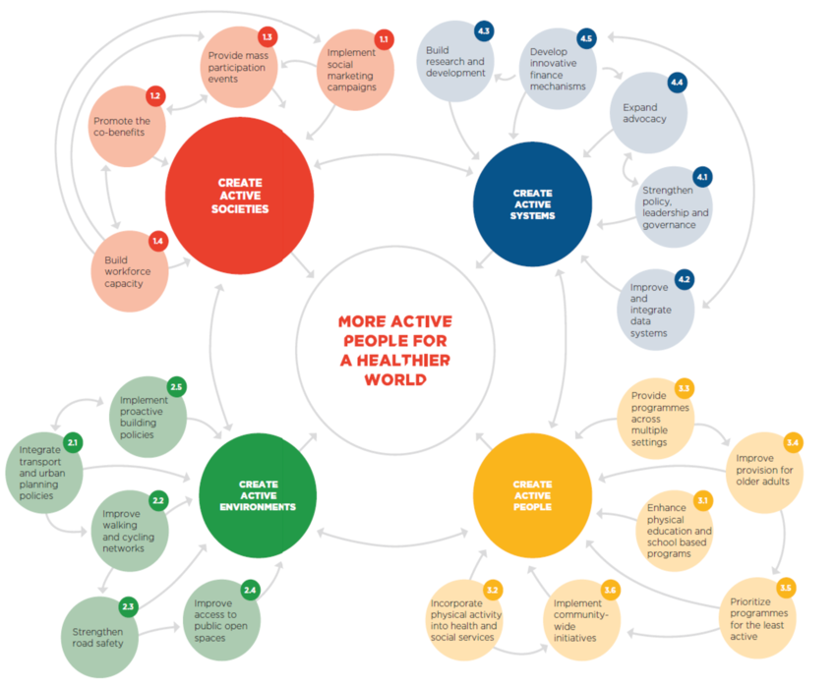

Figure 1: WHO GAPPA Framework as a diagram, WHO, 2018

## Background

Physical activity is a challenge and a priority in Tower Hamlets. There have been significant changes in the borough recently, such as the insourcing of the leisure service under the ‘Be Well’ banner, with the expressed aim of providing a more comprehensive approach to health and wellbeing through the leisure service in the borough.

Physical activity is woven through the strategic priorities of the borough and is recognised as a challenge and an area of significant opportunity across multiple services, community groups and residents. There are multiple co-benefits of physical activity that are particularly relevant to the challenges faced by Tower Hamlets. Increasing physical activity not only tackles physical health issues, but also social issues such as loneliness and isolation, and environmental challenges such as climate change and air quality.

Sport England’s Uniting the Movement strategy recognises the importance of a localised approach in the promotion of physical activity[10]. Sport England has identified Tower Hamlets as a place of need for further investment. Their place need classification process considered both indicators of need and an assessment of area’s readiness to embark on a system change journey.

Tower Hamlets has recently formed a Place Partnership working group with membership from across the council, National Health Service (NHS) and voluntary and community sector. This group will lead on an initial 12-month development process of understanding where Tower Hamlets is, and where the borough wants to get to. This Health Needs Assessment (HNA) is a first step in that journey.

## Aims and Purpose

This HNA provides a snapshot of physical activity in the borough, drawing on the latest available data and information. It will paint a picture to enable the newly developed Tower Hamlets Physical Activity Place Partnership (THPAPP) to make decisions about priorities for investment in physical activity.

**Aim:**

To understand physical activity and inactivity in the borough and the barriers and facilitators of physical activity, with a particular focus on what groups would most benefit from increased investment.

**Objectives:**

1. To ensure that the THPAPP and Sport and Physical Activity Strategy is informed by the most recent quantitative and qualitative data on physical activity in the borough.
2. To provide an overview of the need, barriers and facilitators in relation to physical activity in the borough, particularly considering inequalities and groups excluded from accessing physical activity opportunities such as women and girls.
3. To present evidence and policy and guidance on what works in similar populations to Tower Hamlets.
4. To describe current local services, policy and approach to physical activity, and to benchmark current practice against best practice.
5. To highlight gaps in current knowledge and understanding that could be filled by the Sport England Place Partnership funding or inform future research priorities for the Tower Hamlets Health Determinants Research Collaboration.
6. To make recommendations for local policy and service improvement.

These aims and objectives were developed in collaboration with the THPAPP, the senior officer sponsors of the project, and wider stakeholders.

This HNA will inform the developing THPAPP workplan and bid for future investment from Sport England. It will form the basis of the Place Partnership Sport and Physical Activity Strategy. It will also inform other developing strategies and policies of Tower Hamlets council including the developing Transport Strategy (including the Walking and Cycling Plan and the Road Safety Plan) and Open Spaces Strategy,

## Methods

Set out below is a brief description of methods used for this HNA. For full methods please see appendix 1.

Physical activity is determined by a wide range of individual, social and environmental factors. This means that there is potentially a very large scope for this HNA. Guided by the aims and objectives set out above, this HNA set out to describe activity and inactivity in the borough and describe key data on the areas that determine activity levels.

The WHO GAPPA has been used to structure the analysis plan and final HNA document. The scope and analysis plan were consulted on with public health colleagues, the THPAPP and the co-sponsors of the project.

Qualitative data were collected through discussions with relevant partners, and from existing data sources to bring in insight from residents. A Physical Activity Place Partnership engagement workshop was held in June 2024 bringing together community sector organisations with statutory service providers to discuss where Tower Hamlets is, and where the borough wants to get to. Findings from this session are incorporated into this HNA and a summary of the event can be found in appendix 2.

The main source of quantitative data on physical activity in England is the Active Lives Survey (ALS), undertaken annually by Sport England[9]. This data source has the strength of having been undertaken consistently over many years, and allowing for national and regional comparisons. The ALS asks about the different activities that people do, including walking and cycling, fitness activities, sporting activities and dancing, and adds up bouts of 10 minutes or more to describe people’s overall activity in more of the categories described below.

The ALS has three categories of activity for adults:

* Active (at least 150 minutes a week)
* Fairly active (an average of 30-149 minutes a week)
* Inactive (fewer than 30 minutes a week)

The ALS has three categories of activity for children and young people:

* Active – doing an average of 60 minutes or more a day across the week (420+ minutes a week)
* Fairly active – Doing an average of 30-59 minutes a day across the week (210-419 minutes a week)
* Less active – Doing less than an average of 30 minutes a day across the week (less than 210 minutes a week)

This HNA mainly focusses on levels of inactivity for adults, and the ‘less active’ group for children and young people. This is because we can have the largest impact by supporting the most inactive to be more active.

This HNA uses the Office of Health Improvement and Disparities (OHID) definition of physical activity, which includes gardening, whereas the Sport England definition does not. Therefore, some headline figures may be different to what is presented nationally by Sport England.

While the ALS is the best available source of data on physical activity, it is limited by a small sample size, with only approximately 500 adults in Tower Hamlets taking part each year. This means we need to be careful with our interpretation of the data. Confidence intervals are provided on graphs to give a measure of the statistical support for each result. Where it is available this HNA will refer to other sources of data to support findings. For example, if numbers are too small in local ALS data then data on a regional and national level has been presented.

By contrast to the adult survey. the children and young people’s survey is administered through schools. It is similarly limited by a small sample size of about 300 responses per local authority, and there may be only a small number of reporting schools in a particular year and local authority. Therefore, it is potentially more susceptible to bias and may not necessarily be representative of the whole Tower Hamlets population. To mitigate some of the risk associated with small sample size, this HNA has used aggregated data covering the most recent two years of the ALS. Where sample sizes were deemed too small to draw meaningful conclusions from the data, regional and national data are presented instead.

For the Adults survey, only responses from participants aged 19 years or older were included in the analysis, to align with CMO guidelines.

For the Adults survey only, a logistic regression model was developed to explore the independent association between selected demographic variables and the odds of being inactive. Variables were selected for inclusion in the model based on known relevance to the outcome based on local knowledge. The model and further detail can be found in appendix 1.

To complement data from the ALS, data from the Tower Hamlets Annual Residents’ Survey (ARS) has been used. The ARS is conducted every year by Tower Hamlets council and aims to capture residents’ views on their local area and on council services. It has a larger sample size of about 1000 responses.

The ARS measure of physical activity simply asks residents the binary question of whether they do more or less than the recommended 150 minutes activity per week, and so we are unable to compare inactivity levels (less than 30 mins per week) with the ALS data.

Recommendations were drafted and discussed with the THAPP, co-sponsors of the HNA and senior leaders of Tower Hamlets Council at Directorate Leadership Team meetings before being finalised for publication.

# Understanding Need

This section describes the population in Tower Hamlets and levels of physical inactivity in the population. It also reflects on likely future changes and trends that will need to be considered in planning for physical activity for the future.

## Population Overview

Approximately 310,300 people live in Tower Hamlets. The borough has a young population, with a higher than London average representation of people aged 20-39.

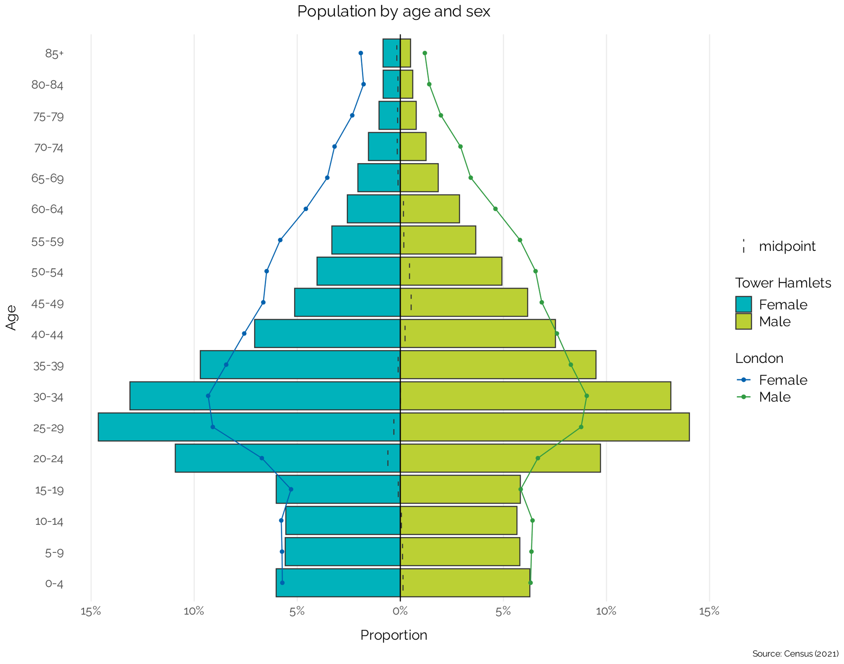

Figure 2: Population by age and sex, 2021

Tower Hamlets has the highest population churn of any local authority in London. In 2023, 40.5% of households had changed in the previous 3 years, rising to 50.1% in the previous 5 years[11].

Ethnicity

Tower Hamlets is one of the most ethnically diverse local authority areas in England. The largest ethnic group in Tower Hamlets is Bangladeshi, making up 34.6% of the population.

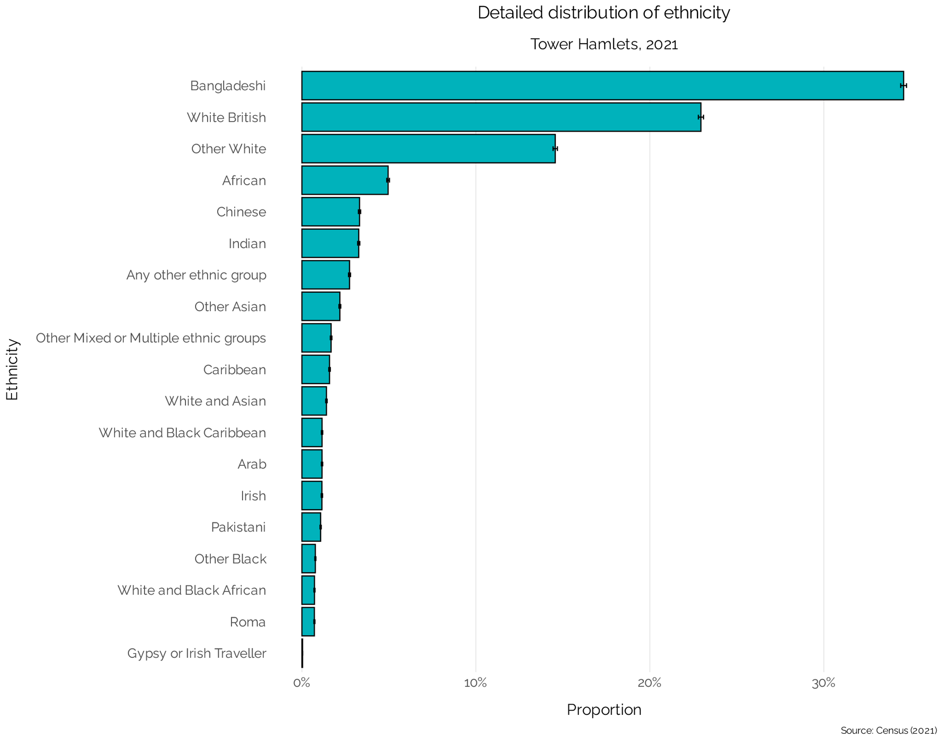

Figure 3: Detailed distribution of ethnicity, 2021

Languages

Tower Hamlets is highly muti-lingual, with 30.4% of the population having a main language other than English. Bengali (including Sylheti and Chatgaya) is the second most spoken language after English in the borough. Around 6.2% of the population cannot speak English well or at all.

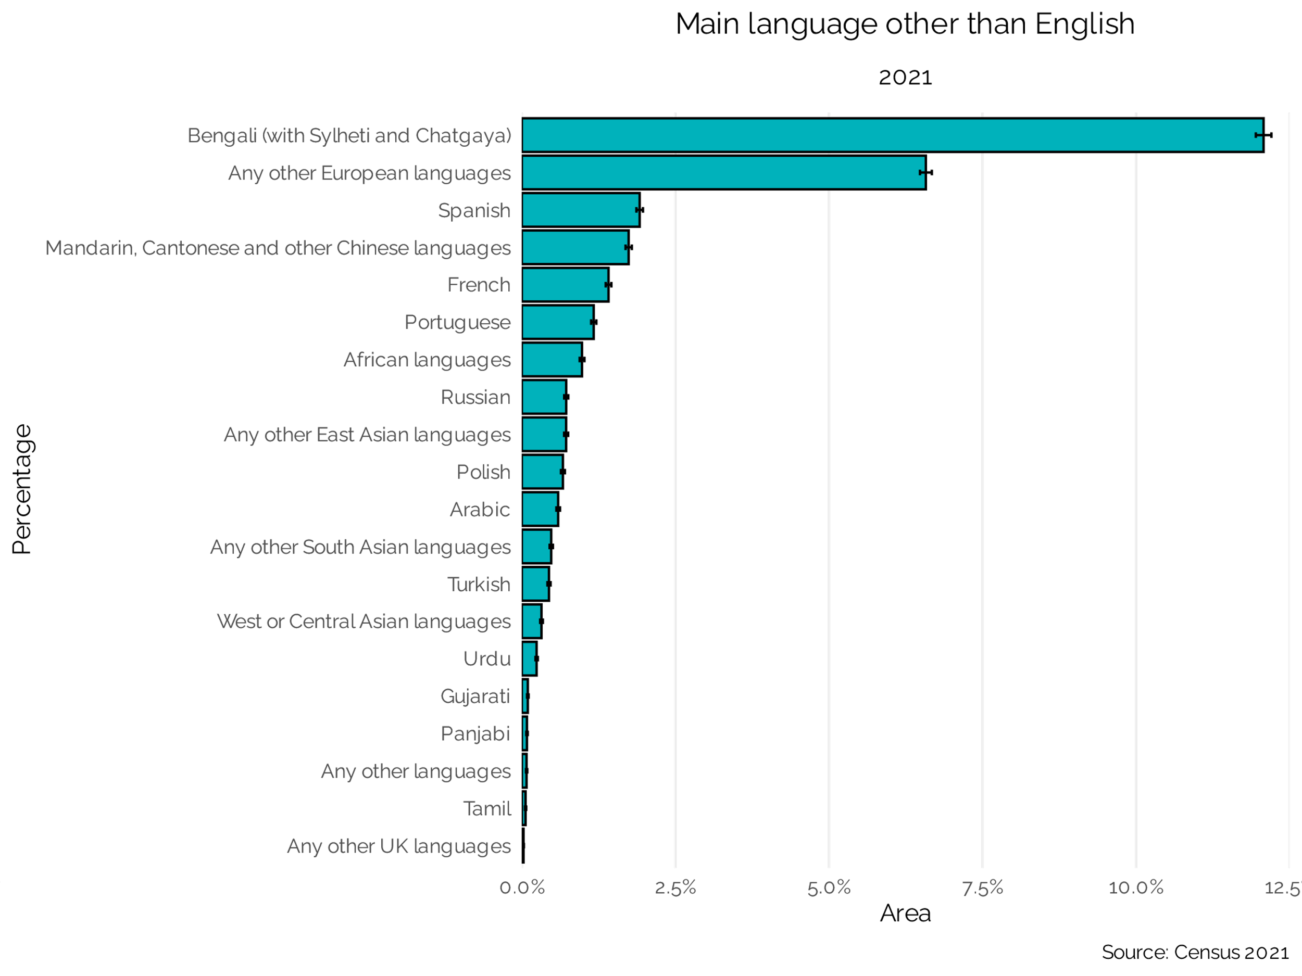

Figure 4: Main language other than English, 2021

Place of birth

Tower Hamlets also has a significant population of people born outside of the UK. As shown below, almost half (46.1%) of Tower Hamlets residents were born outside of the UK.

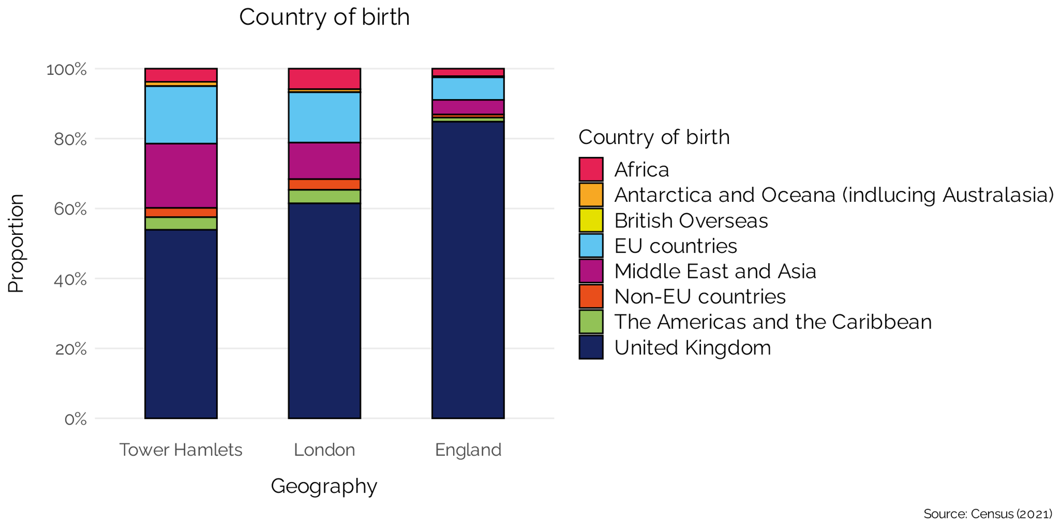

Figure 5: Country of birth, 2021

Sexual orientation

Tower Hamlets has a larger non-heterosexual population than both London and England, with 7.2% of the population identifying as gay, lesbian, bisexual and other non-heterosexual sexual orientations.

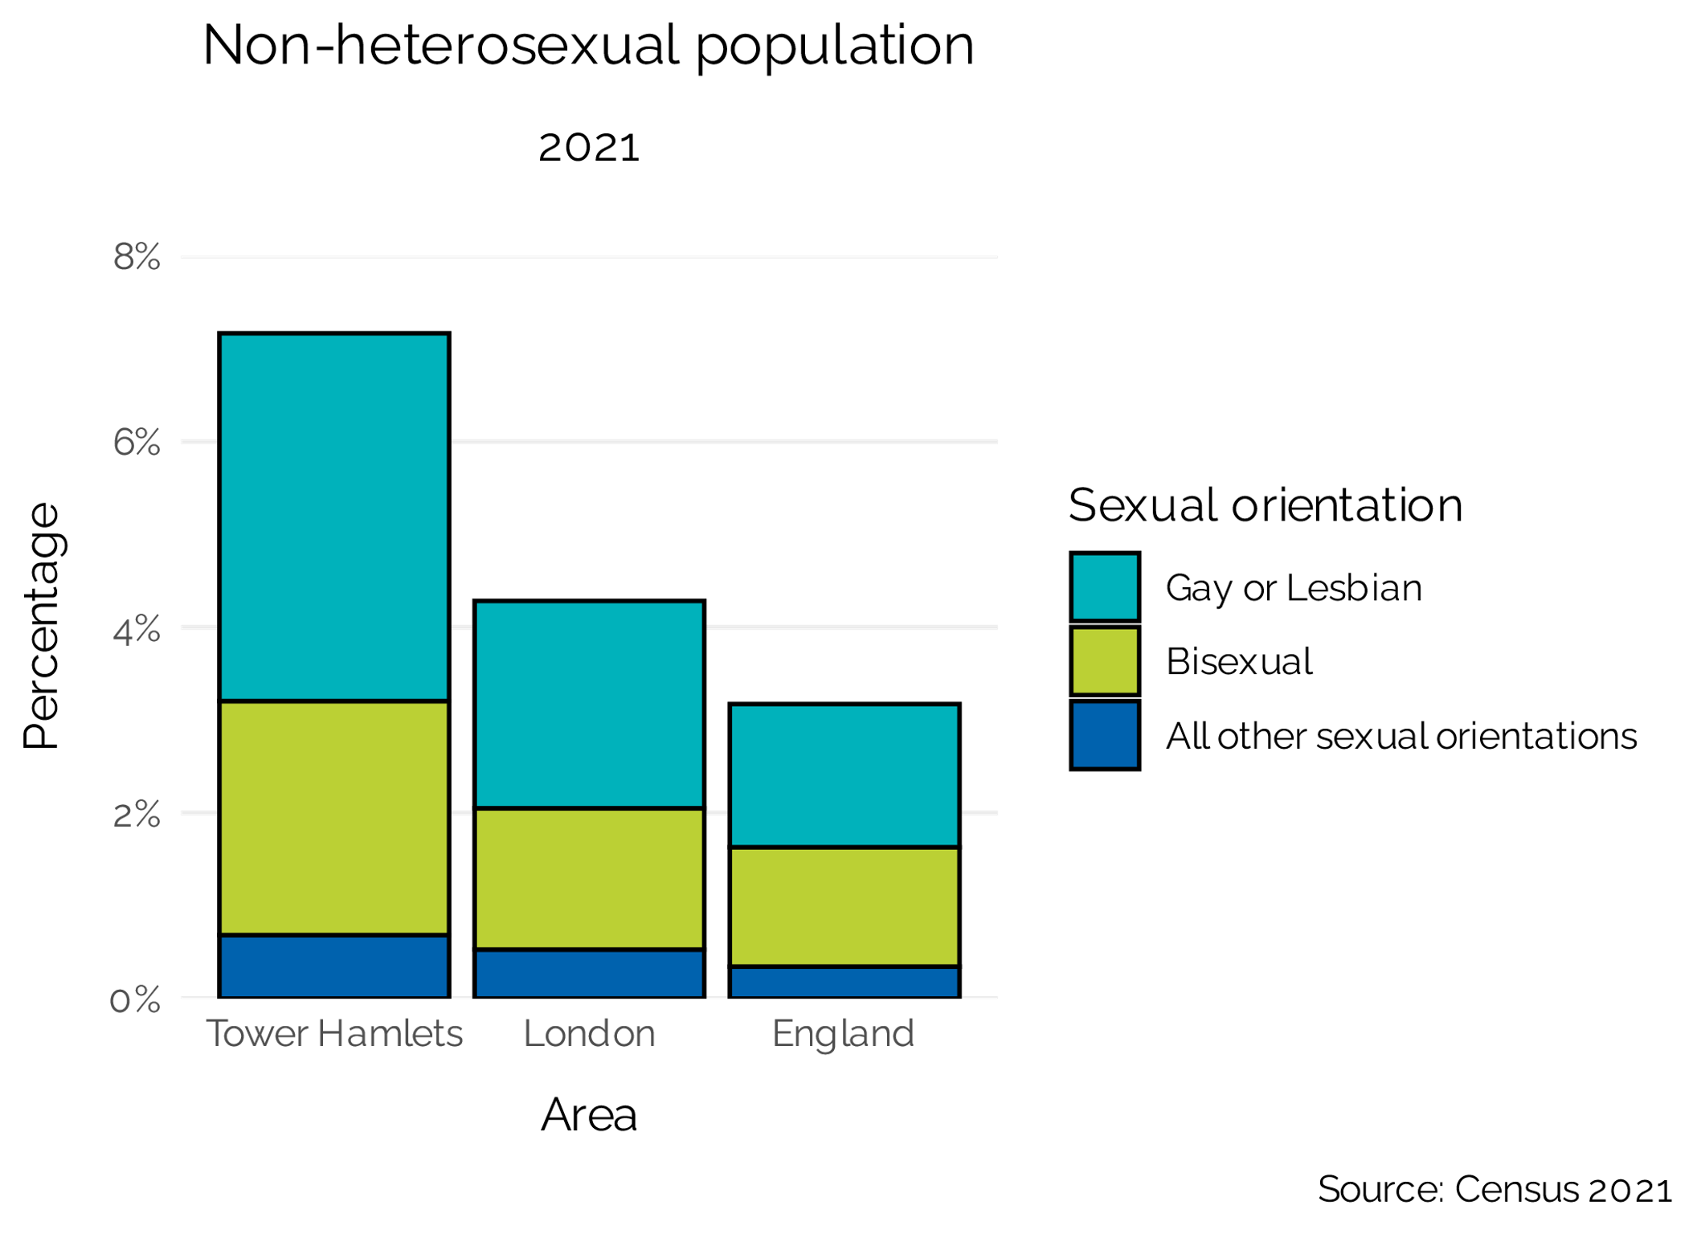

Figure 6: Non-heterosexual population, 2021

Gender identity

It is difficult to measure gender identity in the population. One preliminary estimate comes from the 2021 Census, where over 2,600 people in Tower Hamlets said that they have a gender identity which is different from their sex registered at birth.This represents 1.0% of residents, which is higher than London (0.9%) and England (0.5%). Additionally, compared to London and England, a higher proportion of people in Tower Hamlets said that they have a gender identity other than “man” or “woman”.

These figures should be taken with caution as there is evidence that this question may have been confusing to some people, particularly people whose first language is not English[12].

Nevertheless, it remains important to use gender-inclusive language in public health communications, administrative forms, and community events.

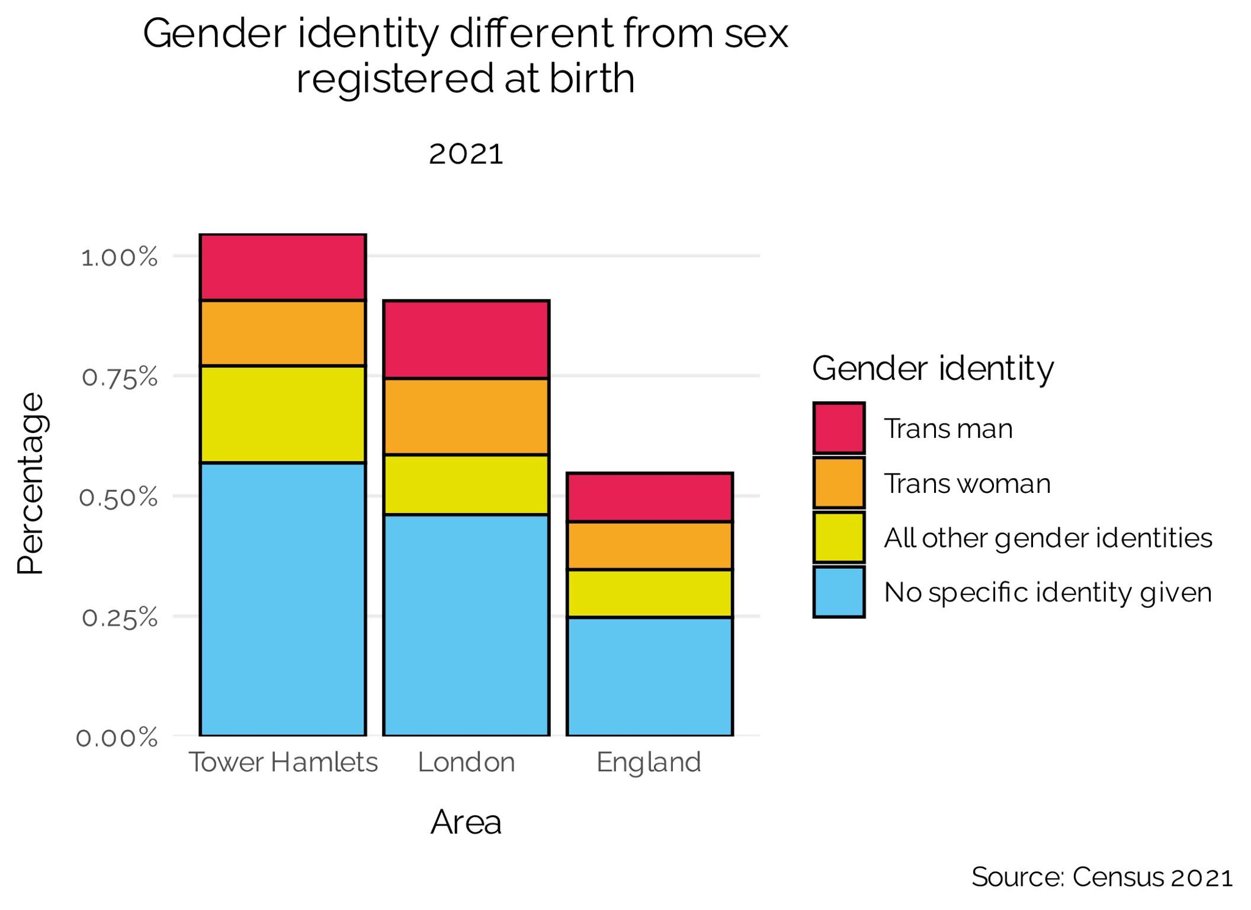

Figure 7: People whose gender identity is different from their sex registered at birth, 2021

Disability

A fifth (20.1%) of the Tower Hamlets population are recorded as having some level of disability, higher than the London and England averages.

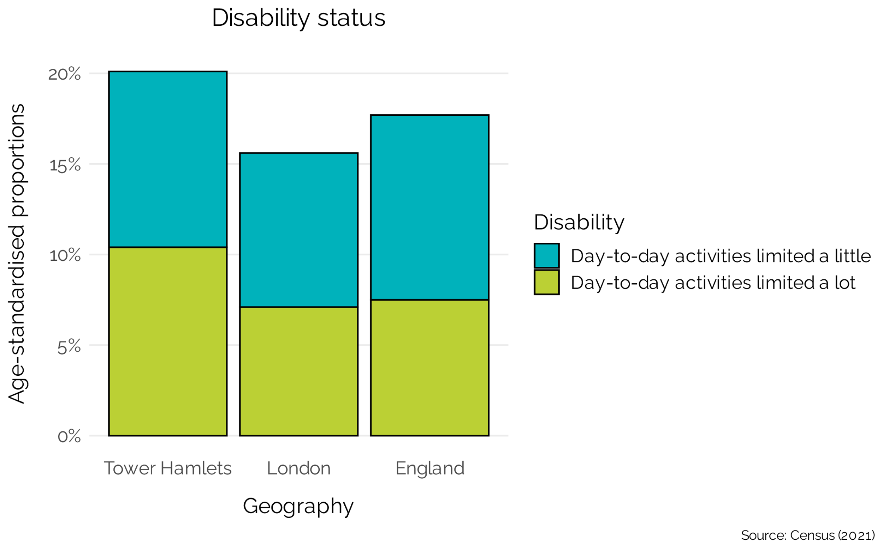

Figure 8: Disability status, 2021

Economic deprivation

Tower Hamlets has high levels on inequality, with the most and least deprived living shoulder to shoulder. 30.6% of the Tower Hamlets population live in the most deprived areas in England. As shown in figure xxx, income deprivation affecting children and older people is particularly bad. Tower Hamlets ranks 14th out of 417 local authority areas for income deprivation affecting children, and 1st for income deprivation affecting older people.

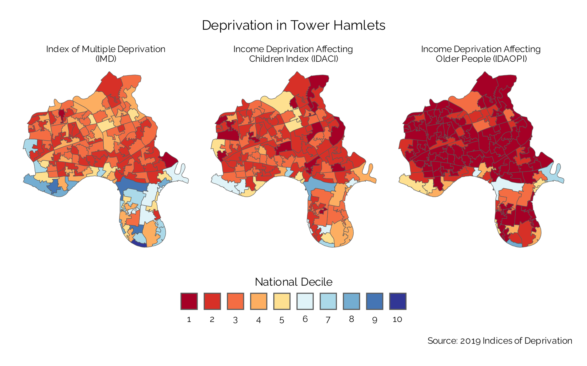

Figure 9: Deprivation in Tower Hamlets, 2019

Population projections

Tower Hamlets was the fastest growing population of any local authority in England between 2011 and 2021, increasing by 22.1% (56,000 people). Over the next 20 years, Tower Hamlets is projected to grow by a further 18.4% (57, 800 people). Those aged 25-49 are projected to contribute by far the largest number of people living in Tower Hamlets.

As shown below, the rate of change is projected to be greatest in the middle aged and older adults. Those aged 50-64 are projected to increase by 53.6% whilst those aged 65+ are projected to rise by 88.5%, compared to 17.1% and 55.7%, respectively, for London[13].

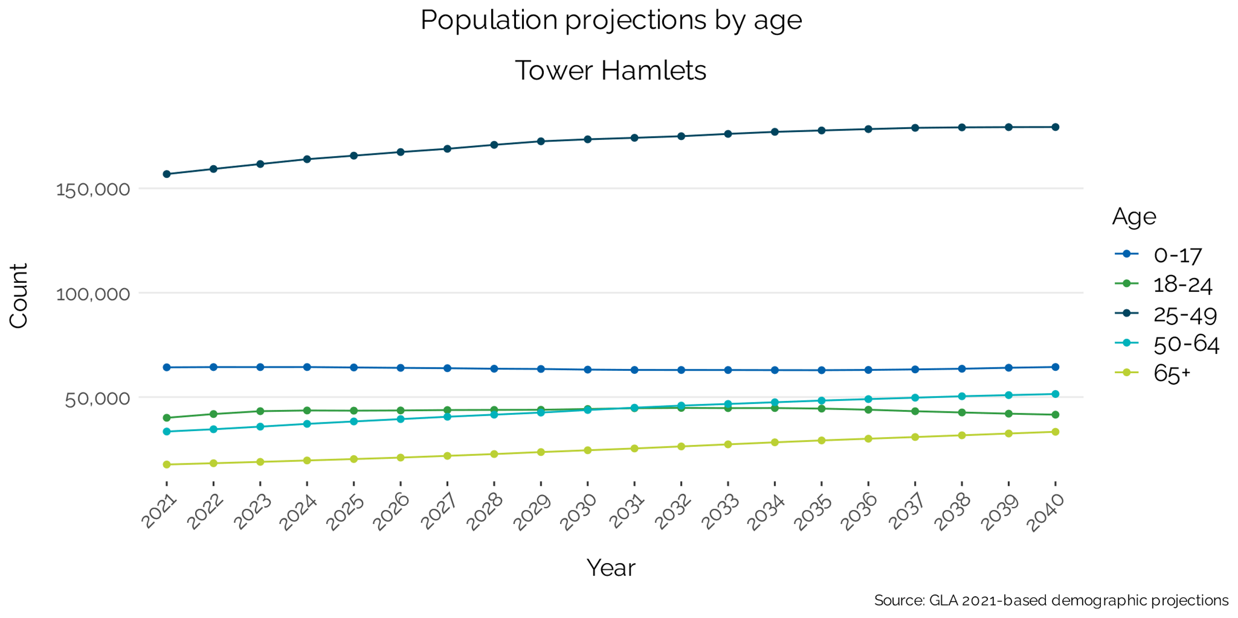

Figure 10: Population projections by age

As the population of older adults in the borough is set to increase, consideration should especially be given to what interventions are offered for this age group.

Overarching health indicators

Life expectancy has improved over the last 20 years from 79 to 81 to females and from 73 to 77 for males. However, as shown below, life expectancy in Tower Hamlets has remained consistently below London and England averages.

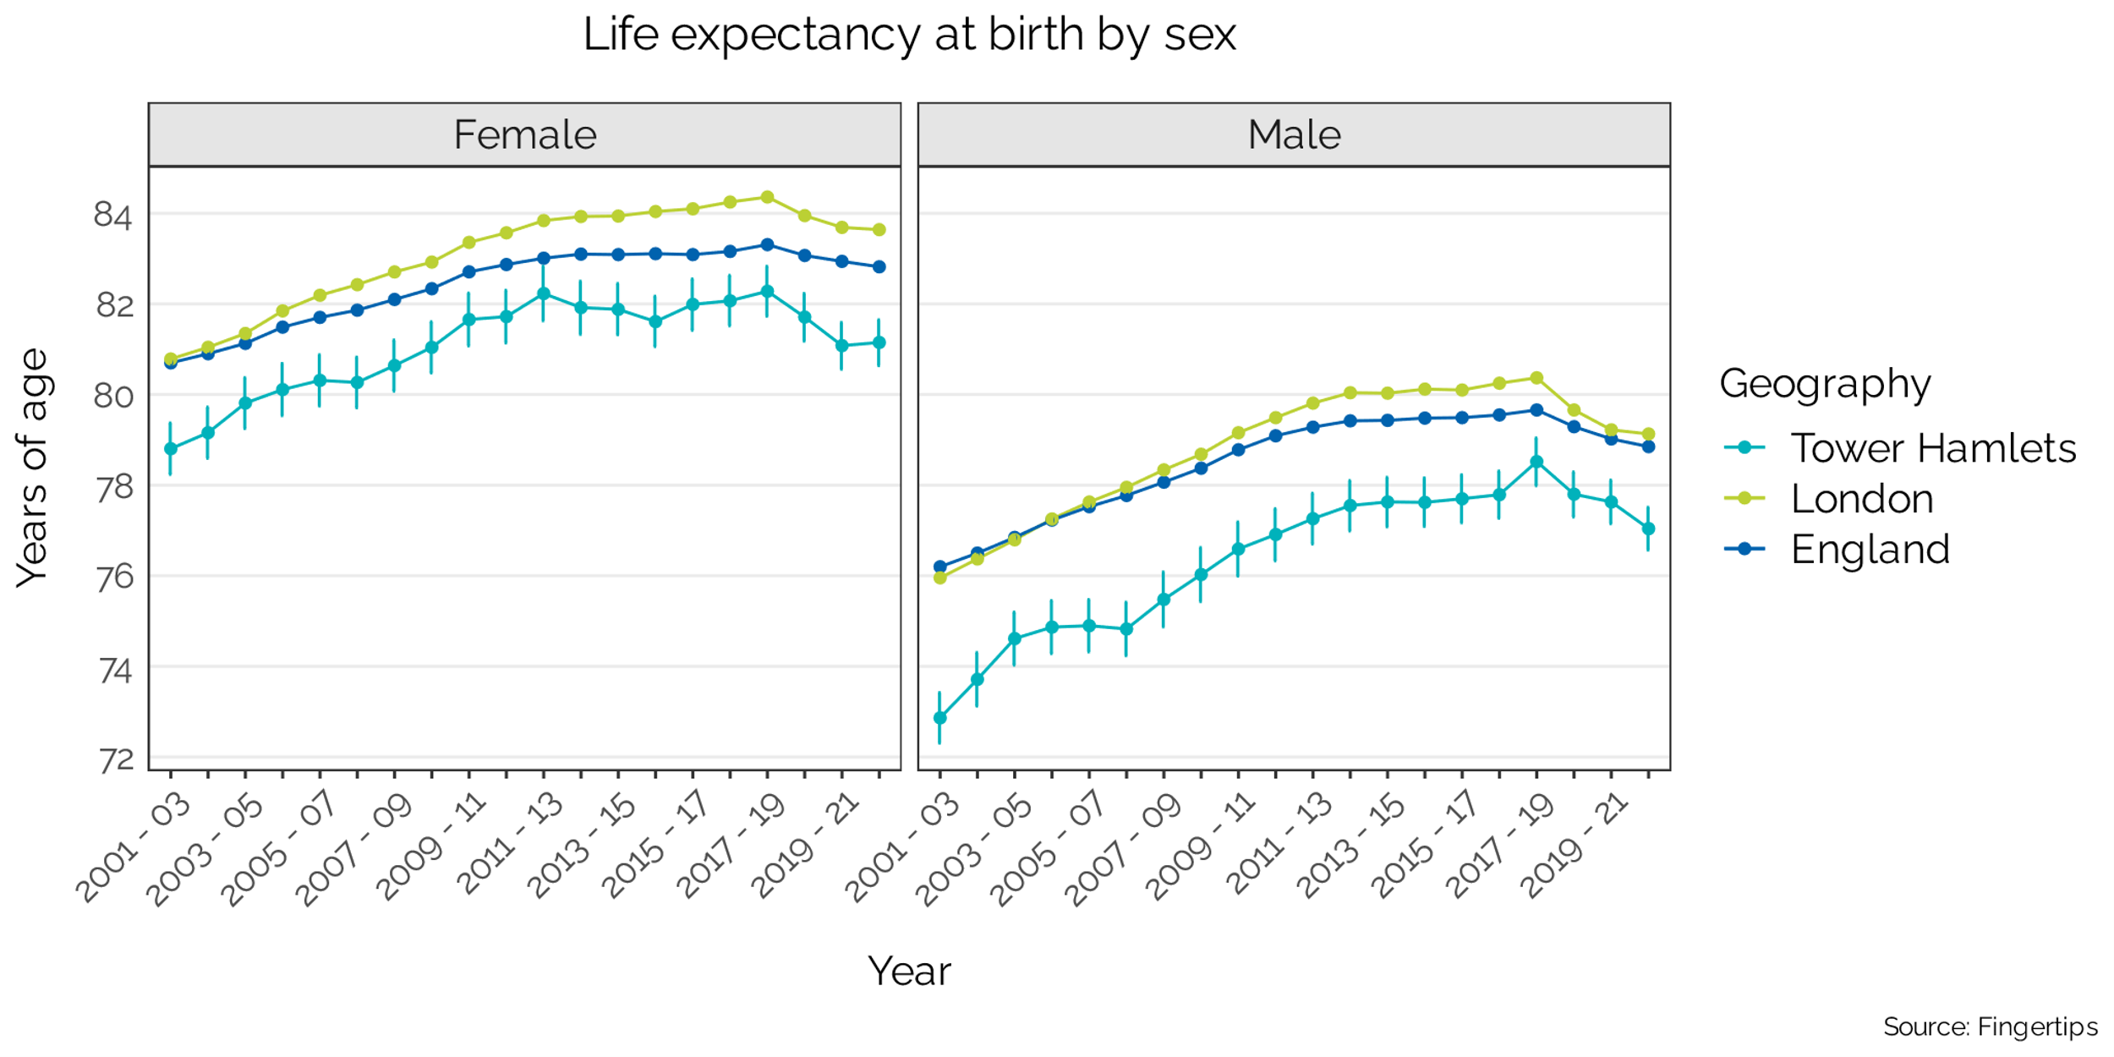

Figure 11: Life expectancy at birth by sex

Heathy life expectancy, which is a measure of the number of years people can expect to live in good health, has increased significantly for males over the last 10 years, reaching 65, which is similar to London and England averages. However, for females in the borough, healthy life expectancy has remained below London and England averages and is currently at 58.

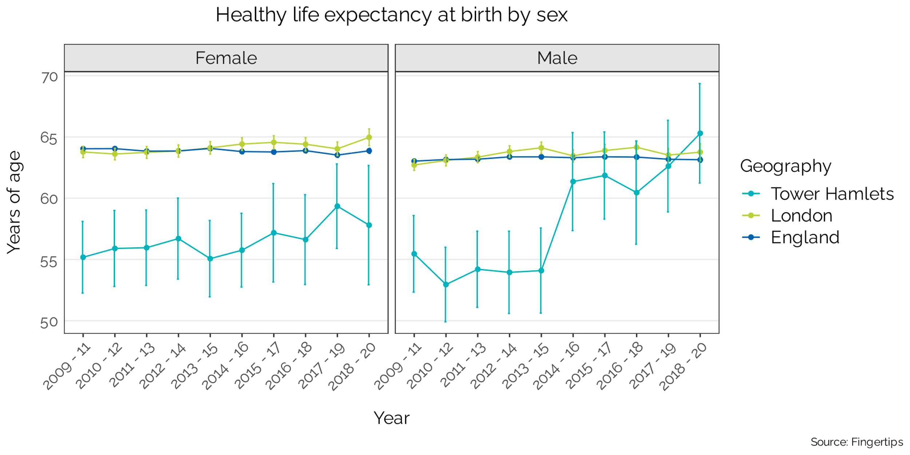

Figure 12: Healthy life expectancy at birth by sex

## Tower Hamlets physical activity in comparison

The section below gives an overview of physical inactivity data in Tower Hamlets, for both adults and children and young people. The levels of inactivity are compared to London and England averages to provide a comparison and benchmark.

#### *Physical activity in adults*

A higher proportion of adults in Tower Hamlets are inactive compared to London and England. The most recent Active Lives Survey found that the proportion of adults (19+) who are inactive (less than 30 minutes of activity per day) is 26%, compared to 23.7% in London and 22.4% in England as a whole.

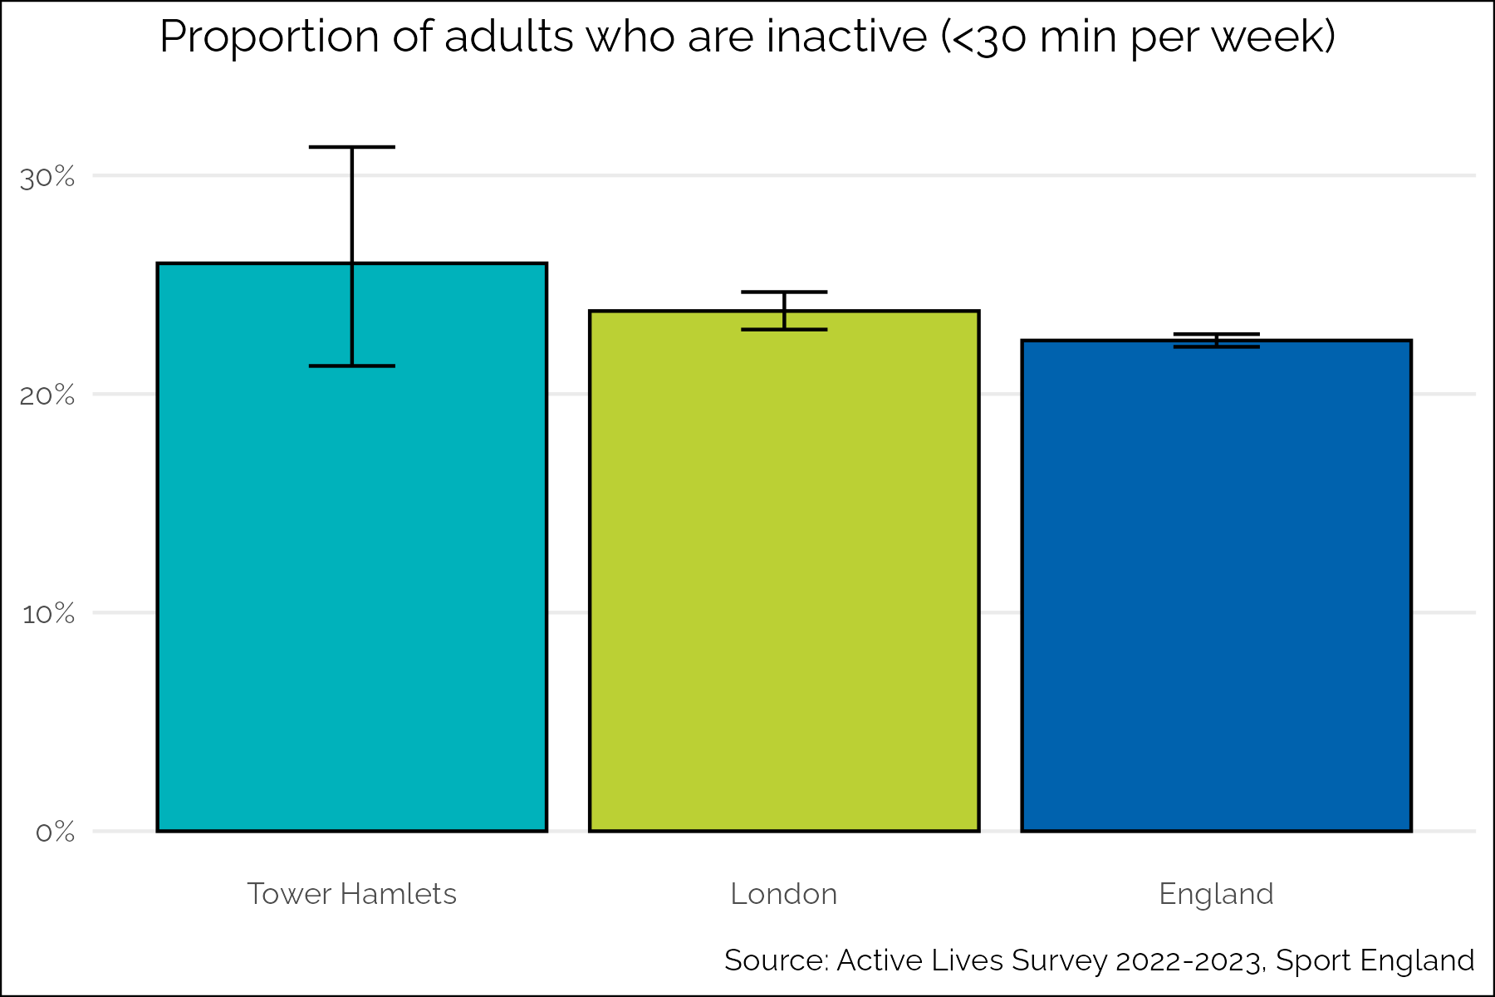

Figure 13: Proportion of adults who are inactive, 2022-2023

However, given that the adult population in Tower Hamlets is relatively young, and younger people tend to be more active, we might expect lower levels of inactivity than other areas. In order to take account of the age profile of the population, the activity data was age-standardised. Once this was done, we find that there is a significantly higher level of inactivity in Tower Hamlets compared to London and England. As shown by the figure below, the age standardised prevalence of inactivity in Tower Hamlets is 32.0% compared to 25.1% in London and 22.9% in England.

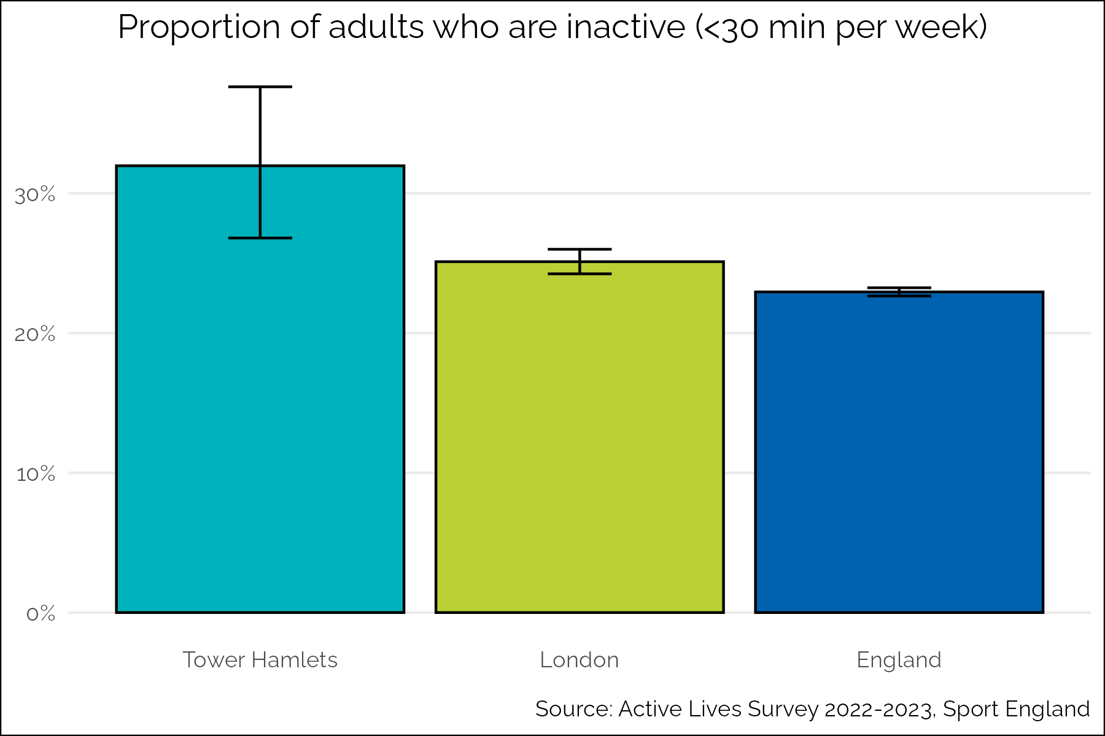

Figure 14: Age-standardised proportion of adults who are inactive, 2022-2023

Over time the levels of inactivity in Tower Hamlets have been broadly similar to the London and England averages, except for the period during the Covid-19 pandemic when the inactivity levels were significantly higher. It is also worth considering here that if we took age into account for the trend over time Tower Hamlets may have higher than average levels of inactivity.

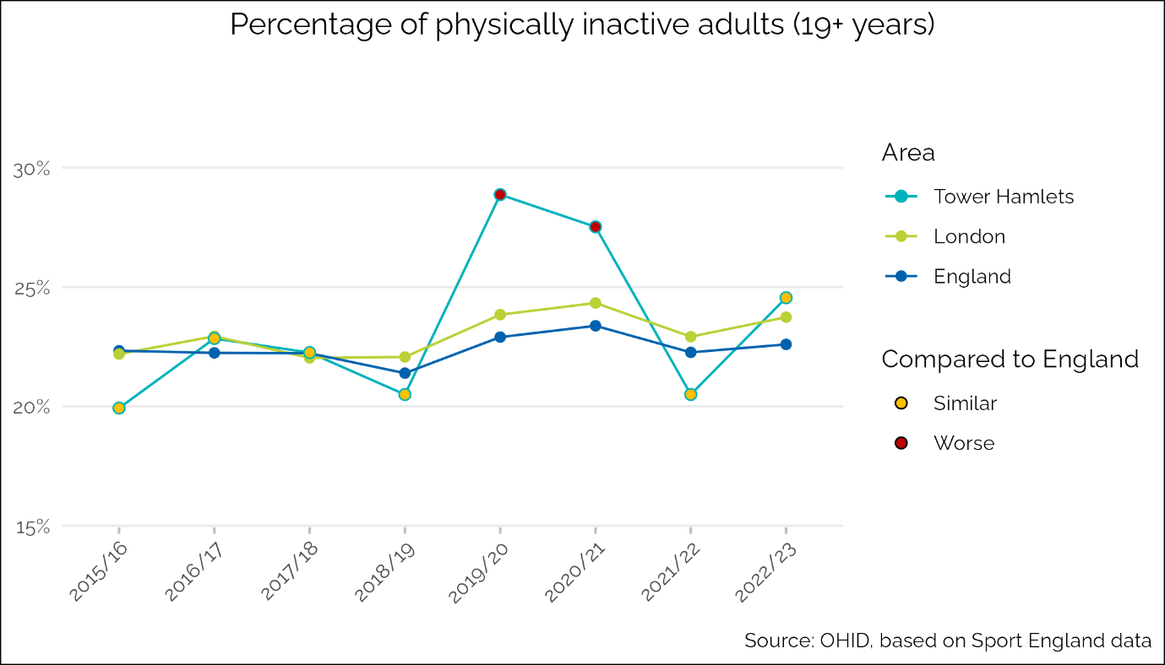

Figure 15: Percentage of adults who are inactive over time, compared to London and England

Insight work for specific service development, which will be touched on in more detail later in this report, suggests that there are a range of barriers to physical activity for the population in Tower Hamlets including affordability, accessibility, lack of time, cultural expectations and safety.

#### *Physical activity in children and young people*

A higher proportion of children and young people in Tower Hamlets are ‘less active’ (doing less than 30 minutes of moderate activity a day) than in London and England. The proportion ‘less active’ is similar in the wider inner North East London (inner NEL) area (Tower Hamlets, City of London, Hackney and Newham). 39.7% of children and young people in Tower Hamlets are ‘less active’, compared to 41.7% in inner NEL, 32.6% in London and 30.3% in England.

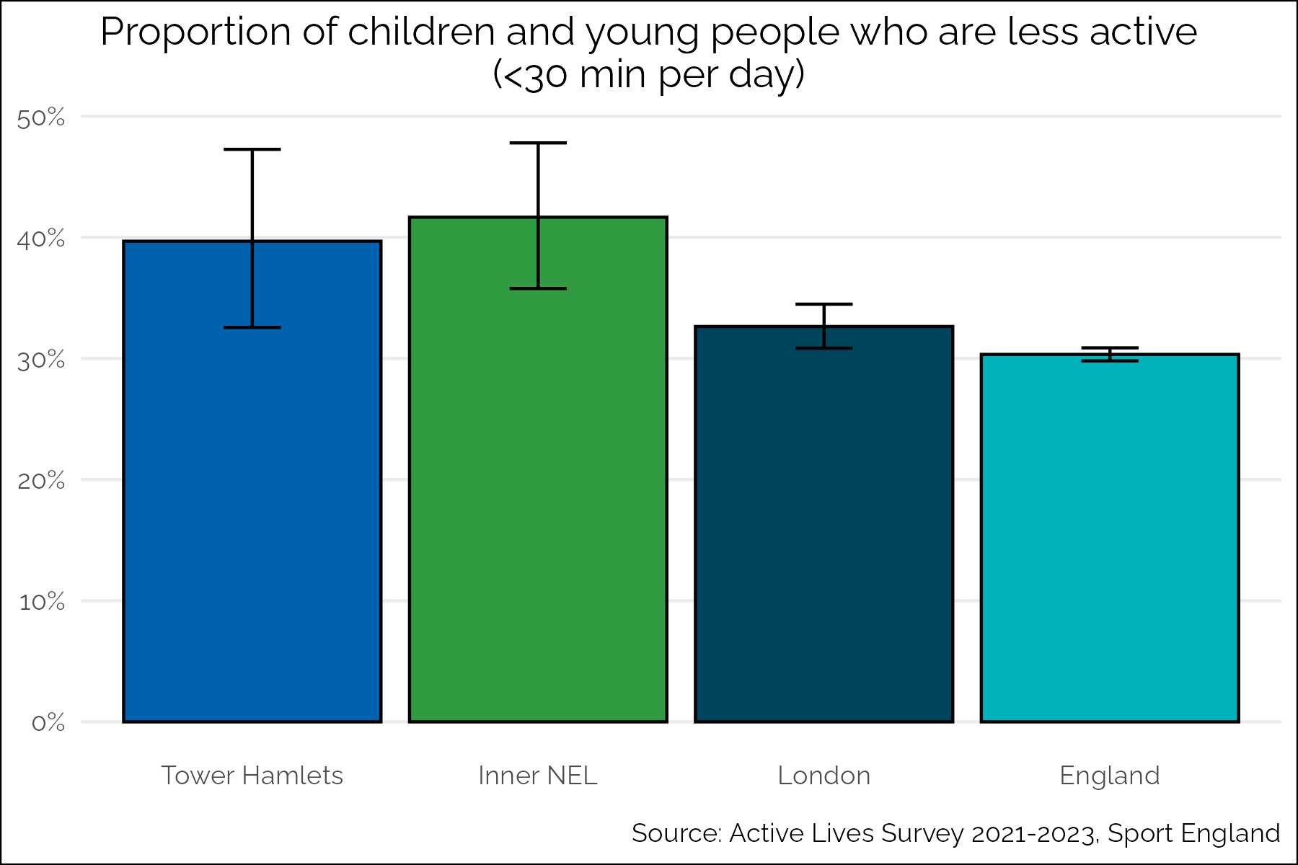

Figure 16: Proportion of children and young people who are 'less active', compared to inner NEL, London and England

There is a paucity of evidence on the main drivers and barriers to physical activity for children and young people in the borough. Insight work that has been done for specific service development will be presented in later sections of the report, and this shows that overall barriers are likely to include feeling unsafe both from crime and road danger, cultural and social expectations, and a lack of facilities and opportunities to be active.

## Inequalities in physical activity

This section describes quantitative and qualitative physical inactivity data by sociodemographic characteristics to highlight where there are inequities in the distribution of inactivity in Tower Hamlets.

#### *Sex*

As shown in the figure below, 22.6% of men in the borough do less than 30 minutes activity per week, compared to 26.2% of women. This suggests that there may be a higher prevalence of inactivity among women than men in the borough. The difference between men and women’s inactivity found locally was not statistically significant. However, on both an England and London level there is a significant difference in inactivity by sex so it is reasonable to assume this may also be the case locally, and that the small sample size when the data is restricted to Tower Hamlets only has limited our ability to detect the difference in this analysis.

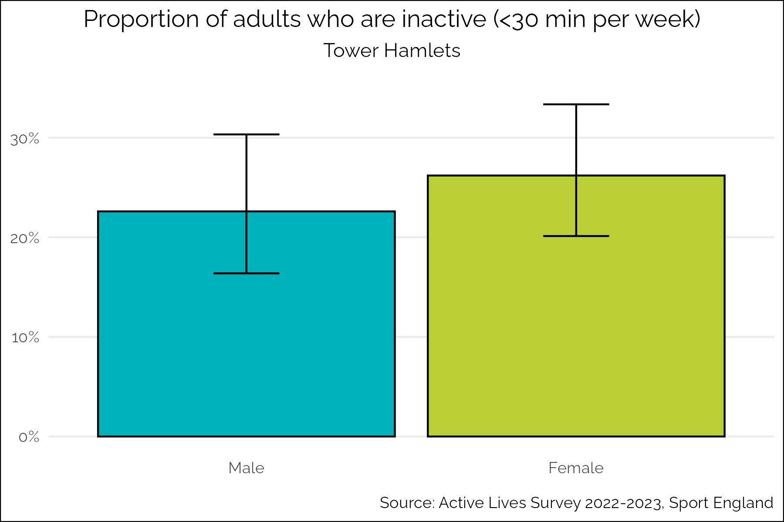

Figure 17: Proportion of adults who are inactive by sex, 2022-2023

Though the overall levels of inactivity are higher for both men and women in Tower Hamlets, the activity gap is broadly similar to the gap in activity between men and women nationally, with 21% of men in England as a whole being inactive, compared to 24% of women.

A difference in activity levels by sex was found in the Tower Hamlets ARS, with 39.5% of men doing less than the recommended amount of activity compared to 50.3% of women.

While we do not have local data on physical activity during pregnancy, national data from the Active Pregnancy Foundation suggests that women’s aerobic activity reduces by about half during pregnancy and that many women do not get back into activity postnatally[14].

Girls in Tower Hamlets are slightly more likely to be ‘less active’ than boys, though the difference was not statistically significant. 39.2% of boys in the borough do less than 30 minutes activity per day, compared to 41.8% of girls.

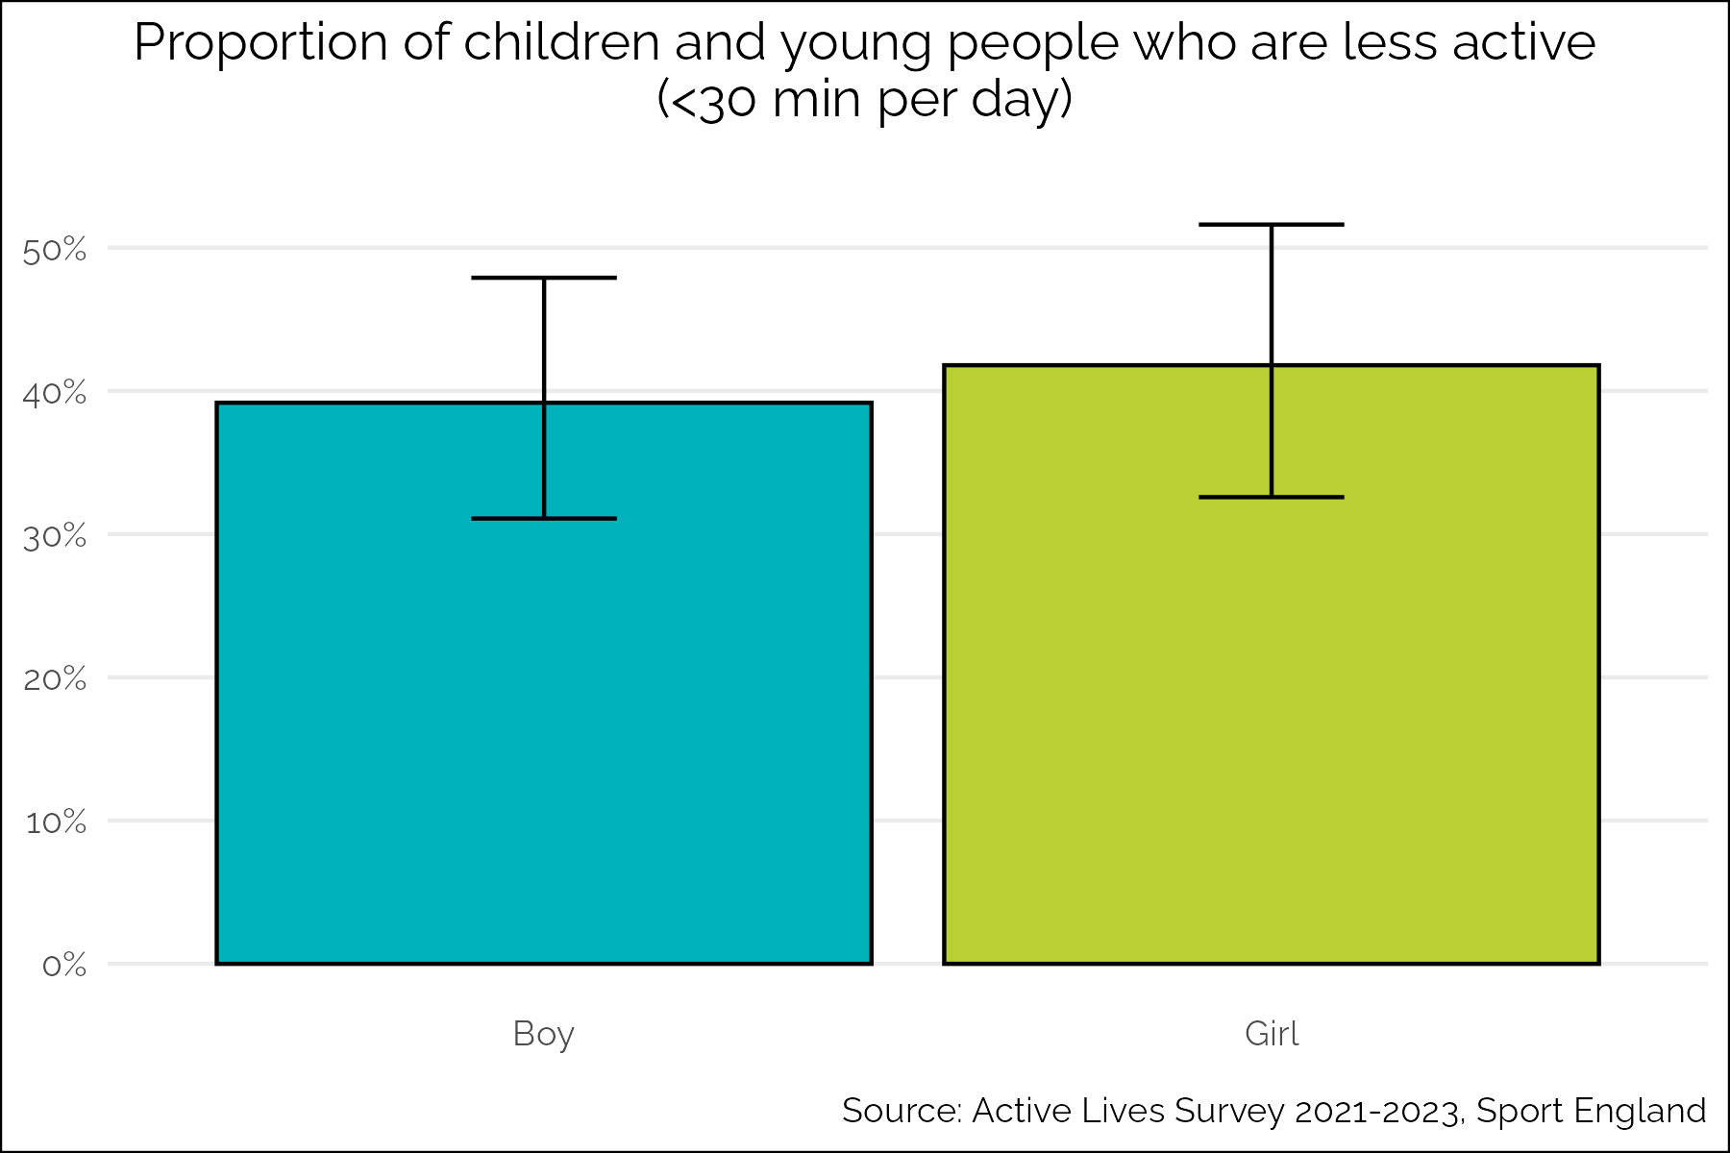

Figure 18: Proportion of children and young people who are less active by sex, 2021-2023

There are likely to be a range of barriers to women and girls’ physical activity in the borough. An engagement session held with 80 local women to discuss the insourcing of the leisure service found the following were barriers to access of leisure services:

* Affordability
* Accessibility for disabled people
* Feeling unsafe getting to and from centres
* Lack of lighting around centres
* Lack of female only sessions
* Poor hygiene in communal areas

This is reflective of national studies, which have highlighted women and girls’ feelings of safety as a key barrier, along with other factors such as lack of time, body image, cultural expectations and social support[15].

#### *Age*

Older adults in Tower Hamlets are more inactive than younger adults. As the figure below shows, 42.7% of older people (65+) are inactive compared to 23.3% of adults under 65.

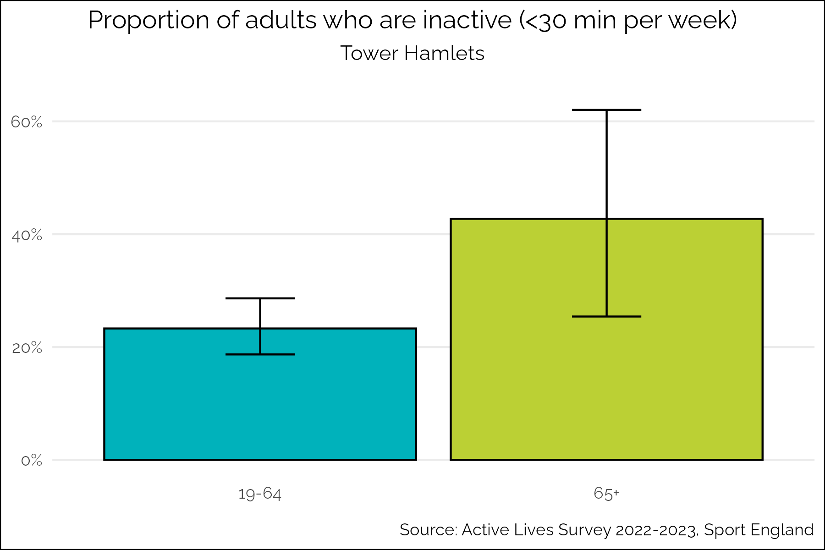

Figure 19: Proportion of adults who are inactive by 2 age groups, 2022-2023

The regression analysis found strong evidence (p < 0.001) for a large positive association between increasing age and increasing odds of being inactive, after controlling for gender, ethnicity, and deprivation. Compared to the baseline group of residents aged 20-24, each unit increase in 5-year age band was associated with 11.9 times the odds of being inactive (OR 11.9, 95% CI 2.9-48.9).

Given the high level of income deprivation among older residents, affordability is often cited as a barrier to more physical activity. As detailed later in this report, older people are particularly impacted by accessibility challenges, both in accessing services such as leisure centres, and in getting around the borough due to narrow and cracked pavements for example.

When we compare these figures to the national breakdown we can see that older people in Tower Hamlets are much more inactive than older people nationally. In England, 20.4% of people 19-64 are inactive, and 29.4% of people 65+ are inactive.

When we breakdown age groups further, as shown in the figure below, we can see that there is potentially a peak of inactivity for people in middle age (45-54). This could be due to increasing caring responsibilities, for both children and older relatives, while often still needing to work.

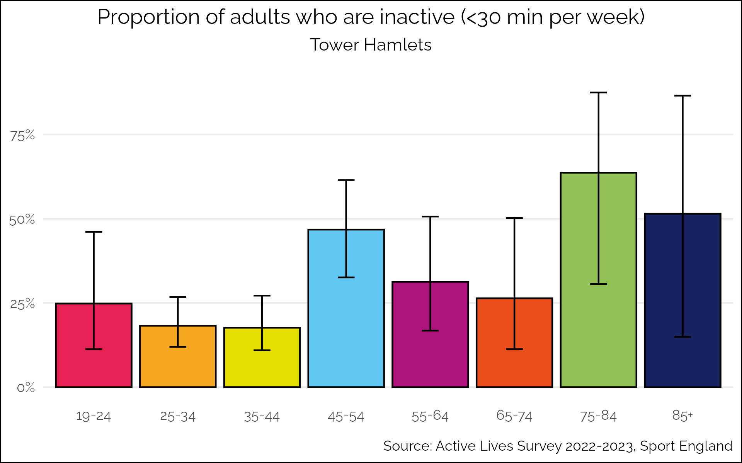

Figure 20: Proportion of adults who are active by 8 age groups, 2022-2023

#### *Socioeconomic position*

Using the Index of Multiple Deprivation as a proxy for socioeconomic position (SEP), we can see that people with lower SEP are more likely to be inactive than people with higher SEP in Tower Hamlets. 26.9% of people living in the most deprived areas are inactive compared 19.3% in the least deprived areas, a gap of 7.6%.

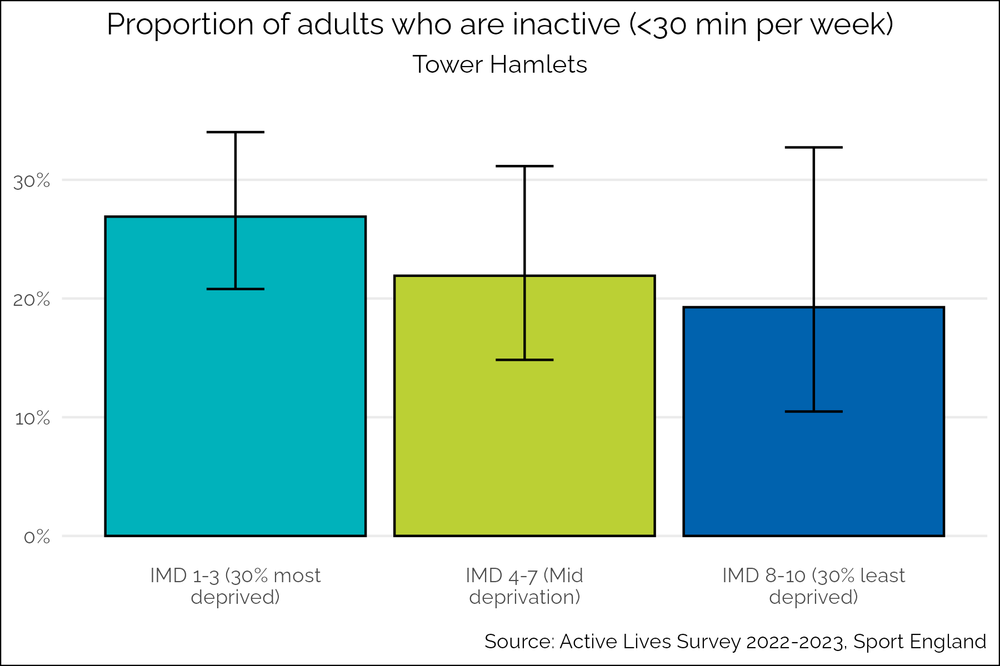

Figure 21: Proportion of adults who are inactive by socioeconomic position, 2022-2023

There is also a gradient of physical inactivity by deprivation seen at a national level, however the gap is smaller in Tower Hamlets. Nationally, 30.8% of people in the most deprived groups are inactive compared to 17.1% in the least deprived areas, a gap of 13.7%.

The differences observed in Tower Hamlets are not statistically significant. However, there is strong statistical evidence for a positive association between deprivation and physical inactivity at the national and regional levels, and deprivation is known to be highly associated with many health outcomes and risk factors. This suggests that the lack of statistical evidence when working at Borough level likely reflects the small sample size when the data is restricted to Tower Hamlets residents only, leading to a lack of power to detect any differences which may exist.

Affordability of physical activity opportunities is often cited as a barrier for residents, and given the levels of deprivation in the borough this is likely to play some part in the higher inactivity among the most deprived residents.

#### *Ethnicity*

There is variation in inactivity levels across ethnic groups in the borough. There is a significant difference between inactivity between the white British and Asian groups. 16.8% of white British adults are inactive compared to 37.8% of Asian adults.

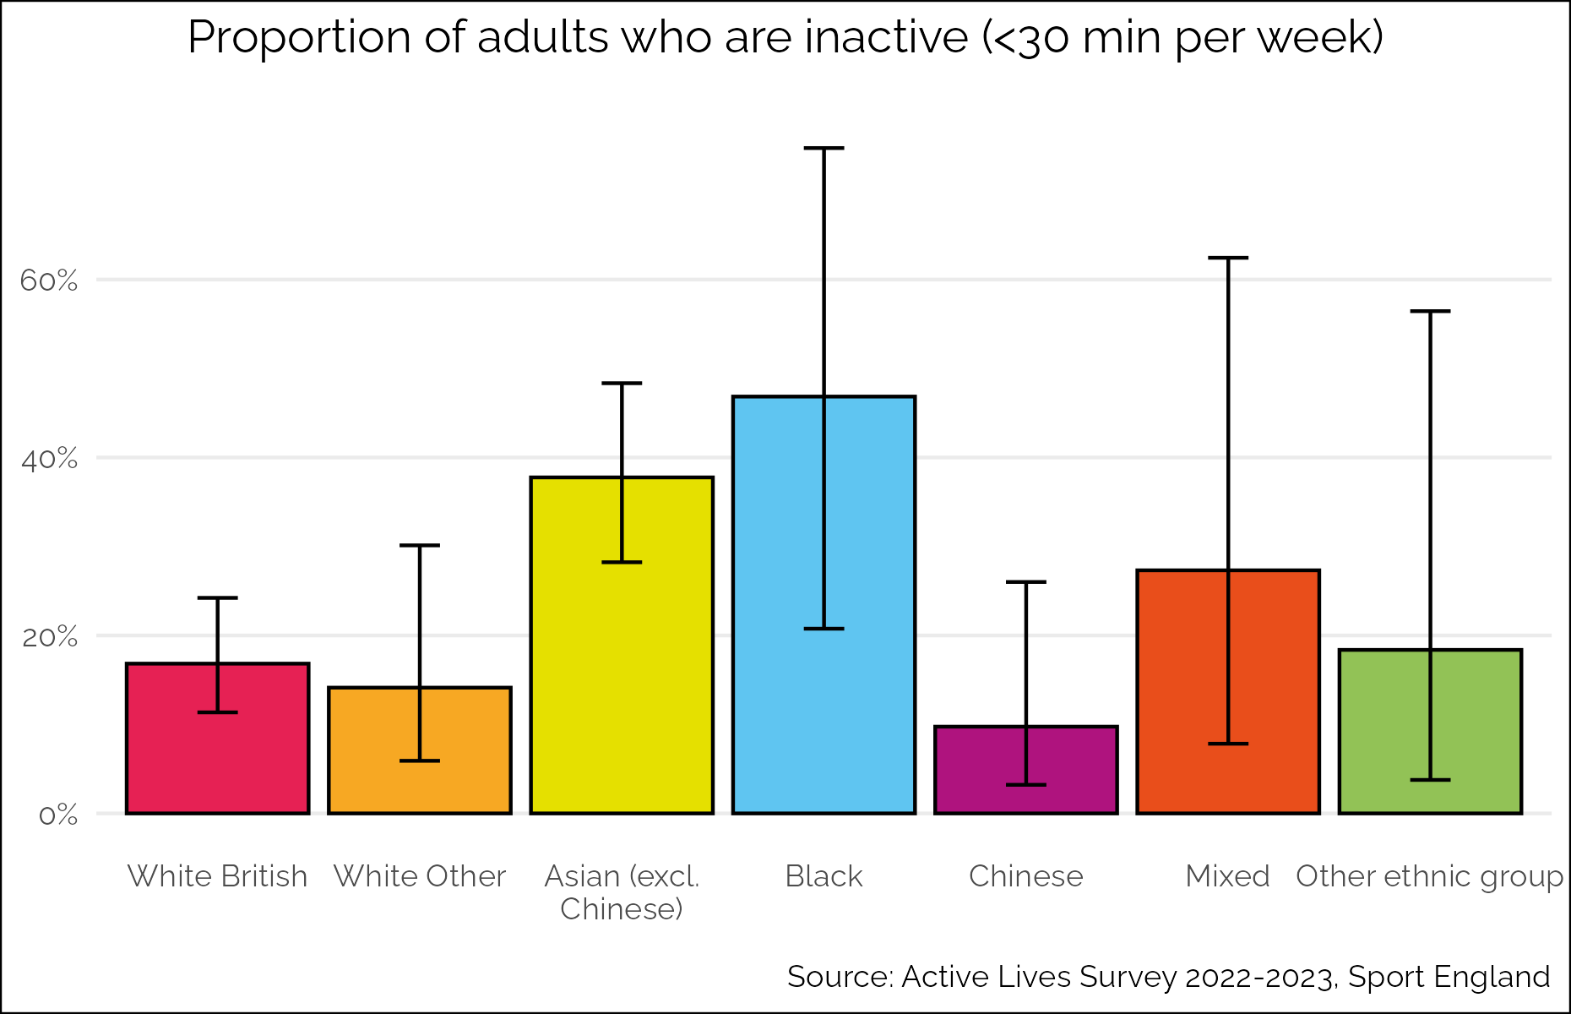

Figure 22: Proportion of adults who are inactive by ethnicity 2022-2023

This difference is reflected in the ARS data, which shows that 51.7% of Asian residents are doing less than the recommended two and a half hours of activity, compared to 39.6% of white residents.

The regression analysis of the Adults ALS data found strong evidence (p < 0.01) to suggest that Asian (excluding Chinese) and Black respondents had higher odds of being inactive compared to white British respondents, after controlling for gender, age, and IMD decile of residence (OR 4.74 (95% CI 2.17-10.38) and 6.37 (95% CI 1.58-25.65) respectively).

A workshop was held in early 2024 with 40 members of the community from diverse backgrounds to discuss their barriers to participation in Parkrun. This found seven themes which give an indication of some of the specific barriers for groups from global majority backgrounds in the borough:

* Lack of clarity on what Parkrun is and why residents might participate
* Lack of diversity of Park Run participants
* Problems with timing and motivation
* Anxiety about participating
* Physical health constraints
* Competing priorities on a Saturday morning
* Digital poverty
* Cold weather

Local data suggests that non-white British children and young people are more active than children and young people from other ethnicities. 59.5% of white British children and young people are less active, compared to 29.3% of children and young people from other ethnicities combined.

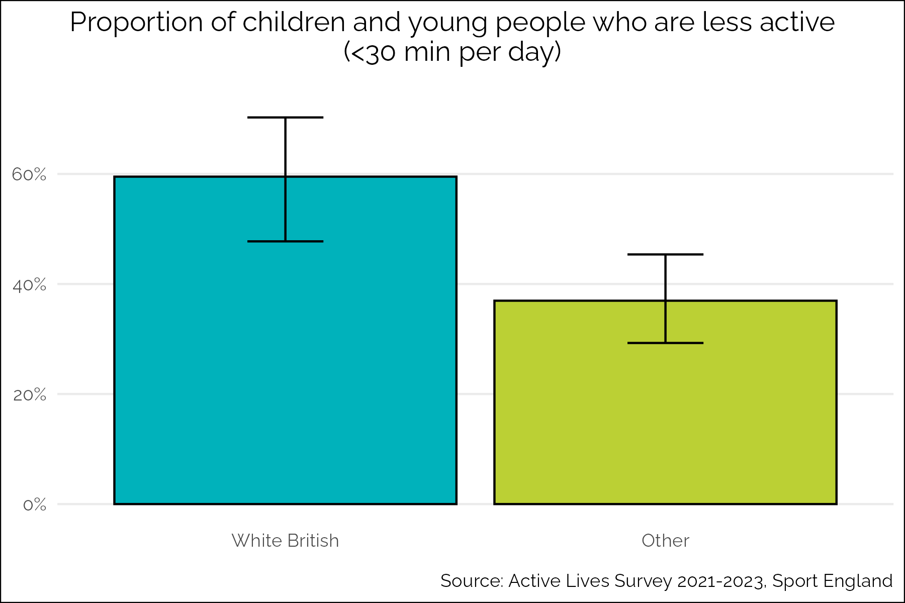

Figure 23: Proportion of children and young people who are less active by ethnicity, 2021-2023

This is the opposite of the national and London picture where we see that children and young people from Black, Asian and other ethnicities are the least likely to be active. In England 27.6% of white British children are ‘less active’ compared to 32.7% of children from other backgrounds. In London 29.0% of white British children are ‘less active’ compared to 32.2% of children from other backgrounds.

As we have very small numbers in the Tower Hamlets analysis for children, we analysed the data for the wider inner north east London area (Tower Hamlets, Hackney and Newham). These figures were similar to the Tower Hamlets findings, with 60.7% of white British children ‘less active’ compared to 38.6% of children from other backgrounds.

This disparity suggests that locally there may be more of an issue with inactivity among white British children than children from ethnic minority backgrounds. However, the limitations of small sample sizes and the fact that the survey was done in schools which can lead to some demographic clustering means that we should be cautious with our interpretation of this data.

#### *Ethnicity by sex*

When we further break down ethnicity data by sex, we find that there is an activity gap between men and women within ethnic groups. This is particularly the case in the Asian (excl Chinese) group, in which 29.1% of Asian men are inactive, compared to 46.4% of Asian women. This suggests that Asian women should be particularly considered in the development of new initiatives to tackle inactivity.

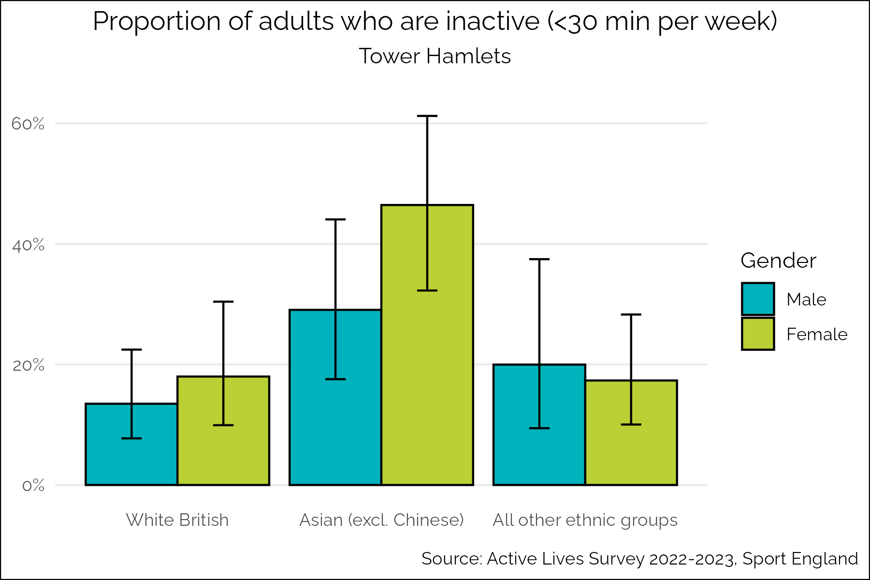

Figure 24: Proportion of adults who are inactive by ethnicity and sex, 2022-2023

A focus group, held with Bangladeshi women to discuss their barriers to taking part in Parkrun in the borough, found that the following were key barriers to participation:

* Awareness of the event
* Cultural and gender barriers such as not being happy to run with men
* Location and safety concerns such as worries about dogs in the park
* Family commitments that clash with the timing of the event

While this focus group only considered Parkrun participation, it gives us some insight into the general reasons why women from Bangladeshi backgrounds might not be taking part in some of the physical activity opportunities offered in the borough.

#### *Disability*

A significantly higher proportion of disabled people in Tower Hamlets are inactive compared to non-disabled people. As shown below, 42.5% of disabled people are inactive compared to just 17.9% of non-disabled people.

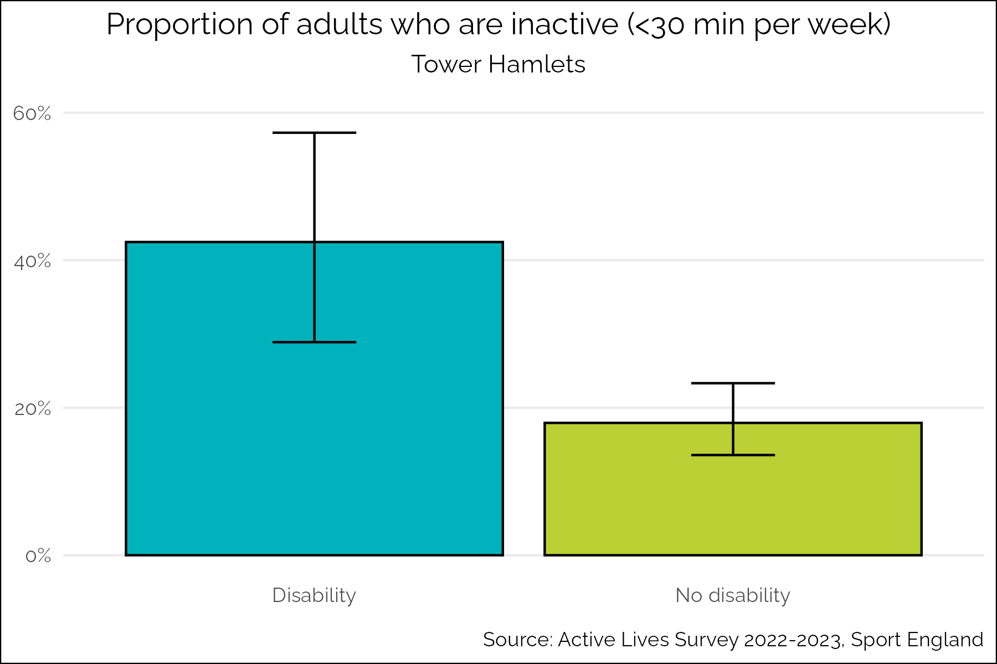

Figure 25: Proportion of adults who are inactive by disability status, 2022-2023

When we compare to national averages, there is a similar activity gap by disability. In England, 35.8% of disabled people are inactive compared to 18.1% of non-disabled people.

Accessibility of services, both in terms of physical accessibility and staff training to support specific needs, is often cited as a key barrier for disabled adults and children and young people in the borough.

For children and young people there is a small difference in activity levels by disability, with non-disabled children and young people more likely to be ‘less active’. As the figure below shows, 41.6% of children and young people with disabilities are less active, compared to 39.9% of non-disabled children and young people.

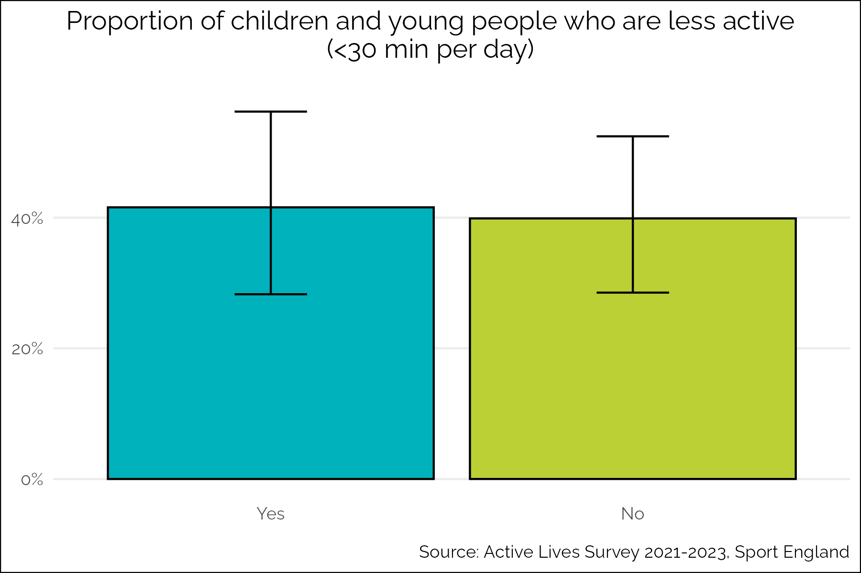

Figure 26: Proportion of children and young people who are less active by disability status, 2021-2023

#### *Sexual orientation*

Neither the ALS nor ARS collect information about physical activity from a large enough sample of non-heterosexual people in Tower Hamlets to present local data here.

National data shows that non-heterosexual people generally have higher levels of activity than heterosexual people. Sport England report that 64% of heterosexual adults are active compared to 71% of gay men, 73% of lesbian women and 70% of bisexual people[9].

We do not know how well this data translates to a Tower Hamlets level, and we have limited insight into whether the needs of non-heterosexual people are met by interventions to improve physical activity in the borough. As we have a large population of non-heterosexual people in the borough it would be valuable to understand more about their levels of physical activity to support the design of services and interventions.

#### *Locality*

The Annual Residents’ Survey allows us to break down activity levels by locality. As the map below shows, 59.9% of the residents in the south west of the borough do less than the recommended 150 minutes of physical activity a week. This is a higher proportion that the south east (50.1%) the north west (37.8%) and the north east (34.8%).

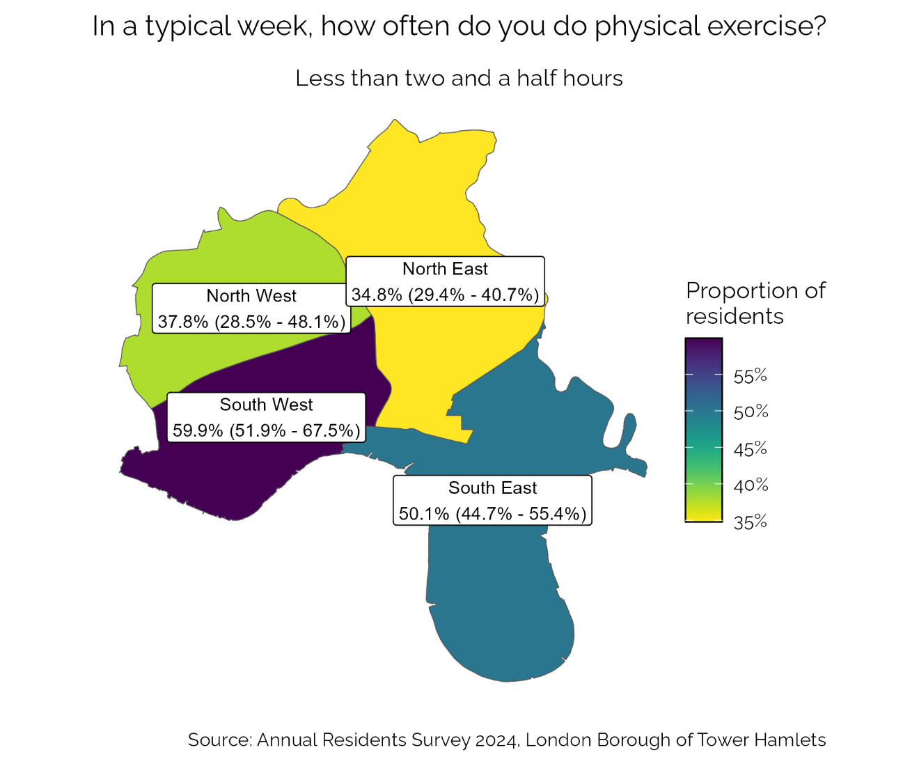

Figure 27: Proportion of adults who do less than two and a half hours of activity a week by locality, 2024

The south west of the borough is also the area with the highest levels of deprivation. As there is a correlation between inactivity and deprivation level this is likely to be related.

# Understanding Best Practice

This section describes best practice in improving physical activity. The section sets out the evidence on what works, what evidence-based interventions exist and what the strategic, operational and commissioning environment should look like for each of the WHO GAPPA themes of active systems, active society, active environment and active people[1].

## Active Systems

This WHO GAPPA theme is about how we strengthen local leadership in physical activity and put in place the right governance, policy and strategy approaches to enable partnerships to support residents to be physically active[1].

#### *Policy, strategy and governance for physical activity*

The WHO GAPPA highlights the importance of high-level multisectoral strategies and action plans on physical activity, bringing together leaders and representatives from across the whole system[1].

In 2017, Sport England funded 12 Local Delivery Pilots to test a place-based approach to improving physical activity. They have compiled learning from these local pilots to produce guidance on how local areas can develop their own Place Partnerships and engage in the work of system change. The key actions that they advise are:

* Develop a common purpose and shared values among the partnership
* Understand lived experience of local communities
* Distribute leadership across the system
* Give capacity and time for reflection
* Test and learn
* Shift power
* Have the right conversations with the people who can influence change
* Understand the system in order to shape it
* Understand value to develop evaluation systems that monitor the right things[16].

For children and young people, NICE recommends that physical activity should be explicitly addressed in children and young people’s plans, joint strategic needs assessments, development and planning frameworks and sustainability plans. They also recommend that plans should be co-produced with children and young people, particularly those who are less likely to be active[17].

#### *Leadership for physical activity*

NICE guidance recommends that Local Authorities appoint a physical activity champion at a senior level, who has physical activity as part of their portfolio, can lead multi-sectoral work, and ensure that physical activity is embedded across and beyond the local authority[18].

NICE guidance for physical activity in children and young people also recommends that a senior council member should be identified to act as a champion for physical activity. Their role should include promoting physical activity, making sure it is a priority in the development of plans and strategies, partnership working across the council and explaining the council’s role to partners beyond the council[17].

#### *Data, reporting, monitoring and evaluation*

Nationally, physical activity data is monitored through the Public Health Outcomes Framework (PHOF)[19]. This has the following indicators related to physical activity:

* The percentage of physically active children and young people
* The percentage of physically active adults
* The percentage of physically inactive adults

The PHOF is not a performance management tool, but it is intended to support local areas in benchmarking and monitoring their own progress against key public health indicators.

NICE recommend that local people are involved in developing local initiatives and defining priorities[20]. This process of collecting and acting on qualitative data should ensure that services and interventions meet the needs of residents and address their barriers to physical activity.

NICE guidance also recommends that physical activity initiatives aimed at children and young people should be regularly evaluated. The evaluation should measure uptake by sociodemographic group and changes in physical activity and health outcomes. Progress towards local targets on physical activity should also be monitored[17].

#### *Research*

The WHO GAPPA calls for more research into what is effective in increasing physical activity, particularly to increase the evidence base around what works for the least active[1].

## Active Society

This WHO GAPPA theme considers social norms and attitudes in relation to physical activity and how they are formed[1].

#### *Physical activity promotion*

The WHO GAPPA recommends that communications campaigns are run to increase awareness of the benefits of physical activity[1]. The Physical Activity Messaging Framework, developed in collaboration with international experts in physical activity, sets out an evidence-based approach to developing physical activity communications. The framework suggests that campaigns should be 1) developed with close consideration to audience and context, that 2) messages should be tailored based on audience and the best evidence of what is effective for each audience and 3) that the first two steps should guide the choice of message format and delivery[21].

The figure below shows the Physical Literacy Consensus Statement, a shared vision developed by Sport England with more than 50 organisations across sport, health, academia and community sectors. This highlights that people have a unique relationship with movement throughout their lives, and it’s important to understanding people’s needs and provide a safe and supportive environment[22]. These principles are important in guiding health promotion activities around physical activity.

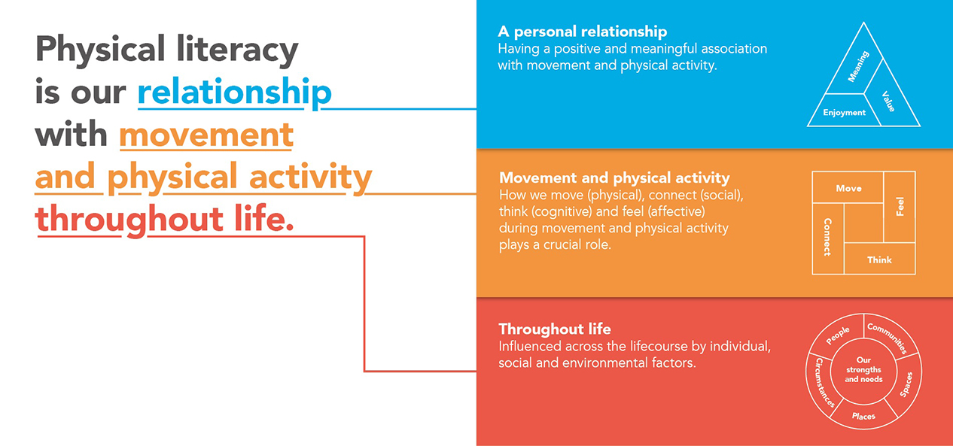

Figure 28: Sport England Physical Literacy Consensus Statement, 2022

Sport England are an arms-length body of the UK government responsible for growing and developing grassroots sport and getting more people active across England. Sport England’s ‘Uniting the Movement’ Strategy highlights that they expect to have a continued national role in delivering health promotion campaigns on physical activity. These will build on the success of recent national campaigns[10].

These recent national campaigns, designed to be tailored to specific audiences and positive in their messages about physical activity include the ‘We are Undefeatable’ campaign, which uses positive messaging to promote the benefits of physical activity to people with long term conditions[23]. ‘This Girl Can’ was designed to promote physical activity to women and girls, and focussed on tackling issues pertinent to women such as safety[24]. The ‘Join the Movement’ campaign was developed to support people to be active in the context of the Covid-19 pandemic and the restrictions on people’s lives[25].

Alongside promoting the benefits of physical activity generally, evidence suggests that promoting active travel is effective in getting people to move more. One systematic review found that promotion of active travel on a community level was significantly associated with increased physical activity levels[26]. For example, a study conducted in Scotland to evaluate a campaign to increase uptake of walking, cycling and use of public transport, found increased levels of physical activity in areas where the campaign had been rolled out compared to where it had not[27].

Active Travel England is the recently formed national government arms-length body responsible for active travel. Their corporate plan sets out that promotion of active travel is a key part of their role[28].

To encourage people from global majority background to cycle, evidence suggests it is particularly important to produce targeted materials featuring people from different backgrounds cycling. This helps address the perception that cycling is not for them[29].

For children and young people, the government have developed the 10 Minute Shake-up campaign, aiming to break down the 60 minutes of recommended activity into short burst, and make it engaging with Disney characters[30].

#### *Mass-participation events*

Mass-participation events, that are open to all, have been shown to be effective in developing social norms around physical activity[31]. Events such as Parkrun, which encourages people of all different abilities to complete a 5km run or walk together weekly, have been shown to improve physical activity levels of people who are traditionally less likely to be active[32].

However, it can be challenging to engage underrepresented groups in these sorts of events, and they are often not designed with them in mind. These inclusivity challenge need to be faced in order to ensure equitable access[33].

#### *Staff training in the benefits of physical activity*

The WHO GAPPA plan recognises that an important component of the development of social norms and attitudes around physical activity is that the staff both inside and outside of health services are aware of the benefits of physical activity and trained in how best to promote equitable access to physical activity for all[1].

A review found that while there appeared to be some benefit in training healthcare staff to promote physical activity, there was little consistency in how this is done, and not enough best practice guidance. They also highlighted that this sort of training is often lacking in other workforces and consideration should be given to rolling it out further[34].

Sport England have funded the national Physical Activity Clinical Champions programme to provide training for clinicians on promoting physical activity to their patients. This programme increases clinicians’ knowledge and skill to enable them to incorporate physical activity into routine care. A local ‘place based’ approach to the programme is currently being trialled in four local authority areas in England[35].

The Active Pregnancy Foundation has developed ‘This Mum Moves’ training for health professionals in supporting pregnant and post-partum women to be active. This training was developed in response to findings that suggest health professionals lack confidence in advising women on physical activity during pregnancy despite the benefits of remaining active during this time[36].

People who work with children and young people should be trained in sector standards such as safeguarding, and how to design, plan and deliver physical activity that meets different needs. A Continuing Professional Development (CPD) programme should be established for people who organise and run formal and informal physical activities that includes:

* Giving children and young people information and advice on physical activity appropriate to their age, ability and medical conditions
* Giving children and young people confidence and motivation
* Understanding local barriers and how to overcome them
* Developing and fostering local partnership working[17].

## Active Environments

This WHO GAPPA theme is about spaces and places in relation to physical activity and considers how we can promote and safeguard equitable access to environments that enable physical activity[1].

#### *Planning Policy*

The WHO GAPPA calls for the integration of planning policy to create connected neighbourhoods and encourage active travel and the use of public transport[1].

An umbrella review undertaken by Public Health England in 2017 found that the key ways in which planning policy can support healthy neighbourhoods are:

1. Enhancing neighbourhood walkability through connectivity and investing in infrastructure to support walking
2. Building complete and compact neighbourhoods, ensuring that amenities are close to where people live
3. Enhancing connectivity and safety infrastructure through public realm improvements such as street lighting[37].

Sport England have developed Active Design guidance including ten principals to guide planners to encourage physical activity including active travel, children’s play, outdoor leisure and anything else that maximises opportunities for people to be active, as well as sport and exercise.

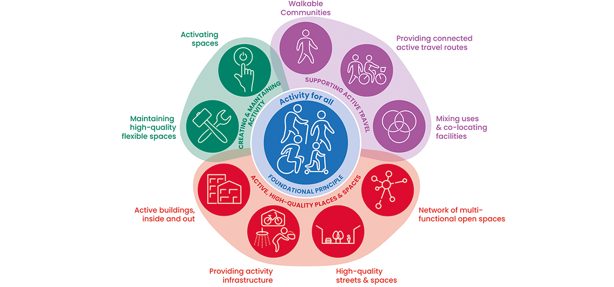

Figure 29: Sport England Active Design guidance, 2023

The National Institute for Health and Care Excellence (NICE) have produced guidance on Physical Activity and the Environment[38]. This includes recommendations to:

* Develop and use local strategy policies and plans to enable physical activity including local walking and cycling strategies and ensuring that people with limited mobility can safely move along streets and in open spaces.
* Increase active travel by improving connectivity, making infrastructure safe and appealing to use and giving pedestrians and vulnerable road users priority.
* Enhance the accessibility, quality and appeal of public open spaces.
* Ensure workplaces and local services are accessible by walking and cycling, and that people are encouraged to use stairs rather than lifts in buildings.

NICE guidelines highlight that planners should ensure provision for children and young people to be physically active, including ensuring that open spaces encourage physical activity, and that physical activity facilities are planned close to walking and cycling routes[17].

#### *Active Travel*

A review of the literature by Zukowska *et al* identified the main transport policy areas where action is effective in increasing physical activity. These are set out below:

1. Convenient transport infrastructure development including pedestrian infrastructure development, bicycle infrastructure development, public transport infrastructure development and friendly infrastructure and urban design.
2. Active travel promotion at a community level.
3. Shift of transport mode including car demotivation interventions and support for cycling and public transport[26].

In 2021, Transport for London (TfL), published a report considering cycling potential in London’s diverse communities. The study aimed to broaden the understanding of barriers affecting Black, Asian and ethnic minority people, low-income groups and disabled people cycling in London. This found that to improve equity, it is particularly important to:

* Address road and personal safety concerns and design cycle routes with safety in mind.
* Ensure access to a bicycle as most non-cyclists can ride a bike and most can store a bike.
* Tackle cycle theft[29].

This study also found that guided cycle rides and cycle training were particularly important for women and those on low income from Black, Asian and ethnic minority backgrounds as well as 16-34 year olds.

The Mayor of London’s Transport Strategy 2018 outlines a London wide commitment to increasing active travel[39]. The strategy is underpinned by the Healthy Streets Approach which encourages boroughs to incorporate the ten indicators detailed in the figure below in the design of their streets to best enable active travel[40].

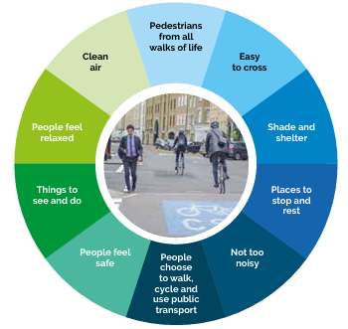

Figure 30: Mayor of London's Healthy Streets Approach, 2018

To support active travel for children and young people specifically, evidence shows that school street schemes can be very effective. School Streets restrict vehicle access around school sites during school drop off and pick up times. A review of School Streets found that in nearly all cases where School Streets had been implemented:

* The total number of motor vehicles across School Streets and neighbouring streets reduced during the School Streets’ hours of operation.
* Active travel to school increased.
* Schemes were supported by most parents of school pupils as well as residents living on the School Street and neighbouring streets.
* Traffic displacement from the School Streets to neighbouring streets did not cause road safety issues of any significance[41].

Active Travel England have recently published guidance setting out how local areas can develop, implement, monitor and evaluate School Streets[42].

NICE recommends that schools and early years settings have active travel plans in place, as travel to and from school and nursery is one of the easiest ways for children and young people to incorporate activity into every day life[18].

#### *Road safety*

How safe people feel, both in terms of their safety as pedestrians and vulnerable road users, as well as how safe from crime people feel, affects their propensity to be active[43].

Improving road safety has been shown to increase walking and cycling and therefore physical activity rates. A WHO review of the evidence on walking and cycling found the following to be effective in improving safety:

* Separation of modes of transport including cars, bicycles and pedestrians.
* Reducing the speed of cars.
* Infrastructure changes, particularly at junctions, to improve the prioritisation of vulnerable road users[44].

The Mayor of London has introduced a ‘Vision Zero’ approach in London, aiming to eliminate deaths and serious injuries from roads by 2041[45]. The Vision Zero action plan includes:

* Safe speeds - including introducing lower speed limits
* Safe streets – through designing infrastructure with safety in mind
* Safe vehicles – including improving bus safety standards
* Safe behaviours – encouraging safe road use through enforcement and marketing
* Post-collision response – learning from collisions and improving justice for victims

#### *Community safety*

How safe people feel from crime and anti-social behaviour can have a major impact on whether they are able to be physically active in their local community. One review found that people’s feelings of safety have a positive impact on their physical activity levels, and that feeling unsafe can reduce adolescent’s willingness to use green space for activity[46].

Feeling unsafe in your neighbourhood is especially a barrier to women’s physical activity. A systematic review on the barriers to activity for women found that women’s safety concerns included:

* Fear for personal safety when walking and cycling in the dark
* Sexual harassment and violence

Therefore, efforts to improve women’s safety outdoors can support them to participate in more physical activity[15].

#### *Open space*

Access to green and blue space is associated with positive health outcomes including for physical activity[47]. Open space that is particularly beneficial includes green space, such as parks, and blue space, such as rivers and canals. These spaces can be used for formal sports, such as football and canoeing, and for informal physical activities such as play and walking.

NICE guidance highlights the importance of local authorities’ roles in protecting, maintaining and improving local open spaces to give everyone the opportunity to move more without the need for costly interventions. The guidance includes recommendations to work closely with residents on designing open space, and to encourage residents to take an active role in feeding back and reporting any issues needing attention from the local authority[48].

#### *Play space*

Play is the most common form of physical activity for children and young people, contributing more to their activity levels than organised activities and sport[49]. NICE recognises that only by fostering enjoyment will children be intrinsically motivated to move more[50]. To play and be active, children need opportunities, time, space, facilities and equipment, permission and encouragement. Sufficient quality and accessible space to play in is essential in encouraging children to play.

NICE guidance highlights that play spaces should meet recommended safety standards, for example ensuring there is sufficient shade from the sun[17].

The campaign group ‘Make Space for Girls’ has highlighted that play spaces are often designed for boys by default, for example by focusing on Multi Use Games Areas (MUGAs) and skate parks, and that girls should be considered through:

* Including a wider range of facilities to create a more inclusive space
* Reaching out to girls in the design of play spaces to ensure their voices are heard[51].

The disability charity Scope has produced guidance on developing play space that is accessible and inclusive for disabled children and young people. This focuses on five principles:

* Plan to go – thinking about the journey to the playground, including considering local parking spaces for disabled people and public transport
* Plan to access – considering if paths are wide enough, whether accessible equipment is on a solid surface and providing accessible toilets
* Plan to play – engaging all the senses
* Plan to rest and recharge – seating with back and arm rests, picnic tables with space for a wheelchair[52].

#### *Sport and Leisure facilities*

The Local Government Association (LGA) has recognised the importance of the leisure sector in improving health and wellbeing. Particularly through forging stronger links between council leisure services and the health sector[53].

A systematic review found than the availability of physical activity equipment is associated with increased vigorous activity and sports. Likewise, the accessibility and convenience of recreational facilities are important factors determining a community’s propensity to engage in physical activity[54].

NICE guidance recommends that sport and leisure facilities used by children and young people for physical activity should be:

* Suitable for children and young people with different needs, particularly those from lower SEPs, ethnic minority backgrounds, with specific cultural requirements and disabled children
* Safe and accessible[17]

## Active People

This WHO GAPPA theme is about how we create and promote programmes and opportunities for all to be physically active[1].

#### *Community Sport*

Community sport is any sport that is organised, formal or informal, and is provided for the local community[55]. Community sport has an important contribution to make in the global effort to reduce inactivity [56]. It also has important co-benefits such as improving mental health through reducing loneliness.

Community and grassroot sports groups face many challenges including staff training, funding and access to space to deliver activities. Sport England supports community sport organisations to grow and become more sustainable. They recognise through the ‘Uniting the Movement’ strategy that enabling community sport to be part of local connected networks will be vital to increasing activity levels[10].

#### *Physical activity for children and young people*

NICE recommend that strategies to improve physical activity in children and young people should ensure that:

* There are indoor and outdoor opportunities for physical activity where children feel safe.
* People responsible for increasing physical activity are aware of local and national policy on physical activity.
* Partnership working is supported and should include all stakeholders working with children and young people such as schools, early years setting, colleges, out-of-school services, further education institutions, family hubs, community clubs and private sector providers.
* Multi-component interventions are developed involving schools, families and communities.
* Local facilitators and barriers for children and young people’s physical activity are identified and acted on.
* Local transport and school travel plans are coordinated to promote active travel.
* School facilities are made available outside of school hours for physical activity[17].

In planning provision for children and young people barriers should be identified and resolved, insight should be gathered about what children enjoy, and providers should be appropriately trained and experienced[17].

NICE guidance also highlights the importance of whole-school or multi-component approached to physical activity. These consider the role of the wider school environment, such as developing opportunities for activity during breaks and after school, or how the school can best develop partnerships with parents and carers to encourage more activity in the home environment[17].

The UK government updated their School Sport and Activity Action Plan in 2023 to refocus on improving the quality of PE[57]. The plan aims to:

* Increase the number of children playing sport in school especially swimming and water sport.
* Ensure equal access to sport during and after school for boys and girls and across all localities.

The key policy actions set out in the plan include:

* A recommendation that all schools deliver a minimum of 2 hours PE time during the school day every week and to have equal access to sport for boys and girls.
* A Sport Premium to provide £600 million over two years (2023-2025) to support PE development.
* Swimming and water safety as part of the primary PE National Curriculum. All pupils should be taught to swim and learn how to be safe around water.
* A focus on finding the right sports and extra-curricular activities for all children.
* Encouraging and promoting the School Games inter-school competition.
* Supporting Schools to make best use of their facilities through the opening School Facilities (OSF) Programme which is making £57 million available until March 2025 to support schools to open up facilities to communities outside of school hours.
* Promoting the Holiday Activities and Food Programme which provides disadvantaged children in England with activities and healthy meals over school holidays.
* Active travel to and from school including delivering initiatives such as Bikeability and walk to school outreach.

The action plan contains several expectations around equity of access to sport and physical activity including:

* Ensuring girls are offered equal access to sports, especially in sports traditionally not offered to girls such as football, rugby and cricket.
* Supporting girls to overcome barriers to participation through taking part in the ‘Your Time’ programme that supports girls to be leaders in sport and physical activity for their peers.
* Supporting the participation of children with SEND through providing an inclusive environment.

Additionally, the government recognises the impact that sports and physical activity can have for young people in the youth justice system, as it can reduce reoffending and improve skills and employability[58].

#### *Social prescribing for physical activity*

Social prescribing connects people to non-medical support to address practical, emotional and social needs that impact on their health and wellbeing. People can be referred by their healthcare professional, a voluntary or community organisation, or self-refer.

Sport England’s ‘Uniting the Movement’ strategy recognises that connecting with health and wellbeing is key to supporting the least active to become more active, particularly through schemes like social prescribing[59]. They have partnered with the National Academy for Social Prescribing to develop evidence and guidance on social prescribing for physical activity that recognises that social prescribing is able to work with people on a one-to-one basis to find activities that will suit them and their lifestyle[60].

A rapid review of social prescribing for physical activity found that taking part in prescribed physical activity can lead to improved:

* Physical health including increased activity
* Mental health and wellbeing
* Patient empowerment

However, it was noted that the studies included in the review were mixed in the types of interventions they researched[61].

#### *Supporting the least active to be more active*

Sport England conducted pilots in 33 areas to specifically tackle inactivity, resulting in improved activity rates for 34.5% or their participants. The findings are detailed in their report ‘Tackling Inactivity’ which recommends that the following principles should be followed to support the least active to become more active:

1. Understand the complex nature of inactivity to design interventions that meet specific needs
2. Use behaviour change theory
3. Use audience insight
4. Reframe the message for example by removing the word ‘sport’
5. Develop and work in quality partnerships for example with local voluntary and community organisations who understand their beneficiaries
6. Make sport and activity the social norm
7. Design the offer to suit the audience
8. Provide support for behaviour change for example through empathetic staff or volunteers
9. Measure behaviour change and impact
10. Scale up what works and make it sustainable[62]

NICE does not recommend that people are referred to physical activity schemes due to being inactive alone if they are otherwise healthy. This should only be considered when people are inactive and have health conditions or other health risk factors[63]. It is important to note here that the NICE guidance is over 10 years old and that it is about exercise on referral specifically, not signposting to activity opportunities which could be beneficial to a wider range of people.

**Physical activity for women and girls**

Evidence suggests there are a variety of barriers to women’s participation in physical activity including:

* Time
* Body image and societal beauty standards
* Family duty
* Social support
* Religious and cultural norms
* Organisation and community facilities and environment
* Safety
* Physical environment[15].

The CMOs have issued guidelines for activity during pregnancy, recommending that women aim for at least 150 minutes of moderate intensity activity per week. They highlight that there is no evidence of harm of physical activity during pregnancy, and that women should listen to their bodies and adapt as their pregnancy journey progresses[64]. Exercise programmes designed specifically for pregnant women tend to evaluate well for improving health outcomes and quality of life[65].

NICE guidance recommends that girls should be consulted on what activities they most enjoy, and that activity should be offered in mixed and single sex spaces. The guidance also encourages providers to address psychological, social and environmental barriers to physical activity for example through ensuring that there are appropriate changing facilities, and that dress policies should be practical, affordable and acceptable to participants[17].

**Physical activity for older people**

A 2019 NIHR study concluded that offering free or discounted access to leisure facilities to people over 60 years also helped slow down the decline into inactivity that often takes place as people get older[66].

A review found that there is good evidence that activity programmes designed specifically for older adults increase activity levels, but that there is a lack of evidence of what is effective in improving the environment and social norms around physical activity for older people[67].

**Physical activity for people with long term conditions**

Physical activity plays a significant role in the prevention and management of many health conditions. However, people with living a health condition or disability often face additional barriers when it comes to physical activity and are as a result less likely to be active than people without health conditions.

There are significant gaps in evidence on whether exercise on referral is effective. However, NICE recommends that people with health conditions or health risk factors who are sedentary or inactive could be referred to these schemes if the techniques of the programme are aligned with NICE guidance on behaviour change approaches, such as ensuring that the individual is open to change and that the programme sets agreed goals and action plans with patients[63].

Physical activity can support people with musculoskeletal (MSK) conditions to manage their pain and rehabilitation. UK Active have recently published a report recommending that local leisure centres and gyms could be developed into MSK hubs to support people with MSK conditions. This involves:

* Creating pathways between health and leisure to connect people with MSK conditions to the services that might support them.
* Training staff in gyms in supporting people with MSK conditions [68].

People with severe mental illness (SMI) can often benefit from physical activity but face additional barriers to access if services are not inclusive. Rethink Mental Illness have developed training to support staff in understanding the needs of people with SMI and to ensure that services are accessible[69].

In 2023, the LGA published a report on the contribution public sport and leisure services can make in promoting health and wellbeing. They particularly recommended the development of closer links between leisure services and health and care partners, though acknowledged some of the challenges especially due to the complexity of our healthcare system[53].

**Physical activity for people on low incomes**

People living in more deprived areas are less likely to be active. Cost and affordability are consistently raised as a barrier to exercise for people on low incomes.

A 2019 NIHR study concluded that offering concessions and free access to leisure facilities was successful in increasing participation in swim and gym activities. This was particularly the case for swimming and gym activities more generally among people living on lower incomes[66].

**Physical activity for disabled people and children with SEND**

The Activity Alliance for disability inclusion in sport has produced ten principles for inclusivity based on their consultation with disabled people:

* Use communication channels that disabled people already use
* Ensure that opportunities are close to home
* Do not focus on ‘disability’ in advertising as this can be off-putting
* Align activities to individuals’ values
* Consider how people’s needs change as they grow older
* Reassure people that activities will be welcoming and suitable
* Include people at varying levels in the same activities
* Listen to people’s needs before an activity starts
* Welcome people when they first join to make them more likely to come back
* Demonstrate activities[70].

# Understanding the Local Picture

This section explores the local situation in Tower Hamlets in relation to the evidence base on physical activity and considers the extent to which the borough is meeting need. It is structured around the WHO GAPPA areas of active systems, active society, active environments and active people[1]. Each subsection will cover:

* Local data and insights
* Services, interventions and assets
* Partnerships and strategies

## ActiveSystems

This section covers the local picture in Tower Hamlets in relation to the active systems WHO GAPPA theme, which is about governance and leadership in relation to physical activity[1].

#### *Policy, strategy and governance for physical activity*

Tower Hamlets has been identified as one of Sport England priority places for receiving Place Partnership funding. The criteria used to choose Tower Hamlets as a place considered both the need for intervention and the readiness of the area for system change.

The Tower Hamlets Physical Activity Place Partnership was newly formed in 2024. Led by London Sport, the partnership brings together stakeholders across health, the local authority, and the voluntary and community sector to understand the need in the local area and design a programme of work to improve physical activity, particularly focussed on the least active.

This work is at an early stage, so it is challenging to evaluate it so far. However, a group has been bought together and is following the process as set out by Sport England guidance. Challenges to progress include a lack of time and resource in the system to ensure that the Place Partnership is successful, and a lack of input from strategic leaders to the process.

Otherwise, Tower Hamlets has a strategic commitment to improving physical activity for residents from all backgrounds. It is recognised across several key strategic documents for the local authority and wider partnerships. For example:

* The Tower Hamlets Partnership Plan 2023-2028, developed by organisations working together across Tower Hamlets, recognises that physical activity is important but that levels are low in the borough[71].
* The Council’s Strategic Plan 2022-26 has the ambition that “residents from all backgrounds benefit from thriving sports, the arts and local business”[72].
* Tower Hamlets’ Health and Wellbeing Strategy (2021-2025) has a key strategic ambition to enable Tower Hamlets to become a “Healthy Borough” and a place that supports health for everyone[73].
* The Child Healthy Weight Action Plan includes actions for children and young people’s physical activity[74].
* The Children and Families strategy, ‘Accelerate’, highlights the importance of play for children across multiple ambitions, and seeks to improve accessibility of sports facilities for children with SEND[75].
* The Tower Hamlets Play Charter demonstrates the borough’s commitment to play[76].
* The Transport Strategy recognises the impact that active travel can have on activity rates in the borough[77].

While physical activity is included in overarching strategies and plans in the borough, a key gap is the sports and physical activity strategy. The most recent strategy is now out of date, leaving services without a clear strategic vision uniting their approach to physical activity in the borough.

One approach to distributed leadership taken in the borough is through the Communities Keeping Well project, a joint initiative between the council and the primary care networks, which aims to engage the community in co-producing interventions for preventing LTCs. This has been rolled out in in eight targeted communities in the borough. The team has engaged in 220 street consultations and delivered four community cafes with 240 residents. The lack of opportunities for physical activity has emerged as a priority from early workshops and work is ongoing to co-produce solutions.

To embed distributed leadership for physical activity in the borough this will need to be considered at all levels of the developing Place Partnership, for example ensuring that youth voice is integrated through engagement with the young mayor and youth council.

#### *Leadership for physical activity*

There is a lack of clear leadership for the physical activity agenda in the borough as highlighted by attendees at the Place Partnership workshop (see appendix 2). The Sport and Physical Activity Team in the council, whose role was to support the sport community to run activities for underserved groups, is currently in a phase of transition due to the insourcing of the leisure service. This has led to unclear roles and responsibilities. In the absence of leadership for this team there is no central focal point for sports and physical activity in the borough.

Several senior decision makers and councillors have physical activity nominally part of their role, for example if they have health or leisure in their portfolios. However, there is no clear identified ‘champion’ for physical activity at a senior level in the borough.

The Place Partnership engagement workshop participants wanted to see leadership in the borough to drive forwards a shared vision and goals for physical activity (see appendix 2). The developing Place Partnership is working towards a shared vision across the borough, and offers an opportunity to link in with senior decision making structures.

#### *Data, reporting, monitoring and evaluation*

There is a lack of good data to guide decision making on physical activity in the borough. ALS survey data is limited by small sample sizes, so while it can give an impression of overall activity levels in the borough, it does not give a clear picture of inequalities by sociodemographic characteristics or locality.

There is a limited understanding of the barriers to and facilitators of physical activity in the borough. Most qualitative insight drawn on for this HNA was gathered to understand barriers and facilitators in the context of specific interventions. There is therefore a lack of understanding about what would work to engage the least active groups in any form of physical activity, formal or informal.

The council’s Annual Residents’ Survey asks some questions relevant to physical activity, but they are not routinely reported in the data summary. Having the questions on the amount of physical activity, and the local environment such as how cycle friendly residents think the borough is routinely reported and monitored could help strengthen action in these areas.

For children and young people, the council undertakes an annual pupil attitudes survey. This asks some questions about how children use their time after school, and how they feel about parks and playgrounds in the borough. This information could better feed into plans for physical activity, and the survey could be used to ask more questions to better understand how children and young people might better engaged in physical activity.

Physical activity outcomes are not closely monitored in the council. The Upshot monitoring and evaluation system has been implemented to support physical activity providers reporting on their activities, but uptake of the system and monitoring has been poor. The new Leisure Management system offers an opportunity for better monitoring, though there are limitations in how data is captured and its ability to meaningfully report on inequalities. This suggests that investment is in this area is required if we are to understand the impact of our current offer.

#### *Research*

Tower Hamlets is home to one of the National Institute of Health Research’s Health Determinants Research Collaboration projects. This brings together the local authority with academics, the voluntary and community sector and other partners to build the research infrastructure of the borough. This is providing opportunities for research priorities to be better aligned with council and community priorities.

The presence of the HDRC in the borough could provide opportunities to explore some of the unanswered research questions around physical activity. For example, understanding local barriers and facilitators, and developing a better understand of what might work for the population in Tower Hamlets.

## ActiveSociety

This section covers the local picture in Tower Hamlets in relation to the active society WHO GAPPA theme. This theme is about social attitudes and norms in relation to physical activity[1].

Data from the Active Lives Survey suggests that generally residents in Tower Hamlets have positive attitudes towards physical activity. The figures below demonstrates that most residents feel that it is important to do sport and exercise regularly, and that they find it enjoyable and satisfying when they do. Most people disagreed that disappointing others is a motivation for them to do exercise. However, over half expressed feelings of guilt when they don’t exercise.

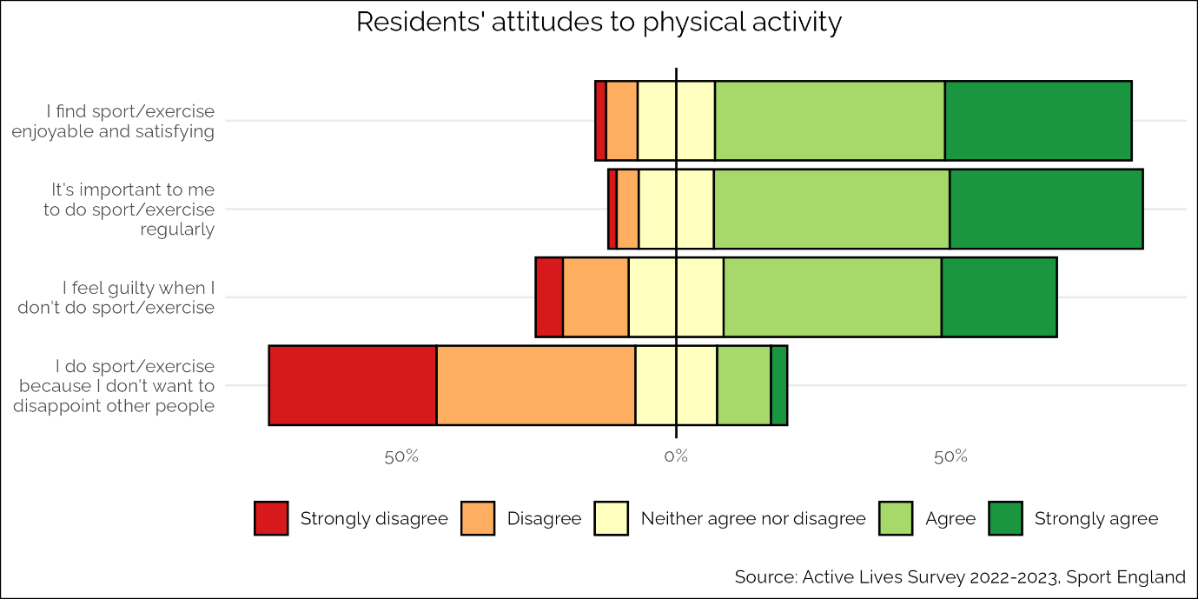

Figure 31: Resident's attitudes to physical activity, 2022-2023

The figure below describes the extent to which residents feel they have the ability and opportunity to be physically active. Around 90% of residents felt that they had the ability to be physically active, whereas 80% of residents felt that they have the opportunity to be active, suggesting that there is a gap in ether the understanding of what is available, or the ability to access it.

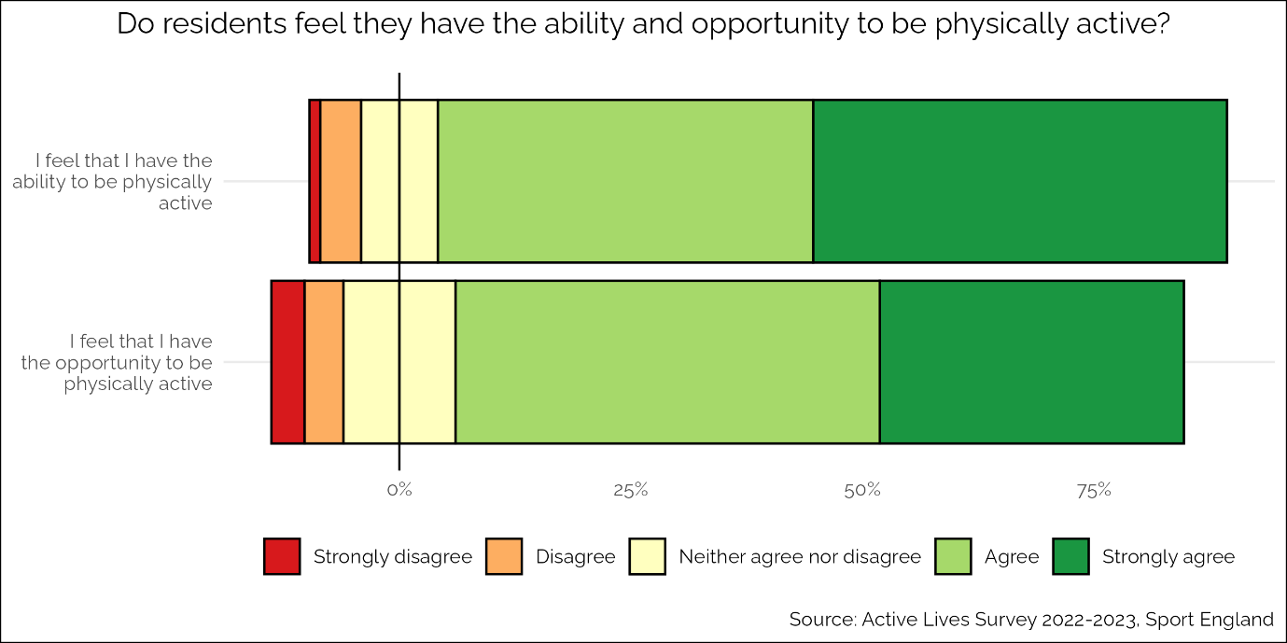

Figure 32: Do residents feel they have the ability and opportunity to be physically active, 2022-2023

#### *Physical activity promotion*

The council have acted on previous findings around physical inactivity to launch health promotion campaigns to support women and girls to be more active. The campaign called “Find your…” was shaped by local women and girls to support them being active in ways that work for them, regardless of age, background or ability[78]. The images below show two examples of the assets used in this campaign.

Tower Hamlets 'find your' campaign images showing women playing sports
**A woman in a head scar playing badminton for the 'find your' campaign
**

Figure 33: Tower Hamlets 'Find your...' campaign, 2024

This campaign followed the evidence-based principles of considering the context and audience and focussing on what is effective for them. However, there is a gap in terms of similar campaigns and approaches for other less active groups in the borough such as disabled people.

The Tower Hamlets Together partnership has launched the Vital 5 campaign to raise awareness about the five modifiable risk factors that would make the most difference to people’s health. The image below shows how the Vital 5 are being presented in a recent workplace health checks campaign. Physical activity is relevant to the healthy weight, blood pressure and mental health parts of this campaign. There are further health promotion campaigns being designed around the Vital 5 message.

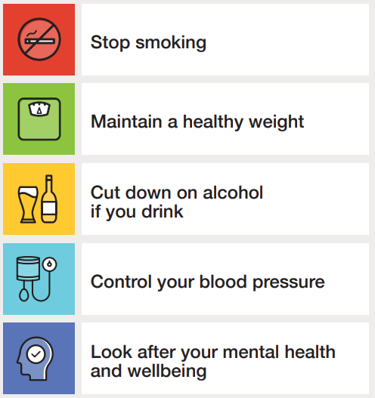

Figure 34: Tower Hamlets Together "Vital 5" campaign, 2024

There is currently no health promotion campaign promoting active travel to residents in Tower Hamlets. This is a gap because evidence shows that these campaigns are effective if targeted appropriately to the local community.

The Place Partnership engagement workshop participants highlighted that they would particularly like to see positive promotion of play as a means to physical activity, as this is one of the most important ways that children and young people can be physically active (see appendix 2).

#### *Mass-participation events*

Various mass-participation events are organised in Tower Hamlets to support the community to get active. For example, the Mayor’s Cup, a football tournament for teams of all ages and genders[79].

Parkrun, a free 5km community run for adults, organised by volunteers, takes place every Saturday in Mile End Park, and a Junor Parkrun for children and young people on Sunday morning[80]. This is a popular and successful event, however there are recognised gaps in participation particularly from women from Bangladeshi, Somali and Black African and Caribbean backgrounds. Focus groups undertaken with these communities highlighted that the main barriers to participation are:

* Lack of awareness of the event
* Timing of the event in relation to family commitments
* Safety concerns including the presence of dogs in the park
* Cultural concerns including that the event is mixed-sex

There has been an effort to promote Junior Parkrun to children and young people, and their families and care-givers. Co-production of promotional materials, taking account of local needs and priorities, and the Physical Activity Messaging Framework, is scheduled for January 2025.

For children and young people there have also been several mass-participation events in recent years, such as mass -participation Daily Mile events organised by the Healthy Lives Team. These have been held at Mile End Stadium and Victoria park, and each of the events involved 700 pupils and staff. In 2024 the council organised a ‘Summer of Fun’ which offered a wide range of free intergenerational family activities and events, including sports events.

As highlighted by the Place Partnership engagement workshop participants, the cultural appropriateness of mass participation events, and how the needs of the least active are considered, should be considered in developing future events (appendix 2).

#### *Staff training in the benefits of physical activity*

Staff in health and social care can access e-learning on physical activity, but there is little promotion of this and uptake is not monitored.

The Physical Activity Clinical Champions programme is piloting a place-based approach in Tower Hamlets, working with local clinicians on ensuring that the programme is tailored to local need. This is a peer-to-peer programme, as part of the Moving Healthcare Professionals national programme aimed at improving the knowledge, confidence and skills of healthcare workers in delivering physical activity advice and supporting behaviour change[81]. The place-based approach is to tailor delivery to local need, and the physical activity of children and young people has been highlighted as an area of particular focus for Tower Hamlets. The clinical champions will target these in addition to the physical activity of adults, and recruitment is due to begin in January 2025.

The ‘This Mum Moves’ training for maternity staff on supporting activity during pregnancy and post-partum is also available in the borough.

Staff in leisure centres have been offered training in promoting physical activity for people with long term conditions and there is training planned with Rethink Mental Illness on how to support residents with SMI. However, more needs to be done to ensure that the whole workforce is trained in how to support less active people to be more active.

London Sport work with community sports groups in Tower Hamlets in ensuring that their CPD needs are met.

Overall, there are pockets of good practice on staff training but there is no clear borough wide picture on what is working and what the gaps are.

## ActiveEnvironments

This section covers the local picture in Tower Hamlets in relation to the active environments WHO GAPPA theme[1]. This theme is about how the spaces and places in the borough can encourage people to be more physically active.

#### *Planning Policy*

The Tower Hamlets Local Plan 2031 sets out spatial policies, development management policies and site allocations to guide and manage development in the borough. Key policies in the Local Plan related how the environment can improve physical activity rates are:

* Health Impact Assessments (HIA) policy which states that rapid HIAs should be carried out for major applications and developments which contain certain uses such as education and health facilities.
* Sustainable travel policy which supports walking, cycling and public transport as priorities for the borough with measures include requesting transport assessments wherever necessary, and mitigation measures where congestion is anticipated to increase because of development. A sustainable approach to parking should be taken, giving priority to cycle parking, cycle-hire, car-club spaces and electric vehicle charging.
* Town centre policies including that retail should be protected in local town centres, to ensure shops are within walking distance of residents.
* Green Grid Strategy – a network of active travel routes to improve access to key destination points and open spaces in the borough.

A Spatial Planning and Health Joint Strategic Needs Assessment was completed in 2023 and sets out several key recommendations for inclusion in the developing Local Plan[82]. This included recommending the full adoption of Sport England’s Active Design guidance into the Tower Hamlets Local Plan.

#### *Active Travel*

The Healthy Streets Scorecard, compiled annual by a coalition of organisations in London, ranks London boroughs on how healthy their streets are according to ten indicators:

1. Low traffic neighbourhoods
2. 20mph speed limits
3. Controlled Parking zones
4. Physically protected cycle track
5. School provision
6. Bus Priority
7. Sustainable modeshare
8. Active travel Rate
9. Road Collision casualties
10. Car ownership rates

As shown below, Tower Hamlets has the 6th best score in London in the Healthy Streets Scorecard. The borough’s overall score is 6.04 out of 10 [83].

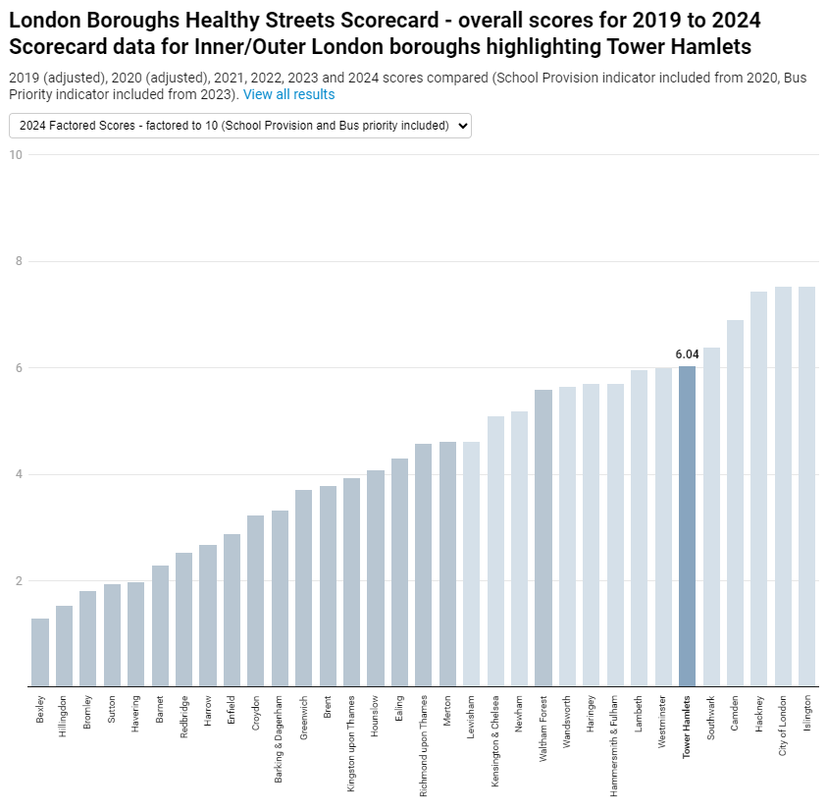

Figure 35: Healthy Streets Scorecard for London Boroughs, 2019-2024

The Annual Resident’s Survey 2024 found that overall, 79.2% of Tower Hamlets Residents find the borough to be either fairly or very cycle friendly. However, as shown below this varies by locality, with residents in the north west of the borough being least likely to think the borough is cycle friendly.

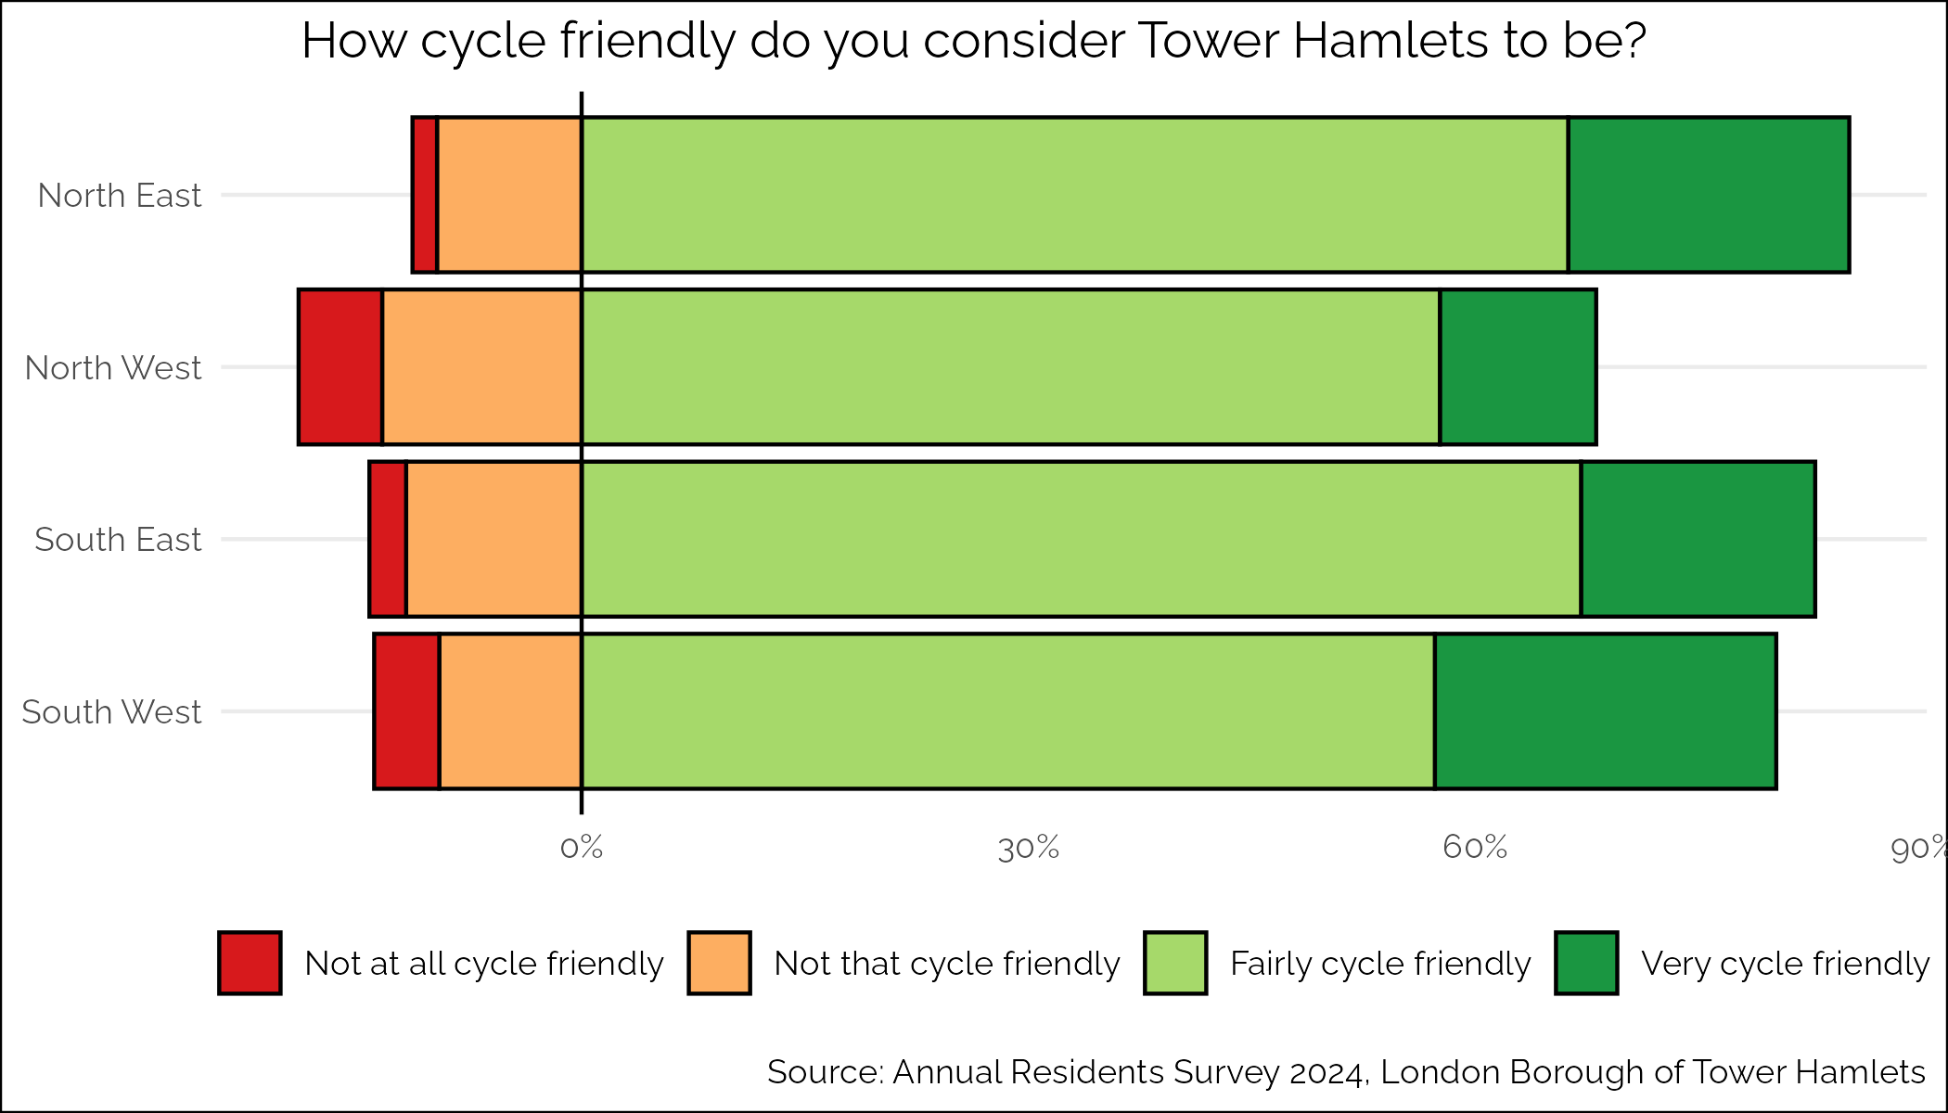

Figure 36: How cycle friendly do residents feel the borough is, by locality, 2024

In 2023, the council commissioned Sustrans to produce a Walking and Cycling Index. This found that in Tower Hamlets:

* 67% of residents are walking or wheeling at least five days a week
* Inequalities in walking and wheeling on at least 5 days per week were found for disabled people (60% compared to 69% for non-disabled people).
* Inequalities in cycling were found for people from lower SEPs, only 10% of people in socio-economic groups D and E cycled at least once a week compared with 30% for people in groups A and B.

It also found that the top three things’ residents wanted to improve the cycling experience in the borough are:

* Better links with public transport, such as secure bike parking at stations
* More traffic free cycle paths away from roads
* More segregated cycle paths alongside road infrastructure[84].

In the Annual Residents’ Survey 2024, 79.8% of residents reported that they never use a bicycle to get around. As shown below, there was a particular difference in response to this question by sex, with 85.9% of women saying they never use a bicycle compared to 73.7% of men.

Bar chart showing distribution of how often residents cycle


Figure 37: How often residents use a bicycle, by sex, 2024

Tower Hamlets offers free one-to-one and group adult cycle skills sessions for anyone who lives, works or studies in Tower Hamlets. These courses are run by Bikeworks on behalf of the council. Between 2019/20 and 2022/23 764 adults were given training to Level 2 “urban” cycle skills with a further 183 provided Level 3 “advanced” cycle skills.

Bikeworks run cycling sessions funded by the council and TfL for people with physical, sensory and learning disabilities using adapted bikes. 164 residents are currently engaged in these sessions.

Insight gathered from disabled residents by REAL DPO to feed into Local Plan development found that barriers for disabled residents in moving around the borough include:

* Pavements being blocked by rubbish, e-bikes and parked cars
* Uneven and narrow pavements
* Poor cycling practice for example on pavement or at high speeds
* Lack of seating
* Lack of blue badge parking

The council commissions a Health Walk programme coordinated by Walk East which currently has seven core groups run from health centres and community centres across the borough offering free regular walks. There were over 300 walks during 2023-24, with 89 participants:

* 53% aged over 60, 24% aged over 70
* 52% white, 42% Bengali, 6% Black African/Caribbean

Tower Hamlets Public Health has also recently funded the Bromley-By-Bow Centre to deliver a walking pilot project which aims to increase physical activity, reduce social isolation and reactivate underused green spaces. This project has co-designed activities with less active residents, leading to 17 residents being trained as Walk Champions and Walk Leads, who will design local walks for residents to take part in. The programme will be evaluated later in 2025.

The Active Lives Survey asks children about how they travel to school. As shown below, this showed that the most common form of transport for getting to school was walking (76.7%) followed by car (16.2%) and then bus (14.6%). Very few children said that they travelled to school using bike (2.1%) or scooter (2.2%)

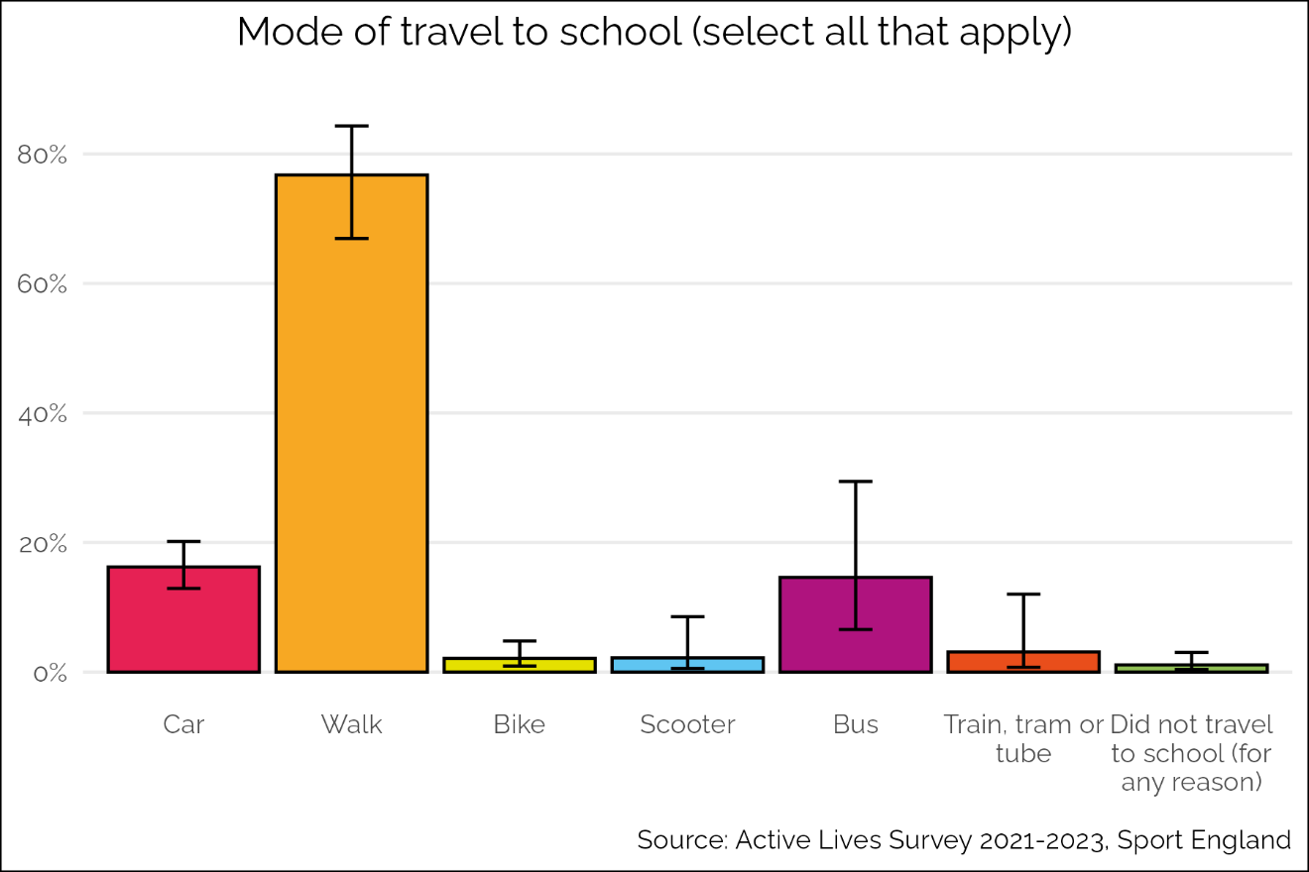

Figure 38: Mode of travel to school, 2021-2023

To date Tower Hamlets has delivered 33 School Streets, closing streets around schools to traffic during pick-up and drop off times, and 44% of schools have been engaged with as part of the TfL Travel for Life School Travel programme. TfL have produced an analysis which identifies priority locations for future School Streets, and the Tower Hamlets Transport Strategy recommends that this is used to guide the future expansion of the School Streets programme in the Borough.

In 2022 the Council’s public health team working with academics from University College London conducted a survey of 258 pupils across four primary schools. The survey questions were based on the TfL healthy streets indicators. This found that:

* 29% of children found it extremely or somewhat hard to cross the road outside school
* 21% of children said fewer cars, empty roads and less traffic would make it easier to cross the road
* 12% of children said that fewer cars, empty roads and less traffic would make it easier to walk to school
* 39% of children felt extremely or somewhat unsafe from traffic on their way to school
* 40% of children said that the air outside their school is either extremely or somewhat unclean
* 24% of children either dislike or strongly dislike the road outside their school
* 27% of children said there weren’t enough play spaces near school

Tower Hamlets has funded the Sustrans Bike It project, which works with schools on understanding the barriers to walking and cycling to school, and then delivers interventions to overcome them. In its most recent year, this project has worked with 9 schools identified as needing interventions, and delivered activities including assemblies and classroom lessons, skills and training on balance bikes, engagement coffee mornings and bike repair events.

Overall, while there has been some focus on infrastructure changes that improve the environment to promote active travel, such as increasing the provision of segregated cycle lanes and improving walkways, and some attempts to engage residents in active travel through health promotion work, Tower Hamlets is not achieving its potential for active travel. The Transport Strategy is currently being refreshed and this is an opportunity to embed policies to improve the environment for active travel.

Road safety

Tower Hamlets has a high rate of people killed and seriously injured (KSI) on the roads with 306 per billion vehicle miles. As shown below, the rate has come down somewhat, it has remained steadily higher than the England average.

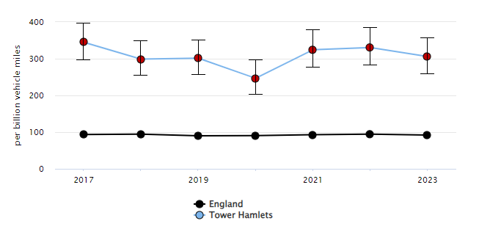

Figure 39: Number of people killed and seriously injured on Tower Hamlets roads per billion vehicle miles, 2017-2023

In recent years several actions have been taken to improve road safety in the borough such as:

* Introducing traffic reduction measures to reduce rat-running on residential streets and prioritise walking and cycling.
* Increasing the coverage of 20mph speed limits.
* Road safety education programmes in schools and older people’s groups.

Road safety is recognised as a key concern for the borough, with a new road safety strategy being consulted on in 2024 due for publication in early 2025. A new road safety data dashboard is being developed to enable the strategy to recommend targeted infrastructure improvements to improve road safety.

#### *Community safety*

The majority of residents feel safe when outside in the borough in the daytime. However, a significant minority of 9.2% say they feel fairly or very unsafe outside in the daytime. Safety after dark is more of a concern for residents. As the figure below shows, 11.4% say that they feel fairly or very unsafe after dark.

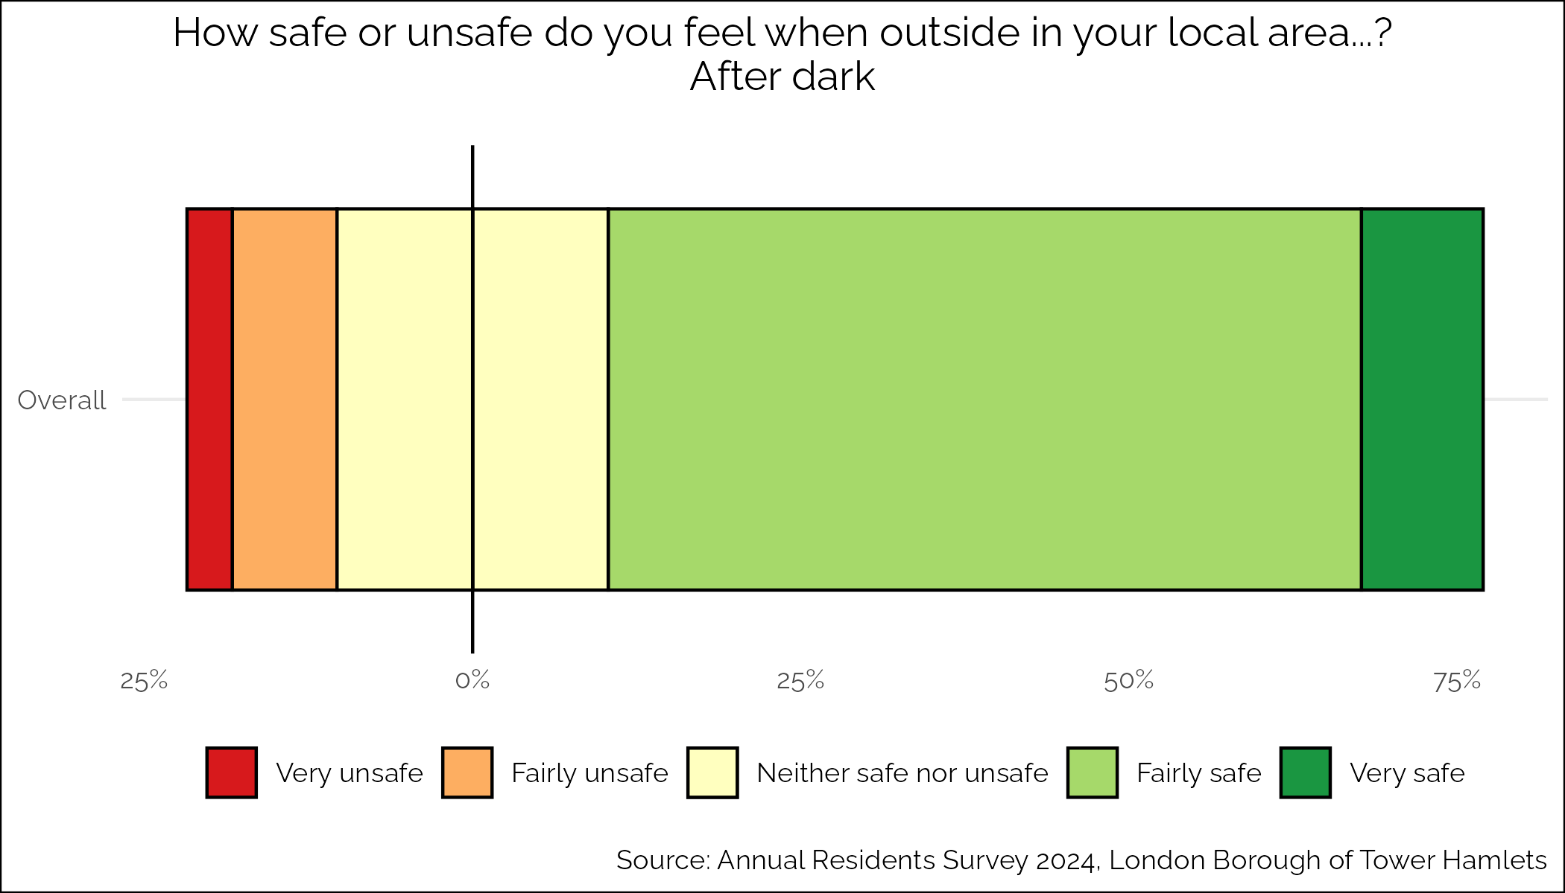

Figure 40: Residents feelings of safety after dark, 2024

There are several targeted community safety approaches in the borough, such as:

* The Neighbourhood Management Pilot and Safer Neighbourhood Team are employing a targeted approach to tackling crime and ASB in Tower Hamlets.
* The multi-agency Operation Continuum has had success in detecting and preventing drug related crime and disorder.
* The council provides funding to support police officers and help deliver an extensive CCTV network.

As the figure below shows, feeling unsafe after dark is a particular problem for women in the borough, with 16.4% feeling fairly or very unsafe after dark, compared to only 6.5% of men in the borough.

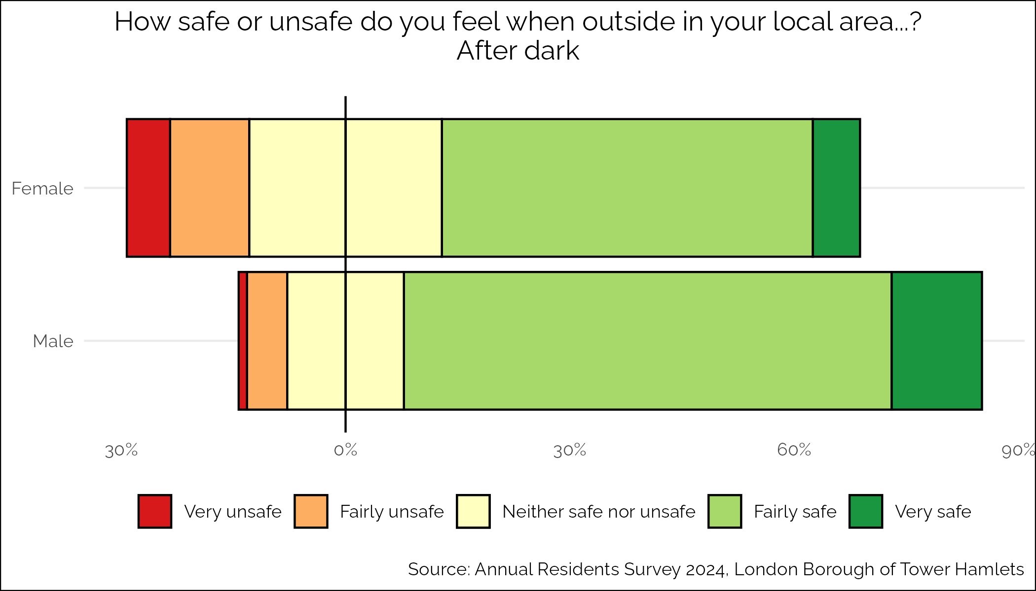

Figure 41: Residents feelings of safety after dark by sex, 2024

A recent report on gender inclusive design in Tower Hamlets, produced in consultation with women in the borough, found that there are multiple factors that feed into how safe women feel in the borough, and that a holistic view of what could be achieved through the planning system would have the biggest impact in Tower Hamlets. The below case study highlights how different elements such as seating and the retail environment can impact on feelings of safety[85].

“You see a lot of people gathered here in the summer. It’s really chilled, everyone has their lunch on the grass. There is plenty of benches and seating for people to sit down together and there is a little grass space for people to sit on, when there is hardly any grass space around here. There are so many food and drink places around here to get their lunch and everyone sits here to have their lunch. It’s a relaxed atmosphere. You do start to recognise people. There is a community here and there are sunflowers in the summer. You don’t feel threatened here, because you can see everything that is happening.” (Female Tower Hamlets Resident)

#### *Open Space*

The Annual Residents’ Survey 2024 found that residents are generally happy with the quality of green space in the borough. The figure below shows that 81.2% of residents are either fairly or very satisfied with the parks and green spaces in Tower Hamlets.

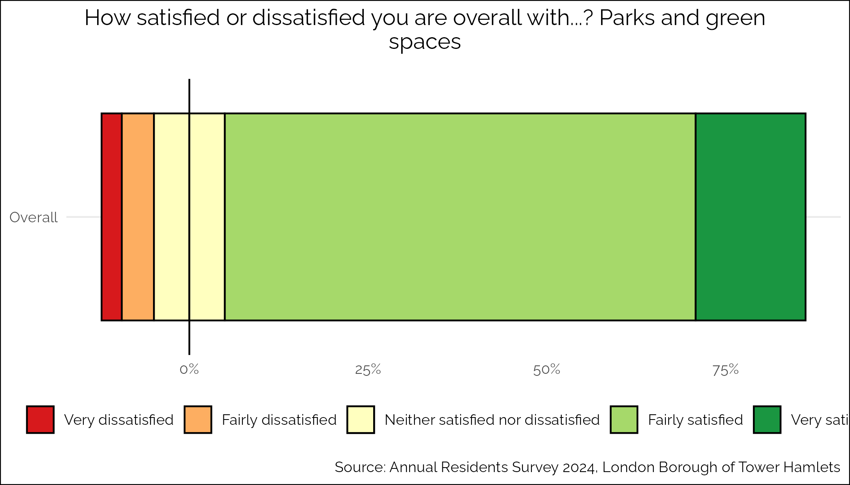

Figure 42: Residents satisfaction with parks and green spaces, 2024

The availability of publicly accessible open space is low in Tower Hamlets with some parts of the borough acutely deficient, including the Isle of Dogs, Shoreditch and Whitechapel. Tower Hamlets has 0.84 hectares of open space per 1,000 residents, which is less than the borough’s open space standard of 1.2 hectares per 1,000 residents[86].

The map below shows the areas of open space deficiency in the borough (in red).

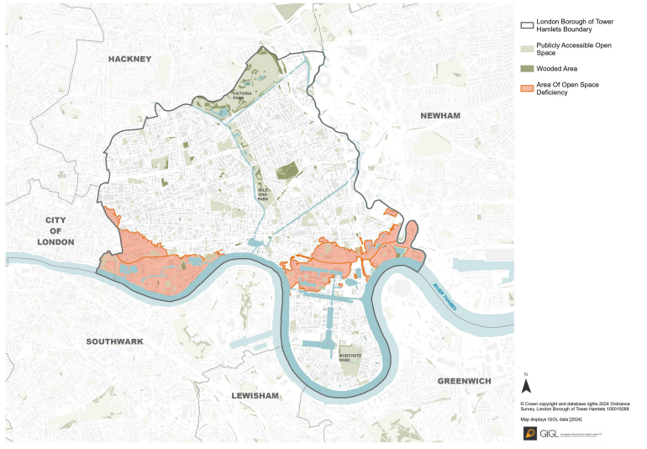

Figure 43: Areas of open space deficiency, 2024

Satisfaction with parks and green spaces is lower in the south west of the borough, as shown below. This aligns with the significant area of green space deficiency in Shoreditch and Whitechapel.

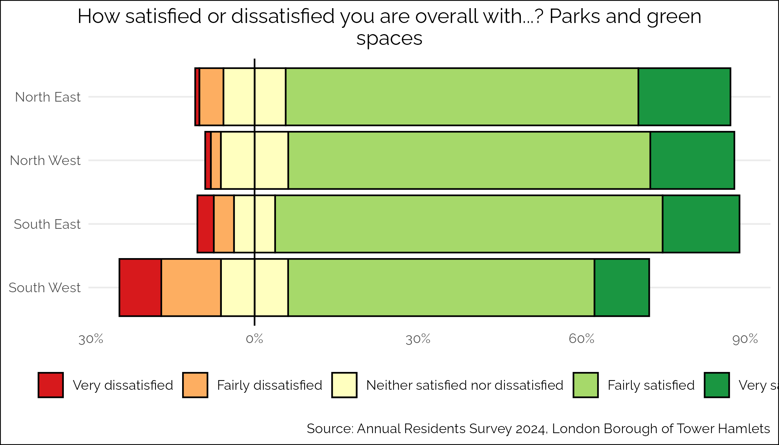

Figure 44: Residents satisfaction with parks and green spaces, by locality, 2024

The Tower Hamlets Local Plan has several policies relevant to the provision of green and blue space in the borough including:

* Requiring developments to contribute to an improved accessible, well-connected and sustainable network of open spaces including contributing to green grid links in line with the Green Grid Strategy.
* Maximising opportunities to create/increase publicly accessible open space in developments, particularly in locations which are expected to experience the highest level of open space deficiency.
* Encouraging community allotments, gardens and pocket parks.
* Requiring development proposals to protect and enhance biodiversity, and improve opportunities to experience nature, especially in deficient areas[86].

The Tower Hamlets Open Space Strategy (2017-2027) recognises the deficiency of space in the borough and highlights that with a growing population, demand for space is set to increase[87]. There is a need to balance the use of these spaces for formal sporting activities with the more informal uses of parks and open spaces. For example, open spaces can be used for people to gather, socialise and play, all of which can support people to move more.

Additionally, as a densely populated London borough with an increasing population, there is significant pressure in Tower Hamlets to build tall to meet the demand for extra housing. Consideration has been given to how building tall can still support residents’ health through the Tall Building Supplementary Planning Document, which requires developers to include high quality outdoor play and amenity space[88].

#### *Play space*

A play audit was recently undertaken considering the quantity and quality of available play space in the borough. According to the Local Plan, there should be a minimum of 10 square meters of high-quality play space per child, but the audit found that we currently have just 4.2 m2 per child. When we also consider the quality of the space, this drops to just 2.23 m2 per child.

Overall, the audit found that play spaces were performing basic functions, such as being safe and providing benches and bins, but that there was:

* Less opportunity for informal, social and nature-based play
* Low scores for inclusion of disabled children
* Variation in quality and value across the borough

The play audit recommends thar there should be a specific focus on areas of the borough with the greatest deficiencies in play space.

#### *Sport and Leisure facilities*

Tower Hamlets has committed to investing in leisure services to promote healthier communities and to reduce health inequalities. In May 2024, the council insourced its leisure services and launched the brand *Be Well* underpinned by the following three pillars: health, wellness and play. The insourcing offers an opportunity to provide a more accessible, inclusive, and high-quality leisure offer to residents that focuses on maximising health outcomes and reducing inequalities.  While these are laudable aims, the operational challenge of insourcing the service has taken much of the focus in the first six months.

To make sure that public health priorities were considered within the design and decision-making of the insourced model, Public Health funded a temporary Programme Manager role to work in partnership with the leisure services to strengthen and develop relationships between leisure and health partners. A logic model was co-developed by partners from across the system with representatives for sport and physical activity, public health, integrated commissioning, primary care and the voluntary sector providing a joined-up vision for the new insourced leisure service (see appendix 3 for the full model).

A comprehensive strategic leisure needs assessment was recently commissioned providing a full, borough-wide assessment of the quality, quantity and accessibility of private and local authority run sports, recreation and leisure facilities. The needs assessment found that sports halls and pools are areas where current supply does not meet current or projected future demand, while the borough is well served with gym facilities.

A further consideration is how facilities are used by the community. With limited space, particularly for pools and sports halls, there is very high demand from community groups. Access to free space has been offered in the borough under the ‘protected hours scheme’ which was an agreement with the former leisure management contract. An internal audit has highlighted a lack of clarity around governance and selection criteria for the free hours. This process is currently being reviewed, offering the opportunity to align the use of these spaces with priority groups for increasing physical activity.

Outdoor gyms have been installed in parks across the borough however it is unclear how well these are used by residents and while there have been attempts made to ‘activate’ the gyms these have not been successful due to a lack of strong community engagement in the programmes.

## ActivePeople

This section covers the local picture in Tower Hamlets in relation to the active people theme in the WHO GAPPA. This theme is about what programmes and opportunities are provided to support people to be more physically active[1].

#### *Community* *sport*

We have a vibrant community sport sector in the borough but feedback from residents suggests it is sometimes challenging for people to connect with what’s available.

A newly developed community activity finder is seeking to compile information about available activities into one place. This is an important development in advertising what activities are available to residents, but it relies on annual funding and organisations keeping information up to date on the platform.

At the Place Partnership engagement workshop, the community sport sector expressed their view that they would like:

* More opportunities to connect as a sector to enable collaboration.
* More support with capacity building for example, support with writing funding bids.
* More access to free or discounted space to hold activities (appendix 2).

#### *Social prescribing for physical activity*

A review of the social prescribing system in Tower Hamlets was recently commissioned. This found that while there is great work being done, the capacity of the service struggles to keep up with huge demand from residents.

Social prescribers in Tower Hamlets do connect residents with physical activity opportunities, but the data on this is patchy. One of the key recommendations of the social prescribing review is to introduce a new client management system to improve how people are connected to opportunities. This would also enable better monitoring of how social prescribing connects people to physical activity opportunities. A potential new client management system is under consideration as a result.

There is currently no formal exercise on referral scheme in the borough, unlike neighbouring local authorities like Newham or Hackney. However, evidence for commissioners to invest in structured exercise on referral schemes is weak, and it is possible that a more informal signposting approach to physical activity would meet needs. The social prescribing team in Tower Hamlets has also expressed the need to be able to refer people into local and affordable physical activity opportunities, especially for groups who are more likely to live in income deprivation such as older adults and for whom cost is likely to be a significant barrier to engagement.

This suggests that local decision makers and commissioners should explore different opportunities to better support social prescribers and other link workers to meaningfully connect and refer people into physical activity opportunities that are attractive and affordable to them.

A ‘Start for Life’ social prescribing pilot is being rolled out in the borough to explore how social prescribing can support families during pregnancy and for the first two years of a child’s life. This has the potential to connect families with activities that will help them move more, and addressing gaps in services around physical activity for this age group is a stated aim of the pilot.

#### *Physical activity for children and young people*

Physical activity for children and young people is encouraged through a variety of programmes and opportunities in Tower Hamlets.

**Early Years**

In the early years, physical activity forms part of the Healthy Early Years Award which is an accreditation scheme for early years education providers. The Family Hubs in the borough offer a range of activities for families with children in the early years such as stay and play sessions. There are also established local community voluntary organisations such as Toy House offering activities for families with babies and toddlers. However, the lack of safe indoor space for crawling babies in the borough is often cited as a barrier to activity for families with children in the early years.

**School-aged children**

Physical Education (PE) in schools is a key opportunity for children and young people to enjoy activity as part of the school curriculum. The Youth Sports Trust recently interviewed headteachers and PE staff at 11 schools in the borough and found that:

* The challenges to schools’ ability to deliver good quality PE and physical activity include children and young people’s challenging home lives, low levels of wellbeing, wider education challenges and a lack of resources.
* The young people most affected by inequalities are those from a Bangladeshi background, in years 7 and 8, with SEND and from non-working families.
* Schools have a range of mechanism for capturing and acting on pupil voice in delivering PE, from giving choices in PE to more formal ‘you said, we did’ approaches. However, there remains scope to improve how children and young people are listened to and how their views are acted on.
* Some partnership working is happening between schools and the local authority and community sports clubs, but there is significant scope to improve this.
* Staff feel that PE and physical activity are important, but there are varying levels of confidence in delivering it, in particular in adapting to the needs of children with SEND.
* Barriers include a lack of time, space, awareness from parents of the importance of physical activity, and a lack of partnership working.
* Facilitators include good leadership, role models, space, time and financial resources.
* On average, PE time falls short of the recommended two hours per week.

Primary schools in the borough have a lack of specialist PE staff and PE leads are often not specialists. Young Tower Hamlets has recently employed specialist sports coaches who are providing sessions in specific sports in schools, but the take up of this service has not been as high as predicted. While schools in the borough are receiving the Sport Premium money from the Department for Education, it is unclear how this is being spent and there is some concern than due to the multiple pressures on school funding it may not always be possible for it to be spent on improving school sport. All of this suggests that schools in the borough are dealing with multiple challenges and physical activity may not be seen as a priority.

A CPD programme has recently been rolled out to schools in the borough to support more specialist PE teaching. The Healthy Lives Team in the council are working with a variety of professional sports organisations to coordinate this including the Royal Ballet School, the Lawn Tennis Association and West Ham United Football Club.

The Healthy Schools London Award is an accreditation scheme recognising the work schools do to support a healthy environment for their pupils. 40 schools have achieved Healthy Schools London Gold Awards in physical activity and 19 schools achieved the Silver Award in these areas. Tower Hamlets has the most Healthy Schools Bronze, Silver and Gold Awards in London.

The Healthy Lives team also work to promote the Daily Mile in schools, encouraging children in schools to take part in a daily run or walk around the school grounds.

The School Games are promoted in the borough and coordinated by the Council’s Sport and Physical Activity Team. This has been challenging in recent years due to the disruption in the team’s capacity during the insourcing of the leisure service.

During school holidays there are a range of activities provided in the borough including through the Holiday Food and Activities programme, aimed at ensuing access for the most deprived families to school holiday activity.

Tower Hamlets is participating in the Opening School Facilities programme funded by the Department of Education. Eight schools have taken part, opening space and facilities for the wider community outside of school hours and holding a range of different activities. This has been challenging to get off the ground due to several barriers, including contractual arrangements as highlighted by participants at the Place Partnership engagement workshop (see appendix 2).

The council’s youth service, Young Tower Hamlets, offers a range of activities through a dedicated sport and adventure learning team. A variety of sports facilities such as climbing walls, and football pitches are available to the youth centres in the borough. Some services are designed to appeal directly to least active groups, such as the SEND provision at the Urban Adventure Centre.

While there has been a strong focus on sports as part of the redesign of youth services, there has been limited co-production with young people, especially with the least active in terms of what would most engage them. There is significant opportunity to improve this by, for example, integrating the young mayor and their team into the design of services more.

A major challenge for youth services is the lack of space for facilities. When young people were consulted on the design of new centres, they expressed a desire for significantly more facilities than it is possible to provide in the current context. This strengthens the call for better partnerships with leisure services and schools to enable young people to access community facilities, but this does come with the need to ensure that these spaces take the needs of young people into account.

The Leisure team are working with the Youth Justice service on developing a joint programme to support young offenders through physical activity. The service will be designed alongside young offenders to ensure that it meets their needs.

Overall, while there are a wide range of opportunities in Tower Hamlets for children and young people to be physically active, there are gaps in provision in terms of space and facilities available, and the integration of youth voice into the development of opportunities.

#### *Supporting the least active to be more active*

There are few programmes and opportunities aimed specifically at people who are inactive or sedentary, with the focus more likely to be on specific groups who are less active such as women and girls, or older adults. However, within the approaches set out below there are good examples of programmes that are likely to appeal to more inactive people due to being designed around social connection and a gentler approach to physical activity.

More could be done overall to ensure that services and initiative understand the barriers for the least active in trying to access them and co-design principles should be followed to support the development of activities that best meet the needs of people who are inactive.

**Physical activity for women and girls**

There has been work to address the physical activity gap for women and girls in the borough for many years. The council’s Sport and Physical Activity team organise a Women and Girls Collective Network of over 30 women’s groups, sports teams and schools to strengthen partnership and collaboration in the delivery of activities. International Women and Girls Week in March 2024 saw over 1200 women and girls participate in a range of activities coordinated by the Sport and Physical Activity Team and funded by Public Health.

There are a range of women only activities such as Box Fit Sessions, Badminton and Cycling sessions. There are also girls sessions in schools holidays such as a girls multi-sport camp at Central Foundation school. A consistent challenge with many activities is the sustainability of funding and the ability to market the activities at the right people at the right time.

Women and girls (as well as older adults) are the focus of the Be Well leisure services free swimming offer. This has been popular but there have been technical challenges with the roll out, including how best to manage the demand for bookings. It has been challenging to monitor success of this programme due to limitations in the data collected, and how the programme should be evaluated is being considered by the team.

There has also been a recent initiative named EmpowHER to trial women-only takeovers of leisure centres for the day at Tiller leisure centre, including having only female staff on that day. Fetuma Hassan, Tower Hamlets Young Mayor, officiated the event and said: “Remaining active isn’t just a way of building lifelong habits for physical wellbeing but it’s also a space for young women to find a community, make friends, reduce stress and improve mental health. By creating spaces for women, we can build a foundation for a healthier, more resilient community."[89].

**Physical activity for older people**

The Tower Hamlets leisure service, Be Well, has had specific provision for older adults in the past and there is planning work underway to develop a new offer for older adults.

In December 2024, discussions with the Tower Hamlets Older People’s Reference Group highlighted a range of barriers preventing older residents engaging with the current leisure and physical activity offer. Cost was a significant concern, which is unsurprising given the high rates of income deprivation among older residents in the borough. The existing Be Well leisure concessionary membership (£32.90/month) was considered unaffordable for the majority.

However, Be Well data usage from the free-swimming initiative shows that only 18% of participants are over 55, and just 6% are over 65, indicating that challenges extend beyond financial barriers. The group identified travel distance to leisure centres and pools as a significant issue, along with difficulties navigating the current digital booking system.

The group also expressed a strong perception that programming for older adults had declined in recent years. Former programmes, I am Tower Hamlets and Young at Heart, offered affordable, targeted leisure and social activities for residents over 55. These programmes were discontinued during the COVID-19 pandemic and have not been reinstated. Many participants felt overlooked but expressed enthusiasm for collaborating on the co-production and development of targeted leisure initiatives as part of the new Be Well service.

**Physical activity for people with long term conditions**

Across the borough there is some consideration and attention being paid to how people with long term conditions can be more physically active. For example:

* Staff in Be Well Leisure centres have been offered training in supporting residents with long term conditions to be more active.
* Rethink Mental Illness training is rolling out in Be Well centres to ensure that staff understand how best to welcome and support residents with SMI.
* There is interest from the local secondary care therapies team in developing MSK hubs in local gyms to support activity for people with MSK conditions.
* Long term condition prevention is the focus of the joint ‘vital 5’ work between the Integrated Care Board and the local authority.
* The Integrated Care Board commission the Good Moves programme from Social Action for Health, which is an 8-week programme of health support, including exercise, for people with long term conditions.

Effective collaboration between leisure services and health services is required to ensure that health and leisure are better aligned, and this can be challenging in an environment of restricted budgets. More clarity around a strategic vision for physical activity could help support services to make the case for spending money on these important interventions. There is potential for more joined up working to consider how different potential sources of funding could be leveraged to support people with long-term conditions to be more active.

**Physical activity for people on low incomes**

A free swimming offer has recently been introduced in the borough for women and girls and men over 55. It is hoped that this will support with the barrier of cost for some residents. There are also discounted leisure centre memberships offered for people in receipt of benefits.

For both schemes it is challenging to measure impact due to a lack of good data from the leisure services data systems.

**Physical activity for disabled people and children with SEND**

In February and March 2024, the Tower Hamlets Health and Adults Scrutiny Committee reviewed the opportunities for disabled adults to access physical activity opportunities in the borough. This heard evidence from a variety of community organisations working with disabled residents (Ability Bow, Disability Sports and Vallance) around the barriers to physical activity for people with disabilities including:

* A lack of inclusiveness in traditional gyms and sports facilities
* Absence of tailored programmes for disabled people
* Lack of staff training
* Not enough representation of disabled staff in the workforce
* Lack of a variety of options
* Inflexible scheduling of sessions
* Lack of a sense of community
* Lack of feedback mechanisms for refining exercise programmes
* Lack of promotion of services

Organisations reported to the committee that they wanted to see more joined up thinking, co-production with disabled residents, and promotion of activities.

There are several organisations operating in the borough that support disabled residents to be more active. For example, Ability Bow offers a specialist gym and has supported 4,885 disabled residents over the last 20 years to participate in exercise. Inclusion criteria encompass any disability or health condition that is controlled and would benefit from engaging in physical activity, often facilitated through GP referrals. Valence and Disability Sport Coach have also been delivering weekly physical activity session for adults and children with SEND within leisure centres under the Protected Hours scheme. However, the lack of monitoring and evaluation makes it difficult to understand reach and impact, and the reviewing of the Protected Hours scheme by the new leisure services means there is uncertainty about the future of this offer.

# Understanding Future Vision

## Summary of findings

The key findings of this HNA are detailed below.

#### Overall

1. Overall, adults and children and young people in Tower Hamlets are not meeting recommended physical activity levels, and levels of inactivity are higher than London and England averages.
2. There are inequalities in the distribution of the harm of inactivity, with children and young people, women, people from lower SEPs, disabled people, older people and people from global majority backgrounds more likely to be inactive.

#### Active Systems

1. Physical activity is recognised as a challenge locally across various policies and strategies, but due to the lack of a Sport and Physical Activity Strategy there is no clear shared strategic vision across the borough.
2. Leadership on the physical activity agenda is lacking, and there is no clear governance on this issue. The emerging Place Partnership work may go some way to filling this gap, but this work needs to be supported and engaged with by senior decision makers and organisations across the borough.
3. There are some emerging examples of distributed leadership in the borough, such as the participatory budgeting approaches being taken by Communities Keeping Well, but these are the exception rather than the rule at the moment.
4. There is limited access to quantitative data on physical activity in the borough, particularly for the purposes of mapping inactivity and understanding inequalities better.
5. The qualitative data we have on physical activity is piecemeal and not of sufficient quality to allow a full understanding of the barriers and facilitators of physical activity in Tower Hamlets for the least active.
6. Physical activity outcomes are not closely monitored with unclear reporting structures.

#### Active Society

1. Residents in Tower Hamlets generally have positive attitudes to physical activity, and some local and targeted health promotion for physical activity has been rolled out such as the women and girls campaign, but there is a gap for other groups who are less active in the borough.
2. There is a lack of concerted promotion of active travel in the borough, despite the high potential for Tower Hamlets to increase this.
3. There has been a focus on mass sporting events in the borough, but limited action to ensure that mass-participation events are encouraging the least active to get involved.
4. Some staff training across health and social care has been rolled out or is planned, but there is no clear picture of what is needed for staff outside of health and social care.

#### Active Environments

1. Tower Hamlets has many policies in the Local Plan that align with guidance on active design, however it is unclear to what extent these are implemented, or whether currently adopted policies are effective in supporting an active environment.
2. Tower Hamlets does well on many indicators for healthy streets and had improved active travel rates in recent years. However, as a compact, central London borough with good access to public transport there is significant potential to increase the active travel rates further.
3. There has been some good recent consideration of public realm concerns for less active groups such as women and girls, older people and disabled people but this has yet to be fully incorporated into ongoing planning processes.
4. Road safety is a concern in the borough and a barrier to activity, particularly to active travel.
5. Community safety is a concern and barrier to activity, particularly for young people and women, and particularly at night.
6. There is a significant deficiency in open space in the borough and while policies are in place in the Local Plan to improve this, the pressure to build more housing can make this challenging. There are also competing priorities for the use of limited green and open space.
7. There is a deficiency of play space in the borough, with a particular concern around inclusion of disabled children, and a lack of opportunity for informal, social and nature-based play.
8. The insourcing of leisure services has demonstrated the council’s commitment to creating a more holistic service that considers health and wellbeing in the round, but operational challenges have made implementing new approaches challenging.
9. The borough is well served with gym facilities for residents, but the provision of sports halls and swimming pools does not meet current or projected demand.

#### Active People

1. We have a vibrant and active community sport sector, but there is a lack of partnership working, difficulties accessing space to deliver activity, and residents are not always aware of what is available.
2. Social prescribing offers an opportunity to connect less active people with opportunities to be more active, but the current data systems make it hard to understand how well this is happening or what could be done differently.
3. Staff in schools recognise the importance of physical activity, but struggle to promote it as much as they would like due to conflicting priorities.
4. Physical activity has formed a core part of the new Young Tower Hamlets offer, however more consideration could be given to how well this engages the least active young people, and how space could be used, particularly exploring more opportunities for connections with leisure services.
5. Groups who are likely to be less active, including women and girls, older people, disabled people and people from global majority backgrounds have been considered to some degree in the design of services, but more consideration of their needs, including through co-production, needs to happen.
6. It is positive to see initiatives such as the free swimming for women and girls and older adults, but it is unclear what impact this is having on participation rates due to poor data collection and reporting.

## Recommendations

Below are set out the key recommendations from this Health Needs Assessment:

#### Active Systems

1. Develop a new Sports and Physical Activity Strategy, led by the Tower Hamlets Physical Activity Place Partnership, to address the findings of this HNA and set a vision across Tower Hamlets.
2. Use the developing Place Partnership as an opportunity to develop governance for physical activity. Ensuring a distributed leadership model is developed and that the community is engaged in all levels of this work.
3. Identify a senior level champion for physical activity, who can ensure that physical activity is advocated for at all levels across the borough.
4. Invest in increasing the sample size for quantitative measures of physical activity, to enable us to better understand inequalities and where to target interventions.
5. Undertake qualitative research to understand barriers and facilitators for specific communities.
6. Ensure that council data sources such as the leisure services data, pupil attitudes survey and annual resident survey are optimised for monitoring and reporting on physical activity outcomes.
7. Review monitoring and reporting structures for physical activity in the borough and ensure that this is a core consideration in the developing strategy.
8. Engage with the HDRC to develop research questions on physical activity, seek partnerships with academics to get these answered and feed findings into policy.

#### Active Society

1. Co-design and roll out targeted health promotion campaigns for the least active groups in the borough, starting with the planned long term conditions campaign.
2. Develop an approach to promoting active travel in the borough, co-designed with the least active residents.
3. Develop co-designed and culturally competent mass-participation events particularly focussed on the least active people in the borough.
4. Assess need for training in physical activity across the health and social care workforce and in staff groups who work with people in other areas such as family hubs and leisure centres. Roll-out a programme of training that supports staff in understanding the importance of physical literacy and promoting physical activity to all.

#### Active Environments

1. Ensure that the progress against active design guidance embedded into the emerging Local Plan is closely monitored.
2. Ensure that the developing Walking and Cycling Plan focuses on the biggest barriers to active travel around road safety and infrastructure.
3. Consider expanding the number of School Streets in the borough, and support schools in developing their active travel plans.
4. Ensure that the needs of the least active are considered in public realm through implementing the gender inclusive design guidance and the findings of the Local Plan disability workshop.
5. The developing Road Safety Strategy should ensure that the borough is making appropriate infrastructure changes, reducing speeds and learning from road traffic collisions.
6. A holistic response to community safety needs should be taken, considering all the levers of planning and public realm, particularly in supporting young people and women to feel safer.
7. Continue to focus on reducing the deficiency of open space, and ensure that the demand for the use of these spaces is balanced across formal and everyday use.
8. Ensure physical activity is considered in planning for new housing, including ensuring that Health Impact Assessment guidance is followed and that vulnerable groups are consulted.
9. Act on findings of the Play Audit, including increasing the availability of accessible playgrounds and addressing the areas of the borough where play space is deficient.
10. Work to ensure better collaboration between leisure services and health services to ensure that opportunities to improve health and wellbeing are maximised through the new Be Well insourced service, particularly working together to resolve funding issues, for example through Place Partnership finding of pilot interventions.
11. Respond to voluntary and community sector concerns about lack of access to space to deliver physical activity opportunities through the new Be Well insourced leisure service, particularly opening-up facilities for the use of organisations who work with the least active residents.
12. Implement the findings of the strategic leisure needs assessment including developing long-term plans to address gaps in provision around sports halls and swimming pools.

#### Active People

1. Encourage providers to update the Community Activity Finder and promote this to residents as the place to find information about what is available. Use the finder as an opportunity to map what is available in the borough and plan to address gaps.
2. Develop a network of community sport providers to support partnership working and capacity building for the sector
3. Implement findings of the social prescribing review, including introducing new client management software to better connect social prescribers with physical activity opportunities and explore innovative opportunities for social prescribers and other healthcare professionals to prescribe and signpost to physical activity opportunities.
4. Better understand the barriers to schools promoting physical activity and support them to increase the participation for example through the further roll out of specialist CPD.
5. Develop a plan for opening community settings such as schools to give more residents access to opportunities to be physically active.
6. Keep physical activity high on the agenda for the developing youth service in Tower Hamlets, ensuring that the needs of the least active young people are considered and acted on, through increasing the role of youth voice in the designing of services.
7. Explore opportunities for partnership between the youth services and other facilities such as leisure facilities, to overcome the barrier of lack of space.
8. Maintain the strategic focus on play due to its importance in physical activity for children and young people and ensure that adequate resource is allocated to coordination on this important priority.
9. Take co-production approaches with all least active groups including women and girls, older people, disabled people, people from lower SEPs and people from global majority backgrounds to understand barriers and tackle them in the design of programmes.
10. Where provision is working, such as interventions for people with physical and learning disabilities, support and roll-out initiatives.
11. Monitor and evaluate the roll-out of the free swimming for women and girls and older adults to ensure it is widening participation in physical activity.

## Summary table

The table below summarises the best practice, local picture, gaps and recommendations on the four GAPPA theme areas.

**Active Systems – leadership and governance**

**Policy. strategy and governance**

|  |  |  |  |
| --- | --- | --- | --- |
| **Best practice** | **Local picture** | **Gaps** | **Recommendations** |
| * Develop high level multi-sectoral strategies on physical activity * Integrate physical activity into wider strategy * Distribute leadership in the community and involve residents | * New Place Partnership for physical activity established * Physical activity referenced in some strategies * Some examples of distributed leadership | * No current sport and physical activity strategy * Resident voice not fully integrated into planning * No clear governance | 1. Develop a new sport and physical activity strategy, led by the Place Partnership 2. Develop a strong governance structure for the Place Partnership, with distributed leadership and community voice at its heart |

**Leadership physical activity**

|  |  |  |  |
| --- | --- | --- | --- |
| **Best practice** | **Local picture** | **Gaps** | **Recommendations** |
| * A senior decision maker should be identified to champion physical activity | * Sport and physical activity team in transition | * Absence of clear leadership for physical activity locally | 1. Identify senior decision maker champion for physical activity |

**Data, reporting, monitoring and evaluation**

|  |  |  |  |
| --- | --- | --- | --- |
| **Best practice** | **Local picture** | **Gaps** | **Recommendations** |
| * Collect and act on quantitative and qualitative data on physical activity * Evaluate interventions to assess how well they meet needs | * Some data to guide decision making, but not sufficient to truly understand inequalities and the barriers and facilitators | * Quantitative and qualitative data not sufficient to understand inequalities and barriers * Lack of monitoring, reporting and evaluation of initiatives | 1. Invest in increasing the sample size for quantitative measures of physical activity 2. Undertake qualitative research to understand barriers 3. Optimise council data sources to monitor outcomes 4. Review monitoring and reporting structures as part of strategy development |

**Research**

|  |  |  |  |
| --- | --- | --- | --- |
| **Best practice** | **Local picture** | **Gaps** | **Recommendations** |
| * Invest in research on physical activity, particularly into what works for the least active | * Tower Hamlets has a developing Health Determinants Research Collaboration (HDRC) | * No clear plans for research on physical activity in the borough | 1. Engage with the HDRC as part of the Place Partnership process to develop research questions and relationships with academics |

**Active Society – attitudes and norms**

**Physical activity promotion**

|  |  |  |  |  |
| --- | --- | --- | --- | --- |
| **Best practice** | **Local picture** | | **Gaps** | **Recommendations** |
| * Deliver promotional campaigns for physical activity, tailored to audience and highlighting benefits * Promotion of active travel is effective at increasing rates | | * Local campaign for physical activity in women and girls | * No campaign for other less active groups e.g. children and young people, older people and people with long-term conditions * No promotion of active travel | 1. Co-design and roll out targeted promotion campaigns for least active groups 2. Develop active travel promotion |

**Mass-participation events**

|  |  |  |  |
| --- | --- | --- | --- |
| **Best practice** | **Local picture** | **Gaps** | **Recommendations** |
| * Provide a range of inclusive mass-participation events, open to all | * A range of mass-participation events are available for adults and children and young people | * Mass-participation events are not always culturally competent or c0-designed | 1. Develop co-designed, culturally competent mass-participation events particularly focussed on the least active people in the borough |

**Staff training**

|  |  |  |  |
| --- | --- | --- | --- |
| **Best practice** | **Local picture** | **Gaps** | **Recommendations** |
| * Staff in health & social care and beyond should be trained in promoting physical activity to the people they work with * Staff working to deliver physical activity interventions should have appropriate training | * Some training available for staff on physical activity promotion | * Unclear to what extent training is taken up across the workforce | 1. Assess training needs in the workforce and roll-out appropriate training for staff |

**Active Environments – spaces and places**

**Planning policy**

|  |  |  |  |
| --- | --- | --- | --- |
| **Best practice** | **Local picture** | **Gaps** | **Recommendations** |
| * Integrate active design guidance into local planning policy | * Active design guidance has been incorporated into the new local plan | * Monitoring and evaluation of planning policy on active design | 1. Ensure that the progress against active design guidance embedded into the emerging Local Plan is closely monitored |

**Active travel**

|  |  |  |  |
| --- | --- | --- | --- |
| **Best practice** | **Local picture** | **Gaps** | **Recommendations** |
| * Implement walking and cycling friendly infrastructure changes * Demotivate car use * Address road safety concerns * Increase bike storage and parking availability * Implement school streets and active travel plans | * Tower Hamlets scores well on healthy streets scorecard * Some school streets implemented * Some consideration of least active groups in public realm changes e.g. accessibility for older people | * Active travel rates are improving but there is significant potential to improve further * Not all schools that could benefit from a school street has one | 1. Use the new walking and cycling plan to focus on the biggest barriers to active travel 2. Expand the number of school streets in the borough, and support schools in developing their active travel plans 3. Ensure that the needs of the least active are considered in public realm developments |

**Active travel**

|  |  |  |  |
| --- | --- | --- | --- |
| **Best practice** | **Local picture** | **Gaps** | **Recommendations** |
| * Separate modes of transport * Reduce speed of cars * Introduce infrastructure changes | * Some traffic reduction measures implemented * Increased coverage of 20mph speed limits | * Road safety remains a barrier to active travel in the borough | 1. The developing Road Safety Strategy should ensure that the borough is making appropriate infrastructure changes, reducing speeds and learning from road traffic collisions |

**Community safety**

|  |  |  |  |
| --- | --- | --- | --- |
| **Best practice** | **Local picture** | **Gaps** | **Recommendations** |
| * Improve feelings of safety particularly for young people and women to increase activity levels | * Gender inclusive design guidance published * Community safety is a priority for the council | * Women and young people report feeling unsafe, particularly after dark | 1. Adopt a holistic response to community safety concerns through planning and public realm |

**Open** **space**

|  |  |  |  |
| --- | --- | --- | --- |
| **Best practice** | **Local picture** | **Gaps** | **Recommendations** |
| * Maximise the availability of parks and open spaces * Involve residents in design and ongoing monitoring of spaces | * Award winning parks and open spaces that residents are satisfied with * Policies and strategies in place to address deficiencies | * Overall deficiency in space given large and growing population * Competing demands for the use of open spaces * Housebuilding pressures on open space | 1. Focus on reducing the deficiency of open space, and find balance between formal and everyday use 2. Follow Health Impact Assessment guidance in housing development and consult vulnerable groups |

**Play space**

|  |  |  |  |
| --- | --- | --- | --- |
| **Best practice** | **Local picture** | **Gaps** | **Recommendations** |
| * Ensure sufficient quantity and quality of play space * Consider the needs of less active children including disabled children and girls * Involve children in design of play space | * Play is a strategic priority * Disabled children and their families have been involved in the design of accessible play spaces * Play space in the borough is safe and well maintained | * There is an overall deficiency in the amount of play space * There is variation in the quantity and quality of space across the borough, with low scores for inclusion of disabled children * Limited opportunity for informal social and nature-based play | 1. Act on the findings of the play audit including increasing playground inclusivity and focussing on areas of the borough with the worst deficiencies in space |

**Sport and Leisure facilities**

|  |  |  |  |
| --- | --- | --- | --- |
| **Best practice** | **Local picture** | **Gaps** | **Recommendations** |
| * Forge strong links between the leisure and health sector * Ensure accessibility and convenience of sports and leisure facilities * Adapt to needs of different groups | * New insourced leisure service with commitment to improving health and wellbeing * Progress on integrating health and leisure | * Funding concerns limiting ability to bring health and leisure together * High demand for use of leisure facilities * Deficiency in sports hall and pool provision | 1. Support integration of health and leisure through resolving funding issues, for example though Place Partnership funding of projects 2. Use the protected hours scheme to ensure that organisations who work with the least active residents are prioritised for use of facilities 3. Develop long-term plans to address gaps in provision of pools and sports halls |

**Active People – programmes and opportunities**

**Community sport**

|  |  |  |  |
| --- | --- | --- | --- |
| **Best practice** | **Local picture** | **Gaps** | **Recommendations** |
| * Ensure community sports organisations are supported to grow and become more sustainable * Connect community sports groups through local networks to support development | * Vibrant and engaged community sport sector | * Hard for people to find out what is available * Lack of connection between groups * Concerns about capacity building and access to space to run activities | 1. Develop and promote the Community Activity Finder 2. Create a network of community sports providers |

**Social prescribing for physical activity**

|  |  |  |  |
| --- | --- | --- | --- |
| **Best practice** | **Local picture** | **Gaps** | **Recommendations** |
| * Social prescribing should work with people to find physical activity opportunities that work best for their lifestyle | * Social prescribing links people with local physical activity opportunities * A recent review has highlighted areas for development | * Insufficient access to information on what is available for social prescribers * Lack of data on physical activity outcomes for social prescribing clients | 1. Roll out new client management system to address data challenges, and explore opportunities for social prescribing to signpost to innovative physical activity interventions |

**Physical activity for children and young people**

|  |  |  |  |
| --- | --- | --- | --- |
| **Best practice** | **Local picture** | **Gaps** | **Recommendations** |
| * Provide indoor and outdoor safe and accessible opportunities for children and young people to be active * Make school facilities available out of hours for wider community use * Develop a whole-school approach to physical activity   throughout the school day   * Deliver a minimum of 2 hours of PE per week, and ensure that children are taught swimming and water safety * Consider the needs of girls and children with SEND in interventions * Ensure that children and young people are engaged in designing interventions | * Lots of programmes and interventions available to support children and young people to be more active * Young Tower Hamlets has a focus on physical activity * Sports coaches are delivering specialist PE and CPD is rolling out for schools * Opening Schools Facilities programme piloting in the borough but has had limited engagement and operational barriers | * Schools find it hard to prioritise physical activity with competing demands, and there is a lack of specialist PE teaching * Space for provision and access to facilities is a challenge | 1. Work with schools to understand and overcome barriers in physical activity provision 2. Work to overcome challenges in the opening school facilities programme 3. Engage youth voice in physical activity through Young Tower Hamlets, particularly the least active young people 4. Develop partnerships between youth services and leisure facilities to overcome space issues 5. Maintain strategic priority on play |

**Supporting the least active to be more active**

|  |  |  |  |
| --- | --- | --- | --- |
| **Best practice** | **Local picture** | **Gaps** | **Recommendations** |
| * Understand barriers, reframe messaging, tailor messages and approach to the least active * Consult and co-design with the least active groups * Scale-up what works * Provide free or discounted opportunities to be active * Ensure services are adapted to meet the needs of people with long-term conditions and disabilities | * Some tailored activities and messages provided for specific groups * Some very successful interventions for e.g. for people with learning disabilities * Free swimming being offered for women and girls, and men over 55 | * Sustained co-production of interventions and a focus on overcoming barriers * Effective monitoring and evaluation of interventions such as the free-swimming offer * Comprehensive staff training to support engagement from the least active groups | 1. Co-produce programmes and interventions for the least active groups including women and girls, older people, disabled people and people from global majority backgrounds 2. Support and up-scale interventions that are proven to be working 3. Monitor and evaluate the provision of free swimming for women and girls and older adults |

# References, Acknowledgements, and Feedback

## Acknowledgements

Jahur Ali, Director of Culture, was an incredibly supportive co-sponsor of the project, ensuring that the recommendations were discussed at the highest levels of decision making in Tower Hamlets. His feedback was invaluable, and he made a huge effort to ensure the author of this report felt part of the Culture team for a while.

Matthew Quin, Acting Associate Director of Public Health, was a fantastic co-sponsor, driving progress on the HNA and ensuring it was underpinned by public health principles. He found time to get into the detail and support the HNA to be robust and effective.

Hannah Choi, Senior Health Intelligence Analyst, provided expertise in health intelligence that was essential in developing the analysis plan and in analysing the data for this HNA. Her guidance and support throughout the process has been invaluable.

Amelie Gonguet, Public Health Programme Manager, provided insight and support to the development of the HNA, including making connections with teams across the borough who provided valuable information. She wrote sections on initiatives for the least active and was a great sounding board throughout.

David Salman, Sports Medicine Registrar, gave expert feedback throughout the process of developing plans for and writing the HNA, and his support was vital in ensuring that the HNA was guided by the latest evidence for policy and practice in physical activity.

Alex Cheuk, Data Scientist, provided expert analysis of the Annual Residents’ Survey, giving extra richness to the data used in this HNA.

Joanne Ferry, Public Health Programme Lead, provided leadership and support for the HNA early in the process.

Katy Scammell, Associate Director of Public Health, who has a passion for physical activity, initiated the HNA and made sure it got off the ground.

Somen Banerjee, Director of Public Health, guided and oversaw the process, providing key support and suggestions to the HNA was grounded in evidence, and that the recommendations were co-produced with the right people.

This HNA was informed by feedback and discussions with many more people across and beyond Tower Hamlets including the current and former members of the Tower Hamlets Physical Activity Place Partnership:

* Tim Clee, Head of Culture, Capital, Projects and Quality Assurance, LBTH
* Naser Mohamed, Development Manager – Place, London Sport
* Daniel Rose, Poplar HARCA
* Millie Downes, Senior VCS Development Officer, LBTH
* Naomi Boulton, Youth Sports Trust
* Tim Hughes - Partnership Programme Lead - Localities & Neighbourhoods Programme, North East London Integrated Care Board
* Susie Hannah, Head of Primary Care & Transformation - Tower Hamlets GP Care Group
* Alison Robert, Partnerships Manager – Tower Hamlets CVS
* Abdirahim Hassan, Chief Executive, Coffee Afrik
* Daniel Murray, Young Tower Hamlets, LBTH
* Ellen Kennedy, Chief Executive, Real DPO
* Simon Cannon, Head of Therapies, Barts Health NHS Trust
* Shuhel Malique, Mayor’s Advisor for Sports, Wellbeing and Youth

Many public health colleagues contributed either through providing feedback at cross-division meetings or one-to-one chats including:

* Habiba Begum, Public Heath Support Officer
* Jennifer Glennon, Public Health Programme Manager
* Zuber Ahmed, Community Navigator
* Phoebe Kalungi, Public Health Programme Lead
* Georgia Ramirez, Public Health Programme Lead
* Gemma Lyons, Public Health Programme Lead
* Liam Crosby, Associate Director of Public Health
* Katie Cole, Associate Director of Public Health
* Emily Humphries, Associate Director of Public Health
* Kevin Siaw, Public Health Programme Manager
* Johnny Lui, Public Health Programme Manager
* Viknesh Akilan, Public Health Programme Manager
* Sophie Bowen, Public Health Programme Officer

Wider council colleagues provided their expert input including:

* Vince Taylor, Head of Parks
* Rob Morton, Principal Engineer, Transport Planner
* Andy Simpson, Head of Strategy, Policy and Improvement
* Sean O’Reilly, Leisure Commercial Manager
* Members of the Housing and Regeneration Directorate Leadership Team
* Members of the Communities Directorate Leadership Team
* Members of the Children’s Directorate Leadership Team
* Members of the Health and Adults Social Care Directorate Leadership Team

Colleagues from wider partnerships contributed their knowledge and insight including:

* Sahdia Warraich, Social Prescribing Manager, Tower Hamlets GP Care Group
* Rob McLean, Strategic Lead – Health, London Sport
* Kabung Lomodong, Locality Health and Wellbeing Manager, Poplar and Limehouse and Healthy Island Partnership Networks
* Malcolm Smith, Technical Consultant, Waterman Aspen
* Lianna Martin, Senior Programme Manager, Transformation Partners in Health and Care

## References

[1] World Health Organisation, “Global action plan on physical activity 2018-2030: more active people for a healthier world: at-a-glance.” Accessed: Sep. 20, 2024. [Online]. Available: https://www.who.int/publications/i/item/WHO-NMH-PND-18.5

[2] The Lancet, “A sporting chance: physical activity as part of everyday life,” *The Lancet*, vol. 398, no. 10298, p. 365, Jul. 2021, doi: 10.1016/S0140-6736(21)01652-4.

[3] “Physical activity.” Accessed: Oct. 02, 2024. [Online]. Available: https://www.who.int/news-room/fact-sheets/detail/physical-activity

[4] “UK Chief Medical Officers’ Physical  Activity Guidelines,” 2019.

[5] “Physical activity guidelines - GOV.UK.” Accessed: Nov. 25, 2024. [Online]. Available: https://www.gov.uk/government/collections/physical-activity-guidelines

[6] “Physical activity guidelines: early years (under 5s) - GOV.UK.” Accessed: Nov. 25, 2024. [Online]. Available: https://www.gov.uk/government/publications/physical-activity-guidelines-early-years-under-5s

[7] “Physical activity guidelines: children and young people (5 to 18 years) - GOV.UK.” Accessed: Nov. 25, 2024. [Online]. Available: https://www.gov.uk/government/publications/physical-activity-guidelines-children-and-young-people-5-to-18-years

[8] “Physical activity guidelines: disabled children and disabled young people - GOV.UK.” Accessed: Dec. 04, 2024. [Online]. Available: https://www.gov.uk/government/publications/physical-activity-guidelines-disabled-children-and-disabled-young-people

[9] “Active Lives | Sport England.” Accessed: Nov. 08, 2024. [Online]. Available: https://www.sportengland.org/research-and-data/data/active-lives

[10] “Uniting the Movement | Sport England.” Accessed: Nov. 08, 2024. [Online]. Available: https://www.sportengland.org/about-us/uniting-movement

[11] “CDRC Residential Mobility Index | CDRC Data.” Accessed: Nov. 25, 2024. [Online]. Available: https://data.cdrc.ac.uk/dataset/cdrc-residential-mobility-index

[12] “Review of statistics on gender identity based on data collected as part of the 2021 England and Wales Census: Final report – Office for Statistics Regulation.” Accessed: Dec. 19, 2024. [Online]. Available: https://osr.statisticsauthority.gov.uk/publication/review-of-statistics-on-gender-identity-based-on-data-collected-as-part-of-the-2021-england-and-wales-census-final-report/

[13] “Population and household projections – London Datastore.” Accessed: Nov. 21, 2024. [Online]. Available: https://data.london.gov.uk/demography/population-and-household-projections/

[14] “Insight.” Accessed: Nov. 25, 2024. [Online]. Available: https://www.activepregnancyfoundation.org/insight

[15] B. Peng, J. Y. Y. Ng, and A. S. Ha, “Barriers and facilitators to physical activity for young adult women: a systematic review and thematic synthesis of qualitative literature,” *International Journal of Behavioral Nutrition and Physical Activity*, vol. 20, no. 1, pp. 1–17, Dec. 2023, doi: 10.1186/S12966-023-01411-7/TABLES/3.

[16] “Place partnerships | Sport England.” Accessed: Nov. 29, 2024. [Online]. Available: https://www.sportengland.org/funding-and-campaigns/place-partnerships?section=learning_and_resources#putting-it-into-practice-23126

[17] “Overview | Physical activity for children and young people | Guidance | NICE”.

[18] “Overview | Physical activity: encouraging activity in the community | Quality standards | NICE”.

[19] “Public Health Outcomes Framework - GOV.UK.” Accessed: Nov. 29, 2024. [Online]. Available: https://www.gov.uk/government/collections/public-health-outcomes-framework

[20] “Quality statement 1: Identifying local priorities | Community engagement: improving health and wellbeing  | Quality standards | NICE”.

[21] C. Williamson *et al.*, “The Physical Activity Messaging Framework (PAMF) and Checklist (PAMC): International consensus statement and user guide,” *International Journal of Behavioral Nutrition and Physical Activity*, vol. 18, no. 1, pp. 1–12, Dec. 2021, doi: 10.1186/S12966-021-01230-8/TABLES/3.

[22] “Physical Literacy Consensus Statement for England published | Sport England.” Accessed: Sep. 20, 2024. [Online]. Available: https://www.sportengland.org/news-and-inspiration/physical-literacy-consensus-statement-england-published

[23] “Be More Active Whilst Living With A Health Condition.” Accessed: Nov. 08, 2024. [Online]. Available: https://weareundefeatable.co.uk/

[24] “This Girl Can | This Girl Can | This girl can.” Accessed: Nov. 08, 2024. [Online]. Available: https://www.thisgirlcan.co.uk/

[25] “Join the Movement | Sport England.” Accessed: Nov. 08, 2024. [Online]. Available: https://www.sportengland.org/news/join-movement

[26] J. Zukowska *et al.*, “Which transport policies increase physical activity of the whole of society? A systematic review,” *J Transp Health*, vol. 27, p. 101488, Dec. 2022, doi: 10.1016/J.JTH.2022.101488.

[27] P. Norwood, B. Eberth, S. Farrar, J. Anable, and A. Ludbrook, “Active travel intervention and physical activity behaviour: An evaluation,” *Soc Sci Med*, vol. 113, pp. 50–58, Jul. 2014, doi: 10.1016/J.SOCSCIMED.2014.05.003.

[28] “Active Travel England’s corporate plan 2023 to 2025 - GOV.UK.” Accessed: Nov. 08, 2024. [Online]. Available: https://www.gov.uk/government/publications/active-travel-englands-corporate-plan-2023-to-2025

[29] “Cycling & walking - Transport for London.” Accessed: Nov. 21, 2024. [Online]. Available: https://tfl.gov.uk/corporate/publications-and-reports/cycling-and-walking

[30] “10 Minute Shake Up games – Healthier Families - NHS.” Accessed: Dec. 04, 2024. [Online]. Available: https://www.nhs.uk/healthier-families/activities/10-minute-shake-up/

[31] K. Milton *et al.*, “Eight Investments That Work for Physical Activity,” *J Phys Act Health*, vol. 18, no. 6, pp. 625–630, May 2021, doi: 10.1123/JPAH.2021-0112.

[32] C. Stevinson and M. Hickson, “Exploring the public health potential of a mass community participation event,” *J Public Health (Bangkok)*, vol. 36, no. 2, pp. 268–274, Jun. 2014, doi: 10.1093/PUBMED/FDT082.

[33] H. Quirk, “Engaging underrepresented groups in community physical activity initiatives: a qualitative study of parkrun in the UK,” *BMC Public Health*, vol. 24, no. 1, pp. 1–12, Dec. 2024, doi: 10.1186/S12889-024-18314-2/TABLES/2.

[34] J. Netherway, B. Smith, and J. Monforte, “Training healthcare professionals on how to promote physical activity in the uk: A scoping review of current trends and future opportunities,” *Int J Environ Res Public Health*, vol. 18, no. 13, p. 6701, Jul. 2021, doi: 10.3390/IJERPH18136701/S1.

[35] “Physical Activity Clinical Champions (PACC) - Moving Medicine.” Accessed: Nov. 25, 2024. [Online]. Available: https://movingmedicine.ac.uk/pacc/

[36] “This Mum Moves - Professionals | The APF.” Accessed: Nov. 25, 2024. [Online]. Available: https://www.activepregnancyfoundation.org/thismummoves-professionals

[37] “Spatial planning for health: evidence review - GOV.UK.” Accessed: Nov. 11, 2024. [Online]. Available: https://www.gov.uk/government/publications/spatial-planning-for-health-evidence-review

[38] “Overview | Physical activity and the environment | Guidance | NICE.” Accessed: Nov. 15, 2024. [Online]. Available: https://www.nice.org.uk/guidance/NG90

[39] “The Mayor’s Transport Strategy - Transport for London.” Accessed: Nov. 26, 2024. [Online]. Available: https://tfl.gov.uk/corporate/about-tfl/the-mayors-transport-strategy

[40] “Healthy Streets - Transport for London.” Accessed: Nov. 25, 2024. [Online]. Available: https://tfl.gov.uk/corporate/about-tfl/how-we-work/planning-for-the-future/healthy-streets

[41] “School street closures could improve amount of walking, cycling and wheeling to school, study shows.” Accessed: Nov. 27, 2024. [Online]. Available: https://www.napier.ac.uk/about-us/news/school-street-closures

[42] “School Streets: how to set up and manage a scheme - GOV.UK.” Accessed: Nov. 27, 2024. [Online]. Available: https://www.gov.uk/government/publications/school-streets-how-to-set-up-and-manage-a-scheme/school-streets-how-to-set-up-and-manage-a-scheme

[43] A. Baobeid, M. Koç, and S. G. Al-Ghamdi, “Walkability and Its Relationships With Health, Sustainability, and Livability: Elements of Physical Environment and Evaluation Frameworks,” *Front Built Environ*, vol. 7, p. 721218, Sep. 2021, doi: 10.3389/FBUIL.2021.721218/BIBTEX.

[44] “Walking and cycling: latest evidence to support policy-making and practice.” Accessed: Nov. 21, 2024. [Online]. Available: https://iris.who.int/handle/10665/354589

[45] “Vision Zero for London - Transport for London.” Accessed: Dec. 11, 2024. [Online]. Available: https://tfl.gov.uk/corporate/safety-and-security/road-safety/vision-zero-for-london

[46] J. Høyer-Kruse, E. B. Schmidt, A. F. Hansen, and M. R. L. Pedersen, “The interplay between social environment and opportunities for physical activity within the built environment: a scoping review,” *BMC Public Health*, vol. 24, no. 1, pp. 1–14, Dec. 2024, doi: 10.1186/S12889-024-19733-X/TABLES/3.

[47] M. J. Zare Sakhvidi, A. H. Mehrparvar, F. Zare Sakhvidi, and P. Dadvand, “Greenspace and health, wellbeing, physical activity, and development in children and adolescents: An overview of the systematic reviews,” *Curr Opin Environ Sci Health*, vol. 32, p. 100445, Apr. 2023, doi: 10.1016/J.COESH.2023.100445.

[48] “Quality statement 3: Public open spaces | Physical activity: encouraging activity in the community | Quality standards | NICE”.

[49] W. Russell, “Lester, S. and Russell, W. (2008) Play for a Change: Play, Policy and Practice – A review of contemporary perspectives, London: National Children’s Bureau.” Accessed: Nov. 26, 2024. [Online]. Available: https://www.academia.edu/415471/Lester_S_and_Russell_W_2008_Play_for_a_Change_Play_Policy_and_Practice_A_review_of_contemporary_perspectives_London_National_Children_s_Bureau

[50] “Considerations | Physical activity for children and young people | Guidance | NICE”.

[51] “Councils.” Accessed: Nov. 26, 2024. [Online]. Available: https://www.makespaceforgirls.co.uk/our-work-3/councils

[52] “Campaigning for Inclusive Playgrounds Guide | Disability charity Scope UK.” Accessed: Nov. 29, 2024. [Online]. Available: https://www.scope.org.uk/campaigns/lets-play-fair-16ef55/campaigning-for-inclusive-playgrounds-guide

[53] Local Government Association, “Sport and leisure: promoting health and wellbeing through public services,” 2023.

[54] W. Wendel‐Vos, M. Droomers, S. Kremers, J. Brug, and F. Van Lenthe, “Potential environmental determinants of physical activity in adults: a systematic review,” *Obesity Reviews*, vol. 8, no. 5, pp. 425–440, Sep. 2007, doi: 10.1111/j.1467-789X.2007.00370.x.

[55] “Community Sport - London Sport.” Accessed: Nov. 27, 2024. [Online]. Available: https://londonsport.org/our-work/increasing-activity/workforce-2/

[56] N. Gilbert, O. Dudfield, and F. Bull, “Embracing community sport to promote global health,” *Lancet Diabetes Endocrinol*, vol. 12, no. 9, pp. 616–617, Sep. 2024, doi: 10.1016/S2213-8587(24)00224-9.

[57] “School sport and activity action plan - GOV.UK.” Accessed: Dec. 04, 2024. [Online]. Available: https://www.gov.uk/government/publications/school-sport-and-activity-action-plan

[58] “Youth Justice Sport Fund - GOV.UK.” Accessed: Dec. 13, 2024. [Online]. Available: https://www.gov.uk/guidance/youth-justice-sport-fund

[59] “Connecting with health and wellbeing | Sport England.” Accessed: Nov. 20, 2024. [Online]. Available: https://www.sportengland.org/about-us/uniting-movement/what-well-do/connecting-health-and-wellbeing

[60] “Physical Activity - National Academy for Social Prescribing | NASP.” Accessed: Nov. 20, 2024. [Online]. Available: https://socialprescribingacademy.org.uk/what-is-social-prescribing/physical-activity-and-social-prescribing/

[61] “Exercise and social prescribing - NASP evidence | NASP.” Accessed: Nov. 20, 2024. [Online]. Available: https://socialprescribingacademy.org.uk/read-the-evidence/physical-activity/

[62] “Inactive people | Sport England.” Accessed: Nov. 20, 2024. [Online]. Available: https://www.sportengland.org/research-and-data/research/inactive-people?section=tool_and_resources

[63] “Recommendations | Physical activity: exercise referral schemes  | Guidance | NICE”.

[64] “Physical activity guidelines: pregnancy and after childbirth - GOV.UK.” Accessed: Nov. 21, 2024. [Online]. Available: https://www.gov.uk/government/publications/physical-activity-guidelines-pregnancy-and-after-childbirth

[65] L. Cilar Budler and M. Budler, “Physical activity during pregnancy: a systematic review for the assessment of current evidence with future recommendations,” *BMC Sports Sci Med Rehabil*, vol. 14, no. 1, p. 133, Dec. 2022, doi: 10.1186/S13102-022-00524-Z.

[66] “The health inequalities impact of reducing the cost of local authority leisure facilities - NIHR School for Public Health Research.” Accessed: Nov. 26, 2024. [Online]. Available: https://sphr.nihr.ac.uk/research/the-health-inequalities-impact-of-reducing-the-cost-of-local-authority-leisure-facilities/

[67] J. Taylor *et al.*, “A scoping review of physical activity interventions for older adults,” *International Journal of Behavioral Nutrition and Physical Activity*, vol. 18, no. 1, pp. 1–14, Dec. 2021, doi: 10.1186/S12966-021-01140-9/FIGURES/3.

[68] “Report on trailblazing MSK Hubs pilot offers hope to millions suffering musculoskeletal pain | ukactive.” Accessed: Nov. 20, 2024. [Online]. Available: https://www.ukactive.com/news/report-on-trailblazing-msk-hubs-pilot-offers-hope-to-millions-suffering-musculoskeletal-pain/

[69] “Fitness instructors to be trained to help people with severe mental illness get active.” Accessed: Nov. 29, 2024. [Online]. Available: https://www.rethink.org/news-and-stories/news-and-views/2024/fitness-instructors-to-be-trained-to-help-people-with-severe-mental-illness-get-active/?whatsnew

[70] “Talk to me principles in action: November 2014 | Research.” Accessed: Nov. 27, 2024. [Online]. Available: https://www.activityalliance.org.uk/how-we-help/research/1910-talk-to-me-principles-in-action-november-2014

[71] “Tower Hamlets Partnership.” Accessed: Nov. 21, 2024. [Online]. Available: https://www.towerhamlets.gov.uk/lgnl/community_and_living/community_plan/tower_hamlets_partnership.aspx

[72] London Borough of Tower Hamlets, “Tower Hamlets Council Strategic Plan 2022-2026,” 2022.

[73] Tower Hamlets Health and Wellbeing Board, “Tower Hamlets Health and Wellbeing Strategy 2021-2025,” 2021. Accessed: Jan. 13, 2025. [Online]. Available: https://democracy.towerhamlets.gov.uk/mgConvert2PDF.aspx?ID=191599

[74] London Borough of Tower Hamlets, “Tower Hamlets Child Healthy Weight Action Plan,” 2024.

[75] Tower Hamlets Council, “The Tower Hamlets Children and Families Partnership Strategy 2024-2029,” 2024. Accessed: Aug. 12, 2024. [Online]. Available: https://democracy.towerhamlets.gov.uk/documents/s226619/Appendix.%201%20for%20Children%20and%20Families%20Strategy%202023-2028.pdf

[76] London Borough of Tower Hamlets, “Tower Hamlets Play Charter.”

[77] J. Biggs and C. David Edgar, “Tower Hamlets Transport Strategy 2019-2041,” 2019.

[78] “Our Vision – Be Well in Tower Hamlets.” Accessed: Nov. 19, 2024. [Online]. Available: https://be-well.org.uk/our-vision/

[79] “Mayor’s Cup 2024.” Accessed: Nov. 13, 2024. [Online]. Available: https://www.towerhamlets.gov.uk/lgnl/leisure_and_culture/sport_and_physical_activity/Choose_a_sport/football/Mayors-Cup.aspx

[80] “home | Mile End parkrun | Mile End parkrun.” Accessed: Nov. 13, 2024. [Online]. Available: https://www.parkrun.org.uk/mileend/

[81] “Moving Healthcare Professionals | Sport England.” Accessed: Jan. 07, 2025. [Online]. Available: https://www.sportengland.org/funds-and-campaigns/moving-healthcare-professionals

[82] London Borough of Tower Hamlets, “Spatial Planning and Health Needs Assessment November 2023,” 2023.

[83] “Tower Hamlets – Healthy Streets Scorecard.” Accessed: Nov. 19, 2024. [Online]. Available: https://www.healthystreetsscorecard.london/your_borough/tower-hamlets/

[84] Sustrans, “Walking and Cycling Index 2023 Foreword Our vision for walking, wheeling and cycling in Tower Hamlets,” 2024. [Online]. Available: www.sustrans.org.uk/walking-cycling-index.

[85] London Borough of Tower Hamlets, “This is for the Majority - Gender Inclusive Design,” 2024. Accessed: Jan. 14, 2025. [Online]. Available: https://democracy.towerhamlets.gov.uk/documents/s242521/Appendix+4+Gender+Inclusive+Design+Report+July+2024.pdf

[86] “Local plan.” Accessed: Oct. 28, 2024. [Online]. Available: https://www.towerhamlets.gov.uk/lgnl/planning_and_building_control/planning_policy_guidance/Local_plan/local_plan.aspx

[87] “Open space strategy.” Accessed: Nov. 27, 2024. [Online]. Available: https://www.towerhamlets.gov.uk/lgnl/leisure_and_culture/parks_and_open_spaces/open_space_strategy.aspx

[88] “Supplementary guidance.” Accessed: Nov. 25, 2024. [Online]. Available: https://www.towerhamlets.gov.uk/lgnl/planning_and_building_control/planning_policy_guidance/supplementary_guidance/supplementary_guidance.aspx

[89] “EmpowHER: Be Well’s women-only takeover at Tiller Leisure Centre.” Accessed: Dec. 13, 2024. [Online]. Available: https://www.towerhamlets.gov.uk/News_events/2024/November/EmpowHER-Be-Well’s-women-only-takeover-at-Tiller-Leisure-Centre.aspx

[90] “Active Lives data tables | Sport England.” Accessed: Dec. 19, 2024. [Online]. Available: https://www.sportengland.org/research-and-data/data/active-lives/active-lives-data-tables

## List of figures

Figure 1: WHO GAPPA Framework as a diagram, WHO, 2018 8

Figure 2: Population by age and sex, 2021 13

Figure 3: Detailed distribution of ethnicity, 2021 14

Figure 4: Main language other than English, 2021 15

Figure 5: Country of birth, 2021 16

Figure 6: Non-heterosexual population, 2021 16

Figure 7: People whose gender identity is different from their sex registered at birth, 2021 17

Figure 8: Disability status, 2021 18

Figure 9: Deprivation in Tower Hamlets, 2019 19

Figure 10: Population projections by age 20

Figure 11: Life expectancy at birth by sex 20

Figure 12: Healthy life expectancy at birth by sex 21

Figure 13: Proportion of adults who are inactive, 2022-2023 22

Figure 14: Age-standardised proportion of adults who are inactive, 2022-2023 23

Figure 15: Percentage of adults who are inactive over time, compared to London and England 23

Figure 16: Proportion of children and young people who are 'less active', compared to inner NEL, London and England 24

Figure 17: Proportion of adults who are inactive by sex, 2022-2023 25

Figure 18: Proportion of children and young people who are less active by sex, 2021-2023 26

Figure 19: Proportion of adults who are inactive by 2 age groups, 2022-2023 27

Figure 20: Proportion of adults who are active by 8 age groups, 2022-2023 28

Figure 21: Proportion of adults who are inactive by socioeconomic position, 2022-2023 29

Figure 22: Proportion of adults who are inactive by ethnicity 2022-2023 30

Figure 23: Proportion of children and young people who are less active by ethnicity, 2021-2023 31

Figure 24: Proportion of adults who are inactive by ethnicity and sex, 2022-2023 32

Figure 25: Proportion of adults who are inactive by disability status, 2022-2023 33

Figure 26: Proportion of children and young people who are less active by disability status, 2021-2023 34

Figure 27: Proportion of adults who do less than two and a half hours of activity a week by locality, 2024 35

Figure 28: Sport England Physical Literacy Consensus Statement, 2022 38

Figure 29: Sport England Active Design guidance, 2023 41

Figure 30: Mayor of London's Healthy Streets Approach, 2018 42

Figure 31: Resident's attitudes to physical activity, 2022-2023 54

Figure 32: Do residents feel they have the ability and opportunity to be physically active, 2022-2023 55

Figure 33: Tower Hamlets 'Find your...' campaign, 2024 55

Figure 34: Tower Hamlets Together "Vital 5" campaign, 2024 56

Figure 35: Healthy Streets Scorecard for London Boroughs, 2019-2024 59

Figure 36: How cycle friendly do residents feel the borough is, by locality, 2024 60

Figure 37: How often residents use a bicycle, by sex, 2024 61

Figure 38: Mode of travel to school, 2021-2023 62

Figure 39: Number of people killed and seriously injured on Tower Hamlets roads per billion vehicle miles, 2017-2023 64

Figure 40: Residents feelings of safety after dark, 2024 65

Figure 41: Residents feelings of safety after dark by sex, 2024 66

Figure 42: Residents satisfaction with parks and green spaces, 2024 67

Figure 43: Areas of open space deficiency, 2024 68

Figure 44: Residents satisfaction with parks and green spaces, by locality, 2024 68

Figure 45: Tower Hamlets Health Promoting Leisure Theory of Change 112

## List of tables

Table 1: Unweighted distribution of sociodemographic characteristics in the ALS for adults, 2022-2023 10

Table 2: Unweighted sample distribution of sociodemographic characteristics for the child ALS, 2021-2023 11

## Appendix 1 – Detailed methods

Physical activity is determined by a wide range of individual, social and environmental factors. This means that there is potentially a very large scope for this HNA. Guided by the aims and objectives set out above, this HNA set out to describe activity/inactivity in the borough and describe key data on the areas that determine activity levels.

The WHO GAPPA has been used to structure the analysis plan and final HNA document. The scope and analysis plan were consulted on with public health colleagues, the THPAPP and the co-sponsors of the project.

Qualitative data were collected through discussions with relevant partners, and drawn together from existing data sources to bring in insight from residents. A Physical Activity Place Partnership engagement workshop was held in June 2024 bringing together community sector organisations with statutory service providers to discuss where we are with physical activity and where we want to be. Findings from this session are incorporated into this HNA and the report of the event can be found in appendix 2.

**Analysis of the Active Lives Survey (Sport England)**

The main source of quantitative data on physical activity in England is the Active Lives Survey (ALS), undertaken annually by Sport England[9]. This data source has the strength of having been undertaken consistently over many years, and allowing for national and regional comparisons. The ALS asks about the different activities that people do, including walking and cycling, fitness activities, sporting activities and dancing, and adds up bouts of 10 minutes or more to describe people’s overall activity in more of the categories described below.

This HNA mainly focusses on levels of inactivity, as we can have the largest impact by supporting the most inactive to be more active.

For this HNA we have used the Office of Health Improvement and Disparities (OHID) definition of physical activity, which includes gardening, whereas the Sport England definition does not. Therefore, some headline figures may be different to what is presented nationally by Sport England.

The ALS has three categories of activity for adults:

* Active (at least 150 minutes a week)
* Fairly active (an average of 30-149 minutes a week)
* Inactive (fewer than 30 minutes a week)

The ALS has three categories of activity for children and young people:

* Active – doing an average of 60 minutes or more a day across the week (420+ minutes a week)
* Fairly active – Doing an average of 30-59 minutes a day across the week (210-419 minutes a week)
* Less active – Doing less than an average of 30 minutes a day across the week (less than 210 minutes a week)

For the Adults survey, participants were selected via random sampling of addresses from the Postcode Address File, where up to 2 adults from each household were invited to complete the survey. Responses were weighted to reduce potential bias, and further details on this can be found in the Technical Report published by Sport England[90].

While the ALS is the best available source of data on physical activity, it is limited by a small sample size, with only approximately 500 adults in Tower Hamlets taking part each year. This means we need to be careful with our interpretation of the data. Confidence intervals are provided with most estimates to give a measure of the statistical support for each result. Where it is available this HNA will refer to other sources of data to support findings. For example, if numbers are too small in local ALS data then data on a regional and national level has been presented.

The table below shows the unweighted distribution of sociodemographic characteristics in the ALS adult sample for 2022-23.

Table 1: Unweighted distribution of sociodemographic characteristics in the ALS for adults, 2022-2023

|  |  |  |
| --- | --- | --- |
| ***Characteristic*** | n | % |
| ***Sex*** |  |  |
| Male | 230 | 46.6% |
| Female | 259 | 52.4% |
| Other | 4 | 0.8% |
| N/A | 1 | 0.2% |
| **Total** | **494** |  |
| ***Age*** |  |  |
| 19-24 | 47 | 9.5% |
| 25-34 | 162 | 32.8% |
| 35-44 | 140 | 28.3% |
| 45-54 | 62 | 12.6% |
| 55-64 | 41 | 8.3% |
| 65-74 | 25 | 5.1% |
| 75-84 | 12 | 2.4% |
| 85+ | 5 | 1.0% |
| **Total** | **494** |  |
| ***IMD Decile*** |  |  |
| 1-3 (30% most deprived) | 261 | 52.8% |
| 4-7 (mid-deprivation) | 179 | 36.2% |
| 8-10 (30% least deprived) | 54 | 10.9% |
| **Total** | **494** |  |
| ***Ethnicity*** |  |  |
| White British | 176 | 35.6% |
| White Other | 92 | 18.6% |
| Asian (excl. Chinese) | 115 | 23.3% |
| Black | 14 | 2.8% |
| Chinese | 31 | 6.3% |
| Mixed | 16 | 3.2% |
| Other | 9 | 1.8% |
| **Total** | **494** |  |
| ***Disability*** |  |  |
| Disability | 62 | 12.6% |
| No disability | 376 | 76.1% |
| **Total** | **494** |  |

By contrast to the adult survey. the children and young people’s survey is administered through schools. Participants are selected based on random sampling of schools from the School Census, followed by random sampling of school years and then classes within each selected school. It is similarly limited by a small sample size of about 300 responses per local authority, and there may be only a small number of reporting schools in a particular year and local authority. Therefore, it is potentially more susceptible to bias and may not necessarily be representative of the whole Tower Hamlets population. To mitigate some of the risk associated with small sample size, this HNA has used aggregated data covering the most recent two years of the ALS. Where sample sizes were deemed too small to draw meaningful conclusions from the data, regional and national data are presented instead.

The table below shows the unweighted distribution of sociodemographic characteristics in the ALS child sample for 2021-23.

Table 2: Unweighted sample distribution of sociodemographic characteristics for the child ALS, 2021-2023

|  |  |  |
| --- | --- | --- |
| ***Characteristic*** | n | % |
| ***Sex*** |  |  |
| Boy | 190 | 57.8% |
| Girl | 105 | 31.9% |
| Other | 2 | 0.6% |
| N/A | 32 | 9.7% |
| **Total** | **329** |  |
| ***Ethnicity*** |  |  |
| White British | 22 | 6.7% |
| Other | 248 | 75.4% |
| N/A | 59 | 17.9% |
| **Total** | **329** |  |
| ***Disability*** |  |  |
| Disability | 42 | 12.8% |
| No disability | 206 | 62.6% |
| N/A | 81 | 24.6% |
| **Total** | **329** |  |

Data from the 2022-23 Adults survey was obtained from the UK Data Service, and a combined dataset covering the 2021-22 and 2022-23 Children and Young People’s surveys was obtained from Sport England directly.

For the Adults survey, only responses from participants aged 19 years or older were included in the analysis, to align with CMO guidelines.

All analysis was conducted in R using the {survey} and {srvyr} packages to calculate weighted estimates accounting for design effects. The crude prevalence of being “inactive” (adults) or “less active” (CYP) was calculated for selected demographic groups. The overall age-standardised prevalence of each respective measure of inactivity was calculated for Tower Hamlets and compared to that of London and England.

For the Adults survey only, a logistic regression model was developed to explore the independent association between selected demographic variables and the odds of being inactive. Variables were selected for inclusion in the model based on known relevance to the outcome based on local knowledge. The final model was as follows:

$$logit\left(p\left(inactive\right)\right)= β_{0}+β_{1}Gender+ β_{2}Age+ β_{3}Ethnicity+ β_{4}IMD$$

Gender (3 groups) and Ethnicity (7 groups) were entered into the model as categorical variables, while Age (17 groups) and IMD (10 groups) were entered into the model as ordered factor variables to estimate their linear association with the odds of being inactive.

**Analysis of the Annual Residents’ Survey (London Borough of Tower Hamlets)**

The Annual Residents’ Survey (ARS) is conducted every year by Tower Hamlets council and aims to capture residents’ views on their local area and on council services. It has a larger sample size of about 1000 responses. Residents were invited to participate via random sampling of addresses from the Postal Address File, stratified by ward and with further measures to provide a representative spread of deprivation, age, and sex.

Data from the 2024 ARS was obtained from the Corporate Research team at Tower Hamlets council and analysed in R, using the {dplyr} and {stats} packages to calculate weighted proportions of survey responses by demographic group. This was used to investigate activity levels by demographic group and local area, as well as residents’ satisfaction with parks and green space and feelings of safety at night.

The ARS measure of physical activity simply asks residents the binary question of whether they do more or less than the recommended 150 minutes activity per week, and so we are unable to compare inactivity levels (less than 30 mins per week) with the ALS data.

Recommendations were drafted and discussed with the THAPP, co-sponsors of the HNA and senior leaders of Tower Hamlets Council at Directorate Leadership Team meetings before being finalised for publication.

## Appendix 2 – Summary of Place Partnership Engagement Workshop 11/06/2024

In response to the questions “**what do we do well?**” the feedback from the participants highlighted the following themes:

* **Access and affordability:** There are some great examples of where access and affordability challenges have been overcome in the borough such as discounted rates for accessing the Be Well centres, personal health budgets being used to access physical activity interventions and free fitness classes for council employees. Some groups are offering inclusive activities such as Love to Swim’s SEND offer.
* **Partnerships and collaboration:** There are strong existing partnerships and collaborations in the borough such as co-location of health and youth services at Spotlight, the Play Partnership and some great specific initiatives that bring groups together such as the Tackling Loneliness initiative.
* **Data, intelligence and expertise:** We have great local intelligence both in data and in local expertise on what people need to improve physical activity.
* **Community-led and asset-based:** There are some great examples of community-led and asset-based services such as Spotlight and learning disability led activities provided by ICM Foundation.
* **Diverse offer:** Participants also highlighted the diverse offer for physical activity in the borough, with a wide range of voluntary and community sector groups as well as statutory bodies offering a vibrant selection of valued activities to the community.

When asked “**what could we do differently?**” feedback covered the below areas:

* **Funding, budgets and offer:** A lack of funding was highlighted by many participants including the amount and sustainability of funding. Specifically, participants wanted to see more funding go to partnership work, adventure playgrounds, facilities and maintenance, community sport, competitions and providing a more diverse offer such as offering canoeing.
* **Leadership:** Participants wanted to see leadership on physical activity, reduced territoriality, the development of shared vision and goals and for the work to be data driven.
* **Partnerships:** There was a clear desire for better partnership working, co-production and collaboration including between leisure services, faith groups, schools, community sports groups and housing associations. Participants wanted to see mapping of the system so that we can better understand what’s happening in physical activity in the borough to enable collaboration.
* **Barriers:** People at the event wanted to see more effort to tackle the barriers to engagement for residents including childcare, work schedules, language barriers, safety concerns, cost, confidence, digital exclusion and customer service. They highlighted that activities should be culturally competent and adapt to the needs of different groups including women and girls and LGBTQ+ people. They also highlighted that there should be better communication about what activities are available.

When asked “**where should we be in 5 years?**”, visions for the borough focussed on the following themes:

* **Collaboration and partnerships:** Participants want to see a borough where partnerships and collaboration are led by the community, and that residents have a voice in service provision. They want to see improved grant and commissioning processes that help develop the sports community. Overall, they want to see a well-developed partnership that supports residents to improve physical activity.
* **Needs, inclusivity, diversity and offer:** People want to see services led by the community, and people who aren’t currently engaged being active in the borough including people with learning disabilities and women and girls. They want to see more affordable and accessible activities, more awareness of what’s available and a leisure sector that isn’t just about sport but about fun and social connection.
* **Health and wellbeing:** After 5 years we should see healthier children and young people, more people taking part and being active, reduced long term conditions like diabetes and improvements in mental health. Participants wanted comms to ensure that people understand play is essential for development, reduced loneliness, and an increase in understanding of how important physical activity is for people’s health and wellbeing.
* **Sustainable investment:** Participants want us to be in a position in 5 years’ time where the community are facilitated to access facilities such as schools and leisure centres to take part in activities at low cost. They would like to see investment in facilities and the workforce and more equity in how the sector is funded. They would like to see increased income that can be fed back into priorities, and a leisure sector that balances commercial interest with social value.

When asked “**how do we measure success?**” participants suggested a variety of measures of success including:

* Equity audit of facilities to ensure we’re reaching target groups
* Local competitive champions emerging
* Community consultation and feedback on services
* Monitoring metrics such as the number of children who can swim
* Health outcomes such as physical activity levels and mental health, particularly monitoring in target groups such as women and girls
* Social outcomes such as social cohesion and loneliness
* Widening of the offer of activities available and monitoring use of facilities
* Number of schools taking part in competitions
* More inclusive comms campaigns

**What word best describes how you feel about the place partnership opportunity?**

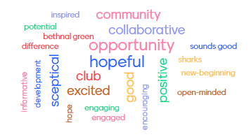

## Appendix 3 – Tower Hamlets Health Promoting Leisure Logic Model

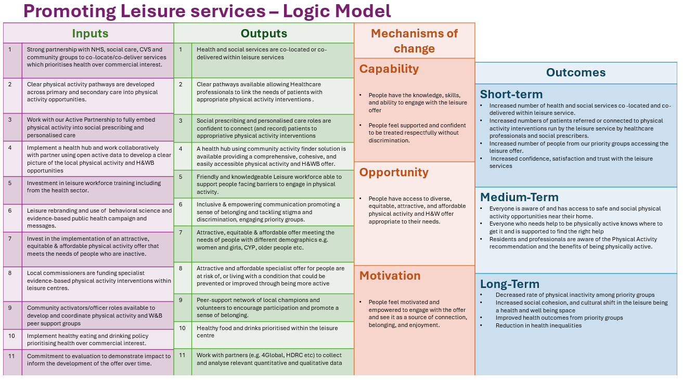

Figure 45: Tower Hamlets Health Promoting Leisure Theory of Change