Health Profile for the Somali population in Tower Hamlets
Using electronic health records from primary care registrations to develop an understanding of the health of adult Somali residents

Nick Payne
Senior Public Health Intelligence Analyst

11/11/2025

Table of Contents

About this report 3
Key Findings 5
Population Overview 6
Adult Risk Factors and Conditions 10
Conclusions 20
Appendix 1 21
Appendix 2 22
References 23

About this report

Aims
This report aims to provide an overview of the population structure and health profile of the adult Somali population in Tower Hamlets, as a basis to help make informed decisions for Somali residents.

Background
The Somali population are more susceptible than the general population to be exposed to socio-economic factors that are known to adversely impact health and wellbeing.
A previous report based on Somali-born residents in Tower Hamlets that used 2011 Census data found that a third (34.0%) of working age residents were in employment, which was around half of the Tower Hamlets average (64.0%). Of those Somali-born residents that were in employment, they were more likely to have lower paid jobs and have more precarious part-time work¹.
Somali-born residents were also less likely to hold higher level qualifications than the general Tower Hamlets population, and around one in five (22.0%) reported they were unable to speak English well or at all.
At a national level, the 2021 Census revealed that nearly 6 in 10 (58.8%) of the Somali population experience overcrowding which is 7 times higher than the national average (8.4%)². Tower Hamlets was found to have one of the highest rates of overcrowding out of any local authority in the country³, suggesting the Somali population are likely to be at risk given their chances of overcrowding are high nationally.
Whilst we have developed a good understanding of the wider determinants of health relating to the Somali population, there is very little information on subsequent health outcomes.
Detailed ethnicity recording in primary care allows us to investigate health metrics for this community and benchmark against the average for Tower Hamlets.

Data Sources
Data relating to the Somali population is limited and therefore presents challenges when providing an overview of the population. The poor availability of data relating to the Somali population is largely a consequence of the lack of detailed ethnicity recording across different data sources. And where the required level of detailed ethnicity is recorded, it can be difficult to access.

Census data
Publicly available data was taken from the 2021 Census to provide an overview of the Somali community in Tower Hamlets. The data rely on self-reported ethnic identity, to provide information on the population structure and where in the borough they live. There is a lack of trend data available with previous Census’ on Somali ethnicity because 2021 was the first year this level of ethnic granularity was recorded.

Primary care routine health records
Restricted (non-public) data in the form of Electric Health Records (EHRs) were used to provide quantitative driven insight into the health status of Tower Hamlets Somali residents for the first time. In this context, EHRs refer to registered patients in primary care services within Tower Hamlets who also live within the borough.
Data from primary care EHRs was extracted from the East London Database (ELDB), which is a curated dataset of primary care records provided by the Clinical Effectiveness Group at the Queen Mary’s University. This data presents a snapshot of primary care EHRs as at 1st April of each year.
Primary care EHR data was also extracted by the North East London Integrated Care Board (NEL ICB) from the Segmentation Cohort Metrics Tool and the NEL ICB Patient Master Index upon request. These datasets provide more breadth of indicators and novel methodological approaches (e.g. segmentation) that add to the ELDB data. The EHR data from NEL ICB are based on registered patients in primary care and were analysed by the NEL ICB to present a snapshot as at 31st December 2024.
Whilst EHRs from primary care provide us with the best possible insight for health in the Somali population, there are some limitations to consider when using primary care EHRs as a source for monitoring health and associated outcomes. Primary care records are susceptible to containing inaccurate information about a patient’s identity and medical history⁴. There can also be variation in the level of reporting between different conditions. For example, long term conditions (e.g. diabetes) are considered to be well captured, but more episodic conditions (e.g. common mental illness) can be more difficult.
These limitations may be compounded in the Somali community, because evidence suggests they typically find it difficult to engage with health and social care services due to barriers around language and other socio-economic factors⁵. It is possible that health related indicators are missed in primary care for the Somali community as a consequence.
Analysis of EHRs in this report are limited to adults (except for autism), because the data we have access to generally relate to adult specific conditions and behaviours. This report is therefore unable to provide insight on the health of Somali resident children.

Key findings

- The Somali population represent a small but also highly deprived population within Tower Hamlets indicating they are at high risk of poor health outcomes
  - Somali account for around 2.0% of the Tower Hamlets population
  - Somali ethnicity has the largest deprivation gap; 2.6 times as many living in the most deprived areas compared to the least, followed by Indian, Pakistani and Bangladeshi (1.9 times) and Black excluding Somali (1.6 times)

- The Somali population generally have worse health than the Tower Hamlets average based on the North East London Integrated Care Board’s population health segmentation model

- Serious mental illness (SMI) disproportionately affects the Somali community more than any other ethnicity across both sexes in Tower Hamlets
  - SMI prevalence is around 3 times higher than the borough average for Somali men (6.7% compared to 2.2%)
  - SMI prevalence is around 2 times higher than the borough average for Somali women (4.6% compared to 2.2%)
  - Conversely, diagnosed common mental illness prevalence is lower than the borough average for the Somali community (4.1% compared to 7.2%)

- Almost 4 in 5 (79%) Somali adults are living with overweight or obesity
  - Obesity prevalence is more than twice as high in Somali women (46.1%) compared to Somali men (20.5%)

- Somali population have the second highest diabetes prevalence (15.1%) of all ethnicities in Tower Hamlets
  - Diabetes and obesity “paradox” in women; Somali women have twice the prevalence of obesity, but the prevalence of diabetes is 6 percentage points lower than Somali men

- Smoking prevalence is around 4 times higher in Somali men (20.6%) compared to Somali women (5.5%), and is similarly high for men in the borough (24.5%)

Population overview

Population structure
There are an estimated 6,180 people who identify as Somali or Somalilander living in Tower Hamlets, which accounts for around 2% of the Tower Hamlets population⁶.
Those who identify as ‘Somali’ amounts to 3,967 (1.3%) people whilst the number who identify as ‘Somalilander’ amounts to 2,213 (0.7%) people (see Table 1)⁶.
Around 5,580 of the Somali and Somalilander community in Tower Hamlets identify as Black which accounts for more than a quarter (27.2%) of this ethnic category. The majority of the Somali and Somalilander community identify more specifically as Black African (around 5,380 people), which accounts for more than a third (35.0%) of those who identify as Black African in the borough. A minority of the Somali and Somalilander population (around 600 people) identify as Other broad ethnic group.
Somali-born residents make up the half of the Somali and Somalilander community in Tower Hamlets, recording a total of 3,102 residents (50.1%) which is similar to what was recorded in the 2011 Census (2,925 people)⁷.
Unless otherwise stated, Somali will refer to those who identify their ethnicity as ‘Somali’ and will not include Somalilander for the remainder of this report because Somalilander data is not recorded elsewhere.

Table 1. Count of Somali and Somalilander residents and their proportion of the Tower Hamlets population from Census 2021
Detailed Ethnic Group | Count of People | Proportion of Tower Hamlets population  (%)
Black, Black British of African background: Somali | 3,350 | 1.08%
Black, Black British of African background: Somalilander | 2,031 | 0.65%
Other ethnic group: Somali | 422 | 0.14%
Black, Black British of Caribbean background: Somali | 195 | 0.06%
Other ethnic group: Somalilander | 182 | 0.06%
Total | 6,180 | 2.0%

Out of the 47 local authorities that provide data for the Somali population in England, Tower Hamlets has the 17th largest population. The majority of local authorities with the largest Somali populations are within London. Tower Hamlets has the 12th largest population out of the London boroughs, with counts ranging from 11,254 people in Brent to 4,010 people in Hammersmith & Fulham⁸.
Females make up the majority of the Somali population, accounting for 53.0% whilst males make up 47.0%⁸. The Somali population is young in Tower Hamlets and the distribution of Somali residents differs to the Tower Hamlets average. The majority of Somali residents (54.5%) are aged 24 years or less⁸. The largest proportion of the Somali population are aged 10-14 years for both sexes, accounting for 12.9% and 15.4% of females and males, respectively (see Figure 1). This is around 15 years younger than the age group with the largest proportion of people for the Tower Hamlets general population, which is the 25-29-year-old age group.

Figure 1. Population distribution by age and sex for the Somali population compared to the Tower Hamlets average
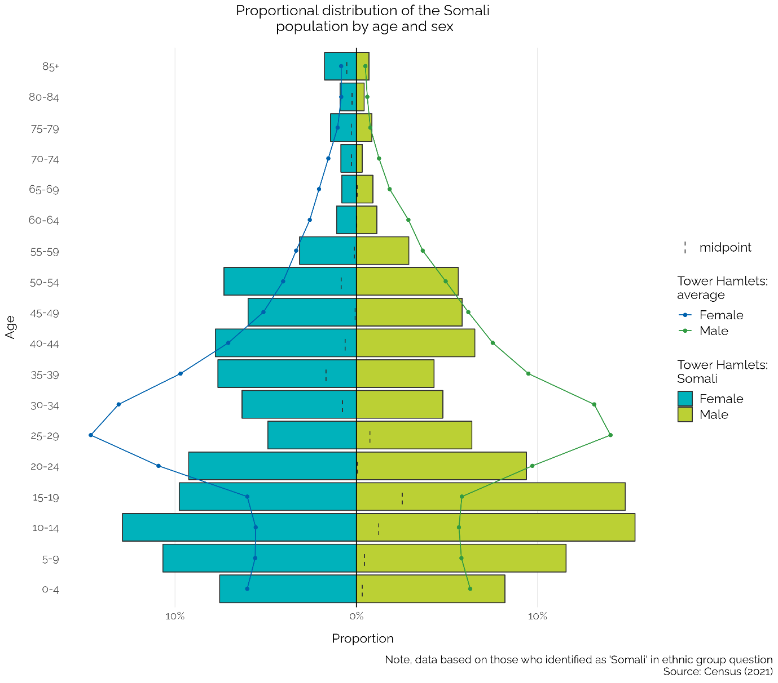

Somali population by place and deprivation
The smallest geographical areas that data are publicly available for is at Middle Layer Super Output Area (MSOA). MSOAs represent statistical geographical boundaries and account for around 5,000 – 15,000 residents per area⁹. In order to make the data more relatable, the spatial analysis in the text below is reported using wards that are most relevant to the MSOAs based on spatial boundary overlap.
The majority of the Somali population are located to the East of the borough, in areas such as Lansbury, Mile End and both North and South Bromley (see Figure 2)⁸. Lansbury and Bromley North are the wards which experience the highest level of deprivation in Tower Hamlets based on the Index of Multiple Deprivation (IMD)¹⁰. The IMD is a relative, local-level measure of deprivation comprised of 7 domains: income, employment, health and disability, education, barriers to housing and services, crime and living environment. The index is based on data from 2015-16 but currently presents the best available metric for local level area-based deprivation.

Figure 2. Distribution of Somali & Somalilander population across Tower Hamlets by Middle Level Super Output Area
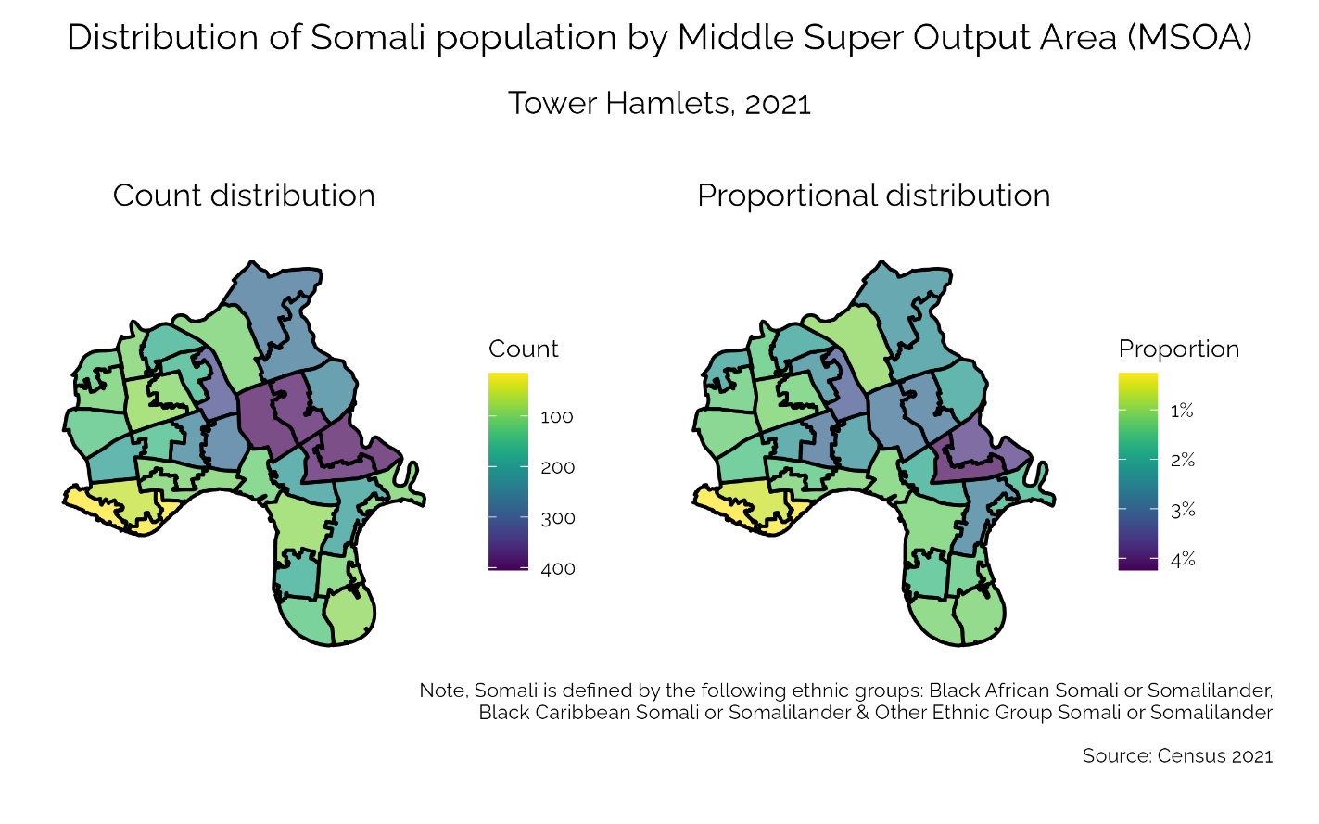

Tower Hamlets specific deprivation quintiles (i.e. fifths) were used to better understand the distribution of the Somali patient population across deprivation groups. Quintile 1 equals the most deprived group and quintile 5 equals the least deprived. Tower Hamlets specific deprivation quintiles were formulated by taking the IMD score for each of the small area neighbourhoods in Tower Hamlets and re-ranking them.
The majority of the adult Somali patient population live in the most deprived areas of Tower Hamlets (see Figure 3). The deprivation gap – the difference between the most deprived quintile and the least deprived – was largest in the Somali population compared to any other ethnic group in Tower Hamlets. There are 2.6 times as many Somali patients living the most deprived areas compared to the least, followed by 1.9 times difference for Indian, Bangladeshi and Pakistani and 1.6 times for Black (excl. Somali). Remaining ethnicities such as Other Asian (incl. Chinese), Other White, Mixed or multiple, Other and White British had a higher proportion of patients living in the least deprived compared to the most.

Figure 3. Distribution of the adult (aged 16+ years) Somali patient population by Tower Hamlets specific deprivation quintile
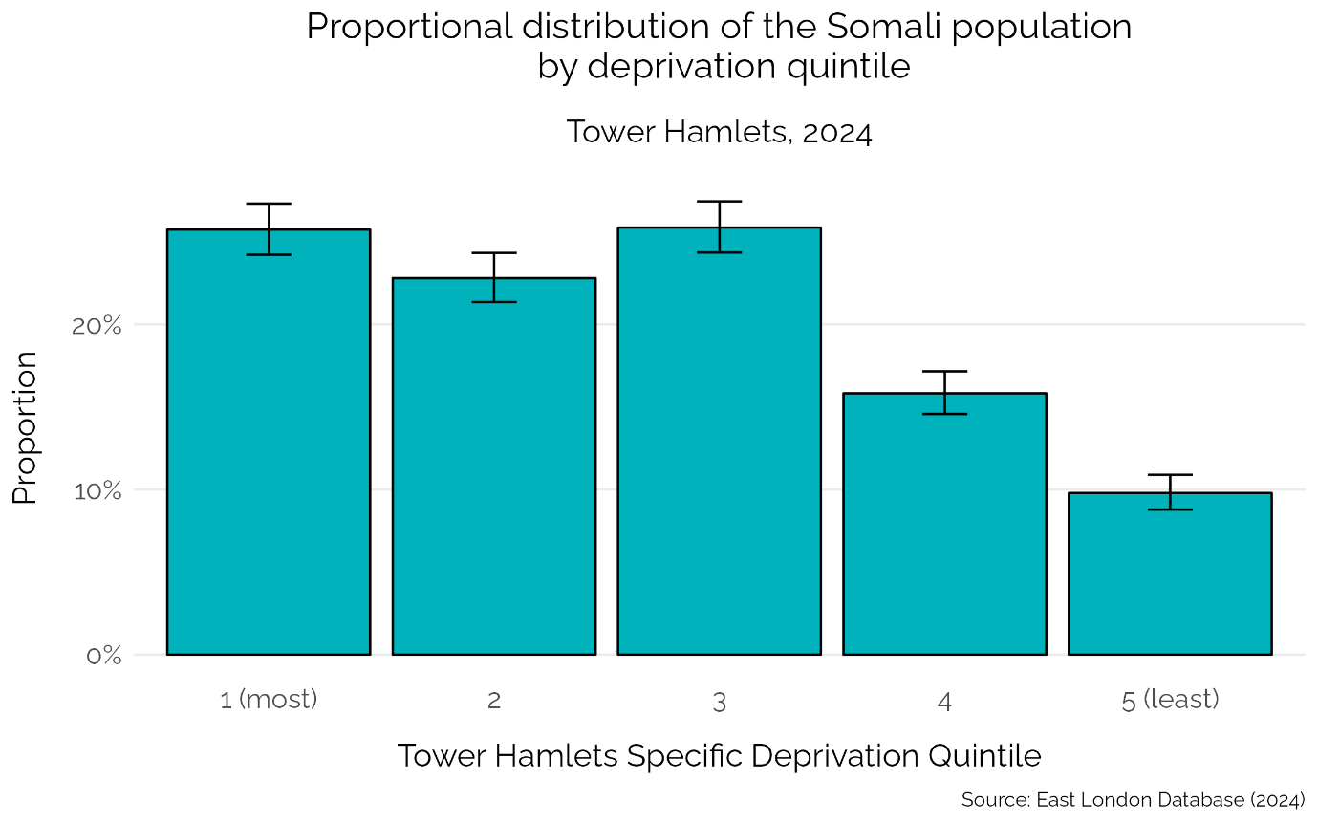

Data from primary care can give an indication of some wider determinants of health, such as homelessness and levels of independence. The crude proportion that were recorded as ever homeless in primary care data is more than twice as high in Somali patients (2.0%) compared to the Tower Hamlets average (0.8%). And a higher proportion of Somali patients are recorded as being housebound (1.3%) compared to the average for the borough (0.7%). However, when observing those who are 70 and over, the proportion of Somali patients who are housebound rises to 16.1%, which doesn’t significantly differ from the Tower Hamlets average.
Some caution is needed when interpreting these findings due to variability in reporting for these metrics between practices and lack of age-standardisation. However, it is clear Somali residents are subject to higher levels deprivation based on the IMD. Exposure to risk factors such as homelessness are associated with the wider determinants of health and therefore are more likely to occur.

Adult risk factors and conditions

Vital 5 indicators
The Vital 5 are a set of indicators that are considered to be key determinants of many long term physical and mental health outcomes. The 5 indicators are smoking, overweight and obesity, alcohol consumption, hypertension (high blood pressure) and common mental illness (anxiety and/or depression). Helping people to improve their exposure or experience with these indicators can lead to people living healthier for longer.
Data for each of these 5 indicators was extracted from primary care records that are stored in the East London database (ELDB) to compare the Somali prevalence with the average for Tower Hamlets (see Figure 4). As at April 1st 2024 the ELDB had 3,066 registered adult (aged 16+ years) patients that were recorded as Somali living in Tower Hamlets. The data are age-standardised and represent adults aged 16 and over, except for smoking which is related to adults aged 18 years or more.

Figure 4. Prevalence of the Vital 5 indicators in Somali adult registered patients compared to the Tower Hamlets average
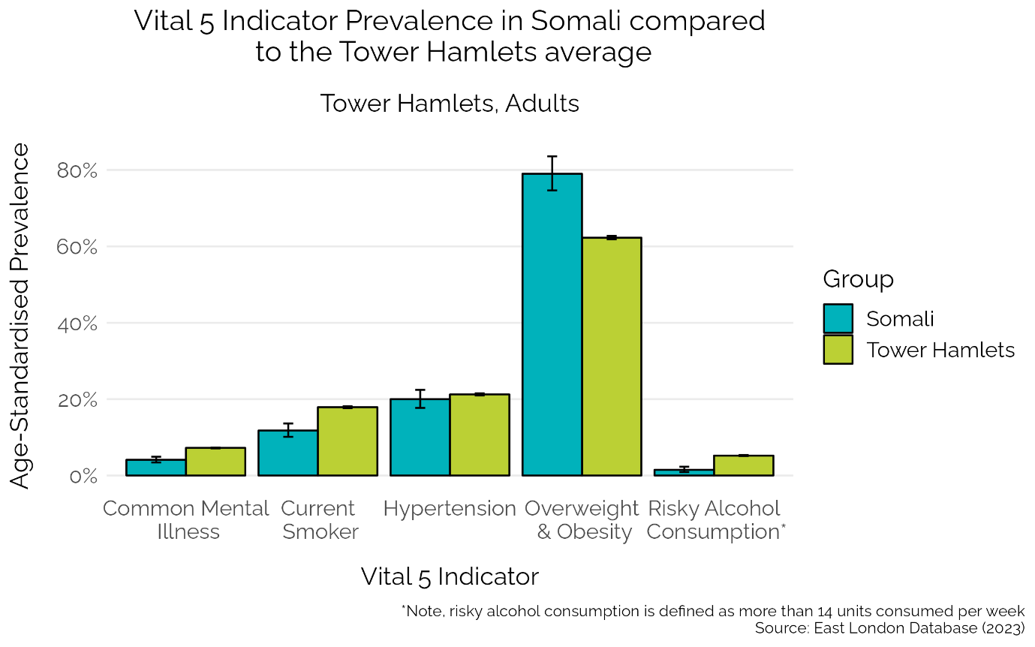

Overweight and obesity prevalence is typically defined as Body Mass Index (BMI) of 25 or higher. However, overweight and obesity for people from Asian, Black African, African-Caribbean or Middle Eastern backgrounds is defined as a BMI of 23 or more, because these ethnic groups have a higher chance of developing health conditions (e.g. diabetes) at a lower BMI^{11,12}. The ethnicity adjustment for BMI was applied to the data in this analysis.
Overweight and obesity prevalence in this analysis represents patients who have a record of BMI status within the last 5 years in adults aged 16 years or more. Around 4 in 5 (79.0%) of the Somali population is overweight and obese, which is higher than the Tower Hamlets average (62.3%: see Figure 4). Somali women are more likely to live with obesity (46.1%) compared to being overweight (21.5%) (see Figure 5). Conversely, Somali men are more likely to be overweight (28.4%) than live with obesity (20.0%).
It is worth noting that around 4 in 10 patients – across both general and Somali patient populations in Tower Hamlets – did not have a record for BMI in the last 5 years. It is possible the sample are skewed towards people who are more likely to be overweight or obese as a consequence, because this data collection is not randomised. However, research from other European countries indicates that women typically have a higher BMI compared to men in Somali immigrant populations^{13,14}, highlighting a need to address weight loss interventions for Somali women.

Figure 5. Prevalence of Body Mass Index (BMI) in Somali adults (aged 16+ years) by sex in Tower Hamlets
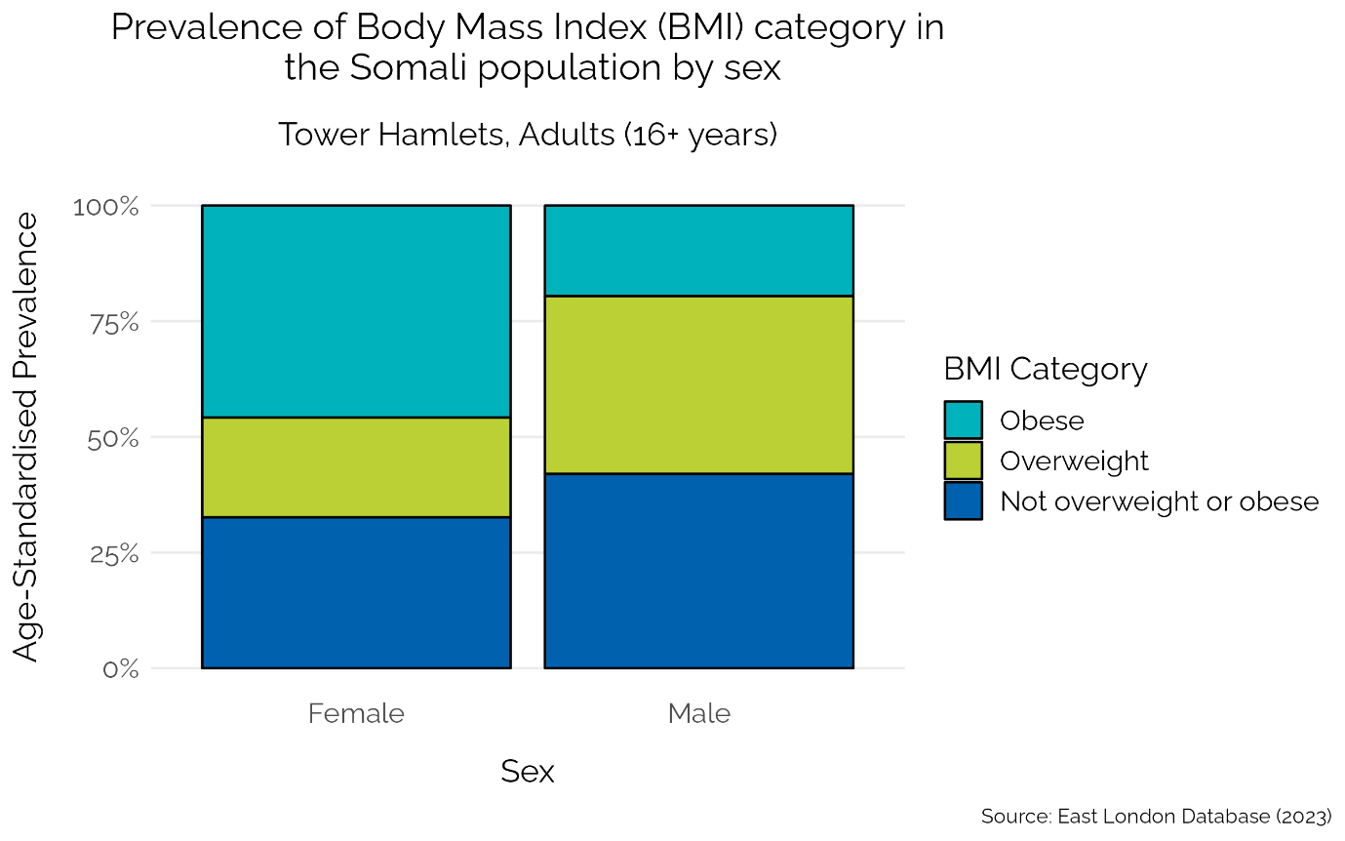

Current smoking prevalence represents patients who have a record of self-reported smoking status within the last 5 years in adults aged 18 years or more. Smoking prevalence in Somali adults (11.8%) is lower than the Tower Hamlets average (17.9%; see Figure 4), however there is a large difference between sexes. Smoking prevalence is around four times higher in Somali men (20.6%) compared to Somali women (5.5%; see Figure 6). This data adds to the consistent finding of higher smoking prevalence in men compared to women across ethnicities^{15,16}, emphasising the importance of reaching all men in the context of smoking cessation.

Figure 6. Prevalence of smoking by sex in Somali adults (aged 18+ years) compared to the Tower Hamlets average
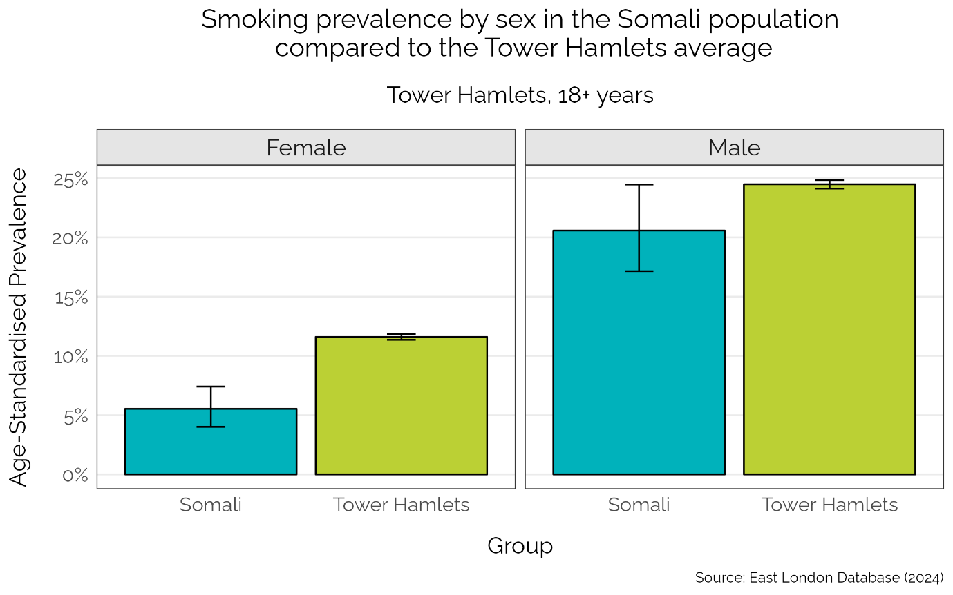

The prevalence of hypertension is similar in the Somali population (20.0%) compared to the Tower Hamlets average (21.2%; see Figure 4). There is no difference in diagnosed hypertension prevalence between Somali men (20.1%) and women (19.9%). People from a Black ethnicity are known to be more susceptible to hypertension and experience worse outcomes when compared to the average^{16–18}.
Hypertension is also known to be underdiagnosed, with national data displaying around 3 in 10 (29%) of people with hypertension were unaware of their diagnosis¹⁹. It is possible that some in the Somali community are undiagnosed, given the difficulties around engaging with health services that have been documented⁵. Monitoring and encouraging attendance to services such as NHS Health Checks, if eligible, could prove beneficial to help patients get the care they need.
Common Mental Illness prevalence is lower in the Somali population (4.1%) compared to the Tower Hamlets average (7.2%; see Figure 4). There is no statistical difference in prevalence between Somali men (3.1%) and women (5.1%).
Similar to hypertension, underdiagnosis of common mental illnesses is common, with estimates suggesting an undiagnosed population between 26-29% based on UK studies^{20,21}. Ethnic minority groups are believed to constitute a significant proportion of the undiagnosed population because of stigma around mental health diagnosis and poor experiences with services that lead to disengagement²².
‘Risky’ alcohol consumption is defined by government guidelines as consuming more than 14 units per week²³. Patients who had a record of their weekly alcohol consumption within the last 5 years were included. The vast majority of Somali adults (98.4%) report to consume less than 14 units of alcohol per week, indicating alcohol use to be a low priority issue within the Somali community (see Figure 4).
Research suggests that the Muslim faith may be a protective factor against risky alcohol consumption²⁴. However, findings from this research also suggested that younger Somali people interviewed were more likely to be open about consuming alcohol, indicating there could be a generational influence influencing alcohol consumption. Indeed, around 60-65% of records are missing for weekly alcohol consumption in patients aged 20-40 years in this analysis. This suggests that the true alcohol consumption could be different to what is presented and may be worth exploring further.

Segmentation model
The segmentation model was developed by the North East London Integrated Care Board and provides an overview of the health of the local population using primary care registered patient records. The model places patients into 1 of 7 segments to provide a proportional distribution which is based on their dominant health need. The 7 segments are: Healthy, Healthy with Risk Factors, Long Term Conditions (LTC; see Appendix 1 for full list of conditions), Serious Mental Illness (SMI), Frailty and Dementia, Organ Failure and End of Life.

Figure 7. Proportion of Somali population within each segment of the Segmentation Model compared to the Tower Hamlets average
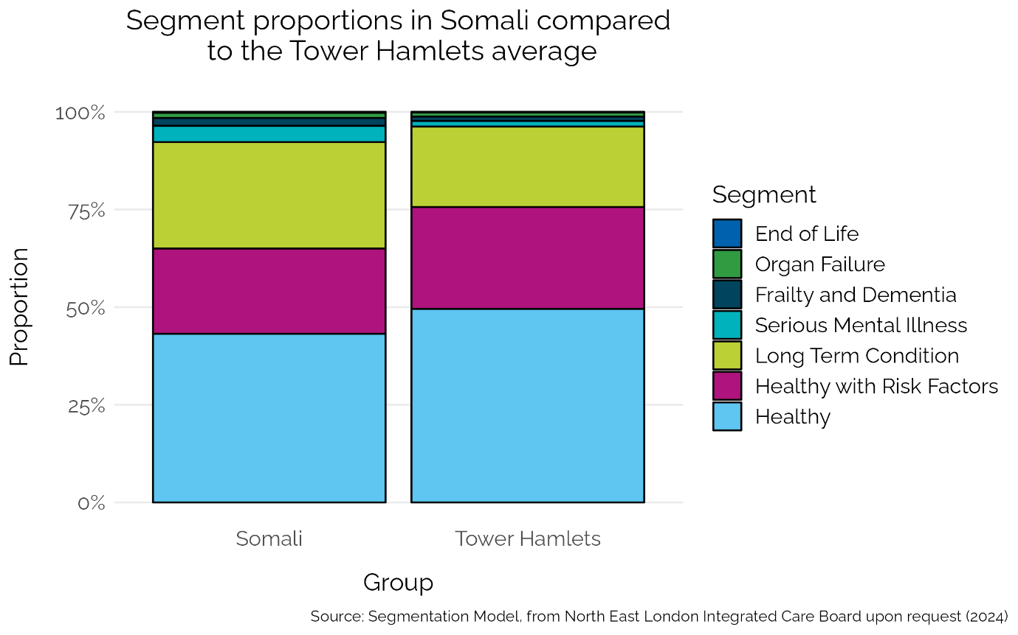
The segmentation model indicates that for both of the ‘healthy’ segments, the Somali population is lower than the Tower Hamlets average (see Figure 7). Conversely, the proportion of the Somali population living in the segments pertaining to poor health (LTC, SMI and Frailty and Dementia) is higher compared to the comparable segments for Tower Hamlets. The proportion falling into the Organ Failure segment is similar between the Somali and Tower Hamlets general population, and there was not enough data to make a reliable comparison for the End of Life segment.
The summary of data presented from the segmentation model indicate the Somali community generally to have poorer health compared to average Tower Hamlets resident. Some caution is needed when interpreting findings from the segmentation model however, because the calculated proportions do not account for age which is important when: a) working with populations that are younger than average (e.g. Tower Hamlets); b) considering conditions that are strongly related to age (e.g. diabetes, cardiovascular disease). The following section aims to address this short coming in the segmentation model by looking at specific long term conditions and standardising for age.
Long term conditions
Data for this section are concerning long term conditions (LTCs) which were largely extracted from the ELDB (2024). A small selection of indicators were not available within the ELDB and therefore were provided by the NEL ICB. Unless otherwise stated, estimates are standardised for age, however in some instances crude prevalence are provided and are clearly labelled in the text.

Figure 8. Long term health conditions in Somali adults (aged 16+ years) compared to the Tower Hamlets average
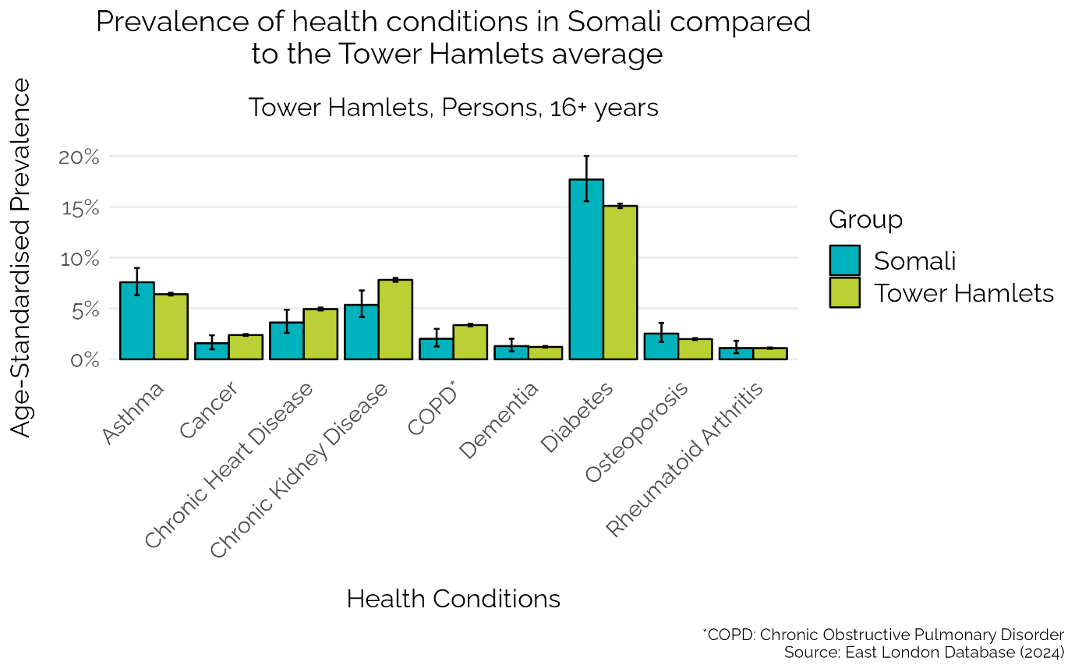

Diabetes contributes by far the largest proportion of diagnosed long term condition cases in the Tower Hamlets population (see Figure 8). When stratifying by ethnic groups, the Somali community experience the second highest prevalence of diabetes (17.7%), after those from Indian, Bangladeshi and Pakistani ethnic groups (28.5%), both of which are higher than the borough average (15.1%).
The prevalence of diabetes is higher in Somali men (21.5%) compared to Somali women (15.1%), although only just not significantly different based on confidence intervals (see Figure 9). This sex difference appears to be paradoxical when considering the pattern observed for overweight and obesity prevalence – which is a major risk factor for diabetes²⁵ – as Somali women are more likely to be overweight or obese compared to Somali men. A possible implication is that Somali women may be experiencing underdiagnosis of diabetes in Tower Hamlets, although further research is needed to investigate this.

Figure 9. Prevalence of diabetes by sex and ethnicity in Tower Hamlets
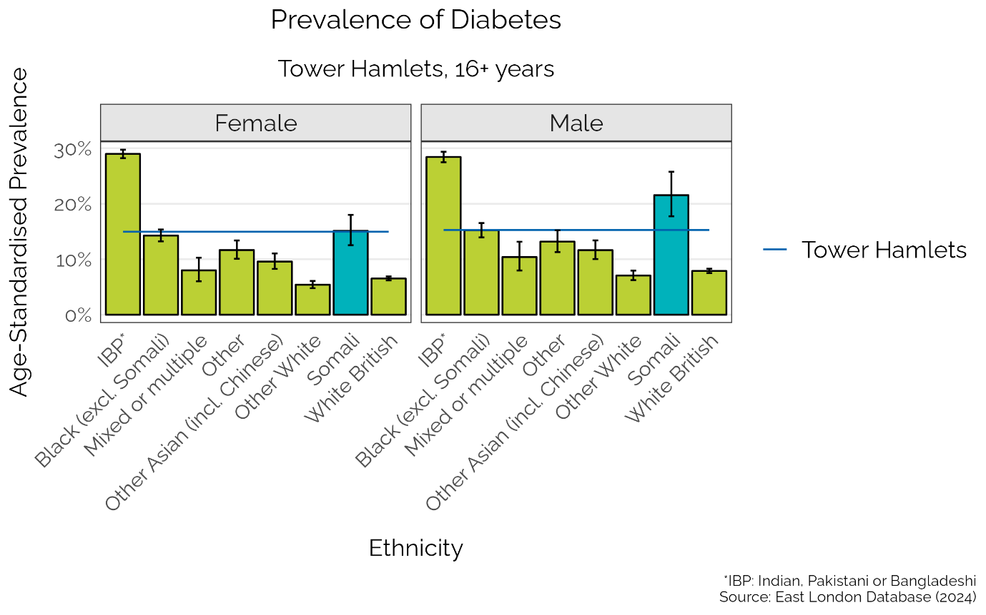

Asthma and chronic obstructice pulmonary disease (COPD) are common respiratory diseases in the general population, although they are associated with different causes^{26,27}. The prevalence of asthma is similar in the Somali population (7.6%) compared to the Tower Hamlets average (6.4%; see Figure 7). There is an indication of a sex difference, with prevalence in Somali women at 9.1% compared to 5.4% for Somali men, although this is not significantly different (see Figure 10). COPD prevalence is lower in the Somali population (2.0%) compared to the Tower Hamlets average (3.4%), and there is no sex difference between Somali men and women (see Figure 8).

Figure 10. Prevalence of asthma by sex and ethnicity in Tower Hamlets
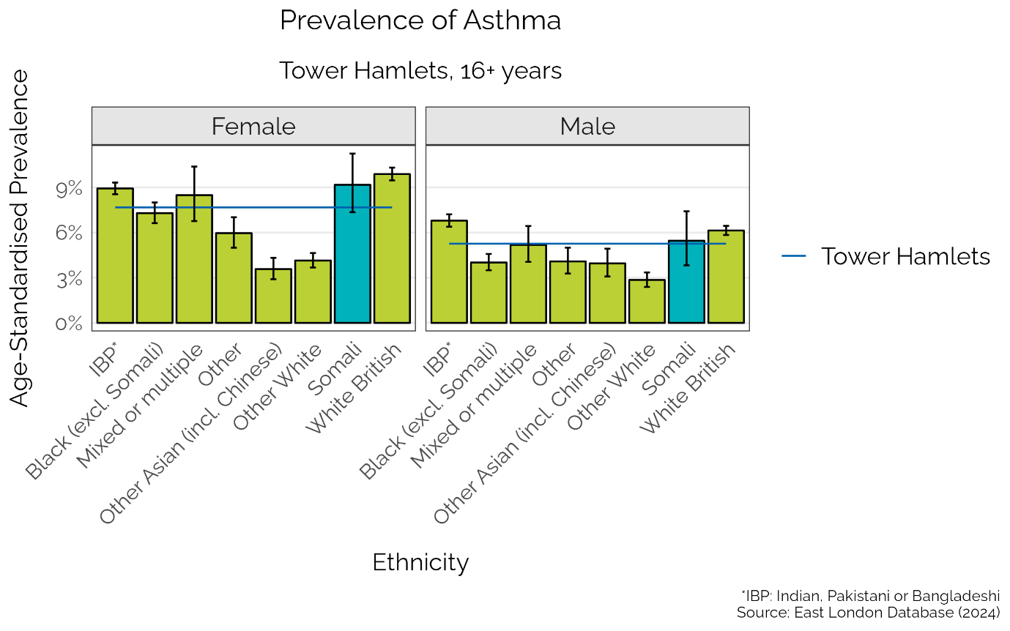

Conditions relating to bones and joints display a varied picture of prevalence in Tower Hamlets. Prevalence of osteoporosis and rheumatoid arthritis in the Somali population is low and similar to the Tower Hamlets average, at 2.5% and 1.1%, respectively (see Figure 8). However, crude prevalence of osteoarthritis in the Somali population (12.3%) is around twice as high as the Tower Hamlets average (6.7%). And crude prevalence of chronic pain is higher in the Somali community (5.8%) compared to the borough average (3.3%). Whilst many conditions can contribute to chronic pain, arthritis is known to be a main contributing factor²⁸. Ensuring the Somali community are receiving appropriate treatment for conditions such as osteoarthritis (as well as other chronic pain conditions) could be an area to prioritise.
Cancer prevalence refers to Tower Hamlets registered patients that have received a cancer diagnosis which is recorded in primary care within the last 10 years. The prevalence of cancer appears to be low in Tower Hamlets, with 1.5% of Somali patients living with cancer, which is similar to the Tower Hamlets average (see Figure 8). No sex difference is observed for cancer prevalence between Somali men and women. Completeness of cancer diagnosis recording in primary care has been documented to be poor compared to other cancer sources (e.g. National Cancer Data Registry)²⁹, and therefore likely presents an underrepresentation of cancer cases across the borough.
Other long term conditions vary for the Somali population in Tower Hamlets. Prevalence of chronic heart disease (3.6%) and chronic kidney disease (5.4%) in the Somali community are similar to the Tower Hamlets average (see Figure 8). There is a higher prevalence of chronic heart disease for Somali men (6.3%) compared to Somali women (2.0%; see Figure 11). No sex difference is observed for chronic kidney disease for the Somali patient population.

Figure 11. Prevalence of Chronic Heart Disease by sex and ethnicity in Tower Hamlets
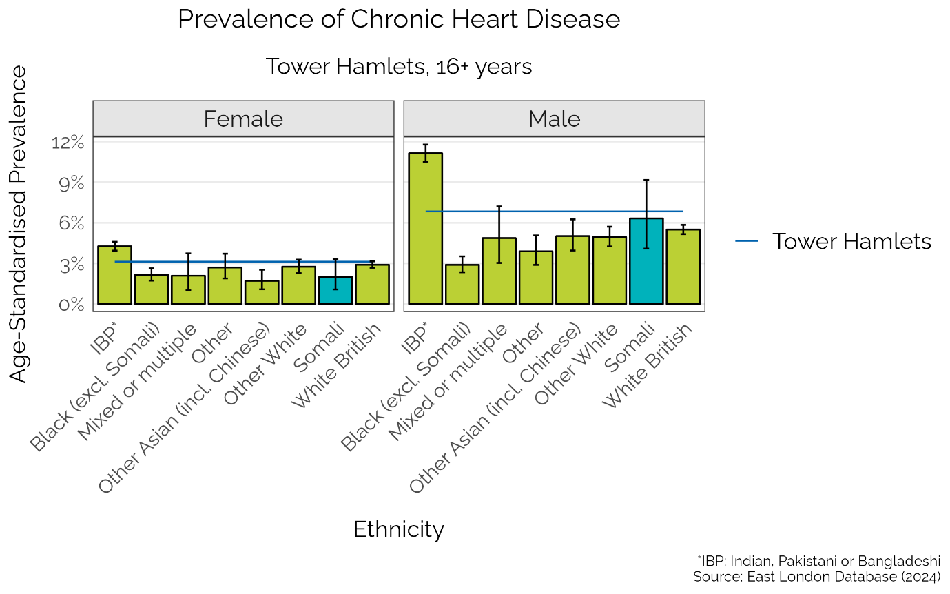

Crude prevalence data indicate chronic liver disease is higher in the Somali population (3.6%) compared to the Tower Hamlets average (1.9%). However this gap could change if the data was age-standardised because neither the Somali nor Tower Hamlets’ young population were accounted for, potentially leading to a lower than expected prevalence.
The prevalence of dementia is low in Tower Hamlets and is similar in the Somali population (1.2%) to the average for the borough (see Figure 8). Counts of dementia diagnosis are low (around 10 counts) across both sexes meaning it is not possible to make a reliable comparison by sex.

Severe mental illness
Severe mental illness (SMI) typically, but not exclusively, accounts for conditions such as schizophrenia and bipolar disorder. People living with SMI are subject to some of the worst inequalities, with life expectancy up to 20 years less than the general population³⁰.
SMI disproportionately affects the Somali community more than any other ethnicity across both sexes in Tower Hamlets. SMI prevalence for Somali men and women is 6.7% and 4.6%, respectively, whilst the average for the borough is around 2.0% across both sexes (see Figure 12). The development of SMI is complex but improving outcomes for the Somali community with SMI involves addressing factors like substance abuse, chronic stress, living conditions, and access to services³¹.

Figure 12. Prevalence of severe mental illness by sex and ethnicity in Tower Hamlets
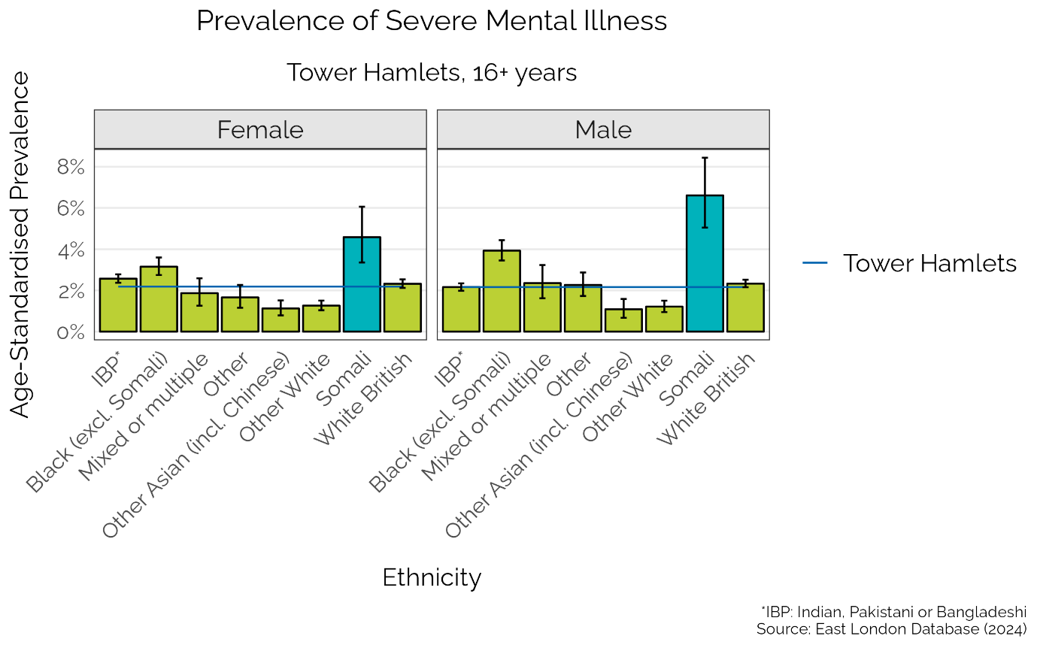

Autism
Autism is a neurodivergent condition that is often associated with anxiety in social situations, difficulty understanding other people’s feelings and struggling to follow social “rules” (e.g. not speaking over one another). Though there are a wider set of symptoms that can differ between sexes³².
The prevalence of autism in Somali residents (0.7%) is higher than the Tower Hamlets average (0.4%), with no clear sex difference observed between Somali men and women (see Figure 13; see Appendix 2 for autism prevalence in children and young people). Research found that people with autism can face difficulties receiving appropriate healthcare, with self-reported adverse health outcomes as a result³³. It is important to ensure those who are trying to access services are supported to receiving appropriate treatment.

Figure 13. Prevalence of austim by sex and ethnicity in Tower Hamlets
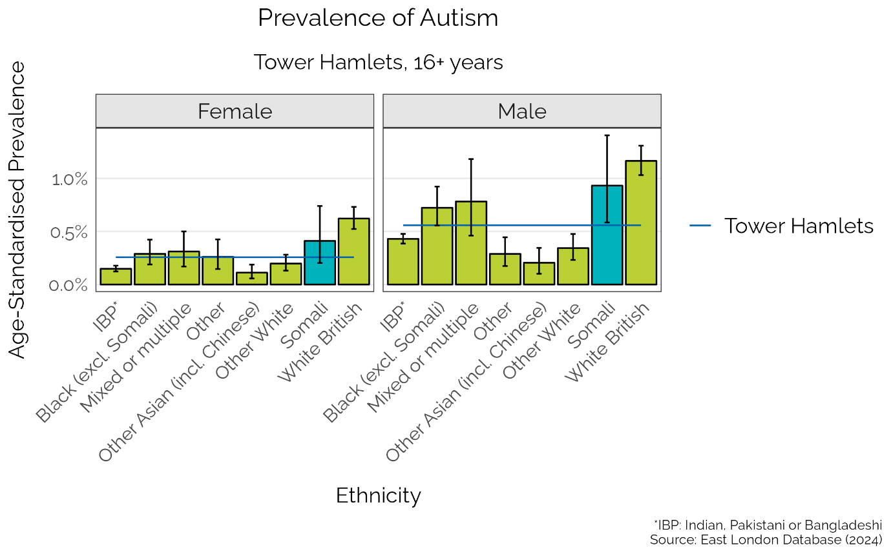

Learning and physical disabilities
People living with learning or physical disabilities often are at a higher risk of experiencing health inequalities compared to the general population. The median age of death for people with a learning disability was found to be 62.9 years compared to around 84 years for the general population³⁴. Around 3 in 10 of people living with a physical disability reported to be in ‘good health’ compared to around 9 in 10 for those without a self-reported disability³⁵.
Learning disabilities constitute mainly genetic disorders that result in a developmental delay (e.g. Down syndrome). The prevalence of Somali residents living with learning disabilities is 0.6% which is similar to the Tower Hamlets average (see Figure 14). There is no difference in prevalence between Somali men and women.
Physical disabilities recorded in primary care refer to neurological and congenital conditions, amputations, and visual and hearing impairments. The crude prevalence of residents living with a physical disability is higher in the Somali population (7.5%) compared to the average for the borough (5.1%). Living with a physical disability often requires a higher level of support to manage day-to-day activities, and this data suggest Somali residents have a higher need for aid that should be monitored to ensure they are receiving the help they require.
Figure 14. Prevalence of learning disabilities by ethnicity in Tower Hamlets
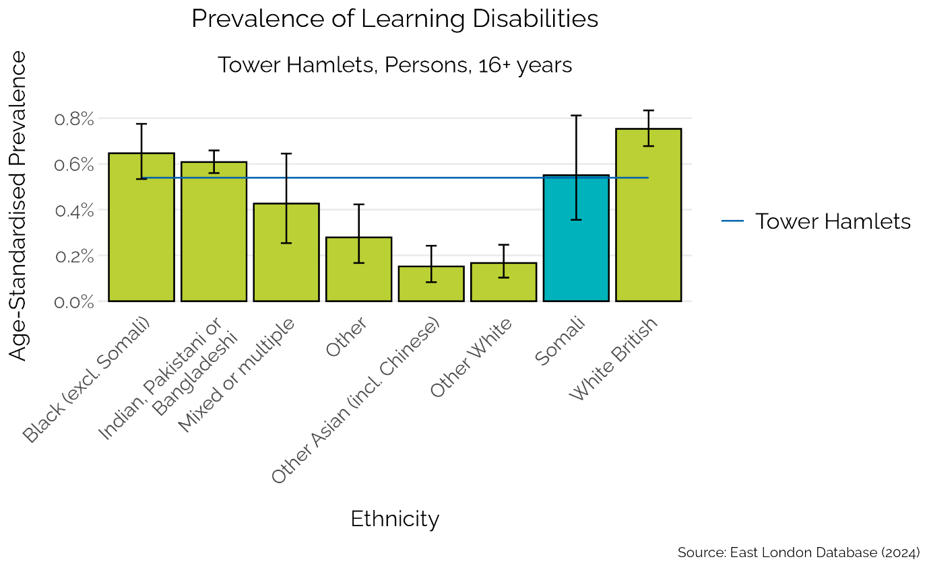

Conclusions

This report reveals that the Somali population are more likely to live in areas of high deprivation and experience worse health compared to the general population in Tower Hamlets.
The segmentation model helps to highlight the health inequality in Somali residents, with larger proportions of the Somali population placed in segments relating to poor health. Data taken from the primary care registrations further emphasise the health inequality, by displaying noticeably higher than average prevalences for a range of key health metrics such as overweight and obesity, diabetes and serious mental illness. Osteoarthritis and chronic pain are also noticeably higher in the Somali population, but data are based on crude prevalence which need to be treated with caution.
Future research could investigate the interaction of the Somali population with health services such as the NHS Health Checks or secondary care to better assess the possible inequity in care the Somali community experience.
The health of children and young people would be another area to explore as they were beyond the scope of this report, but they form a considerable proportion of the Somali community living within the borough.

Appendix 1

Long term conditions included within the North East London Integrated Care Board Segmentation model:
- Asthma
- Atrial fibrillation
- Bronchiectasis
- Cancer
- Cerebrovascular disease
- Chronic kidney disease
- Chronic liver disease
- Chronic obstructive pulmonary disease
- Cystic fibrosis
- Diabetes
- Eating disorders
- Epilepsy
- Heart failure
- Inflammatory bowel disease
- Multiple sclerosis
- Osteoarthritis
- Osteoporosis
- Parkinson’s disease
- Peripheral vascular disease
- Pulmonary heart disease
- Sarcoidosis
- Sickle cell disease

Appendix 2

Autism is a condition that is typically diagnosed in childhood and recorded in primary care electronic health records (EHRs). We have therefore provided a summary of autism data for children and young people (aged 0-19 years) in Tower Hamlets below.
The prevalence of autism in Somali children and young people is 3.7%, which does not differ significantly to the Tower Hamlets average (2.9%).
Autism prevalence is more than 3 times higher in young Somali males (5.7%) compared to young Somali females (1.7%). Neither young Somali males nor young Somali females differ from their respective sex-specific borough average.

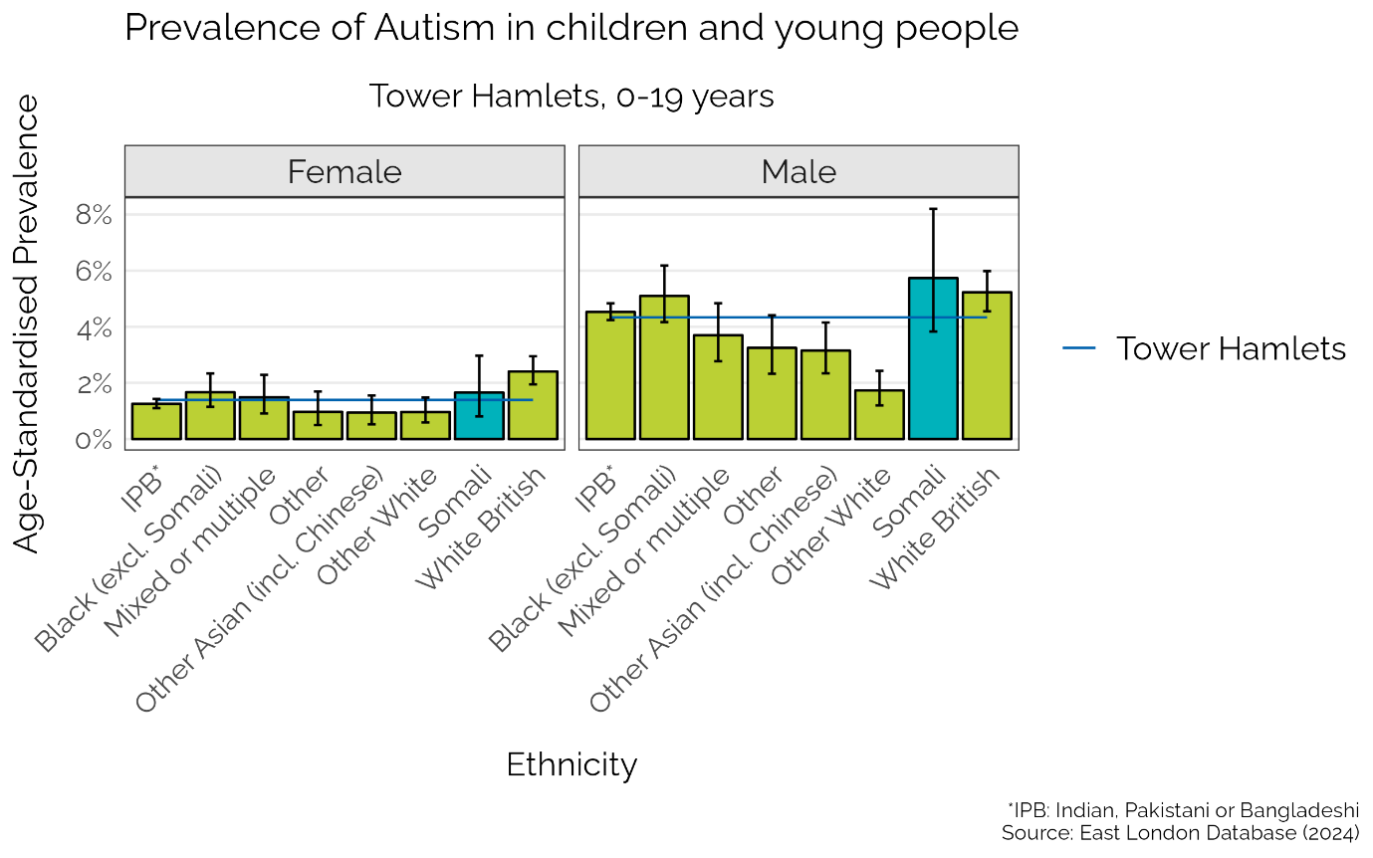

References

1. Matin, S. et al. A profile of the Somali-born population in Tower Hamlets: key facts.
2. Somali populations, England and Wales - Office for National Statistics. https://www.ons.gov.uk/peoplepopulationandcommunity/culturalidentity/ethnicity/articles/somalipopulationsenglandandwales/census2021.
3. Overcrowding and under-occupancy by household characteristics, England and Wales - Office for National Statistics. https://www.ons.gov.uk/peoplepopulationandcommunity/housing/articles/overcrowdingandunderoccupancybyhouseholdcharacteristicsenglandandwales/census2021.
4. The extent and impact of inaccurate NHS patient records | Healthwatch. https://www.healthwatch.co.uk/blog/2025-05-01/extent-and-impact-inaccurate-nhs-patient-records (2025).
5. Health Inequalities: Somali people’s experiences of health and social care services in Birmingham. Healthwatch Birmingham https://healthwatchbirmingham.co.uk/news/health-inequalities-somali-peoples-experiences-of-health-and-social-care-services-in-birmingham/.
6. Nomis - Query Tool - TS022 - Ethnic group (detailed). https://www.nomisweb.co.uk/query/construct/summary.asp?mode=construct&version=0&dataset=2095.
7. Create a custom dataset - Office for National Statistics. https://www.ons.gov.uk/datasets/create.
8. Small population, England and Wales: Census 2021 - Nomis - Official Census and Labour Market Statistics. https://www.nomisweb.co.uk/sources/census_2021_sp.
9. Census 2021 geographies - Office for National Statistics. https://www.ons.gov.uk/methodology/geography/ukgeographies/censusgeographies/census2021geographies.
10. English indices of deprivation 2019. GOV.UK https://www.gov.uk/government/statistics/english-indices-of-deprivation-2019.
11. Calculate your body mass index (BMI) for adults - NHS. nhs.uk https://www.nhs.uk/health-assessment-tools/calculate-your-body-mass-index/calculate-bmi-for-adults (2023).
12. Caleyachetty, R. et al. Ethnicity-specific BMI cutoffs for obesity based on type 2 diabetes risk in England: a population-based cohort study. The Lancet Diabetes & Endocrinology 9, 419–426 (2021).
13. Ahmed, S. H., Meyer, H. E., Kjøllesdal, M. K. & Madar, A. A. Prevalence and Predictors of Overweight and Obesity among Somalis in Norway and Somaliland: A Comparative Study. Journal of Obesity 2018, 4539171 (2018).
14. Gele, A. A. & Mbalilaki, A. J. Overweight and obesity among African immigrants in Oslo. BMC Res Notes 6, 119 (2013).
15. Adult smoking habits in the UK - Office for National Statistics. https://www.ons.gov.uk/peoplepopulationandcommunity/healthandsocialcare/healthandlifeexpectancies/bulletins/adultsmokinghabitsingreatbritain/2023.
16. Health Survey England Additional Analyses, Ethnicity and Health, 2011-2019: Data Tables. NHS England Digital https://digital.nhs.uk/data-and-information/publications/statistical/health-survey-england-additional-analyses/ethnicity-and-health-2011-2019-experimental-statistics/data-tables.
17. Abdulle, A. M. et al. Under- treatment and under diagnosis of hypertension: a serious problem in the United Arab Emirates. BMC Cardiovascular Disorders 6, 24 (2006).
18. Abrahamowicz, A. A., Ebinger, J., Whelton, S. P., Commodore-Mensah, Y. & Yang, E. Racial and Ethnic Disparities in Hypertension: Barriers and Opportunities to Improve Blood Pressure Control. Curr Cardiol Rep 25, 17–27 (2023).
19. Risk factors for undiagnosed high blood pressure in England - Office for National Statistics. https://www.ons.gov.uk/peoplepopulationandcommunity/healthandsocialcare/healthandwellbeing/articles/riskfactorsforundiagnosedhighbloodpressureinengland/2015to2019.
20. Anosova, O. et al. Estimating the burden of underdiagnosis within England: A modelling study of linked primary care data. PLOS ONE 20, e0313877 (2025).
21. Collins, B. et al. Investigating the impact of undiagnosed anxiety and depression on health and social care costs and quality of life: cross-sectional study using household health survey data. BJPsych Open 9, e201 (2023).
22. Bansal, N. et al. Understanding ethnic inequalities in mental healthcare in the UK: A meta-ethnography. PLoS Med 19, e1004139 (2022).
23. Chapter 12: Alcohol. GOV.UK https://www.gov.uk/government/publications/delivering-better-oral-health-an-evidence-based-toolkit-for-prevention/chapter-12-alcohol.
24. Yussuf, A., Asquith, P. & Ali, S. Chewing It Over. Khat Use in Lambeth’s Somali Community.
25. Risk factors | Background information | Diabetes - type 2 | CKS | NICE. https://cks.nice.org.uk/topics/diabetes-type-2/background-information/risk-factors/.
26. Prevalence | Background information | Asthma | CKS | NICE. https://cks.nice.org.uk/topics/asthma/background-information/prevalence/.
27. Stone, P. W., Osen ,Michael, Ellis ,Andrew, Coaker ,Rebecca & and Quint, J. K. Prevalence of Chronic Obstructive Pulmonary Disease in England from 2000 to 2019. International Journal of Chronic Obstructive Pulmonary Disease 18, 1565–1574 (2023).
28. Salaffi, F., Giacobazzi, G. & Di Carlo, M. Chronic Pain in Inflammatory Arthritis: Mechanisms, Metrology, and Emerging Targets—A Focus on the JAK-STAT Pathway. Pain Res Manag 2018, 8564215 (2018).
29. Margulis, A. V. et al. Validation of Cancer Cases Using Primary Care, Cancer Registry, and Hospitalization Data in the United Kingdom. Epidemiology 29, 308–313 (2018).
30. Health matters: reducing health inequalities in mental illness. GOV.UK https://www.gov.uk/government/publications/health-matters-reducing-health-inequalities-in-mental-illness/health-matters-reducing-health-inequalities-in-mental-illness.
31. Lindert, J., Bilsen, J. & Jakubauskiene, M. Public mental health. European Journal of Public Health 27, 32–35 (2017).
32. Signs of autism in adults. nhs.uk https://www.nhs.uk/conditions/autism/signs/adults/ (2023).
33. Barriers to healthcare and self-reported adverse outcomes for autistic adults: a cross-sectional study | BMJ Open. https://bmjopen.bmj.com/content/12/2/e056904.
34. Inequalities in healthcare and employment for people with a learning disability and autistic people - Women and Equalities Committee. https://publications.parliament.uk/pa/cm5804/cmselect/cmwomeq/134/report.html#heading-1.
35. Inequalities in good health by disability status | The Health Foundation. https://www.health.org.uk/evidence-hub/health-inequalities/inequalities-in-good-health-by-disability-status (2025).

