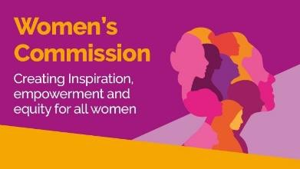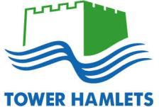
Community Leadership Formal Public Review Date: 25th September 2025, 10AM to 1PM Location: Council Chamber, Town Hall

Time | Item No. | Agenda Item | Lead | Page No.
10.00am | 1. | Introduction and Welcome | Manzila Uddin, Chair of  Women’s Commission
10.05am | 2. | Evidence on the Lived Experience of Women  - Overview of findings from engagement | Claire Christopher, Senior Strategy and Policy Officer | P.g. 2
 |  |  | Muslima Miah, Strategy and Policy Officer
10.20am | 3. | London Borough of Tower Hamlets | Cllr Maium Talukdar, Deputy Mayor | P.g. 22
 |  |  | Steve Reddy, Corporate Director of Children’s Services
10.50am | 4. | Olmec – Black on Board | John Mayford, Senior Associate- Olmec | P.g. 33
11.10am |  | Break
11.20am | 5. | Poplar HARCA | Andrea Baker, Director of Housing & Corporate Services | P.g. 75
11.50am | 6. | Canary Wharf Group | Sophie Goddard, Director of Sustainability | P.g. 81
12.20pm |  | Break
12.30pm | 7. | Reflections and Recommendations | Manzila Uddin, Chair of  Women’s Commission
12:50pm | 8. | Close | Manzila Uddin, Chair of  Women’s Commission
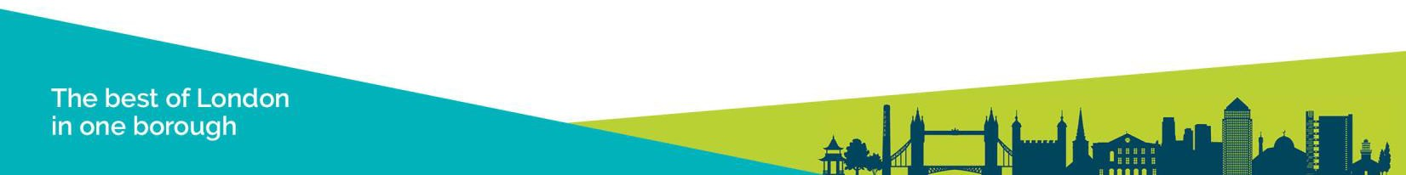
For further information, please contact: Muslima Miah, Strategy and Policy Officer Email: Muslima.miah@towerhamlets.gov.uk
Summary of table: This table shows the agenda for the public review. It includes the speaker times, the organization who was presenting, and the names of the speakers who attended. The right column includes page numbers with the slides they used, which is found in this document.

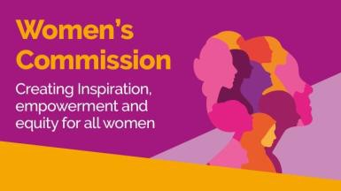

Women’s Commission
Leadership Evidence Pack

The Women’s Commission

The Women’s Commission was established by the Council in 2024 to investigate and address inequalities affecting women in the borough. It responds to the fact that outcomes for women fall behind men:

- Women tend to spend fewer years in good health than men.
- Women’s employment rate is significantly lower, with Black, Asian and Multi-Ethnic

90%
80%

69%

Gender Inequalities in Tower Hamlets
84% 86%

75%

women experiencing the greatest disadvantage.
- Nearly double the percentage of women are in insecure jobs.
- Only 40 per cent of councillors are women.
- Seventy-five per cent of domestic abuse survivors are women.
70%
60%
50%
40%
30%
20%
10%
0%

47%
60%

24%

14%

40%
60%

25%


- Ninety-five per cent of perpetrators of domestic violence are men.
Healthy Years Employment Rate Insecure work Councillors Domestic abuse
survivors
Black, Asian and Multi-Ethnic women Women Men

Purpose and Scope of The Women’s Commission

- The Women’s Commission represents a borough-wide commitment to addressing inequalities for women and ensuring all women can lead safe, healthy, and fulfilling lives.
- A workshop was held with residents in June 2024 to identify four key priority areas:

Leadership

Enabling and supporting women to take up decision making roles.

Safety

Gender inclusive design and feeling of safety in public spaces.

Health

Improving physical health, healthy eating, and pathways to health services.

Employment
Removing barriers to secure employment and helping women flourish within well-paid and fulfilling work.

Engagement Approach – Let’s Talk Tower Hamlets
Survey
To explore the lived experience of women in leadership, the Commission conducted extensive consultation with residents across the borough:

Idea Store Whitechapel

Let’s Talk Tower
Hamlets Survey
Supplementary Community Workshops
Themed Community Workshops

TH Town Hall x 2

The survey was hosted on Let’s Talk Tower Hamlets and was open for eight

weeks.
  - Accessible survey: offered online, in print, in a simplified format, and
translated into Bengali, with support
  - Promoted: council communication channels and community organisations
  - Monitoring: weekly, engagement strategies adapted for representation
  - Outreach: 7 stalls in 8 weeks, improving access for all women.
TH Women’s
Awards

Muslim Women’s Health Fair

Overland Family Hub

Idea Store Chrisp Street

Engagement Approach – Community Workshops

To gain deeper insight into the lived experiences of women, the Commission convened community workshops.
- From July to September 2025: two per theme delivered with local partners.
- Participation: 133* women participated in community workshops overall, with 41 attending Leadership specific workshops delivered in partnership with Tower Hamlets Volunteer Centre and Account3.
- Safe spaces: trusted venues, women-only, officer support.
- Accessibility: inclusive venues, translators, participation packs.
- Recognition: participants renumerated for time and contribution.

* Two themed community workshops are taking place in late September and early October with the
estimated number of women involved being 15 per workshop.

“All voices were heard and welcomed in a safe and encouraging environment. The session was relaxed and all were respectful” Participant from Tower Hamlets Volunteer Centre Workshop

"Great session and interactive. Safe space, dynamic group, and very well facilitated"
Participant from Account3
Workshop

Engagement Approach – Supplementary Workshops

The Commission delivered a series of supplementary workshops to ensure that women had the opportunity to share their lived experiences and to address lower engagement among specific groups.
  - Themes: health, employment, safety and community leadership.
Vietnamese and
Chinese women

Women with
disabilities

Women with disabilities
Community of Refugees from Vietnam

Apasen

Look Ahead

  - Target groups: young women, digitally excluded,
Asian (non-Bangladeshi), disabled, and LGBTQ+.
  - Delivered with partners: in safe, trusted spaces
  - Accessibility: inclusive venues, translation, participation packs.
Digitally Excluded women

LGBTQ+
women

Young women
and girls
St. Hildas and
AgeUK

ELOP

Youth Council
and NumbiArts

Engagement Approach – Respondents Information
In total, 308* women shared their lived experience with the Commission, 111 from the survey,133* from community workshops and 64 from supplementary workshops.

Of the 308* women who engaged with the Commission, 237 shared information about their protected characteristics.

Engagement reflected a broad cross- section of women, with some overrepresentation in the 35–64 age group and underrepresentation for young girls aged 0-15 years.

Strong representation included:
- 35% identifying as disabled
- 15% aged 65 or older

70%

60%

50%

40%

30%

20%

10%

0%

18%19%

3%

63%

44%

22%
15%

6%
Respondent Information*

44%46%

35%

25%

14%
7%
2%

38%

21%

8% 5% 5%

4% 4%

* Two themed community workshops are taking place in late September with the estimated number of women involved being 15 per workshop.
0-15 16-34 35-64 65+ Disabled Carer Asian White Black Mixed Other
Women's Commission 2021 Census
* Percentages may not add up to 100% due to the ‘prefer not to say’ category.

Engagement Approach – Respondents Information
Of the 308** women we spoke to, 138 (45%) spoke about leadership. Sixty women engaged with us through the Survey, 41 from community workshops and 37 from supplementary workshops.

Women were from a range of backgrounds and largely followed the same pattern of representation
as the Commissions overall respondent information, but with a higher proportion of carers.
Leadership Respondent Information*

70%

60%

59%

50%

40%

30%

20%

10% 6%

24%

11%

39%

12%

37%

32%

18%

8%
5%

0%
0-15 16-34 35-64 65+ Disabled Carer Asian White Black Mixed Other
* Percentages may not add up to 100% due to the ‘prefer not to say’ category.
** Two themed community workshops are taking place in late September with the estimated number of
women involved being 15 per workshop.


Our Mission for Leadership

The Commission seeks to support and enable more women to take part in decision-making roles across the borough’s civic, political, and voluntary sectors.
True progress means not only having women present in positions of influence but ensuring their contributions shape outcomes in ways that are meaningful and visible.
To tackle existing inequalities across the borough, we have listened to women and their experiences to understand the barriers they face, the support they need, and the opportunities that must be created to make leadership in Tower Hamlets more inclusive, respectful, and representative.

Women's view of Community Leadership

Women reported a consistent concern in the Let’s Talk Tower Hamlets survey and across our community workshops: that many women in Tower Hamlets feel excluded from both leadership and local decision making.

- Nearly two-thirds (62 per cent) of women did not identify as a community leader.
- Similarly, two-thirds of women (63 per cent) did not feel involved with decisions made by the council or other public bodies.
- Women were twice as likely (69 per cent) to feel that there were barriers to being active in their communities as leaders than not (31 per cent).
80%
70%
60%
50%
40%
30%
20%
10%
0%

38%

62% 63%

37%

69%

31%

I see myself as a
community leader
Involved in Council
decisions

Agreed Disagreed
Barriers exist preventing participation as a leader

Barriers to Women’s Leadership
Women were twice as likely (69 per cent) to feel that there were barriers to being active in their communities as leaders than not (31 per cent). The following factors were raised by women as barriers to leadership and decision-making spaces.

Everyday barriers
- Lack of Opportunities
- Meeting times, locations and formats
- Time pressures from multiple roles
- Caring responsibilities (incl. childcare)
“The council and public bodies could do a lot more to make decision-making spaces more welcoming and accessible for women. That means offering things like flexible meeting times, childcare support, and making sure venues are accessible for people with disabilities.”

Expectations of Women
The strain of managing paid work, unpaid domestic labour, and caring duties left women overextended, with limited time or energy to pursue or sustain leadership opportunities.

Cultural norms reinforced these pressures, with women expected to prioritise home and caregiving over leadership. This unequal distribution of responsibility restricted ambition and reinforced perceptions that leadership was incompatible with women’s roles.

Diverse Leadership (1)

Underrepresentation of women
  - Concern was expressed about the low number of female councillors particularly in cabinet and leadership roles
  - This imbalance was described as devaluing and at odds with the borough’s values.
  - Decision-making spaces were found to lack the lived experience and understanding needed to engage with women specific issues. Decisions were reported to be made about women’s lives without women’s voices represented.

Impact on aspiration and role models
  - The absence of women in visible leadership roles impacted aspiration and motivation, with many finding it harder to picture themselves stepping into leadership.
  - Participants highlighted a lack of advocates, mentors and champions to support other women’s
progression and a lack of pathways to guide women into leadership roles.
  - Of the few women who did reach senior roles, many felt their presence was tokenistic and pressure to downplay their identity, avoid advocating for gender equity, or adapt their behaviour to fit into male-dominated cultures.

Diverse Leadership (2)

Intersectional barriers
  - Women emphasised that the lack of diversity extended beyond gender.
  - Ethnic minority women, particularly those from the Somali community, described stark and systemic barriers to entering leadership and decision-making spaces.
  - Even women from communities, like women from Bangladeshi heritage, who have been for a significant period of time have not made significant progress, indicating systemic issues for women.
  - While the younger generation were viewed as bilingual, educated, and well placed to bridge communities, these talents were perceived as consistently overlooked.
  - This lack of representation reduced trust and reinforced the perception that leadership spaces were not inclusive or designed with all communities in mind.

Summary
Women emphasised the urgent need for greater diversity and representation in leadership and decision-making spaces, both to ensure that decisions reflect the realities of women’s lives and to inspire women to become leaders.

“We need a woman role model who can help women progress and support each other.”

Exclusion and Sexism in Leadership Spaces (1)

Undermining women’s contributions
  - Sexist attitudes and behaviours were a barrier to leadership and decision-making spaces.
  - Women’s contributions were overlooked, dismissed or only acknowledged when said by men.
  - Subject experts felt their knowledge and experience were underestimated or treated as
secondary to men.

Intersections Experiences
  - Ageist assumptions (e.g. being seen as “senile,” “out of touch,” or less capable) often intersected
with sexist attitudes, worsening feelings of exclusion.
  - Asian women described being viewed as more docile or submissive due to islamophobia and prejudice.
  - Black women reported being dismissed because of stereotypes such as the ‘angry black woman’.
  - These experiences caused women to feel frustrated, fatigued and pessimistic about the potential for meaningful change.

Exclusion and Sexism in Leadership Spaces (2)

Consequences of exclusion
- These behaviours drained women’s energy, discouraged participation, and reinforced a sense of systemic unfairness.
- Women stressed that genuine engagement requires:
  - Acknowledgment of contributions
  - Visible follow-up
  - Transparent action on issues raised
- Without these, participation risked feeling tokenistic and performative rather than meaningful.

Summary

“Being a woman in leadership can be lonely. You’re a lone voice and can be made to feel like you have to be in your place. Sometimes you are heard and sometimes not. But you have to fight to be there. You have to be tough.”

The current status quo reflects that women are not welcome in leadership roles or spaces and that opportunities are not afforded to them.

Sexist and ageist attitudes in leadership spaces undermine women’s contributions, discourage engagement, and reinforce exclusion. Addressing these behaviours is essential to building trust and enabling women to participate fully and equally in decision-making.

Inclusive Leadership Spaces for Women (1)

Fostering opportunities and active participation
- Women highlighted the need for leadership spaces that actively welcome and support them.
- Male-dominated cultures and limited encouragement for women contributed to self-doubt and imposter syndrome, reducing applications for leadership roles and undermining confidence.
- All women should be able to claim to participate not just those who are ‘approved’ by male- dominated cultures.
- Current feedback and engagement structures were often described as impossible to access or participate in, rigid, tokenistic, or inaccessible.
- Women emphasised the need for spaces where they can openly discuss issues and participate fully in decision-making.

Inclusive environments - health and wellbeing considerations
- Leadership and workplace structures often fail to account for women-specific health challenges
(e.g., menopause, endometriosis, menstruation).
- Lack of flexible arrangements and limited awareness among colleagues and managers left women feeling unsupported, reinforcing the perception that leadership spaces are not designed with women’s needs in mind.

Inclusive Leadership Spaces for Women (2)

Creating Change
- Systemic changes are required to ensure leadership opportunities and the positions women occupy are equitable.
- Male allies need to step forward and actively support, amplify, and champion women.
- All leadership positions must embrace intersectionality of all communities.

Summary
Women’s experiences highlight the need to reimagine leadership spaces to go beyond token participation: addressing structural barriers, validating lived experiences, fostering an inclusive culture, and implementing measures to enable all women to contribute fully and pursue leadership roles.

“Sometimes it’s not that women don’t want to get involved, it’s just that the spaces aren’t built with them in mind”
“I’ve had good male mentors, imagine what a difference it would be to have a woman mentor”

Summary (1)
- Barriers to Participation
Structural challenges, the “double burden” and societal expectations limit participation and access to
decision-making spaces.
Recommendations from women
- A council-led communication campaign promoting inclusive leadership
- Flexible participation options to support women with multiple responsibilities or access barriers.
- Use virtual challenges to engage with women on key issues, such as virtual briefings or bulletins.
- A scrutiny committee made up of predominantly women to review certain services when necessary.

- Lack of Diversity in Leadership
Low numbers of female councillors were demoralising for women, limited role models and mentors and restricted aspirations of women.

Recommendations from women
- Women need to be selected in safe seats as councillors.
- Mentorship and work experience opportunities, from political parties and wider organisations.
- Host events recognising women in leadership
- Provide training on women’s issues to tackle prejudice, and ensure the impact is monitored.

Summary (2)
- Exclusion and Sexism
Women’s contributions often ignored or only recognised when repeated by men; expertise undervalued.
Recommendations from women
- Training for councillors and leaders to challenge prejudice, sexism and embed gender equality.
- Have measures in place to hold the Council and individuals accountable for sexism.
- Inclusive and Supportive Leadership Spaces
Safe, accessible spaces are needed to ensure women’s voices are heard and valued.
Recommendations from women
- Run training and communication campaigns on menopause, endometriosis and menstruation to promote equity in leadership culture

Summary
Women face overlapping barriers to leadership, and addressing these challenges require flexible structures, inclusive cultures, supportive allies, and intersectional approaches to ensure all women can be present, actively participate and progress their communities.
“In Tower Hamlets, most meetings are very male-dominated, and I have felt isolated …specific forums for women, young people, families, people with disabilities etc. would be good”

Sources

Department of Health and Social Care (2021). Health Profile for England: Chapter 1 – Life expectancy and healthy life expectancy. London: UK Government. Available at: https://www.gov.uk/government/publications/health-profile- for-england/chapter-1-life-expectancy-and-healthy-life-expectancy
Women’s Budget Group (2023). Women and the Labour Market. London: WBG. Available at: https://www.wbg.org.uk/publication/women-and-the-labour-market
UK Government (2023). Employment by Ethnicity. Ethnicity Facts and Figures Service. Available at: https://www.ethnicity-facts-figures.service.gov.uk/work-pay-and-benefits/employment/employment/latest
Lancaster University (2023). New study shows working women at sharp end of cost-of-living crisis, with 26% trapped in severely insecure work. Lancaster: The Work Foundation. Available at: https://www.lancaster.ac.uk/news/new- study-shows-working-women-at-sharp-end-of-cost-of-living-crisis-with-26-trapped-in-severely-insecure-work
Office for National Statistics (2024). Domestic abuse victim characteristics, England and Wales: year ending March 2024. London: ONS. Available at: https://www.ons.gov.uk/peoplepopulationandcommunity/crimeandjustice/articles/domesticabusevictimcharacteristics englandandwales/yearendingmarch2024
Women’s Aid (2023). Domestic abuse is a gendered crime. London: Women’s Aid Federation of England. Available
at: https://www.womensaid.org.uk/information-support/what-is-domestic-abuse/domestic-abuse-is-a-gendered-crime



Community Leadership and Women’s Empowerment
Chief Executive Stephen Halsey Deputy Mayor Cllr Maium Talukdar

Introduction

Tower Hamlets Council is committed to gender equality, as reflected in our:
- Equality Policy 2023-27
- Continuous Improvement Plan
- Strategic Plan 2022-26
- A Tower hamlets for All - Partnership Plan 2023-28
- Corporate Equalities Plan 2024-26
- Draft Strategic Vision for Tower Hamlets
Equality Policy “Our vision for equality is to build a strong, inclusive and fair borough, addressing
inequalities through our work and ensuring that our workforce reflects the community.”

Corporate Equality Plan, 2026
“Improve safety and opportunities for women. We will develop dedicated programmes and
spaces for women and deliver a Women’s Commission…to produce an agreed Women's
Strategy for Tower Hamlets”


Strategic Plan, 2026 “Support and empower women, particularly ethnic minority women, with dedicated
programmes and dedicated community facilities”

Gender Pay Gap 2025

- Just over half (54%) of the workforce in Tower Hamlets Council were female in March 2024.

10%
Mean Gender Pay Gap

8.43% 8.43%

- Our Gender Pay Gap 2025 report shows ^{8%} that women earn more than men when 6% considering both mean (2.03% more) and median (5.68% more) gender pay gaps. 4%
- This is a significant improvement from _{2%}
2018 where men earnt on average 8.43%
more than women 0%
8.04%

7.17%

1.09%

0.05%

0.60%

-2%
2018 2019 2020 2021 2022 2023 2024 2025

-2.03%

-4%

Council-Led Initiatives
A learning, development, health and wellbeing
space providing ‘cradle to grave’ services for all women.
It will be run by women, for women, in a safe space.
The Women’s Resource
Centre
It will produce a Women’s
Strategy for the borough, due to be published in early 2026.
The Women’s Commission
seeks to address inequalities and unequal outcomes for women across the borough.
The Women’s
Commission
An awards ceremony that uplifts, celebrates and recognises the unsung heroines who go above and beyond in their daily
lives to create a fairer
place to live.
In 2025, it welcomed 250 women across the borough.
Tower Hamlets Women’s
Awards

Council Grants Initiatives

Children Education Group:
Young Women and Girls Empowerment Project

Tower Hamlets Youth
Numbi Arts:
Empower Her

Mayor’s Small Grants Programme*
Society Links

Mayor’s community Grants*

£767,767 to tackle
East London Advanced Technology Training

Volunteer Centre

League United:
Young Female Led
Project

Weavers Community
Forum:
£800,000
2023-2027

To improve the lives of residents
inequality

86 orgs funded

110 projects
delivered
Working Well Trust

Account3

Youth Empowerment Project
*Examples are of initiatives focused on women’s leadership, but
funding is not limited to these organisations.

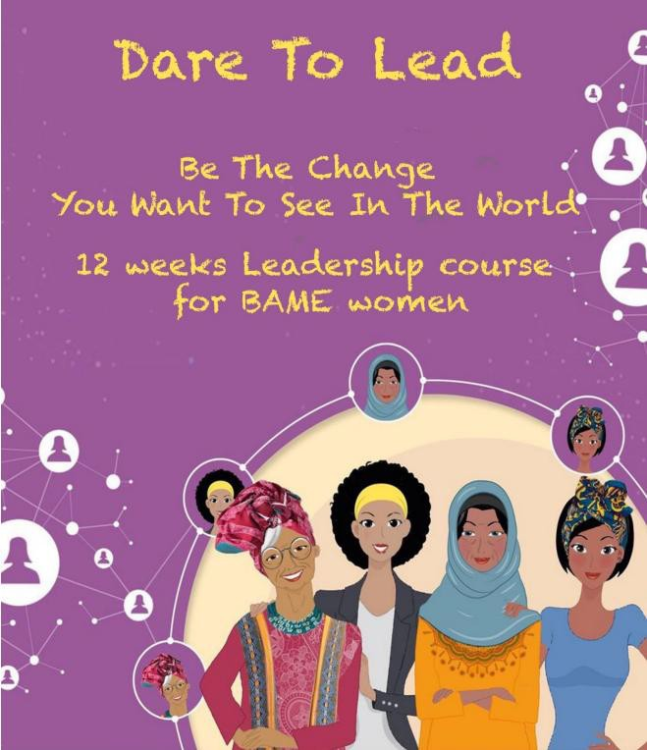
Case Study: Supporting Aspiring Leaders

Dare to Lead, Account3
- The Mayor’s Community Grants funds £85,417 to deliver the

‘Dare to Lead’ BAME Leadership course for local women.
- A customised BAME Women focused leadership programme, designed to support BAME women who are in
,or aspire to, leadership roles through a development
programme.
- The participating women completed a series of online classes on leadership topics and required women to develop a Social Action Project to bring together and build on their learning.


Case Study: Supporting Aspiring Councillors

Be a Councillor Campaign, LGA
- The Council supports the Local Government Associations ‘Be a
Councillor’ campaign.
- The campaign seeks to increases the awareness of what a councillor does and the different routes to participation.
- It aims to encourage people from underrepresented groups in the
borough, including women.
- The Council held two in-person events, and the women’s event resulted in a 23 per cent increase in understanding of the councillor role.
- There was a 20 per cent increase in women expressing more of an interest in standing for local election.

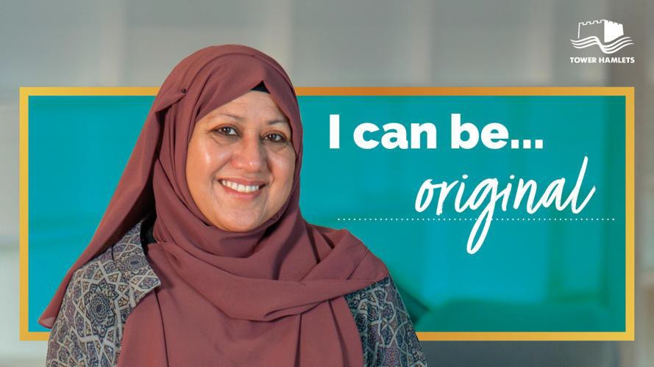
Case Study: Supporting Aspiring Leaders

“I can be” campaign, Olmec
  - The campaign ran from November 2024 to March 2025 and inspired a new generation of community leaders in support of the LGA’s “Be a Councillor” Campaign.
  - It emphasised Black, Asian and Multi-Ethnic (BAME) residents being the change they want to see.

Black on Board Community Leadership Programme, Olmec
  - Black on Board has been running in the borough from November 2024 and specialises in training
and mentoring candidates to take up board positions.
  - It provides a range of programmes and learning options that support people with a Black, Asian and Minority Ethnic background to identify and apply for board positions.

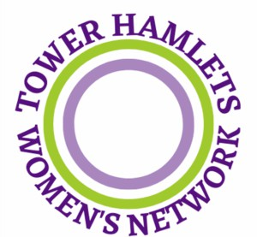
Case Study: Raising the Profile of Women in Tower Hamlets

Equalities Hub Women’s Network, Account3
- The Equalities Hub funds Account3 to deliver the Tower

Hamlets Women’s Network.
- This network delivers a programme of activities that raises the profile of women in the borough and explores current issues impacting women in Tower Hamlets.
- It seeks to provide inspiration for creating a more equal
society for the benefit of the whole community.
- The Women’s Network holds meetings, newsletters, events, workshops and opportunities for women to learn and develop.


Case Study: Empowering Women to Lead Change
Communities Keeping Well, NHS and TH Council
- A fund that helps communities take the lead to stay healthy and reduce risk of long-term health conditions.
- It has empowered women to transform ideas into action by supporting them to develop project plans, present them with impact at local community meetings, and bring them to life through funding.
- In 2024, programme engaged over 850 residents in 8 of the boroughs most
deprived, diverse and multilingual neighbourhoods.
- Supported over 100 residents to pith their ideas at local community voting days and select projects relevant to the local community
- It supported 65 residents and VCS led projects to tackle locally-specific wider determinants of health.

Summary
- Tower Hamlets is committed to ensuring women’s equalities in all spaces, including in community leadership.
- There has been continuous improvement in the gender pay gap, with women now earning more than men when considering both mean and median pay gaps.
- The council delivers initiatives and strategies that promote women’s
equality in leadership, such as the Annual Women’s Awards.
- The council supplies numerous grants to organisations across the borough that carry out leadership initiatives for women, such as Account3’s “Dare to Lead” programme.

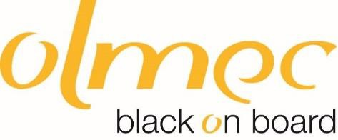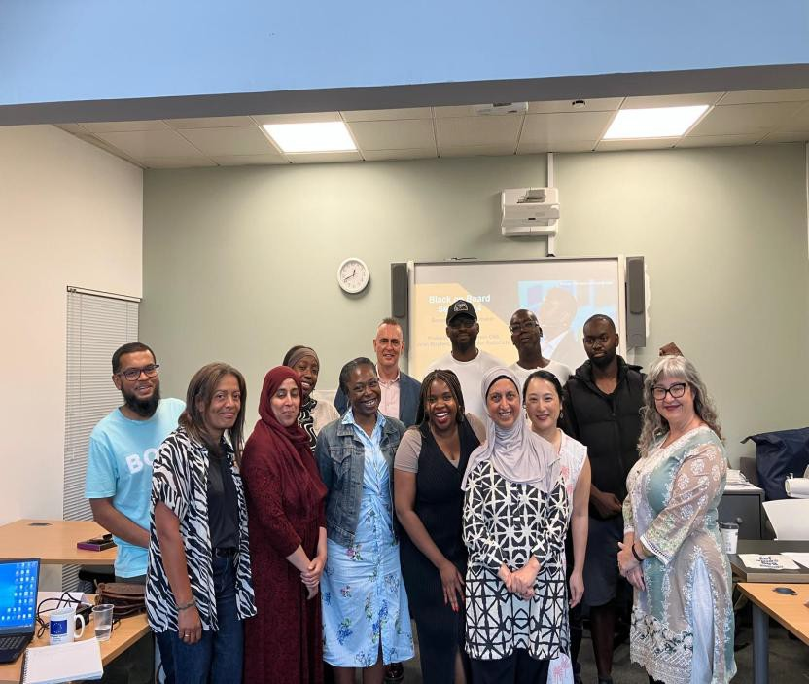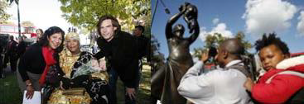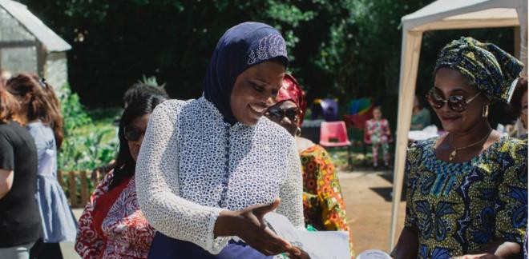

Tower Hamlet’s Women’s Commission
Formal Public Review on women’s inequalities in leadership.
Leadership and Women’s Empowerment
Thursday 25th September 2025

Leadership and Women’s Empowerment

  - About Olmec
  - Olmec work to empower local women in community leadership roles – Black on Board 2024/5
  - Barriers faced by women in community leadership
  - Recommendations for the wider borough and partners support women into leadership


Olmec history
- Olmec was founded by
Presentation Housing
- Independent in 2010
- Presentation was founded by Black and Asian families clubbing together to buy houses in the 1960s because they were unable to get loans from banks
- Issues of structural racism faced in
the 1960s persist in 2021

About Olmec

  - Race Equality Through Economic & Social Justice
  - A social enterprise:
  - Board of 8 - 100% BMC
  - 14 Associates
  - Our team is 90% BMC and 50% gender balance
  - Trainers are highly experienced, all current board members with CEO / senior management who draw on lived experience
  - Olmec Chair Dr Curtis Asante
  - Former Olmec Chair Dr Omar Khan; secretariat APPG Race & Community, &
UN report on UK performance on Race Equality
http://www.olmec-ec.org.uk/

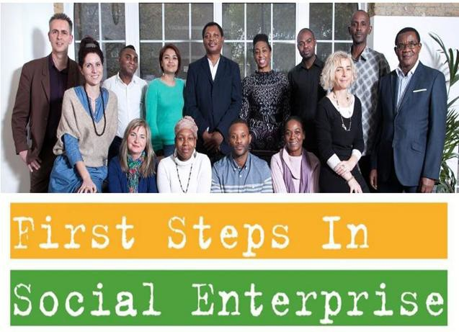

About Olmec
Supporting people from Black Minoritised and Racialised Communities (BMC) into jobs, social enterprise and boards.
Empowering communities through anti-racist
training and community arts.

- Black on Board
- Step Change
- Rise Into Employment
- First Steps in Social Enterprise
- Migrant and refugee women’s hub
- Bronze Woman
- 100 Great Black Women Speak
- Funky Reggae Party
- Anti-racist training

About Olmec – approach to designing all programmes
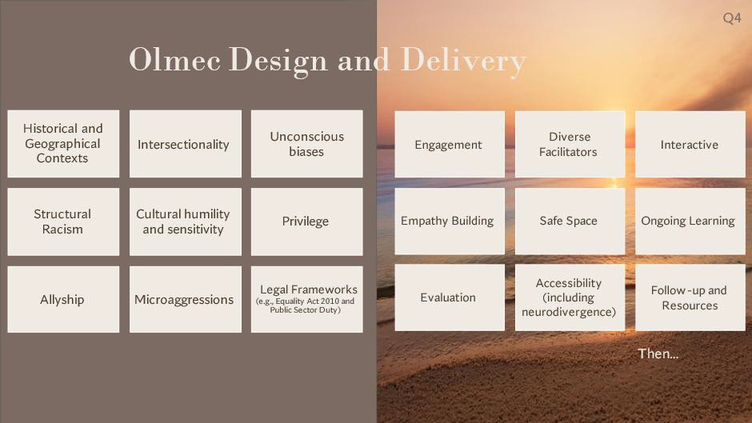

www.olmec-ec.org.uk

Olmec’s work to empower women in Tower Hamlets
Olmec was awarded a tender to pilot our Black on Board Community leadership programme in the Tower Hamlets in 3 cohorts
  - Set up in 2003 to address under representation at board level on boards
  - Since 2018 trained 650 people of colour
  - 450 people on boards or in community leadership positions
  - 80% take up by women
  - 100% reported increased learning against every indicator in the programme
  - 75% of graduates consistently achieve community leadershi
  - Cohort 1 in Tower Hamlets 10 out of 12 graduates achieved board positions

Olmec’s work to empower women in Tower Hamlets
Olmec was awarded a tender to pilot our Black on Board Community leadership programme in the Tower Hamlets in 3 cohorts
  - Set up in 2003 to address under representation at board level on boards
  - Since 2018 trained 650 people of colour
  - 450 people on boards or in community leadership positions
  - 80% take up by women
  - 100% reported increased learning against every indicator in the programme
  - 75% of graduates consistently achieve community leadershi
  - Cohort 1 in Tower Hamlets 10 out of 12 graduates achieved board positions

Black on Board Curriculum

Session 1 | Building your brand and direction & the role of the board
Session 2 | Meeting conduct: understanding meetings as a negotiation tool
Session 3 | Strategic and operational planning
Session 4 | The role of boards; legal obligations & governing documents
Session 5 - | Leading People
Session 6 | Applying for promotion, management, senior and board positions
Session 7 | Managing Risk
Session 8 | Employing people and managing performance.
Session 9 | Managing finance
Session 10 - June | Role of board. Role of departments
Session 11 - July | Induction, the first meeting and unlocking the board papers
Session 12 - July | Mock interviews
Session13 - Sept | Getting the message across through public speaking & marketing in the digital age.
Session 14 - Sept | How to develop as a change maker or influencer

Olmec’s work to empower women in Tower Hamlets

- We circulate board vacancies and leadership
opportunities to Black on Board delegates
- We organise Graduation Ceremonies and
BoB’s Fairs
- We broker leadership opportunities with
organisation like MoJ, DBS, and BME London

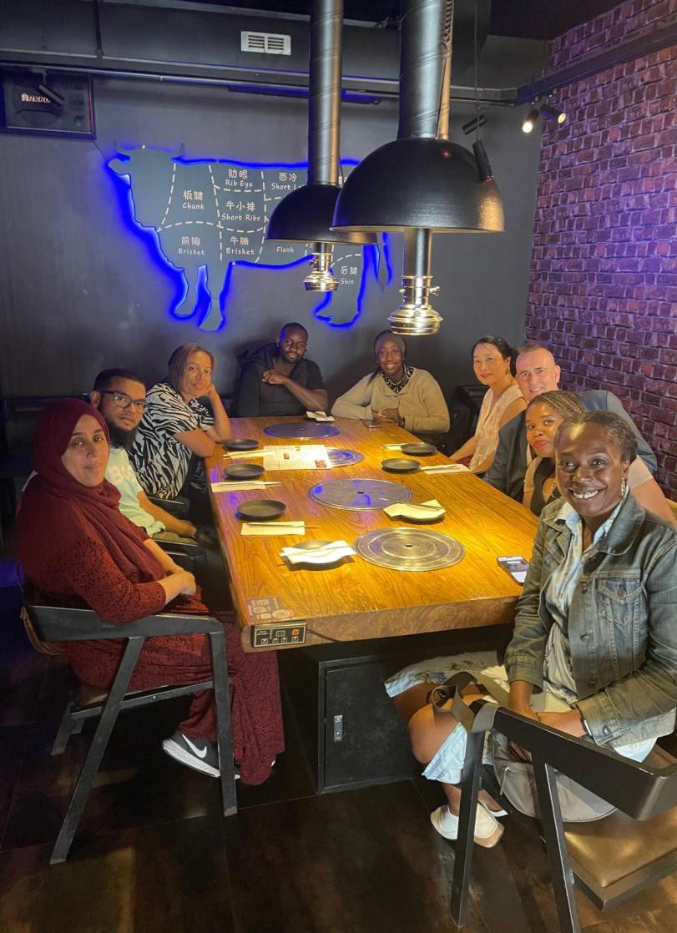
Tower Hamlets case studies – women of colour

- Case study 1 – Graduate is on a grant making
body Collaboration Circle
- Case study 2 – Graduate is on a local arts charity, and applying for national places
- Case study 3 – joined an NHS Trust
- Case Study 4 – 2 graduates have established a Community Interest Company for women
- Case Study 5 – Established a social enterprise to empower women, is a Trustee and applying for public appointments

Barriers faced by women of colour in Tower Hamlets Women's Commission Data

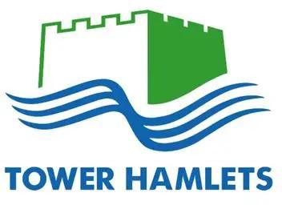
Women tend to spend fewer years in good health than men.

  - Women’s employment rate is significantly lower, with Black,
Asian and Multi-Ethnic women experiencing the greatest
disadvantage.

- Nearly double the percentage of women are in insecure jobs. •
Only 40 per cent of councillors are women.

- Seventy-five per cent of domestic abuse survivors are women.

  - Ninety-five per cent of perpetrators of domestic violence are
men

Women's Commission that many women in Tower Hamlets feel excluded from both
community leadership and local decision making.

- Nearly two-thirds (62 per cent) of women did not identify
as a community leader.
  - Similarly, two-thirds of women (63 per cent) did not feel involved with decisions made by the council or other
public bodies.
    - Women were twice as likely (69 per cent) to feel that
there were barriers to being active in their communities as leaders than not (31 per cent)

Barriers face by women of colour in Tower Hamlets – race disparity overview

Black people are 18 times more likely to be stopped and searched under Section 60 than
their white counterparts

For every £1 of White British wealth, Indian households have 90-95p, Pakistani households 50p, Black Caribbean 20p, and Black African and Bangladeshi households have 10p.

Fewer than 1% of students at GCSE level study a book by a writer of colour. 46% of ethnic minority children are living in poverty in Britain.

75% of women of colour have experienced racism at work, and 61% report
changing themselves to ‘fit in’. Runnymede Trust/Fawcett Society Report 2022.

Barriers face by women of colour in Tower Hamlets – race disparity overview

BMC communities face disadvantage in the education system, housing, employment, mental health services, health & are over-represented in prison and underrepresented on boards.

Documented in data sets Race Disparity Audit

Barriers face by women of colour in Tower Hamlets – race disparity overview

McGregor Report 2017

If race discrimination in employment was stamped out, it would be worth 24 Billion to the UK economy.

Barriers face by women of colour in Tower Hamlets – race disparity overview


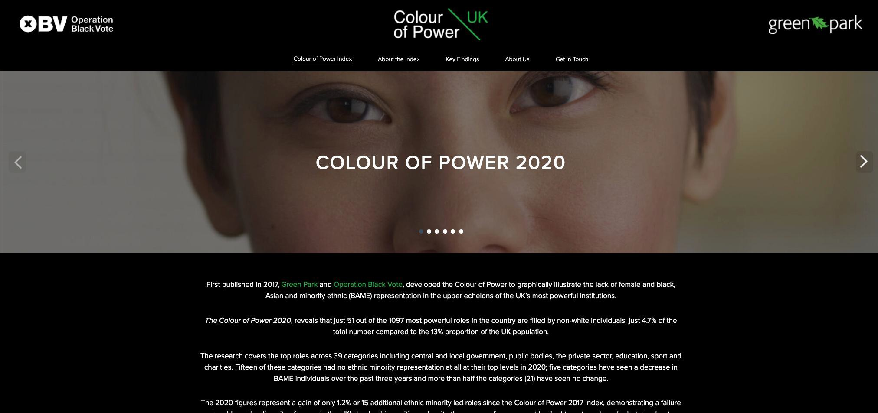
Diversity on boards is important

https://thecolourofpower.com/
Colour of Power Index · The Colour of Power

Barriers face by women of colour in Tower Hamlets – race disparity overview

2016
Parker Review
While 14% of the population identify as black and minority ethnic, only 1.5% of directors in FTSE100 boardrooms are UK citizens from a minority background. More than half of the FTSE 100 Boards are exclusively white.

2024 this figure has increased but still below 14% of BMC population

Barriers face by women of colour in Tower Hamlets – race disparity overview



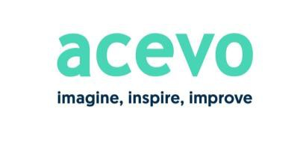
2019 ACEVO REPORT ON THE CHARITY SECTOR

- Acknowledge there is a problem with racial diversity in the charity sector

- Learn about racial bias and how it impacts leadership decisions.

- Commit to setting permanent and minimum targets for diversity

- Commit to action and invest resources

- View staff as the sum of many parts rather than a single entity

- Recruit for potential, not perfection.

- Value lived experience to bring insights to an organisation

Recommendations for the wider borough and partners support women into leadership

- Develop a Tower Hamlets Borough women into leadership strategy with targets taking an intersectional approach
and implement with resources
- Develop a race equality strategy with targets taking an intersectional approach and implement with resources and implement with resources
- Ensure programmes that work are invested in for a minimum of 3 to 5 years
- Encourage equalities, equity and diversity good practice and targets with stakeholders in public, private and third sector including local business, cooperative and social enterprise.
- Work with partners to ring fence leadership positions including mentoring, apprenticeships, observation position
- Invest in governance training programmes
- Invest in anti-sexism training programmes and explore innovative models including action learning
- Invest in anti-racism and allyship training
- Work with local role models and trusted organisations
- Build on existing work in education, health, police and criminal justice.

Additional information about Olmec and Black on Board

Black on Board Trainers

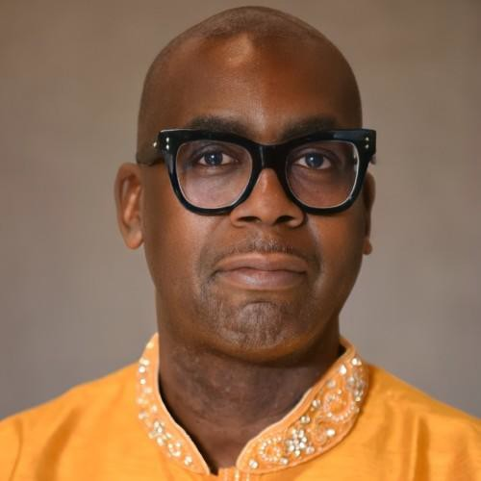

Professor PATRICK VERNON OBE is a Clore and Winston Churchill Fellow, a fellow at the Imperial War Museum, a fellow of the Royal Historical Society and a former associate fellow for the Department of the History of Medicine at Warwick University. Patrick was awarded an OBE in 2012 for his work in tackling health inequalities for ethnic minority communities in Britain. Since 2010 he has been leading the campaign for Windrush Day and in 2018 kick-started the campaign for an amnesty for the Windrush Generation as part of the Windrush Scandal which led to a government U-turn in immigration policy.

Professor Patrick Vernon OBE - Black on Board Trainer

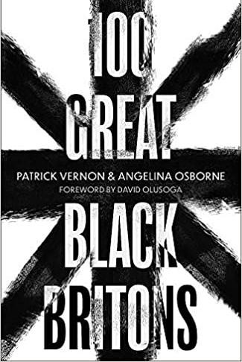
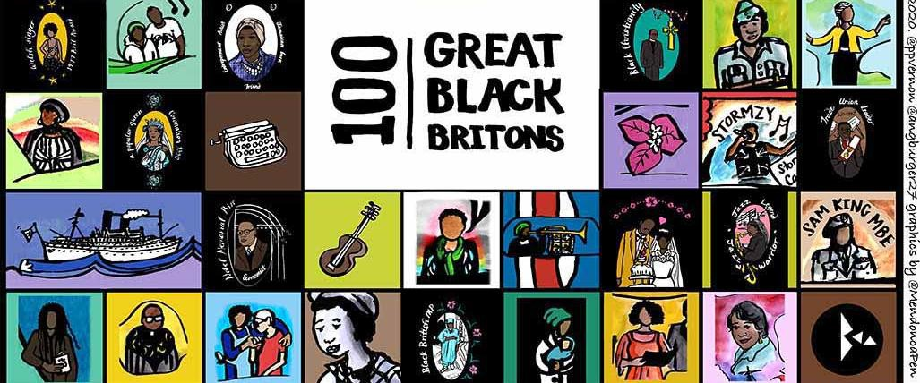

Olmec Trainers

Lara Oyedele
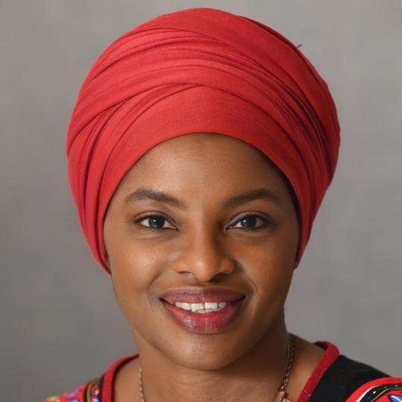

Lara served as the President of the Chartered Institute of Housing (CIH), board member of Housing 21 and Trustee of homelessness charity Hope Housing. Lara is a social housing committee and social entrepreneur.

Lara brings to Olmec a 30 career within the social housing sector culminating in 8 years as CEO of a small BME housing association. Lara was founding Chair of BMENational, the collective of BME housing associations in England. She trained as a journalist, has a Masters in Housing from the London School of Economics and is a graduate of Henley Business School.
www.olmec-ec.org.uk


Olmec Trainers

John Mayford FRSA - Senior Associate
John was CEO at Olmec for 15 years and possesses over 30 years senior level third sector experience. John guided Olmec from being a subsidiary charity of Notting Hill Housing Trust in 2010 to becoming an award winning, independent race equality organisation that supported BMC people, into jobs, boards and into social enterprise businesses. John was shortlisted by Foundervine in 2024 for the prestigious Ally of the Year award, in recognition of his EDI work in London and the UK. John continues his work in the race and EDI sector as a freelance consultant, CEO mentor, trainer and programme design specialist.

As a director and co-founding director of Action Time Vision cooperative in Bristol, John initiated the “Night in Easton” heritage and identity project. The project documented and celebrated Irish, Somali, Caribbean and Hindu diaspora life and culture in postcard and film format between 2005 and 2007

Black on Board Trainers

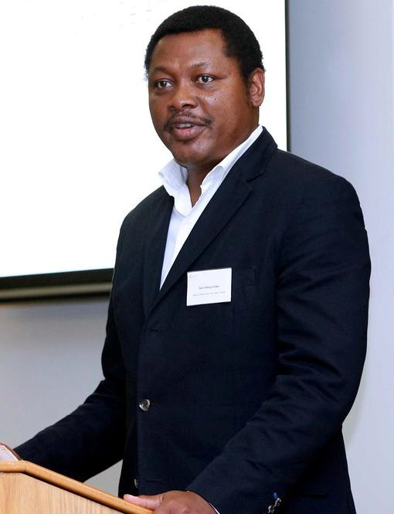

Sam Obeng-Doyki
Sam has been working with Olmec since 2008 successfully delivering social enterprise and the Black On Board programme. He has fulfilled a number of senior management roles in the voluntary sector, including the role of Director of Capacity Building at Full employ, a national charity. He also worked with Voluntary Action Islington, providing capacity building support to a significant number of voluntary and community organisations.

He has in the last six years supported over 200 VCO’s and individuals through training, one-to-one support, networking events and seminars in Lambeth to help them achieve their social and sustainability goals.
www.olmec-ec.org.uk

Black on Board Track Record

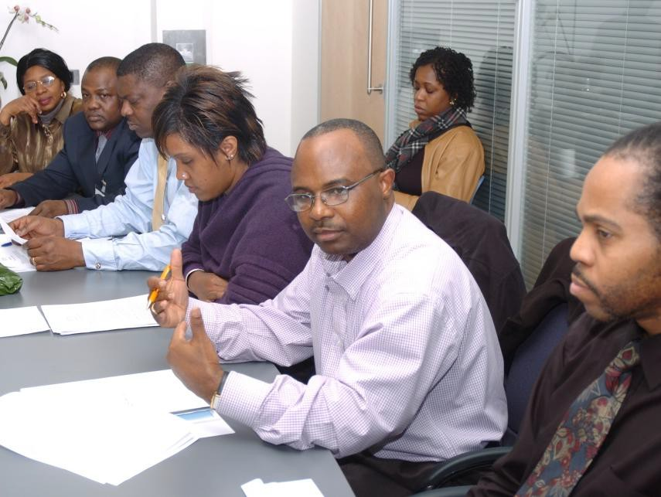


- 25 times since 2005

- 75% of graduates are supported into board positions, trustees, school governors or onto NHS Trusts

- Widen remit to SMT & promotion

Black on Board: why apply?

Route to:
- Promotion
- Board position
- Improved career prospects
- Increased confidence
- Public Speaking
- Enhanced professional skills
- Networks and contacts
- Power: a seat at the table

Black on Board Units

- Role of the Board  - Meeting conduct  - Legal Obligations  - Governing documents  - Employing people  :  - Managing Risk  - Managing Finance  Building your brand | - Managing performance  - Board recruitment and induction  - Strategic and operational planning  - Decision making  - Applying for places  - Understanding your sector  - Public speaking  - Getting your message across in the digital age

Outside the “classroom”

- CV and supporting statement review

- Mock Interviews

- one to one mentoring pre and post applications

- Graduation Ceremony

- Black on Board Community

Black on Board: Community

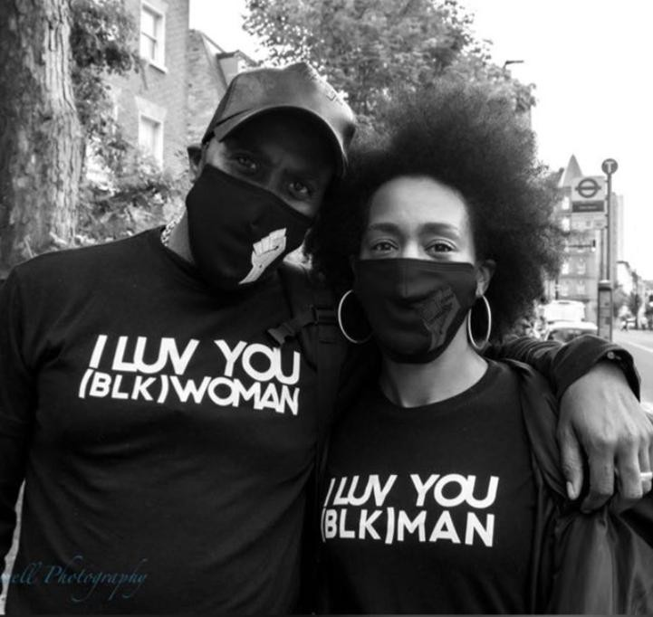

- A community for graduates of the programme.

- Continue their learning journey, mutual support
and promote the programme.

- Saturday masterclasses

- Discounted / free training

- Pay an annual subscription of £24

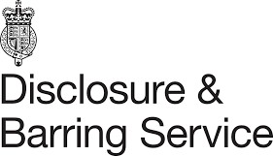


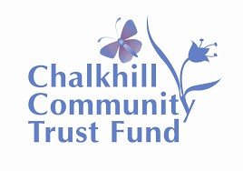
Our Impact: Example of Boards that BoB graduates achieved

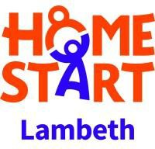

Migration Foundation


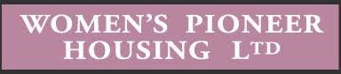



Testimonies

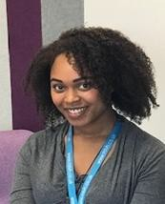

“Since Completing the Black on Board programme, I have given myself permission to be powerful. This means that I am now more confident in my capabilities which is reflected in my day to working role. It is also an approach in everyday life”

Phoebe Raphael



Jessica Bembridge
"Black on Board seeks to essentially disrupt the status quo by giving BAME people the skills and confidence to break through the glass ceiling and assume positions of power so that they can initiate real change. Having completed the programme I now truly feel that I can be that catalyst for change and advocate for people like me.”

Testimonies



‘I wanted to give a voice to underrepresented people, those, who look and talk like me, but who feel disconnected from organisations whose actions and decisions impact on their daily lives’
Jason Bowen

Testimonies

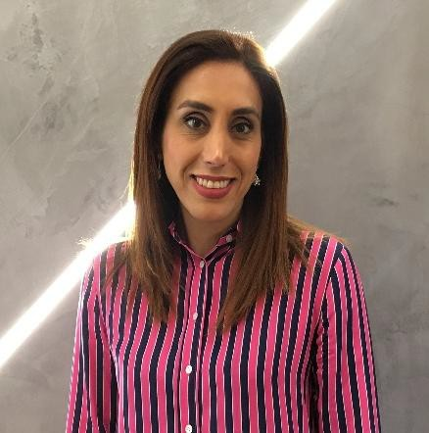

"Black on Board gave me the courage and skills to pursue a Board position, coming along with me step by step from application to interview. It also made me feel very valued, because the organisation is investing in me to achieve my own goals.’”
Somayeh Tousi

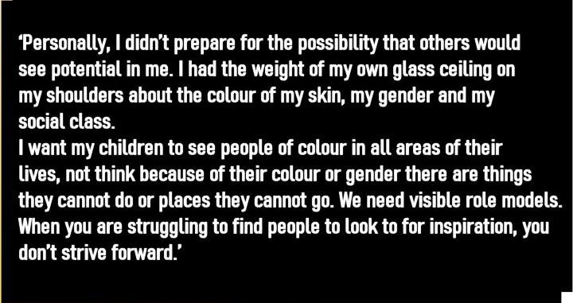
Testimonies
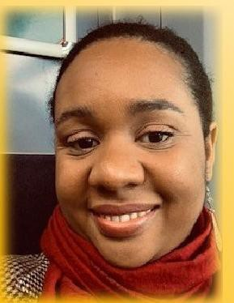

Chana King

Where to find us





www.olmec-ec.org.uk



www.linkedin.com/company/olmec/
https://www.youtube.com/@OLMEC-UK



https://x.com/olmecempcomm?s=21

info@olmec-ec.org.uk
jmayford@olmec-ec.org.uk

The Race Disparity Audit, The Stephen Lawrence Inquiry (Macpherson) Report, the McGregor-Smith Review, The 2017 Independent review of deaths and serious incidents in police custody by Dame Elish Angiolini QC

“We agree with Martin Luther King’s daughter and many other civil rights leaders that the term and aims of Black Lives Matter align with the civil rights struggle that provides the context of origin of Olmec, and informed the development of our charitable objects, vision and mission.”

Akala Great Reads YouTube
I Can’t Breathe…Dawn Butler MP Structural and systemic racism can exist without individual acts of racism and it is literally killing us. #BLMUK #COVID19 #BlackLivesMatter
Layla F. Saad – Me and White Supremacy Layla F. Saad _ Me and White Supremacy YA Edition
Reni Eddo-Lodge – Why I’m No Longer Talking To White People About Race
David Olusoga – Black and British: A forgotten History
Akala – Native the ruins of Empire
Afua Hirsch – Brit(ish) Afua Hirsch (@afuahirsch) · Twitter Robin DiAngelo – White Fragility
Ibram X Kendi – How to Be an Antiracist

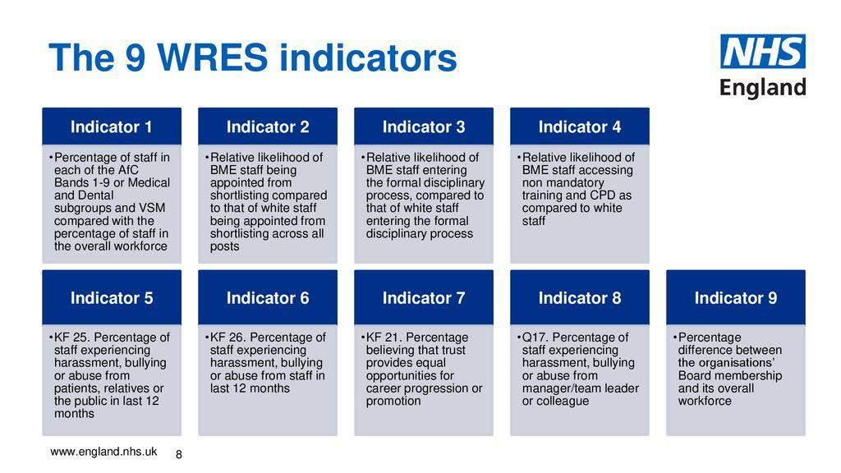

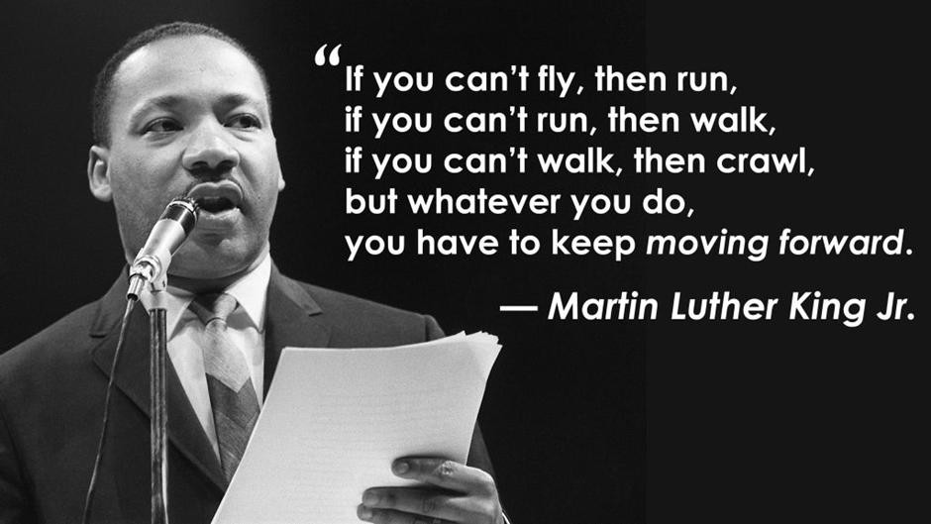


Tower Hamlets
Women’s
Commission
EMPOWERMENT, CHOICE, REPRESENTATION

Female Leaders Take Many Forms





one-size-doesn’t-fit-all
formal roles, advocacy, grassroots organising, family
visibility + influence
- both matter
HARCA:
board members, executives, local leaders, community champions

Barriers

Gender stereotypes & cultural expectations
Culturally perceived as male domain, measures reflect male-centric models
Glass ceiling, tokenism, &
misogyny
Limits to upward mobility, appointed to appear inclusive, not given real influence
Work-life balance &
responsibilities
Difficulties balancing leadership roles with family responsibilities
Organisational bias
Receive fewer opportunities for mentorship, networking, and leadership training
Internalised psychological
barriers
Psychological barriers - lack of confidence, fear of failure, and imposter syndrome
Lack of role models &
mentors
Scarcity of role models creates cycle where aspiring women lack guidance and inspiration

Breaking Barriers

Mentorship & sponsorship
Repeatedly cited as a key driver of leadership development
Policy & structural change
Flexibility, equitable pay, gender-inclusive policies, transparent HR processes, leadership pipelines, succession planning
Training
Targeted leadership development and unconscious bias training for all employees
Self-confidence & skill building
leadership skills through training, coaching, and self- reflection
Networking & peer support
Professional networks and peer support groups
Inclusive culture
Diverse leadership models and recognising the value of feminine leadership traits

HARCA’s Leadership

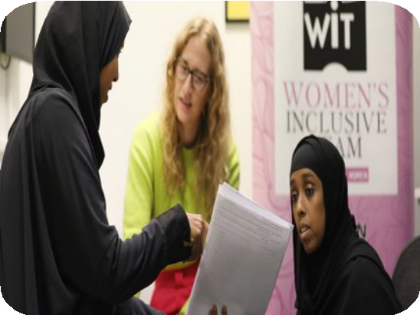
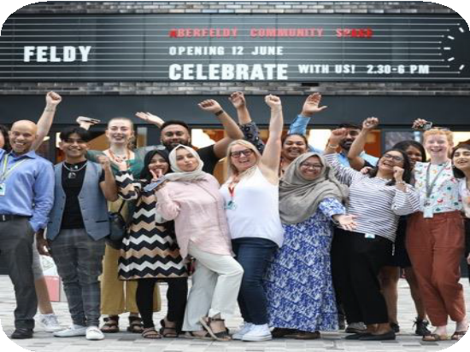
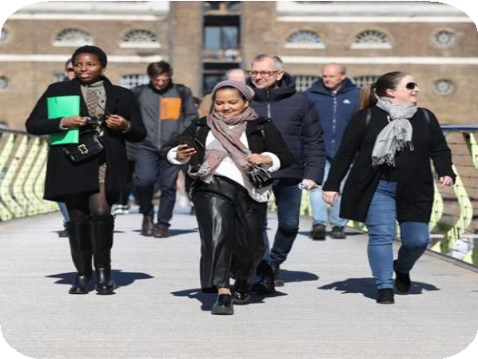

partnerships to develop skills and confidence

estate-based opportunities
centres, youth mentoring, cultural projects, health, wellbeing

female representation
Board and Executive

HARCA’s Female Leaders

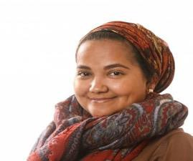
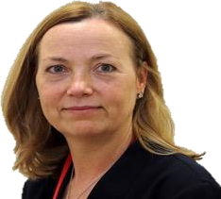
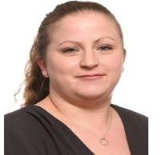
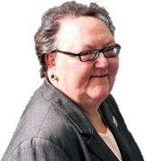


Momtaz Ajid

HARCA Board, founder Leaders in Community
Bernadette Conroy HARCA Chair, now Chair
Regulator of
Social Housing

Tanya Martin

HARCA Vice- Chair, now Director for Women in Sport
Christine Searle MBE HARCA Chair, founder successful housing consultancy

Liz Williams

Chief Operating Officer, started in Repairs Team

T wer Hamlet’s Women’s Commission
Tower Hamlet’s Women’s Commission



Tower Hamlets Women’s Commission
Canary Wharf Group

September 2025


What the Canary Wharf Group have done to empower women in community leadership roles, and how (2)
What specific barriers and learnings you have gained concerning women in community leadership (3)
Suggestions and recommendations around what the wider borough and partners can be doing to support women into leadership roles. (4)
Our session


Any lived experiences or case studies you may wish to speak on. (1)

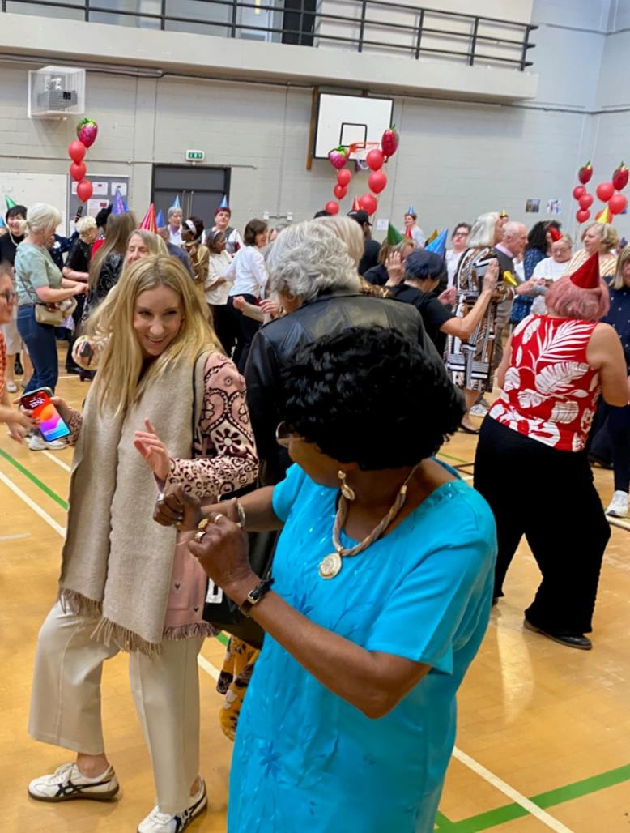




What I do now
3

When I was younger, I wanted to be….

The journey so far
SOPHIE GODDARD

One thing a love about MY JOB

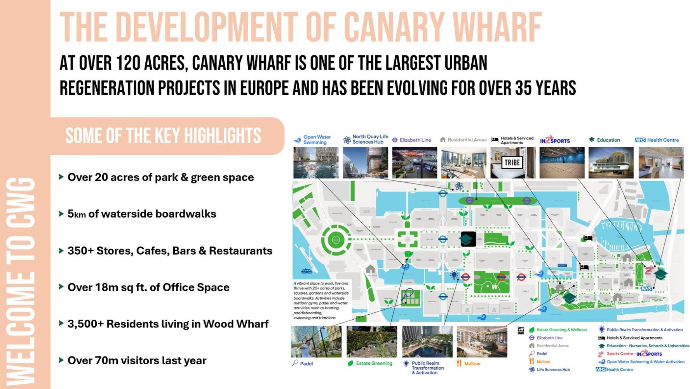
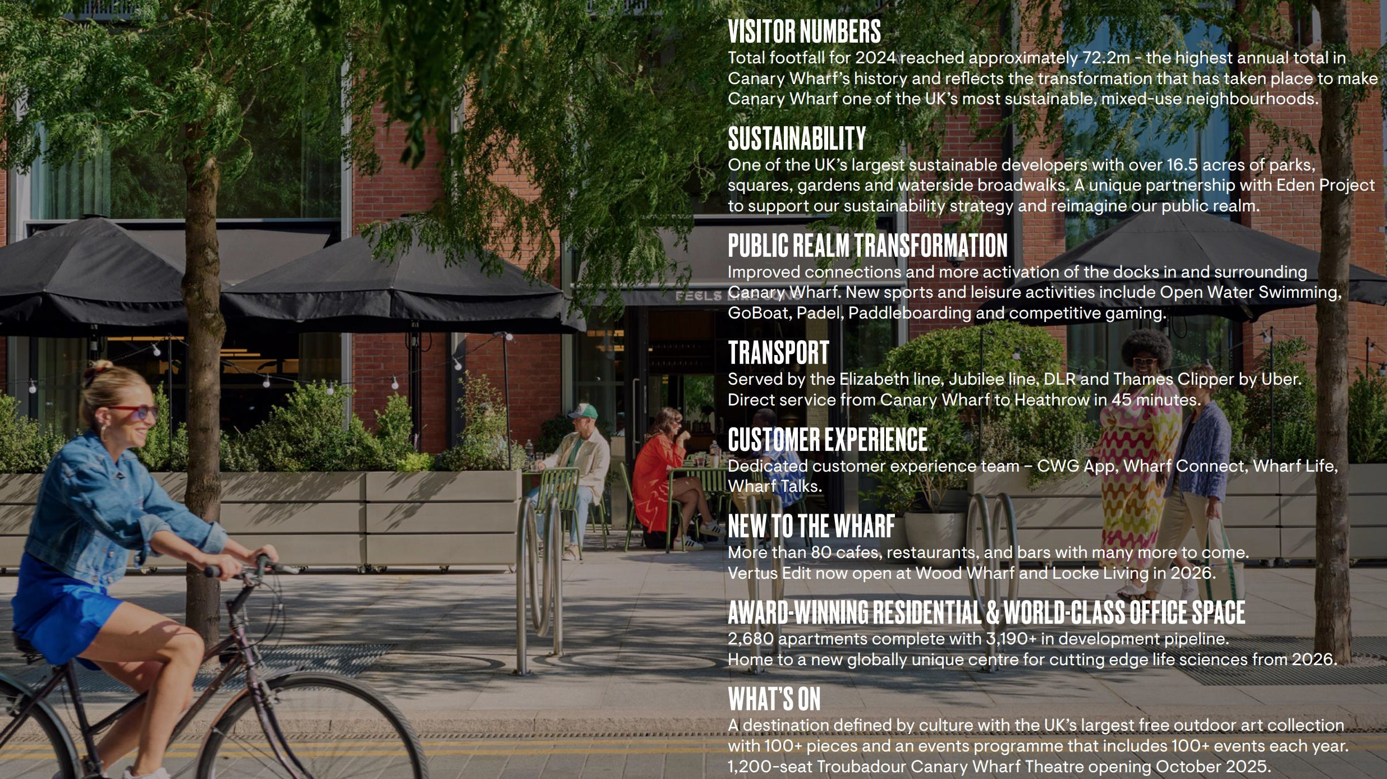



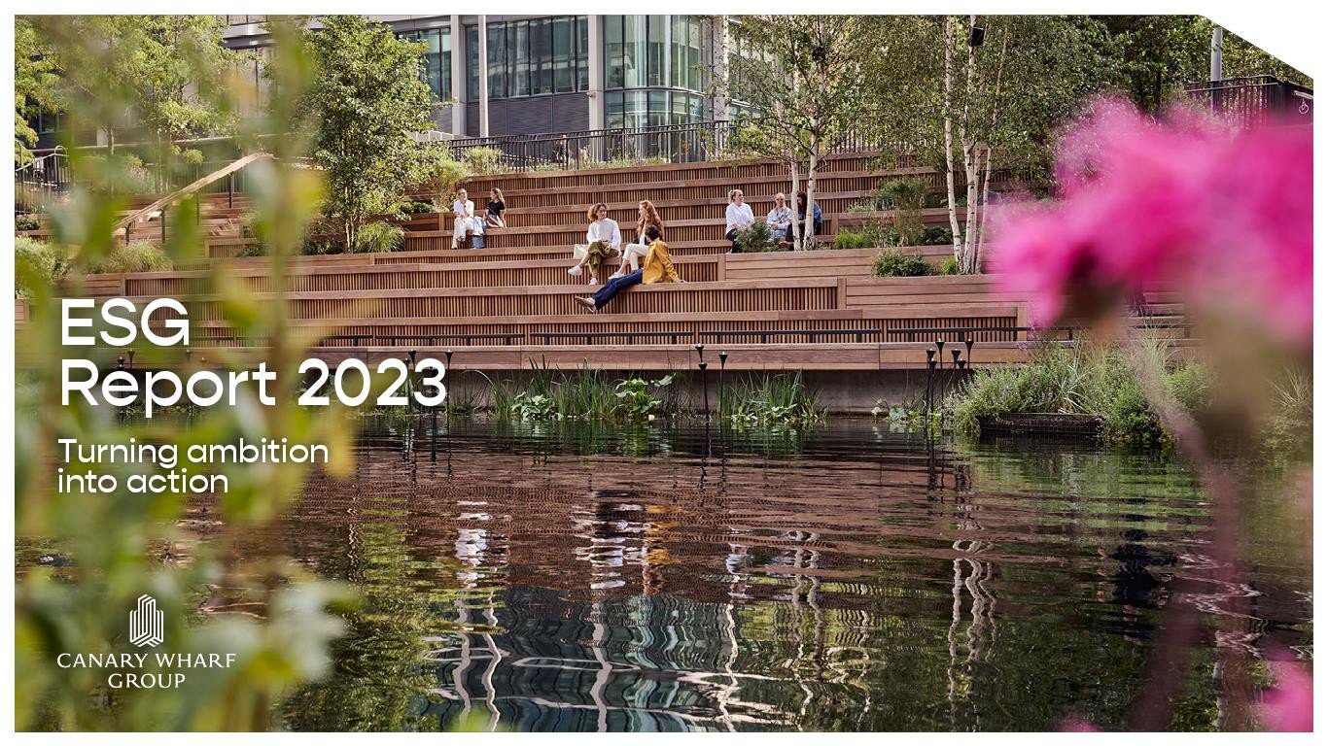
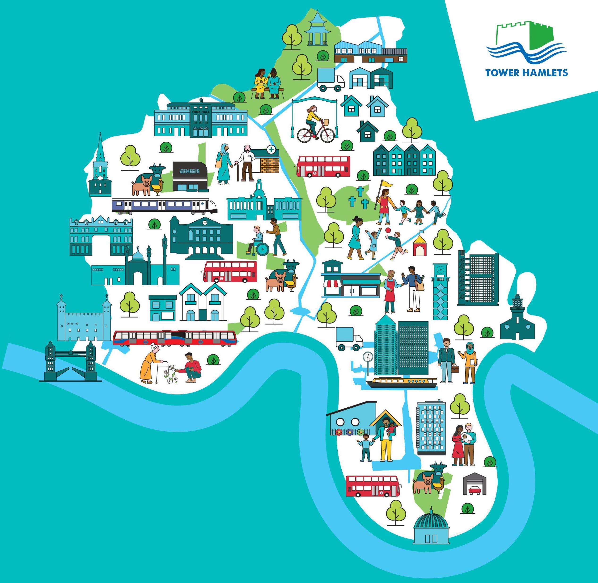
BUSINESS
6
Why does it matter to us?

COMMUNITY STAKEHOLD
