Gender Pay Gap 2023

A group of people, representing different sexes, races and disabilities



31/01/2023

Table of Contents

Context 3

Gender Pay Gap 3

Equal Pay and Gender Pay Gap 3

What do we report on? 3

Do we report data on any other protected characteristic? 3

Workforce Profile - Gender 4

Mean Gender Pay Gap 5

Median Gender Pay Gap 5

Bonus Gender Pay Gaps 6

Proportion of Men and Women by Pay Band 7

Workforce Profile – Ethnicity 7

Mean Ethnicity Pay Gap 8

Median Ethnicity Pay Gap 9

Bonus Ethnicity Pay Gap 9

Proportion of Black, Asian and Multi-Ethnic Staff by Pay Band 10

Workforce Profile – Disability 11

Mean Disability Pay Gap 12

Median Disability Pay Gap 12

Bonus Disability Pay Gap 13

Proportion of Disabled and Non-disabled Staff by Pay Band 14

Workforce Profile – Sexual Orientation 14

Mean LGBT Pay Gap 15

Median LGBT Pay Gap 16

Bonus LGBT Pay Gap 16

Proportion of LGBT and Heterosexual Staff by Pay Band 17

Pay Gap – Religion and Belief 18

Pay Gap – Age 19

Next steps 19

# Context

All public sector employers with over 250 employees are required to publish Gender Pay Gap Reporting under the Equality Act 2010 (Specific Duties and Public Authorities) Regulations 2017.

# Gender Pay Gap

The gender pay gap shows the difference between the average (mean or median) earnings of men and women. This is expressed as a percentage of men’s earnings. Used to its full potential, gender pay gap reporting is a valuable tool for assessing levels of equality in the workplace, male and female participation, and how effectively talent is being maximised.

The regulations relating to publishing gender pay gap information do not make provision for trans and non-binary employees, an issue the Council raised in its response to the original consultation on the legislation. As the Council’s monitoring systems evolve to allow better self-identification around gender, this information will be included in future reports.

# Equal Pay and Gender Pay Gap

The gender pay gap differs from equal pay. Equal pay deals with differences between men and women who carry out the same jobs, similar jobs or work of equal value. It is unlawful to pay people unequally because they are a man or a woman.

# What do we report on?

Using a snapshot of pay from **31 March 2022**, we use six calculations to show the difference between the average earnings of men and women in our organisation.

These are:

1. Our mean gender pay gap

2. Our median gender pay gap

3. Our mean bonus gender pay gap

4. Our median bonus gender pay gap

5. The proportion of men and women receiving a bonus payment

6. The proportion of men and women divided into four quartile pay bands

This information will be published on our own website and published on the government’s gender pay website by 30 March 2023.

# Do we report data on any other protected characteristic?

Yes, although there is no legislative requirement to. Since 2018, when the duty to report the gender pay gap was introduced, we have reported on the following, in addition to the gender pay gap:

1. Ethnicity pay gap
2. Disability pay gap
3. LGBT pay gap
4. Religion/Belief average hourly rates
5. Age band average hourly rates

# Workforce Profile - Gender

When we calculate gender pay figures, calculations are based on all full pay employees, a reduced pay employee being someone who is receiving less than their standard salary, for example on career break, maternity leave etc. The workforce headcount at 31st March 2022 was 4409, of which 2555 (58%) were females and 1854 (42%) were males.

At 31st March 2022, our total number of full pay employees was 3743, of which 2131 (57%) were females and 1612 (43%) were males.

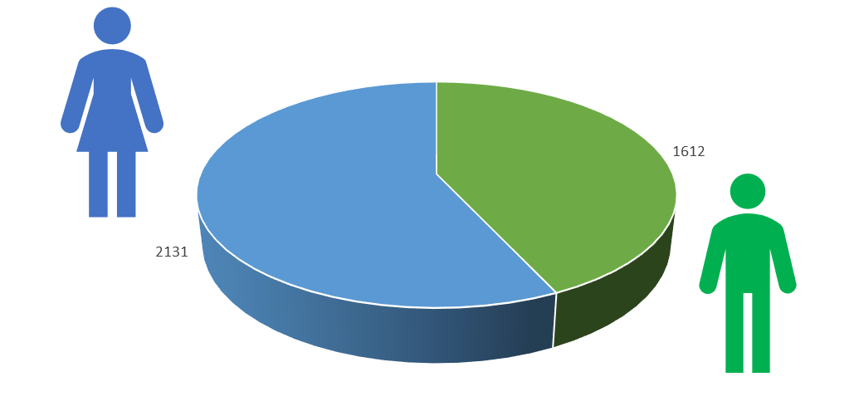

# Mean Gender Pay Gap

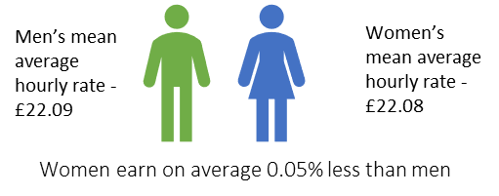

The **mean gender pay gap has decreased from 8.43% in 2018 to 0.05%** in 2023. This figure is relatively hard to benchmark due to the differing make up of services that are offered by different councils. The Council has both traditionally lowest paid male workforce (waste collection) and traditionally lowest paid female workforce (contract services) in house.

# Median Gender Pay Gap

# 

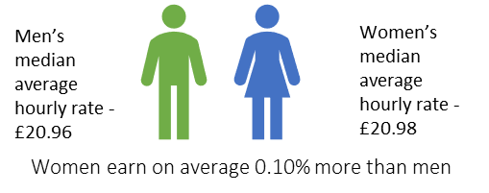

The **median gender pay gap has decreased from 6.75% in 2018 to -0.10%** in 2023.

# Bonus Gender Pay Gaps

**Mean average bonus pay gap**

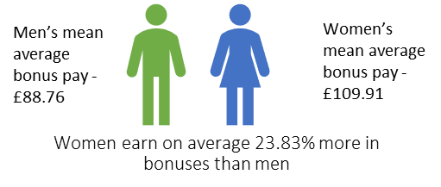

**Median average bonus pay gap**

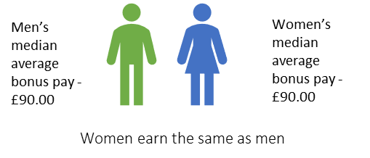

The Council does not operate any performance related pay or bonus schemes. Bonuses in the context of the specific definition in relation to the gender pay gap is mostly recruitment and retention payments for difficult-to-recruit posts.

# Proportion of Men and Women by Pay Band

Below, we have split the workforce into quartiles to show the proportion of men and women in each broad pay band.

There are 935 people in the lower quartile and 936 in each of the other quartiles.

With our overall workforce split between men and women being 43:57, this is a useful benchmark against which to compare the balance in each of the quartiles.

Women are fairly evenly spread across the two highest pay quartiles, are proportionately under-represented in the lower quartile and proportionately over-represented in the lower middle quartile.

# Workforce Profile – Ethnicity

When we calculate ethnicity pay figures, calculations are based on all full pay employees, a reduced pay employee being someone who is receiving less than their standard salary, for example on career break, maternity leave etc.

At 31st March 2022, our total number of full pay employees was 3743, of which 2073 (55%) were Black, Asian and Multi-Ethnic, 1487 (40%) were White and 183 (5%) had not disclosed their ethnicity.

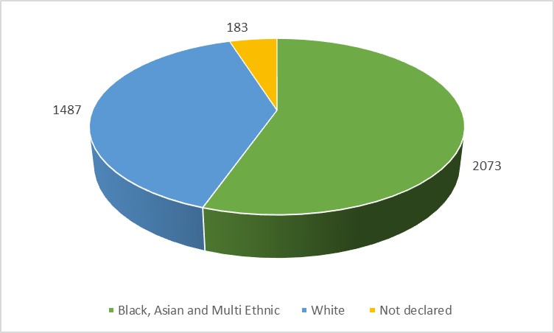

# Mean Ethnicity Pay Gap

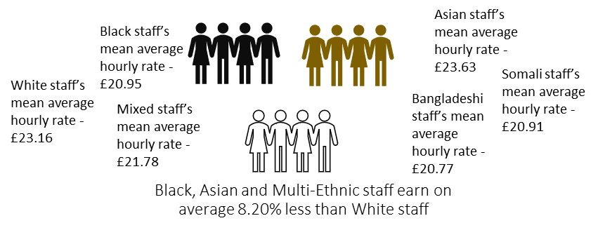

The mean ethnicity pay gap has decreased year on year, from 15.66% in 2018 to 8.20% in 2023.

# Median Ethnicity Pay Gap

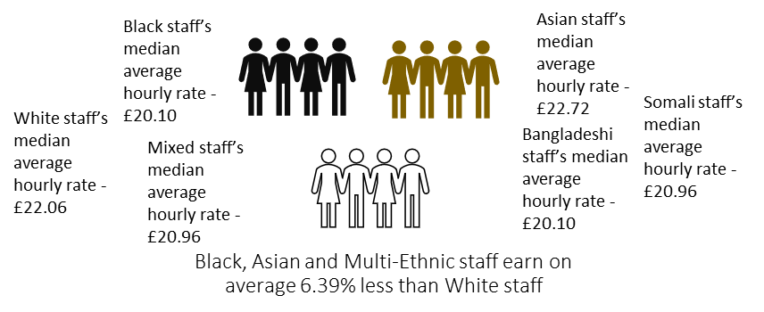

The median ethnicity pay gap has increased since last year, when it was 5.50% but has reduced from its highest point, which was in 2021 when it was 8.91%.

# Bonus Ethnicity Pay Gap

**Mean average bonus pay gap**

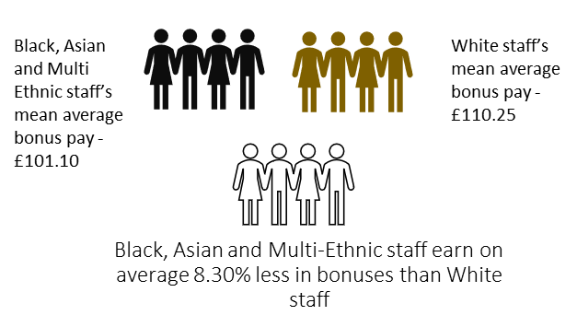

**Median average bonus pay gap**

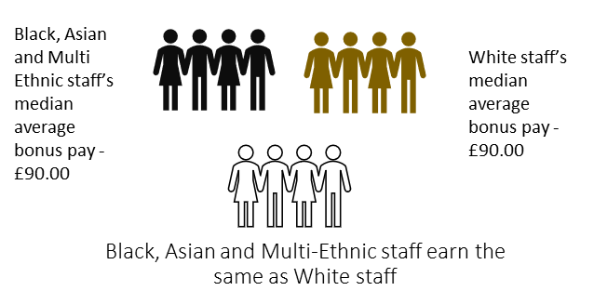

The Council does not operate any performance related pay or bonus schemes. Bonuses in the context of the specific definition in relation to the ethnicity pay gap is mostly recruitment and retention payments for difficult-to-recruit posts.

# Proportion of Black, Asian and Multi-Ethnic Staff by Pay Band

Below, we have split the workforce into quartiles to show the proportion of Black, Asian and Multi-Ethnic staff compared to White staff in each broad pay band.

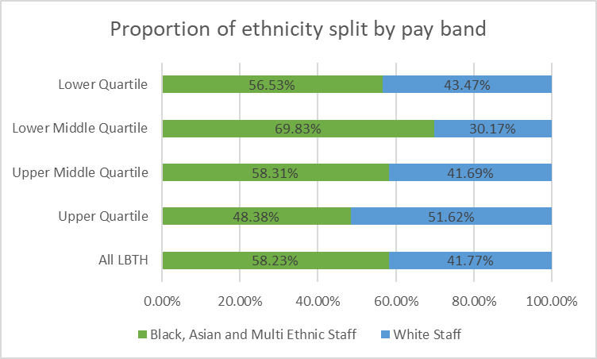

There are 935 people in the lower quartile and 936 in each of the other quartiles.

With our overall workforce split between Black, Asian and Multi-Ethnic staff and White staff being 58:42, this is a useful benchmark against which to compare the balance in each of the quartiles.

Black, Asian and Multi-Ethnic staff are proportionately overrepresented in the lower middle quartile and proportionately underrepresented in the upper quartile.

# Workforce Profile – Disability

When we calculate disability pay figures, calculations are based on all full pay employees, a reduced pay employee being someone who is receiving less than their standard salary, for example on career break, maternity leave etc.

At 31st March 2022, our total number of full pay employees was 3743, of which 232 (6%) were disabled, 3001 (80%) were not disabled and 510 (14%) had not disclosed their disability status.

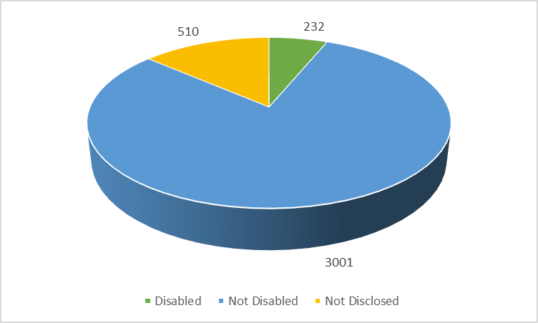

# Mean Disability Pay Gap

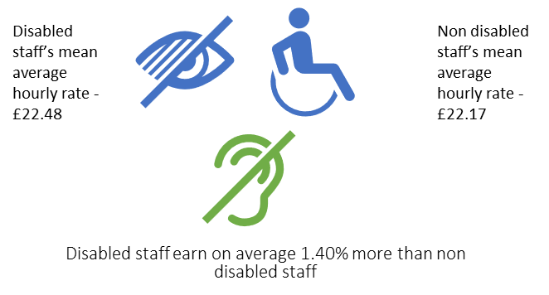

The mean disability pay gap has decreased from last year, when it was -5.22%, to -1.40% in 2023.

# Median Disability Pay Gap

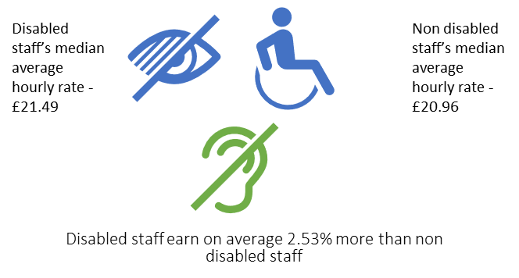

The median disability pay gap has decreased since last year, when it was -4.25%, to -2.53% in 2023.

# Bonus Disability Pay Gap

**Mean average bonus pay gap**

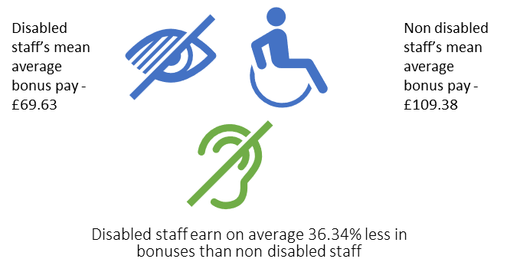

**Median average bonus pay gap**

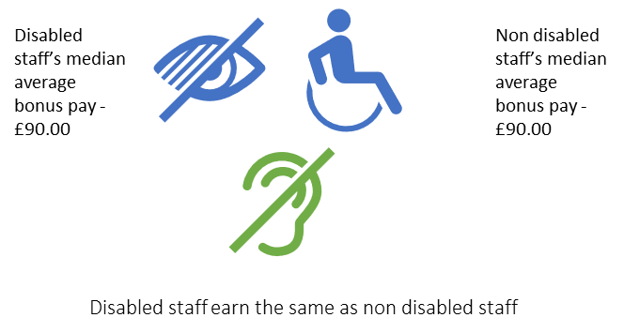

The Council does not operate any performance related pay or bonus schemes. Bonuses in the context of the specific definition in relation to the ethnicity pay gap is mostly recruitment and retention payments for difficult-to-recruit posts.

# Proportion of Disabled and Non-disabled Staff by Pay Band

Below, we have split the workforce into quartiles to show the proportion of disabled staff compared to non-disabled staff in each broad pay band.

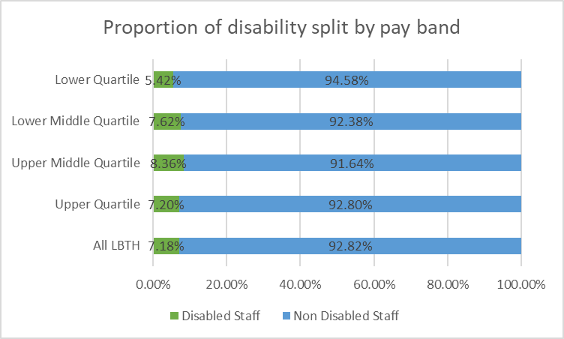

There are 935 people in the lower quartile and 936 in each of the other quartiles.

With our overall workforce split between disabled staff and non-disabled staff being 7:93, this is a useful benchmark against which to compare the balance in each of the quartiles.

Disabled staff are proportionately overrepresented in the upper middle quartile and proportionately underrepresented in the lower quartile.

# Workforce Profile – Sexual Orientation

When we calculate sexual orientation pay figures, calculations are based on all full pay employees, a reduced pay employee being someone who is receiving less than their standard salary, for example on career break, maternity leave etc.

At 31st March 2022, our total number of full pay employees was 3743, of which 139 (4%) were LGBT, 2826 (75%) were heterosexual and 778 (21%) had not disclosed their sexual orientation.

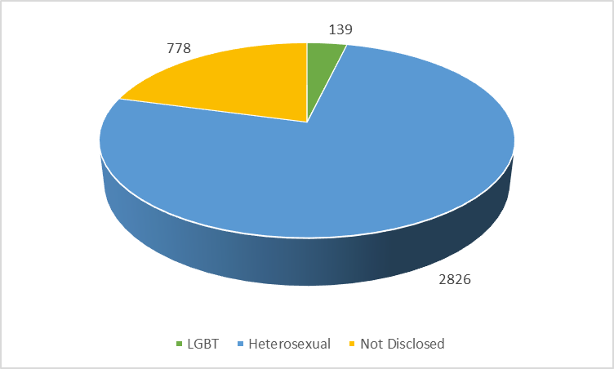

# Mean LGBT Pay Gap

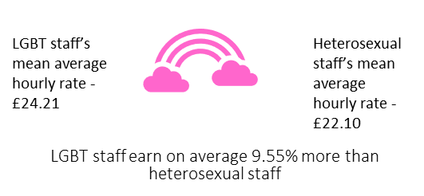

The mean LGBT pay gap has increased from last year, when it was -6.87%, to -9.55% in 2023.

# Median LGBT Pay Gap

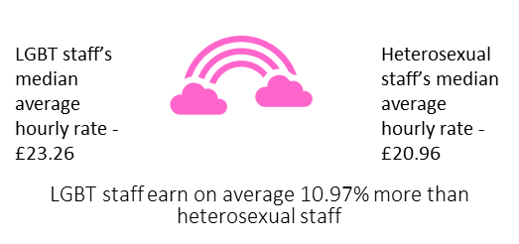

The median LGBT pay gap has increased since last year, when it was -4.92%, to -10.97% in 2023.

# Bonus LGBT Pay Gap

**Mean average bonus pay gap**

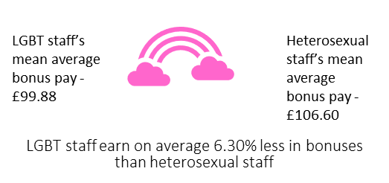

**Median average bonus pay gap**

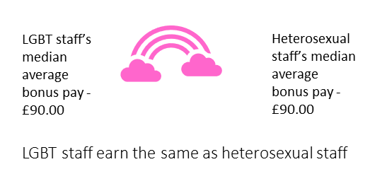

The Council does not operate any performance related pay or bonus schemes. Bonuses in the context of the specific definition in relation to the ethnicity pay gap is mostly recruitment and retention payments for difficult-to-recruit posts.

# Proportion of LGBT and Heterosexual Staff by Pay Band

Below, we have split the workforce into quartiles to show the proportion of LGBT staff compared to heterosexual staff in each broad pay band.

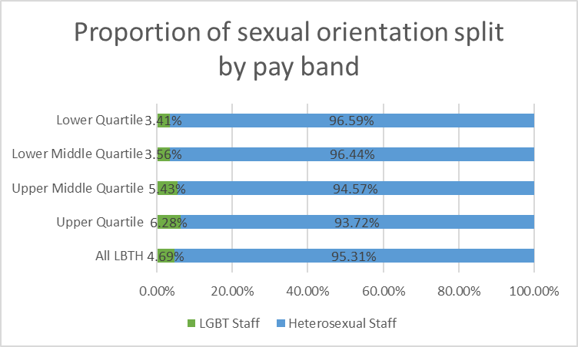

There are 935 people in the lower quartile and 936 in each of the other quartiles.

With our overall workforce split between LGBT and heterosexual staff being 5:95, this is a useful benchmark against which to compare the balance in each of the quartiles.

LGBT staff are proportionately overrepresented in the upper middle and upper quartiles and proportionately underrepresented in the lower middle and lower quartiles.

# Pay Gap – Religion and Belief

The hourly rates of pay are provided for religion/belief as there is no direct comparator. No analysis is provided since the table provides the information in what is a clear format.

This is a table showing by each religious group the number of staff in the workforce, the mean average hourly rate of pay and the median hourly average rate of pay.

Buddhist staff (21) earn £24.90 mean and £22.86 median.
Christian staff (1224) earn £21.77 mean and £19.75 median.
Hindu staff (42) earn £22.41 mean and £20.18 median.
Jewish staff (27) earn £23.31 mean and £20.18 median.
Muslim staff (1025) earn £20.70 mean and £18.39 median.
Staff with no religion (656) earn £24.61 mean and £22.86 median.
Other religion (117) earn £22.22 mean and £20.60 median.
Sikh staff (24) earn £22.87 mean and £21.18 median.
Staff whose religion is unknown (607) earn £22.10 mean and £20.30 median.
Total staff (3743) earn £22.08 mean and £19.75 median.

# Pay Gap – Age

The hourly rates of pay are provided for age band as there is no direct comparator. No analysis is provided since the table provides the information in what is a clear format.

This is a table showing by age bands the number of staff in the workforce, the mean average hourly rate of pay and the median hourly average rate of pay.

Staff aged 16-24 (37) earn £17.75 mean and £16.82 median.
Staff aged 25-34 (540) earn £21.05 mean and £20.07 median.
Staff aged 35-44 (950) earn £22.25 mean and £20.60 median.
Staff aged 45-54 (971) earn £22.65 mean and £19.90 median.
Staff aged 55-64 (1060) earn £22.43 mean and £19.75 median.
Staff aged 65-74 (178) earn £20.42 mean and £18.39 median.
Staff aged 75-84 (the number is not given as it is sufficiently small that the identification of individuals may be possible) earn £15.03 mean and £14.62 median.
Staff aged 85+ (the number is not given as it is sufficiently small that the identification of individuals may be possible) earn £12.83 mean and £12.39 median.
Total staff (3743) earn £22.08 mean and £19.75 median.

* Numbers in these categories are sufficiently small that identification of individuals may be possible

# Next steps

The challenge, as it is nationally, is to eliminate any of our pay gaps and we will continue to analyse and compare these figures year on year. Our Corporate Leadership Team will continue to review this data and work is taking place, linked to the Race Inequality Commission and Workforce to Reflect the Community, to better understand the biggest gap, which is the ethnicity pay gap, what is driving it, and how we can close it with targeted actions.

Actions related to addressing the ethnicity pay gap include:

* Analysing disaggregated data so we understand the specific gaps faced by each ethnic group
* Engaging a Data Analyst to undertake more detailed analysis of the data, including the intersectionalities between protected characteristics
* Model targeted actions to address the ethnicity pay gap and analyse their potential impact
* Deliver targeted actions to close the ethnicity pay gap
* Engage stakeholders, including the Trade Unions and staff networks in this work