31/3/2021 LBTH Transparency Chart
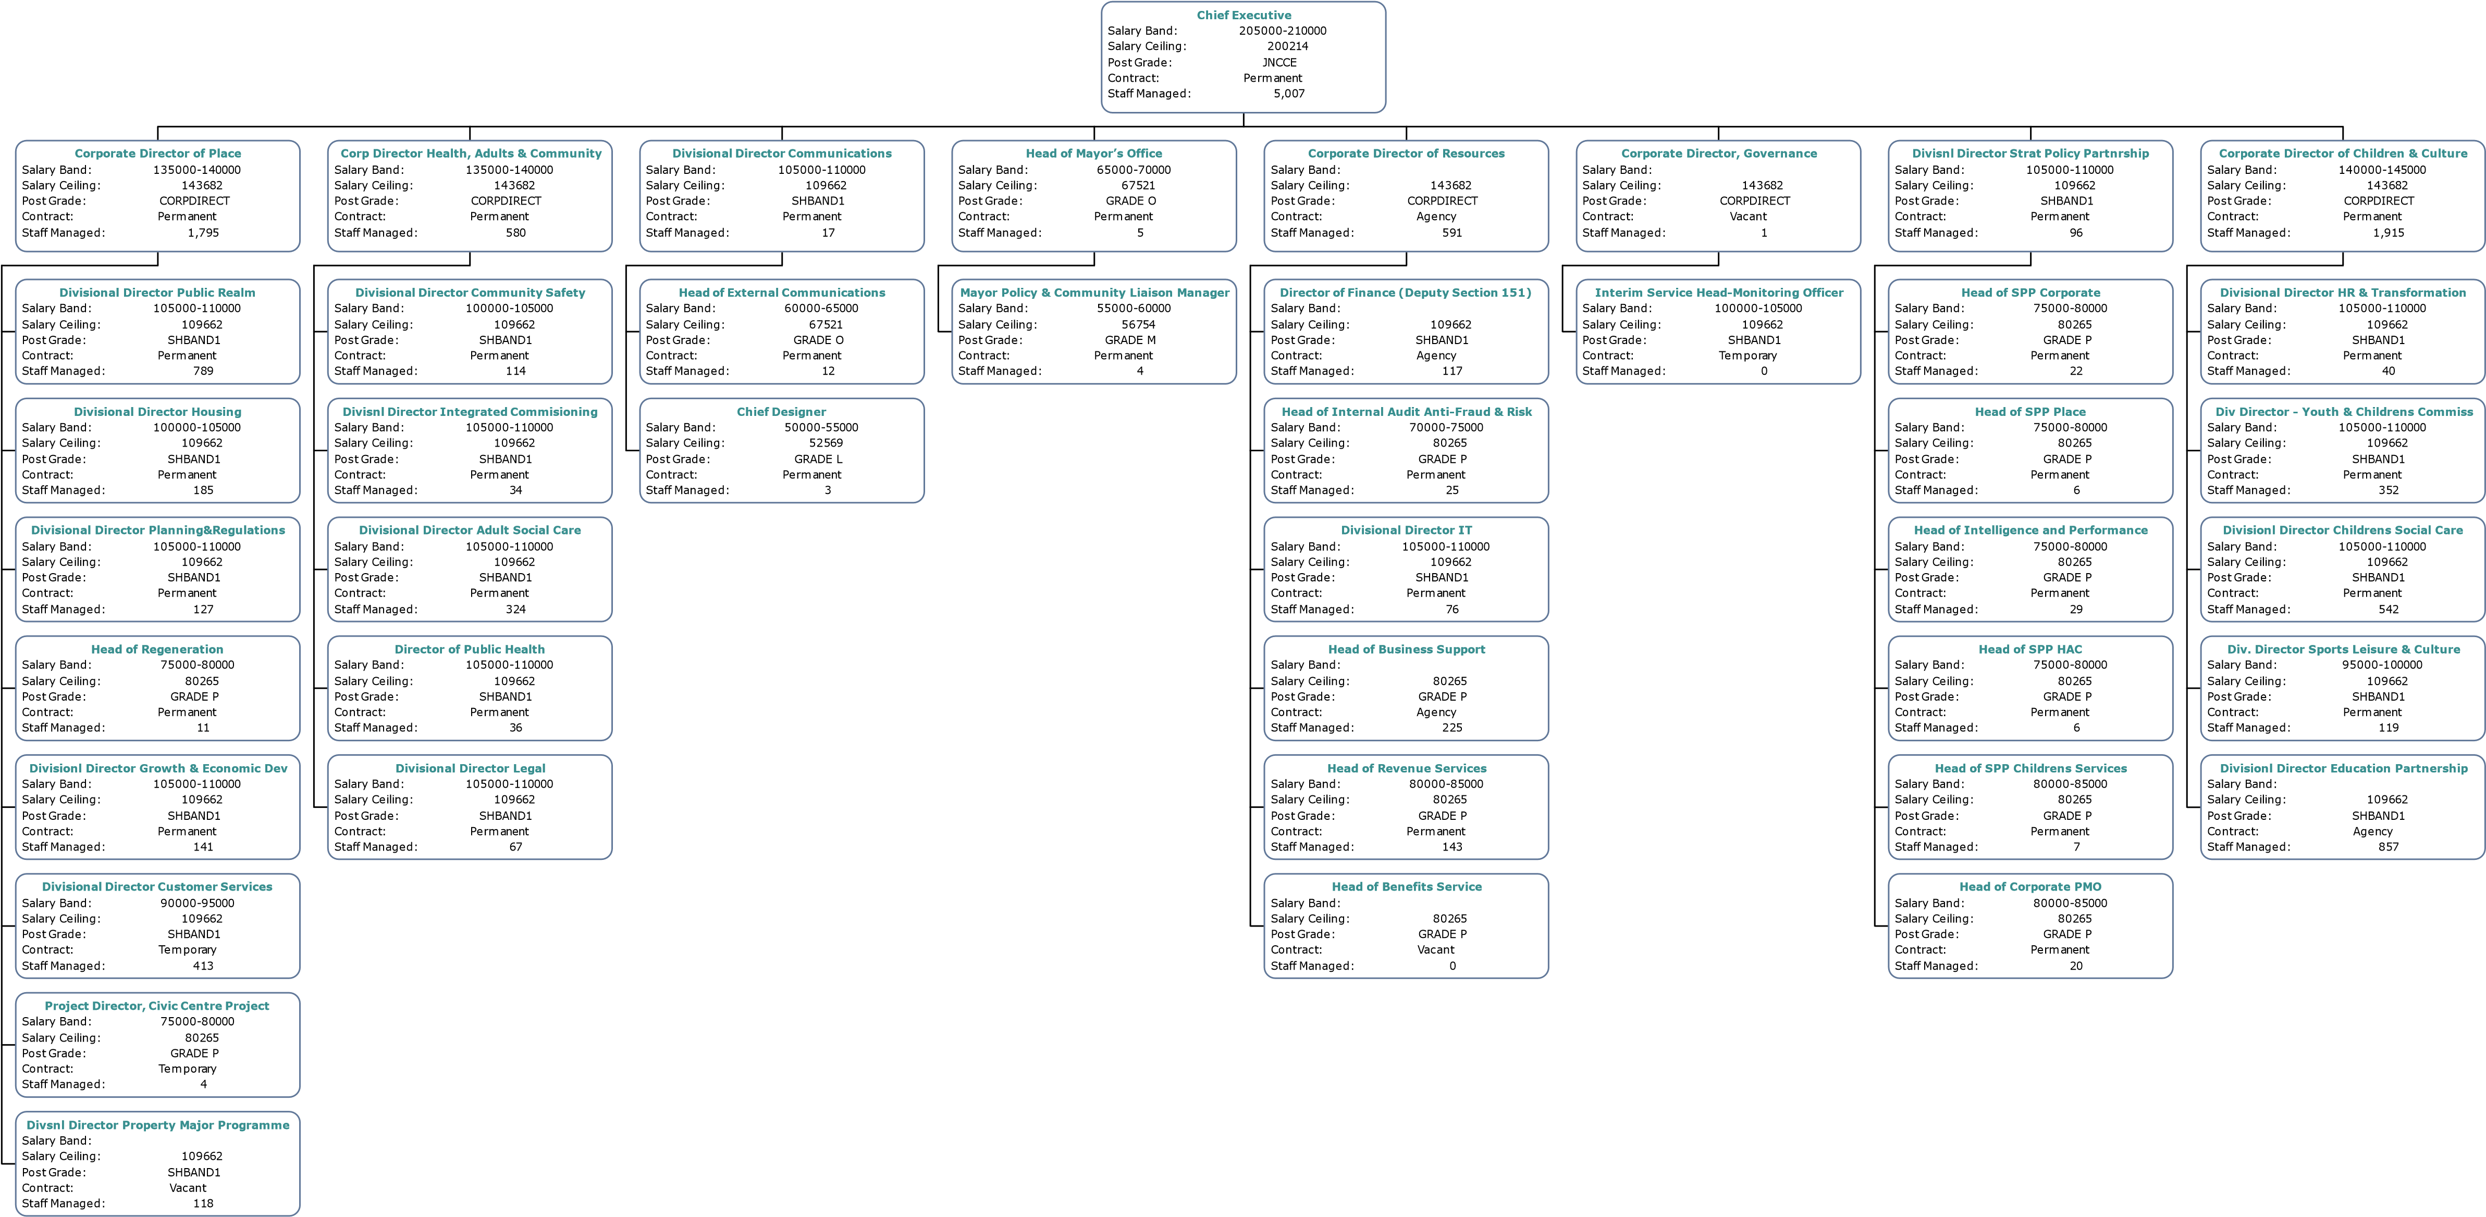

Post Title | Staff Managed | Post Grade | Salary Band | Salary Ceiling | Contract | Reports To
Chief Executive | 5,025.00 | JNCCE | 205000-210000 | 200,214.00 | Permanent
Corporate Director of Place | 1,795.00 | CORPDIRECT | 135000-140000 | 143,682.00 | Permanent | Chief Executive
Divisional Director Public Realm | 789 | SHBAND1 | 105000-110000 | 109,662.00 | Permanent | Corporate Director of Place
Divisional Director Housing | 185 | SHBAND1 | 100000-105000 | 109,662.00 | Permanent | Corporate Director of Place
Divisional Director Planning & Regulations | 127 | SHBAND1 | 105000-110000 | 109,662.00 | Permanent | Corporate Director of Place
Head of Regeneration | 11 | GRADE P | 75000-80000 | 80,265.00 | Permanent | Corporate Director of Place
Divisional Director Growth & Economic Dev | 141 | SHBAND1 | 105000-110000 | 109,662.00 | Permanent | Corporate Director of Place
Divisional Director Customer Services | 413 | SHBAND1 | 90000-95000 | 109,662.00 | Temporary | Corporate Director of Place
Project Director, Civic Centre Project | 4 | GRADE P | 75000-80000 | 80,265.00 | Temporary | Corporate Director of Place
Divisional Director Property Major Programme | 118 | SHBAND1 |  | 109,662.00 | Vacant | Corporate Director of Place
Corp Director Health, Adults & Community | 512 | CORPDIRECT | 135000-140000 | 143,682.00 | Permanent | Chief Executive
Divisional Director Community Safety | 114 | SHBAND1 | 100000-105000 | 109,662.00 | Permanent | Corp Director Health, Adults & Community
Divisional Director Integrated Commissioning | 34 | SHBAND1 | 105000-110000 | 109,662.00 | Permanent | Corp Director Health, Adults & Community
Divisional Director Adult Social Care | 324 | SHBAND1 | 105000-110000 | 109,662.00 | Permanent | Corp Director Health, Adults & Community
Director of Public Health | 36 | SHBAND1 | 105000-110000 | 109,662.00 | Permanent | Corp Director Health, Adults & Community
Divisional Director Legal | 67 | SHBAND1 | 105000-110000 | 109,662.00 | Permanent | Corp Director Health, Adults & Community
Divisional Director Communications | 28 | SHBAND1 | 105000-110000 | 109,662.00 | Permanent | Chief Executive
Head of External Communications | 12 | GRADE O | 60000-65000 | 67,521.00 | Permanent | Divisional Director Communications
Chief Designer | 3 | GRADE L | 50000-55000 | 52,569.00 | Permanent | Divisional Director Communications
Head of Mayor's Office | 12 | GRADE O | 65000-70000 | 67,521.00 | Permanent | Chief Executive
Mayor Policy & Community Liaison Manager | 4 | GRADE M | 55000-60000 | 56,754.00 | Permanent | Head of Mayor's Office
Corporate Director of Resources | 659 | CORPDIRECT |  | 143,682.00 | Agency | Chief Executive
Interim Corporate Director, Resources | 117 | SHBAND1 |  | 109,662.00 | Agency | Corporate Director of Resources
Head of Internal Audit Anti-Fraud & Risk | 25 | GRADE P | 70000-75000 | 80,265.00 | Permanent | Corporate Director of Resources
Divisional Director IT | 76 | SHBAND1 | 105000-110000 | 109,662.00 | Permanent | Corporate Director of Resources
Head of Business Support | 293 | GRADE P |  | 80,265.00 | Agency | Corporate Director of Resources
Head of Revenue Services | 143 | GRADE P | 80000-85000 | 80,265.00 | Permanent | Corporate Director of Resources
Head of Benefits Service | 0 | GRADE P |  | 80,265.00 | Vacant | Corporate Director of Resources
Corporate Director, Governance | 1 | CORPDIRECT |  | 143,682.00 | Vacant | Chief Executive
Interim Service Head-Monitoring Officer | 0 | SHBAND1 | 100000-105000 | 109,662.00 | Temporary | Corporate Director, Governance
Divisional Director Strat Policy Partnership | 96 | SHBAND1 | 105000-110000 | 109,662.00 | Permanent | Chief Executive
Head of SPP Corporate | 22 | GRADE P | 75000-80000 | 80,265.00 | Permanent | Divisional Director Strat Policy Partnership
Head of SPP Place | 6 | GRADE P | 75000-80000 | 80,265.00 | Permanent | Divisional Director Strat Policy Partnership
Head of Intelligence and Performance | 29 | GRADE P | 75000-80000 | 80,265.00 | Permanent | Divisional Director Strat Policy Partnership
Head of SPP HAC | 6 | GRADE P | 75000-80000 | 80,265.00 | Permanent | Divisional Director Strat Policy Partnership
Head of SPP Children’s Services | 7 | GRADE P | 80000-85000 | 80,265.00 | Permanent | Divisional Director Strat Policy Partnership
Head of Corporate PMO | 20 | GRADE P | 80000-85000 | 80,265.00 | Permanent | Divisional Director Strat Policy Partnership
Corporate Director of Children & Culture | 1,915.00 | CORPDIRECT | 140000-145000 | 143,682.00 | Permanent | Chief Executive
Divisional Director HR & Transformation | 40 | SHBAND1 | 105000-110000 | 109,662.00 | Permanent | Corporate Director of Children & Culture
Divisional Director - Youth & Children’s Commission | 352 | SHBAND1 | 105000-110000 | 109,662.00 | Permanent | Corporate Director of Children & Culture
Divisional Director Children’s Social Care | 542 | SHBAND1 | 105000-110000 | 109,662.00 | Permanent | Corporate Director of Children & Culture
Div. Director Sports Leisure & Culture | 119 | SHBAND1 | 95000-100000 | 109,662.00 | Permanent | Corporate Director of Children & Culture
Divisional Director Education Partnership | 857 | SHBAND1 |  | 109,662.00 | Agency | Corporate Director of Children & Culture

