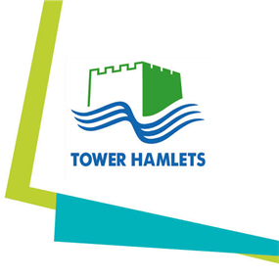
Appendix 1 London Borough of Tower Hamlets
Driving Assessment Form
Candidate details

Name
As presented on licence

Department / Team Date of assessment

Email address

Address on licence

Has the candidate registered on TTC Continuum for Licence Check?
Yes / No
If no, please speak to the Fleet Office and this can be organised for you

Acknowledge candidate has received a copy of “Fleet Safety P&P”
Yes / No
This would have been emailed to you prior to your assessment, if not please speak to the
Feet Office

Digital tachograph Driver CPC Log Book
Yes / No / N/A
Yes / No / N/A
Yes / No / N/A
Was “record book for
drivers in road transport”
issued (Domestic Hours Conviction details Pending charges
Yes / No

Please state year, If yes, please provide
offence code, points, details
notified insurers,
time served
Yes / No
Glasses / Contacts / None
Eyesight Eyesight 20m assessment passed
Candidate’s eye complies with
Legal requirements

Disabilities that affect driving: Diabetes,
Heart Conditions, DVLA noted, Insurers note, medication

Signature Date

Cost code

All driving assessment cost £60 which will be recharged to the relevant team after the assessment takes place. Please provide valid cost code

Cost code

This part to be completed by assessor only (Assessor to include assessment report)

I hereby certify that the above-named person on completing the road test, has passed / failed the council driving assessment.
PASSED / FAILED

Signature Date

